Chris Vaccaro
RESEARCH AND/OR CREATIVE WORKS
Poetry
“Blow Off,” “Ode to a Beer-soaked Muscle Cub,” “Sauna Sex,” “The Zen of Sadism.” | Hibernation: and Other Poems by Bear Bards. Ed. Ron Suresha. Bear Bones Press. (2014).

PUBLICATIONS
Books
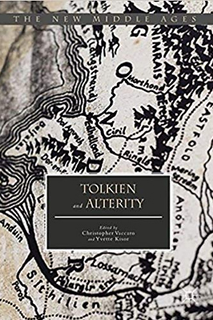 | Vaccaro and Yvette Kisor. (Eds). Tolkien and Alterity. Palgrave, 2017.
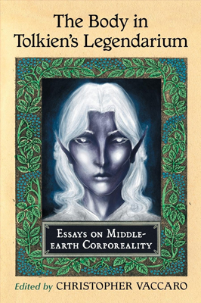 | Vaccaro. (Ed). The Body in Tolkien’s Legendarium. McFarland Press (2013)
Seclected Articles and Chapters
“‘Dyrne Langað’: Secret Longing and Homo-amory in Beowulf and J.R.R. Tolkien’s The Lord of the Rings” | Journal of Tolkien Research Vol. 6: Issue 1, Article 6 (August, 2018)
“‘Morning Stars of a Setting World’: Alain de Lille’s De Planctu Naturæ and Tolkien’s Legendarium as Neo-Platonic Mythopoeia” | Mythlore 36.1 Fall/Winter (2017): 81-102.
“Contexts and Comrades: Teaching Homo-eroticism and Homo-amory in Beowulf.” | Practical Guide to Teaching Beowulf. Ed. by Aaron Hostetter and Larry Swain. (Medieval Institute Publications, 2019)
“Saruman’s Sodomitic Resonances: Alain de Lille’s De Planctu Naturae and J. R. R. Tolkien’s The Lord of the  Rings.” | Tolkien and Alterity (Palgrave, 2017): 123-47.

