Valerie Rohy

PUBLICATIONS
Books
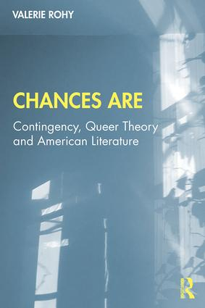 | Chances Are: Contingency, Queer Theory and American Literature, Routledge, October 2019
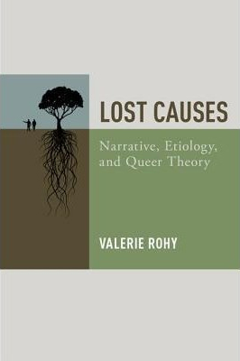 | Lost Causes: Narrative, Etiology, and Queer Theory (New York: Oxford University Press, 2015).
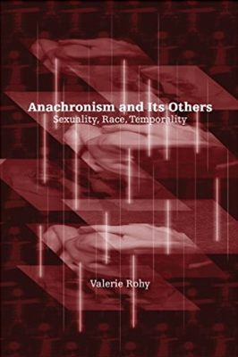 | Anachronism and Its Others: Sexuality, Race, Temporality (Albany, NY: SUNY Press, 2009).
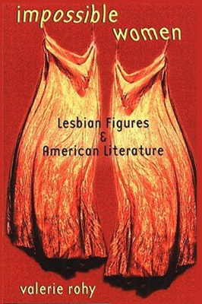 | Impossible Women: Lesbian Figures and American Literature (Ithaca, NY: Cornell University Press, 2000).
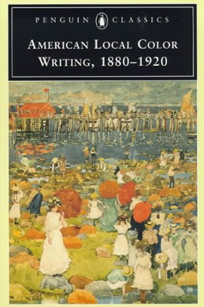 | American Local Color Writing, 1880-1920, ed. with Elizabeth Ammons (New York: Penguin, 1998).

Selected Articles
"Freeman's Object Lessons," | Legacy 37:1 (2020): 42-59.
"Absent-Minded Historicism" | co-authored with Elizabeth Fenton, J19: The Journal of Nineteenth-Century Americanists 7:1 (2019).
“Queer (Narrative) Theory” | The Cambridge Companion to Narrative Theory, ed. Matthew Garrett (New York, Cambridge University Press, 2018): 169-82.
"See It Now: Queer History and Archival Fantasy" | Textual Practice 32:4 (2018)
"The Calculus of Probabilities: Contingency and The Mystery of Marie Rogêt" | The Oxford Handbook of Edgar Allan Poe, ed. J. Gerald Kennedy and Scott Peeples (Oxford UP, 2018)
“The Cinema of the Impossible: Queer Theory and Narrative” | The Edinburgh Companion to Narrative Theory, ed. Mark Currie, Zara Dinnen, and Robyn Warhol (Edinburgh University Press, 2018).

