Susanmarie Harrington
PUBLICATIONS
Books
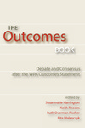 | Harrington, Susanmarie, R. Fischer, K. Rhodes, R. Malenczyk, eds. The Outcomes Book: Debate and Consensus in the Wake of the Outcomes Statement. Logan UT: Utah State University Press, 2005.
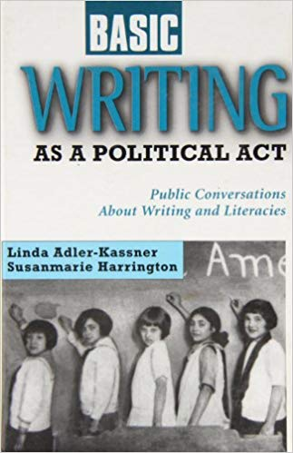 | Adler-Kassner, Linda and Susanmarie Harrington. Making Basic Writing Political: Basic Writers and Basic Writing In the Contemporary Academy. Cresskill NJ: Hampton Press. 2002.
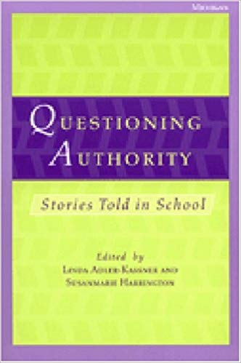 | Adler-Kassner, Linda, and Susanmarie Harrington, eds. Questioning Authority: Stories Told in School: The Essay and Who Writes It. Ann Arbor MI: University of Michigan Press, 2001.
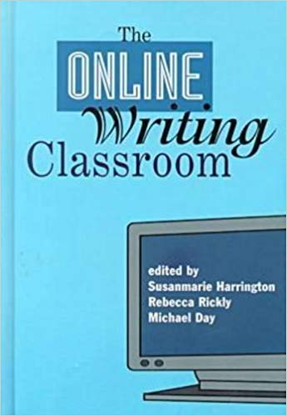 | Harrington, Susanmarie, Rebecca J. Rickly, and Michael J. Day, eds. The Online Writing Classroom.  Cresskill NJ: Hampton Press, 2000.

Selected Articles, Essays, and Book Chapters
“Harnessing the Intersections of Writing and  Information Literacy” | DeSanto, Dan, and Susanmarie Harrington. In ACRL Proceedings 2017. Baltimore MD, March 2017. Association of College & Research Libraries. Online
“Citing Sources is a Basic Skill Learned Early On” | Harrington, Susanmarie. Bad Ideas About Writing. Morgantown VW: West Virginia University Libraries, Digital Publishing Institute. 2017. 250-255.
“Turning Stories from the Writing  Center into Useful Knowledge: Writing Centers, WID Programs, and Partnerships for Change” | Harrington, Susanmarie and Sue Dinitz, with contributions by tutors Rob Benner, Laura  Davenport, Bronwen Hudson, and Kathryn Warrender. In Writing Programs, Collaborations, and Partnerships: Working Across Boundaries, ed. Lynee Lewis Gaillet and Alice Myatt, Palgrave/Macmillan, 2016. 141-160.
“Revising FYC Outcomes for a Multimodal, Digitally  Composed World: the WPA Outcomes Statement for First-Year Composition (Version 3.0)” | Dryer, Dylan B, Darsie Bowden, Beth Brunk-Chavez, Susanmarie Harrington, Bump  Halbritter, and Kathleen Blake Yancey. WPA Journal. 38.1 (2014/2015): 129-144.
“The Role of Disciplinary Expertise in Shaping  Writing Tutorials” | Dinitz, Susan, and Susanmarie Harrington. Writing Center Journal 33.2 (2014): 73-98.
“What is Assessment?” | Harrington, Susanmarie. In A Rhetoric for Writing Program Administrators, ed. Rita Malenczkyk. Clemson SC: Parlor Press. 2013. 156-168.

