Sarah Nilsen

RESEARCH AND/OR CREATIVE WORKS
Monkey Love | Screenplay for a biographical feature length film about Dr. Harry Harlow, the father of attachment parenting.
Shelter | Screenplay for a television pilot about an animal shelter in Vermont.

PUBLICATIONS
Books
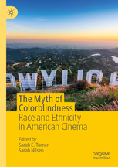 | The Myth of Colorblindness: Race and Ethnicity in American Cinema, eds. Sarah E. Turner and Sarah Nilsen, Palgrave Macmillan, forthcoming November 2019
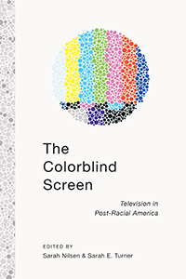 | The Colorblind Screen: Television in Post-Racial America. eds. Sarah Nilsen and Sarah Turner (New York University Press, 2014).
 | Projecting America: Film and Cultural Diplomacy at the Brussels World’s Fair of 1958 (McFarland & Company, 2011).

Articles and Chapters
“Some People Just Hide in Plain Sight”: Historicizing Racism in Mad Men” | The Colorblind Screen: Television in Post-Racial America. eds. Sarah Nilsen and Sarah Turner (New York University Press, 2014).
“All-American Girl?: Annette Funicello and Suburban Ethnicity in the Mickey Mouse Club” | Mediated Girlhoods: New Explorations of Girls’ Media Culture ed. Mary Celeste Kearney (Peter Lang, 2011).
“America’s Salesman: Walt Disney’s USA in Circarama” | Beyond the Mouse: Disney’s Documentaries and Docudramas, ed. A. Bowdoin Van Riper (McFarland, 2011). Recipient of the PCA/ACA Ray and Pat Browne Award for "Best Edited Collection in Popular and American Culture" for 2011.
“Be Sure You’re Right, Then Go Ahead”: The Davy Crockett Gun Craze” | Red Feather: An International Journal of Children’s Visual Culture 1:1 (Spring 2010). (Reprint in A Walt  Disney Reader, University Press of Mississippi)
“White Soul: The ‘Magical Negro’ in the Films of Stephen King,” | The Films of Stephen King: From Carrie to Secret Window, ed. Tony Magistrale (New York: Palgrave, 2008): 129-140.

