Philip Baruth

RESEARCH AND/OR CREATIVE WORKS
Novels and Story Collections:
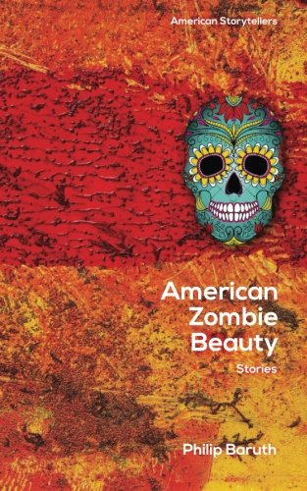 | American Zombie Beauty: Collected Stories, Wolfson Press, University of Indiana - South Bend, April 2015.
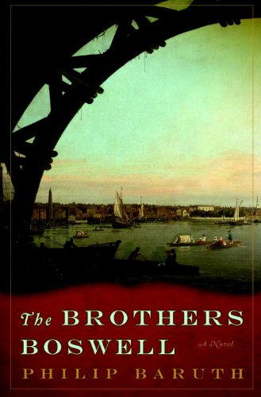 | The Brothers Boswell, Soho Press, May, 2009.  *British Edition, Grove/Atlantic, August, 2010.
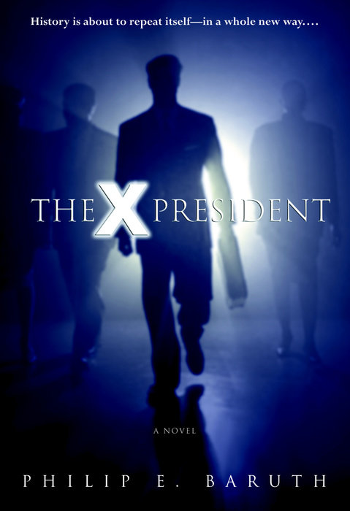 | The X President, Bantam, 2003.
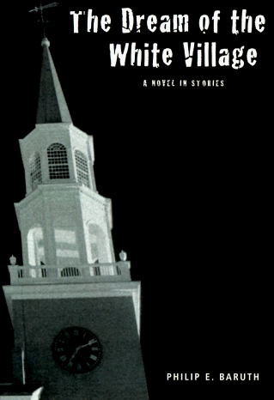 | The Dream of the White Village, RNM Inc., 1998; Paperback edition, Onion River Press, 1999.
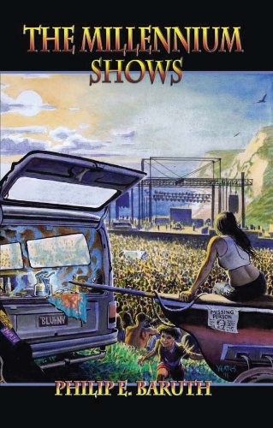 | The Millennium Shows, Albion Books, 1994.  Republished by Kearney Street Books, 2012.

Novellas:
James and Allison | New England Review, Spring, 1995, Vol. 17, #2, pp. 22-56.

Short Stories:
“The Celebrated Phish Tanks Of Burlington, Vermont” | collected in The WRUV Reader (Ed. Chris Evans), Burlington, Vermont, 2012
“American Zombie Beauty” | collected in The Storyteller Speaks: Rare and Different Fictions of the Grateful Dead (San Francisco: Kearney Street Books, 2010)
“Nancy & Tonya & The Long Hard Rain” | New England Review, Winter, 1999, Vol. 20, #1, pp. 118-129.
“Anthony Buys Pornography” | Black Warrior Review, 1996, Vol. 12, #2, pp. 117-136.
“Soft Creeping, Words on Words” | Rocky Mountain Review, Spring, 1995, Vol. 49, #1, p. 9-26.
“Deep in Oneida Nation” | New England Review, Fall, 1994, Vol. 16, #4.
“Fecundity” | Faultline, 1994, Vol. 4, pp. 36-48.
“The Tour of Helen” | TriQuarterly, Winter, 1992-93, #86, pp. 120-136.
“Voice of Egypt” | Pennsylvania Review, 1993, vol. 5, #2, 83-93.
“Peaheart” | Black Warrior Review, Fall, 1993, vol. 20, #1, pp. 65-82.
“Men and Grace” | Carolina Quarterly, vol. 43, #2, Winter, 1991, pp. 51-56.
“I Am These Dead” | Denver Quarterly, vol. 25, #1, Summer, 1990, pp. 61-74.
“Death of a Cable-Whore” | Santa Clara Review, vol. 77, #3, Spring, 1990, pp. 59-62.
“The Canteen” | The Bellingham Review, vol. 13, #1, Spring, 1990, pp. 23-33.
“Opie Dog Rules” | Real Fiction, #6, 1990, pp. 42-48.
“Basket-Boy” | Other Voices, #10, 1989, pp. 186-194.

PUBLICATIONS

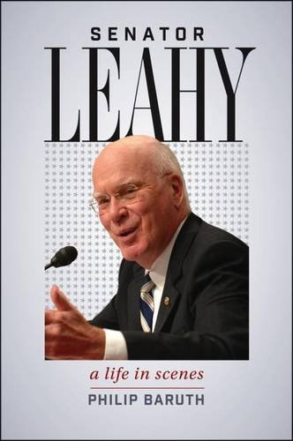 | Senator Leahy: A Life in Scenes, Hanover: University Press of New England, 2017.
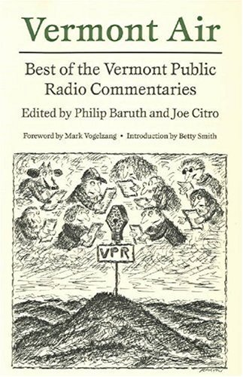 | Vermont Air: The Best of the Vermont Public Radio Commentary Series, Co-edited with Joseph Citro, Hanover: University Press of New England, 2002.
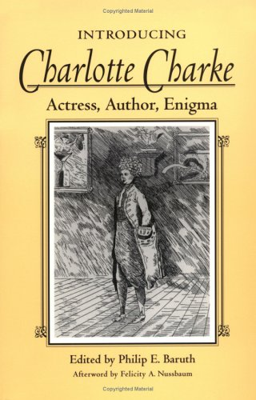 | Introducing Charlotte Charke: Actress, Author, Enigma (Editor), Urbana: University of Illinois Press, 1998.

