Mary Lou Kete

PUBLICATIONS
Books
 | Reconsidering Lydia Sigourney: Critical Essays and Cultural Views, Co-edited with Elizabeth Petrino. (University of Massachusetts Press, 2017).
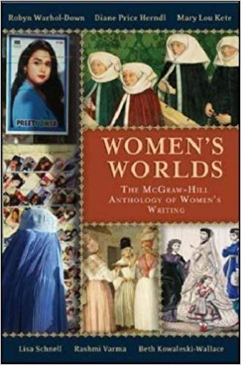 | McGraw-Hill Anthology of Women's Writing World Wide in English. McGraw-Hill. 2008. 2016 pp. Co-author.
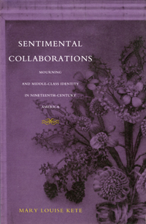 | Sentimental Collaborations: Mourning and Middle-class Identity in 19th Century America. (Duke University Press, 2000).

Selected Articles and Book Chapters
“Lydia Sigourney: From Re-invention to Re-consideration” | co-written with  Elizabeth Petrino, for Reconsidering Lydia Sigourney: Critical Essays and Cultural Views. (University of Massachusetts Press, 2017).
“Phillis Wheatley and the Political Work of Ekphrasis” | The Call of Classical Literature for the Romantic Age, co-edited by James Engell and Kevin Van Anglen. (Edinburgh University Press, 2017).
“Claiming Lucy Terry Prince: Literary History and the Problem of Early African American Women Poets” | Cambridge History of Nineteenth-century American Women’s Poetry, co-editors Jennifer Putzi and Alexandra Socairdes. (Cambridge University Press, 2016): 17-37.

