Maria Hummel

PUBLICATIONS
Books
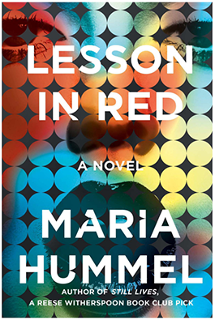 | Lesson in Red  Counterpoint Publishing, June 2021
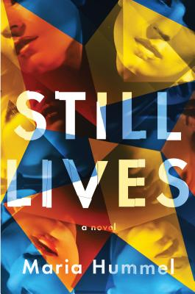 | Still Lives (novel), Counterpoint Press, 2018
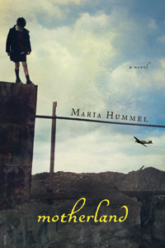 | Motherland (novel), Counterpoint Press, 2014.
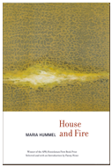 | House and Fire (poems), American Poetry Review, 2013. Finalist for the 2014 VCU Larry Levis Prize.
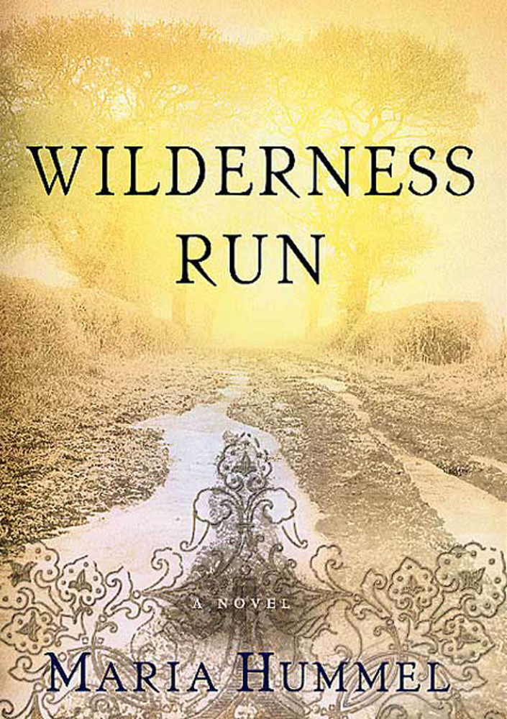 | Wilderness Run (novel), St. Martin’s Press, 2003.

