John Gennari

RESEARCH AND/OR CREATIVE WORKS

Books
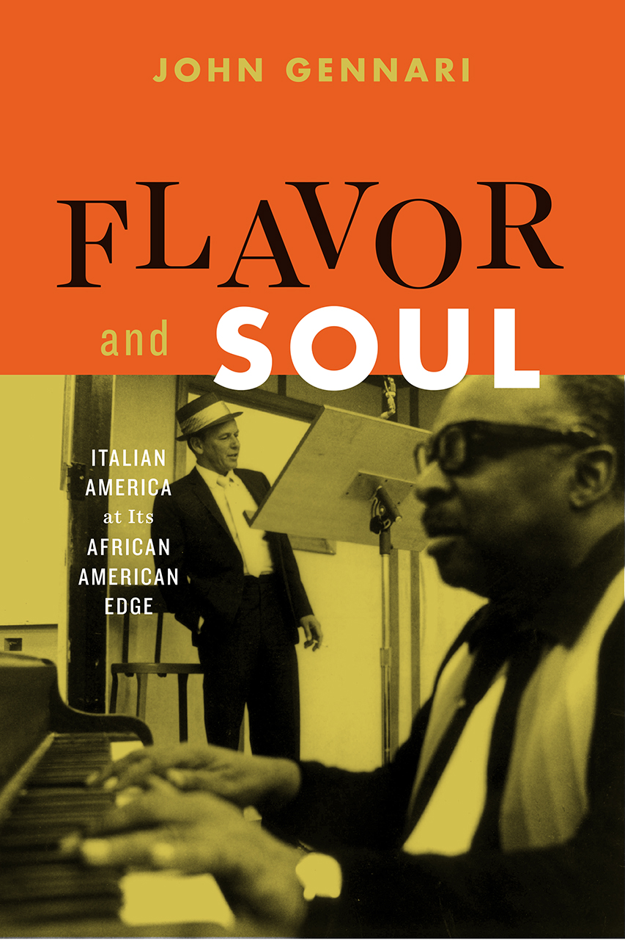 | Flavor and Soul: Italian America at its African American Edge (University of Chicago Press, 2017)
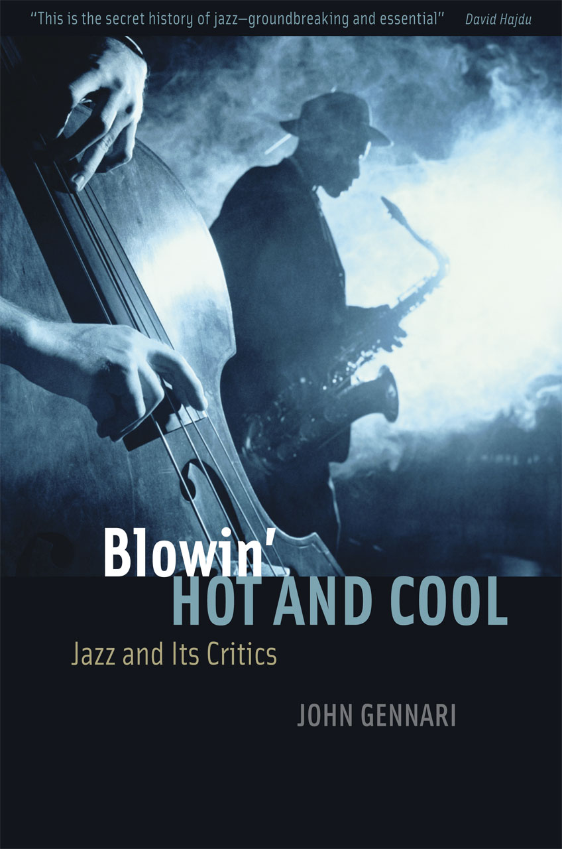 | Blowin’ Hot and Cool: Jazz and Its Critics (University of Chicago Press, 2006; second edition, 2017).

Selected Recent Articles, Chapters, and Essays
“Wacky Post-Fluxus Revolutionary Mixed Media Shenanigans”: Rethinking Jazz and Jazz  Studies through Jason Moran’s Multimedia Performance” | The Routledge Companion  to Jazz Studies, eds. Nicholas Gebhardt, Nichole Rustin, and Tony Whyton (London and  New York: Routledge, 2018).
"Tuck this Accent Back into the Bronx Earth: Annie Lanzillotto’s Language of Sopravvivenza” | Introduction to Annie Lanzillotto, Pitch Roll Yaw (Toronto: Guernica): xvii-xxvi.
“Solid Sound: Growing Up in an Italian American World” | Vermont Quarterly (Fall 2017): 16-17.
“Keeping America Great” | i-Italy  (www.i-Italy.org/magazine/focus/op-eds/article/keeping-America- great), February 2017
“Groovin’: A Condensed History of Italian Americans in Popular Music and Jazz” | The Routledge  History of Italian Americans, ed. William J. Connell and Stanislao Pugliese (London and New  York: Routledge): 415-432.
“Jazz in America after 1945” | The Oxford Research Encyclopedia of American History, ed. Jon  Butler, Online. 2016
“The Sound and the Fury: The Acoustics of Afro-Italian Life in Kym Ragusa’s The Skin Between Us” | Voices in Italian Americana 26/2 (Fall 2015): 34-46.

