Jenny Grosvenor

PUBLICATIONS
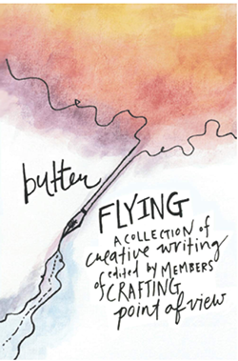 | Butterflying: A Collection of Creative Writing  Independent Publishing, November 2020
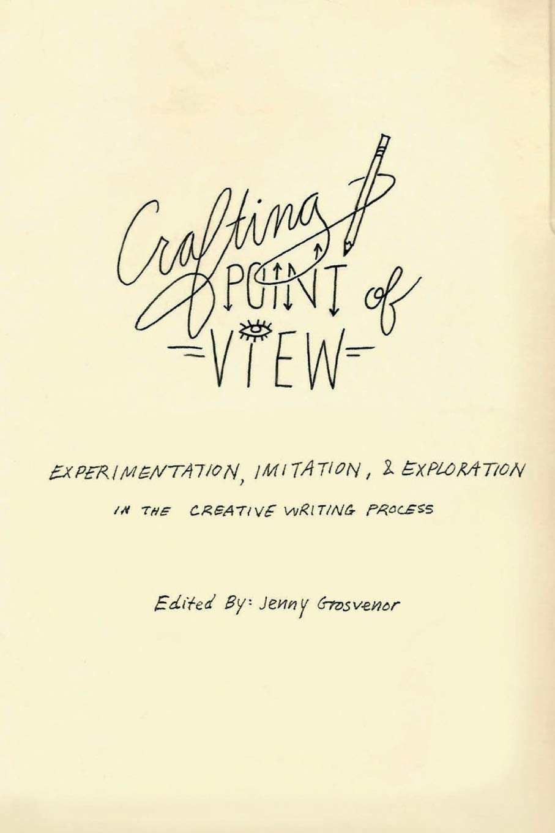 | Crafting Point of View: Experimentation, Imitation & Exploration in the Creative Writing Process  Jenny Grosvenor  CreateSpace Independent Publishing  (July 31, 2018)
“Due Process” | Writing On the Edge (WOE), On Writing and Teaching Writing (University of California, Davis: The University Writing Program, Volume 27, Number 1, Fall 2016): 69-94.
“The Rhetoric of Suicide Notes” | Writing On the Edge (WOE), On Writing and Teaching  Writing (University of California, Davis: The University Writing Program, Volume 23, Number 2, Spring 2013): 48-59.
“Researching Rhetorically” | The Bennington Review (Bennington, VT: The Bennington  Writing Seminars, 2012): 53-58.
New Eyes, The Creative Writing Magazine of Stowe Elementary School | Editor (Stowe, VT,  2008)
The Apostle Newsletter | Editor, (Stowe, VT: St. John’s in the Mountains Episcopal Church,  2002)
The Gator Gazette | Editor (Palm City, FL: Bessey Creek Elementary School, 1999)
“Get the Feeling” | Writer/Producer, Advertising Campaign, Video Production, Marketing &  Media Guide, Sports Illustrated Magazine (New York, NY: Time Incorporated, 1987)
“LIFE: The Legend Continues” | Writer/Producer, Audio-Visual Production (New York, NY/Dublin, Ireland: Time Inc./LIFE Magazine, 1984)

