Isaac Cates

RESEARCH AND/OR CREATIVE WORKS
Plays
Essays on Louise Glück, Robinson Jeffers, Daniel Clowes (www.indyworld.com), etc.; numerous reviews of contemporary poetry (www.smartishpace.com - Unmentionables & www.smartishpace.com - Bucolics) and graphic novels. Poems in 32 Poems, Southern Poetry Review, Southwest Review, Hayden's Ferry Review (haydensferryreview.com), Unsplendid (www.unsplendid.com), etc.
Selected Poems
“Fidelity and the Dead Singer.” | The American Scholar 28 February 2016.
“Topical Sonnets” (with Elizabeth Fenton) and “Legerdemain.” | In The WRUV Reader, ed.  Chris Evans. 2012.
“Fallow Field” and “Ars Lapidarii.” | Hayden’s Ferry Review 43 (Fall/Winter 2008-2009)
Selected Comics
Cartozia Tales | (contributor, editor, and publisher). Nine issues, 2013–2016
“Draw Two Panels.” | Okey-Pankey, October 2015.
“I Was Not This Guy” | (with Mike Wenthe). I Saw You...: Comics Inspired by Real-Life Missed Connections, ed. Julia Wertz (Three Rivers Press, 2008).

PUBLICATIONS
Books
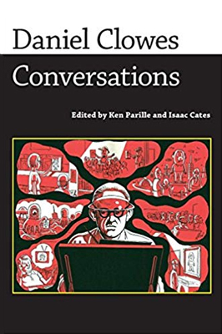 | Daniel Cloves: Conversations. Ed. Ken Parille and Isaac Cates. University Press of Mississippi, 2010.

Selected Articles
“Memory, Signal and Noise in the Collaborations of Neil Gaiman and Dave McKean.” | Drawing from Life: Memory and Subjectivity in Comic Art, ed. Jane Tolmie. University Press of Mississippi, 2013.
“On the Literary Use of Superheroes; or, Batman and Superman Fistfight in Heaven.” | American Literature 83 (December 2011)
“The Inhumanist Poetics of Robinson Jeffers.” | Raritan 30.3 (Winter 2011).

