Hilary Neroni

PUBLICATIONS

Books
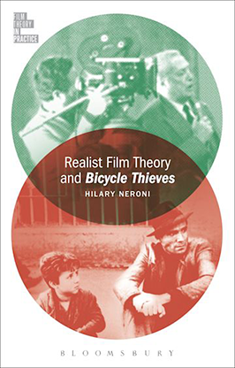 | Realist Film Theory and Bicycle Thieves.  Bloomsbury Academic (June 15, 2023)
 | Feminist Film Theory and Cléo from 5 to 7. New York: Bloomsbury Press, 2016.
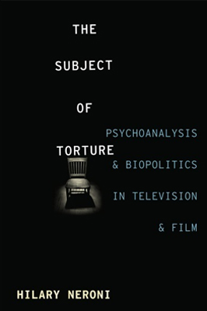 | The Subject of Torture: Psychoanalysis and Biopolitics in Television and Film. New York: Columbia University Press, 2015.
 | The Violent Woman: Femininity, Narrative, and Violence in Contemporary American Cinema. Albany: State University of New York Press, 2005.

Articles
“Confederate Signifiers in Vermont: Fetish objects and Racist Enjoyment.” | In Lacan and Race: Racism, Identity and Psychoanalytic Theory , New York: Routledge, Eds. Sheldon George and Derek Hook, (in press forthcoming 2020)
“The Political Efficacy of Torture in Costa Garvas’s The Confession.” | In The Films of Costa Gavras,Ed. Homer Petty, Manchester University Press, (2019)
“The Truth of Atrocity: Oppenheimer’s The Act of Killing, The Look of Silence and the enjoyment of violence.” | In On The Act of Looking: Reading Joshua Oppenheimer’s Duptych, edited by Rex Butler and David Denny, New York: Bloomsbury Press, (2019)
"Feminist Filmmaking on Television: Lacan, phallic enjoyment, and Jane Campion's Top of the Lake." | Intertexts: A Journal of Comparative and Theoretical Reflection, special issue on Lacan and culture, (2018)
"Orphan Black and the Ideology of DNA." | Orphan Black: Performance, Gender, Biopolitics, Eds. Andrea Goulet and Robert Rushing. Intellect Ltd. Press, (2018).
“Lars von Trier’s Fantasy of Femininity in Nymphomaniac.” | Lars von Trier’s Women, Ed. David Denny. Albany: State University of New York Press (2016).
“Revelation, Not Resolution: Claire Denis’s Bastards and the Perversion of Patriarchy.” | Cinematic Cuts. Ed. Sheila Kunkle. Albany: State University of New York Press (2016).
“Feminism and Loss: The Short Circuits of Veronica Mars.” | Hysteria 3. “Abjection” (2014).
“Following the Impossible Road to Female Passion: Psychoanalysis, the Mundane, and the Films of Jane Campion.” | Discourse 34:2-3 (2013): 290-310.
“Violence and Cinema.” | Oxford Bibliographies in Cinema and Media Studies. Ed. Krin Gabbard. New York: Oxford University Press (2012)
“Documenting the Gaze: Psychoanalysis and Judith Helfand’s Blue Vinyl and Agnes Varda’s The Gleaners and I.” | Quarterly Review of Film and Video 27:3 (2010): 178-192.
“The Nonsensical Smile of the Torturer.” | Studies in Documentary Film 3:3 (2009): 245-257.
“Jane Campion’s Jouissance: Holy Smoke and Feminist Film Theory.” | Lacan and Contemporary Film. Eds. Sheila Kunkle and Todd McGowan. New York: The Other Press, 2004.
“Lost in Fields of Interracial Desire: Claire Denis’ Chocolat (1988).” | Kinoeye 3:7 (2003).
“Expressions of Masculinity: Violence in American Film.” | Journal for the Psychoanalysis of Culture and Society 5:2 (2000): 256-263.

