Helen Scott
PUBLICATIONS
Forthcoming
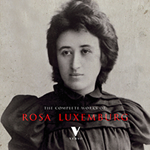 | Helen Scott and Paul Le Blanc, eds., Volume 5 of The Complete Works of Rosa Luxemburg (Verso, forthcoming)

Books
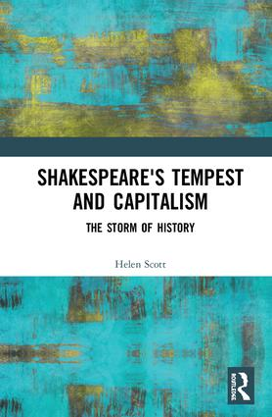 | Shakespeare’s Tempest and Capitalism: The Storm of History. London: Routledge, 2019.
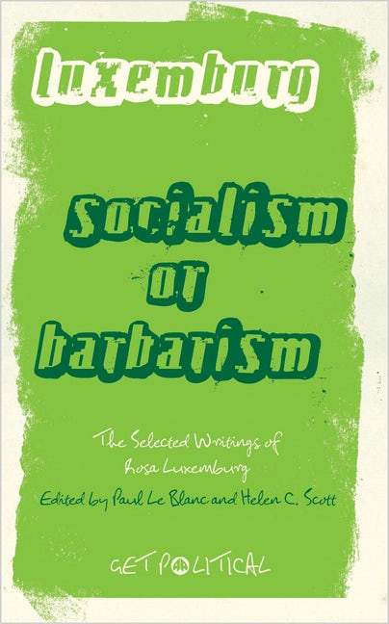 | Edited, with Paul Le Blanc. Socialism or Barbarism: a Rosa Luxemburg Anthology. London: Pluto, 2010.
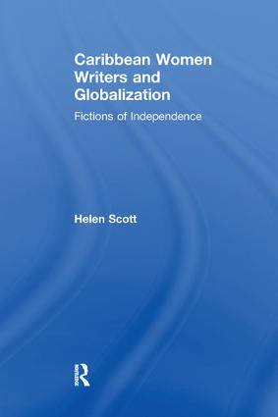 | Caribbean Women Writers and Globalization: Fictions of Independence. Aldershot, UK: Ashgate, 2006.

Selected Articles and Chapters
“Capitalism in ‘all corners of the earth’: Luxemburg and Globalization." | New Formations 94. Rosa Luxemburg: Capitalism, Imperialism, and the Postcolonial. Felippo Menozzi and Jeremy Gilbert, eds. (Autumn 2018): 23-42.

