Greg Bottoms

PUBLICATIONS
Books
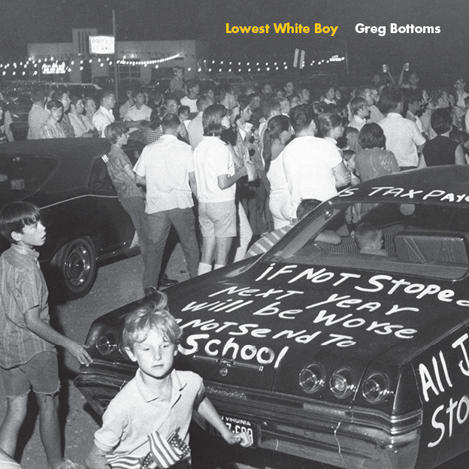 | Lowest White Boy, West Virginia University Press, 2019.
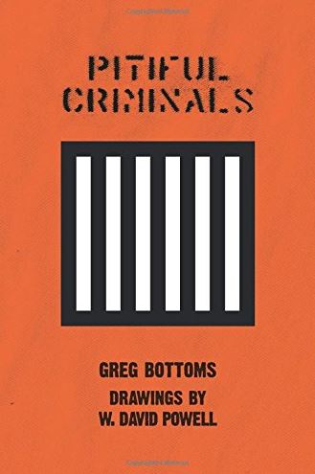 | Pitiful Criminals, Counterpoint Press, 2014.
 | Spiritual American Trash: Portraits from the Margins of Art and Faith, Counterpoint Press, 2013.
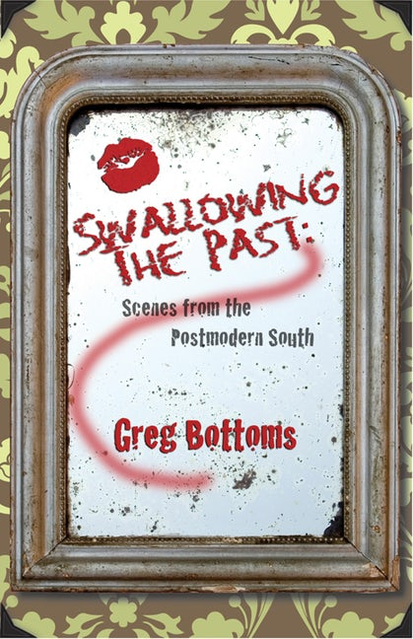 | Swallowing the Past, Texas Review Press, 2011.
 | Fight Scenes, Counterpoint Press, 2008.
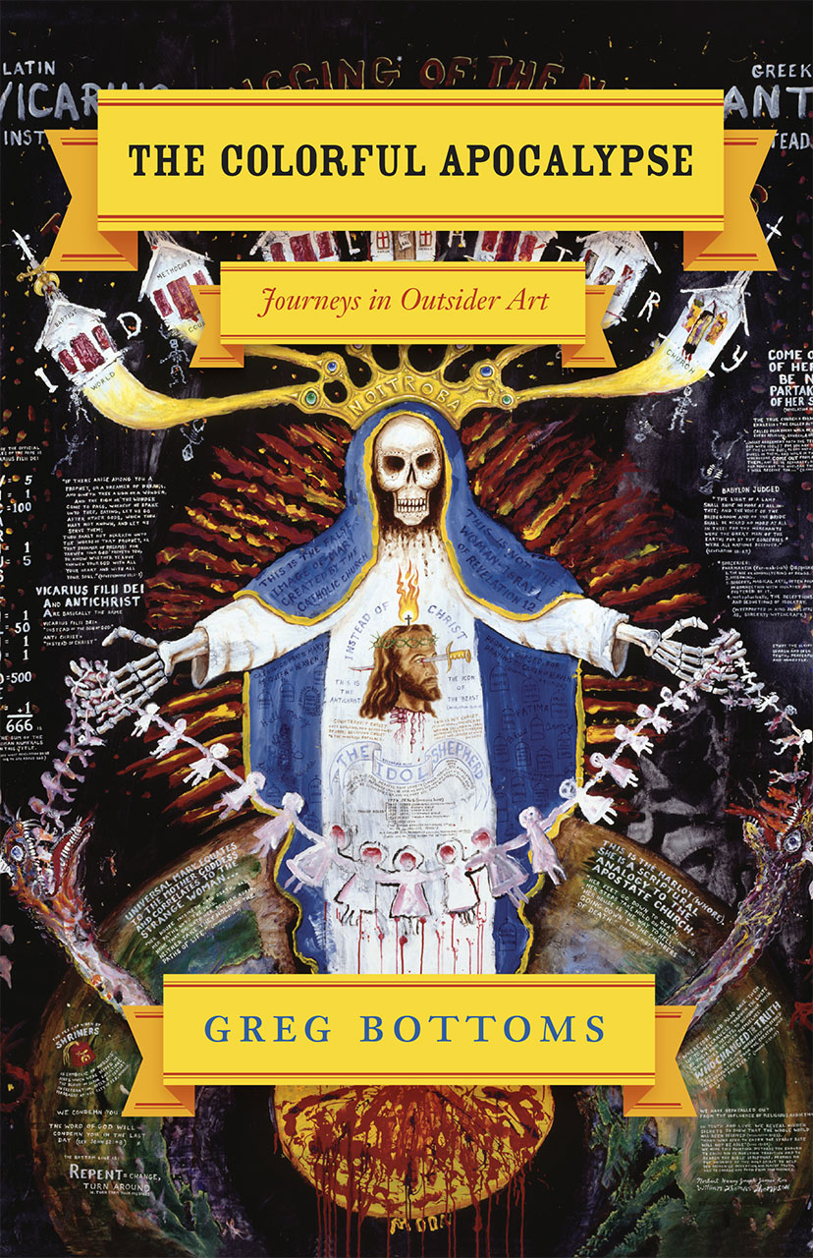 | The Colorful Apocalypse: Journeys in Outsider Art, University of Chicago Press, 2007.
 | Sentimental, Heartbroken Rednecks, Context, 2001; Counterpoint, 2007.
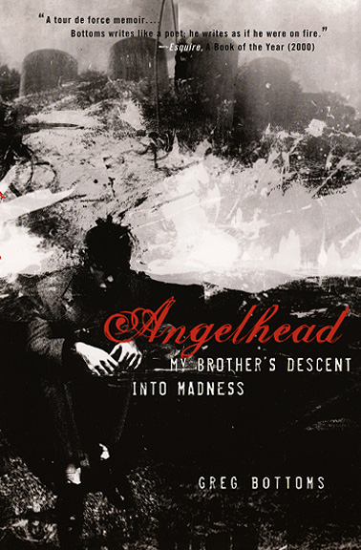 | Angelhead: My Brother’s Descent into Madness, Crown, 2000; University of Chicago Press, 2005.

Anthologies featuring Professor Bottoms’ work
The Beacon Best of 1999, edited by Ntzoke Shange, Beacon Press, 1999.
The Inevitable: Contemporary Writers Confront Death, edited by Bradford Morrow and David Shields, Norton, 2011.
Between Song and Story: Essays for the Twenty-first Century, edited by Sheryl St. Germain, Autumn House Press, 2011.
Words Without Walls: Writers on Addiction, Violence, and Incarceration, edited by Sheryl St. Germain and Sarah Shotland, Trinity University Press, 2015.
Best Creative Nonfiction of the South: Volume I: Virginia, edited by Casey Clabough and Thorpe Moeckel, Texas Review Press, 2016.
Editorship
Texas Review, Nonfiction Editor, 2012-

