Emily Bernard

PUBLICATIONS
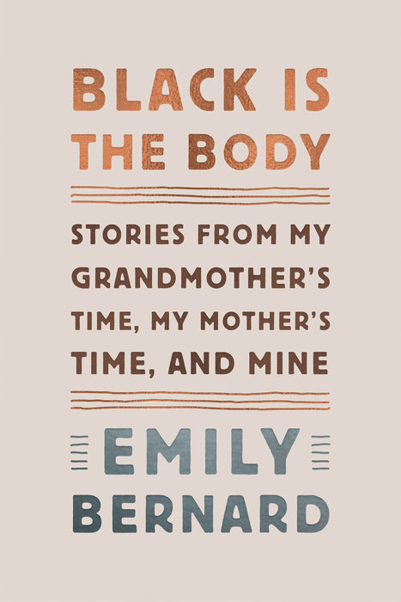 | Black is the Body, Knopf, 2019.
 | Introduction to Passing by Nella Larsen. Penguin Classics: New York, 2018.
 | Carl Van Vechten and the Harlem Renaissance: A Portrait in Black and White. New Haven: Yale University Press, 2012.
 | Michelle Obama: The First Lady in Photographs (with Deborah Willis). New York:W. W. Norton, 2009.
 | Some of My Best Friends: Writings on Interracial Friendship. (Editor) New York:Amistad/HarperCollins, August 2004.
 | Remember Me to Harlem: The Letters of Langston Hughes and Carl Van Vechten (1925-1964). (Editor) New York: Knopf, Inc., 2001.

