Daniel Fogel

PUBLICATIONS
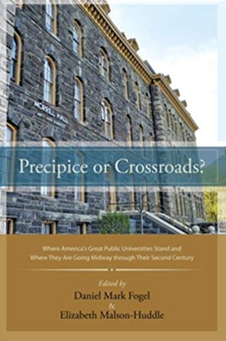 | Precipice or Crossroads? Where America’s Great Public Universities Stand and Where They Are Going Midway through Their Second Century, co-ed. with Elizabeth Malson-Huddle (Albany: SUNY Press, 2012).
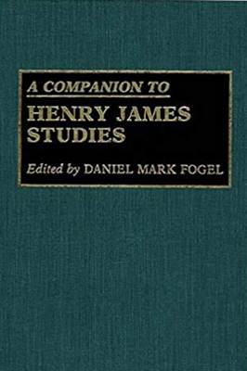 | A Companion to Henry James Studies (Greenwood P, 1993).
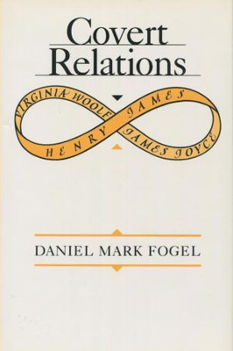 | Covert Relations: James Joyce, Virginia Woolf, and Henry James (University Press of Virginia 1990).
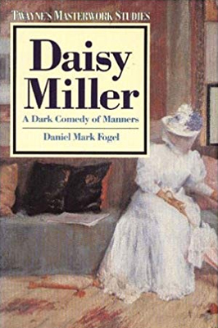 | DAISY MILLER: A Dark Comedy of Manners (Twayne, 1990).
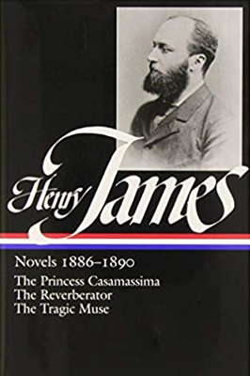 | The Princess Casamassima, The Tragic Muse, and The Reverberator, by Henry James (edited volume in the Library of America, 1989; main selection, June, 1989, Reader’s Subscription Book Club).
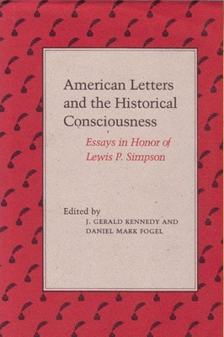 | American Letters and the Historical Consciousness, introd. and co-ed, with J. Gerald Kennedy (Louisiana State University Press, 1987).
 | Henry James and the Structure of the Romantic Imagination (Louisiana State University Press, 1981; publisher’s nominee for the Pulitzer Prize).
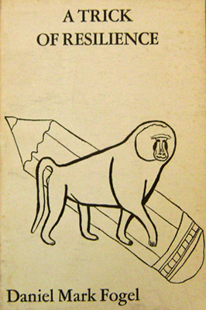 | A Trick of Resilience (poems; Ithaca House, 1975).

