Anthony Magistrale

PUBLICATIONS
Selected Publications
 | Violence in the Films of Stephen King  Lexington Books, July 2021
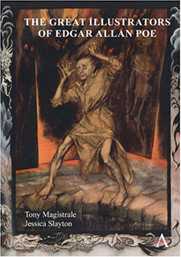 | The Great Illustrators of Edgar Allan Poe  Anthem Press, May 2021
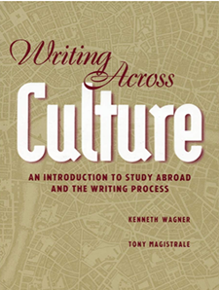 | Writing Across Culture: An Introduction to Study Abroad and the Writing Process  Peter Lang Inc. February 2019
 | Magistrale, Tony, Dialogues Among Lost Tourists (Finishing Line Press, 2017)
 | Grady, Maura & Magistrale, Tony, The Shawshank Experience: Tracking the History of the World's Favorite Movie (Palgrave Macmillian, 2016).
 | Entanglements  Fomite, April 2013
 | The Last Soldiers of Love  Literary Laundry, February 2012
 | Magistrale, Tony, Stephen King: America's Storyteller (Praeger, 2009).
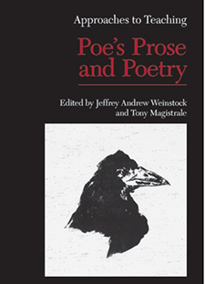 | Approaches to Teaching Poe’s Prose and Poetry  Modern Language Association of America, January 2008
 | The Films of Stephen King  Palgrave MacMillan, January 2008
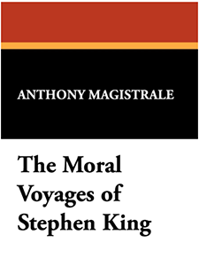 | The Moral Voyages of Stephen King  Borgo Press, August 2008
 | What She Says about Love  Bordighera Press, September 2008
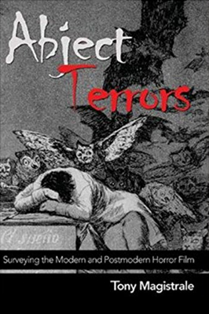 | Magistrale, Tony, Abject Terrors: Surveying the Modern and Postmodern Horror Film (Peter Lang Inc., International Academic Publishers, 2005).
 | Hollywood’s Stephen King  Palgrave Macmillan, November 2003
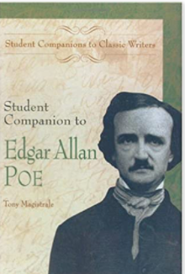 | Student Companion to Edgar Allan Poe  Greenwood, April 2001
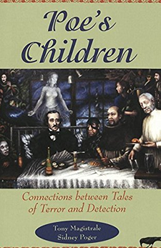 | Poe’s Children: Connections between Tales of Terror and Detection  Peter Lang Inc., November 1999
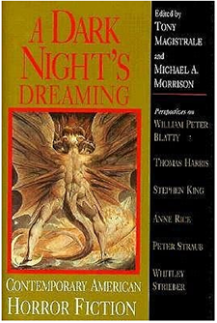 | A Dark Night’s Dreaming  University of South Carolina Press, March 1996
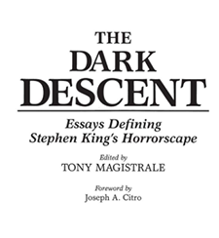 | The Dark Descent: Essays Defining Stephen King’s Horrorscape  Praeger, March 1992
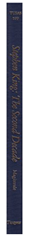 | Stephen King-Second Decade: ‘Danse Macabre’to’The Dark Half’  Twayne Publishers March 1992
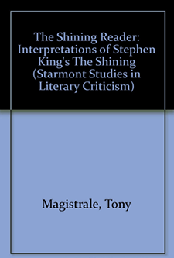 | The Shining Reader  Borgo Press, December 1989
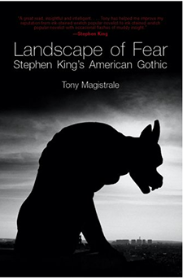 | Landscape of Fear: Stephen King’s American Gothic  University of Wisconsin Press, June 1988
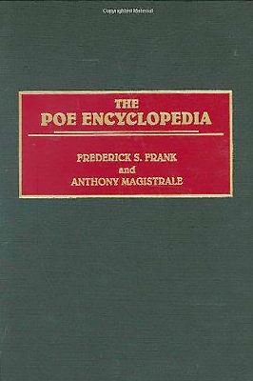 | Frank, Frederick S. & Magistrale, Tony, The Poe Encyclopedia (Greenwood, 1997).

