Annika Ljung-Baruth

PUBLICATIONS
Books
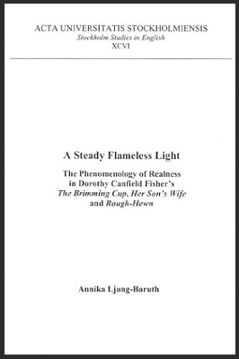 | A Steady Flameless Light: The Phenomenology of Realness in Dorothy Canfield Fisher's The Brimming Cup, Her Son's Wife, and Rough-Hewn. Stockholm: Almquist & Wiksell International, 2002.

Articles
“The Virtue of Responsibility: Femininity, Temporality, and Space in Michael Cunningham’s The Hours” | Virtues and Passions in Literature: Excellence,  Courage, Engagements, Wisdom, Fulfilment. Analecta Husserliana: The Yearbook of Phenomenological Research. Vol. XCVI. Ed. Anna-Teresa Tymieniecka. Dordrecht: Springer, 2008. pp. 159-167.
“In Search of a Moral Erotic Standard: Female Subjectivity and Eros in Dorothy Canfield Fisher's Rough-Hewn and The Brimming Cup” | The Enigma of Good And Evil: The Moral Sentiment in Literature. Analecta Husserliana: The Yearbook of Phenomenological Research. Vol. LXXXV. Ed. Anna-Teresa Tymienecka. Dordrecht: Springer, 2005. pp. 573-583
“A Paradox of Love: The Manifestation of Life and the Moral Sentiment in  Dorothy Canfield Fisher's Her Son's Wife” | The Enigma of Good And Evil: The Moral Sentiment in Literature. Analecta Husserliana: The Yearbook of Phenomenological Research. Vol. LXXXV. Ed. Anna-Teresa Tymienecka. Dordrecht: Springer, 2005. pp. 29-45.
“A Trace of Joy: Female Sexuality and Meaning in The Brimming Cup and Rough-Hewn” | Dorothy Canfield Fisher Newsletter. Vol. 10, Winter 2003. pp. 2-6.
“The Question of Presence in Two Novels by Dorothy Canfield Fisher: A  Reading Based on Emmanuel Levinas and Michel Henry” | Phenomenological Inquiry. Vol.24, October, 2000. pp. 92-117.

