Andrew Barnaby

RESEARCH AND/OR CREATIVE WORKS
Plays
“A Man Had Three Daughters” (playlet: one-scene play) | Critical Survey 29 (2017): 94-118
Hamlét Mignon (one-act play) | Upstart: a Journal of English Renaissance Studies (online: September  8, 2014)
Comedy of Errors (a Shakespearean adaption) | commissioned by Very Merry Theatre (a young actors company) for Spring 2010 production

PUBLICATIONS
Books
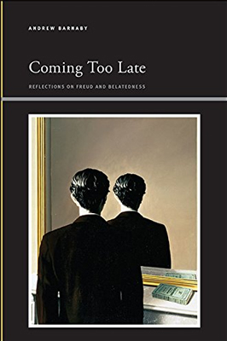 | Coming Too Late: Reflections on Freud and Belatedness, SUNY Press, 2017 (Series: Insinuations--Philosophy, Psychoanalysis, Literature)
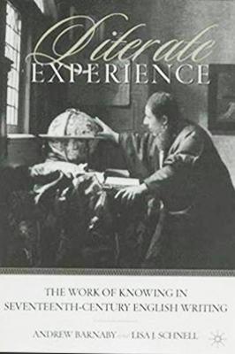 | Literate Experience: The Work of Knowing in Seventeenth-Century English Writing, co-authored with Lisa J. Schnell, Palgrave / St. Martin's Press, 2002

Recent Articles
“Debt Immense: the Freudian Satan, Yet Once More” | Milton Studies 60 (2018)
"After the Event": Freud’s Uncanny and the Anxiety of Origins | Psychoanalytic Quarterly 84 (2015):  975-1006
"The Botome of Goddes Secretes:: 1 Corinthians and A Midsummer Night’s Dream | Renaissance  Drama 43 (2015): 1-26
"It is the cause … Let me not name it!”: (mis)Reading Memento through Othello | Adaptation 8  (2015): 89-110
"The Purest Mode of Looking": (Post)Colonial Trauma in Wole Soyinka’s Death and the King’s  Horseman | Research in African Literature 45 (2014): 123-49
“Tardy Sons: Hamlet, Freud, and Filial Ambivalence” | Comparative Literature 65 (2013): 220-41
“Coming too Late: Freud, Belatedness, and Existential Trauma” | Substance 41 (2012): 119-38
“Teaching Experience to Read and Write: Locke’s Epistemological Subject and the Politics of  Baconian Reform” | Locke Studies 12 (2012): 45-83

