Climate Adaptation Plan, Farm Name Here
[Date]
Background notes on farm (size, management, history):

1. Goals
What are the overall or immediate goals of your farm operation? Articulate two to four goals that inform your choices and priorities. Consider not only climate impacts, but foundational values, financial requirements, organization strengths, farm resources, aspirations, etc.

2. Climate Impacts
What impacts of climate change have you observed and experienced on your farm? Check all that apply. Highlight the most concerning impacts.
Changing Precipitation Patterns
☐ Wetter springs or falls
☐ More frequent extreme precipitation
☐ Saturated soils affecting planting, weeding, and/or harvest
☐ Seasonal drought
☐ Increased need for irrigation
☐ Decreased pasture/forage yield
Extreme Weather
☐ Flooding and/or ponding
☐ Increased erosion
☐ Nutrient leaching
☐ High wind effects
☐ Infrastructure damage due to wind, snow, rain, or temperatures
☐ Wildfire & smoke impacts
Increased Temperatures
☐ Increased seasonal temperatures
☐ More extreme temperatures
☐ Changing pest or disease patterns
☐ Increased weed vigor
☐ Increased cooling needs
☐ Heat stress (human/crop/animal)
☐ Animal health/productivity declines
Seasonal Shifts
☐ Wetter spring/fall
☐ Unpredictable frosts, fruit loss
☐ Warmer winter/summer
☐ Changes in timing of planting/harvest
☐ Crop or variety not adapted
☐ Pollination mismatches
Other
☐

Remember to consider projected climate changes over the next 30 years:
 | Projected changes in weather in New England: 2050s
 |  | ANNUAL TEMP | SUMMER TEMP | WARM NIGHTS | EXTREME HEAT | FREEZE DAYS | ANNUAL PRECIP. | EXTREME PRECIP.
 |  | yearly average | mean temp for June, July, Aug | days with min. temp. over 70°F | days over 90°F | days with min temp below 32°F | avg annual total | days with precip. over 1 inch
CT | change from avg 1980-2010 | + 5 °F | + 5 °F | + 14 days | + 18 days | -29 days | + 3 inches | + 2 days
 | projected mean | 54 °F | 74 °F | 18 days | 24 days | 103 days | 50 inches | 12 days
MA | change from avg 1980-2010 | + 5 °F | + 5 °F | + 12 days | + 15 days | -30 days | + 3 inches | + 2 days
 | projected mean | 53 °F | 73 °F | 16 days | 20 days | 106 days | 49 inches | 11 days
VT | change from avg 1980-2010 | + 5 °F | + 5 °F | + 3 days | + 10 days | -29 days | + 3 inches | + 1 days
 | projected mean | 47 °F | 69 °F | 3 days | 12 days | 148 days | 47 inches | 8 days
NH | change from avg 1980-2010 | + 5 °F | + 5 °F | + 3 days | + 12 days | -29 days | + 3 inches | + 2 days
 | projected mean | 48 °F | 70 °F | 4 days | 15 days | 147 days | 49 inches | 9 days
ME | change from avg 1980-2010 | + 5 °F | + 5 °F | + 2 days | + 7 days | -26 days | + 3 inches | + 1 days
 | projected mean | 46 °F | 68 °F | 3 days | 9 days | 150 days | 48 inches | 9 days
Data source: Downscaled geographic climate (LOCA2-Ensemble) projections for SSP3-RCP7.0, published April 2025, part of the US Climate Resilience Information System, derived by NOAA and generated for the 5th National Climate Assessment. https://cris.aws.esri-ps.com/cris-explorer-dev/ County level data were area-weighted to calculate state averages. Processed by Bonnie McGill, December 2025.

3. Risks Assessment
Based on your observations of climate impacts, and considering projected changes in climate, what are 4 major vulnerabilities of your farm operation? Where do the identified climate impacts directly impact your top farm goals? What areas of land, important crops, animals, or essential infrastructure are a priority to address. What is most at risk?

Mind Map:
Use this space to map out critical areas of the farm, brainstorm issues, or take notes.

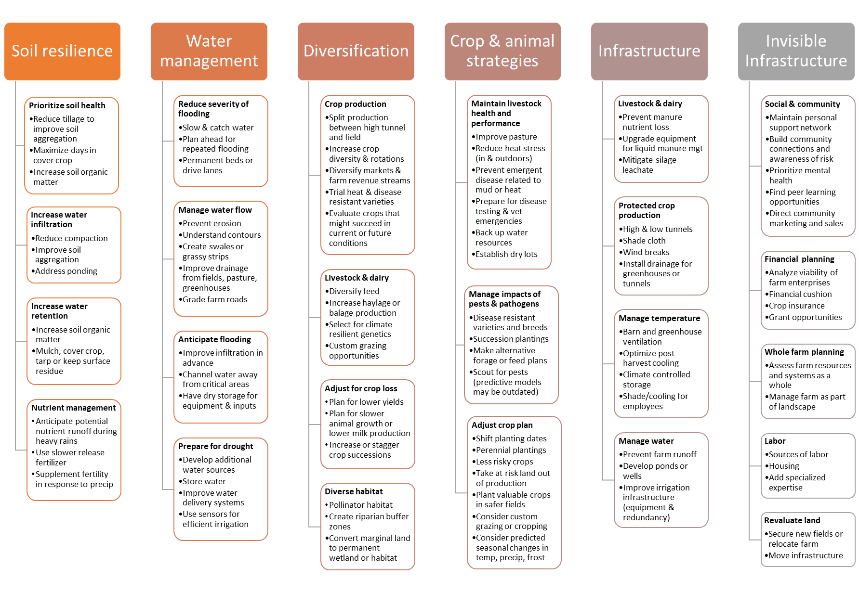
4. Adaptation Practices
- Prioritize the most significant risks from Step 3. Priority should be given to large financial risks, preventable losses, and both short- and long-term priorities. Use the table below to develop your plan.
- Looking at the chart on the previous page, what strategies might be used to mitigate these risks?
- What specific practices could serve to increase the resilience of your farm? Have those been successful for other farmers?
- Remember that adaptive practices should include:
  - Flexible management that can adapt with new information or changing conditions
  - “No regrets” decisions that will create broad benefits with little risk
  - Financial and technical supports available in your network
  - A realistic and specific timeline

Climate Risk: (fill in)
Strategy | Practice/ Description | Co-benefits | Timeframe | Cost | Priority
Notes on management/implementation:

Climate Risk: (fill in)
Strategy | Practice/ Description | Co-benefits | Timeframe | Cost | Priority
Notes on management/implementation:

Climate Risk: (fill in)
Strategy | Practice/ Description | Co-benefits | Timeframe | Cost | Priority
Notes on management/implementation:

Possible funding opportunities:

5. Evaluate
Choose one or two criteria to measure the effectiveness of your adaptation practices. What will indicate success? How often or when will you measure it? Consider tools like the NRCS In-Field Soil Health Assessment, financial analysis, soil testing, water usage, or crop yields.
- Collect/measure....
- When/dates….
- How frequently….

- Collect/measure....
- When/dates….
- How frequently….

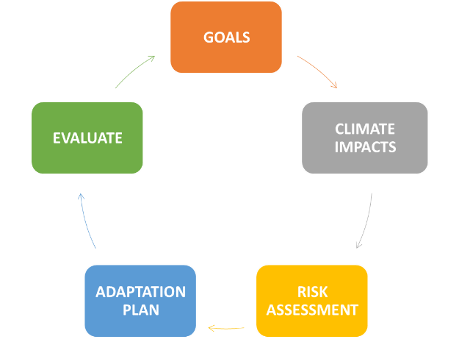
In Summary:
This climate adaptation planning cycle should be repeated over time as new practices yield results, information is collected, and new challenges or solutions emerge. Good luck with your climate resilience planning!
This planning tool was adapted by Julie Fine from Adaptation Resources for Agriculture: Responding to Climate Variability and Change in the Midwest and Northeast. USDA Midwest, Northeast, and Northern Forests Climate Hubs, 2016. Download available at https://farmland.org/climate-adaptation-worksheet/
Adaptation Resources for New England Producers
Northeast Climate Adaptation Workbook: Resiliency Planning and Practices for Farmers
Adaptation Resources for Agriculture
Cultivating Climate Resilience on Farms and Ranches
AFT/UVM Climate Adaptation Resource Database
Webinar: Climate Adaptation for Vegetable and Flower Farms
New England Adaptation Survey for Fruit and Vegetable Growers
Planning Tools
NOFA-VT Climate Risk Analysis Workbook
Climate Adaptation & Mitigation Fellowship Planning Tool
Five Step Guide to Farm Resilience
The Adaptation Workbook
Practice Resources
Building Soils for Better Crops
Managing Cover Crops Profitably
Northeast Cover Crops Decision Tool
NRCS Climate Smart Conservation Practices
UVM Extension High Tunnels and Extreme Weather
Cornell Climate Smart Farming Program
Real World Resilience Stories

Financial & Social Resources
The Carrot Project
Disaster Preparedness and Program Guide for New England Farmers
Find Your Local NRCS office
Vital Communities
Climate Adaptation & Mitigation Fellowship Funding Resource Library
Farm Resource Network

