Climate Adaptation Plan, Farm Name Here
[Date]
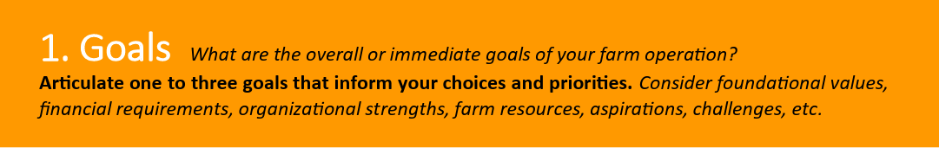
Farm Goals


Climate Impacts of Concern at X Farm
Template Instruction: delete irrelevant impacts, then delete this note
Changing Precipitation Patterns
☐ Wetter springs or falls
☐ More frequent extreme precipitation
☐ Saturated soils affecting planting, weeding, and/or harvest
☐ Seasonal drought
☐ Increased need for irrigation
☐ Decreased pasture/forage yield
Extreme Weather
☐ Flooding and/or ponding
☐ Increased erosion
☐ Nutrient leaching
☐ High wind effects
☐ Infrastructure damage due to wind, snow, rain, or temperatures
☐ Wildfire & smoke impacts
Increased Temperatures
☐ Increased seasonal temperatures
☐ More extreme temperatures
☐ Changing pest or disease patterns
☐ Increased weed vigor
☐ Increased cooling needs
☐ Heat stress
☐ Animal health declines
Seasonal Shifts
☐ Wetter spring/fall
☐ Unpredictable frosts, fruit loss
☐ Warmer winter/summer
☐ Changes in timing of planting/harvest
☐ Crop or variety not adapted
☐ Pollination mismatches
Other
☐

Remember to consider projected climate changes over the next 30 years:
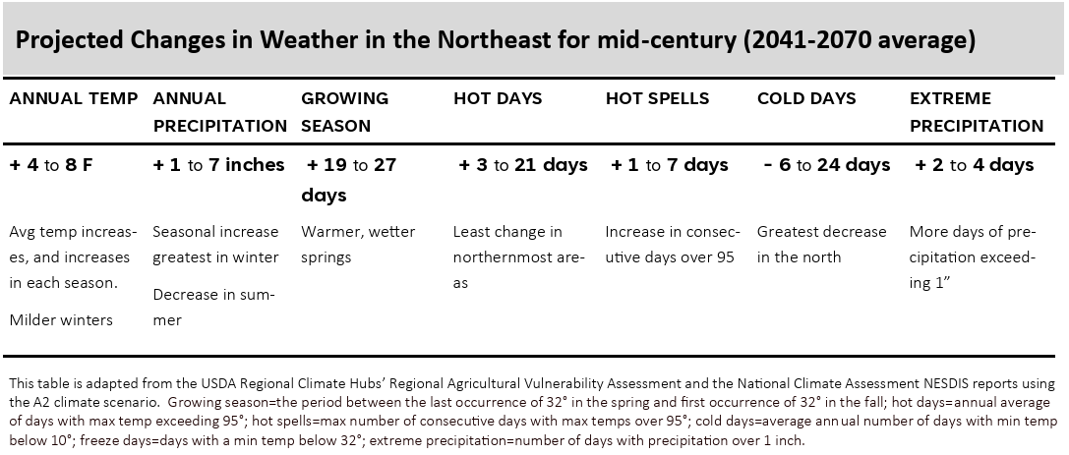

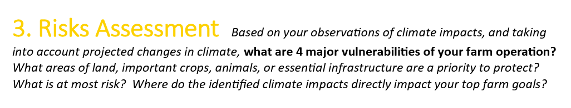Risks Assessment

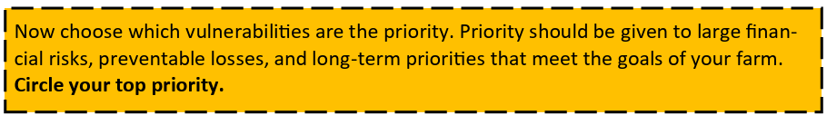

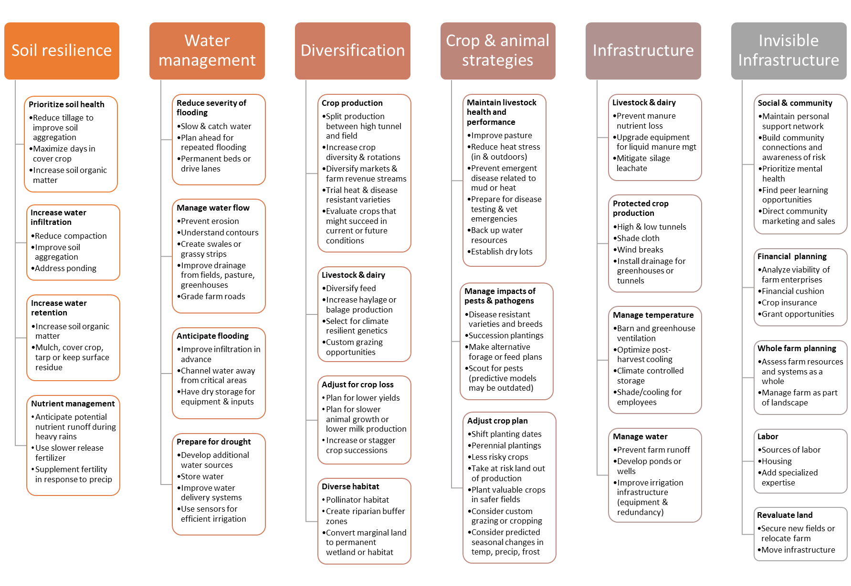
4. Adaptation Practices
- Identify your most significant risks from Step 3. Use the table below to develop your plan.
- Using ideas from the previous page, what strategies might be used to mitigate these risks?
- What specific practices could serve to increase the resilience of your farm? Have those been successful for other farmers?
- Remember that adaptive practices should include:
  - Flexible management that can adapt with new information or changing conditions
  - “No regrets” decisions that will create broad benefits with little risk
  - Financial and technical supports available in your network
  - A realistic and specific timeline

Climate Risk: X
Strategy | Practice/ Description | Co-benefits | Timeframe | Monitoring & Maintenance | Potential Funding | Priority

Climate Risk: Y
Strategy | Practice/ Description | Co-benefits | Timeframe | Monitoring & Maintenance | Potential Funding | Priority

Climate Risk: Z
Strategy | Practice/ Description | Co-benefits | Timeframe | Monitoring & Maintenance | Potential Funding | Priority

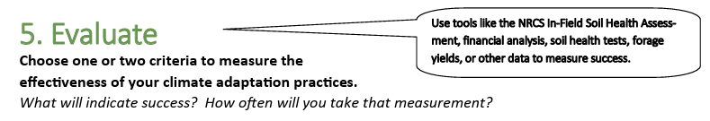
Evaluation:
- Collect....
- Measure....

