Remote Sensing and Electromagnetic Energy
A Primer

Introduction

Heat energy can be transferred by 3 main physical processes:

Conduction which involves contact. Heat energy is transmitted by point-to-point contact with neighboring molecules. This is exhibited in solid substances, by holding a metal rod in a fire and the heat is conducted from one end to the other. Solids are good conductors while fluids and gases (e.g. the atmosphere) are poor conductors.

Convection which involves movement. Heat is transmitted by molecules moving from one place to another. This occurs in fluids and gases (e.g. atmosphere) but not solids. Examples include the daytime sea breeze and nighttime land breeze which both involve the movement of air.

Radiation: transfer of heat energy without involvement of a physical substance (e.g. solid, fluid or gas) in the transmission. Thus the energy can be transmitted through a vacuum (space) or a transparent medium (atmosphere). The incoming solar energy is an example of radiation.

Electromagnetic energy - Basics

Remote sensors aboard satellites are designed to observe and record
energy reflected (i.e. visible satellite imagery) and energy emitted (i.e. Infrared or IR satellite imagery) by or from the earth/atmosphere system.

In the simplest terms, radiation is a form of energy. This energy is emitted by all substances above absolute zero (0 K, -273.15°C or
-459.7°F). This energy is transmitted in the form of a wave. The specific characteristics of the wave vary, but follow the form in figure 1 below:

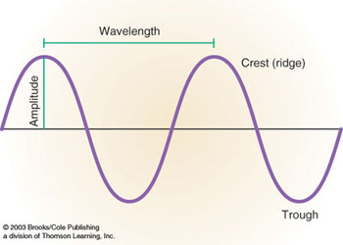
  - wavelength, λ(meters)
  - amplitude, a (meters)
  - velocity, v (m/s)
waves move at the speed of light
(c ~ 3.00 × 10⁸ m/s)
- frequency, f
where v = (f) * (λ)
Figure – 1

Characteristics of Electromagnetic (EM) Energy

These waves of energy are constantly moving all around the universe in the form of radio and TV transmissions, gamma and X-rays from space, and heat in the earth system. The energy we will be discussing ultimately is generated by the sun. These energy waves consist of both electric and magnetic wave characteristics moving perpendicular to each other.

These waves are classified by their frequency (i.e. ranging from high to low) or their wavelength (i.e. ranging from short to long). However, all EM energy waves travel at the speed of light, regardless of their frequency or wavelength.

The entire electromagnetic (EM) spectrum contains all the differing wavelengths, and this is depicted in figure 2.

The shorter wavelengths (e.g. gamma or x-rays) have more energy, while the longer wavelengths (i.e. lower frequency) have less energy (e.g. TV and radio waves). The visible wavelengths lie somewhat in the middle, as depicted figure 2:

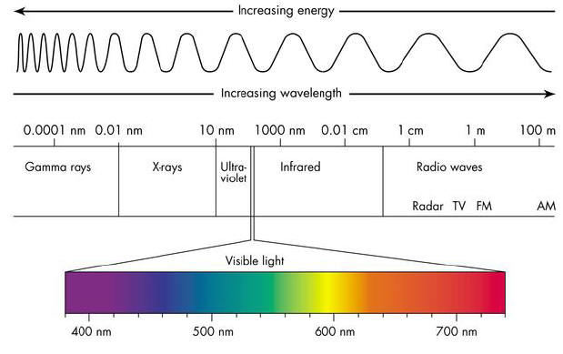
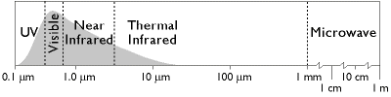
Fig 2 - Electromagnetic spectrum of the sun. http://www.antonine-education.co.uk/physics_gcse/Unit_1/Topic_5/em_spectrum.jpg

To summarize, the EM spectrum can be expressed in terms of energy, wave-length or frequency.
Mathematically, this is stated as:
v = (f) * (λ)
Each parameter used to view or express the EM spectrum are inter-related as noted in the equation above.
Figure 3 clearly relates energy and wavelength, with the short wave length being the most energetic.
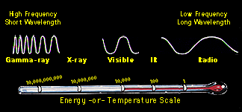
Fig – 3 EM spectrum relationships Courtesy:http://imagine.gsfc.nasa.gov/index.html
EM spectrum and Satellite Cloud detection
Our eyes are only sensitive to the visible portion of the EM spectrum. Thus equipment onboard the satellite can produce pictures of the earth and clouds based on the wavelength of the energy emitted. These include the visible or VIS images which are based on the solar energy reflected. Thus visible imagery can only be acquired during daylight hours (i.e. reflected energy).
In contrast to our eyes detecting by seeing, our bodies “feel” infrared radiation as heat. The temperature of any object determines the characteristics of its radiated energy (e.g. visible or IR) and where it falls on the EM spectrum.
A hot object (e.g. the sun) emits large amounts of energy at short wavelengths. In contrast, a cooler object (e.g. earth and clouds) will emit lower amounts of energy at longer wavelengths. Thus the temperature and energy are inversely proportional to the wavelength.

Student activities
1. Physical student activity: Recall the classroom discussion of a rope stretched between two students. By flicking the rope they can generate waves. It the rope is vigorously flicked, the wave form moves fast with a shortwave length. However, if it’s flicked slowly, the wave form moves slowly with a long wavelength.
2. Mathematical student activity, the mathematical relationship between wavelength and temperature (energy) is stated as follows (Wein’s displacement law):
temperature ( energy)is inversely proportional to the wavelength
mathematically it’s stated as:
λ_{max} = 2897/T
where
λ = wavelength of maximum energy
T is temperature in kelvins (K)

Since the sun has an effective radiating temperature of 6000K, this results in:

λ_{max} = 2897/6000 = .482um

which is in the visible portion of the EM spectrum (figure 2), thus we see this as visible light energy (insolation).

On the other hand, the earth’s effective radiating temperature is around 300K, thus:
λ_{max} = 2897/300 = 9.65 um.
Based on figure 2, energy emitted by the earth is in the IR portion of the EM spectrum.
Graphically, this information is displayed in figure 4. The maximum energy from the sun is transmitted at a much shorter wavelength then that of the earth.
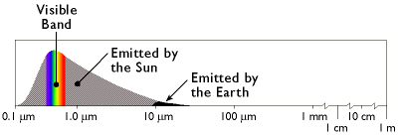
Fig – 4 Wavelength of maximum energy of the sun (gray) compared to the earth (black)
Thus the IR sensors onboard the satellite allow us to monitor the IR energy (long wavelength) emitted by the earth.
This is why we are able to assign temperatures (shades of grey) to the radiation emitted by clouds. These shades of gray allow us to view clouds in the IR imagery. This is important because it permits us 24/7 cloud monitoring capability.

Incoming and outgoing radiation
Solar radiation (insolation) that strikes the earth is either absorbed (and then re-emitted) or reflected. Radiation moving through the atmosphere may also be scattered. The albedo is that portion of the insolation that is reflected away from the earth. The reflected energy is what is measured and displayed in visible imagery. A bright or high albedo is exhibited by fresh snow cover, thick clouds and sandy deserts in visible satellite imagery. Areas such as forests, dark soil and oceans have a low albedo and appear dark in visible imagery.
In the atmosphere, the incoming shortwave solar radiation and outgoing longwave terrestrial radiation is absorbed, scattered/reflected, or allowed to reach the earth’s surface. Any object (ie clouds) that absorbs energy will re-emit it. It is re-emitted at the lower energy level (longer wavelength) and appears on the IR imagery as shades of gray.

Atmospheric windows
The various atmospheric gases allow some wavelengths of solar energy to enter while others are absorbed or blocked. Ozone, in the upper atmosphere, blocks shortwave gamma and ultraviolet radiation.
The atmosphere is transparent to other wavelengths, such as the visible and portions of the IR spectrums. It’s these windows or transparent bands (figure- 5) that allow radiation from the earth and clouds to escape into space. These are the energy wavelengths (visible and IR) that are measured by satellites.
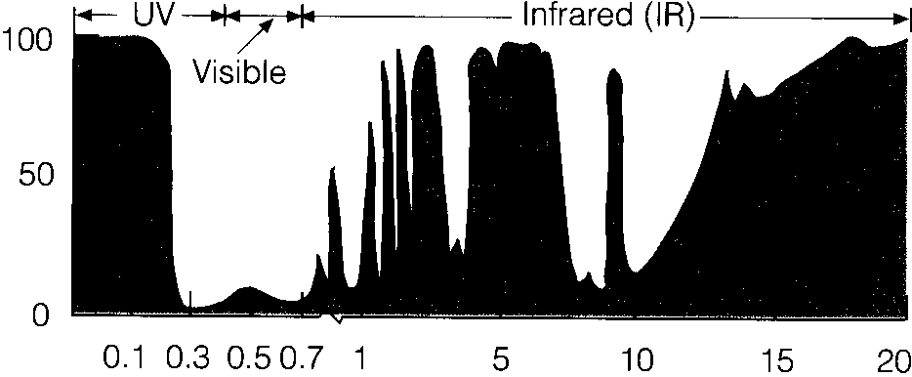
Fig 5 - Vertical axis is percentage of radiation blocked. Shaded wavelengths block or absorb radiation (e.g. UV and greenhouse gases in IR portion), whereas unshaded wavelengths are transparent to radiation (i.e. windows), such as the visible and portions of IR spectrums.

Summary
Thus the visible imagery is a depiction of the reflected solar energy (visible energy spectrum) from clouds and earth. The IR imagery is a display of (gray shades) of temperature based on the IR (long wave energy) radiation emitted from the earth-atmosphere system.

