Comparison of Indirect Estimates of Leaf Area Index for Intensively Managed Douglas-Fir

Nicole Rogers: College of Forestry, Oregon State University, Corvallis, OR 97330
Email: nrogers@uvm.edu Phone: 207-542-4953

Douglas Maguire: College of Forestry, Oregon State University, Corvallis, OR, 97330 Email: Doug.Maguire@oregonstate.edu

Douglas Mainwaring: College of Forestry, Oregon State University, Corvallis, OR, 97330
Email: Doug.Mainwaring@oregonstate.edu

Abstract
Leaf area index is an important dimension of forest ecosystems, providing a measure of the photosynthetic factory and, hence, potential gas exchange and interception of solar radiation by the forest canopy. As such, leaf area index is fundamental to simulating ecophysiological processes like evapotranspiration and net photosynthesis in models of forest productivity. However, accurate estimation between varying stand conditions and silvicultural regimes remains a challenge. For this research indirect estimates of leaf area index were compared to direct estimation from destructive sampling in managed Douglas-fir (Pseudotsuga menziesii) forests in northwestern Oregon. Indirect estimates include measurement of light attenuation by the Li-Cor 2200 Tall Plant Canopy Analyzer and application of leaf area:sapwood area allometric relationships. Estimates from light attenuation ranged between 1.64 and 5.29, from leaf area:sapwood area allometrics between 2.04 and 6.35, and from destructive sampling from 2.64 to 11.47. Underestimation relative to direct estimates from destructive sampling suggests current methods for indirectly sampling leaf area index are inadequate at the desired levels of accuracy. Improved estimates may be achievable through calibration to local stand conditions and attributes specific to Douglas-fir forests.
Keywords: Canopy structure, leaf area index, gas exchange, light interception, pipe model.
Introduction
Leaf area index (LAI), conventionally defined as the projected foliage area of plants per unit area of occupied ground, is an important structural parameter controlling forest productivity. LAI represents the total photosynthetic surface area of a stand and therefore stand-level capacity for interception of solar radiation and exchange of water vapor, CO₂, and O₂ with the surrounding atmosphere (Grier and Running, 1977). Methods of estimating LAI commonly employed in forestry include use of allomteric equations or ratios for conversion from sapwood area (SA) to leaf area (LA) based on the pipe-model theory (Waring et al. 1982) and estimation of LAI from light attenuation through the canopy (Chen et al., 1997; Dewey et al., 2006, Whitehead et al., 1984). These methods have been proposed to avoid the expensive and time consuming nature of direct measurement of LAI by destructive sampling of plots, trees, or branches, especially those with large and complex forest canopies (Breda, 2003; Jonckheere et al., 2003).
The appeal of applying leaf area to sapwood area allometrics (LA/SA) is the relative ease of measuring sapwood width at breast height from increment cores. Additionally, the physiological balance between transpiring leaf area and the cross-sectional area of sapwood supplying water to the foliage is well recognized (Grier and Waring, 1977). Patterns in LA/SA over a wide range of forest types have provided a relatively large information base about variation among species, sites, stands, and trees within stands (Waring et al., 1982; Smith et al., 1991). Because SA tapers from the base of the tree to the lowest live branch (Maguire and Batista 1996), LA/SA allomterics have been developed for sapwood area measured at both breast height (SA_{BH}) and crown base (SA_{CB}). Stands of varying density will differ in height to live crown (Ritchie and Hann 1987, Hann and Hanus 2004) and, hence, in SA_{CB}/SA_{BH}. Due to this variability, LA/SA_{CB} is generally considered more stable across stands of varying density. In fact, the relative stability in LA/SA_{CB} confers a key advantage relative to LA/SA_{BH} allometrics that estimate LA from DBH.
Estimation of LAI from light attenuation is based on Beer’s Law that established the negative exponential relationship between the amount of incident light that penetrates a light-absorbing medium and the depth into that medium (Campbell and Norman 1998). In forested systems, depth into a medium is represented by LAI. If the correlation between LAI and light attenuation is sufficiently strong, this approach offers a potentially rapid, cheap, and effective approach to estimating LAI (Gazarini et al., 1990; Smith, 1992). Likewise, this approach eliminates the problem of destructive sampling on plots that are intended to be continuously monitored for productivity (Gower and Norman, 1991).
Successes in measurement of LAI from light attenuation has resulted in a variety of instruments that incorporate Beer’s Law to convert light absorption into LAI (Smith et al., 1991; Bolstad and Gower, 1990). The Li-Cor 2200 Plant Canopy Analyzer has been developed to estimate LAI from light attenuation for an assortment of canopy structures. Varying levels of success have been achieved with this instrument in forested systems, in part because light attenuation is affected by not only LAI, but also by the distribution of foliage and surface area in non-photosynthetic tissues, specifically branches and tree boles (Barclay and Trofymow, 2000). Correction of LAI estimates inferred from light attenuation has been achieved by applying foliage clumping factors for Douglas-fir canopies (Smith et al. 1993), and conversely light attenuation has been accurately estimated from simple measures of Douglas-fir stand structure (Smith 1991).
The goal of this study was to identify the feasibility and accuracy of alternative techniques for estimating LAI of intensively managed stands of Douglas-fir, especially their ability to distinguish relatively small differences in LAI attributable to canopy structure. Toward this goal, the specific objectives of the study were to (1) indirectly estimate LAI from site-specific allometric equations and ratios based on the pipe-model theory, (2) indirectly estimate LAI from light attenuation measured with the Li-Cor plant canopy analyzer, (3) evaluate indirect estimates against direct estimates from destructive sampling for foliage mass, (4) quantify changes in LAI relative to variation in canopy structure.

Material and Methods

Study Site
Research for this project was conducted within the Panther Creek Watershed on the eastern edge of the Oregon Coast Ranges within Yamhill County and adjacent to the Willamette Valley (Figure 1). Panther Creek covers over 2500 hectares of both public and private ownership. Elevation across the watershed ranges between approximately 170 and 700m. Dominant vegetation includes Douglas fir (Pseudotsuga menziesii), western hemlock (Tsuga heterophylla), western red cedar (Thuja plicata), big leaf maple (Acer macrophyllum), and red alder (Alnus rubra). Most of the stands are under active management for timber production.
The study area can be characterized as having cool, wet winters and hot, dry summers. Periodic drought is common during summer months. Precipitation averages 1600 mm annually with minimum January temperatures ranging from -2 to 2º C and maximum July temperatures from 20 to 28ºC (ClimateWNA).
Twenty two circular fixed area plots with a 16-m radius were administered by the USDA-Bureau of Land Management. For this research, plots were confined to those with ≥ 80% of the total plot basal area in Douglas-fir. The compositional threshold was established because Douglas-fir is the desired commercial species and because a large amount of previous work had been done on the relationship between light attenuation and canopy and stand structure in Douglas-fir stands [CITATIONS]. In contrast, the ecophysiological and morphological information for other species on the site was limited and coul complicate interpretation. Breast-height age of the Douglas-fir trees on sample plots ranged between 21 and 139 years. Plot basal area and tree density ranged from 25.9 to 104.7 m²/ha and 223 to 1255 trees/ha, respectively (Table 1). Nineteen of the twenty-two plots were naturally regenerated after clearcut harvesting; the three remaining plots were planted.

Sampling Design and Field Measurements
All Standing Trees
Diameter at breast height (DBH) was recorded to the nearest tenth of a centimeter on all live trees on each plot using a diameter tape. In addition, total height (HT) and height to lowest live branch (HCB) were measured to the nearest 0.01m on all trees using a laser hypsometer.
Sapwood Area on Standing Trees
Sapwood area was measured on a subsample of trees on each of the 22 plots. At each plot between 15 and 20 trees ≥ 10cm at breast height were sampled uniformly across the plot diameter distributions. Two cores were extracted from opposite sides of each tree, i.e., separated by 180º around the tree circumference. Cores were taken as close to breast height as possible and perpendicular to the slope of the ground. Sapwood width was measured to the nearest tenth of a centimeter and recorded in the field. If the distinction between sapwood and heartwood was not clearly visible, methyl orange dye was applied to accentuate the division between these two zones.
Measurements were collected between mid-August 2012 and mid-September 2012 under the assumption that the majority of diameter growth for current growing season had finished and that sapwood area and leaf area had reached equilibrium.
Sapwood Area on Felled Trees
In addition to cores for sapwood thickness, sapwood was also measured on disks of destructively sampled trees. Sampling was completed on 22 trees across the watershed outside of the research plots. Selected trees represented approximately the 10th, 50th and 90th quantile by DBH of the Douglas-fir population measured on the 22 Panther Creek study plots. Disks were cut out of each tree at breast height and crown base. On each disk, heartwood diameter and total diameter inside bark were measured to the nearest 0.1 cm on the longest axis and on the axis perpendicular to the longest. Sapwood area for each sample disk was estimated as the difference between heartwood area and total cross-sectional area inside bark, assuming an elliptical cross-section of each.
Li-Cor
Canopy light absorption was measured with the Li-Cor LAI 2200 Tall Plant Canopy Analyzer, designed to estimate LAI by comparing light intensity above and below the canopy (Li-Cor Environmental, Lincoln, NE). Readings were taken through a fish eye lens with five zenith angles to calculate intercepted blue light (320-490 nm).
Li-Cor samples were collected between mid-August and mid-September 2012 to capture LAI after the completion of the summer growing season. Readings were taken on clear days before 9 a.m. to minimize variation from sun flecks. Two types of readings were collected at each plot, “A” readings representing light above the canopy and “B” readings taken under the canopy. To avoid the challenge of elevating the instrument above the canopy, the A readings were taken in an opening as close to the plot of interest as possible. Readings were taken at least two tree lengths from the nearest tree to avoid shading the lens with the wand facing west. A 45º view cap was placed on the lens to account for clumping and gaps in the canopy and to ensure consistency among plots of varying slope. A readings were taken at fifteen seconds intervals for two minutes prior to B readings, and again every fifteen seconds for two minutes immediately after B readings.
The B readings were taken at thirteen points under the canopy at each plot with the wand held at chest height. The first reading was taken at plot center with subsequent readings along N, S, E, and W transects (Fig. 2). Readings were taken five meters and ten meters away from plot center. On NE, NW, SE, and SW transects readings were taken ten m from plot center (Figure 2). At each point a Li-Cor reading was taken with the wand pointing north, south, east and west.
When A and B readings were completed, the Li-Cor console provided an LAI estimate in the field. Data were stored and processed using the Li-Cor FV2200 software.
Destructive Sampling for Foliage Mass
In addition to the indirect measures of LAI, direct measures were taken by sampling branches from the same 22 destructively sampled trees described above. Destructive sampling provided calibration necessary for evaluation of the two indirect measures of LAI. Basal diameter (cm) and height (cm) were recorded for every live branch on the 22 felled trees. Crowns of felled trees were then split into thirds by live crown length. Three branches were randomly selected from the top and middle thirds and two branches were randomly selected from the bottom third, totaling 176 sample branches. Each sample branch was returned to the lab and oven dried; foliage was separated from woody material, re-dried, and weighed to get branch-level estimates of foliage mass.

Statistical Analysis
Estimated Sapwood Area
Sapwood area at breast height (m²) was estimated for each cored sample tree from sapwood thickness (cm) and DBH assuming a circular cross-section of heartwood and stemwood. The following weighted, nonlinear model was fit separately at the plot level to facilitate estimation of sapwood area at breast height for all trees that were not cored:
[1] 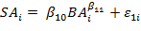
where SA_{i} is sapwood area at breast height (m²) on the ith tree, BA_{i} is basal area at breast height on the ith tree (m²), the β_{1k}s are parameters to be estimated from the data, and ε_{1i} is the error term with ε_{1i} ~N(0, BA^{m}σ₁²) and m=1, 2, or 3. Each observation was weighted by the reciprocal of BA^{m} to homogenize the variance of the residuals. Sapwood area at crown base (SA_{CB}) was also estimated on these trees from sapwood area at breast height (SA_{BH}) by applying an equation developed for this purpose (Hann and Maguire 2013).
Sapwood Area Regression Models
Leaf areas of the Panther Creek sample trees were regressed on sapwood area to develop a predictive model specific to the Panther Creek watershed, resulting in the following linear regression model:
[2]
where LA_{SWi} represents the leaf area estimated by sapwood area at crown base of the i^{th} destructively sampled tree (m²), SA_{CBi} is sapwood area at crown base of the i^{th} destructively sampled tree (cm²), β_{2k}s are parameters estimated from the data, and ε_{2i} is the error term with ε_{2i} ~N(0, σ₂²).
Equation 2 was also fit with the intercept dropped with parameter estimates
Leaf area of Panther Creek sample trees was also estimated assuming the following non-linear form:
[3] 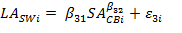
where LA_{SWi} and SA^{CB}_{i} are defined above, β_{3k}s are parameters estimated from the data, and ε_{5i} is the error term with ε_{3i} ~N(0,σ₃²). Plot level estimates of leaf area were made by applying fitted equations [2] and [3] to estimates of SA_{CB} on all trees from equation [1].
Leaf Area : Sapwood Area Ratios
Sapwood area was first converted to tree leaf area assuming a ratio 0.54 m² of leaf area for each cm² of sapwood area at crown base (Waring et al. 1982). A second estimate was made interpreting the slope parameter from equation [2] as the average LA/SA_{CB} ratio for Panther Creek, given that the intercept term from equation [2] was not significantly different from 0 at α=0.05.
Total plot leaf area estimated by each above approach was determined by summing leaf area of all Douglas-fir trees on the plot. Total plot leaf area (m²) was converted to LAI by dividing by the plot area expressed in the same units (804 m²).
Estimated Foliage Mass
Foliage mass (g) at the branch level was modeled with the following log transformed linear regression model:
[4]
where BFM_{i} is foliage mass (g) of the ith branch, BRD_{i} is the basal diameter (cm) of the ith branch, RH_{i} is relative height of the ith branch (proportion), the β_{4k}s are parameters to be estimated from the data, and ε_{4j} is the error term with ε_{4j} ~N(0, σ₄²). To estimate total tree foliage biomass, this equation was applied to all the live branches on each felled sample tree. Log bias was corrected by multiplying estimated foliage biomass by e^{MSE/2} , where MSE is the mean squared error from the regression model (Flewelling and Pienaar, 1981).
An equation for estimating foliage mass at the tree-level was developed in the form of the following nonlinear regression:
[5] 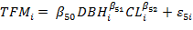
where TFM_{i} is foliage mass (g) of the i^{th} tree, DBH_{i} is diameter at breast height (cm) of the i^{th} tree, CL_{i} is crown length (cm) of the i^{h} tree, the β_{5k}s are parameters to be estimated from the data, and ε_{3i} is the error term with ε_{5i} ~N(0,σ₅²). Tree level foliage mass was then predicted for each plot tree from the 2012 tree inventory. Foliage mass was converted to leaf area by multiplying by an average specific leaf area of 53.3 (cm²/g) and expanding to m². Total plot leaf area (m²) was converted to LAI by dividing by the plot area expressed in the same units (804 m²).
Method Comparisons
After plot-level LAI was estimated for each of the 22 plots, a comparison was made between indirect estimates of LAI and the direct measurement of LAI from destructive sampling. The correlations between the direct estimates and those from the Li-Cor and LA/SA methods were computed to measure the degree of consistency between the alternative approaches. Additionally, mean difference, mean square difference, mean absolute difference, and mean relative difference were calculated between direct and indirect estimates.
LAI and Crown Structure
Cross-sectional crown area was calculated for each plot at 0.5-m intervals from the forest floor to the top of the canopy using equations developed by Dubrasich et al. (1997). Next, Shannon’s diversity index (‘H) was calculated by height class for each plot (Kneeshaw and Burton 1997). Correlation between LAI from destructive sampling and crown area was also calculated to show strength of the relationship (Table X).

Results
Results from this analysis showed, in general, under prediction of LAI from indirect estimates relative to direct estimates from destructive sampling. A clear trend was visible between increased canopy structural diversity and LAI for direct estimates, while no relationship was evident between indirect estimates and canopy structural diversity.
Leaf Area Index
Estimates of LAI from the Li-Cor (LAI_{L}) were approximately 35% lower than those from direct measurement of sample branches (LAI_{FM}) on all plots, with the exception of three plots on which Li-Cor predicted higher values of LAI (Figure 3). The correlation between LAI_{L} and LAI_{FM} was low (-0.06) (Table 4). LAI_{L} ranged from 1.6 to 5.9; LAI_{FM} ranged from 2.65 to 11.47 (Table 5). Calculated mean difference was 2.70, mean square difference was 14.59, mean absolute difference was 3.01, and mean relative difference was 2.11 (Table 6).
Estimates of LAI from sapwood allometrics varied between methods of prediction (Figure 4). Estimates of LAI from the full form of equation [2] were consistently lower than those from the reduced equation [3]. The highest estimates of LAI using sapwood as a predictor were generated by applying the Panther Creek average ratio of leaf area to sapwood area (0.66), followed by the average ratio of 0.54 previously suggested for Douglas-fir in general (Waring et al. 1982). On average, LAI estimates assuming a leaf area to sapwood area ratio of 0.54 m²/cm² (LAI_{SW}) were approximately 27% lower than LAI_{FM}. Estimates of LAI_{SW} using this ratio were between 2.4584 and 5.1962, and its correlation with LAI_{FM} was low and negative (-0.20298).
Estimates applying the average leaf area:sapwood area ratio of 0.66 for Panther Creek (LAI_{SP}) were on average approximately 6% lower than LAI_{FM}. Estimates of LAI_{SP} ranged from 3.0048 to 6.3509, and the correlation between LAI_{SP} and LAI_{FM} was again low and negative (-0.20298). The mean difference between LAI_{SP} and LAI_{FM} was 1.17, the mean squared difference was 9.11 the mean absolute difference was 2.34, and the mean relative difference was 3.82 (Table 6).
A trend existed between LAI_{FM} and stand age, DBH (cm), and basal area (m²) (Table 5). In general, LAI_{FM} increased as average DBH, basal area, and average age increased.
Of all the methods applied for indirectly estimating LAI, estimates based on leaf area:sapwood area ratios (LAI_{SW} and LAI_{SP}) were closer to LAI_{FM} than were those based on LAI_{L}. However, the ability of LAI_{SP} for estimating LAI_{FM} decreased when LAI_{FM} was eight or greater (Figure 4).
Crown Structure
Diversity in crown structure increased with increasing LAI from destructive sampling (Figure 5a). The correlation was high and positive. However, low and negative relationships were evident between indirect estimates of LAI crown diversity (Figure 5b).

Discussion
Range in LAI
Estimates of LAI from foliage mass were determined to be the most appropriate as they fell with the range of LAI for Douglas-fir observed in other studies (Table 7). Smith (1993) estimated LAI between 3.2 and 8.9 for sites with basal areas between 10.5 m²/ha and 97.8 m²/ha. Turner et al. (2000) estimated LAI of Douglas-fir as high as 16 in old growth stands with an average basal area of 84.1 (m²/ha). Marshall and Waring (1986) estimated LAI values between 12 and 7.3 for old growth Douglas-fir (Table 7).
Li-Cor
Underestimation of LAI from light attenuation measured by the Li-Cor instrument, relative to direct estimates from sampling felled trees, was consistent with findings in several other studies (Chen et al., 1991; Smith et al., 1993). Underestimation could be due to clumping of foliage which violates the Beer-Lambert assumption that all foliage is randomly distributed, an assumption that is built into the Li-Cor estimates. This assessment is in line with another study that that concluded that underestimates of LAI from the Li-Cor instrument when LAI values were high was due to severe clumping of foliage (Cherry et al. 1998).
Additional bias in estimating LAI from the Li-Cor instrument probably accrues from light intercepted by non-photosynthetic tissues. In this regard, any estimate from the Li-Cor could be more appropriately considered a plant area index, although such an index would still be sensitive to the spatial distribution of light-intercepting surface area. In this regard, the Li-Cor measurements would be sensitive to shrubs taller than breast height, tree branches, and tree boles. Cherry et al. (1998) also attributed overestimation of LAI by the Li-Cor, to light intercepted by non-photosynthetic tissues. At Panther Creek, several Li-Cor overestimates probably resulted from light absorption by heavy vine maple (Acer circinatum) occupying the understory of several study plots.
To improve the accuracy of Li-Cor estimates of LAI, other studies have developed calibration procedures that range from simple to complex and applied them with varying degrees of success (Cherry et al., 1998; Gower and Norman, 1991). However, each calibration method requires the use of destructive sampling, and because calibration is probably specific to a given stand structure, this requirement for ensuring accurate estimates of LAI from the Li-Cor instrument limits its appeal as a reliable non-destructive approach to estimating LAI.
Sapwood
The closer match between LAI_{FM} or LAI_{SW} and LAI_{SP} for smaller values of LAI than with large values of LAI was consistent with previous studies (Turner et al., 1999). Trees with a higher LAI_{FM} were older and larger with very different stand structure from stands with younger trees. Plots with high LAI_{FM} had visibly larger crowns than plots with low LAI_{FM.} Additionally, the higher basal area and higher DBH in plots with high LAI_{FM} suggest that the ratio of leaf area to sapwood area may be different or more variable among older trees and may require information about sapwood conductivity (e.g., Whitehead et al. 1984), ostructural/gravitational effects on water potential, or other physiological parameters to adjust LA:SA ratios for tree size and stand structure.
Foliage Mass
Estimates of foliage mass provide theoretically the most unbiased values of foliage amount on the Panther Creek trees. However, sampling error in estimating total foliage mass of a sample tree can arise from numerous sources. As is typical of biomass studies, sample trees on which foliage mass was measured were not selected randomly from a clearly identified population or stratified by diameter class; therefore, the scope of inference is not clearly defined and biases are possible across tree diameter classes. The crown stratification and random branch sampling approach, however, should have provided an unbiased estimate of foliage mass on a given sample tree.
Because the objective in this study was to estimate projected leaf area, a potential source of error in estimating LAI from foliage mass estimates is the value of specific leaf area (SLA) used to convert from foliage mass to leaf area. The selected value 53.3 cm²/g was based on knowledge of the area and an understanding of the range in values of SLA for intensively managed Douglas-fir (e.g, Maguire and Bennett 1996). However, SLA is known to vary across a number of environmental gradients. The range of SLA for a given species is genetically pre-determined, but within a species SLA varies systematically with incident light intensity and hence position in the crown and overlying crown structure (Weiskittel et al., 2007; Marshall and Monserud, 2003; Borghetti et al., 1986). Borgehetti et al. (1986) found variability in SLA between age classes and branch position in the crown, with values ranging from 85.357 (cm²/g) for current foliage in the bottom layer of the live crown to 50.648 (cm²/g) in the two-year age class of foliage at the top of the tree. Weiskittel el al. (2007) found similar ranges in SLA for Douglas-fir. Current foliage had an average SLA of 74.62 ± 19.07 (cm²/g), and four-year foliage had an average SLA of 57.81 ± 13.73 (cm²/g). Foliage samples were not measured for SLA at Panther Creek, but 53.3 cm2/g seems to represent the low end of SLA that is typical near the top of Douglas-fir trees. This value of SLA therefore may underpredict average SLA for entire crowns and canopies, suggesting that the allometric estimates of LAI would be more likely underestimated than overestimated; yet, the allometric equations with this SLA clearly gave much larger LAI estimates that the other approaches.
Creation of foliage mass equations specific to the Panther Creek watershed does provide an advantage over application of the regional equations previously available (e.g. Gholz et al. 1979). Several sources of potential error must be kept in mind when applying regional equations. First, they were developed for sites outside of the Oregon Coast Ranges, so parameter estimates may be biased for Panther Creek. Additionally, sample sizes used for these biomass equations were typically small relative to the population for which they are estimating, and the target population itself is usually poorly defined; hence, variances may be large and the risk of potential bias by choosing a sample that is not entirely representative of the population must be considered. Equations by Snell and Anholt (1981) were created for dominant and co-dominant trees, but applied to trees that ranged from suppressed to dominate at Panther Creek. Equations by Gholz et al (1979) and Jenkins et al. (2003) only used DBH to predict FM, primarily because the former were being applied in unmanaged stands with little variation in stand density and, hence, a stronger correlation between DBH and crown length that is typical of young stands managed under a range of density regimes. In the equation developed from the Panther Creek data, live crown length in combination with DBH and total height served as a surrogate for local stand density. Stands managed at lower densities produce trees with longer crowns (Curtis and Reukema 1970) and hence greater foliage mass for a given DBH (Snell and Anholt 1981). The equation developed by sampling trees at Panther Creek can also account for local differences in attributes such as foliage density that typically cannot be accounted for by combinations of only DBH, total height, and crown length
ADD CROWN STRUCTURE DISCUSSION

Conclusions
Stand LAI is a key attribute influencing actual and simulated forest evapotranspiration and net photosynthesis. LAI is a variable and dynamic parameter that differs by stand structure and changes over the course of stand dynamics. Application of previously-developed allometric equations for estimating foliage mass and/or area lead to underestimates of large LAIs, and estimates based on light attenuation measured by the Li-Cor 2200 Plant Canopy Analyzer require calibration to provide reasonable values. Until progress is made on current indirect estimates, the most reliable means to estimate LAI at the accuracy required for simulating physiological process is through direct and destructive sampling of the target population. With efficient sampling designs, e.g., randomized branch sampling (Gregoire and Valentine 2008), this approach seems the most reliable for achieving the required accuracy in estimating LAI. Technologies such as LiDAR offer alternative methods (Zheng and Moskal 2009), but present some of the same challenges with distinguishing photosynthetic from non-photosynthetic surfaces.

Literature Cited
Barclay, H . & Trofymow, J., 2000. Relationship of readings from the LI-COR canopy analyzer to total one-sided leaf area index and stand structure in immature Douglas-fir. Forest Ecology and Management 132, 121–126
Bartelink, H.H. 1996. Allometric relationships of biomass on needle area of Douglas-fir. Forest Ecology and Management 86, 193-203
Bolstad, P. V. & Gower, S. T., 1990. Estimation of leaf area index in fourteen southern Wisconsin forest stands using a portable radiometer. Tree physiology 7, 115–124
Borghetti, M., Vendramin, G. G. & Giannini, R., 1986.Specific leaf area and leaf area index distribution in a young Douglas-fir plantation. Can. J. For. Res. 16, 1283–1288
Bréda, N. J. J, 2003. Ground‐based measurements of leaf area index: a review of methods, instruments and current controversies. J. Exp. Bot. 54, 2403–2417.
Campbell, G.S. and J.M Norman. 1998. An Introduction to Environmental Biophysics, 2nd Edition. Springer, New York. 286 p.
Chen, J. M., Plummer, P. S., Rich, M., Gower, S. T. & Norman, J. M.,1997. Leaf area index measurements. Journal of Geophysical Research 102, 29–429
Cherry, M., Hingston, A., Battaglia, M. & Beadle, C., 1998. Calibrating the LI-COR LAI-2000 for estimating leaf area index in eucalypt plantations. TASFORESTS-HOBART- 10, 75–82.
Curtis, R.O. and D.L. Reukema. 1970. Crown development and site estimates in a Douglas-fir plantation spacing test. Forest Science 16:287-301.
Dewey, J. C., Roberts, S. D. & Hartley, I., 2006. A comparison of tools for remotely estimating leaf area index in loblolly pine plantations. Proceedings of the 13th biennial southern silvicultural research conferenceGen. Tech. Rep. SRS 92, 71–75
Dubrasich, M., Hann, D., Tappeier, J. II. 1997. Methods for evaluating crown area profiles of forest stands.
Flewelling, J. W. & Pienaar, L. V., 1981. Multiplicative Regression with Lognormal Errors.
Gazarini, L. C., Araujo, M. C. C., Borralho, N. & Pereira, J. S., 1990. Plant area index in Eucalyptus globulus plantations determined indirectly by a light interception method. Tree physiology 7, 107–113
Gholz, H. L., 1982. Environmental limits on aboveground net primary production, leaf area, and biomass in vegetation zones of the Pacific Northwest. Ecology 63, 469–481
Gower, S. T. & Norman, J. M., 1991. Rapid estimation of leaf area index in conifer and broad-leaf plantations. Ecology 72, 1896–1900
Gregoire, T.G. and H.T. Valentine. 2008. Sampling strategies for natural resources and the environment. Chapman & Hall, Boca Raton, LA, USA.474 p.
Grier, C. G. & Running, S. W., 1977. Leaf Area of Mature Northwestern Coniferous Forests: Relation to Site Water Balance. Ecology 58, 893–899.
Grier, C.G. and Waring 1977 Forest Science.
Hann, D.W. and M.L. Hanus. 2004. Evaluation of nonspatial approaches and equation forms used to predict tree crown recession. Canadian Journal of Forest Research 34:1993-2003.
Hann, D.W. and D.A. Maguire. 2013. Predicting sapwood area at crown base of Douglas-fir trees. College of Forestry, Oregon State University, Corvallis, OR. Forest Biometrics Research Paper 8. 13 p.
Jenkins, J.C., D.C, C., L.S, H. & R.A, B., 2003. National-Scale Biomass Estimators for United States Tree Species.
Jonckheere, I. et al., 2004. Review of methods for in situ leaf area index determination: Part I. Theories, sensors and hemispherical photography. Agricultural and Forest Meteorology 121, 19–35
Kneeshaw, D. and P. Burton. 1997. Canopy and age structures of some old sub-boreal Picea stands in British Columbia.
Lefsky, M. A. et al., 1999. Lidar remote sensing of the canopy structure and biophysical properties of Douglas-fir western hemlock forests. Remote Sensing of Environment 70, 339–361.
Maguire, D.A. and J.F.L. Batista. 1996. Sapwood taper models and implied sapwood volume and foliage profiles for coastal Douglas-fir. Canadian Journal of Forest Research 26:849-863.
Maguire, D.A. and Bennett. W.S., 1996. Patterns in vertical distribution of foliage on coastal Douglas-fir. Canadian Journal of Forest Research 26:1991-2005.
Maguire, D. A., Brissette, J. C. & Gu, L., 1998. Crown structure and growth efficiency of red spruce in uneven-aged, mixed-species stands in Maine. Canadian Journal of Forest Research 28, 1233–1240
Marshall, J. D. & Monserud, R. A, 2003. Foliage height influences specific leaf area of three conifer species. Can. J. For. Res. 33, 164–170
Marshall, J.D. & Waring, R.H., 1986. Methods of Estimating LAI in Old-growth Douglas-fir. Ecology. 67, 975-979
Means, J. E. et al. 2000. Predicting forest stand characteristics with airborne scanning lidar., PE & RS- Photogrammetric Engineering & Remote Sensing 66, 1367–1371
Medhurst, J. L. & Beadle, C. L., 2001. Crown structure and leaf area index development in thinned and unthinned Eucalyptus nitens plantations. Tree Physiol 21, 989–999
Richardson, J. J., Moskal, L. M. & Kim, S.-H., 2009. Modeling approaches to estimate effective leaf area index from aerial discrete-return LIDAR. Agricultural and Forest Meteorology 149, 1152–1160
Ritchie, M.W., and Hann, D.W. 1987. Equations for predicting height to crown base for fourteen tree species in southwest Oregon. Forest Research Lab, Oregon State University, Corvallis, OR, USA. Research Paper 50.
Smith, F. W., Sampson, D. A. & Long, J. N., 1991. Comparison of leaf area index estimates from tree allometrics and measured light interception. Forest Science 37, 1682–1688.
Smith, N.J. 1991. Predicting radiation attenuation in stands of Douglas-fir. Forest Science 37:1213-1223.
Smith, N. J., Chen, J. M. & Black, T. A. 1993. Effects of clumping on estimates of stand leaf area index using the LI-COR LAI-2000. Can. J. For. Res. 23, 1940–1943.
Snell, J.A. and B.F. Anholt. 1981. Predicting crown weight of coast Douglas-fir and western hemlock. USDA-FS Res. Pap. PNW-281.
Standish, J.T., G.H. Manning, and J.P. Demaerschalk. 1985. Development of biomass equations for British Columbia tree species. Pacific Forestry Research Centre, Victoria, BC. Can. For. Serv. Inf. Rep. BC-X-264.
Thomas, S.C. and Winner, W.E. 2000. Leaf area index of old-growth Douglas-fir forests estimated from direct structural measurements in the canopy. Canadian Journal of Forest Resources 30, 1922-1930
Turner, D. P., Acker, S. A., Means, J. E. & Garman, S. L., 2000. Assessing alternative allometric algorithms for estimating leaf area of Douglas-fir trees and stands. Forest Ecology and Management 126, 61–76
Waring, R. H., Emmingham, W. H., Gholz, H. L. & Grier, C. C., 1978. Variation in Maximum Leaf Area of Coniferous Forests in Oregon and Its Ecological Significance
Waring, R.H., Schroeder, P.E., Oren, R., 1982. Application of the pipe model theory to predict canopy leaf area. Journal of Forest Science 12, 556-560
Waring, R. H., Thies, W. G. & Muscato, D., 1980. Stem growth per unit of leaf area: a measure of tree vigor. Forest Science 26, 112–117
Weiskittel, A. R., Temesgen, H., Wilson, D. S. & Maguire, D. A., 2008. Sources of within-and between-stand variability in specific leaf area of three ecologically distinct conifer species. Annals of forest science 65, 103–103
Whitehead, D., Grace, J. C. & Godfrey, M. J. S., 1990. Architectural distribution of foliage in individual Pinus radiata D. Don crowns and the effects of clumping on radiation interception. Tree Physiology 7, 135–155.
Zheng, G. and L.M. Moskal. 2009. Retrieving leaf area index (LAI) using remote sensing: Theories, methods, and sensors. Sensors 9:2719-2745.

Table 1. Attributes of 22 sample plots associated with soil pits on the Panther Creek Watershed.
Table 2. Plot-level parameter estimates and standard errors for estimating sapwood area at breast height from DBH (Equation 1).

Table 3. Parameter estimates, standard errors and associated p-values for estimating branch-level foliage biomass (Equations [2]), tree-level foliage biomass (Equation [3]), and tree-level foliage area from sapwood area at crown base (Equation [4]).

Parameter | Estimate | Standard Error | P-Value
β20 | -0.9171 | 0.2203 | < 0.0001
β21 | 2.0396 | 0.0776 | < 0.0001
β22 | 0.5535 | 0.0792 | < 0.0001
β30 | 1.2615 | 0.9867 | 0.2173
β31 | 1.9255 | 0.1124 | < 0.0001
β32 | 0.3858 | 0.1083 | 0.0022
β40 | -34.2883 | 16.758 | 0.0548
β41 | 0.66009 | 0.04182 | < 0.0001
β4a1 | 0.58770 | 0.02401 | < 0.0001
β51 | 0.16499 | 0.08805 | 0.0764
β52 | 1.20179 | 0.08661 | <0.0001

Table 4. Correlations between LAI estimates from light attenuation (LAI_{Licor}), LA:SA ratios (LAI_{Sap_}), and destructive sampling (LAI_{FolMass}).

Table 5. Range in LAI estimates based on light attenuation (Li-Cor Tall Plant Canopy Analyzer), destructive sampling of felled trees for foliage mass, and two alternative LA:SA ratios.

Table 6. Mean difference statistics for comparing methods of LAI estimation.

Table 7. Ranges in LAI from the literature derived through multiple methodologies.

Figure captions:

Figure 1. Map of the Panther Creek Watershed with location of soil research plots adjacent to the vegetation plots analyzed in this study for LAI, along with stands delineated by species composition, stand density, and age/tree size.
Figure 2. Distribution of sample points for Li-Cor measurement of light attenuation.

Figure 3. LAI estimates from Li-Cor measurement of light attenuation and leaf area:sapwood ratios plotted on LAI estimated by destructive sampling and local allometric equations. Perfect correspondence between indirect methods and felled tree sampling would be indicated by points on the 1:1 line.

Figure 4. Comparison between estimates of LAI from alternative leaf area to sapwood area ratios (LA/SA_{x}).
Figure 5a. Crown diversity as a function of LAI estimated directly from destructive sampling.
Figure 5b. Crown diversity as a function of LAI estimated indirectly.

Fig. 1
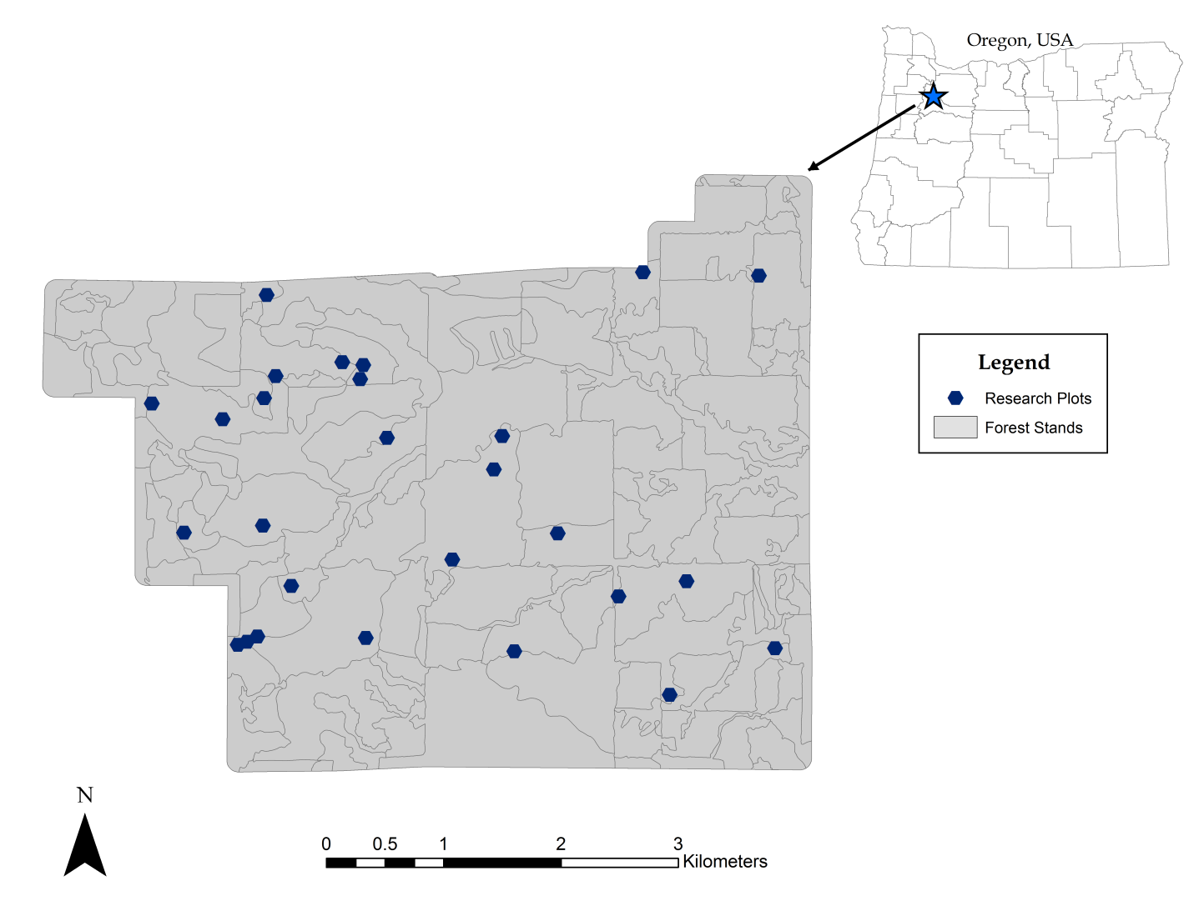

Fig. 2
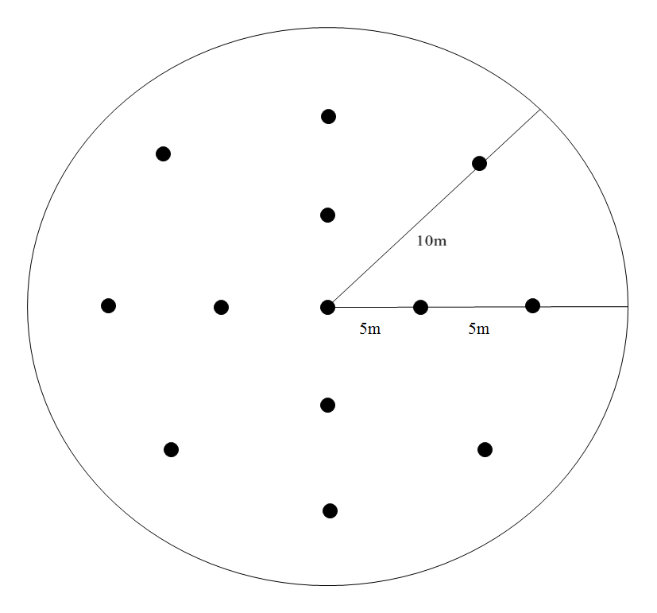

Fig. 3
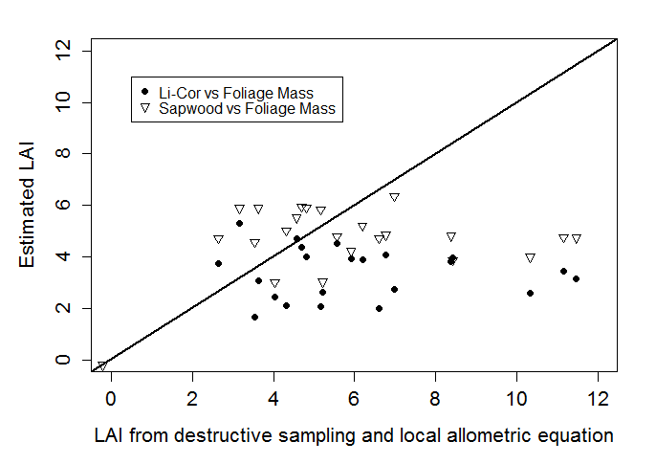

Fig. 5
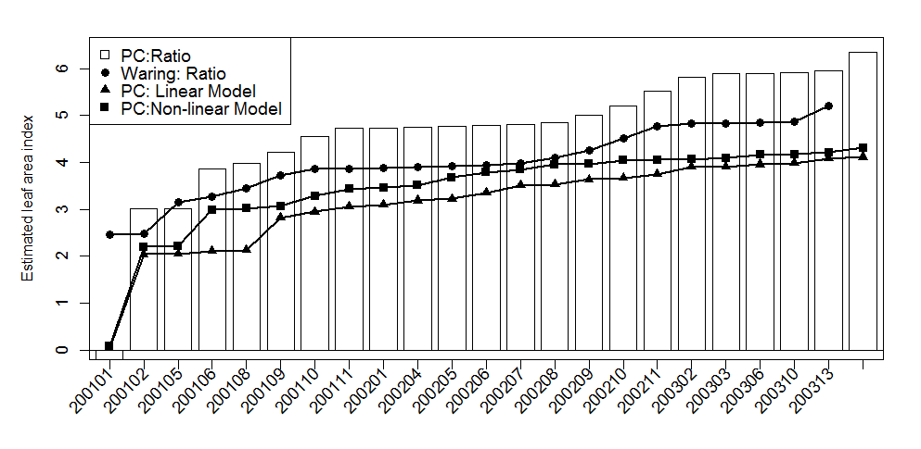

Figure 5a.
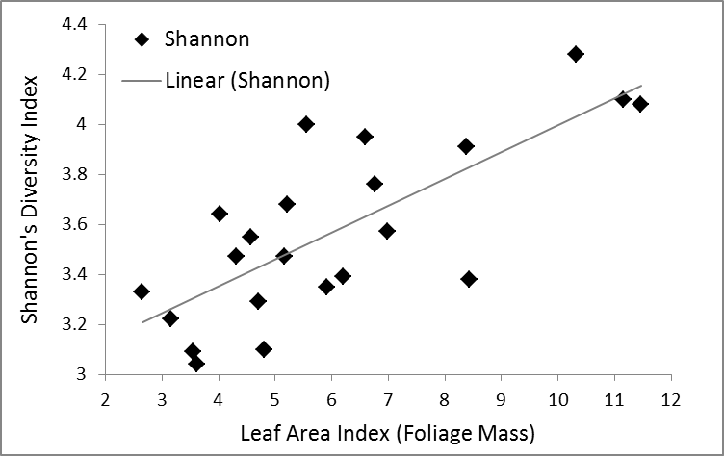
Figure 5b.
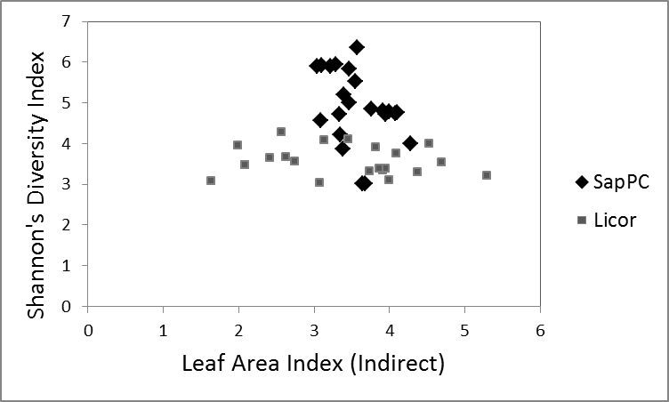

Current address: Rubenstein School of Environment and Natural Resources, University of Vermont.

