Hydrologic Investigations and Monitoring Design of a Vermont Kettlehole Bog

Paula J. Pitcher & W. Cully Hession
For submission to Hydrology (hopefully)

March 28, 2002

ABSTRACT
Groundwater movement and water chemistry were studied an ombrotrophic kettlehole peatland near Stowe, Vermont. Flow patterns showed discharge from peat to groundwater regardless of precipitation, resulting from drought conditions throughout the state. Monitoring wells were installed in a factorial statistical design which allowed for investigation of interaction effects between depth in peat profile, distance from open pond, and time of sample. Kriging was used to evaluate flow, conductivity, and chemistry between well locations. Results indicate that flow patterns in the upper portion of the bog do not fluctuate widely and the flow patterns should be predictable up to several months.

INTRODUCTION
Ombrotrophic bogs are defined as peatlands which receive the majority of their source water directly from precipitation, resulting in highly acidic and nutrient-poor water chemistry (Gore, 1983). Their hydrologic response is highly complex and variable (Price and Waddington, 2000); the difficulty in quantifying their water flux is attributed to intrinsic peat characteristics. Hydraulic conductivity varies with moisture content, age of decomposition, and type of decaying material (cite here). Previous studies have attempted to understand peatland hydrology by comparing water flux patterns to pore-water chemistry (Fraser et al, 2001; Waddington and Roulet, 1997; Hemond, 1980; Wilcox et al., 1986; Damman, 1986; Hill and Siegel, 1991), concentration of sorbed substances on the peat substrate (Donahoa and Liu, 1998; McKnight et al., 1985), or surface vegetation (Glaser et al, 1981). Even in a combined hydrologic and chemical analyses, the flow patterns within a specific bog may not be fully understood. This presents challenges to scientists attempting to conserve and reconstruct these delicate ecosystems.

Changes in hydrology due to global warming, land clearance, and urbanization over the past three centuries have had a profound effect on wetland distribution. Because bog succession happens on a much slower time scale than other wetlands (>5 cm/year), human impacts are more difficult to quantify in these systems. Major hydrologic changes around peatlands may go unseen for several decades only to result in permanent impacts to the ecosystem. Long term field studies offer an insight into the dynamics of water movement within peatlands. Previous designs, however give an indication of the resulting error associated with measurements over time and thus, their predictability.

Previous field studies quantifying peatland hydrology range in size small raised boreal peatlands to larger more complicated peatlands ___. Well locations are typically orientated in perpendicular transects (cite here) based on direction of groundwater flow. This type of design is useful in representing flow patterns for specific transects within the peatlands but does not give a good spatial distribution of head data. Geostatistical methods such as kriging, developed within the last two decades has been used successfully in mineral-soil groundwater studies (cite here). Kriging estimates flow and conductivity values between well locations by minimizing and estimating the error at nests. Our field design involves three major elements; (1) distance from a central kettlehole pond, (2) depth of well screen, (3) and time of sample as statistical factors in our evaluation of water movement of a 3-acre bog. We use these elements to predict the variability associated with water can chemical movement within the small bog and to evaluate interactions between major hydraulic barriers at the site.

STUDY SITE AND METHODS

Study Site
Molly Bog is located off Vermont State highway Route 100 between Stowe and Morristown (N44° 29.9’, W72° 37.6’) (Figure 1) and is owned and managed by the University of Vermont’s Natural Area Conservation Group. Molly bog is a small portion of a much larger peatland complex, estimated at 55 acres in size (Sanderson, Cambell, and Neitlich, 1993). A total of three bogs are located in the Molly Bog Peatland Complex, connected by a coniferous peatland swamp system. Molly bog is the only open pond peatland within the complex, the two other bogs are completely blanketed by peat and vary in their size, peat depth, and source of water supply. The degree of ombrotrophicness changes from west to east; Andromeda bog hosts limited fen vegetation (cattails and sedges) to the west and Beaugrand’s bog hosts dense ombrotrophic vegetation (pitcher plants and snowberry) to the east. Molly bog itself varies in degree of trophy in this same direction (west-east); the densest populations of pitcher plants are located in the northeast portion of the floating mat. The pond is home to several distinct types of vegetation including bladderwort (Utricularia geminiscapa), water shield (Brasenia schreberi) and spatterdock (Nuphar variegatum). Leatherleaf (Chamaedaphne calyculata), bog cranberry (Vaccinium oxycoccus), pale laurel (Kalimia polifolia), bog rosemary (Andromeda glaucophylla) pitcher plant (Sarracenia purpurea), sundue (Drosera intermedia), beak rush (Rhynchospora alba), cotton grass (Eriophorum spp.) and peat mosses (Sphagnum spp.) dominate the floating mat and surrounding peatland.

Molly bog’s uniqueness has been document by several authors. Volgemann (1964) cited Molly as a “near-perfect example of a postglacial bog” and the National Park Service (1973) defined Molly as “a classic example of a small, early successional, absolutely unspoiled cold northern bog”. The open pond portion of Molly bog is approximately 2.2 acres in size and >12 meters deep at its center. It is surrounded by a floating peat mat approximately 15 m wide and 1.5 meters thick at its deepest depth. Outside the floating mat is a broad peatland that overlays mineral soil at depths >2 meters in some areas and extending a distance >75 meters. Core samples of a thick clay layer overlaying silt, sand and gravel from underlying soil indicate Molly bog developed in a glacially-made depression as a typical New England kettle hole bog. Logging, farming, ditching and urban development in and around the complex caused Molly bog to be listed as a threatened National Natural Landmark by the National Park Service in 1998.

Hydrology

The major hydrologic components for Molly bog can be summarized as a mass-balance model of peat water movement (equation 1). The natural design of the peatland’s kettelehole structure simplifies the components in our hydrologic model. The central pond has no surface inlets or outlets. A topographic survey conducted during the summer 2001 showed the peat slopes at a gradient of ___ towards the central pond, thus direct overland flow was considered negligible. The main components considered for measurement include precipitation, pore-water movement, groundwater seepage in/out and evapotranspiration.
$P+q_{\text{ri}}+q_{\text{gi}}−E−T−q_{\text{ho}}−q_{\text{go}}=ΔS$ Equation 1
where
P = precipitation,
q_{ri} = river/pond seepage in,
q_{gi} = groundwater flow in,
E = evaporation,
T = transpiration,
q_{ho} = horizontal seepage out,
q_{go} = groundwater seepage out, and
$ΔS$= change in peat storage with time.

Precipitation
Precipitation was measured at Molly bog using a rain gauge tipping bucket and snowfall adapter (Campbell Scientific Inc, Logan, UT) from Sept 2001-Aug 2002. Precipitation data agreed with data from the Morrisville airport weather station, located approximately 2 miles northeast Molly bog (statistics test will say p<something).

Evapotranspiration (Evaporation and Transpiration lumped together)
Evapotranspiration was estimated using the Priestly and Taylor model (1972) with data from the Morrisville weather station. These values were compared to evapotranspiration values measured at the Essex, VT weather station, located approximately 20 miles from Molly Bog at an elevation of 110 m. Results were compared using a standard t-test.

Pore-Water Movement
The peat pore-water movement was monitored using nested piezometers at 15 locations around the bog (Figure 2). Each nest contained three 1-inch ID SCH 80 PVC pipe slotted over the bottom 10 cm and capped at the both ends. Piezometers were installed at depths of 0.5, 0.75 and 1.0 meters below the peat surface.

Ground-Water Movement
Nested steel piezometers were installed at six locations around the bog to monitor groundwater seepage across the base of the peatland (Figure 2). Each nest contained two ¾ inch drive-point piezometers with inlet holes over the bottom 3.5” lined with stainless steel screen (Solinst, Waterloo, CA). Piezometers were installed to depths of 1.0 and 3.0 meters below the ground surface.

Hydraulic Conductivity
Hydraulic conductivities were measured at each well using the hydrostatic time-lag method developed by Hvorslev (1951). Both slug and bail tests were conducted for each well. The location and elevation of PVC and steel piezometers were determined using a total station during Fall 2001 (Corvallis Micro Technologies Inc., Corvallis, OR).

Water Chemistry
Peat water and groundwater samples were taken from each well using a portable peristaltic pump (Solinst, Waterloo, CA) and immediately chilled to 4°C. Samples were tested for electric conductivity, pH and total acidity in the UVM Environmental Engineering Laboratory. Electrical conductivity was measured using a platinum electrode conductivity meter (VWR, West Chester, PA). Prior to measurement the meter was calibrated to temperature and conductivity using a standard 0.01 KCl solution. Sample pH was measured using a glass electrode pH meter (Beckman Instruments Inc., Fullerton, CA) calibrated using a two point calibration curve with standard buffer solutions of 4 and 7. Total acidity was measured by the phenophalein titration standard method 2310 (Greenberg, 1992).

Statistical Design
Two statistical methods were used to evaluate data from this study (1) repeated measure analysis of variance (ANOVA) and (2) kriging. The repeated measure factorial model (Kuehl, 2000) is used to analyze time trends on the individual responses of factors and interactions between factors. The factors considered in this study are (A) radius from the peat-water interface and (B) depth to well screen. Factor A contains five distances: 0, 15, 30, 45, and 60 meters. Factor B contains four depths: 0.5, 0.75, 1, and 3 meters. Repeated samples of water level, general water chemistry and hydraulic conductivity were taken at each well for the sampling period (Figure 3).

The kriging statistical model is used to analyze data containing spatial and temporal components by interpolating values between known positions and estimating the error of values at known locations (Isaack and Srivastava, ). Widely used to evaluate geological data, this method has seldom been used in peatland hydrologic studies with the exception of Bradley (1996) who used it to estimate error associated with his MODFLOW model of a floodplain wetland.

Results

Hydrology
The water balance for Molly bog is shown in Figure 4. Cumulative precipitation and evapotranspiration over the sample period August 24, 2001 - November 15, 2001 (Julian dates 236-319) totaled 197 and 212 mm, respectively. This resulted in a total change in storage of –15 mm. Over one third the total precipitation came during during the week of September 21-September 27th, dropping 64 mm rain. Rainfall, evapotranspiration, and water table position are plotted on Figure 5. The grouped rainfall events totaling 42 mm at the beginning of the sample period followed by several days of lowered evapotranspiration had a large effect on water table position closest to the pond (15 meters) while effects from this storm were dampened further away from the peat-water interface. Water table position nearest the pond (15 meter) remains relatively constant over the sample period, increasing a total of only 7.3 cm, while the further distances (30 and 45 meters) show much greater increases of 22.1 and 25.2 cm, respectively. Because the water table position changes are much greater than the calculated change in storage resulting from the water balance, there appears to be a significant groundwater-peat supply source. The pore-water is flowing in three radial directions out from the pond (Figure 6). The largest gradient is on the southeast side of the bog, with a rate of 0.0275 cm/cm. This outward gradient may be the result of a year of drought in Vermont.

(I also plan to include vertical gradient profiles in this section)

Water Chemistry
The pH in the 1 meter wells for 11-17-01 is shown in Figure 7. The values decrease from the pond out in a radial direction towards the northwest and southeast. Conversely, the pH values increase towards the southwest where the 1 meter well reaches a mineral soil.
Specific conductance, however, follows a reverse trend towards the southeast; increasing with distance (Figure 8). This may be do to groundwater recharge from previous wetter periods.

(I would also like to present chemical data with depth profiles in this section)

Hydraulic Conductivity
Two bail tests were conducted on 3-21-02 for well nests 12 and 8, located on the northwest side of the bog. Although the tests were conducted in wells at the same peat depth (0.5 m) the basic time lag was an order of magnitude different (Figure 9). This results in conductivity values in WN12 and WN8 of 8.32 x 10-3 cm/s and 8.32 x 10-4 cm/s , respectively.

(We plan to conduct bail tests on each well at the bog within the next few months for a total of 52 conductivity values.)

Statistics
I hate to tell you this you guys but I haven’t run any stats models on my data yet. From the repeated measures model, I expect to find strong interaction effects between (1) distance from the pond and head levels and (2) depth of soil and water chemistry. The kriging model should give me an indication that the pH varies significantly over the sample period through a large error value. This will mean that although I am seeing a lower pH in one month, it doesn’t necessarily mean it’s an ‘ombrotrophic bog’. I think the conductivity values will have a lower error because they are varying more with degree of groundwater recharge which doesn’t appear to fluctuate significantly over time. For head values, kriging should give me a lower error value, indicating that if properly designed well locations at a site like this can be minimized. Conductivity will probably have a very large error value because it varies so much through time and space.

Discussion
The stratigraphy at Molly bog has significant effects on peat water movement, conductivities and water chemistry. During dry periods, the central pond serves as a constant head discharging to local groundwater sources, specifically in the northwest and southwest directions where the glacial deposit left a relatively thin layer of clay as a hydraulic barrier. Peat-water flow in the northeastern direction is probably exchanged with the ombrotrophic Beaugrand’s bog. Core samples taken in the mineral soil in this direction indicate the clay barrier is much thicker (>0.5 m), resulting in significantly lowered conductivities.

Head values, even at distances >45 m from the pond change in a relatively slow manner, approximately 0.25 m over three months. Water chemistry, in contrast, changes drastically with changes in surface precipitation at the surface. Thus, in the case of Molly, the head values are may be enough to determine the hydrology alone, chemistry may have been a waste of time and money.

Statistics should show that in a kettlehole bog like Molly, only major changes in hydrology will effect peat development at this stage. Because I think the head values are going to show low statistical error through time, I think the major obstacle in developing a useful model for kettlehole bogs is the varying conductivities. If the statistics are able to give an indication of how these vary with time…we’re in business.

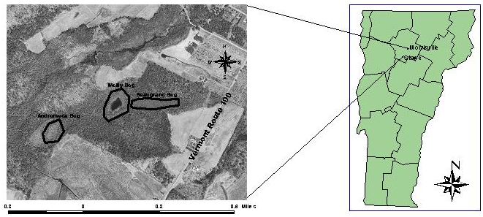
Figure 1. General location of Molly bog in northern Vermont. Andromeda bog is located to the southwest and Beaugrand bog is located directly east of Molly bog.

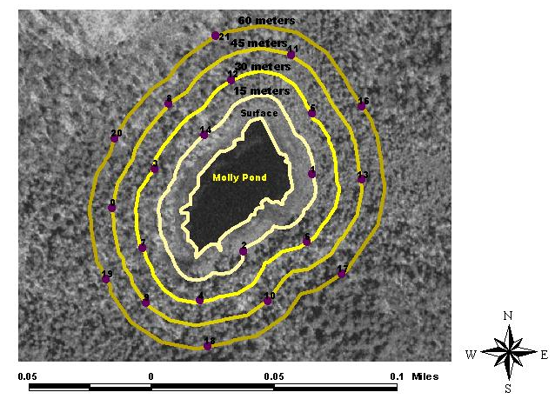
Figure 2. Location of nested PVC piezometers (ID 0-14) and drive point piezometers (16-21) at Molly bog.
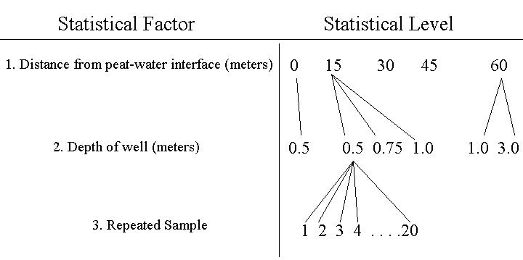
Figure 3. Design of the repeated measure statistical design. Depth of wells are nested within distance from peat-water interface while repeated samples are crossed between wells.

Figure 4. Water balance at Molly bog between August 24-November 15, 2001 Evapotranspiration (ET), precipitation (P), and storage change are plotted as cumulative fluxes (mm).

Figure 5. (Note: ET data was only available to day 319 that’s why the figures don’t line up.) Daily precipitation, evapotranspiration and water table position at Molly Bog, Vermont. The three water table positions represent averages at radial distances of 15, 30 and 45m from the peat-pond interface with one standard deviation error bars.

Figure 6. Horizontal flow contours at Molly bog on 11-30-01.
Figure 7. Contours of pH at Molly bog for wells located 1m below peat surface on 11-17-01.
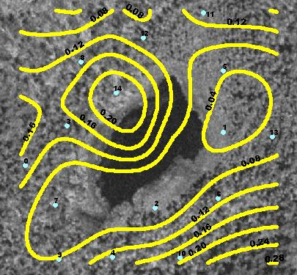
Figure 8. Specific conductance contours (mS/cm) on 11-17-01 at Molly bog.

Figure 9. Conductivity tests for well nest 12 and 8 on 3-21-02. Determination of the basic time lag requires a semi-log head ratio plot over time.

