Introduction: (Problem statement)
1. General description of the problem you will address.
2. State your general goal and how you will solve that problem.

Background: (Project Concept)
1. Describe the specific problem you will try to help solve, including a description of the specific location where you will work and specific project at hand.

List of specific objectives and methods for achieving objectives (pg. 93, 117).
1.Justify and explain what you’re doing – how will your project contribute to solving the problem.
2.Break down your goal into specific objectives and explain the method you will use to achieve each objective (pg. 117).

Obligations of group and Sponsor (pg. 50)
1. Group obligations – what’s your role in the project.
2. Sponsor obligations – a description of your sponsor’s role in facilitating the project. This role may be simply helping you to define the problem, providing you with contacts on site and a brief evaluation of the work.

3. Timeline of responsibilities: activity, person responsible and week it will take place (see page 51).

Example:
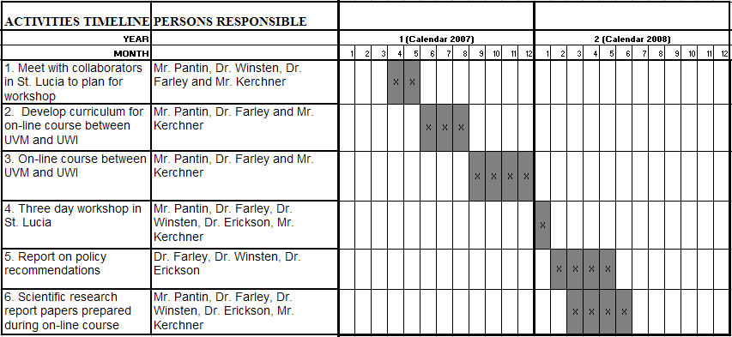

Project outputs (deliverables)
1. Specifically, what will you be providing to the project partners (i.e. final report, presentation on final day, micro-hydro unit).

