Micro-Hydro Project Proposal and Contract

Introduction
As crude oil prices increase (Figure 1) and climate change accelerates, alternative and efficient energy sources are increasingly important. This is especially true for small island nations that are frequently dependent on external sources of energy. One energy alternative that has not been fully explored is micro hydropower. Micro hydropower is well-suited for small area landscape sites with large amounts of flowing water and high rainfall. The micro-hydro project team from the University of Vermont will install a demonstration unit to illustrate the potential of micro hydro units to offer the small island nation of St. Lucia increased energy autonomy while adhering to their sustainable energy goals.

Background
The Honorable Dr. Julian R. Hunte, permanent ambassador of St. Lucia to the United Nations, noted that addressing energy issues, “is of great importance to Small Island Developing States (SIDS) given our sheer vulnerability to climate change and the highly intricate linkages between energy and our sustainable development” (2006).

Figure 1: Increase in oil price from 2002-2008
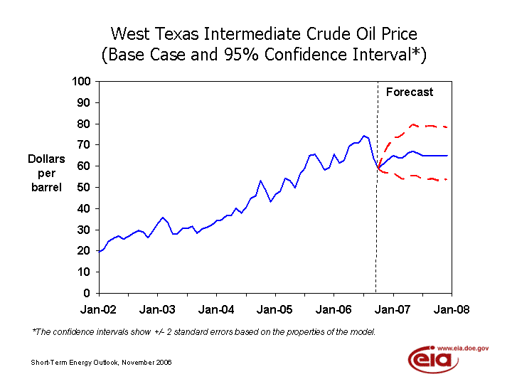

.

Source: Energy Information Administration, U.S. Department of Energy

The small island state of St. Lucia has been committed to alternative energy sources since 2001 when it declared its goal of becoming the world’s first “Sustainable Energy Demonstration Country”. Their 10 year national Sustainable Energy Plan examines alternative energy options as wind, geothermal and solar (Climate Institute, 2006). One energy alternative that has not been fully explored is micro hydropower. By capturing a small amount of water flow a micro-hydro unit produces electricity. Electricity prices are of particular concern in St. Lucia. Most St. Lucian’s’ get their electricity from the diesel-powered grid (Climate Institute, 2006). Micro hydropower has proven to be an effective method of reducing electricity costs in other island nations. For example, in the Ifugao province of the Philippines, micro hydropower provided home electricity to 200 families in a sustainable fashion (Tan et al n.d.).

Our group will be addressing St. Lucia’s strong dependency on foreign non-renewable energy sources by demonstrating that micro hydropower is an alternative energy source that is feasible, affordable and renewable. Our project is a continuation of previous projects, incorporating information from groups who worked on renewable energy projects in 2004-2005 and 2005-2006. The first group discussed St. Lucia’s current supply of electricity and the feasibility of micro-hydro as an alternative. Previous goals addressed seeking out viable locations for the installation. The following year measurements of head and flow were taken for micro-hydro potential in St. Lucia at various locations. Potential river locations for micro-hydro sites in the past include: Troumasse, Cul de Sac, Roseau, Mabouya, Canaries, Doree, Cannelles, Soufriere, Viuex Fort, Choc, Dennery, Marquis, Ans la Raye, and La Tille Gardens. This year, we have chosen the site of La Tille Waterfall on the property of project partner Sly Joseph. We plan to install a micro hydropower unit and work with Sly Joseph on the maintenance of the unit.

The community affected will initially be Sly Joseph and the surrounding families and residents who will be able to observe the micro-hydro unit. This example of a successful unit will educate community members about the benefits of micro hydropower while providing electricity to households.

List of Specific Objectives and Methods for Achieving Objectives
Our project focuses on successfully installing a micro-hydro unit on the island of St. Lucia. Specifically, we will be diverting a fraction of the total water flow from the downstream of the La Tille waterfall through the micro-hydro system; thus creating a source of energy that is not dependent on imports. This micro-hydro system will generate more than enough electricity to power Sly Joseph’s home. As a result, our project should set an example of the practicality of micro-hydro electricity in St. Lucia.

Our project partner, Sly Joseph, is providing the site for the installation of the micro-hydro unit, La Tille waterfall. The waterfall is already a tourist attraction; the addition of a micro-hydro unit will offer an educational aspect to the site.

Obligations of Group and Sponsor:
Sponsor’s Name: Sly Joseph
Sponsor’s Telephone Number: 1-758-454-4413
Sponsor’s Address: La Tille Gardens

Group Obligations: Our group will be responsible for technical and physical support around the installation of the project. We will also have the financial responsibility of providing the following necessary materials:
Items | Costs
ES&D Micro-Hydro System | US$2,9997
Deep Cycle Battery | US $150
Governor for Dumpload | US $300
800 feet of wire | US $150
Inverter | US $259
Intake tank & screen | US $100
Regulator -XANTREX c40 | US $150
Glue & Sandpaper | US $149
Valves | US $80
Wood Frame | NA

Sponsor Obligations: To insure that once in St. Lucia our efforts will be focused on installing the unit, our project partner, Sly Joseph will be researching the prices and availability of the materials we plan to purchase there. He will also be responsible for the transportation of materials from the hardware stores to his site. Sly Joseph will also be responsible for the proper maintenance of the unit after installation. We expect the St. Lucian Ministry to supply the three inch piping for the penstock section of the apparatus. A 40% cost-share by project partners is required for any funding sources from the University of Vermont. The pipe can either be poly pipe or PVC piping. The length of the penstock is approximately 400 feet. However, the Ministry of Agriculture Forestry and Fisheries should measure the distance from the intake to where the turbine will be placed to be accurate. Additionally, the micro-hydro unit will serve to educate the public on alternative energy.

Project Outputs (Deliverables):

- We plan to successfully install a micro-hydro system on project partner, Sly Joseph’s property. This system will demonstrate a successful and viable alternative energy source and provide a substitute to foreign energy sources.
- Upon completion of our time in St. Lucia, we will deliver a final report outlining in detail our project’s progress. This final report will address potential benefits and concerns of micro-hydro electricity as an alternative energy source.
- We plan to deliver a presentation on the final day of our stay in St. Lucia to the St. Lucian Ministry officials. The presentation will also explain the potential benefits and concerns of micro-hydro electricity while including additional information for the future.

Activities Timeline | Persons Responsible | Month | S-06 |  |  |  | O-06 |  |  |  | N-06 |  |  |  | D-06 |  |  |  | J-06
Activities Timeline | Persons Responsible | Week | 1 | 2 | 3 | 4 | 1 | 2 | 3 | 4 | 1 | 2 | 3 | 4 | 1 | 2 | 3 | 4 | 1 | 2 | 3 | 4
Formed Group | Alan, Marc, Jared, Nate, Nikola
Began Researching Micro-Hydro information | Alan, Marc, Jared, Nate, Nikola
Contact our sponsor Professor Lindsley Philbert | Marc
Contact our sponsor Sly Joseph | Jared
Begin detailing necessary parts required | Nikola, Marc, Alan, Nate, Jared
Detail of objectives and obligations | Nikola, Alan
Draft of project concept | Nicola, Jared, Alan
Order Hydro Unit | Gary Flomenhoft
Finalize project concept | Marc, Nate
Develop Contract with Sponsor | Nate, Jared, Alan
Receive Hydro unit | Nikola, Marc, Alan, Nate, Jared
Test Unit | Nikola, Marc, Alan, Nate, Jared
Present to Class | Nikola, Marc, Alan, Nate, Jared
Forward project to St. Lucian ministry | Marc, Alan
Travel to St. Lucia | Nikola, Marc, Alan, Nate, Jared
Meet with Sly | Nikola, Marc, Alan, Nate, Jared
Work on Micro-Hydro unit Installation | Nikola, Marc, Alan, Nate, Jared
Fly Home to St. Lucia | Nikola, Nate

Works Cited

Caribbean Nations Vie to be First Renewable Economies. Climate Institute. Retrieved 11/30/06 from http://www.climate.org/programs/caribbean_first.shtml.

Hunte, Dr. Julian R., Honorable, SLC, OBE. (May 2006) Statement at the 14th Session of the Commission on Sustainable Development: New York.

Tan, Charlene C. Hazel, Larisse Gale D. Garcia, and Maria Antonia Tanchuling. Micro Hydropower: a Renewable Energy Technology in the Philippines: University of the Philippines. Retrieved 11/30/06 from http://energygender.stepan.org/fileadmin/user_upload/projects/Annex4_Paper_Presentation_awarded.pdf.

Images
Energy Information Administration, U.S. Department of Energy. Retrieved 11/30/06 from http://www.eia.doe.gov/emeu/mer/prices.html.

