Integrated Watershed and Coastal Areas Management in the
Fond D’or Watershed, St. Lucia

CDAE 195/295 Final Report
Amanda Richardson
Mark Kolonoski
Ben Rumsey
Josh Smith

Introduction 3
Background 3
Objectives and Methods for Achieving Objectives 3
Group Obligations 3
Sponsor Obligations 3
Preliminary Results 3
Household Surveys 3
Farmers Surveys/Opportunity Cost 3
Tourist Surveys 3
Observations 3
Recommendations 3
Communication 3
Survey Logistics 3
Next Steps for the IWCAM Watershed Valuation Project 3
Water Distribution and Infrastructure 3
Work Cited: 3
Appendix A: Fond D’or Watershed Project Area 3
Appendix B: Household Willingness to Pay for Water Source Protection 3
Appendix C: Respondents’ Satisfaction with Water Quality and Quantity 3
Appendix D: Opportunity Cost for Agricultural Land Producing Yams and Dasheen 3

Introduction
While it is understood that all humans depend on ecosystem services for survival, most of these services remain outside the realm of the market and, therefore, are not considered in policy decisions because they are unaccounted and unpriced (Costanza et al., 1997; Kumar, 2005). Ecosystem managers, concerned by the loss of ecosystem services in the last 50 to 60 years, are unable to make decisions about how to best manage ecosystems without information regarding the value of those services (Kumar, 2005). Economic valuation of ecosystems attempts to answer those questions by examining the losses (or gains) across different stakeholders groups. Valuation is founded on the fact that humans derive benefit (or utility) from ecosystem goods and services, either directly or indirectly, whether currently or into the future (Costanza et al., 1997; Kumar, 2005).
In response to decreasing environmental quality in watersheds, market incentives have been implemented as an innovative approach to sustainable watershed management. In order to work, market-based incentive projects must be founded on accurate economic data, such as the costs and benefits of water provision. Successful projects have been implemented in places like Costa Rica and New York, while many projects have failed due to a lack of appropriate economic information.

Background
Small island nations face a unique set of environmental problems due to their small size, topography, and relative isolation (Reynolds, DeSisto, Murray, & Kolodinsky, 2007). One current environmental challenge that Caribbean nations face is the management of water resources—access to freshwater resources being of primary concern (Cosgrove & Rijsberman, no date). With its steep topography and volcanic bedrock, St. Lucia experiences high levels of run-off, sedimentation, erosion, gully formation and landslides. The lack of natural catchments for water collection and storage for treated water adds to the difficulty in supplying freshwater to communities. Water scarcity in rural areas during the dry season has reached critical capacity (Ministry of Physical Development Environment and Housing, 2004). Population growth, internal migration, and infrastructure development are all factors contributing to rising demand. Weak water policies, a low degree of governance and limited institutional developments also contribute to degrading water quality and quantity (Kumar, 2005). Small island developing states are more susceptible to the impacts of climate change because of their low adaptive capacity and high vulnerability (Gopaul, 2005).
Environmental degradation is not only the result of natural disasters; human-induced environmental impacts such as agriculture, wastewater disposal, tourism and economic development play a significant role in the degradation (Ministry of Physical Development Environment and Housing, 2004).
To combat environmental and social problems in developing countries, several approaches have been explored. Approaches that compensate a land user directly for providing environmental services are known as a payment for ecosystem, or environmental, services (PES) (Pagiola, Arcenas, & Platais, 2005). Approaches, like PES, address the problem that individuals seek what is in their best interest by aligning incentives to conserve with society as a whole (Ferraro & Simpson, 2001; Pagiola et al., 2005). This approach recognizes the inherent trade-offs and seek to bridge conflicting interests by means of compensation (Wunder, 2007). Well-designed market-based approaches have been shown to achieve environmental goals at less cost than command-and-control approaches, with inducement for continual development and improvement (Landell-Mills & Porras, 2002; Scherr, White, Khare, Inbar, & Molnar, 2004).
Kumar, 2005 describes the economic valuation of ecosystem services as taking place in two steps. First, the specific service being valued must be identified. This step includes detailing the nature of the service, the scale of the service, how the service would be affected by shifts in ecosystem processes, who—or what land use—provides the service, who benefits from the service, alternatives to the service, trade-offs in service provision. The bulk of valuation work is in the first step, which involves quantifying biophysical relationships. The second step estimates the monetary value of impacts to the ecosystem service. This can be done in using a variety of methods.
Our group addressed the need to improve water service provision and livelihoods within the Fond D’or watershed in St. Lucia by administering three surveys that will provide the data for an economic evaluation of those services. This project valuated both the supply and demand side of water services in St. Lucia using appropriate methods.

Objectives and Methods for Achieving Objectives
The goal of this project was to achieve sustainable use and provision of water services while improving livelihoods within the Fond D’or watershed of St. Lucia. This project also contributed to the Millennium Development Goals (MDGs) of environmental sustainability and poverty alleviation.
Objectives:
- Gain local perspective on environmental issues in St. Lucia.
- Methods: Survey implementation provided an opportunity to interact with citizens of St. Lucia and discuss environmental issues that they face. Partnering with local organizations provided insight into the issues facing St. Lucia and what has been done to address those issues.
- Collect data for an economic analysis of the watershed.
- Methods: Opportunity cost and willingness to pay will be calculated from data collected through household, tourist and farmer surveys.
- Contribute to integrated watershed and coastal areas management in the Fond D’or watershed.
- Methods: Make policy recommendations based on our research findings for developing market-based incentive mechanisms for watershed services.

Group Obligations
Our group was responsible for the development and implementation of three surveys. One survey was be aimed at farmers who own land on the Fond D’or watershed; another was aimed at those households who receive water from the watershed; and the third focused on tourists’ willingness to pay for clean beaches and coastline. We assumed the financial responsibility of providing the survey materials and transportation to/from our project partner’s office.

Sponsor Obligations
The Mabouya Valley Development Project (IWCAM), a project of the Ministry of Agriculture, Forestry and Fisheries, served as our primary project partner. Our sponsor assumed responsibility for organizing local volunteers to partner with UVM students in the field to assist with any language or cultural barriers. Our project partners also divided the communities within the valley into clusters for household sampling purposes, provided transportation to/from our community sites, and facilitated our introduction into a Fair Trade Organization farmer’s meeting for the farmer surveys.

Preliminary Results

Household Surveys
We focused on and devoted most of our time to the household surveys in the Fond D’or watershed. Through these household surveys we tried to determine residents’ willingness to pay for reforestation within the watershed. We conducted surveys in 5 different areas within the watershed, each being a cluster of several smaller villages. These clusters consisted of 1) La Caye, Lumere, and LaPerle 2) Aux Lyon, Gardette, LaRessources, and Despin 3) Richfond and Grande Ravine 4)Deniere Riviere and Belmont, and 5) Grande Riviere, Mornpanache, Debonaire, and Tomazo (see Appendix A).
To conduct the surveys, each member of our group was paired with a community volunteer, both for navigation of the areas we covered and also to break any cultural gap we may have encountered along the way, the biggest one being language. With the help of these volunteers, over the course of 5 working days and 235 man hours, we were able to complete 308 surveys.
The household surveys collected information that contributes greatly to evaluating the potential for implementing a benefits transfer, or PES program in the watershed. The first question on the survey asked the respondent if they believe that there is a problem with the drinking water they receive from WASCO, the water company of St. Lucia. Out of a small sample of 100 surveys, the responses were overwhelmingly negative: that there is a problem with water. The surveys then went through a series of questions to understand sources of water for a household as well as water usage— which type and how much of each water source were used in those everyday tasks. Along with this, we asked their satisfaction of the pipe water they received in terms of quality and quantity.
A scenario was included in the survey that explained the importance of healthy forests, outlining how they provide soil stabilization (preventing erosion), flood and drought control, and support wildlife habitat. The respondents were then asked if they would be willing to help support a program that would compensate farmers for taking some of their farmland near water sources out of production to plant trees, allowing for forest re-growth to protect a clear source of water into the future. Emphasis was placed on the fact that there would be no immediate effects on the water quality and quantity, but that such a program is necessary to help sustain the watershed and allow for improved water services for future generation’s use.
The main objective of a willingness to pay study is to discover respondent’s willingness and ability to pay for ecosystem services. By conducting a study one can identify the true demand for socially acceptable services, and use the information obtained to create sustainable services that benefit the future. It’s very important to use proper research methods to obtain the maximum willingness to pay results, and a lot of time was spent before we traveled to St. Lucia perfecting the methods in our survey that could obtain the best and most accurate data.
Out of the data of the 100 surveys entered and analyzed so far, 86% of households believed that landowners should be compensated for reforestation on their land, with 62% of the respondents saying they would be willing to pay an additional amount on their water bill each month that would go directly to those farmers for reforestation purposes (see Appendix B). For each household that showed willingness to pay, we received a good estimate as to how much they would be willing to pay in most cases. The sample data also shows that 79% of those households were either unsatisfied or very unsatisfied with the quality of their water, and 61% unsatisfied or very unsatisfied with the quantity of water they received (see Appendix C).

Farmers Surveys/Opportunity Cost

Twenty-nine farmers in the Mabouya Valley were surveyed at a weekly Fair Trade Organization meeting. Thirty minutes were given to us in which to conduct our surveys and survey administration occurred in one small room. The setting was loud, making communication difficult. Language barriers occurred frequently.
The purpose of the farmer survey was to determine a farmer’s willingness to participate in a benefits transfer program and attitude towards environmental practices on his/her farm. Socio-economic and demographic information was also collected.
In addition to farmers’ willingness to participate, their opportunity cost of participating in a market incentive program for reforestation in the Fond D’or watershed was also needed. To calculate opportunity cost, information on the costs and benefits of the best alternate use of their land (i.e. agriculture) was needed. Opportunity cost represents a trade-off between the two best alternative uses of a farmer’s land: reforestation or agriculture.
The Ministry of Agriculture, Forestry and Fisheries provided recent data on the fixed costs, variable costs, and revenues of several agricultural crops in St. Lucia. Because there are no variable costs involved in the production of yams or dasheen (Clocasia esculenta), the opportunity cost is the same as the profit from production. The opportunity cost for agricultural land producing yams is $63,826.27 EC. The opportunity cost for agricultural land producing dasheen is $32,418.20 EC (see Appendix D).

Tourist Surveys
Seventy-nine tourist surveys were completed at the Hewanorra International Airport located outside of Vieux-Fort, St. Lucia. The goal of the surveys was to gather information on visitors’ reasons for visiting St. Lucia, the importance of clean beaches and coastlines to their liking of St. Lucia and information on the cost of their trip (flights, hotels, attractions, etc). The survey also included several WTP scenarios; each respondent worked through a different set of scenarios subject to their response to different policy options that would sustain forest conservation measures on the island. Fifty-eight respondents said that they would support one or more of the policy options; eight did not support any of the policy options or did not know; only one respondent elected not to answer.

Observations
Prior to implementing the household survey, we had little expectation on what to expect for willingness to participate from water users. Throughout the semester we had minimal feedback from our project partners as to whether or not St. Lucian’s would be receptive to our questions. We were hopeful our questions would be understood and thorough responses would be received. We attempted to make the questions as clear and precise as possible and leave room for further explanation of the water situation. Fortunately, with the assistance of community volunteers, these methods resulted in open and honest responses from nearly all of the 308 surveys we completed.
When asked if they were satisfied with water quality received from WASCO, the only water company in St. Lucia, nearly all respondents said they were either unsatisfied or very unsatisfied. When we asked then to explain why, we heard a variety of reasons. The most common was that the water was consistently dirty. I had one man show me the water from his faucet. He had allowed it sit in a bucket for twelve hours. There was a layer of silt and sand at the bottom and the water was murky as if chlorine has just recently been added. Another respondent said she often finds live worms floating in the water. One man said he consistently finds rat feces in his water supply. Many mothers said they will not allow their children to drink the water as it makes them ill. Breastfeeding mothers said if they drink the water their baby’s get sick as a result. Some people said they must shower with boiled rainwater because the tap water causes them to break out in a rash.
When asked about satisfaction with water quantity received from WASCO the majority of people were not satisfied, yet a greater percentage said they were satisfied. We can attribute this difference to the location of the households. Many of the communities in the Mabouya Valley are located along hill sides. Those at the bottom of the hills are more likely to receive water due to the fact that the water does not have to be piped up hill. The flat areas are also where the major water pipes converge, making water availability less of a concern for residents in these areas. The respondents who said they were not satisfied with the water supply said it was because the supply was not consistent. The dry season was particularly hard and some people said they may go as long as four months without receiving piped water. The water supply is also turned off when there are abundant amounts of rain. The increased amount of surface runoff during these periods causes the supply to become too contaminated for distribution. Therefore, during periods of heavy rain and lack of rain the water supply cannot be depended on.

Recommendations

Communication
One of the biggest problems not only for our project but for all the class’s projects was the lack of prior communication with St. Lucian contacts and project partners. We designed the surveys without much feedback from project partners so we were forced to make many assumptions. During the first meeting with the government and project partners in St. Lucia we learned so much more about our project and logistics. For future projects it’s essential that there is better communication between project partners prior to the class arriving in St. Lucia.

Survey Logistics
Due to the lack of communication with project partners prior to the class arriving in St. Lucia we had a very vague idea of how the surveys were to be conducted and the project area we would work in. We also didn’t know how people would respond to us or the survey questions. Below are some recommendations for a continuation of the IWCAM surveys in future years:
- It is most important that the survey be reviewed by someone familiar with the community and area where the surveys will be conducted. Had our surveys been pre-tested in St. Lucia, we would have realized the need for less-academic language and that some questions were not applicable.
- The communities that we worked in were very diverse. The application of our survey differed from community to community within our project area for this reason.
- Timing of survey administration is also very important. Because we surveyed during the day time on weekdays, many people were not home. We encountered many housewives, children, and retired persons, some of which did not speak English. Depending on the household, the respondent may or may not have known household financial information.
- Local partners are essential. We were assisted in the field with local community volunteers. They knew many people, knew how to get around, how to approach people and were able to help us bridge some cultural barriers. We recommend that any survey work within communities in St. Lucia be conducted by a UVM student and a local partner.

Next Steps for the IWCAM Watershed Valuation Project
We feel that there is great potential for future groups to build upon the work that we completed. First and foremost, we recommend that a future group continue this project and work primarily with farmers in the Mabouya Valley, just as we primarily worked with households. For a benefits transfer scheme to be in place in the watershed, we must understand farmers’ willingness to accept (WTA) compensation and specifics of their farm and land use. We recommend that a future group make site visits in order to uncover this information. We also recommend that a feasibility study of each farm be conducted to determine the locations for implementing watershed improvements, such as reforestation, near water sources.
As part of the feasibility study we suggest that the water be tested upstream and downstream from farms to verify where water quality is being impacted. It would be an undertaking to conduct these kinds of site visits as the farms are geographically spread out and access to the farm owner might be difficult. However, we think with proper planning (communication with locals and studying maps of the project location) it could easily be accomplished over the time in St. Lucia.

Water Distribution and Infrastructure
Another unforeseen complication that we encountered was the reality of the water situation in the Mabouya Valley. On the first day of survey work we immediately found that many people don’t receive water for a good part of the year. Some people don’t receive water in their pipes during the day and others don’t receive it for 5 months at a time. It became difficult to inquire into people’s willingness to pay for water when they rarely received water at all. Many respondents noted their willingness to pay for a reforestation program was contingent upon an improvement in the quality and quantity of water that they receive. The issue of water distribution and infrastructure goes beyond the scope of this project. This issue concerns St. Lucia’s water provider: WASCO. We feel that part of a project to improve water quality within the Mabouya Valley must bring WASCO on board and involve infrastructure improvements.

Work Cited:

Appendix A: Fond D’or Watershed Project Area

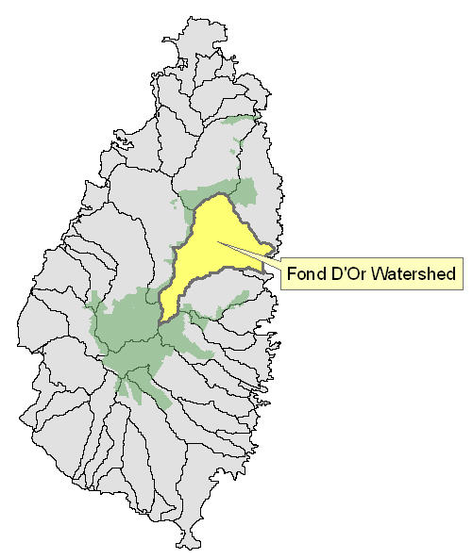

Appendix B: Household Willingness to Pay for Water Source Protection

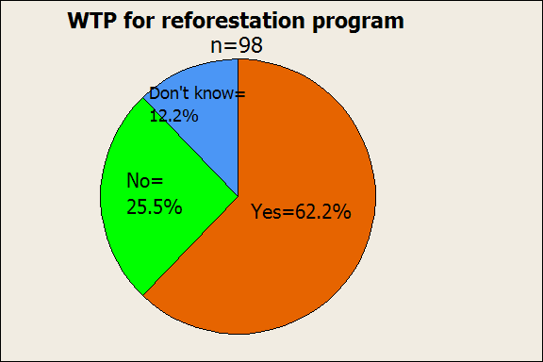

Appendix C: Respondents’ Satisfaction with Water Quality and Quantity

N=98
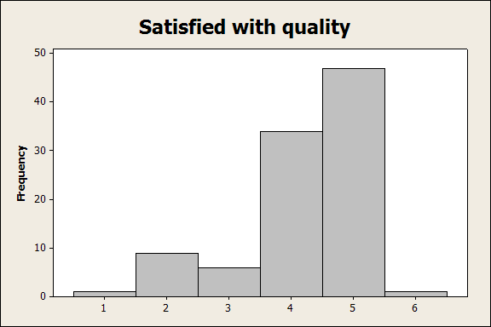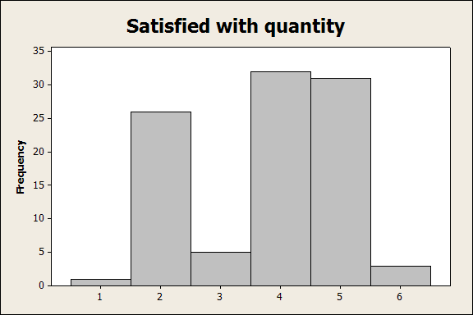
1= Very satisfied
2= Satisfied
3= Neither satisfied nor dissatisfied
4= Unsatisfied
5= Very Unsatisfied
6= Don’t Know

Appendix D: Opportunity Cost for Agricultural Land Producing Yams and Dasheen

Table 1: Costs and Profits of Yam Production
Item/Operation | Unit | Quantity | Unit Prices | Total Cost
Land Clearing | Man Days | 8 | 50 | 400
Ploughing | Man Days | 12 | 50 | 600
Planting Material Preparation | Man Days | 2 | 50 | 100
Planting | Man Days | 8 | 50 | 400
Fertilizing | Man Days | 3 | 50 | 150
Weed Control | Man Days | 30 | 50 | 1500
Pest and Disease Control | Man Days | 4 | 50 | 200
Harvesting Days | Man Days | 6 | 50 | 300
Drying and Storing | Man Days | 2 | 50 | 100
Transportation | Trips | 3 | 80 | 240
Fertilizer | Bags | 30 | 90 | 2700
Lime | Bags | 10 | 30 | 300
Planting Material | Lbs | 3195 | 2.5 | 7987.5
Benlate | Kg. | 2 | 130 | 260
Slug Bait | Bags | 1 | 60 | 60
Vydate | Gallons | 1 | 128.77 | 128.77
TOTAL |  |  |  | 15426.27
Marketing yields |  | 19360 | 2.5 | 48400
PROFIT |  |  |  | 63826.27

Table 2: Costs and Profits of Dasheen Production
Item/Operation | Unit | Quantity | Unit Prices | Total Cost
Land Clearing | Man Days | 8 | 50 | 400
Ploughing | Man Days | 15 | 50 | 750
Planting Material Preparation | Man Days | 2 | 50 | 100
Planting | Man Days | 8 | 50 | 400
Fertilizing | Man Days | 6 | 50 | 300
Weed Control | Man Days | 35 | 50 | 1750
Pest and Disease Control | Man Days | 4 | 50 | 200
Harvesting Days | Man Days | 8 | 50 | 400
Treating and Storing | Man Days | 2 | 50 | 100
Transportation | Trips | 3 | 80 | 240
Fertilizer | Bags | 30 | 90 | 2700
Lime | Bags | 10 | 30 | 300
Planting Material | Plants | 6969 | 0.3 | 2090.7
TOTAL |  |  |  | 9730.7
Marketing yields | Lbs. | 18150 | 1.25 | 22687.5
PROFIT |  |  |  | 32418.2

