General and Alternative Energy Contacts in St. Lucia

Ryan Mastropaolo- Peace Corps volunteer in Micoud
758-285- 5101
(will help with contacts in Micoud)

Sly Joseph- Local
John.latillegardens@hotmail.com
758-454-4557
758-489-6271
(local who is familiar with alternative energy, possible project partner)

Lindsley Philbert- Lecturer at the Sir Arthur Lewis Community College in Castries
lindsleyp@yahoo.com
758-720-6245
(knowledgeable in wind turbines (esp. inverters), can help link to educational resources, make it educational, possible project partner)

Neranda C Maurice- Ministry of Sustainable Development
758-287-0330
alwaysranda@yahoo.com
(contact early to get the site approved, and the development of the structure itself: she will help with funding, contacting the Commissioner of Crown Lands (Peter Felix 758-468-4477), contacting the Deputy Permanent Sec.(George James 758-468-4119) Ministry of Physical Development, and the Micoud Fisheries extension officer)

Island Water- Electrical Equipment (inverters)- Rodney Bay
758- 452-0212
758-487-8397

Edson Francis - Electrical Engineer (volunteer to help with wiring)
758-514-1734
classelect@candw.lc
(owns a local business called Classical Electricals, huge help with 2008 turbine)

Andy Behl- Peace Corps Volunteer in Mon Repos
758-285-6815
Andybehl@gmail.com

Greta Joseph- Praslin Community Counselor and Rep. for the local government
758-455-3537
758-284-6230
(she has a whole list of community plans for Praslin, but she expects a lot)
The following photographs depict a peninsula, Vierge Point, in Micoud that the Development Committee would like to see utilized.
Vierge Point

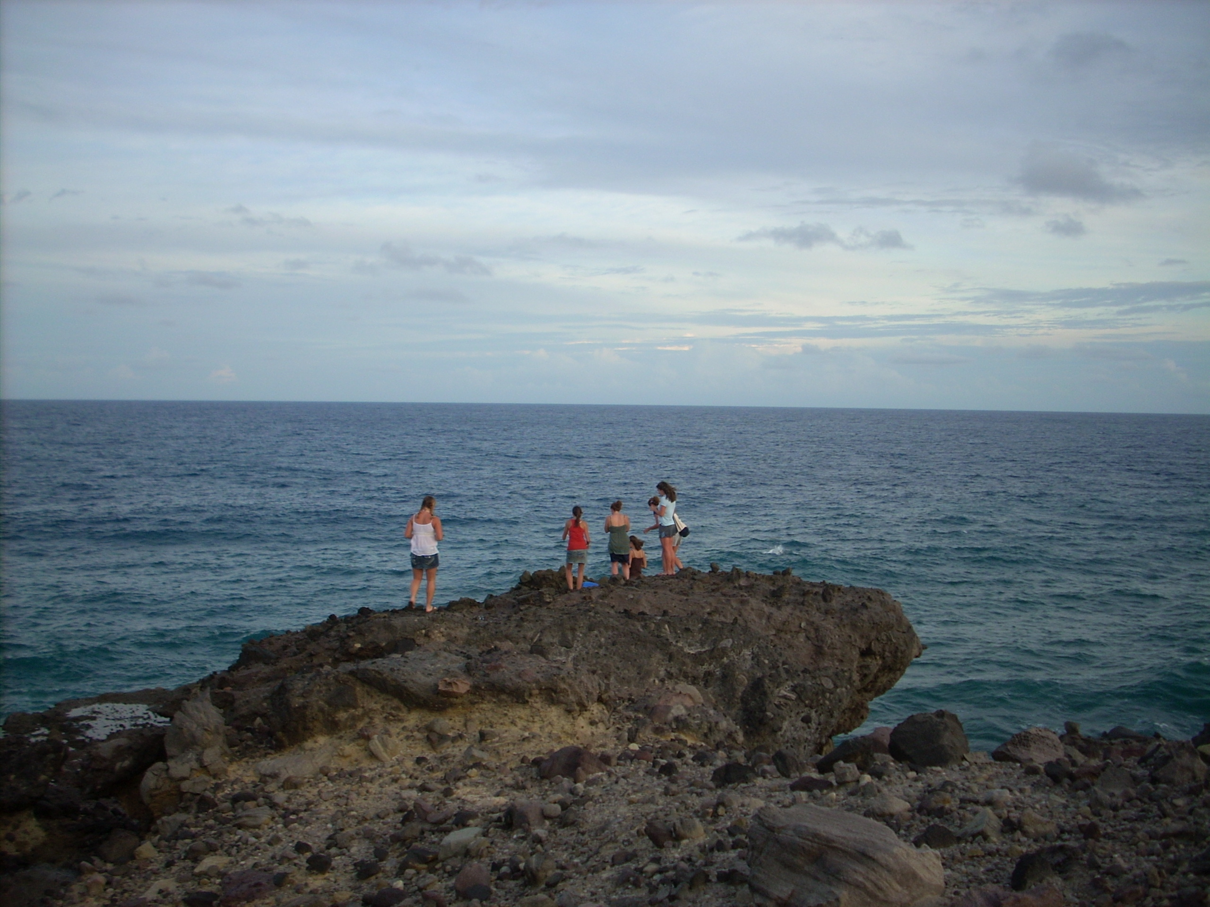
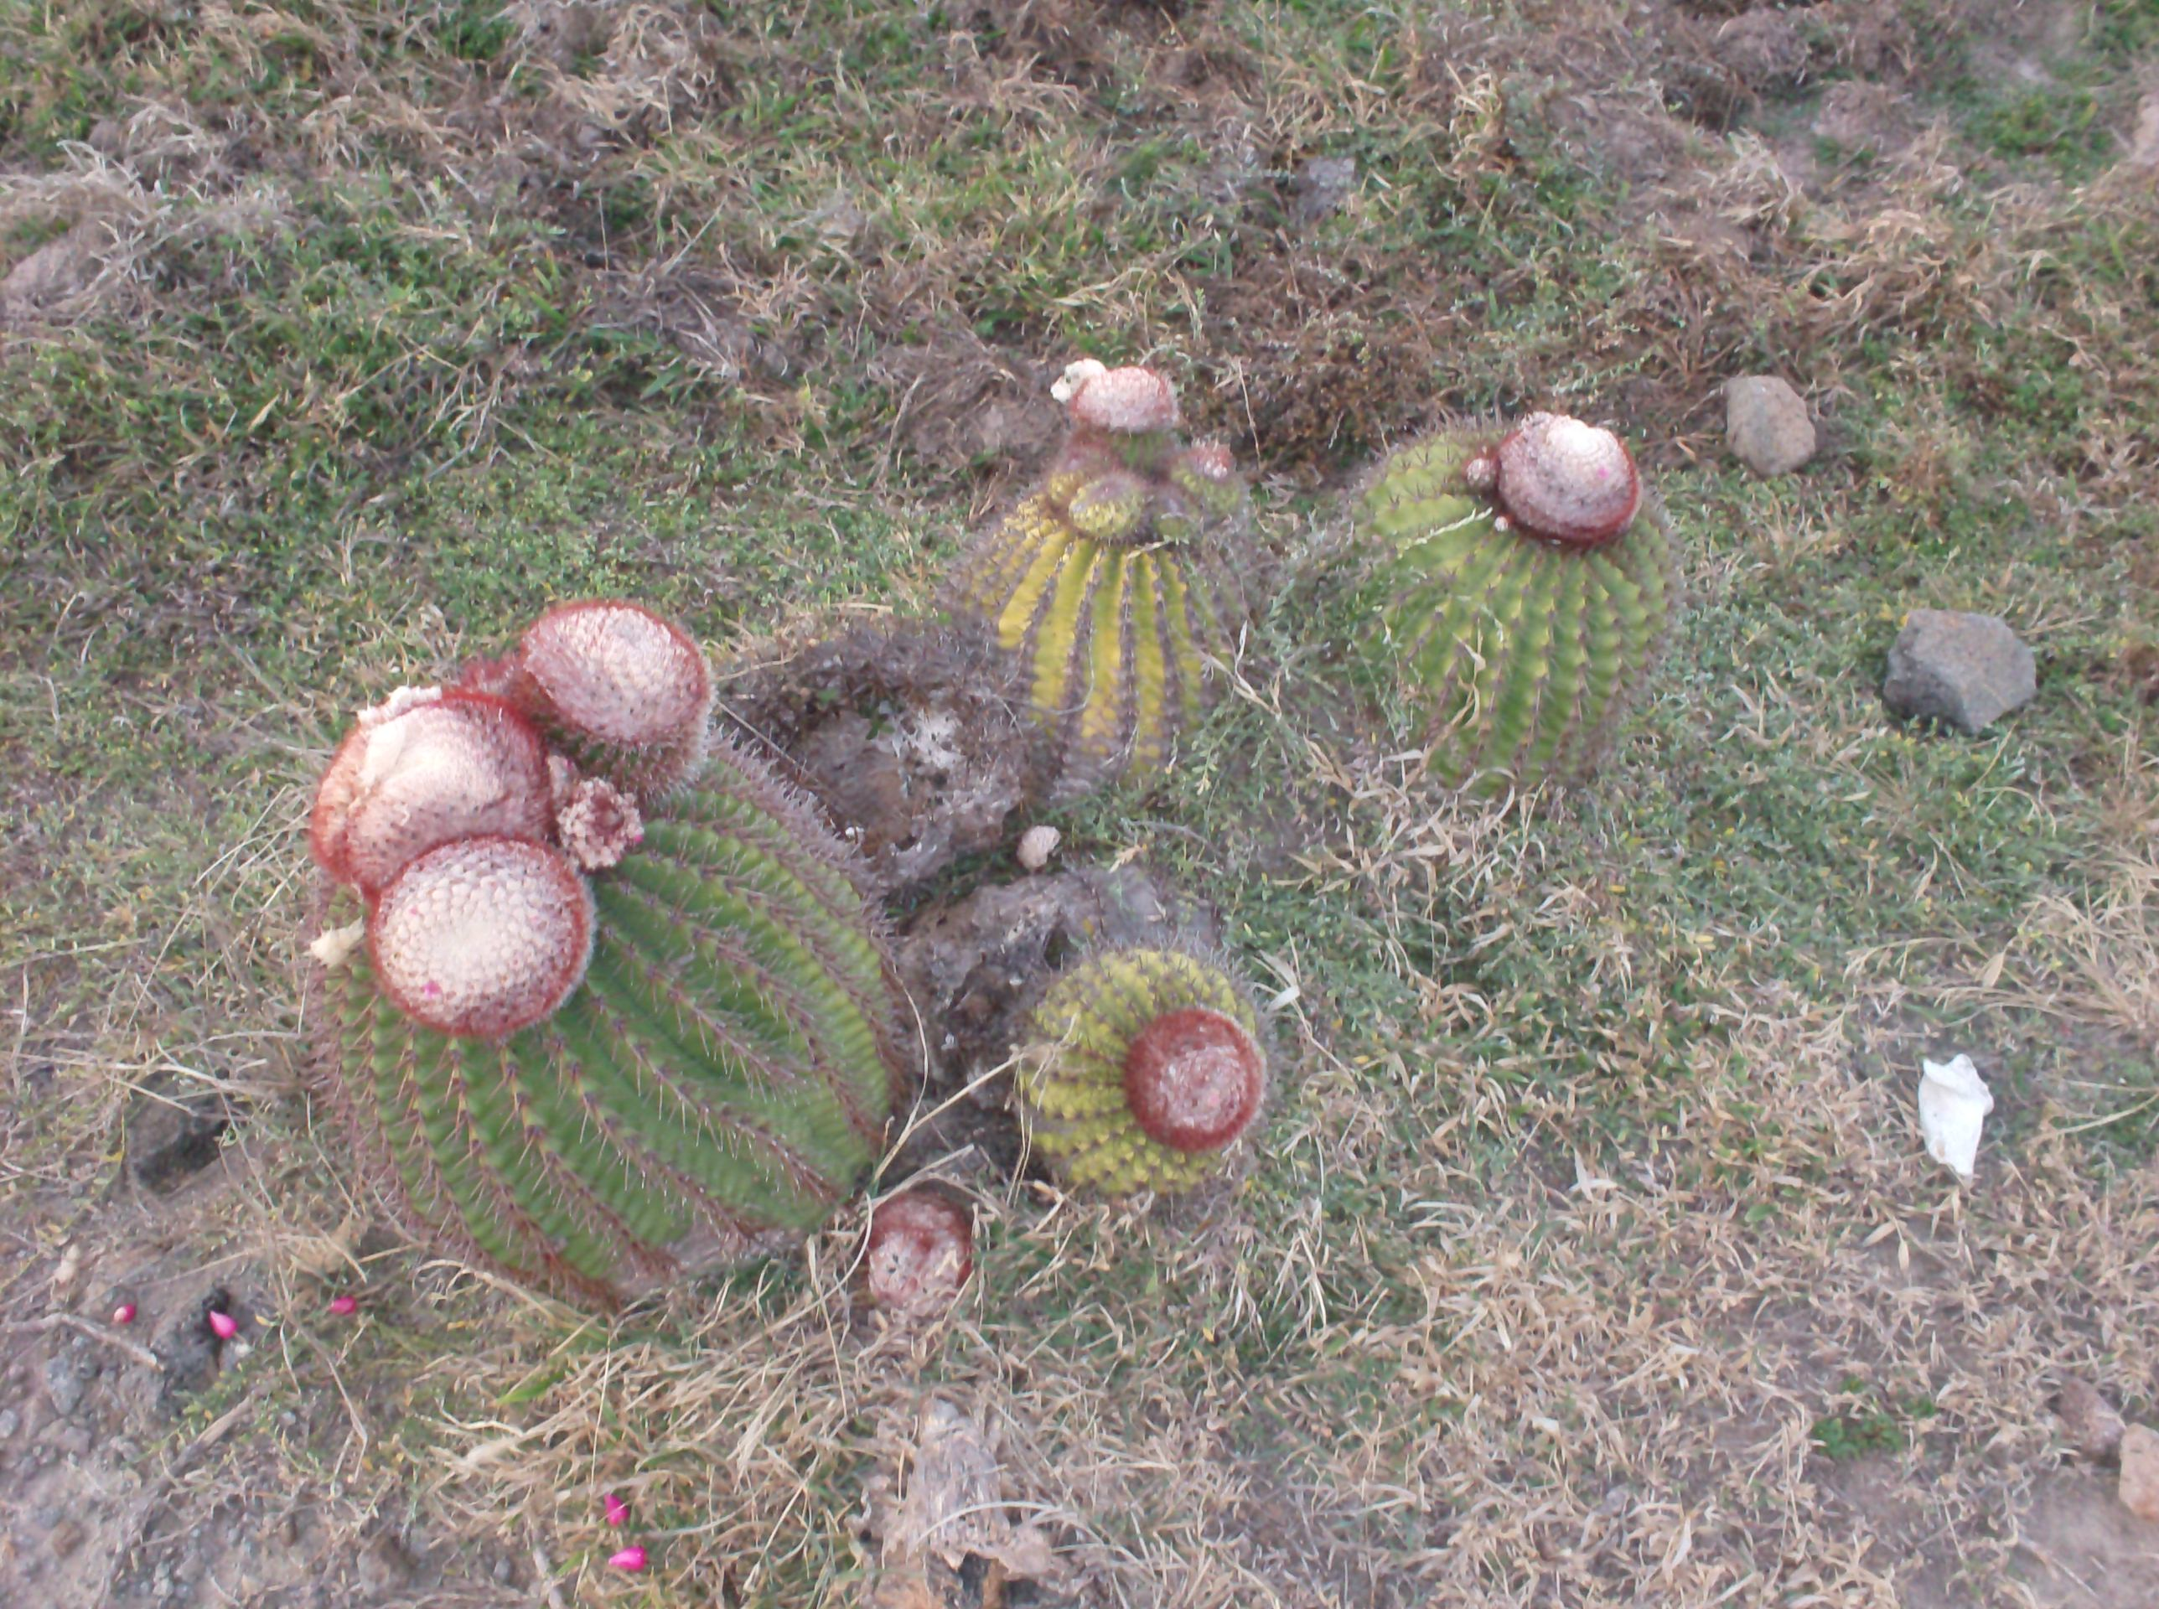

Landscape
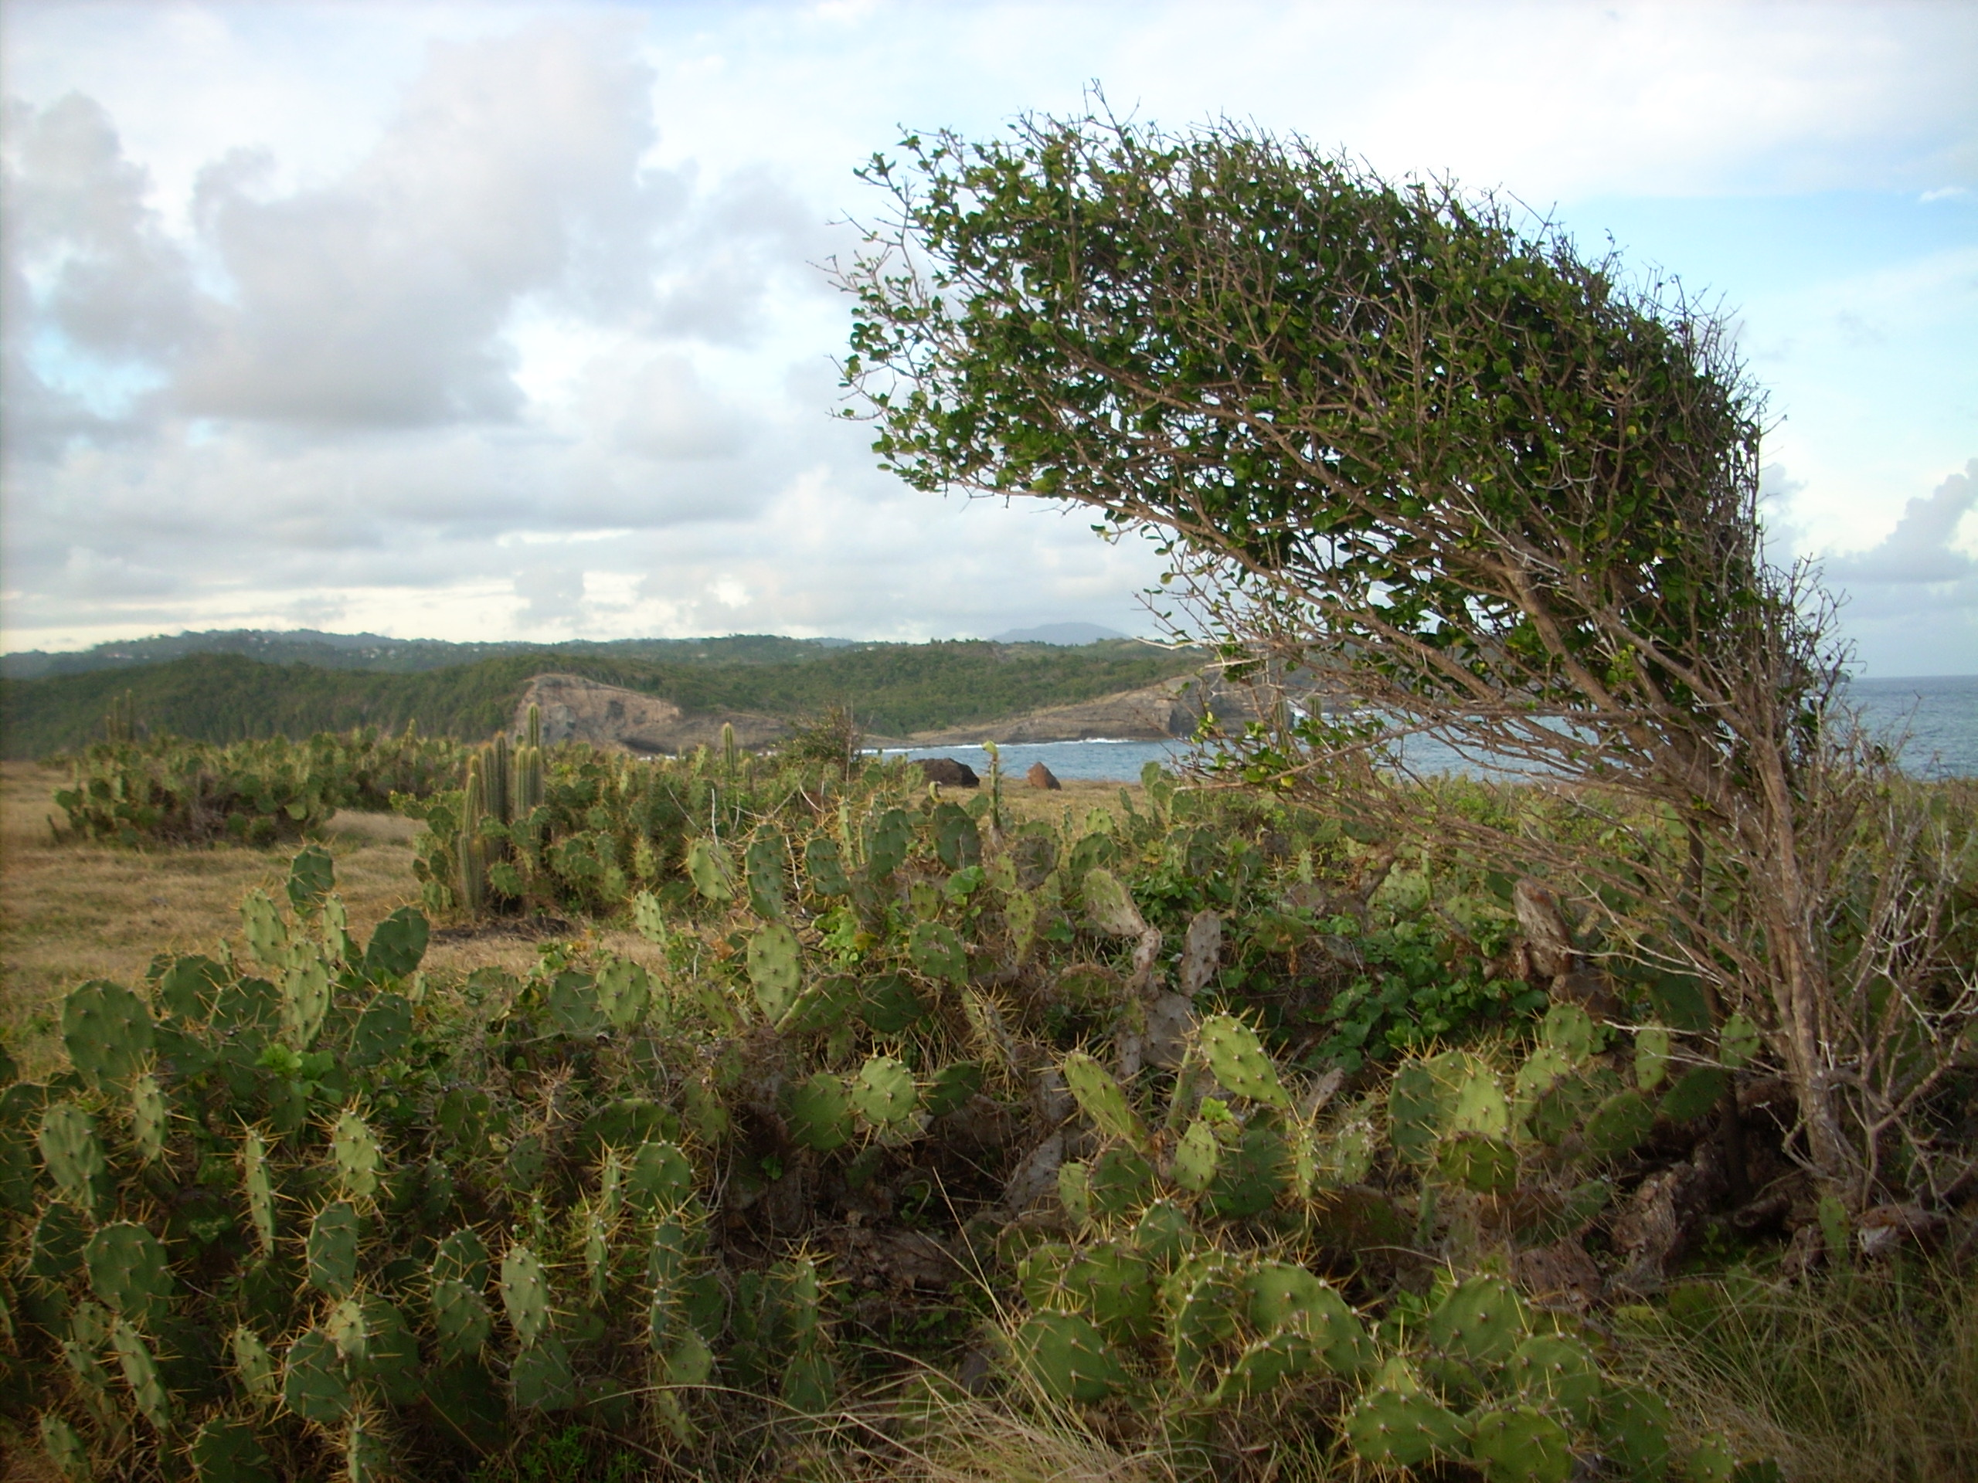

Endangered Cactus

