Micro-Hydro in Saint Lucia
Final Report

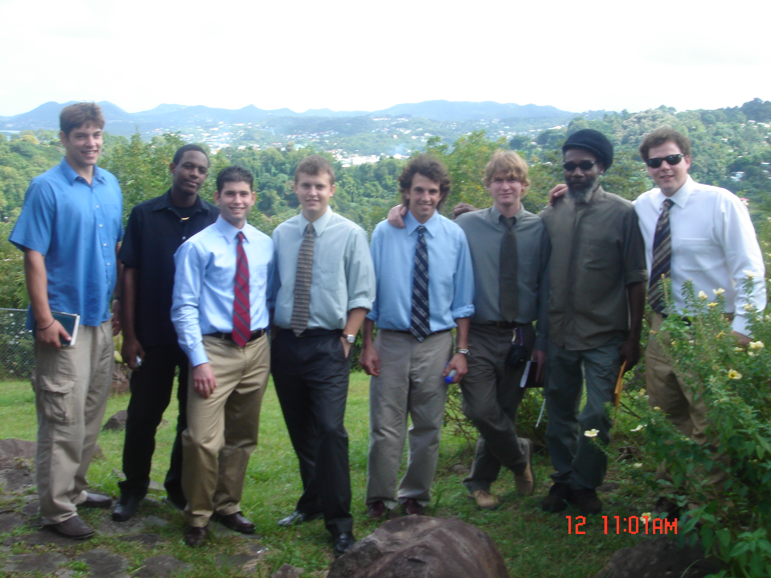

By: Jared Kross, Nate Berg, Alan Trinkle, Marc Weinman and Nikola Janjic

Abstract:

The micro-hydro service-learning project, conducted on the island of Saint Lucia, has been under development for three years strong, with the participation of a multitude of students and professor Flomenhoft. The site selection for a micro-hydro unit took the majority of the first year along with contacting potential project partners. The second year measurements were taken along with site specific potentials. The third year we have successfully installed a functioning micro-hydro unit on the property of project partner, Mr. Sly Joseph. Contact was made with Mr. Joseph in October and discussion began about the feasibility of this project. After our initial contact, we drafted a project contract and proposal that delegated our group obligations along with our project partner’s obligations. This service-learning project was a basic cost-share project. The University of Vermont supplied the micro-hydro unit, along with the regulator, dump load, and technical assistance, and Mr. Joseph supplied the inverter, along with his time for maintaining the unit after our departure from the island. Research was conducted to find the most optimal unit for our selected site at La Tille waterfall, while paying close attention to select the most reasonably priced unit. The final decision was made by Professor Flomenhoft, who is an expert in the field of renewable energy. While in Saint Lucia, our group met with the Ministry of Agriculture, Forestry, and Fisheries and presented our project contract and proposal to them in order to solicit their support in supplying the PVC piping necessary to complete the instillation. With their help, our group was able to install the intake of the micro-hydro system, along with connecting the 300’ of PVC piping. The construction of manifold allowed us to test the water flow and insure we had the necessary pressure. With the help of Professor Philbert from the Community College Of St. Lucia, and his electrical engineering students, the wiring from the unit to Mr. Joseph home and the switchboard were put together. The micro-hydro unit is running successfully minus a small issue with the inverter. The housing for the unit was left incomplete before our departure; however we were assured by Mr. Joseph that it would be completed shortly, along with the replacement of the inverter.

Project Concept:

Our project will address the concern of the increasing crude oil prices and St. Lucia’s dependency on foreign oil for generation of electricity. (Figure 1 displays the steady increase of crude oil prices from 2002 – 2006) Our approach to solving this complex problem is to offer a renewable alternative energy source. Our project goal will focus on successfully installing a micro-hydro system on the property of Mr. Sly Joseph called La Tille Gardens. Upon completing the installation of a functional micro-hydro system, the site will be used as an educational tool to inform the citizens of St. Lucia about the feasibility of renewable alternative energy.
Figure 1
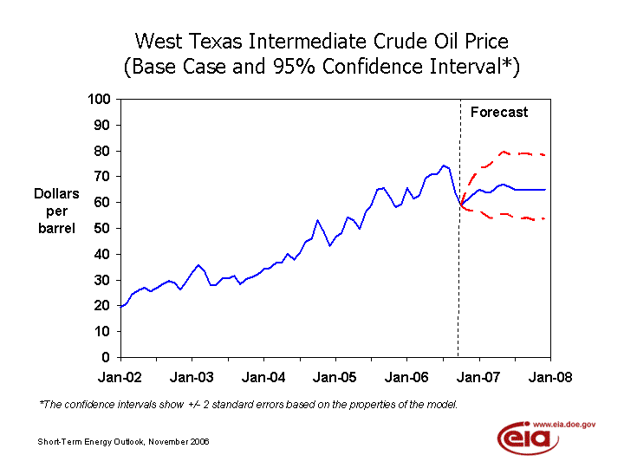
.
Source: Energy Information Administration, U.S. Department of Energy

Background – Problem Statement:

Our project is a continuation of previous projects, incorporating information from groups who worked on renewable energy projects in 2004-2005 and 2005-2006. The first group discussed LUCILEC’s monopoly of electricity and the feasibility of micro-hydro as an alternative. Previous goals addressed seeking out viable locations for the installation. The following year measurements of head and flow were taken for micro-hydro potential in St. Lucia at various locations. Potential river locations for micro-hydro sites include: Troumasse, Cul de Sac, Roseau, Mabouya, Canaries, Doree, Cannelles, Soufriere, Viex Fort, Choc, Dennery, Marquis, and Ans la Raye. This year, we have chosen the site of La Tille Waterfall on the property of project partner Sly Joseph. This is one of many potential sites for renewable energy sources. The specific problem our group will attempt to help solve is to reduce St. Lucia’s strong dependency on foreign non-renewable energy sources and offer an alternative energy source that is feasible and affordable, such as micro-hydro electricity. The specific location of this project is on the island of St. Lucia, more specifically on the property of local St. Lucian, Sly Joseph. The community affected will initially be Sly Joseph and the surrounding members of his community whom will be able to observe the micro-hydro unit. This will be an example of a successful unit, which will hopefully provide an educational purpose along with encouragement of micro-hydro development. Here will we install the micro-hydro unit and post a sign describing the unit along with a brief history of the project.
List of Specific Objectives:

Our project focuses on successfully installing a micro-hydro system on the island of St. Lucia. Specifically, we will be diverting a fraction of the total water flow from the downstream of the La Tille waterfall through the micro-hydro system; thus creating useful energy without depending on foreign energy sources. This micro-hydro system will generate more than enough electricity to power Sly Joseph’s home. As a result, our project should set an example of the practicality of micro-hydro electricity in St. Lucia.
Our project partner, Sly Joseph, is providing the site for the installation of the micro-hydro system, La Tille waterfall. This is already a tourist attraction and in the future this area can offer an educational aspect as well.
- Specific Objectives

  - Make contact with project partners – Method : via phone and e-mail
    - Sly Joseph
    - Lindsley Philbert

  - Order/Gather Materials – Method : order parts online, help from Professor Flomenhoft and Sly.

  - Assemble micro-hydro unit/ Test run @ UVM – Method : Help from Professor Flomenhoft.

  - Travel to St. Lucia – Method : via airplane.

  - Meet Project Partners – Method : contact and make appointment.

  - Survey Site – Method : travel to site and observe area, find best spot.

  - Installation – Method : hard work and preparation, working with Sly and Professor Kerchner.

  - Final Report/Presentation – Method : Microsoft Word/PowerPoint.

  - Ecotourism/Educational Aspect - Method: Construction of sign (Sly)

Methods:
- Establishing Contacts
In order to feasibly enact this project we had to make the necessary contacts with people in St. Lucia to work with us on this project. Before departure we contacted Sly Joseph and worked with him successfully as our project partner. We also contacted Professor Lindsley Philbert who proved to be a vital addition to the success of our project. As an electrical engineer he has a lot of experience and expertise working with electronics and donated his time and knowledge to helping us successfully wire the unit to the electrical panel. He used our project as a hand-on learning experience for his students who worked along side him wiring the unit.
Once we arrived in St. Lucia we had a meeting with ministry officials to discuss our ideas and present our project proposals to them. We explained who we are, our obligations and plans, as well as how the unit works and the amount of power/energy the unit can produce. The ministry was impressed and supportive of our ideas. After hearing about our plans, Felix Jaria agreed to donate 300 ft of schedule 40 PVC piping. This donation really made out project possible since locating that much piping at an affordable cost would have been extremely difficult. Mr. Jaria even had the pipe dropped off the next day.
- Water Diversion
To generate power from a Micro-Hydro unit water must be diverted from a water source with optimal head and flow and ran through the unit itself before returning to the stream. To achieve this we built a make-shift damn out of sand bags at the top of the Latille Gardens water fall. This damn created our intake pool located on the right side of the waterfall. A 3inch PVC pipe carried the water to our intake bucket which screened the water for any silt or debris. We used only 3inch PVC because we did not need to divert more water from the waterfall because Mr. Joseph did not need an excessive amount of power. We could have used 4 inch but it was not necessary to do so.
- Piping
After the water is filtered through the bucket, it flows into the 4ich pipe we had donated by Mr. Jaria. We spent a day’s work assembling and supporting the pipe as it ran along the side of the cliff. We attached rope and wiring to the piping to keep it together and hung it from trees at the top of the cliff. We used 340 feet of piping to channel the water from the top of the waterfall to the site picked out for the hydro-unit itself.
- Micro-Hydro Unit Housing
We picked out a site downstream that gave us 40 feet of head and was located above the 5 year flood plane. This location was also accessible along a footpath which made it feasible to work in. Our method for housing the unit consisted of us leveling the ground and preparing the area for concrete. Sly Joseph contacted his good friend Ras who lives in the village of Micoud as well, to help with the masonry work. Ras has experience in construction and worked very hard building the foundation with which the unit was to be mounted. While our short work week did not provide us nearly enough time to see the completion of the housing, the back wall was built. The electrical components will be mounted on this wall.
In order to construct the housing we had to haul numerous bags of sand and concrete stones as well as cinderblocks from the top of the waterfall down to the sight itself. This took a great amount of time and was very labor intensive. But through dedication and teamwork we successfully accomplished the goal.

Obligations of Group and Sponsor:
Sponsor’s Name: Sly Joseph
Sponsor’s Telephone Number: 1-758-454-4413
Sponsor’s Address: La Tille Gardens

Group Obligations:
Our group will be responsible for technical and physical support around the installation of the project. We will also have the financial responsibility of providing the following necessary materials. Some will be purchased prior to our departure date while others will be purchased upon arrival to the island.

Cost-Share of Micro-Hydro Service Learning Project:

Items | Cost
ES&D Micro-Hydro System | $3000.00
Deep Cycle Battery | $300.00
Governor for Dumpload | $300.00
Intake tank & screen | $40.00
Regulator -XANTREX c40 | $300.00
Glue & Sandpaper | $20.00
Valves | $250.00
Misc. tools/materials | $290.00
400 feet PVC Pipe | Donated
800 feet of wire | Donated
Inverter | Donated
Breaker | Donated
Conduit for wire | Donated
Cement/Cinder Blocks | Donated
Total Cost | $4,500.00

Sponsor Obligations:

In order to insure that our efforts are not put to waste while being in St. Lucia and the days prior we will need the help of our project partner, Sly Joseph. Because some of the materials will be purchased in St. Lucia it will be his job to find out the prices and availability in such cases. In addition, it will be just as important to insure that the new technology is properly maintained so it can be used as an educational tool in the future. Sly has also offered his and a worker’s time to aid in the installation.

Project Outputs (Deliverables):

- Upon completion of our time in St. Lucia, we will deliver a final report outlining in detail our project’s success. This final report will address potential benefits and concerns of micro-hydro electricity as an alternative energy source.
- We plan to deliver a presentation on final day of our stay in St. Lucia. In this presentation we will address similar ideas as in the report along with additional information for the future.
- We plan to successfully install a micro-hydro system on project partner, Sly Joseph’s property. This system will demonstrate and provide an alternative energy source to foreign sources.

Activities Timeline | Persons Responsible | Month | S-06 |  |  |  | O-06 |  |  |  | N-06 |  |  |  | D-06 |  |  |  | J-06
 |  | Week | 1 | 2 | 3 | 4 | 1 | 2 | 3 | 4 | 1 | 2 | 3 | 4 | 1 | 2 | 3 | 4 | 1 | 2 | 3 | 4
Formed Group | Alan, Marc, Jared, Nate, Nikola
Began Researching Mico-Hydro information | Alan, Marc, Jared, Nate, Nikola
Contact our sponsor Professor Lindsley Philbert | Marc
Contact our sponsor Sly Joseph | Jared
Begin detailing necessary parts required | Nikola, Marc, Alan, Nate, Jared
Detail of objectives and obligations | Nikola, Alan
Draft of project concept | Nicola, Jared, Alan
Order Hydro Unit | Gary Flomenhoft
Finalize project concept | Marc, Nate
Develop Contract with Sponsor | Nate, Jared, Alan
Receive Hydro unit | Nikola, Marc, Alan, Nate, Jared
Test Unit | Nikola, Marc, Alan, Nate, Jared
Present to Class | Nikola, Marc, Alan, Nate, Jared
Forward project to St. Lucian ministry | Marc, Alan
Travel to St. Lucia | Nikola, Marc, Alan, Nate, Jared
Meet with Sly | Nikola, Marc, Alan, Nate, Jared
Work on Micro-Hydro unit Installation | Nikola, Marc, Alan, Nate, Jared
Fly Home to St. Lucia | Nikola, Nate

Results:
After using the calculations for head and flow measurements from last years research for various sites we were able to order the Energy Systems and Design Stream Engine turbine. This particular electric generator was operable at a range of five to four hundred feet of head and could handle a volume of water up to 400 gallons per minute. The measurements from last year suggested that the river was flowing at 350 gallons per minute with a head of 56 feet.
Upon arriving at the site we knew that we would not be diverting the entire stream to the turbine and had to decide how much could be diverted with out disturbing the aesthetics of the water fall. We were also fortunate enough to receive a generous donation from the Ministry of Agriculture for four inch pipe which meant we would have less frictional losses. This allowed us to install the micro-hydro only 35 feet below the intake. Once the pipe was installed we again measured the flow at the end of the pipe. Here after all frictional losses were accounted for the flow was 75 gallons per minute. This would be sufficient for our purposes and could increase at times during the rainy season or decreased by closing off valves.
Under these circumstances the generator would be producing 222.26 continuous watts. In other words this would be 5.33kWh/day. This should be sufficient for our project partner to provide eight-nine bungalows with refrigeration and lighting.

Power Output (continuous watts) = Net Head (feet) x Flow (gallons/min.) / 11.81
Power Output = 35 feet x 75 gallons/min. / 11.81
Power Output = 222.26 continuous watts = 5.33 kWh/day
Conclusion:
Saint Lucia’s severe dependency on the conventional methods of energy production from fossil fuels poses a serious and direct threat to the economy and the ecology of the island. “The Mauritius Strategy for the Sustainable Development of Small Island Developing States (SIDS) is very clear on the inter-linkages between energy and Climate change, and the urgent need for real action on renewable energy. (Statement by the Honorable Dr. Julian R. Hunte, Ambassador to the United Nations, on May 1st, 2006).” Furthermore, the economic constraint of dependency on the importation of foreign petroleum, which is used by the sole electric service provider LUCELEC in their diesel power plant, subjects the island of Saint Lucia to economic forces outside its sphere of influence. “The energy sector in St Lucia is influenced significantly by developments in the international petroleum market. Developments in international oil prices have been influenced by a number of factors including, increased supply side pressure and increasing global demand. (St. Lucia 2005 Economic and Social Review, Retrieved 11/06/2006, www.stlucia.gov.lc).”
The pursuit of clean and renewable energy systems in Saint Lucia will provide a viable solution for both the ecological and economical problems which are presented by current methods of electrical production. The Sustainable Community Development in Small Island States class of 2007 demonstrated that the implementation of renewable energy systems is achievable, both economically and logistically, by installing a fully functioning micro-hydro unit at La Tille Waterfall to serve as a demonstration and education site.
Adoption of further micro-hydro systems, as well as other clean energy technologies such as solar, wind, geothermal, and tidal wave energy, will offer a feasible method of demand side management of energy consumption, as well as the reducing the supply side pressures by lowering the dependency of foreign petroleum imports. Progressive management of electrical production with clean energy technologies can have the effect of reducing the harmful green house gas emissions, the preservation of natural resources and the local ecology, the development of a viable small business sector, as well as drastically lowering the domestic cost of electricity.
Future Recommendations:

After a successful installation of a hydro-electric generator, the group can consider part of its project complete. The micro-hydro unit is in place and generating power as intended from the powerful force of water. The second part of our project is to have the unit act as an educational tool. The word has already been spread in the local community and over the news. The ministry officials have been informed on the potential for hydro-electric power on the island. They know of the basic costs and savings that are associated with this alternative energy source.
In the future we would like to see this example setting device expanded upon and implemented around the island and world. In a quest to reduce the amount of harmful ecological effects of other sources of power, the potential should be researched in more detail with an exact cost-benefit analysis.

Ideally, a program with interests in expanding renewable energy would be set up and financially supported. One option for this would be a type of installation and payback plan. The government would have to invest some amount of money into a program. A team of people who are well educated in energy efficiency could be put together to run the program. The basic idea is that they would upgrade lights and appliances at people’s homes and businesses in order to reduce the usage of electricity. The fund could also pay for and install micro-hydro units, wind turbines, and solar power at varying locations. These power sources could feed any number of houses and businesses. The people benefiting from this new source of electricity would continue to pay their electricity bill just like the past. The hope is that these payments would go back into the fund and upon the time that the installation of whichever source of new power is paid off, the customers and public will see a lower cost of electricity.
Besides immediate adoption and expansion of the project, the group would like to see this site being used like a classroom. Educating the general public is very important and one of the easiest ways to do so is through the youth. With the help of Peace Corp volunteers, community advocates, and teachers trips can be set up to visit the site. Like a science project, the students can learn how electricity is made and see it hands on. This can spark interest and curiosity so that words “energy efficiency” will be come common place at home, in the classroom, and politics.

Works Cited

Caribbean Nations Vie to be First Renewable Economies. Climate Institute. Retrieved 11/30/06 from http://www.climate.org/programs/caribbean_first.shtml.

Hunte, Dr. Julian R., Honorable, SLC, OBE. (May 2006) Statement at the 14th Session of the Commission on Sustainable Development: New York.

Tan, Charlene C. Hazel, Larisse Gale D. Garcia, and Maria Antonia Tanchuling. Micro Hydropower: a Renewable Energy Technology in the Philippines: University of the Philippines. Retrieved 11/30/06 from http://energygender.stepan.org/fileadmin/user_upload/projects/Annex4_Paper_Presentation_awarded.pdf.

Images
Energy Information Administration, U.S. Department of Energy. Retrieved 11/30/06 from http://www.eia.doe.gov/emeu/mer/prices.html.

