Renewable Energy Demonstration Project

St. Peter’s Church

Dennery, St. Lucia

Alexandra Bambery
CDAE 195: Sustainable Development In the Island Economy
January 31, 2005

Project Overview:
Increase capacity for Independent Power Producers (IPP’s) by installing a working model of a solar energy system to increase awareness of renewable energy technology and demonstrate potential economic savings to the whole community. The workshop will advocate for the benefits of reducing Green House Gas (GHG) emissions, ending dependency on imported fuel, and explain environmental and economic benefits of energy efficiency and renewable energy.

I. Completed Aspects of Project

-Location Selected
-Government Support and Communication Achieved
-Potential Funding Sources Identified
-Sponsors/Partners Established
-Government Economic Incentives Confirmed
-Loan Interests on Island Confirmed
-Maintenance Provider within Government Confirmed
-Initial Load Assessment Completed

II. Aspects of Project Yet To Be Completed

-Funding and Total Cost Analysis
-ROI (Return in Investment) after tax must be > 15%
-Benefit costs ratios 1 or NPV (Net present Value) > 0
-Net foreign exchange savings
-Net Reduction in Green House Gas (GHG) emissions
-Project levelised cost of energy and capacity < avoided cost of electric energy capacity
-Must have signed letter of support from the government
-Must have signed letter of support from rep. from Church

-Letters of Inquiries/Grant Proposals To be Drafted
-University of Vermont URECA (Undergraduate Research Excellence Competitive Awards) >$3,000 US
-CRETAF (Caribbean Renewable Energy Technical Assistance Facility) sub activity of the CREDP (Caribbean Renewable Energy Development Program) >$150,000 US
-INSULA (International Scientific Council for Island Development)
-EREC (European Energy Renewable Council)
-Climate Institute: Nasir Khattak

-Develop curriculum for Sir Author Lewis College students
-Coordinate renewable workshop class with Professor Alexander of electrical engineering
-Provide written background and technical information to St. Lucia college students
-Seek approval of curriculum from UVM Professor Gary Flomenhoft

-Follow up on offer to have government executed energy audit of Dennery church
-Michael Shewordor: Ministry Public Works, Chief Electrical Engineer

- Design display of workshop to be included at
“Energy Awareness Week” Castries, City Hall, December 2006

III. Load Analysis for Site Location

-Peak demand/ Surges
-Average watt usage per day/week/month
-Suggestions for energy efficiency/ retrofitting
-Estimation of sun exposure daily (on South Facing Bell Tower)

IV. Contacts

Government Contacts

-Cornelius Fevrier
Ministry of Planning, Sustainable Development and Technology
PO Box 709 Greaham Lousy Administration Building
Castries, St. Lucia
758.468.4459
758.451.8746
cfevrier@planning.gov.lc

-Marc Alexandre
Ministry of Planning, Sustainable Development and Technology
malexander@planning.gov.lc

-Judith Ephriam
Ministry of Planning, Sustainable Development and Technology
jephriam@planning.gov,lc

-Michael Sewordor
Ministry of Communication, Public Works, Transport, Public Utilities Chief Electrical Engineer
Union Office Complex
758.468.4317
758.453.2769
mcw_electrical@hotmail.com
-Francis Shurman
Technician, Ministry of Communication, Public Works, Transport, Public Utilities

Sponsor Contacts
-Gary Flomenhoft
Gund Institute for Ecological Economics, University of Vermont
590 Main Street, Burlington, VT. 05405-0088
Phone: 802 656-2996 Fax: 802 656-2995
http://www.uvm.edu/giee
glfo@uvm.edu

-Cosmos Alexander
Professor of Electrical Engineering, Sir Author Lewis Community College
584.9351
712.0427
456.0548
cossyy@hotmail.com

-Father Theo Joseph
Pastor at St. Peter’s Church in Dennery
453.3311

-Parry Husbands
Lawyer and Solar System Consultant
584.7151

-Sepco: Solar Electric Power Company
7984 SW Jack James Drive
Stuart FL, 34997
561.220.6615/ fax 561.220.8616
sepco@tcol.net

- Other Contacts

-Gary Eugene
Sub-station Engineer and Public Relations Outreach, LUCELEC
St. Lucia Electricity Service Limited
P.O. Box 230
Castries, St. Lucia
Tel: 1 (758) 452 2324 Fax: 1 (758) 452 1127
geugene@lucelec.com

-Nasir Khattak
Director of Climate Institute
nkhattak@climate.org

- Project Communication

Energy is crucial to St. Lucia’s economic security and development. Currently, 98% of all of the St. Lucia’s electricity is generated using high cost imported diesel fuel, even though renewable energy is viable and cost effective in the long term, especially solar as identified by the St. Lucian government. The two major barriers to developing solar installations in St. Lucia include the expensive initial capital investment, as well as general of knowledge and trust in renewable energy sources. This demonstration project will provide a working example for St. Lucians which will emphasize the untapped potential for solar electric systems as well as bring attention to the current government incentives and economic pay back periods.
The government of St. Lucia is both a stakeholder in the electric utility as well as a proponent of renewable energy; this factor will influence the success of renewable energy projects in St. Lucia. In the final draft of the government’s Sustainable Energy Plan (SEP), it is clear that there is a focus on encouraging independent power providers (IPP’s). In the final draft of SEP the government of St. Lucia outlined actions necessary to end dependence on imported energy; in this plan the Ministry of Planning, Development, Environment and Housing explicitly include:
- Adopt Policies that Encourage Private Power Development
- Renewable-Energy Capacity and Awareness-Building Initiatives
- Support the Use of Solar Photovoltaic Systems in Widespread Installation.

On a national level, the government of St. Lucia is well aware of their vulnerability to fuel costs, and representatives have made international declarations proclaiming commitment to renewable energy. In the Energy Sector Policy and Strategy report the cost of solar was indicated as a favorable type of technology,
Cell prices have fallen steadily from their extremely high level in the 1970s, when they first became commercially available. At present, the ex-factory price for reasonably large orders of crystalline silicon modules is about US$4.00 to 5.00/peak watt (Wp). The installed prices of arrays depend on transport and labor costs, profit margins, the size of the order, and a variety of other factors and are unlikely to be less than US$7.00 to US$8.00/Wp.

On November 16, 2000 Dr. Kenny Anthony, former prime minister, announced at the Fifth Meeting of the Conference of Parties of the United Nations Framework Convention on Climate Change that St. Lucia was committed to becoming a “Renewable Energy Demonstration Country” by the year 2008-2012. St. Lucia is clearly committed to fostering the development of renewable energy, and in particular the Sustainable Energy Plans mentions the potential for solar energy.
Solar Photovoltaic (PV) systems offer advantages for a diverse set of applications. With its price falling and the cost of traditional electricity in Saint Lucia remaining high, increasing PV may be a cost-effective alternative in several areas. The use of PV in demonstration applications will introduce the nation to the demands and the potential of these units…
Action: Identify and deploy solar PV systems on a variety of installations, both connected and unconnected to the grid. Such applications may include back-up power for hurricane shelters and schools, demonstration units at gasoline service stations, and demonstration units at government buildings.

In order to help St. Lucia realize their goal of becoming a “Renewable Energy Demonstration Country” as advertised to the global community at the UNFCC meeting in 2000, a solar installation workshop will be held at Saint Peter’s Roman Catholic Church in the village of Dennery, in conjunction with an electrical engineering class taught by Professor Cosmos Alexander at the Sir Author Lewis Community College in Castries. The church is also a community center, hurricane shelter, and has an adjunct unit for elderly care. This location is ideal because it is a community center in the public eye and also a particular location of concern identified by the Ministry Planning Development Environment and Housing who is interested in being an active partner in developing a renewable energy plan. The Ministry of Communications, Public Works and Transit has been contacted to conduct a complete energy audit of the church unit.
With fuel surcharge prices rising many St. Lucians can no longer afford to maintain a certain standard of living and private sectors like manufacturing and tourism risk heavy losses. The first step in promoting solar energy is to have a working model in a communal space; the existence of the technology in clear sight will confirm that there is potential for the use of alternative energy systems, and actions taken by the church to retrofit their buildings and increase energy efficient will be displayed to community members. Information regarding economic pay back on the renewable system must be properly calculated and effectively communicated to residents and commercial electricity users in order for this project to have lasting and snowballing impacts.

- Nature and Extent of Problem

In St. Lucia, the current energy policy is an obstacle to more sustainable development in this small island state. There is 62.4 MW of installed diesel generating capacity and a growing demand for electricity at a rate of 1.7%, with a current peak demand at 43.4 MW. The electric utility LUCELEC was given the legal rights to electricity generation and its sales in 1994, under the Energy Supply Act (ESA). Currently, there is no net metering system on the island and all renewable projects must be disconnected from the grid.
Stakeholders in the utility include the Saint Lucian Government, the Commonwealth Development Corporation (CDC), the Castries City Council, and other foreign investors. Profits generated by LUCELEC on the average kWh are the third highest compared to all other utilities in the Caribbean; 45% of company shares belong to the CDC Corporation. The composition of voting shareholders illustrates another aspect of the energy problem; about half of LUCELEC profits are leaving the island instead of being recycled back into the national economy.
Electricity is priced with regard to maintaining certain profit margins guaranteed to LUCELEC, so any extra fuel charges are directly passed on to the consumer. In January 2005, fuel surcharge rate resulted in electricity available at 0.55 $EC per kWh to the customer. St. Lucians are dependant upon imported fuel with growing costs, coupled by a dependence on imported electric appliances which are often more inefficient than necessary. World Bank forecasts continue to predict a fall in crude oil prices, yet past projections question the validity of this economic estimation.
In 2005, crude oil prices are hovering at around US$ 45 dollars per barrel, when predictions made by the World Bank Development Prospects Group in 2001 estimated cost of diesel fuel to fall in 2005, 2010, 2015 respectively.
[T]he average price of crude oil is projected to decline from $25 per barrel in 2002 to $23 per barrel in 2003. By 2005, crude oil prices are projected to decline to $19 per barrel in today’s prices.

The rising demand for electricity is attributed largely to the growing tourism sector; the hotel industry energy consumption alone comprises 78% of the 56.33% reported by LUCELEC below.
Table #1: Historical Consumption of Electricity in Saint Lucia by Sector
(% of total MW used)

 | 2000 | 1999 | 1998 | 1997 | 1996 | 1995
Domestic | 36.34 | 36.86 | 38.04 | 38.51 | 39.74 | 38.37
Commercial/Hotel | 56.33 | 55.93 | 54.63 | 53.80 | 52.37 | 52.46
Industrial | 5.66 | 5.69 | 5.85 | 6.24 | 6.57 | 7.77
Street Lighting | 1.66 | 1.52 | 1.47 | 1.44 | 1.32 | 1.40

This increasing need for energy imports is adding to the country’s ballooning budget deficit. “St. Lucia imports about 95,000 Tons of oil equivalent (TOE), at a cost of some US$25 million or 20% of the island's total export earnings. About 30% of this is used for electricity generation.” This is a key factor when evaluating the economic benefits of lessening the need for energy imports in the context of St. Lucia’s national budget deficit.
As energy needs are rapidly increasing certain areas of the government are pushing for renewable systems and IPP generation. The need for IPP’s is explicitly stated in St. Lucia’s Sustainable Energy Plan (SEP). Section 2 of the SEP also emphasized the serious legal ambiguity over renewable technology. In a meeting with public relations representative Gary Eugene of LUCELEC, it was communicated that the off grid renewable systems are completely legal, even though a provision in the Energy Supply Act (ESA) directly contradicts this statement.
The Act at Section 21 (1) [of the ESA] is unclear, as it appears to allow the generation of electricity for “a person’s” own use, but then seems to take away that right in the proviso which indicates that the right is only exercisable after the grant of a sub-license; which is at the sole discretion of LUCELEC.

This legal framework is central to the nature and extent of this problem. In order for IPP development to proceed and be successful, this particular grey area must be resolved. Not having a clear communication from the government as to what is legally acceptable is identified as a major area of concern and area for further research and progress.
The true scope of this problem becomes even clearer when evaluating the present trend of discovered supply of oil with respect to demand. The Hubert curves illustrate that energy prices are likely to be rising even more rapidly within the next decade. (Appendix Graph #1) Global discovery of oil peaked in 1962, which means that as production has increased to meet demand there is not a rate of discovery that can maintain supply, which translates into a huge increase in price per unit of oil.
- Goals of Project

- Establishment of workshop location with consideration to largest potential audience
- Locate sponsors/ Communicate project goals with sponsors
- Conduct Energy Audit/ Load Assessment of Location
- Identify government department involved in maintenance, and develop and terms of agreement for servicing if damaged or broken
- Investigate legal relationship of a potential IPP with LUCELEC
- Identify companies on/off island as provider of equipment (consider warranties)
- Investigate general public perception of renewable technologies
- Calculate payback period
- Compile list of possible funding sources

- Actions Prior/Actions During

A) Actions Prior
-Researched history of Electric Utility (LUCELEC)
-Researched current events in St. Lucia/ Government Policy on Renewable Energy
-Researched Solar Hot Water heating Campaign
-Researched renewable activities currently implemented / existing in St. Lucia
-Attended and videotaped Micro-Hydro Workshop
(December 19, 2004 University of Maryland) Attendance: UVM, Gund Institute, SUNY Engineers Without Borders, Project Executive Alvin Chan
-Communication achieved
-Nasir Khattak (Director of the Climate Institute)
-Communication achieved
-UN Trust Fund for Renewable Energy Supervisor
-Communication attempted
-Judith Ephriam

  - Actions During
-Communication of project achieved
-Ministry of Planning
-LUCELEC Represensentative
-Professor of Electrical Engineering at Sir Author Lewis
Community College
-St. Peter’s Church
-Research on Loan interest to calculate economic pay back
-First Caribbean Bank Meeting (1.13. 05)
-First Bank of St. Lucia Limited Meeting (1.13. 05)
-Research on Solar Hot Water Incentives
-Solar Services and Maintenance Meeting
-Research on general public perception of renewables

IX. Conclusions/Results/Funding Sources

- Energy Assessment: Saint Peter’s Roman Catholic Church
Church Street, Dennery
Customer ID # 20335-6

Dennery Presbytery
Office/Guest Rooms/Community Room

Appliance | # | AC/DC | Run Watts | Hours/Day | Days/Week | % Total | Surge
AC Unit  (Akita) Temp 18°C  Model # KF25GW | 1 | AC | 1150 watts
Rechargeable Phone  (Radioshack)  No. 43-3538 | 3 | DC | 6 watts  9 volts  220amp
Fax/Copy machine  (Brother)  Model # MFC-420CN | 1 | AC | 120 watts  100/120 volts  .045 amps
Computer  Ethernet Connection | 1 | AC | 220 watts  100/240 volts  .4 amps
Printer | 1 | AC | 120 watts
Monitor | 1 | AC | 125 watts
Speaker | 1 | AC | 12 watts
Ceiling Fan | 3 | AC | 60 watts
TV (color) small | 1 | AC | 71 watts
TV (color) large | 1 |  | 125 watts (?)
DVD Player | 1 | AC | 15 watts
Stereo | 1 |  | 25 watts
Stereo | 1 | AC | 12 watts
Water Pump  Electric Beckman (24 l.)  49716 Meppen | 1 |  | 900 watts  Q_{max} 3300 (I/h)  H_{max} 45 m |  |  |  | 3300
Refrigerator /Freezer | 1 | AC | 2000 w (?)
Toaster Oven | 1 | AC | 1400 w (broil)  1568 w (toast)
Electric Kettle | 1 | AC | 2400 watts
Coffee Maker | 1 |  | 900 watts
Microwave | 1 |  | 1600 watts
Blender | 1 |  | 300 watts
Iron | 1 |  | 1200 watts
Ceiling Fan | 4 |  | 60-100 watts (?)
Incandescent Lights | 8 |  | 60 watts
Fluorescent Lights  (Tungsgram) | 4 |  | 20 watts
Fluorescent Lights  (Tungsgram) | 6 |  | 40 watts
Fluorescent Lights  (Tungsgram) | 2 |  | 18 watts
Fluorescent Lights | 3 |  | 36 watts
Halogen Light | 1 |  | 300 watts

Chapel

Appliance | # | AC/ DC | Run Watts | Hours/Day | Hours/Week | % Total | Surge
Fans | 5 |  | 140 watts  220-240 volts  .62 amps
Audio Signal | 1 | DC | 12 volts
Pre-Amp 1 | 1 |  | 50 watts  220 volts
Amp 1 | 1 |  | 25 watts  110 volts
Pre-Amp 2 | 1 |  | 20 watts  120 volts
Amp 2 | 1 |  | 100 watts  20 volts
Efficient Bulbs | 27 |  | 20 watts  220 volts
Inefficient Bulbs | 14 |  | 60 watts (?)
Florescent Bulbs | 12 |  | 15 watts (?)

Elderly Care Unit

Appliance | # | AC/DC | Run Watts | Hours/Day | Hours/Week | % Total | Surge
Freezer | 1 | 193 watts  220 volts  2.2 amps
Refrigerator | 1 | 210 watts  220 volts  1,200 amps
Coffee Maker | 1 | 2,200 watts
Blender | 1 | 300 watts  240 volts
Washer | 1 | 600 watts  220 volts |  |  |  |  | ?
TV | 1 | 120 volts  1 amp
Ceiling fans | 13
Florescent Lights | 16
Outside Light | 1 | 75 watts

B) Case Study: Cost Analysis of Electricity at St. Peter’s Church
(2003-2004, 17 months)

Appendix #1: Electricity Bills 2003-2004 Meter # 92166377

-Average kWh used per month 1363 kWh/month
-Average Balance Forwarded per month 746.53 $EC/per month
-Average Fuel Surcharge per month 0.21 $EC/ per month

C) General Pricing Information (2003) St Lucia Development Corporation

Electricity Statistics
240 volts single phase
415 volts three phase
Frequency of 50 Hertz
Cost per Kilowatt/hour: EC$0.45(200)

Utility Charges
Industrial Rates: EC$0.318 per unit from 1-180 units
EC$0.368 per unit from 181 upwards

Commercial/Hotel: All units (low tension) EC$0.468 per unit
(A company, which uses less than 75 kilo unit, is charged the basic fee.)

Industrial Rates Bulk (high tension) EC$0.428 per unit

Street lighting: All units - $0.463 per unit

- Loan Rates: St. Lucia Co-Operative Bank (Quote given: 1.12.05)

Amount Loaned | Monthly Payments | Rate | Time Period
10,000 $EC | 370 $EC | 11% | 3 years
20,000 $EC | 739 $EC | 11% | 3 years

- Funding Sources: Details

-Undergraduate Research Excellence Competitive Awards (URECA)
Letter of Inquiry Requirements
http://www.uvm.edu/~provost/ureca/

i. Cover Page
ii. Project Description (> 3 Pages / >10pt font)
iii. Eligibility Statement (>1 Page)
iv. A Budget Page (Listing all items needing funding)
v. A Budget Justification Page
vi. Student Resume (> 2 Pages)
vii. Curriculum Vitae (Indicating Faculty expertise, > 3Pages)

-Caribbean Renewable Energy Development Program (CREDP)
i. Caribbean Renewable Energy Technical Assistance Facility (CRETAF ) (More info: www.credp.org)
-ROI (Return in Investment) after tax must be > 15%
-Benefit costs ratios 1 or NPV (Net present Value) > 0
-Net foreign exchange savings
-Net Reduction in Green House Gas (GHG) emissions
-Project levelised cost of energy and capacity < avoided cost of electric energy capacity
-Must have signed letter of support from the government
-Must have signed letter of support from rep. from Church

- Non-Profit Potential Collaborator/Funder
Climate Institute
1785 Massachusetts Ave NW, Washington DC 20036
Nasir Khattak: 202.547.0104
www.climate.org

Global Sustainable Energy Island Initiative Funding (GSEII)
-GSEII was launched with a grant from the Rockefeller Brothers Fund.
-The United States Department of Energy and the Turner Foundation were also initial supporters of GSEII.
-The United Nations Foundation (UNF)
-The United Nations Industrial Development (UNID)
-United States Agency for International Development (USAID)
-Renewable Energy and Energy Efficiency Partnership (REEEP)
-The Organization of American States (OAS)
-Global Environment Fund (GEF)
-United Nations Development Programme (UNDP)

GSEII Current Projects
-St. Lucia Cooperatives League and Credit Unions Solar Hot Water Heating Financing Program
-St. Lucia Ciceron Landfill Gas to Energy Project
-Poultry Litter to Energy Project
-Sulphur Springs Geothermal Project
-Energy Efficient Lighting Project
-Energy Audits & Training Project for Hotel Industry
-Energy Efficiency and Renewables Awareness Campaign
-LUCELEC Point de Caille 4.25 MW Wind Farm

X. Suggestions to Future Students

At this stage, the next most urgent step needing to be completed is a formal energy audit of St. Peter’s Church in Dennery. This data is needed to accurately complete the CRETAF grant. In addition, all calculations should be directed to Gary Flomenhoft for approval and/or revision when completed. Micheal Sewordor, chief electrical engineer in the Ministry of Communications, Public Works, and Transportation should be contacted to complete the audit, as he has vocalized willingness to contribute to this project’s formation, execution and future maintenance if contacted.
The Sepco Company should be contacted to estimate the cost of materials needed for a 1800 peak watt demand with surge included. This company has been selected because it has other installations on the island: one at the school in the Village of Bouton, and another at the St. Lucian National Trust sponsored Belvedere Heritage Tourism Campground. The Ministry of Public Works is confident in the quality of their products, but it is encouraged that other companies are researched in regard to prices. The model solar system suggested for this project is a DR2424 (2400 VA, 95% Efficiency Max).
The number of batteries, estimation of sun exposure annually, and the best materials needed to mount the PV panels on the Bell Tower (currently being constructed) require further exploration and analysis. Suggestions for energy efficiency beyond lighting should also be explored.
Ideally, this project should be displayed at the Castries City Hall “Energy Awareness Week” in December 2006. This is a perfect venue to help increase the awareness of renewable energy plans on the island.
This project should also be communicated to LUCELEC in an official capacity by the Ministry of Planning, to ascertain the legal relationship the church will be subject. A LUCELEC representative has deemed creating off-grid renewable energy systems legal and perfectly fine, but further inquiry would be wise. This site has potential to be used for testing “Net Metering”, as mentioned in the LUCELEC annual report such locations are desired to be identified.
Using the information above in section IX, subsection B and D, payback on a system costing 20,000 $EC dollars would be feasible if monthly electric bills did not exceed 739 $EC. However, systems for this type of load require more up front investment than 20,000 $EC dollars. Estimated cost for the system at Dennery would range between 30,000 $EC- 40,000 $EC. Of course, there is no tax needed to be added on these imports; the government of St. Lucia has removed all taxes on renewable energy imports.
The curriculum for the class at the Sir Author Lewis Community College must be created under the supervision of professor Gary Flomenhoft and presented to professor Cosmos Alexander for further approval. The UVM Dominica Renewable Energy Workshops should be used as a model.

UVM Model Workshop Information: Instructor Gary Flomenhoft

University of Maryland
Institute for Ecological Economics
Workshop 2001
Sustainable Tourism in Small Islands of the Caribbean;
Lessons from Dominica
http://www.uvm.edu/giee/ateliers/dominica/

Dominica Renewable Energy Workshop:
Step #1 Assessing the State of Renewable Energy in Dominica
Feb 26-27, 2003
http://www.uvm.edu/cdae/news/dominicasummary2.htm

Springfield Plantation Guest House, Dominica
March 13-21, 2004
http://www.uvm.edu/giee/ateliers/dominica/hydro_workshop/

Micro-hydro Installation at Springfield Guest House
January 2-18, 2005
http://www.emba.uvm.edu/%7Emedialab/Fall04/ee187/Microhydro/

- Literature Review

Articles

1) Khattak, N. (2001, July 4) The Global Sustainable Energy Island Initiative
(GSEII): Small island States Taking the Lead. Climate Institute Newsletter Retrieved on October 19, 2004 from www.oas.org/reia/GSEII/GSEII.htm

Government Documents

1) Government of Saint Lucia: Ministry of Planning, Development, Housing and
Environment. (October 2003) Energy Sector Policy and Strategy, A Green Paper: For Discussion Vol. I, Castries, St. Lucia

2) Government of Saint Lucia: Ministry of Planning, Development, Housing and
Environment. (May 3, 2001) Sustainable Energy Plan, Final Draft, Castries, St. Lucia

3) Government of The United States: National Renewable Energy Laboratory
(1999) A Guide for Financial Feasible Large-Scale/Small Scale Solar Thermal IPP’s. Retrieved October 19, 2004 from, www2.dlr.de/PSA/publis/ises_1999.pdf
Henry W. Price, Email address: henry_price@nrel.gov

4) Government of St. Lucia, Ministry of Planning. , Development, Housing and
Environment. (2001 February) Energy Audit of Victoria Hospital, Castries. Organization of Eastern Caribbean States (OECS), Natural Resources Management, Press Release

5) Government of St. Lucia, Ministry of Planning, Development, Housing and
Environment. (2001 February) Energy Audit of Greaham Lousiy Building, Government of St. Lucia, Castries, Organization of Eastern Caribbean States (OECS), Natural Resources Management Press Release
Reports

1) Identification of Policy Framework Options and Elements For Enhanced
Efficiency of Energy in the OECS States; (January 2001) Prepared for OECS Natural Resources Management Unit, Prepared by: Lewis Engineering Inc., Marbek Resources Consultants Ltd., LUCELEC, (Executive Press Release)

2) A Guide to Investing in St. Lucia: Your Business Horizons (2003) Saint Lucia
National Development Corporation. Retrieved October 19, 2004 from, www.stluciadc.com

3) World Bank Reports
a) World Bank Report: St. Lucia at a Glance. Retrieved Novemeber, 13, 2004 from http://www.worldbank.org/cgibin/sendoff.cgi?page=%2Fdata%2Fcountrydata%2Faag%2

b) World Bank Report: St. Lucia Poverty Reduction Fund Project. Retrieved November 13, 2004 from
http://www-wds.worldbank.org/servlet/WDS_IBank_Servlet?pcont=details&eid=

c) The World Bank: ESMAP Technical Paper 009 “Photovoltaic Applications in Rural Areas of the Developing World”

4) Guidelines for Conducting Energy Audits of Administrative, Commercial, and
Office Buildings, (November 2001) Lewis Engineering Inc., Retrieved October 19, 2005 from http://www.lewiseng.ns.ca

5) Identification of Policy Framework options and Elements for Enhanced
Efficiency of Energy Use In the OECS States. (January 2001) Lewis Engineering Inc., Marbek Resource Consultants Ltd.

6) Caribbean Renewable Energy Development Programme (CREDP) Funding
Summary (2003, October 8) Roland Clarke, Ph.D., Project Manager of CREDP and CARICOM Secretariat, Georgetown, Guyana, rclarke@caricom.org

7) Financial Overview: Global Environment Facility. (2001) GEF General
Environmental Fund Retrieved November 13, 2004 www.theGEF.org
GEF Project Number: RLA/00/G31 (May 22, 2000)
Contact: Hutton Archer (Senior External Relations Coordinator)
St. Lucia: Bernard La Corbiniere, GEF Focal Point, Government of Saint Lucia: Ministry of Development, Planning, Environment and Housing,

GEF Project SUMMARY: This project aims at removing barriers to renewable energy utilisation in the Caribbean. Through specific actions to overcome policy, finance, capacity and awareness barriers it is estimated that the contribution of renewable energy sources to the region’s energy balance will be significantly increased. Currently, renewable energy provides less than 2% of the region’s commercial electricity. It is estimated that due to the planned barrier removal activities the share of renewable energy could reach 5% by 2015. This would imply annual reductions of CO2 emissions by some 680,000 tons.

- Photos

Front View of Church

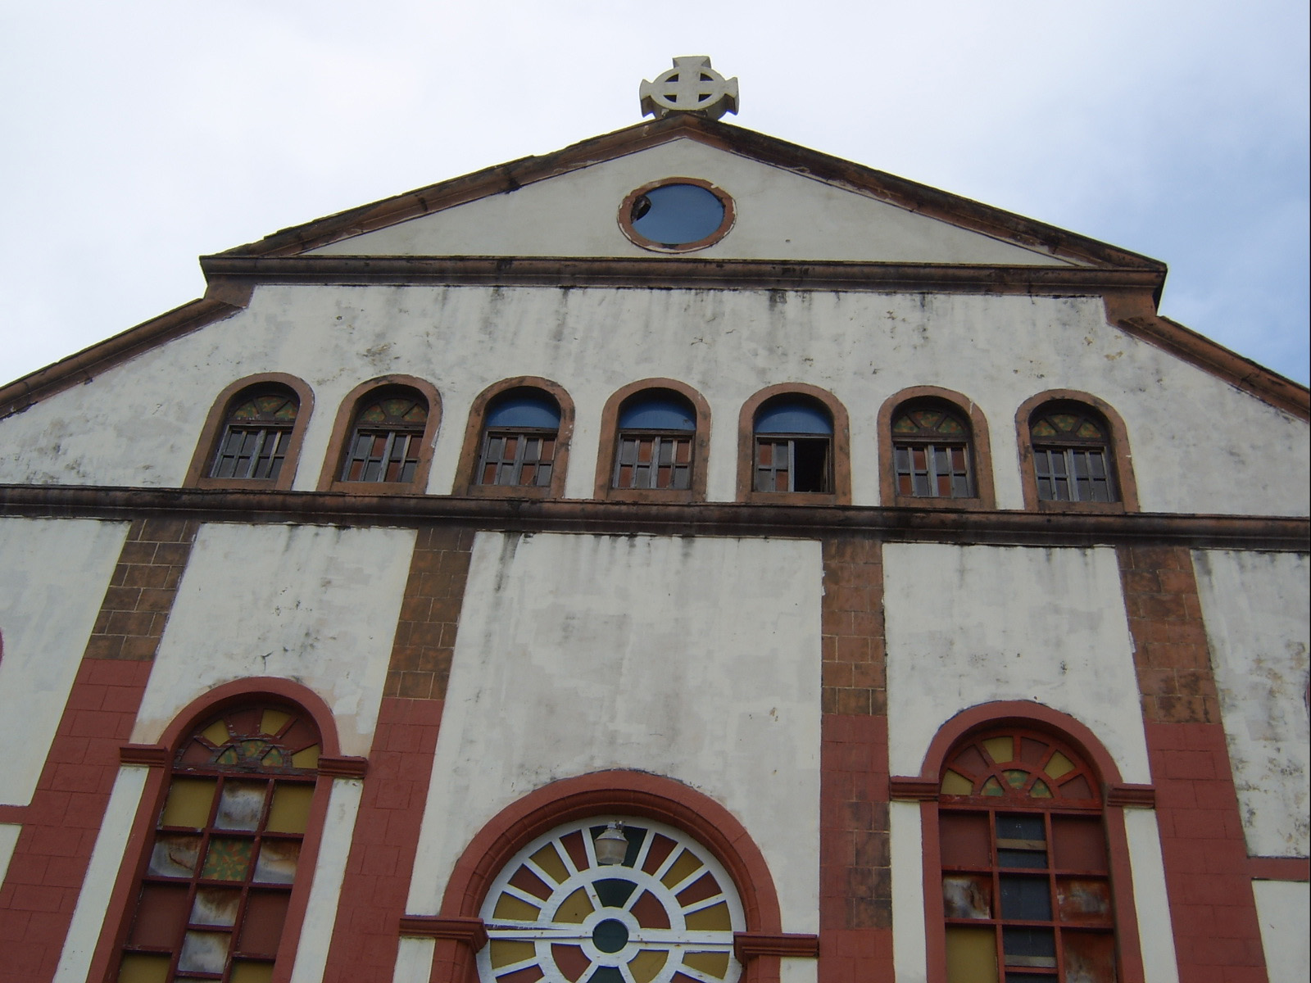

South Side of Church: Bell Tower Construction

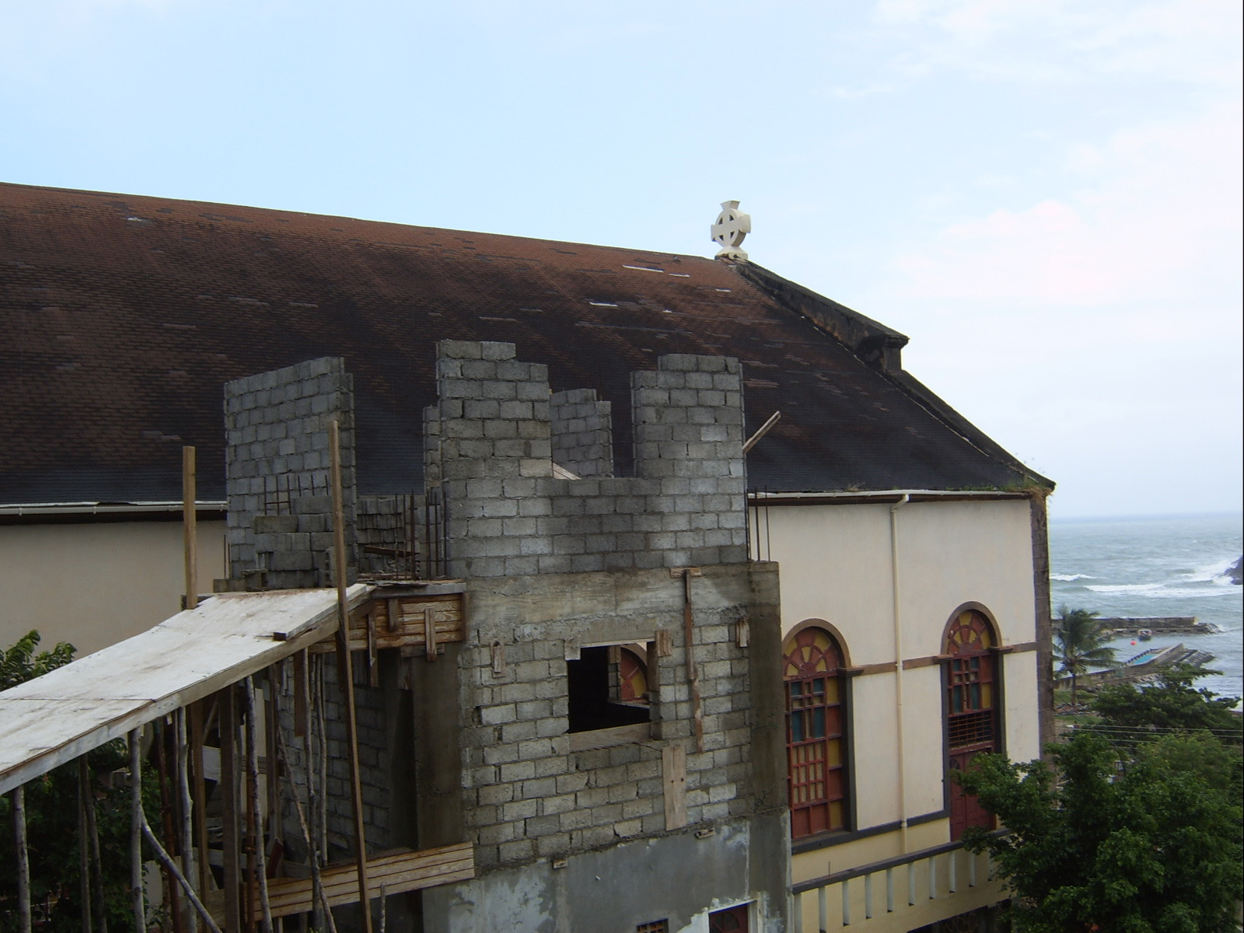

Group Photo (Left to Right)
Marc Alexander, Cornelius Fevrier, Ben Garber, James Carney, Mike Sclefani, Alexandra Bambery



Final Draft Sustainable Energy Plan, May 3rd, 2001 Ministry of Development, Housing, Environment, and Housing, St. Lucia
Ibid p. 4
Ibid. p 6
Ministry of Planning, Development, Environment, Housing (2003 May) Energy Policy and Strategy: A Green Paper for Discussion, p. 72
November 16, 2000, The Hague http://www.climate.org/programs/st_lucia_speech.shtml
Final Draft Sustainable Energy Plan, May 3rd, 2001, p 5
Ministry of Planning, Development, Environment, Housing (2003 May) Energy Policy and Strategy: A Green Paper for Discussion, p. 12
Ibid, p. 29
LUCELEC Commission Report and LUCELEC Annual Report 2002
Sales of electricity grew from 163,300 MWh to 215,661 - a 32% increase over the period 1995 to 1999. The number of customers grew from 36,713 to 45,000 - an increase of 22.5%. (LUELEC Annual Report)
Ministry of Planning, Development, Environment, Housing (2003 May) Energy Policy and Strategy: A Green Paper for Discussion, p. 56
Ministry of Planning, Development, Environment, Housing (2003 May) Energy Policy and Strategy: A Green Paper for Discussion, p. 13
January 12, 2005
Bank of Saint Lucia Limited (2003, April) St. Lucia Electricity Services Limited: Research Report, LUCELEC Retrieved January 21, 2005 from, www.ecseonline.com/PDF/LUCELEC%20RESEARCH%20REPORT.pdf
M.K. Hubert Official Website (2005) http://www.hubbertpeak.com/ Retrieved January 31, 2005
This analysis does not take into account one room, belonging to Father Theo, which was locked during the assessment. Question marks indicate absent label. (Meter # 92166377)
Meter # 92166377

