Why not petroleum oil?
Fossil Fuels
Petroleum is a fossil fuel, a resource that has a finite supply within our earth. Beginning 150 years ago, when technology needed a fuel with greater efficiency and power, a system was developed to extract and refine oil to make fuel. Since then, we have been depleting the supply of fossil fuels at an increasing rate.

By 1930, 17 billion barrels of oil had been extracted worldwide. By 1970, over 17 billion barrels of oil were being extracted each year. According to the U.S Department of Energy, if the worldwide rate of consumption of oil remained constant at the current amount of 24 billion barrels of oil per year, we would run out of oil in 2040. As the amount of oil within the earth continues depleting the price will continue to rise.
Fossil fuels shrink the economy of a country; money spent on importing foreign petroleum oil could be put towards local economy, resulting in greater sustainability.

Effects on the earth
The extraction, refining, and use of fossil fuels cause permanent damage to the earth. In the combustion process of an automotive engine carbon and oxygen are combined to form carbon dioxide. Carbon dioxide is a greenhouse gas, therefore one of the causes to global warming. Greenhouse gases act like a glass bubble around the earth, letting sunlight into the earth’s atmosphere but not letting it out. For every gallon (3.8 liters) of gasoline that a car burns, 22 pounds (10 kilograms) of carbon dioxide are released into the atmosphere. With the increased number of cars, the levels of carbon dioxide in the atmosphere are higher today than they have been in 160,000 years and are still increasing each year. With the evidence that fossil fuels are causing global warming, and the fact that there is a limited amount within our earth, we must look to alternate fuel sources for the future of our planet.

Renewable Fuels
Renewable fuels are replenishable, they form from plants transforming solar energy into chemical energy and store the energy in hydrocarbons. The product of this process is storage of energy in plants which can be used as a biofuel. For example, biodiesel can be made from vegetable oil and ethanol. When vegetable oil is made into a fuel, replacing fossil fuels, it is a cleaner, more efficient, renewable fuel. The energy produced is coming straight from the sun, and can be regrown. This is also considered a closed loop carbon cycle. As many of us know our earth is heating up from excess carbon dioxide in the air, but when we are burning a plant product, that same plant will take the same amount of carbon back out of the atmosphere.

Why focus on Dominica?
Diesel Fuel Statistics


One Hundred percent of the diesel oil used in Dominica is imported from other countries, allowing millions of dollars to leave the country each year. Whether dealing with a single person, a city, or an entire country, biodiesel is the largest step one can take toward using a sustainable energy source. Biodiesel can be produced and consumed locally for either transportation or electrical needs.

The diesel oil imported to Dominica each year is shown below in both the ec$ value, and the percentage (relative to total imports).
 | 1995 |  | 1996 |  | 1997 |  | 1998 |  | 1999
 | Value | % T.I. | Value | % T.I. | Value | % T.I. | Value | % T.I. | Value | %T.I.
Diesel Oil | 5,211,000 | 1.74 | 10,017,000 | 2.8 | 8,655,000 | 2.4 | 6,396,000 | 1.8 | 9,048,000 | 2.4
Table 1. Diesel Oil Import Values
Figure 1. Diesel Oil Import Fluctuations
The chart above shows that Dominica sends anywhere from 5.2-10 million ec$ out of the country every year for diesel fuel. By importing millions of dollars worth of fuel, this showcase’s how there is already a demand for a fuel such as biodiesel.

There are two primary uses for Biodiesel:
- Electrical Generation
- Transportation

Electrical Generation
In the year 2000, approximately 60% of the electricity for the Commonwealth of Dominica was produced by burning diesel fuel in a generator. The other 40% of electricity came from hydroelectric generators. The figure and chart below compare the two sources of electrical generation over the years 1995-2000.
Figure 2. Diesel vs. Hydroelectric Generation

Electrical Generation (kWh)
Year | 1995 | 1996 | 1997 | 1998 | 1999 | 2000
Diesel | 26,847,000 | 23,867,000 | 31,942,000 | 36,630,000 | 42,226,000 | 45,336,000
Hydro | 29,362,000 | 36,226,000 | 33,841,000 | 33,670,000 | 32,670,000 | 31,590,000
Table 2. Electrical Generation in Kilowatt-Hours

Shown in the figure above is that electricity from diesel generators surpassed hydroelectric generation in the year 1997. The amount of electricity produced from diesel has increased 12% on average each year from 1995 – 2000. The amount of hydro-electric has decreased about an average of 1% per year over 1995-2000.
Shown below is the increase in the use of diesel fuel in gallons over the years 1995-2000. This graph is consistent with the electrical production shown above.
Figure 3. Electrical Diesel Consumption per Year

Table 3. Diesel Fuel Consumption
Diesel Fuel Used in Generation
Year | 1995 | 1996 | 1997 | 1998 | 1999 | 2000
Gallons | 1,584,463 | 1,502,680 | 1,850,422 | 2,131,978 | 2,462,890 | 2,683,510

Table 2 shows that the use of diesel (for electrical purposes) has increased 70% over the years 1995 to 2000.
Biodiesel can be used directly as a replacement for traditional diesel fuel in any generator.

Transportation
There is a great demand for diesel as a transportation fuel. This can be offset through the use of biodiesel, which is fully capable for use as an automotive fuel with little to moderate modifications to the automobile. It is possible to run an automobile on an alternative fuel by either of these two methods:
- Biodiesel is the name of the fuel which is chemically altered form of a vegetable oil or similar oil. Biodiesel is suitable to use in a car with no modifications. The biodiesel can be poured straight into the fuel tank. The fuel itself is what is altered in this case.
- Vegetable or similar oil can be used in a car but requires engine and fuel tank modifications. In this scenario, the car is modified to accommodate the characteristics of straight veggie-oil. New or used oil can be used; all that is required is to heat the oil before it is combusted and to install finer fuel filters. To heat the oil, the car needs an additional fuel tank, which will be heated by modifying the existing coolant lines. This process is best explained in the book From the Fryer to the Fuel Tank by Josh Tickell, available at www.veggievan.com as referenced at the end of the paper.

Since Dominica is highly dependant upon diesel oil for both the production of electricity and automotive use, one will hope that oil is a stable and secure source of energy. Unfortunately, oil is neither. Understanding Dominica’s energy future requires an in depth analysis taking into account more than the tables and figures above provide.
The semi-constant slopes of Figure 2 give the impression that diesel fuel will remain a stable source for electrical production in the coming years. Fossil fuel production has reached a production peak, and thereby the price of diesel fuel will not remain constant. Eventually the price of diesel will greatly increase, making it uneconomical to import and use. Hence, diesel fuel has a highly unstable future. The price of diesel fuel is a highly unstable commodity which is only going to become more expensive over time. Thus the alternative of biodiesel must be looked upon now. Biodiesel is a reliable, economical, and fun alternative to minimizing the use of diesel fuel.

What is biodiesel?
Biodiesel is an alternative fuel source derived primarily from oils found in the nuts and seeds of plants, corn, and soybeans (vegetable oil.) It is made from 80-90% vegetable oil, 10-20% alcohol (methanol or ethanol), and .35-1.5% catalyst (sodium hydroxide or potassium hydroxide.) It is a stable fuel, performs well on all diesel engines while producing cleaner emissions, and can be mixed with petroleum diesel fuel. Biodiesel has approximately 12% less energy than diesel fuel, but only results in a 5% decrease in torque, power, and fuel efficiency. This difference from pure diesel fuel is usually not noticed, plus the benefits can be viewed as heavily outweighing the 5% decrease in power. Biodiesel can be used for other purposes other than fuel for vehicles. For example, diesel heaters, lanterns, and stoves, and many times it can be substituted for kerosene. It is also successful in various home heaters. 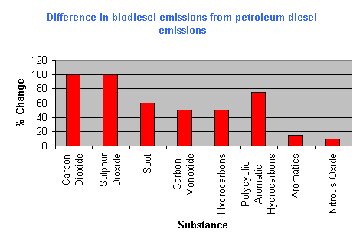
Environmentally friendly
Biodiesel is biodegradable and non-toxic. Its exhaust contains no lead, sulfur dioxide, halogens, and has reduced particulates, unburned hydrocarbons, carbon monoxide, and carbon dioxide. Biodiesel can also use used vegetable oil which cuts down on waste. Instead of restaurants throwing this away it can be collected and used as the base for an alternative fuel. This decrease in pollution is less harsh on the earth’s ecosystems and human health.

Chemistry
Biodiesel = 80-90% vegetable oil + 10-20% alcohol + .35-1.5% catalyst
The procedure of making biodiesel from vegetable oil is called transesterification. Although this sounds complicated, it really is not that hard to make happen. This is the transformation of one type of an ester into another type of ester. An ester is a hydrocarbon chain that bonds with other molecules.

The oils from the nuts and seeds of plants contain triglycerides which are composed of three esters (fatty acid chains) covalently bound to a glycerol. The esters found in triglycerides vary in chain length and degree of unsaturation. Because there are numerous compositions of these fatty acids it is important to find which oil, or mixture of oils, will result in the best biodiesel. Simply, this can be seen by observing a series of mixtures and finding the one that separates into two layers the best. The separation will be biodiesel on the top and fatty acids and glycerin settled to the bottom.

The glycerin produced is 20% of the vegetable oil and is what makes the oil thick and sticky; in the biodiesel making process it will be replaced by an alcohol. After settling to the bottom during the production, the biodiesel results as a thin liquid floating on top of the settled glycerin that could then be made into soap.

The vegetable oil can be new or used, if used it can be collected from any local restaurants. With used vegetable oil it is more efficient to first filter the food particles out using a piece of fabric such as cheesecloth or ideally a 5 micron fuel filter.
The alcohol can be either methanol or ethanol; methanol is made from coal, natural gas, or wood, while ethanol is made from grains. Methanol is a harsher alcohol that has the ability to dissolve rubber, because of this it is best to use ethanol unless you are planning on changing the rubber gaskets on the diesel engine. The biodiesel reaction of the alcohol is the breaking of each triglyceride molecule into three esters and one glycerin molecule. Each of the three esters attaches to an alcohol.

The catalyst is a substance that initiates a reaction between other substances. In the making of biodiesel, the catalyst can be sodium hydroxide (NaOH) or potassium hydroxide (KOH.) Sodium hydroxide is a white substance called lye or caustic soda, both can be used in powdered, granular, or palletized form and both are damaging to the skin and eyes. Sodium Hydroxide is used as a common drain cleaner powder. This catalyst is what breaks the triglycerides in the oil into four pieces, one glycerol and three esters.

In general the chemical reaction that is taking place is:
Veggie Oil + Methyl Alcohol + Sodium Hydroxide = Biodiesel + Glycerol + Waste

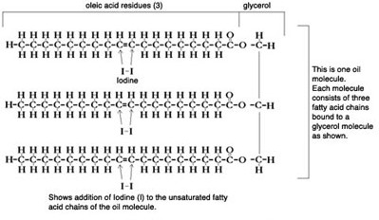

Our demonstration: Trial and Error Mini Batches
We will be using used vegetable oil collected from a local restaurant and The Springfield Plantation Guest House. As well as a drain cleaner purchased from a local pharmacy. The methyl or ethyl alcohol has been ordered from the Medical Supply Shop that supplies the hospital with it in Rosa.

In order to determine how much catalyst is necessary to be used a chemical process must be carried out. It is possible to do a titration, but that needs special equipment and different chemicals. So in order to figure out the amount of Sodium Hydroxide needed without that special equipment we will be doing a mini batch experiment. Each mini batch will have a different amount of catalyst (lye) per liter of vegetable oil. The batch that has the best separation of biodiesel and glycerin-fatty acid mix will be the percentage of catalyst we use in the large biodiesel reaction. These mini batches will use the same vegetable oil, alcohol, and catalyst that will be used in the large reaction. The mini batches will be scaled up to a five gallon batch of biodiesel using the same percentage of catalyst (lye) of the best resulting mini batch.

Safety Precautions:
Gloves and safety glasses should be worn at all times when working with methanol or ethanol and sodium hydroxide or potassium hydroxide.

Procedure:
- Dissolve .35 grams of lye into 30 ml of ethanol.
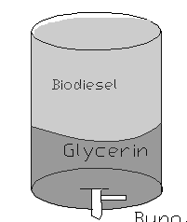
- Add 100 ml of vegetable oil to the mixture.
- Mix vigorously for 15 minutes.
- Allow to settle for 30 minutes.

The result will be 80-90% biodiesel (esters) in the top layer and a 10-20% bottom layer of darker, thick mixture of glycerin, catalyst, and alcohol. Since used vegetable oil was used, the bottom layer will also consist of food particles. This bottom layer has the option of being transformed into glycerin soap

Glycerin Soap
After removing the biodiesel the resulting bottom layer is non-toxic and biodegradable and contains food particles, unreacted alcohol, catalyst, and glycerin. The glycerin mix can be heated to remove a majority of the unreacted alcohol and catalyst; it becomes a liquid and can then be filtered to remove the food particles. When cooled fragrances can be added and the glycerin hardens into soap. This soap is great to be used on greasy hands or washing equipment, although may have a few impurities.

Oil Producing Plants


As we have mentioned before, diesel engines invented in 1900 by Dr. Rudolf Diesel were originally intended to be run on thick vegetable based oils. The petroleum industry has made us believe that the fuel that we buy from their companies is the only thing that these diesel engines will run on. Something that they do not tell people is that the same diesel engine that your car, truck, or generator has can be run on vegetable oil. This means that it is possible to grow your own fuel. Instead of importing and paying a lot money for the fuels you can cultivate your own. There are also environmental reasons to produce your own fuels locally, including not having to use so much fuel to transport the fuel to other far away places.

There are many plants which produce oils, all of these vegetable oils can be used as fuel, or turned into biodiesel. Below, in Table 1, are listed the top ten oil producing plants that are now used for production of oil around the world. Also included is the amount of oil per amount of land that can be produced. The figures are averaged internationally, which means that some of the plants will produce more in better growing climates, like tropical areas. The palm oil trees have the highest production of oils of all of these plants and has two different forms, palm oil, or palm kernel oil.

In tropical areas the production of these plants is very feasible and can greatly increase the local economy. When a community can begin to grow high priced commodities such as their fuel, it will make them much more competitive with other countries. The richest countries in the world are the ones who control their own fuel production. As fossil fuels become scarcer, it will become harder for smaller countries to compete in the fuel economy. It is best to begin working toward not importing fuel at all, before it becomes difficult to do so.

Production Averages for Ten Common Oil Crops
Plant | Latin Name | Pounds of Oil per Acre | Kilograms of Oil per Hectare
Oil Palm | Elaeis guineensis | 4585 | 5000
Coconut | Cocos nucifera | 2070 | 2260
Jatropha | Jatropha curcas | 1460 | 1590
Rapeseed | Brassica napus | 915 | 1000
Peanut | Arachis hypogaea | 815 | 8900
Sunflower | Helianthus annuus | 720 | 800
Safflower | Carthamus tinctorius | 605 | 655
Soybean | Glycine max | 345 | 375
Hemp | Cannabis Sativa | 280 | 305
Corn | Zea mays | 135 | 145
Taken from: From the Fryer to the Fuel Tank, 2003.

Oil from Algae
At this point algae is known to be the largest producer of oil per unit weight of any living thing. Algae produces 30-50% oil by mass, which makes it the largest producer known. Compared to canola oil, assuming a 1000 m^2 pond versus a 1000 m^2 field, algae will produce 2007 gallons of oil in a year, while canola only produces 50 gallons. The production of oil from algae is so high that according the United States Department of Energy, algae could produce enough oil to fulfill the US demand for diesel. These ponds would not take up as much space or valuable farmland as other oil producing crops would. Algae has a very high growth rate, multiplying very fast. Another amazing thing about algae is that it helps to clean the water that it is growing in and could be used as a purification method at the same time as producing fuel. At this point, it is not as easy to remove the oil from the algae as it is to get the oil out of other oil crops, so doing this yourself is not yet feasible.

Pressing the Oil
In order to use the oil from these seed crops mentioned above it is necessary to extract the oil. This extraction is usually done through some kind of press. These presses could range from a small hand build pump to a large industrial factory, and every level in between. When beginning to produce oil for yourself, a small hand pump type of oil press will work just fine. When larger amounts of oil need to be pressed, a larger diesel powered model could be used.

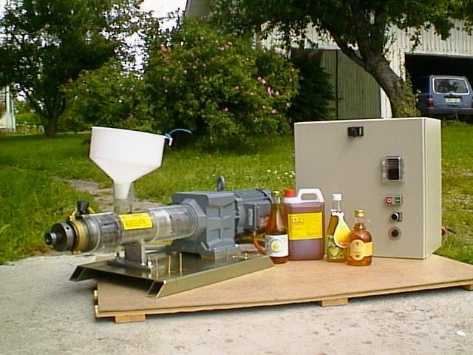
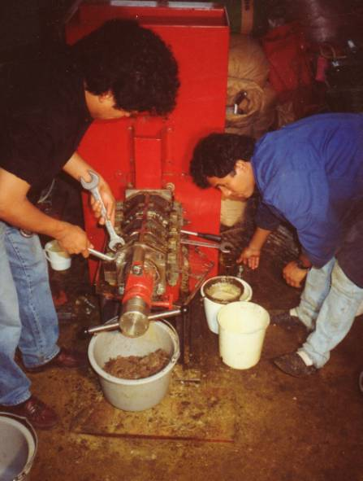
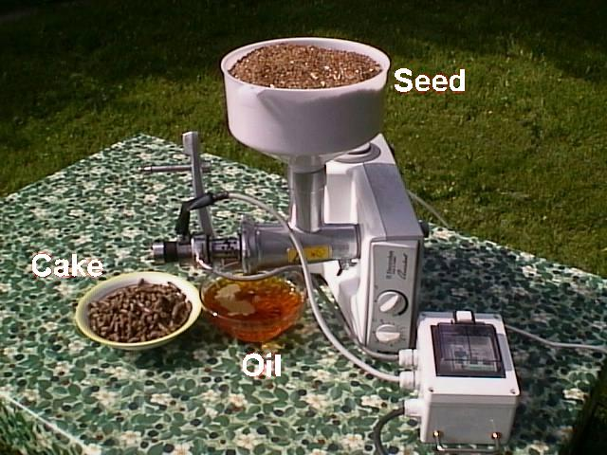

Resources:

Commonwealth of Dominica Central Statistical Office. Annual Report on External Trade (Summary Tables), 1999.

Commonwealth of Dominica Central Statistical Office. Environmental Statistics, 2002.

www.greasecar.com

http://journeytoforever.org

Tickell, Joshua. From the Fryer to the Fuel Tank: The Complete Guide to Using Vegetable Oil as an Alternative Fuel. Joshua Tickell Media Productions, New Orleans LA, 2003.

www.veggievan.com

Special thanks to Scott Gordon, PhD, Department of Chemistry, University of Vermont.

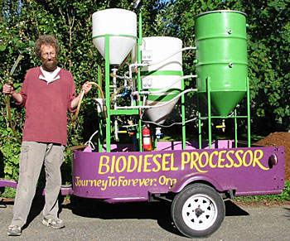

Biodiesel Workshop
Springfield, Dominica
March 19, 2004
Compiled and Presented by:
Jillian Abraham
Jessica Clark
Timothy Krebs
of the
University of Vermont


