What is a Gem?
Introductory ideas:  - Gems have been part of human history for over 20,000 years.  - very early gems were generally of organic materials.  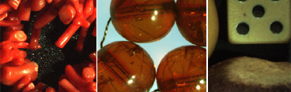  Examples include (left-right) coral, amber, and vegetable ivory (tagua nuts).  - most gems used today are inorganic minerals.  - early crystal gems were probably derived from alluvial sources.  - as found, gems are rather ordinary-looking, unlike cut gemstones:  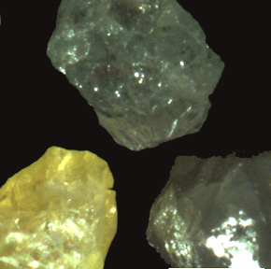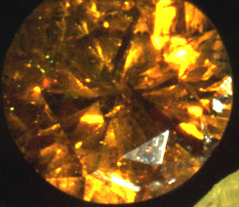  - there are many different kinds of gems, and most come in many colors  - gems can be synthesized  - gems can be enhanced (and most commonly are)  - simulants are different from synthetics  - names: trade or commercial names obscure the true identity of a gemstone or simulant material  In this course we will consider what gems are, the factors that affect their value, where gems form, how gems are identified, why gems are colored, and other important gemology concepts such as simulants, synthetics, gemstone enhancement, and related issues. | 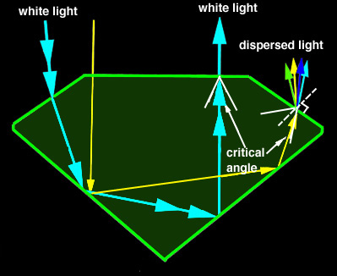
A gem is a naturally occuring material desirable for its beauty, valuable in its rarity, and sufficiently durable to give lasting pleasure.
- It should be naturally occuring, but it need not be crystalline.
- Beauty is determined by brilliance, iridescence, color, sparkle, and play of color.
- A gem should be durable against heat and common household chemicals. It should not be easily scratched or broken. Brittleness is a measure of the gem's tendency to crack or cleave.
- How rare is rare?:
  - Typically, a diamond deposit yields about 5g gem/1000kg of mined material. That's 5g per million grams!

Beauty:
Beauty of a gemstone is determined by brilliance, luster, fire and color (later lecture). The first three quantities depend on the cut of the stone. Before we can understand why cut gems sparkle, we need to learn some basic terms to describe cut stones.
Cut stone vocabulary:  - Polished planar surfaces are referred to as facets.  - The midline of a facetted gem is called the girdle and may or may not be facetted.  - The area above the girdle is called the crown; the factes on the crown are the table, the star facets, the kite (or bezel) facets and the upper girdle facets.  - The area below the girdle is called the pavillion; these facets are known as the lower girdle facets, the pavilion facets and the culet.  - The type of cut where gems have a flat bottom surface and a rounded upper surface is called cabochon. | 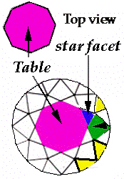  Click for larger image.
Why are gems cut the way they are?  - Reflection and refraction  In order to understand why gems are faceted, it is essential to understand how light behaves once it passes into a gemstone.  Light can either be reflected off a surface or pass through the surface into the new substance.  When light passes from one material into another, it is bent or refracted. But by how much?  The amount light is bent is determined by the density difference between the gem and air. A measure of the amount light is bent is termed the "refractive index" or 'RI'.  - The Critical Angle  The critical angle is the angle at which total internal reflection is achieved. But what do we mean by "internal reflection"?  Light travelling through a stone intersects the stone-air surface. If it passes within the critical angle (measured relative to the normal to that surface), it will exit the stone. If it passes outside the critical angle, it will be internally reflected.  We use these facts to determine how facets should be placed in order to control the path of light in a gemstone!  Naturally, in order to achieve brilliance and sparkle, we do NOT want light to escape from the pavillion. We DO want light to escape from the top facets!  Thus, to recap, the placement of facets on a gem is determined using critical angle information, which comes from the refractive index information.  Many gem cuts that meet the basic critical angle requirements can be created.  Two important examples are the "Brilliant Cut" and "Emerald Cut".  For this course, we are not concerned about how facets are created in practice. However, take a look here if you are curious! | 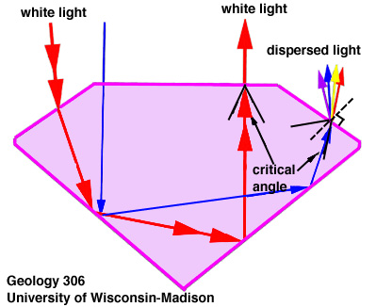  Internal reflection, critical angle.  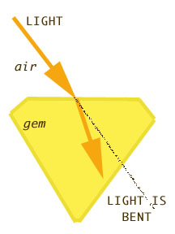  Refraction

Luster
Not only does the placement of the facets matter, but the smoothness of the surface (called "luster") does too. Luster is a function of both the surface and the RI of the mineral itself. Terms used to describe luster include adamantine, pearly, metallic, silky, vitreous, resinous, and waxy. Gem grading reports refer to "finish" or "polish" to describe how well polished the surface is. "Luster" is also used to describe how mirror=like the surface of a pearl is.
- When the surface of the gem is polished, the light is internally reflected, as expected.
- If the surface of the gem is left rough, light is lost through unplanned leakage.
Fire  "Fire" refers to the rainbow-like flashes of color seen in cut stones.  Fire is especially obvious in diamonds.  Another example: the rainbows should be obvious!  Where do these come from?  It is important to realize that the extent to which light is refracted (bent on passing into or out of the gem) is dependent upon the wavelength (color) of the light. Note that blue light is bent more than red light  The phenomenon of different amount of bending of different colored light is referred to as dispersion.  Dispersion is measured:  dispersion = refractive index of violet - refractive index of red light.  Dispersion varies greatly with the mineral type. Lists of dispersion values are available  The fire of a gem is a consequence of the cut of the stone, coupled with its dispersion.  Many of the light behaviors we have thought about here (reflection, refraction, dispersion) are commonly observed in everyday life! Excellent examples can be found in the atmosphere. | Fire  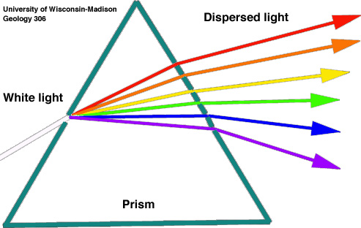  Fire in diamonds  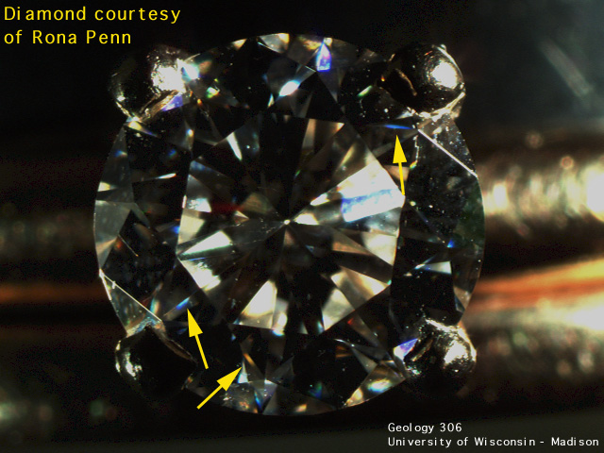

Durability
Some minerals (such as those formed by evaporation of sea water) dissolve easily and clearly these would be poor gem materials.
Resistance to scratching: this is evaluated by consideration of gem hardness. There are two measures of hardness: scratch hardness and indentation hardness. Generally, we use the scratch hardness.
If we compare two different minerals, for example diamond and quartz (the main ingredient in beach sand) we will find that quartz crystals are readily scratched by diamond but diamonds can not be scratched by quartz. Thus, diamond is much much harder than quartz.
Commonly available materials can be arranged into a sequence of increasing hardness, e.g., talc-fingernail-copper coin-pocket knife-glass-steel file.
This can also be done with minerals. Moh arranged 10 minerals into a sequence that is known as Moh's hardness scale. This scale has talc (found in talcum powder) at the soft end and diamond at the hard end. The hardness of talc is 1, quartz is 7, diamond is 10.
Unfortunately, most minerals with hardness greater than 7 on Moh's hardness scale are brittle. Hardness is not toughness -- even a diamond can be broken.
Minerals can break by irregular fracture (like bottle glass) or by cleaving.
Value  The 4 factors that affect the value of a gemstone are easily remembered as the "4 c's":  - Color: we will deal with the origin of color in gemstones in a separate lecture. Clearly, color affects value. Some colors are more desirable than others. In part, this is dictated by personal taste and in part by industry standards (e.g., for diamonds).  - Clarity: flaws (crack, inclusions) decrease the value of a gemstone.  - Cut: the ideal proportions for gems (to optimize brilliance and fire) are not always to be found in a faceted stone. Poorly cut stones have much lower value. Small errors in the placement of facets decrease the value of a gem. For example,  - extra facets,  - an off-center culet  - or a gem with improperly pointed facets.  - Carat weight: bigger is not always better, but for otherwise equal color, clarity, cut, the larger the stone will be more expensive!  1 carat = 0.2 g, thus 5 carat = 1 g <--- remember this!  Notice that the number of carats depends on density, so two different types of gems of the same size will normally be a different number of carats!  Obviously, the rarity of a gemstone is an important factor in determining the value. However, some other things that affect value that are unrelated to the 4c's and rarity. The supply of a specific type of gem can be controlled to improve the value or a specific gem may greatly change in value due to consumer demand or perceived investment potential. It is interesting to look at the values of specific gemstones and see how these change over time.  The value of a gem may be much lower if its apparent clarity or color has been improved by treatment. Furthermore, synthetic gems (made by humans) have very much lower values than natural stones ... and beware! - the gemstone is not always the material it is claimed to be: it may be a simulant (look-alike). How do you know?  Many people turn to a professional organization such at The Gemological Institute of America (GIA) and American Gemological Laboratories (AGL) for the "final" determination, especially for more expensive stones. These organizations provide certificates that document the characteristics of individual gems. | 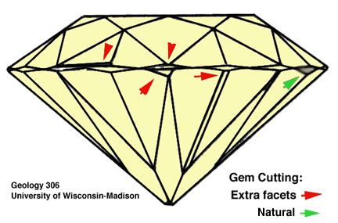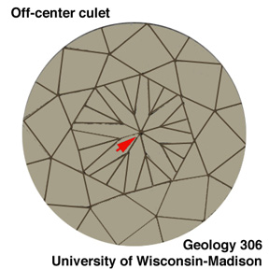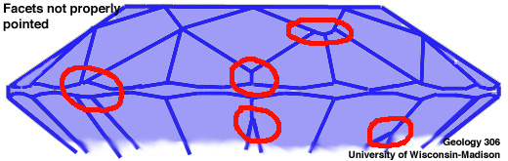

Where do gems form?

&

Where are they found?
Gems form in many different environments in the Earth. We will examine the most common and important environments and formation processes in this lecture.  It is important to distinguish where gems are formed from where they are found.  Almost all gems are formed below the Earth's surface.  • Some are brought to the surface through mining  • Some are brought to the surface through earth processes (faulting, folding, large scale uplift, volcanism). These processes can move rock up from more than 400 km below the surface. | Formation environments:  • Water near Earth's surface  • Hydrothermal deposits  • Pegmatites  • Magmatic gems  • Metamorphic gems  • Gems of the mantle

Formation Environments:
In the following sections we will examine how gems form. We will start with examples at or near the Earth's surface and move down into the mantle.
1. Formation from water near the Earth's surface  Water near the Earth's surface interacts with minerals and dissolves them. The ability of these solutions to maintain elements in solution varies with physical conditions. If the solution conditions change (for example if the solution cools or evaporates), minerals will precipitate. A similar, familiar processes is formation of salt crystals by evaporation of sea water.  The mineral that forms is determined by what the dissolved elements are. If the water has interacted with silica-rich rocks (e.g., sandstone), silica-rich minerals will form:  - Silica (SiO2)-based minerals: amethyst (quartz); agate ; and the formation of opal. Of these, only opal is non-crystalline (ordered blobs of gel less than a micron in diameter).  If the water has interacted with copper-rich rocks, copper minerals will form:  - Cu-bearing minerals: malachite and azurite; or turquoise. | 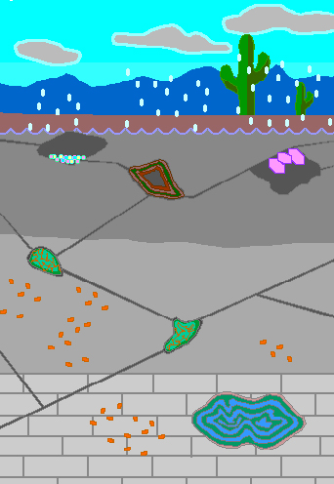  This shows formation of agate, amethyst, opal, turquoise, and malachite/azurite. Note the importance of alternating wet periods (when solutions are dilute and can dissolve a large amount of silica, copper, etc.) and dry periods (when solutions evaporate and minerals precipitate).
2. Hydrothermal deposits  The formation of gems by hydrothermal processes is not dissimilar to formation of gems from water near the Earth's surface  The solutions involve rain water and/or water derived from cooling magma bodies< Gems crystallize from solution when it encounters open spaces such as cracks. As a result, 'veins' of minerals fill preexisting cracks.  Minerals such as beryl (e.g., emerald), tourmaline need unusual elements, and some of these, like beryllium (for beryl) or boron (for tourmaline) are derived from cooling molten rock (magma). | 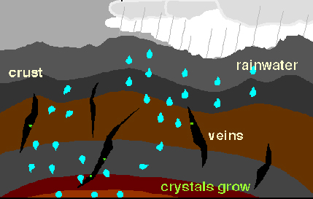
3. Pegmatites  Pegmatites are unusual magma bodies.  As the main magma body cools, water originally present in low concentrations becomes concentrated in the molten rock because it does not get incorporated into most minerals that crystallize. Consequently, the last, uncrystallized fraction is water rich. It is also rich in other weird elements that also do not like to go into ordinary minerals.  When this water-rich magma (also rich in silica and unusual elements) is expelled in the final stages of crystallization of the magma, it solidifies to form a pegmatite.  The high water content of the magma makes it possible for the crystals to grow quickly, so pegmatite crystals are often large. Of course, this is important for gem specimens!  When the pegmatite magma is rich in beryllium, crystals of beryl form.  If magmas are rich in boron, tourmaline will crystallize.  You should note that beryllium and boron are extremely rare elements in most rocks and it is only because the above process efficiently concentrates these unusual elements that crystallization of boron and beryllium-rich minerals can occur. | 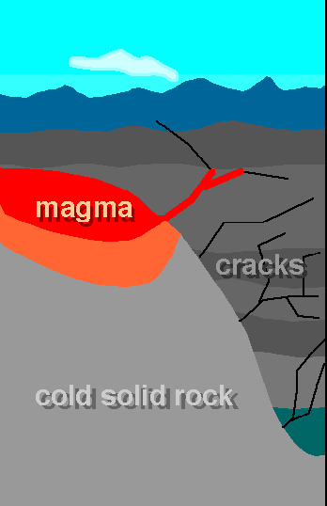  This movie shows formation of crystals such as emeralds and tourmaline in pegmatite bodies associated with cooling intrusive (magmatic) rocks
4. Magmatic gems  Some gems crystallize in magmas or in gas bubbles (holes) in volcanic rocks. Examples include: zircon, topaz, ruby, etc. | 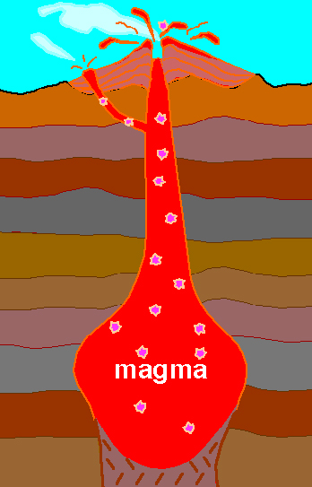  This movie shows formation of crystals such as ruby or zircon (pink crystals) and topaz in open cavities (e.g., holes made by gas bubbles) in volcanic rocks.
5. Metamorphic gems  Metamorphic rocks are rocks changed by heat, pressure, and interaction with solutions. There are a number of types of metamorphic environments:  - Plate tectonics creates metamorphic environments characterized by high temperature and high pressure - produce jadeite (jade). In extremely rare cases, pressures in metamorphic rocks may be high enough that diamonds form.  - Regionally metamorphosed rocks: large volumes of rock that are buried and changed in response to increases in pressure and temperature. Minerals found in these rocks might include gems such as garnet and cordierite. | 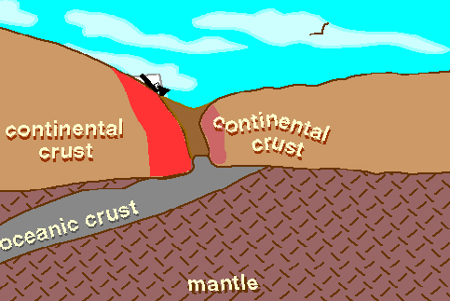  This movie shows metamorphism of rocks resulting from continent-continent collision associated with a subduction zone. Note the formation of large crustals such as garnet in the deformed, heated zone.  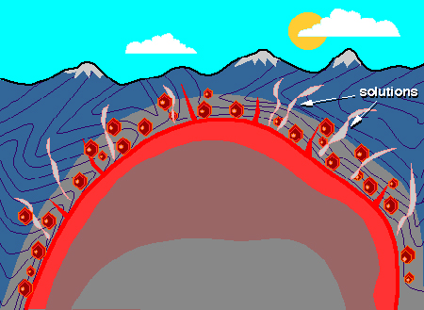  This movies illustrates the process of contact metamorphism. This is the process by which the minerals in rocks change in response to proximity to a hot intrusive body. For example, a limestone intruded by a magma undergoes significant change in crystal size, mineral content, and chemistry (due to addition of solutions released from the cooling magma). These rocks contain gems such as garnet.
6. Gems formed in the mantle  - The most abundant upper mantle mineral is olivine (peridot). Slabs of mantle material are brought to the surface through tectonic activity and volcanism.  - Deep mantle gems. Rocks such as kimberlites are erruptive volcanics that come from quite deep in the mantle and carry with them diamonds. Diamonds are made from carbon. The stable form of carbon at the Earth's surface is graphite. High pressures and temperatures are required to convert graphite to diamond. Thus, almost all diamonds formed about 100 miles below the Earth's surface. Dates suggest that their formation was restricted to in the first few billion years of Earth history.  Rarely, diamonds are formed in very high temperature and pressure metamorphic rocks. | 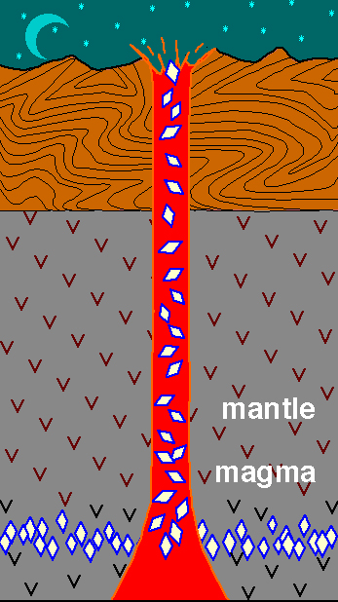  This figure shows that diamonds do not form in the kimberlite magma but are carried up to the surface by the magma.
Alluvial Gem Deposits:  After rock is brought to the surface, gems may be released from the rock by weathering (some minerals dissolve, others are transformed to clay minerals, and some others survive unchanged). The minerals that survive unchanged may be washed into streams, etc., where they are concentrated by river / ocean processes.  - Gems retrieved from alluvial deposits are often rounded due to rolling around in rivers and oceans.  - Gems are often those minerals that are resistant to chemical weathering. They are commonly concentrated in stream beds and beach sands in what are known as alluvial deposits.  - Gems often have quite a high specific gravity (density) compared to other minerals so that they are easily trapped in depressions in stream beds. This causes them to become concentrated and makes it easier to mine them. Other valuable and durable things are also concentrated by these processes. Gold is a well known example.  In summary, gems are not always found where they were formed, nor are they formed where they're found! | 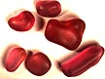

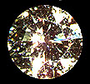Diamonds and Diamond Simulants

Remarkable facts:
- All diamonds are at least 990,000,000 years old.
Many are 3,200,000,000 years old (3.2 billion years)!!!
How do we know this?
Age: from Carbon dating? NO! C-dating only works for very young carbon. You need to use other radioactive decay schemes (e.g., uranium-lead) to date inclusions in diamonds. Inclusions used for dating are around 100 microns in diameter (0.1 mm).
- Diamonds are formed deep within the Earth: between 100 km and 200 km below the surface.
Diamonds form under remarkable conditions!
  - The temperatures are about 900 - 1300 C in the part of the Earth's mantle where diamonds form.
  - The pressure is between 45 - 60 kilobars. (kB)
    - 50 kB = 150 km = 90 miles below the surface
    - 60 kB = 200 km = 120 miles below the surface
- Diamonds are carried to the surface by volcanic eruptions.
The volcanic magma conduit is known as a kimberlite pipe or diamond pipe. We find diamonds as inclusions in the (rather ordinary looking) volcanic rock known as kimberlite.
NOTE: The kimberlite magmas that carry diamonds to the surface are often much younger than the diamonds they transport (the kimberlite magma simply acts as a conveyer belt!).
- Diamond is made of carbon (C), yet the stable form (polymorph) of carbon at the Earth's surface is graphite.
- To ensure they are not converted to graphite, diamonds must be transported extremely rapidly to the Earth's surface.
It is probable that kimberlite lavas carrying diamonds erupt at between 10 and 30 km/hour (Eggler, 1989). Within the last few kilometers, the eruption velocity probably increases to several hundred km/hr.
- Diamond is the hardest material.
Diamond is the hardest gem on the MOHS harness scale and graphite (also made from carbon atoms) is the softest! Given that both diamond and graphite are made of carbon, this may seem surprising.
The explanation is found in the fact that in diamond the carbon atoms are linked together into a three-dimensional network whereas in graphite, the carbon atoms are linked into sheets with very little to hold the sheets together (thus the sheets slide past each other easily, making a very soft material).
- Diamonds are found in many localities, both overseas and in the US.
How rare are diamonds?  How many grams do you need to mine to get 5 grams of diamonds?  (5g/1000 kg) @ 1000 g/kg = 5 g /1,000,000 g!  But only 20 % are gem quality (80 % of these are sold in a "managed selling environment") and the remainder are used for industrial purposes (this material is known as "bort" or "carbonado" (carbonado is finer)). | This emphasises that diamonds do not form in the kimberlite magma, but are carried up to the surface by the magma.
Basic Data  • Hardness = 10  • Crystal System = cubic  • This is what crystals look like before they are faceted: note their natural octahedral shape! Uncut diamonds are also found in cubic forms.  • Diamond has four good cleavages, thus diamonds tend to cleave on impact.  • Refractive Index = 2.42  • Dispersion=0.044  • Specific Gravity = 3.52 | 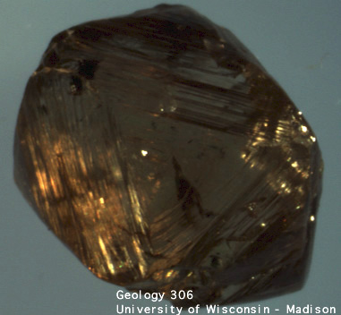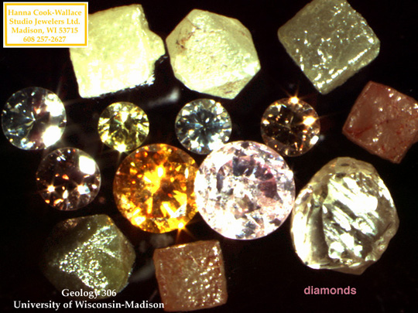
Value  The 4 "C" words are used to summarize the value determining factors:  The required basic information describing what is meant by these terms is provided below.  - Color is determined by 'grading' visual comparison with 'knowns' or by instrumental means.  - Consider the amount of yellow color (yellowish color decreases the value of a "colorless" stone). In order of increasing yellow content:  blueish-white -> white -> silver -> yellow  - 'Fancy', or strongly colored stones have their own appeal and special value.  - Colored diamonds may be yellow, green or brown, green or shades of pink.  - Larger pink diamonds are quite rare and currently very expensive.  - Natural blue diamonds contain the element boron (B), and this changes the conductivity of the diamonds. Natural yellow diamonds contain the element nitrogen (N). | 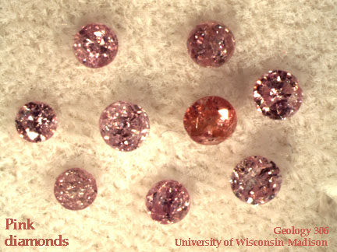
- Clarity is decreased by the presence of blemishes or flaws, scratches, nicks, 'naturals' (the original surface of an uncut stone).  - There are many systems of nomenclature.  - Some terms include:  - perfect  - flawless  - imperfect  - very slightly included  - very very slightly included  - other descriptions:  - "Perfect," "internally flawless," and "flawless" are not synonymous. "Flawless" is reserved for diamonds having no visible inclusions under 10x magnificantion and having no external blemishes of any kind.  - Clarity grades refer to what is visible at 10x magnification. With sufficient magnification, inclusions will be revealed in any diamond. "Perfection" is relative.  - "pique" (used below and in older literature) is an old trade term and has been supplanted by the GIA-developed international standard, from IF to I3.  - "first pique" inclusions readily recognizable at 10x mag., not significantly diminishing brilliance  - "second pique" larger inclusions, can be seen with naked eye  - "third pique" many large inclusions, diminishing brilliance  - Examples of clarity-reducing inclusions:  - inclusions  - cracks  - a crack along the pavillion | 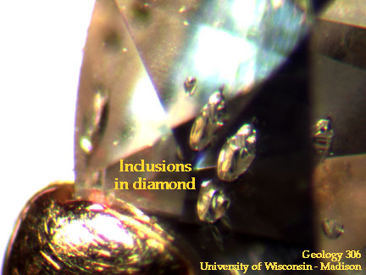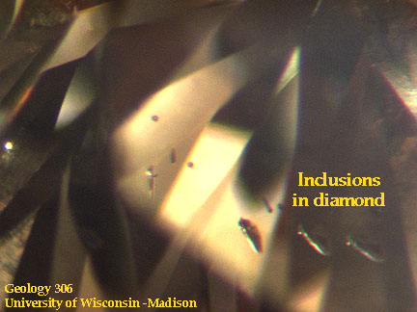
  IF | VVS1 | VVS2 | VS1 | VS2 | SI1 | SI2 | I1 | I2 | I3
  internally flawless | very, very slightly included |  | very slightly included |  | slightly included |  |  |  | imperfect
- Cut: Facets are placed so as to maximize the brilliance and fire of a stone.  - Remember that in the first lecture we talked about how the proportions of a faceted gemstone are determined based on the refractive index?  - Review the basic concepts:  - Refraction is dependent upon the wavelength.  - Refractive Index (RI) is proportional to wavelength; red RI < violet RI (dispersion is due to the different amounts different wavelength are bent).  - Fire,which is seen as rainbows and glints of color, is due to dispersion (a consequence of the placement of faces on the crown to take advantage of the prism effect).  - The brilliant cut (modern round brilliant cut or Tolkowsky cut) is a typical cut chosen for diamonds. Tolkowsky determined the optimal proportions are such that the table width is 53% of the diameter of the cut stone. Appraisers will penalize diamonds with tables above 64%. Significant deviations, up to table widths of more than 70% are not uncommon.  - There are many alternative diamond cuts.  - A poorly cut stone is characterized by poorly chosen proportions (poor optimization of brilliance and fire or, worse still, leakage of light from the pavillion). Misplaced facets, extra facets, and problems at facet junctions are also characteristics that reduce the quality of "cut".  - Ranking: VERY GOOD ... GOOD .... MEDIUM ... POOR | Review the light path in a correctly cut gem!  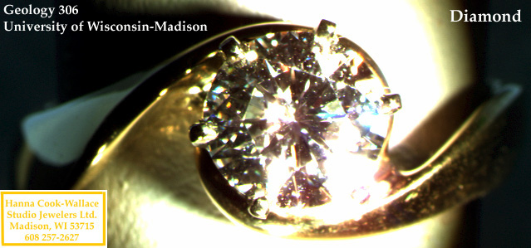
- Carat Weight
  - Recall: 1 carat = 0.2 g, thus 5 carats=1g
  - For example, compare the size of a one point diamond to that of a 0.67 carat diamond.
Just FYI: This site explains the GIA grading report used for diamonds, including information on desirable characteristics.
Other issues: Treatment, simulants, synthetics  Treatments:  - filling of cracks  Surface cracks and cleavages reaching the surface are often filled with a glass-like material.  Identification: when examined with an optical microscope, filled stones will show:  - greasy appearance  - flash effects  - bubbles  Problem: Filling does not always resist polishing and cleaning  - drilling of inclusions Drilling inclusions involves using a laser to drill into the inclusion. Solutions can be poured into the resulting "hair-width" diameter hole to bleach colored inclusions. This is compared to getting a filling in your tooth.  - irradiation  Irradiation is used to change the color of the diamond. A common color produced by irradiation is green.  Early attempts: beginning of 20th Century: diamonds exposed to radium - the problem was that the diamonds remained radioactive! However, modern irradiation treatments do not produce radioactive stones.  Irradiation involves the use of devices such as:  - linear accelerators  - gamma ray facilities  - nuclear reactors  Detection of irradiation treatment:  Electron irradiation only changes the surface of the stone. Thus, it produces a concentration of color where the gemstone is thin. For example, electron irradiation produces a color concentration at the culet or keel line of the faceted gem. | 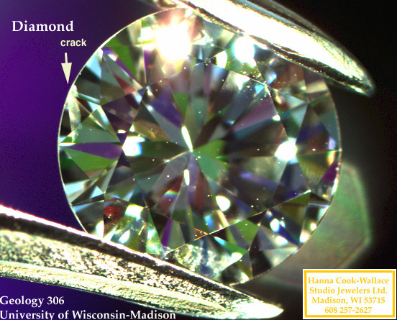  Above, a diamond with a surface crack.  Below, examples of irradiated diamonds.  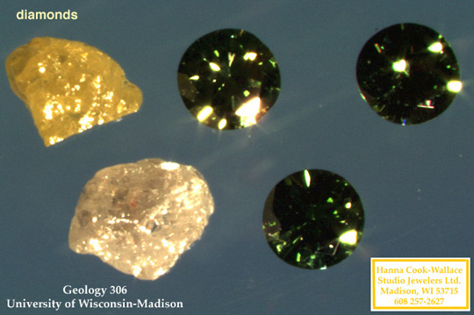
Simulants - simulate the appearance of diamond  The distinction between a synthetic diamond (man-made diamond consisting of carbon atoms arranged in the typical diamond structure) and a diamond simulant (not a carbon compound with the diamond structure) is very important!  In order of increasing R.I., the most common simulants are:  - YAG = yttrium aluminum garnet  - GGG = gadolinium gallium garnet  - CZ = cubic zirconia  - Strontium titanate  - diamond.  This mnenonic can be used to memorize the common diamond simulants in the above order:  You go crazy staring at diamonds.  Again: Simulants (look alikes) differ from synthetics (synthesized by humans!)!  Another diamond simulant, synthetic moissanite (Silicon carbide or carborundum) was introduced to the jewelry market in 1998; manufactured by C3 Inc. and Cree Research. It has become the gold standard for diamond simulants in the last few years.  Source: Jewelers of America  Simulants are distinguished from diamonds using measurement or observation of various properties, such as:  - R.I.  - "Read through effect"  - Dispersion  - Hardness  - Specific Gravity  - Reflection pattern  - Shadow patterns  Note: not all diamond simulants have been around for the same length of time! | 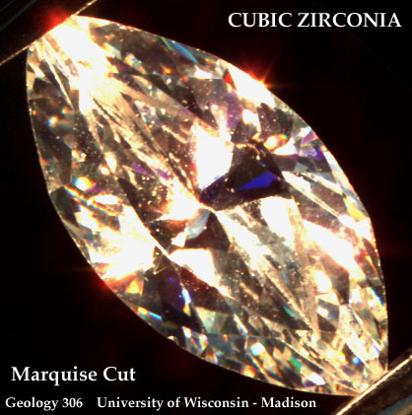
  Crystal Structure | hexagonal
  HARDNESS | 9.5
  R.I. | 2.65-2.69
  Specific gravity | 3.17-3.20

Synthesis (Details on gem synthesis)
Synthetic diamonds are often yellowish in color (rarely used for gem purposes, more commonly used as diamond grit for industrial purposes. Modern synthesis of thin film diamond has other industrial applications).
A 5 mm diamond (0.5 carat) takes over a week to grow. Synthesis requires:
- high pressure
- high temperature
- a special apparatus
Synthetic diamonds can sometimes be distinguished from natural diamonds by the presence of flux inclusions (Ni, Al or Fe).

