Vermont Genetics Network - Proteomics
Lab Manual

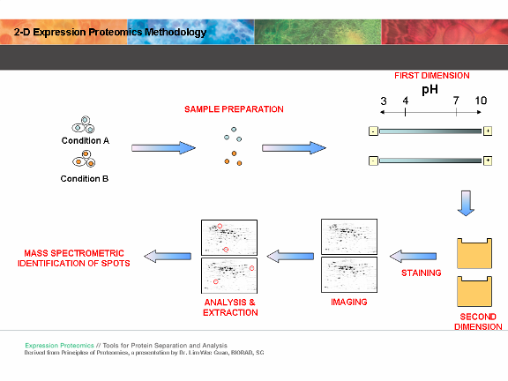

Instruction Team:
Bryan Ballif, Tim Hunter, Scott Tighe, Pat Reed and Janet Murray
Overview

What is Proteomics?

“Encoded proteins carry out most biological functions, and to understand how cells work, one must study what proteins are present, how they interact with each other and what they do………..The term proteome defines the entire protein complement in a given cell, tissue or organism. In its wider sense, proteomics research also assesses protein activities, modifications and localization, and interactions of proteins in complexes.”
[Barbara Marte, Editorial Comment, Insights: Proteomics, Nature 422, 191 (13 March 2003)]

Challenges in Proteomics

The complexity of the proteome must be appreciated. Genomics looks at DNA/RNA content each consisting of 4 bases. Proteins are made up of 20 different amino acids and proteins can undergo multiple types of post-translational modification. The yeast genome contains ~6000 genes but due to alternative splicing and post-translational modification the cell is capable of producing a much larger number of proteins. The composition of the proteome in scale must also be appreciated. Some proteins are in a large abundance while others have very few molecules in the cell and although biologically important, may be very hard to detect.

Experimental design (briefly)

During the next 6 weeks we will conduct a proteomics experiment using the baker’s yeast (Sacchromyces cerevisiae) as our model organism (see flow chart on page 3). This will not be an exhaustive study but will determine several proteins whose expression changes between untreated yeast and those treated with a known agent. This experiment will involve isolating proteins from yeast cells, performing 2-dimensional analysis of these proteins and identifying those yeast proteins whose expression changes due to treatment using mass-spectrometry. The proteins identified will be further studied using accessible databases to create hypothesizes of the biological significance of these changes.

Proteomics Module Flow chart

Day 1

Day 2

(Day 2.5)

Day 3

Day 4

Day 5

Day 6

Protein Prep

Quantitation 2D Analysis

SDS-PAGE Protein/IPG Strip 1-D gel Rehydration

Iso-electric Focusing

2nd Dimension SDS-PAGE

Image Analysis
Spot Picking and
Trypsinization

Mass Spec at UVM

Bioinformatics

Why Use Yeast (S. cerevisiae)??
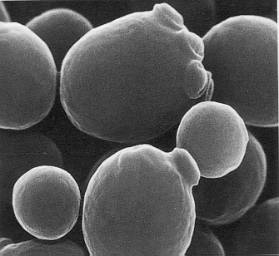
- easily manipulated in the laboratory

- simple eukaryote, unicellular
- rapid growth (doubling 1.5 - 2.5 hours)
- non-pathogenic
- stable haploid and diploid states
- complete genome sequenced
- very well characterized
- many pathways are conserved

Yeast Life cycle

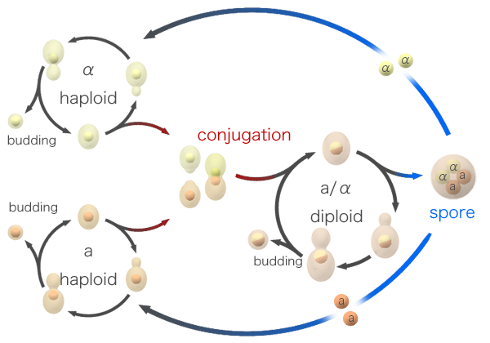
http://www.bath.ac.uk/bio-sci/images/profiles/wheals2.gif
Oxidative Stress / H₂O₂ treatment

Defense mechanisms in Saccharomyces cerevisiae:
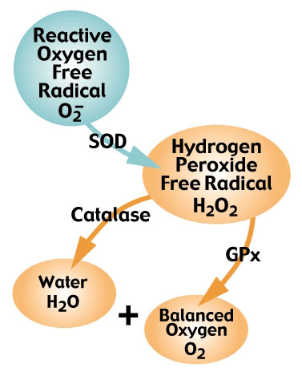
Aerobic organisms utilize oxygen, so they have developed defense mechanisms to combat the effects of Reactive Oxygen Species (ROS).

Oxidative Stress: When the concentration of ROS present in the cell exceeds the capacity of the cells ability to detoxify or to repair damages

Oxidative Stress: H₂O₂ Overload
When the H₂O₂ exceeds the capacity of Catalase and Gulathione peroxidase, it can be reduced to form a hydroxyl radical ·OH.
The hydroxyl radical is highly reactive and can lead to:
DNA Degradation
Protein Peroxidation
Lipid Peroxidation

SOD: Superoxide dismutase GPx: Glutathione peroxidase
http://www.fluidessentials.com/images/glisodin-chart.gif
Hydrogen Peroxide is formed from an oxygen radical and considered to be an (ROS) because it has the ability to form ·OH in the presence of metal ions.

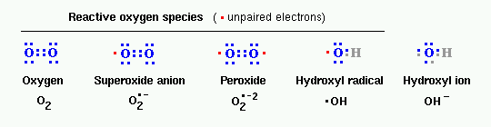
http://www.vivo.colostate.edu/hbooks/pathphys/misc_topics/ros.gif

Special Notes

1] Record all data in notebooks.

2] Label the tops and sides of tubes with:
Sample ID/Initials
Date
What is in the tube
Concentration

3] Check off lines in the lab protocols as you complete them.

4] Read the Technical Discussion section before each day. This is fair game for quiz questions.

5] MSDS safety sheets are available for each chemical in the front of the room.

6] RPM on a Centrifuge does NOT equal G-force. See the conversion chart below.

*Please read through all laboratory procedures prior to each lab.
Proteomics Data Sheet

Name:_____________ Sample ID(used on tubes):____________ _Date:__________

1) Total protein concentration

- 1D gel image amt of sample loaded on gel _____________

- 2D gel image amt of ppt. sample loaded on gel _____________

Set-up before day 1: Instructor

Note: The broth culture must be inoculated about 18-24 hours before the treatment procedure of day 1.

Note : The treatment procedure must occur 30 minutes before class so it is ready 30 minutes after class begins—1 hour total.

Protocol for Preparing Yeast Cultures for Proteomics Module

Necessary Supplies

Autoclave (tape, tinfoil)
Inoculating loop (or sterile swabs) and Bunsen burner
Sterile flasks containing stir bars that are the same size: (1) 1000 ml flask, (2)125 ml flasks
(2) Stir plates
5 and 25 ml pipets (sterile)
Tape and sharpies for labeling

Supplies provided by VGN

Yeast Strain Saccharomyces cerevisiae [NRRL Y-12632 or ATCC 18824]
YPD nutrient media (Difco powder form)
Hydrogen Peroxide (H₂O₂)
Sterile DI Water

Notes:
The broth culture must be inoculated 24 hours before the treatment procedure of day 1. Incubation should be conducted in a room that is 70-73 °F (21-23 °C). It is best to inoculate this culture from a pre-culture that is in log phase.

Plan the treatment of the cultures so that the 1 hour treatment is complete 30 minutes AFTER the start of class on Day 1.

Please read through all instructions before proceeding.
______________________________________________________________________________________________________________________________________________________________________________________________________________________________________________________________________________________________________________________________________________________________________________________________________________________________________________________________________

A) Making YPD media and sterilizing [2] 125 ml flask with stir bars.

____1) Prepare 250 ml of half strength YPD broth in a 500ml flask (use 6.8gm/250ml). Place a stir bar in the flask, wrap tin foil loosely around the top, label the flask, and autoclave under standard conditions (15 psig at 121°C) for 15 minutes.
________________________________________________________________________________________________________________________________________________

____2) Also autoclave (2) 125 ml flasks each containing the same size stir bar. Wrap top in foil.
________________________________________________________________________________________________________________________________________________

It is important not to autoclave LONGER than 15 minutes as the sugars will caramelize and degrade with extended autoclaving.

B) Inoculating the parent culture

____1) Remember to use sterile technique throughout the procedure. Bacterial contamination will be undetectable throughout the rest of the experiment and will adversely affect the final results.
________________________________________________________________________________________________________________________________________
____2) The parent culture should be inoculated 24 hrs before class (Day 1).
_________________________________________________________________________________________________________________________________

____3) Wearing gloves, touch the sterile end of the inoculating loop to a yeast colony on the plate. Your aim is to pick up a small amount. Alternatively, if a liquid culture is used, a 10 ul aliquot can be transferred to the new media using a P20 micropipet with a sterile aerosol resistant tip.
________________________________________________________________________________________________________________________________________________

____4) Uncap and tilt the 500 ml flask at a 30 degree angle [or so] and inoculate the YPD broth with the loop (yeast).
__________________________________________________________________________________________________________________________________________________________
Remember that you want to minimize the time the flask is open AND you do not want your hands or sleeves over the flask opening. Broth is easily contaminated and it will not be possible to detect this until the very end of the experiment.

____5) Flame the mouth of the flask and place the tinfoil cap back on the flask. Replace the tinfoil around the mouth of the flask, but not too tightly as it is necessary for oxygen to get in. It is important that the yeast grow aerobically as respiration is the metabolic process that builds cell mass.
________________________________________________________________________________________________________________________

____6) Place the flask on stir plate and stir approximately 24 hours at a medium speed at room temp (22-25°C). Do not have the speed so high that there is foaming.

C) Treatment of yeast cultures (must be started 30 minutes before class on day 1)

____1) Aseptically transfer 25.0 ml of the yeast broth culture into two (2) sterile 125 ml flasks each containing a stir bar using a sterile 25 ml pipette.

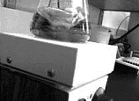

____2) Label one flask as “treated” and aseptically add enough H₂O₂ from the “working stock" to achieve a final H₂O₂ of 5.0 mM [See next page]. Label the control flask as “control” and add an equal amount of HBSS as you did H₂O₂.
____________________________________________________________________________________________________________________________________________________________

Preparing working solution of H₂O₂ to achieve a final concentration of 5.0 mM in culture flask
Preparation of H₂O₂ Stock Solution: Combine 5.0μL of 30% H₂O₂ and 495 μL of Hanks Balanced Saline Salt [HB without phenol red, Mg, or Ca]. Vortex to mix well.
Working H₂O₂ solution : Make a 1:10 dilution by combining 100μL H₂O₂ stock solution with 900μL HBSS and vortex. Use this for spectrophotometer measurement and for the experiment.
Measure the absorbance at 240nm.
Blank the spectrophotometer with HBSS and determine the absorbance of the working solution. Ab₂₄₀ = ____________
Concentration of H₂O₂ in Working Solution : (Ab₂₄₀) x 229 = ______mM of H₂O₂ in working solution = A
Volume of working H₂O₂ solution to use in experiment to achieve a 5.0 mM final concentration in a 25 ml culture volume.
ul of working solution to use = [5.0 mM/AmM] x 25ml x 1000ul/ml
where A = concentration of H₂O₂ in working solution as determined above.

____3) Place each flask on separate stir plates and stir at room temperature for 1.5 hour at [as close as] the same speed as possible. Cultures should be ready for harvest 30 min after the start of the first class period. Therefore, H₂O₂ is added 1 hour before the start of the class.
___________________________________________________________________________________________________________________________________________________
DAY 1
Protein harvest from yeast, precipitation-clean up and protein assay

Technical Overview

Protein Extraction from Yeast

Protein isolation from cells first requires permeation of the cells. Yeast cells have a cell wall that must be weakened before proteins can be harvested. The lysis solution contains reducing reagents which help to destabilize the cell wall and lithium chloride which makes the cell membrane permeable A cocktail of protease inhibitors are added to the lysing solution to inhibit any endogenous yeast proteases. A nuclease is added as well to digest the genomic DNA that can make the lysate very viscous. Insoluble material including the cell wall and membranes are then removed by centrifugation. It is important to note that some proteins are lost in this step. The proteins in the lysate represent only those which are soluble in the lysis buffer. Importantly, this proteomics experiment only examines changes in “soluble” yeast proteins due to the selected treatment.

Protein Assay

Standard protein assays such as Bradford or Lowry cannot be used on samples which contain detergents, reducing agents and high levels of urea. For this reason we will be using the RC (Reducing-agent Compatible) DC (Detergent Compatible) Protein Assay from Bio-Rad. This is, in essence, a modified Lowry assay. The Lowry method uses Cu²⁺ ions along with Folin (a combination of phosphomolybdic and phosphotungstic acid complexes that react with Cu⁺⁾. Cu⁺ is generated from Cu²⁺ by readily oxidizable protein components, such as tyrosine and tryptophan and to a lesser extent, cysteine and histidine. Although the precise chemistry of the Lowry method remains uncertain, the Cu⁺ reaction with the Folin reagent gives intensely colored products which are measured spectrophotometrically at a wavelength of 600nm (a wavelength from 595nm to 700nm gives an accurate absorbance measurement).

Appendix
DAY1
YeastBuster Protein Extraction
ProteoExtract Protein
RC DC Protein Assay

Proteomics Module Flow chart

Day 1

Day 2

(Day 2.5)

Day 3

Day 4

Day 5

Day 6
Protein Prep

Quantitation 2D Analysis

SDS-PAGE Protein/IPG Strip 1-D gel Rehydration

Iso-electric Focusing

2nd Dimension SDS-PAGE

Image Analysis
Spot Picking and
Trypsinization

Mass Spec at UVM

Bioinformatics

Day 1
Protein harvest from yeast, precipitation-clean up and protein assay
Materials and ordering information:
Protein Preparation
YeastBuster Protein Extraction Reagent- Novagen #71186
Yeast Buster Reagent – contains a mild detergent (ASB-16) and protein stabilization buffer (Lithium Chloride and Ethylene Glycol).
THP (tris(hydroxypropyl)phosphine) - reducing agent
Protease Inhibitors – Calbiochem - Protease Inhibitor Cocktail Set IV #539136
Benzonase- nuclease – Novagen #71205-3
ProteoExtract Protein Precipitation kit – Calbiochem #539180
Precipitation Reagent
Wash solution
Protein Concentration Determination
RC DC Protein Assay- Bio-Rad # 500-0121
RC Reagent I – contains Universal Protein Precipitation Agent I (UPPA I)
RC Reagent II – contains (UPPA II)
Reagent A – an alkaline copper tartrate solution
Reagent B – a dilute Folin reagent
Reagent S – sodium dodecyl sulfate (SDS)

- Harvest yeast cells from culture
Saccharomyces cerevisiae culture: Grow overnight in YPD broth at room temperature. A magnetic stir bar is used at a speed sufficient to cause minor bubbles for aeration. This step has been done for you.
_____1. Label a 1.7 ml microcentrifuge tube (L, sample ID, date and initials) and transfer 1.5 ml of the culture to the tube. Centrifuge for 2 minutes at full speed. Be certain to always centrifuge microcentrifuge tubes with the hinge facing the outside of the centrifuge.
_____2. Decant all the media and discard. Invert the tube and blot with a paper towel.

- Extraction of the soluble proteins from the yeast cells using YeastBuster Reagent.
YeastBuster lysis solutions: enough for one sample: multiply values by number of samples to get total volume needed. Stock made fresh by instructor.
300 ul YeastBuster Reagent 3 ul 100X THP Solution
3 ul protease inhibitors 0.3 ul Benzonase Nuclease

_____ 3. Add 300 ul of YeastBuster lysis solution to the tube and vortex until the pellet is totally resuspended.
_____4. Place the tube on tube rocker for 15 minutes. While the samples are rocking go to step 6 and 7 and label the sample tubes you will need (see diagram on next page).
_____ 5. Centrifuge the tube at high speed for 10 minutes.
_____ 6. Label a new 1.7 ml microcentrifuge tube with the letter “Q” along with the sample ID, date and your (group) initials and transfer 250 ul of the supernatant to it. Make sure not to disrupt the pellet during this step.
This sample will be used for 1D SDS-PAGE, 2D sample preparations and protein concentration assay.
_____ 7. Label a new 0.5 ml microcentrifuge tube with “1D” along with the sample ID, date and your (group) initials and transfer 12ul of Q sample to this tube (Instructors will collect this sample). This sample will be used for 1 D gel electrophoresis.
Label a new 1.7 microcentrifuge tube “2D” along with the sample ID, date and your (group) initials and transfer 200 ul of the Q sample to it. This sample will be used to 2D gel electrophoresis and to isolate proteins for identification.
Label 2 new 1.7 microcentrifuge tubes “Pc1” and “Pc2” along with the sample ID, date and your (group) initials and transfer 10ul of the Q sample into each tube. These samples will be used for protein assay.

See diagram for labeling on the next page.

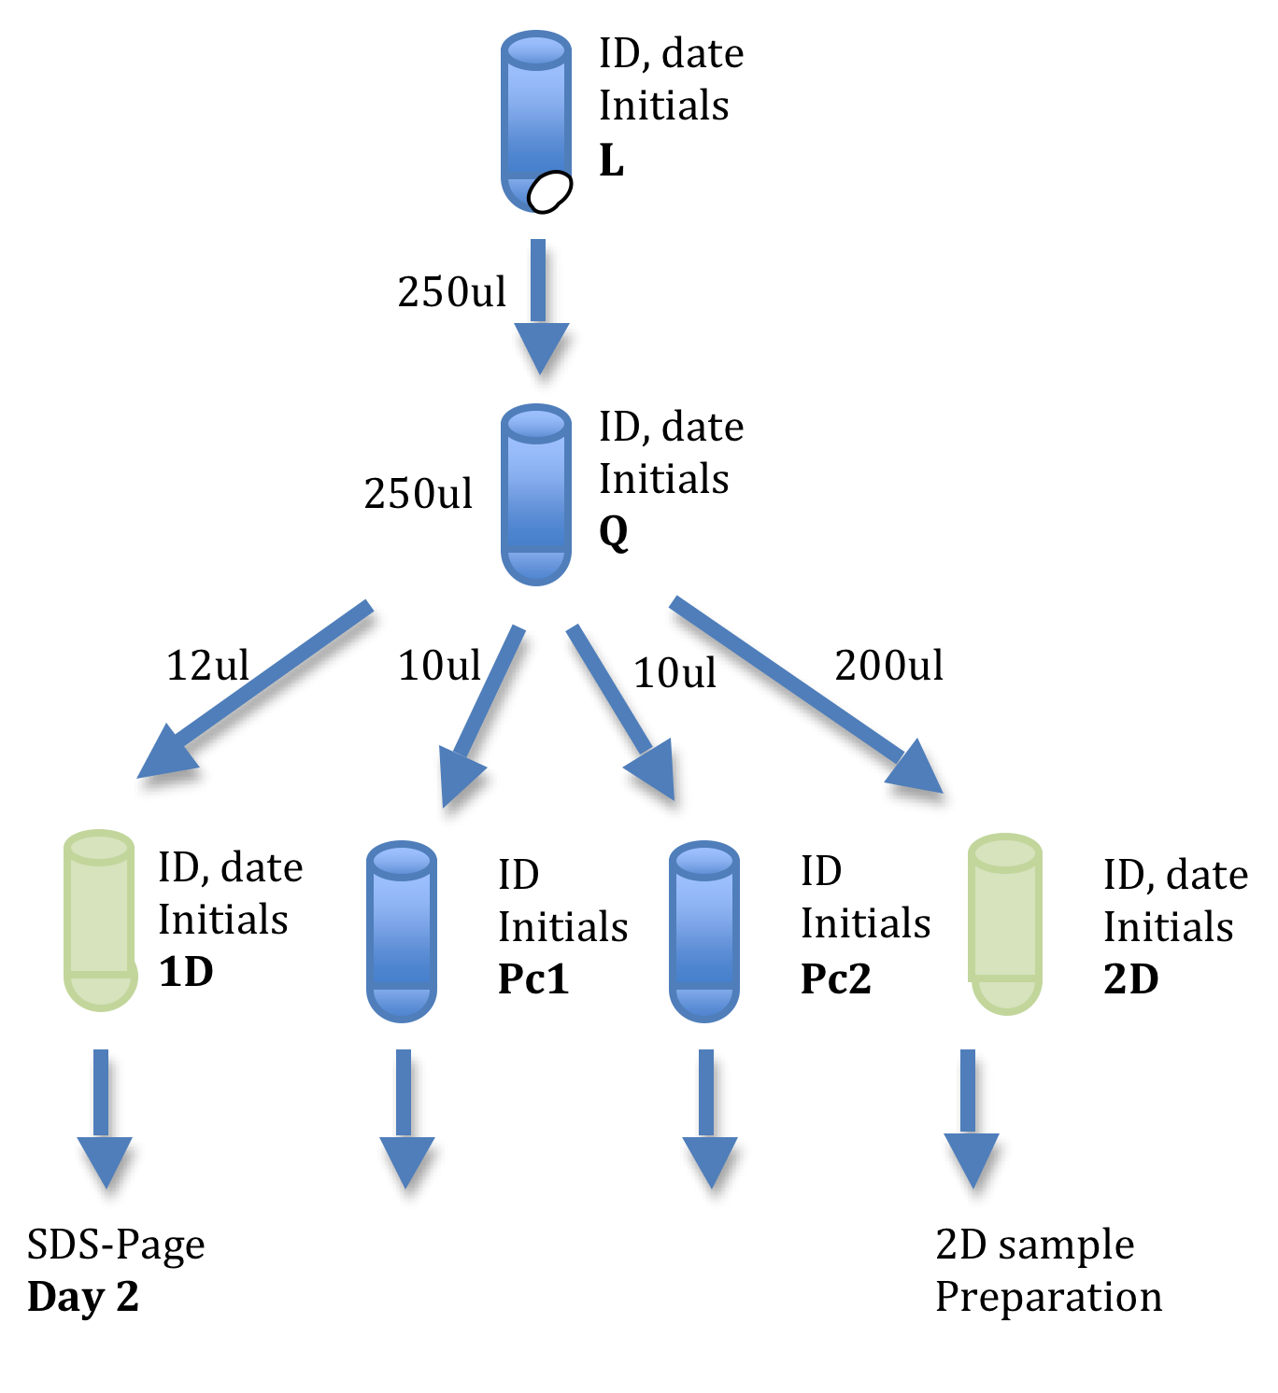
Protein Concentration Determination

Preparation of samples for 2D analysis
- Precipitation and washing of soluble proteins (2D sample prep):

_____ 8. To the 200 ul 2D sample, add 800 ul cold Precipitation Agent (PA) solution to the tube and vortex for 5 seconds. The PA solution should be kept on ice.

_____ 9. Place the tube in a rack and place the rack in a – 20ºC freezer for 30 minutes.

- While you are waiting, begin the protein assay on page 19.

_____ 10. At the end of 30 minutes, remove the tube from the freezer and centrifuge at high speed for 10 minutes at room temperature.

_____ 11. Decant the supernatant by pouring and blot the tube with a tissue. Discard the supernatant.

_____ 12. Add 500 ul Wash Solution (WS) to the tube and vortex for 5 seconds.
_____ 13. Centrifuge for 2 minutes at high speed at room temperature.

_____ 14. Decant the supernatant and discard (make sure most of the supernatant is discarded).

_____ 15. Add 500 ul WS again, vortex and centrifuge as above.

_____ 16. Decant the supernatant and discard.

_____ 17. Centrifuge the tube for 30 seconds. Using a 100 ul pipettor, carefully remove the remaining supernatant from the pellet. Discard the supernatant.

_____ 18. Leave the top of the tube open, set the tube on its side on the rack and let the protein pellet dry at room temperature for 60 minutes.

_____ 19. Close lid on the tube and place in -20ºC freezer (Instructor will collect).

- Protein Concentration - Bio-Rad RCDC Protein Assay (using Q sample)
Technical note: all samples should be run in duplicate.

Steps 1 and 2 are to be done by the instructor at the beginning of the laboratory session.

_____ 1. Standard curve sample preparation: Label 3 sets of 1.5 ml microcentrifuge tubes labeled 1-6. Use one set to prepare the protein concentrations using the following:

Tube # total protein (in 25ul) 2.0 ug/ul BSA standard ul ddwater
- 0 ug 0.0 ul 60.0 ul
- 5 ug 6.0 ul 54.0 ul
- 10 ug 12.0 ul 48.0 ul
- 20 ug 24.0 ul 36.0 ul
- 30 ug 36.0 ul 24.0 ul
- 40 ug 48.0 ul 12.0 ul

Total volume is 60.0 ul. Vortex to mix. Pipette 25.0 ul of each standard above into the two other sets of labeled tubes. Use these duplicate tubes to determine the protein amount and to generate the standard curve following steps 4 through 9.

_____ 2. Preparation of Working Reagent A. For each duplicate set of samples to be analyzed (standard curve and experiment samples) add 5.0 ul DC Reagent S to 250 ul DC Reagent A.

Example: You have the 6 duplicate standard curve samples and 6 duplicate experiment samples to analyze = 12 duplicate samples altogether. Multiply the volume of each reagent by 12 to prepare Working Reagent A.

e.g. For 12 duplicate samples use 60 ul DC Reagent S (12 x 5 ul) to 3000 ul DC Reagent A (12 x 250 ul).

To be done by each student or group:

_____ 3. Add 15.0 ul ddwater to Pc1 and Pc2. Vortex to mix.

_____ 4. Add 125 ul RC Reagent I to each tube and vortex to mix. Let sit at room temperature for 1 minute

_____ 5. Add 125 ul RC Reagent II to each tube and vortex to mix. Centrifuge at high speed for 5 minutes.

_____ 6. Carefully pipette off as much of the supernatant as possible and discard. Be careful not to disturb the protein pellet.

STOP: Return to step 10 on page 17 and complete steps 10-17 before proceeding to step 7 below.

_____ 7. Add 127 ul Working Reagent A to each tube, vortex and let sit at room temperature for 5 minutes.

_____ 8. Vortex the samples again and add 1,000 ul DC Reagent B to each tube and vortex immediately. Let stand at room temperature for 15 minutes.

_____ 9. Use the BioPhotometer to measure the absorbance of all tubes at 600 nm. Use tube 1 from the standard curve samples as a blank. Record the results. See the next page for directions for using the BioPhotometer.

_____ 10. Standard Curve: For each tube of the standard curve samples: Plot the absorbance vs. the ug total protein in each tube (graph paper on page 21). Draw a line of best fit using zero as one data point.

_____ 11. Protein sample concentration: Calculate the average absorbance for each protein sample and use the protein standard curve to determine the total protein in each sample. Divide this value by 10 to determine the protein concentration in each sample in ug/ul. (Note: this is done because you started with 10 ul of sample) Record the concentration of the protein sample on page 7.
Directions for using the Eppendorf BioPhotometer

_____ 1. Turn the BioPhotometer and the printer on.

_____ 2. Select option 5 (OD at 600) on the front panel.

- NOTE: When pouring samples into the cuvets, make sure there are no bubbles in the cuvet. Bubbles will interfere with the light passage and give false readings.
- Use the 1st tube of the standard curve as a blank.

______ 3. Pour at least 100 ul of the blank into a cuvet. Insert the cuvet in the cuvet holder of the BioPhotometer, making sure the light path of the cuvet is in the same direction as the light path or the arrow on the instrument cover. Press the “Blank” button. This will establish the blank absorbance for the assay.

_____ 4. For each sample to be measured, pour at least 100 ul into a cuvet and place the cuvet in the cuvet holder of the BioPhotometer. Press the “Sample” button. The absorbance of the sample will be recorded on the printer paper.

_____5. As the printer paper scrolls off the printer, use a pen to identify each sample.

_____ 6. When your samples are complete, use the recorded absorbance for each sample for parts 10 and 11 of the protein assay directions.

DAY 2
1D protein electrophoresis and staining, rehydrating proteins and IPG strips,

Technical Overview

Iso-electric Focusing

Isoelectric focusing (IEF) represents the first dimension of two- dimensional (2D) electrophoresis, and immobilized pH gradient (IPG) strips facilitate this analysis. Each sample protein applied to an IPG strip will migrate to its isoelectric point (pI), the point at which its net charge is zero.
Isoelectric focusing requires ampholytes, complex mixtures of bifunctional amphoteric (both acid and basic) buffer molecules which form a pH gradient in the medium during electrophoresis. Within that gradient a protein will migrate toward the anode or cathode until it arrives at the point equal to its pI value. At this point it will have a net charge of zero, will no longer migrate and is said to be focused.
Immobiline DryStrip gels contain a pre-formed pH gradient immobilized in a homogeneous polyacrylamide gel. The gels are cast on a plastic backing and delivered dried. Prior to use, they are rehydrated in rehydration solution containing a matching IPG buffer. Therefore to perform iso-electric focusing the protein pellet must be resuspended in the IPG buffer and this protein solution will then be used to rehydrate the IPG strip. Once the IPG-strip is rehydrated, isoelectric focusing will be performed, separating the proteins based on their pIs.
1D electrophoresis of proteins

We will perform SDS-PAGE (sodium dodecyl sulfate - polyacrylamide gel electrophoresis) of total-soluble yeast protein from DAY1 (1D) to determine if the protein is degraded or intact. SDS is a negatively charged detergent that “coats” proteins making them all uniformly charged and therefore, they will separate on the polyacrylamide matrix bases solely based on their molecular weight. A reducing agent is also added to the loading buffer in order to cleave any disulfide bonds making the proteins run more uniformly.

Appendix
DAY2
Isoelectric focusing, Garfin, et. al.
Protein Standards Information

Proteomics Module Flow chart

Day 1

Day 2

(Day 2.5) done by instructor

Day 3

Day 4

Day 5

Day 6

Protein Prep

Quantitation 2D Analysis

SDS-PAGE Protein/IPG Strip 1-D gel Rehydration

Iso-electric Focusing

2nd dimension SDS-PAGE

Image Analysis
Spot picking and
Trypsinization

Mass Spec at UVM

Bioinformatics

Day2
1D protein electrophoresis and staining: Rehydrating proteins and IPG strips,
Materials and ordering information:

Loading Buffer (Laemmli Sample Buffer) - Bio-Rad # 161-0730
Protein Standards (SDS-PAGE Standards) -Bio-Rad # 161-0320
Bio-Rad Ready Gel 10% Tris-HCL gel – Bio-Rad # 161-1155
1X TGS (10X Tris/Glycine/SDS- Bio-Rad #161-0732)

Bio-Safe Coomassie Blue stain – Bio-Rad #161-0786
ddH₂O – deionized H₂O (milli-Q)

Rehydration Buffer – Bio-Rad # 163-2106
8M Urea
2% CHAPS
50mM DTT
0.2% Bio-Lyte 3/10 ampholyte,
0.001 Bromophenol Blue
Mineral Oil
IPG (immobilized pH gradient)-strips (Immobinine Drystrips pH 4-7) – GE Healthcare #18101660

Today you will begin the 1-D SDS-PAGE gel electrophoresis and during the time it is running you will rehydrate the 2D protein sample and set up the IPG strip for 2-D electrophoresis. To begin the day, remove protein samples from the freezer, so they will thaw. A method for heating protein samples before loading should be identified.

- 1-D SDS-PAGE (Gel Electrophoresis): Use the 1D protein sample

_____ 1. Remove the Bio Rad Ready Gel (10% Tris-HCl) from its packaging. Use a razor or scissor point to score the strip along the bottom of the gel. Peal off the strip to expose the open slot at the bottom of the gel. Place the gel in the gel clamp assembly with the short plastic plate facing the inside. If only one gel is being run, place the dam in the second position in the clamp. Clamp the gel into position and place the clamp assembly into the electrophoresis chamber.

____ 2. Add 1 X TGS electrophoresis buffer to the upper and lower chambers. Make sure the upper buffer chamber is filled above the short plastic plate and the lower chamber filled to the line on the electrophoresis chamber. Remove the gel comb from the Ready Gel.

_____ 3. The 12 ul 1D protein sample from step 7 on Day 1 will be run on the SDS-PAGE gel. Spin sample briefly and add 3 ul protein loading buffer.

_____ 4. Heat the sample tubes and protein standard at least to 95º C for 5 minutes.

_____ 5. Centrifuge the sample for 2 minutes at maximum speed to pellet any insoluble material.

____ 6. Transfer 10 ul of each sample into a well in the gel (take the top portion of the sample - do not disturb any pelleted material). Use a gel tip if necessary. Make sure the pipette tip is centered over a well and is between the glass plates of the gel before dispensing. (10 ul of protein standards need to be added to one well on each gel). Record the lane number in which each sample is placed, including the protein standards.

_____ 7. Place the lid on the electrophoresis chamber, plug the leads into the power supply (black into black, red into red) and turn on the power supply.

_____ 8. Set the voltage to 50 V and the time to 10 minutes. Press the run button to start.

- Go to Rehydrating Proteins and setting up IPG strip step 1 on page 27

_____ 9. At the end of the 10 minutes, reset the voltage to 150 V and the time to 35 minutes. Press the run button to start. (Check the amperage periodically…what should happen to the amperage during the run?)

_____ 10. At the end of the run, turn off the power supply, disconnect the leads and remove the lid from the electrophoresis chamber. Remove the clamp assembly and remove the gel from the clamp.

_____ 11. Use a razor or scissors to score the plastic strip along each edge of the gel and separate the two gel plates.

- Bio-Safe Coomassie Blue stain of electrophoresis gels

____ 1. Transfer gel from gel plate into a staining dish using ddwater. Be careful not to tear the gel when transferring.

Wash the gel three times with ddwater as follows:

_____ 2. Add more ddwater to completely submerge the gel if necessary. Cover the dish and place it on a rocker for 3 minutes. Set the rocker to a gentle back and forth motion.

_____ 3. Decant the water and add fresh ddwater, completely submerging the gel as before and place on the rocker for another 3 minutes.

_____ 4. Decant the water and add fresh ddwater and rock for another 3 minutes. Decant the water.

_____ 5. Add sufficient Bio-Safe Coomassie blue stain to cover the gel. Place on the rocker for at least 45 minutes. (bands will appear within 20 minutes but best results are seen after 45 minutes. Staining can continue beyond 45 minutes with no additional advantage)

- Go to Rehydrating Protein and setting up IPG strip step 3 on page 27

_____ 6. Decant the stain and add ddwater sufficient to cover the gel. Place on the rocker for 10 minutes. Decant the water and add fresh ddwater to the dish. Continue rocking until the gel clears. (This can continue overnight if necessary)

- Go to Rehydrating Protein and setting up IPG strip step 4 on page 27

_____ 7. Gels can be left in ddwater for up to 2 weeks.
Rehydrating proteins and setting up IPG strip: use the 2D protein sample

_____1. 300 ug of total protein will be added to the IPG strip. Calculate the protein
amount in the 2D protein pellet to determine the volume of rehydration buffer to
use to yield a final concentration of 1.5 ug/ul. You carried 200 ul of sample into the 2D tube. Multiply 200 ul by the protein concentration (determined by the RCDC protein assay) to determine the ug of protein in the 2D tube. Divide this value by 1.5 to determine the number of ul of rehydration buffer to use in the next step.

- Example: Protein concentration = 2.5 ug/ul
2.5 ug/ul x 200 ul = 500 ug protein. 500 ug/1.5 ug/ul = 333 ul of rehydration buffer to use in the next step. (NOTE: you must add at least 200 ul)

_____2. Add the calculated amount of rehydration buffer from above (bromophenol
blue already added) and vortex the samples. Place on a tube rocker for 1 hour. Periodically check the samples (check for mixing of pellet) and vortex again.

_____ 3. At the end of 1hr check sample with an instructor. If the sample is solubilized centrifuge the samples for 30 minutes at high speed at room temperature.

(During this time you can rinse and stain the 1D gel)

_____ 4. Transfer 200 ul of the sample (avoid any remaining pellet that maybe in the tube) to a channel of the isoelectric focusing tray. Disperse the sample evenly along the channel. Keep a record of which sample is in which channel.

_____ 5. Remove an IPG gel strip from its packaging. Remove the protective plastic covering from the strip. Place the strip in the channel with the writing side up and the “+” end of the strip at the “+” end of the tray.

_____ 6. Thoroughly cover the gel strip with mineral oil.. Place the tray lid on top of the tray.

_____ 7. Place the focusing tray in the tray rack of the BioRad Protean IEF Cell Pack with the “+” contact of the tray on the red contact and the “-“ contact on the black contact. Close the lid.

_____ 8. Plug in the instrument and turn on the power. A selection menu will appear on the screen on the front panel. Select the following settings:

Press the button next to “rehydrate” (line 1). A new screen will appear.
Set the following:
“active @ 50V” by pressing the button next to that line (line 2):
“20º C” (line 3). To change the setting, if necessary, use the buttons on the blue key pad on the front panel.

_____ 9. Press the “run icon” button on the upper front panel to start. Run the samples overnight.
Day 2.5. ****To be done by faculty on site the day after the IPG strip setup

- First dimension Electrophoresis using Isoelectric Focusing (IEF)

_____ 1. Place two wicks per IPG strip into a weigh boat or other clean dish. Add enough ddwater to hydrate the wicks.

_____ 2. Turn off the power to the IEF Cell Pack. Open the lid of the unit and remove the tray lid.

_____ 3.Wipe off excess ddwater from the wicks on a kimwipe and place one under each end of the IPG strip. Gently lift the strip and layer the wick under the end so the wick is over the contact wire on the tray. Gently press the gel strip onto the wick. Return the tray lid to the tray securely.

_____ 4. Turn on the IEF Cell Pack. A selection menu will appear in the screen on the front panel. Press the button next to the “preset method” (line 2). A new menu screen will appear. Select the following:

For “Voltage Slope” press the button next to “rapid” (line 2) and select the following on the next screen.

rehydration = “NO”
gel length = “11”
focus temp = “20º C”

Press “next” and a new screen will appear.
Select the following settings:

S1: set to “250V” for “00:15” min (line 1): use the blue key pad to make changes if necessary.
S2: set to “hours/min” (line 2)
S2: 8,000V for 2:30 hrs (line 3)

Press “next” for a new screen
Select the following settings:
S3: set to “vhours” (line 1)
S3: 8,000V, 35,000 (line 2)
S4: set to “500V/hold”: “yes” (line 3)

Press “next” for a new screen
“Enter # of Gels” (line 3): press the button next to the line and use the blue key pad to enter the # of IPG strips to be run.

Press the “run icon” to start the procedure.

_____ 5. IPG strips can be left at the S4 setting overnight. When the run is finished, samples can be continued directly to washing and SDS-PAGE electrophoresis or the trays can be wrapped in plastic wrap or placed in a Ziploc bag and stored in a -20ºC freezer without further processing. (Make sure that the strips are covered well with mineral oil before freezing).
DAY 3

Second dimension electrophoresis using SDS-PAGE

Technical Overview

2nd Dimension Electrophoresis

After isoelectric focusing the IPG strip will be prepared for the 2nd dimension electrophoresis. In this dimension the proteins will be separated based on their molecular weight. We will use standard SDS-PAGE. The IPG-strip will be washed with an equilibrium buffer (EB) containing SDS to “coat” the proteins on the strip. EB1 contains DTT to reduce any disulfide bonds in the proteins. Iodoacetamide is added to EB2. Iodoacetamide is an alkylating sulfhydryl reagent used to bind covalently with cysteine amino acids, so the protein cannot reform any disulfide bonds.

When we stain the gel with coomassie blue we should see individual spots on the gel. It is important to remember that multiple proteins can have similar pIs and molecular weights. This means that one spot on a gel can contain more than one protein.

Proteomics Module Flow chart

Day 1

Day 2

(Day 2.5)

Day3

Day4

Day 5

Day 6

Protein Prep

Quantitation 2D Analysis

SDS-PAGE Protein/IPG Strip 1-D gel Rehydration

Iso-electric Focusing

2nd Dimension SDS-PAGE

Image Analysis
Spot Picking and
Trypsinization

Mass Spec at UVM

Bioinformatics

Day 3:
Second dimension electrophoresis using SDS-PAGE Electrophoresis
Materials:
EB (Equilibration Buffer)
375 mM Tris-HCL pH 8.8
6M Urea
2%SDS
DTT (dithiothreitol)
Iodoacetamide

Criterion Precast Gel Cassette (10% Tris-HCL, 11cm IPG + 1 well) –Bio-Rad #345-0101
Overlay Agarose – Bio-Rad #163-2111

- Processing IPG strips

_____1. Remove the IPG strips from the freezer. Frozen strips must be thawed before proceeding. Remove each IPG strip from the electrophoresis tray and gently remove the excess mineral oil by wiping the edge of the strip with a tissue. Be careful not to disturb the gel. Place the strip in a channel of an equilibration tray with the gel side up (writing side down). During the next two steps make sure to record the location of each strip.
Prepare EB1 and EB2 (EB = equilibration buffer) and mix thoroughly. 5 ml is sufficient for two IPG strips.

EB1—20.0 ml EB (rehydrated bottle) plus 200 mg DTT
EB2—20.0 ml EB (rehydrated bottle) plus 240 mg iodoacetamide

_____2. Add enough EB1 buffer to cover the strips. Place on a rocker-mixer for 10 minutes at room temperature. Remove the strip from its channel and blot with a tissue along the edge of the strip being careful not to disturb the gel.

_____3. Move each strip to a new channel and add enough EB2 buffer to cover the strips. Place on a rocker-mixer for 10 minutes at room temperature.

- SDS page electrophoresis

_____4. For each IPG strip use a BioRad Criterion Precast gel cassette (10% Tris-HCl, 1.0 mm: 11 cm + 1 well comb, IPG). Remove the gel cassette from its packaging, peel off the protective strip at the bottom and place it in the BioRad electrophoresis chamber. Remove the green comb from the gel. Using a pipette with a gel tip, remove any excess preservation buffer from the protein standard well.

_____5. Drain off excess EB2 buffer from each IPG strip, blot with a tissue as before and carefully place the strip on the top of the gel. Place the IPG strip between the two plates so the “+” end of the strip is to the left and the writing on the strip is readable. Make sure the strip is in close contact with the top of the gel with no trapped air bubbles. Use forceps to help with this process.

_____6. Melt the overlay agarose (0.5% with bromophenol blue) in a microwave.
Let it cool slightly before using. Use a transfer pipette to layer the agarose over the IPG strip but not the well used for the protein standard. The agarose should form a seal between the two plates and cover the top of the IPG strip.

_____7. Using a gel tip, pipette 5.0 ul of the protein standard to the single well in the gel. Transfer some of the agarose to cover the well. Let it set for 1 minute.

_____8. Fill the upper and lower buffer chambers with 1X TGS electrophoresis buffer. Make sure the upper buffer chamber is filled to cover the agarose overlay of the IPG strip and the lower buffer chamber is to the “fill” line on the outside of the chamber.

_____9. Place the lid on the chamber, plug into the power pack and turn the power pack on. Run the gel for 45 minutes at 200V. The bromophenol blue dye front should be at the bottom of the gel when finished.

_____10. At the end of the electrophoresis run, turn off the power, unplug the cords from the power pack, remove the lid from the chamber and remove the gel cassette(s) from the chamber.

_____11. Using the design on the end of the chamber lid, break open the gel cassette and separate the two halves. Gently transfer the gel to a staining tray using ddwater to assist in the transfer.

_____12. Stain the gel following the directions for Bio-Safe Coomassie Blue stain used on Day 2. (page 26)

DAY 4
Image analysis

Technical Overview

Image Analysis

The Prodigy SameSpots Image Analysis Software (Non-linear Dynamics) will be used to help us compare the gel images and identify gel spots (proteins) that appear to be differentially expressed between the control and treated yeast cells. The identified spots will be cut out of the gel with a razor blade and then prepared for trypsin digestion.

Proteomics Module Flow chart

Day 1

Day 2

(Day 2.5)

Day 3

Day 4

Day 5

Day 6

Protein Prep

Quantitation 2D Analysis

SDS-Page Protein/IPG Strip 1-D gel Rehydration

Iso-electric Focusing

2nd Dimension SDS-Page

Image Analysis
Spot Picking and
Trypsinization

Mass Spec at UVM

Bioinformatics
Day 4:

- Scanning the second dimension gel after staining with Bio-Safe Coomassie Blue stain

_____1. Turn on the HP Scanjet G4050 scanner and computer. Start the scanning software by clicking the icon for Adobe PhotoShop CS4.

_____2. Transfer the gel to the glass platen on the scanner. Use water to help the transfer and orient the gel. Remove all air bubbles from under the gel. Leave the scan lid open.

_____3. From the Adobe Photoshop home page. Click “file” on the tool bar and select the Import…HP Scanjet (G24050 TWAIN) from the drop down list. This will
activate the scanning software and warm up the scanner. This may take several minutes. It will run a preliminary scan. (Takes ~2 minutes before scan.)

_____4. When the preliminary scan is finished, close the lid on the scanner and click “scan” on the tool bar. Click on “scan profile” and then “load”. Press the “load” button. A second preliminary scan will be done. (Takes ~2 minutes before scan.)

_____5. A scan image will appear when complete. Click on the lit scan box and drag it over the gel so that the full gel is covered within the lit box. Hit “accept”. A final image of the gel within the box will be scanned.
IMAGE MODE Select grayscale discard

_____6. Save the image to the desktop as a “tif” file. To do this, click on “save as” and select the “tif” file format from the drop down menu. Give the scan image a label you can identify as yours. Click “save”.

- Non-linear prodigy software

We will use the Prodigy software SameSpots to analyze and compare our gel images. This software compares the gels and helps determine which spots should be chosen for further analysis. We will be using this software today. A guided tutorial will be presented.

Appendix
Prodigy SameSpots Tutorial
Day 4
Spot Picking and Trypsinization of Gel Plugs
Technical Overview

Trypsin Digestion (within a polyacrylamide gel matrix)

Trypsin is secreted into the duodenum, where it acts to hydrolyze peptides into their smaller building blocks, namely amino acids. Trypsin is a serine protease that predominantly cleaves peptide chains at the carboxyl side of the amino acids lysine (K) and arginine (R), except when either is followed by proline (P) or when obstructed by a post-translational modification. It is used for numerous biotechnological processes. The process is commonly referred to as trypsin proteolysis or trypsinization and proteins that have been digested/treated with trypsin are said to have been trypsinized. Trypsins have an optimal operating pH of about 8 and optimal operating temperature of about 37°C.
Predicted HDAC1 Trypsin cleavage map (80% or more cleavage probability) (ExPASy Peptide Cutter http://www.expasy.org/tools/peptidecutter/ )
| | | | |
MAQTQGTRRKVCYYYDGDVGNYYYGQGHPMKPHRIRMTHNLLLNYGLYRK
1--------+---------+---------+---------+---------50
| | | | | |
MEIYRPHKANAEEMTKYHSDDYIKFLRSIRPDNMSEYSKQMQRFNVGEDC
51--------+---------+---------+---------+---------100
| | | |
PVFDGLFEFCQLSTGGSVASAVKLNKQQTDIAVNWAGGLHHAKKSEASGF
101--------+---------+---------+---------+---------150
| | | |
CYVNDIVLAILELLKYHQRVLYIDIDIHHGDGVEEAFYTTDRVMTVSFHK
151--------+---------+---------+---------+---------200
| | | | |
YGEYFPGTGDLRDIGAGKGKYYAVNYPLRDGIDDESYEAIFKPVMSKVME
201--------+---------+---------+---------+---------250
| | |
MFQPSAVVLQCGSDSLSGDRLGCFNLTIKGHAKCVEFVKSFNLPMLMLGG
251--------+---------+---------+---------+---------300
| | |
GGYTIRNVARCWTYETAVALDTEIPNELPYNDYFEYFGPDFKLHISPSNM
301--------+---------+---------+---------+---------350
| | | |
TNQNTNEYLEKIKQRLFENLRMLPHAPGVQMQAIPEDAIPEESGDEDEDD
351--------+---------+---------+---------+---------400
| | | | | | | | |
PDKRISICSSDKRIACEEEFSDSEEEGEGGRKNSSNFKKAKRVKTEDEKE
401--------+---------+---------+---------+---------450
| | | | | | | |
KDPEEKKEVTEEEKTKEEKPEAKGVKEEVKLA
451--------+---------+---------+-482

Day 4:
Spot Picking and Trypsinization of Gel Plugs
Materials:
70% Ethanol
HPLC-grade water
50mM ammonium bicarbonate
50mM ammonium bicarbonate-50% acetonitrile
100% acetonitrile
trypsin in 50mM ammonium bicarbonate (instructor - make up same day and keep on ice)

- Cutting out gel spots and trypsinizing proteins in preparation for Mass Spectrometry

_____1. Clean a glass plate with soap and water and rinse thoroughly with ddwater. Rinse again with 70% ethanol. Let the plate dry.
_____2. Carefully remove the gel from its container and place on the glass plate.
_____3. Label a 1.7 ml microcentrifuge tube with appropriate identification for each protein spot to be analyzed. Select the gel spot picker for the size of the spot to be removed and clean with 70% ethanol before using and between cutting each spot. When choosing a spot picker select one that will minimize the amount of gel you take with it. Cut out the selected gel spot and transfer it to the labeled tube.
_____4. Add 900 ul of HPLC-grade water to each tube. Incubate at room temperature for five minutes.
_____5. Centrifuge at high speed for 30 seconds. Using your pipettor set to 1000 ul, carefully remove the water and discard it in the waste container provided. Use a new pipet tip for each sample. Be careful not to lose the gel in this process.
Note: The following steps use acetonitrile, which is poisonous. It also tends to leak from pipet tips when being measured. Always wear eye protection and gloves when handling it or transferring it. Always dispose of acetonitrile in its special waste receptacle. If you get acetonitrile on your gloves, change your gloves.
_____6. Add 750 ul destain solution (50mM ammonium bicarbonate, 50% acetonitrile) to each tube. Close the tube cap and mix gently by inversion. Incubate the tubes at 37 degrees C for 20 minutes.
_____7. At the end of 20 minutes inspect the gel. If it is still very blue, repeat the destain process with more destain reagent. To do this, briefly centrifuge the tube, carefully pipet off the liquid, add 750 ul new destain reagent and incubate for an additional 15 minutes. Make sure you put the discarded destain solution in the provided waste receptacle. Repeat one more time if needed. Change gloves if you get acetonitrile on them and wash skin with water if it contacts the acetonitrile.
_____8. When the gel sample is clear and no longer contains blue color, centrifuge the tube at high speed for 30 seconds. Carefully remove all the destain solution and discard it in the waste receptacle.
_____9. Add 100 ul of 100% acetonitrile to each tube. (The gel pieces should be entirely immersed, if not add more). The gel pieces will turn white as they dehydrate. Incubate the tubes for 2 minutes at room temperature.
_____10. Centrifuge for 30 seconds and carefully pipet off all the acetonitrile. Discard in the provided waste receptacle. Use a 200 ul pipettor to carefully remove the residual liquid from the tube.
_____11. Keep the tube lid open, lay the tube on its side and let the gel dry completely for 5 minutes at room temperature. Close the lid before proceeding to the next step.
_____12. Place the tubes on ice for 5 minutes. Add 25 ul ice cold trypsin/50mM ammonium bicarbonate solution to each tube. Incubate on ice for five minutes. Add 25 ul cold 50 mM ammonium bicarbonate solution to each tube. Make sure the gel is completely immersed in the solution. Add more ammonium bicarbonate solution if necessary.
_____13. Incubate the tubes on ice for an additional 30 minutes.
- At this point tubes may be processed following steps 14 and 15 or can be transferred directly to UVM for further processing. They do not need to be kept on ice, but packaged so the contents will not spill.
_____14. Transfer the tubes to a 37º C incubator. Incubate the tubes overnight (8-16 hrs).
_____15. Store the tubes at 4º C until ready for further analysis.

