Name ____________________________ Date ______________ Pre-assessment / Post-assessment

(Please circle one above.)

SWAC – Weather Balloon Launch Workshop

1. How do scientists actually study conditions in the atmosphere? Try to list at least 3 different ideas.

*Starter idea: weather balloons*







5. Does the atmosphere have “layers?” Why or why not?
6. Using what you know, please **draw a line or curve** to show what happens to each variable (temperature and pressure) as you **increase in altitude** in the atmosphere.

***Atmospheric Temperature vs. Altitude Atmospheric Pressure vs. Altitude***

*ALTITUDE*

*low high*

*cold warm*

*TEMPERATURE*

C:\Documents and Settings\lenorovitzk\Local Settings\Temporary Internet Files\Content.IE5\740YPR8E\MC900083557[1].wmf

C:\Documents and Settings\lenorovitzk\Local Settings\Temporary Internet Files\Content.IE5\YZ98YGFI\MC900232066[1].wmf

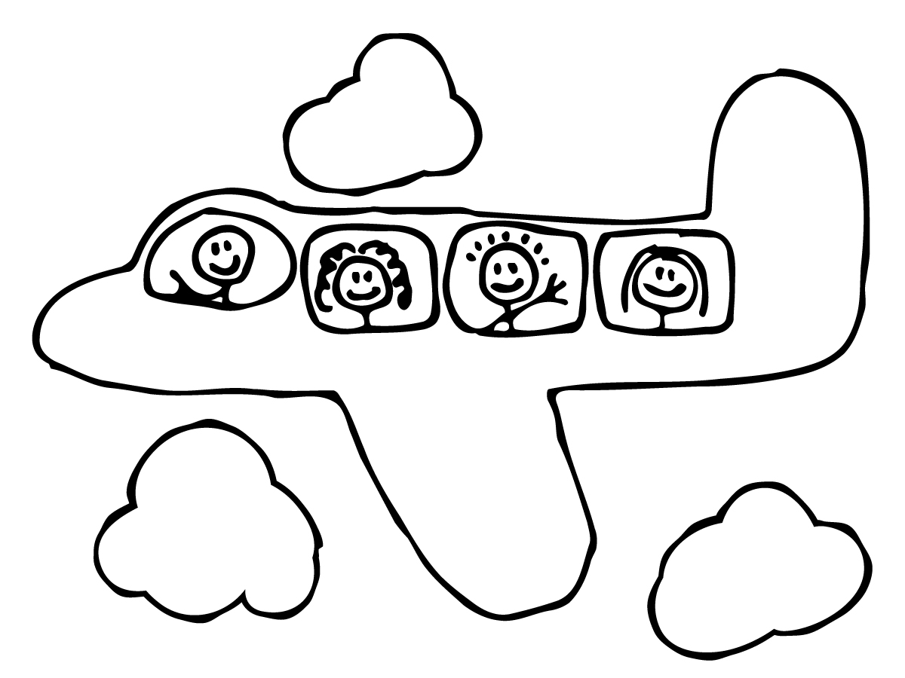

*ALTITUDE*

*low high*

*low high*

*PRESSURE*

C:\Documents and Settings\lenorovitzk\Local Settings\Temporary Internet Files\Content.IE5\YZ98YGFI\MC900232066[1].wmf

C:\Documents and Settings\lenorovitzk\Local Settings\Temporary Internet Files\Content.IE5\740YPR8E\MC900083557[1].wmf



1. What kind(s) of information do weather balloons help meteorologists collect? Why are balloons helpful?
2. How do scientists “get” the information collected by a weather balloon?
3. Use the information below to fill in the blanks on the following chart.

|  |  |  |  |
| --- | --- | --- | --- |
|  | **Temperature (°F)** | **Temperature (°C)** | **Temperature (K)** |
| **melting point of water** |  |  |  |
| **human body temperature** |  |  |  |
| **boiling point of water** |  |  |  |

1. Why might scientists choose to use the Kelvin (K) scale to communicate temperature data?
2. How might you incorporate a weather balloon launch into your teaching?
3. Please answer the appropriate questions below:
   1. What’s one thing you hope to gain from today’s workshop? (pre-assessment only)
   2. What’s one thing you did gain from today’s workshop? (post-assessment only)
   3. What questions do you have after today’s workshop? (post-assessment only)