Creating a scatter plot graph in Excel

First, you’ll need to enter your data.
Image #1
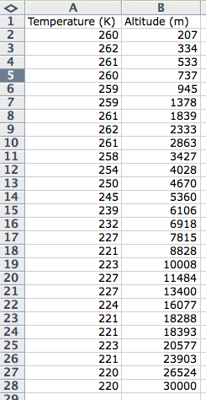

- Open a blank workbook in Excel.

- Enter (or copy and paste) your data in columns.

  - The data in the first column will be the data displayed on the horizontal (x-axis). For our purposes, temperature will go on the horizontal axis.

  - The data displayed on the second column will be the data displayed on vertical (y-axis). For our purposes, altitude will go on the vertical axis.

- At this point your Excel sheet should look similar to image #1.

Next, you’ll need to tell Excel to make a graph.
Image #2
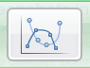

- When you’ve entered all of the data, use the cursor to highlight all of your data (including your column headings).

- Then, click on the insert menu at the top of the screen (on a Mac, select insert “chart”). From there, click on the “scatter” graph symbol. You want the option that says, “smooth marked scatter.” See image #2.
Image #3
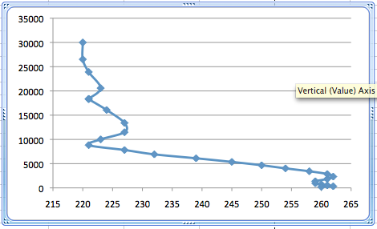
- Now you should see a graph like the one in image #3.

- Next you will take several steps to add axes labels and units, and add a title.

Now, it’s time to adjust the scales of the axes, add labels and units, and a title.

- Click on the “Layout” tab at the top of the page (on a Mac, click to highlight your chart, then click on “view” and select “formatting palette”).
Image #4
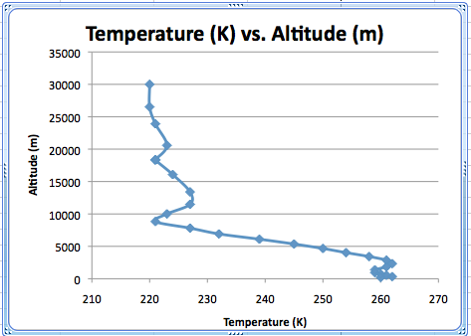

- Click the “chart title” button to add a title to your graph.

- Click on the “axes title” button to add labels and units to each of the axes.

- Your graph should look like image #4.

