**Weather Pattern - Late April into Early May, 2014**

**SWAC review paper April 30, 2014**

**Introduction**

I thought it might be interesting to look at the current weather pattern in terms of the items we discussed this year in SWAC. I’m using a new computer and the latest version of MS-WORD so be patient if typo errors crop up.

Recall the journal article and internet presentation by Jennifer Francis (Rutgers University) regarding the warming of the polar region with reduced ice coverage. She postulated that this resulted in a decrease in the slope between the tropical and polar tropopause, resulting in a reduced zonal (west to east) component of the polar jet with an increased meridional (north-south) flow. This increased amplitude to the upper level flow moves warm air north and cold air south, but it also locks in weather patterns due to their slow eastward progression. This resultant flow pattern from the Francis study is depicted in figure 1.



Fig-1: Region of study: 140W to 0W. Schematic of ridge elongation

(dashed vs. solid) in upper-level heights caused by enhanced warming

in Arctic relative to mid-latitudes. Higher amplitude waves progress

eastward more slowly, as indicated by arrows. (J. Francis article)

**Late April Weather Pattern**

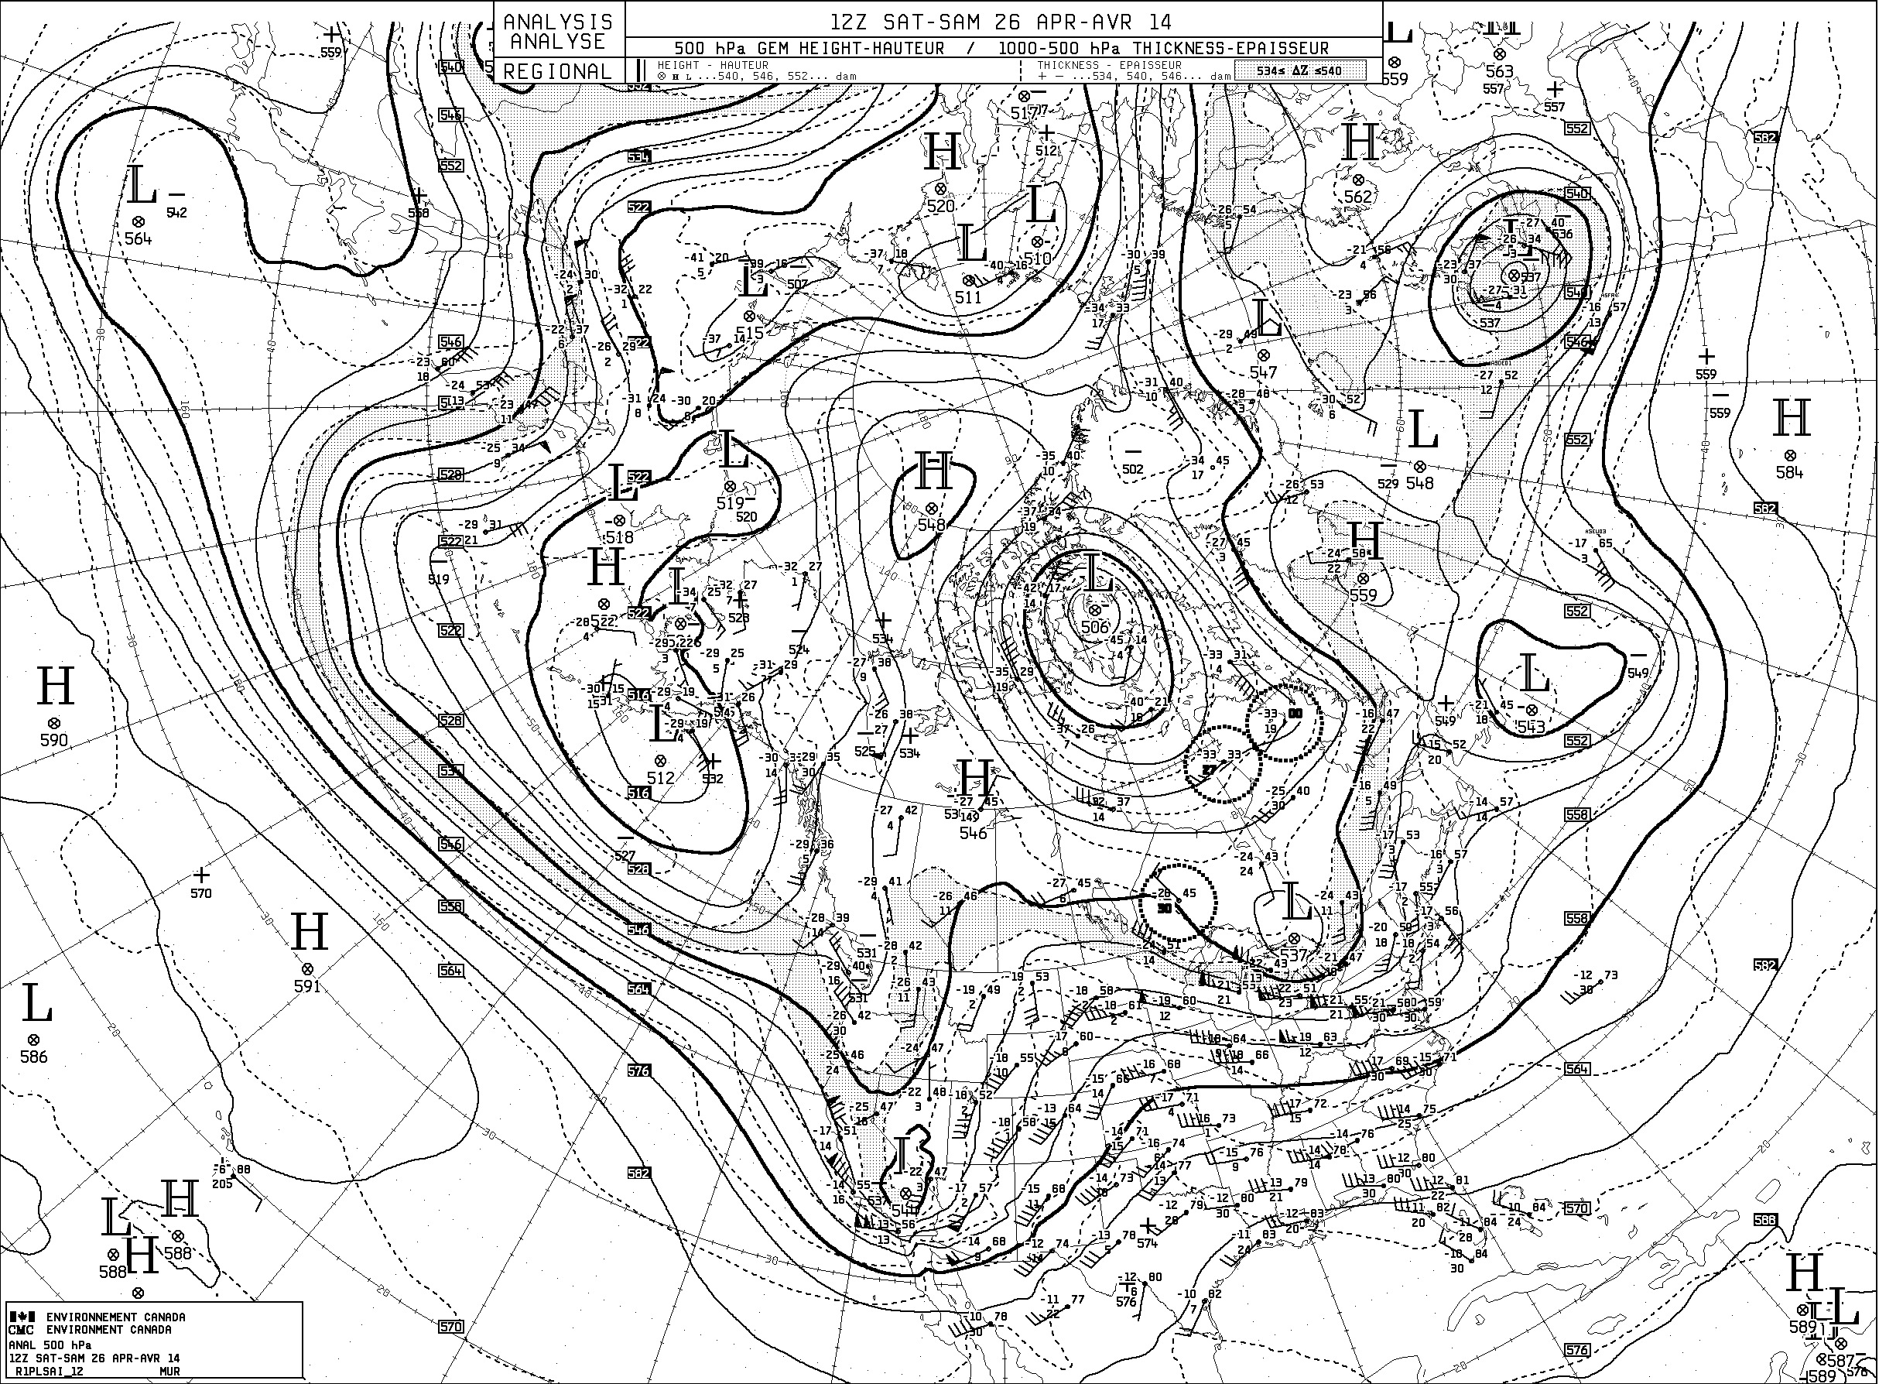Compare this pattern with the actual 500mb (~20,000feet) analysis for Saturday, April 26, 2014 (figure 2). Note the approximate troughs along the east and west coasts of the United States and ***the building ridge*** in the Rocky Mountain States. Of special note is the wavy north-south flow pattern ***developing*** (meridional flow as opposed to zonal flow). Figure 3 highlights the strong ocean storm that moved slowly across the Atlantic waters south of Nova Scotia and Newfoundland.

Fig 2: 12z 500mb Apr 26, 2014 Environment Canada. Note increasingly meridional flow

across United States and western Atlantic.

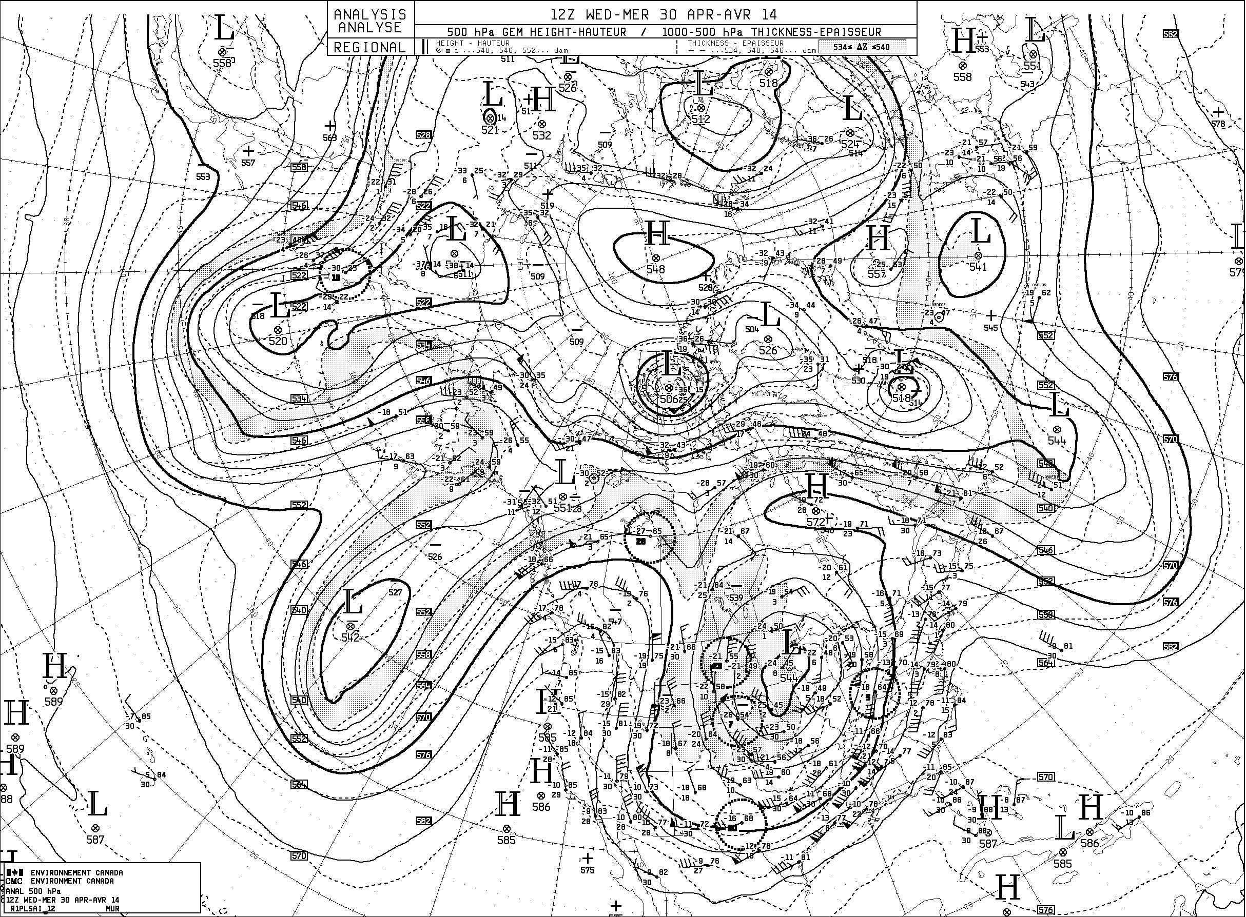By the morning of Wednesday, April 30, 2014 the 500mb flow pattern ***had evolved*** into a very wavy ***large*** ***amplitude flow***. Note the upper level ridge now anchored off the west coast of the US, and the large upper level troughs over the central US and central Atlantic Ocean. This fits closely with the pattern in figure 1. While we can’t yet prove the climatic teleconnections to the Arctic, the resultant meridional flow results in slow eastward progression of weather patterns. It certainly seems we have been locked into an unsettled weather pattern with rain and showers in our region. The narrow yet enhanced upper level ridge over New Enland and eastern Canada (between the two lows) gave us dry weather on April 29.

Fig 3: 12z 500mb Apr 30, 2014 Environment Canada. Note increasingly meridional flow across northern hemisphere.

The National weather Service (NWS) long term national forecasters caught this in their discussion on Sunday, April 27, 2014 as noted below (with my emphasis added):

EXTENDED FORECAST DISCUSSION

NWS WEATHER PREDICTION CENTER COLLEGE PARK MD

1118 AM EDT **SUN APR 27 2014**

VALID 12Z WED APR 30 2014 - 12Z SUN MAY 04 2014

...PATTERN OVERVIEW...

***A BLOCKY FLOW PATTERN*** *CONTINUES THIS WEEK AS HIGHLIGHTED ALOFT*

*OVER THE NATION BY AN AMPLIFIED WARMING* ***RIDGE OVER THE WEST COAST***

*AND A* ***CLOSED LOW/TROUGH OVER THE EAST-CENTRAL US****. A DEEP SURFACE*

*LOW AND WRAPPED MODEST PCPN WILL SLOWLY TRACK FROM THE GREAT LAKES*

*WED/THU AND ERN CANADA FRI-SAT...BUT LOCALLY HEAVIER CONVECTIVE*

*ACTIVITY SHOULD LINGER THIS WEEK ALONG A MULTI-WAVE TRAILING FRONT*

*OVER THE ERN AND ESPECIALLY SERN US. THIS ALL OCCURS* ***AS THE SLOW***

***MOVING MEAN TROUGH*** *IS PERIODICALLY REINFORCED AS IMPULSE*

*ENERGY/SURFACE FRONTS WITH LIMITED PCPN IN* ***UNSEASONABLY COLD AIR***

***DIG DOWN FROM CENTRAL CANADA*** *DOWNSTREAM OF A DEVELOPING REX BLOCK*

*AS A RIDGE HELD OVER AK AND ANOTHER CLOSED LOW/TROUGH WORKSUNDERNEATH*

*OVER THE NERN PACIFIC. THIS DEEP SYSTEM AND UNSETTLED WEATHER/PCPN SHOULD*

*PROVE SLOW TO APPROACH THE NWRN US NEXTWEEKEND.*

The local Burlington NWS Forecast office also mentioned these slow moving features in their discussion (again I added the emphasis):

.LONG TERM /WEDNESDAY THROUGH SUNDAY/...

AS OF 357 PM EDT SUNDAY...***SURFACE LOW WILL CONTINUE TO MEANDER***

OVER THE GREAT LAKES REGION ON WEDNESDAY WITH COLD FRONT LIFTING

ACROSS THE NORTH COUNTRY WEDNESDAY NIGHT. WEDNESDAY NIGHT WILL

FEATURE THE HIGHEST POPS...THOUGH ***ALMOST ALL PARTS OF THE***

***EXTENDED WILL MENTION AT LEAST A CHANCE FOR PRECIP AS SEVERAL***

***SHORTWAVES ROTATE AROUND UPPER LEVEL TROF WHICH REMAINS ANCHORED***

***OVER THE GREAT LAKES REGION FROM WEDNESDAY THROUGH FRIDAY NIGHT.***

OVER THE WEEKEND THE AFOREMENTIONED UPPER TROF WILL FINALLY TRACK

EASTWARD...NORTH OF THE INTERNATIONAL BORDER. DAYTIME MAX TEMPS

WILL TREND TOWARDS NORMAL AFTER STARTING OUT BELOW NORMAL AND MIN

TEMPS WILL BE NEAR NORMAL. GMOS AND ECMWF ARE PRETTY CLOSE ON

The numericals models caught this flow pattern and allowed meteorologists to forecast potentially hazardous weather well in advance. The European forecast model depicted the slow moving nature of the surface patterns in the western Atlantic and the western and central US from April 26 through May 2, 2014 (figure 5). The US GFS model also catured this feature.

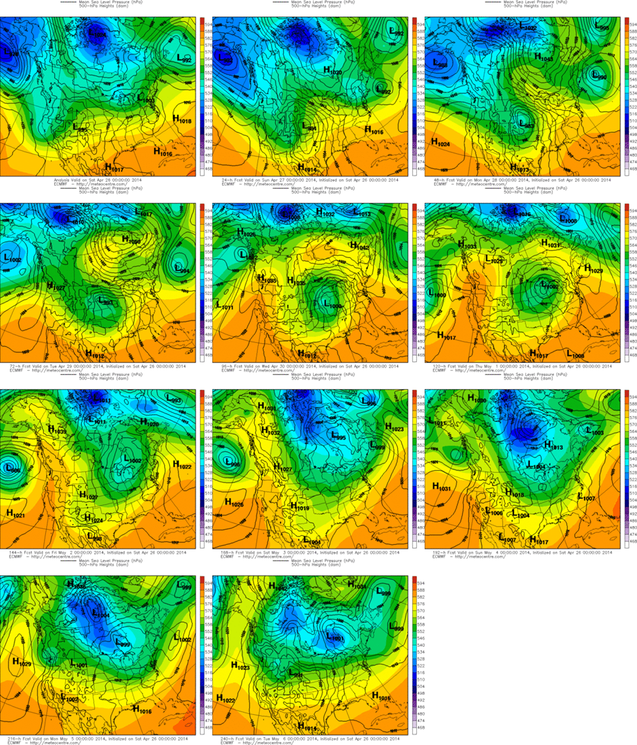

ECMWF model surface weather features April 26 – May 2, 2014. Courtesy:Meteocentre.com

Finally, satellite imagery helped forecasters both verify the numericals output and monitor the progression of this pattern. The imagery from April 28th highlights the blocking low over the Atlantic south of Nova Scotia. The swirl of clouds over Nebraska and Kansas indicates the evolving midwestern storm system, and the opening of the Gulf of Mexico as a moisture source noted by the plume of clouds from the Texas coast north into the Missouri Valley.

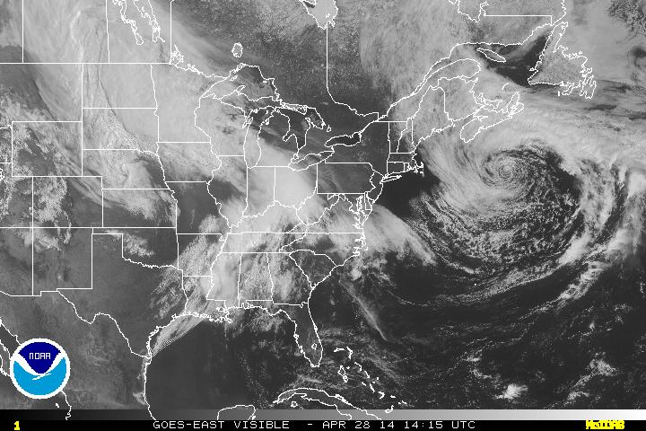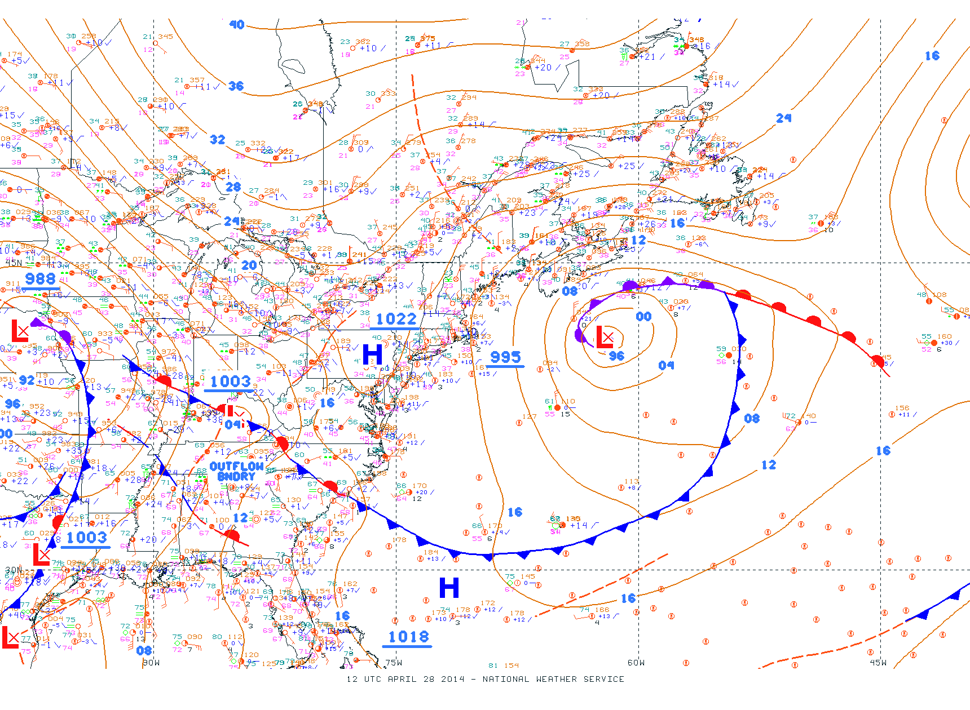

Figure 6: Satellite imagery (1415z) and surface map (12z) both April 28. Courtesy NOAA/NWS.

**Conclusion**

It is not the goal of this brief SWAC review paper to either prove or disprove the link of arctic amplification to meriodonal flow in the mid-latitudes***. However, it is known that with increased amplitude (meriodonal flow) in the upper level flow pattern, the eastward progression of weather systems slows down***. As stated by Francis, this increased amplitude results “in slower moving circulation systems. More prolonged weather conditions enhance the probability for extreme weather due to drought, flooding, cold spells, and heat waves. The second effect is a northward elongation of ridge peaks in 500 hPa waves, which amplifies the flow trajectory and further exacerbates the increased probability of slow-moving weather patterns.”

These slow moving weather systems impact the amount of moisture squeezed out of the atmosphere over a particular region, whether a synoptic storm system or a band of thunderstorms training over a particular region. ***The slow moving large amplitude flow during the last week of April 2014 resulted in both prolonged severe thunderstoms and tornadic activity across the midwest and Tennessee valley regions as well as excessive rainfall in the Gulf States*** (note newspaper article in references).

Understanding the signs of these patterns setting up in advance leads to an informed citizenry that is better able to protect itself. Weather agencies such as ***the NWS working with media and emergency management officials are able to get the weather word out to the public***. However, it is incumbent upon the public to be ***educated to what that weather word means and what action(s) to take***. ***SWAC certainly can have a role in educating our young citizens in this arena.***

**Referrences**

1. Francis paper on Arctic Amplification

http://marine.rutgers.edu/~francis/pres/Francis_Vavrus_2012GL051000_pub.pdf

2. Newspaper article on Gulf States flooding April 2014

http://www.nola.com/weather/index.ssf/2014/04/severe_weather_causes_historic.html

(S. Hogan SWAC Apr 2014)