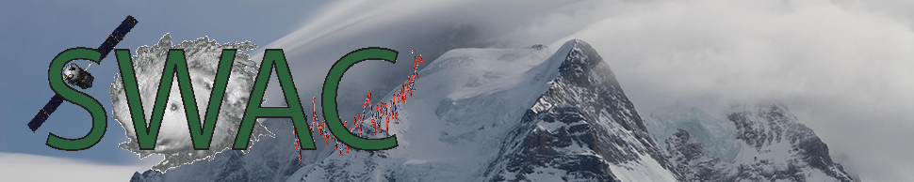

Satellites, Weather, and Climate (SWAC) Teachers Summer Institute

16-18 July, 2014 New Teachers

30 June-2 July, 2014 Returning Teachers
The Satellites, Weather and Climate (SWAC) professional development program at the University of Vermont (UVM) and Lyndon State College (LSC) is pleased to invite in-service K-12 science and mathematics teachers to the 6th annual SWAC Summer Institute. Come and acquire content knowledge in meteorology and climatology to implement in your geography, earth science, physics, chemistry and math classrooms. You will also become skilled in the use of satellite imagery for stimulating your students’ interests in the world around them. Participating teachers will receive a yearly stipend and meet monthly during the school year to become even more proficient in the topics learned during the summer institute. SWAC relies heavily on models of problem and project-based learning, the reciprocity of service-learning and involves student engagement and peer mentoring at the K-16 levels. Summer accommodations are available for teachers outside of Chittenden County. We utilize the videoconferencing capabilities of the CISCO WebEx and Learning Network of Vermont to allow all teachers to fully participate regardless of distance.
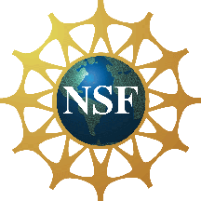
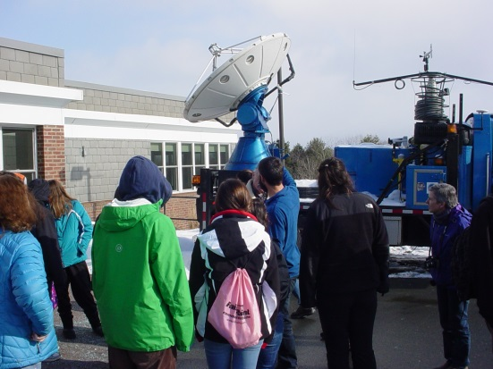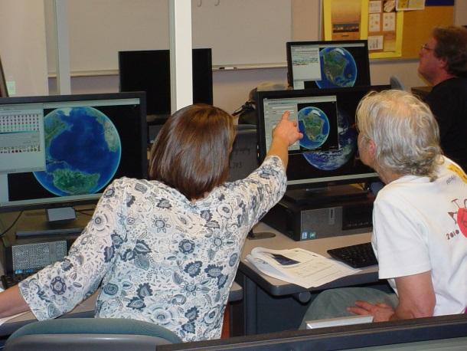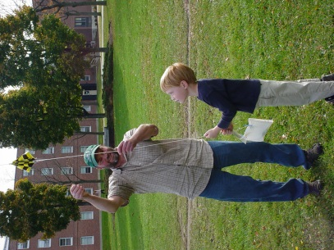
For more information and registration details please contact by 15 May 2014:
Dr. Lesley-Ann Dupigny-Giroux at
ldupigny@uvm.edu or 802-656-2146 (phone)
http://www.uvm.edu/~swac

PLEASE RETURN ONLY THIS PAGE OF THE REGISTRATION

SWAC 2014 REGISTRATION

NAME:____________________________________________________________________
SCHOOL:__________________________________________________________________
ADDRESS:_________________________________________________________________
E-MAIL:___________________________________________________________________
(please include one that is accessible during the summer as well)
GRADE(S):__________________________________________________________________

EXPECTATIONS FROM PARTICIPATING IN THE SWAC PROGRAM
___________________________________________________________________
___________________________________________________________________

Please return this form to Dr. Dupigny-Giroux by 15 May 2014
Go to http://www.uvm.edu/filetransfer, select “send a file”, then “sending a file to a UVM affiliate” and enter ldupigny@uvm.edu in the recipient email address box and upload your form.
Dr. Lesley-Ann Dupigny-Giroux
Department of Geography - University of Vermont
200 Old Mill Building
94 University Place
Burlington, VT 05405-0114

ldupigny@uvm.edu 802-656-2146 (phone)

