CITI Login and Course Completion
- Open your browser and go to https://www.citiprogram.org.

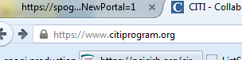

- Click “Log In” which is located at the top right of the CITI page.
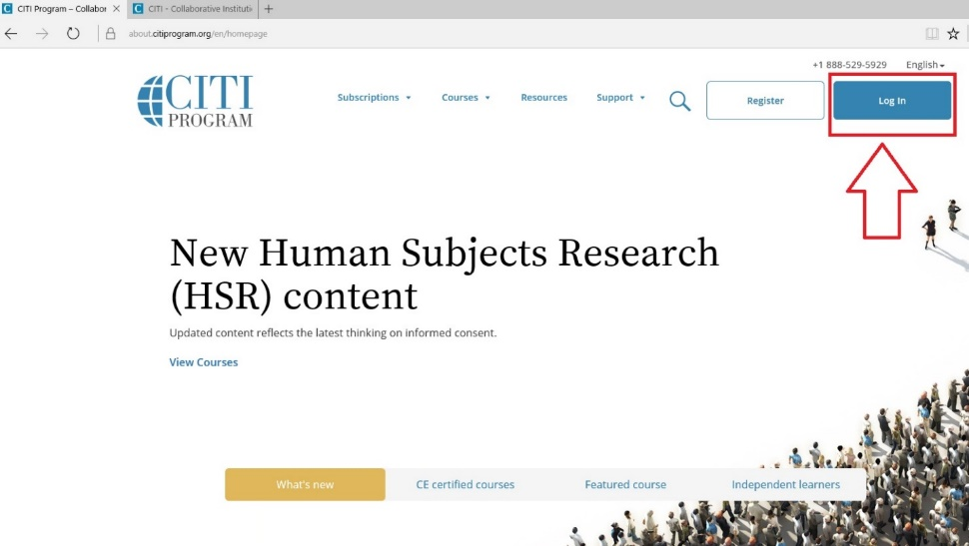
- Then, click "Log In Through My Institution", scroll down to click on “University of Vermont” and use your UVM Net ID and password to sign in.
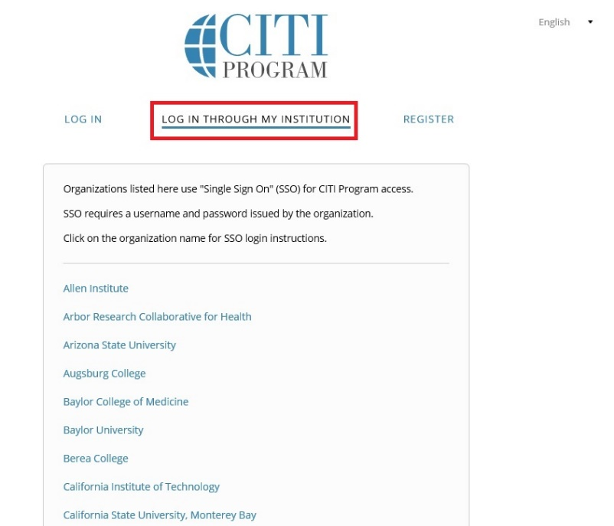

  - Make sure you have an active UVM NetID in order to log in. If you haven’t updated your password in the past year, you may need to go to https://www.uvm.edu/account/ to change your NetID password or reset a forgotten password.
  - If you don’t have an active UVM NetID, you may complete the Request for UVM Net ID for Required Training form and submit it to the RPO.

- If you haven’t associated your UVM account with CITI, you’ll see the following screen (see below). Click the “Continue” button. If you don’t see this screen, proceed to step 6.
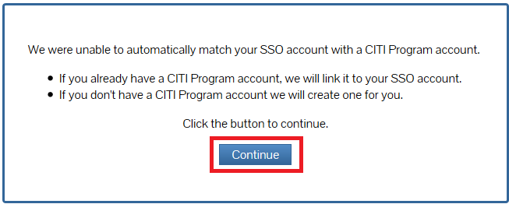

- If you have set up a CITI account in the past, choose the first option and follow the instructions to link your UVM account. Otherwise, choose the second option (shown below) and click “Click here to create a new CITI Program account.”
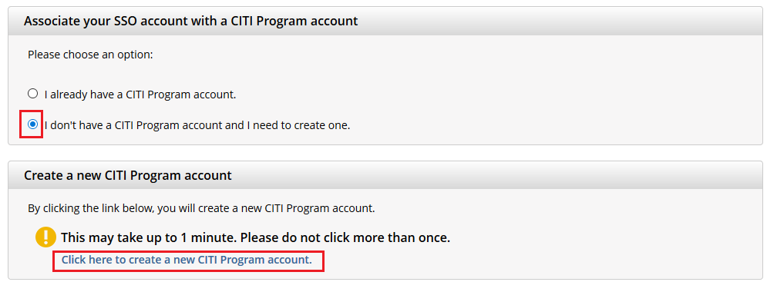
- From the Main Menu, click on “University of Vermont Courses”. Then, click “Add a Course.” 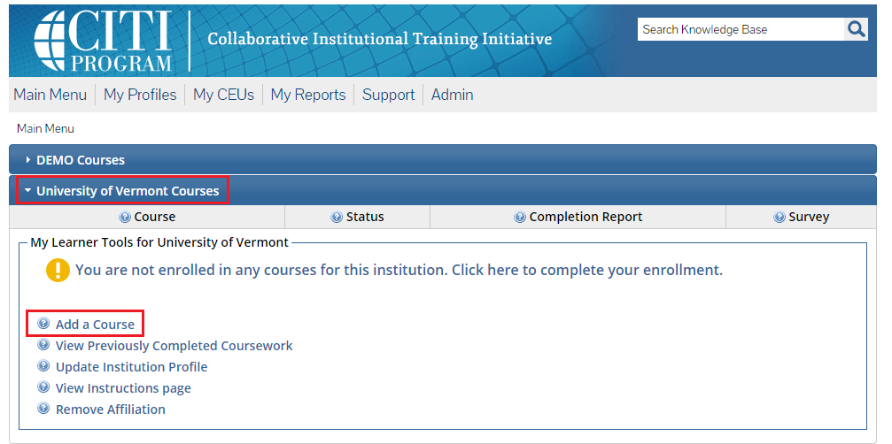

- On the following screen, check “IRB – Human Subjects” if you are PI or research personnel and click Next. Please note that the “GCP – Good Clinical Practice” should also be checked if you are PI or clinical research personnel on a clinical trial.
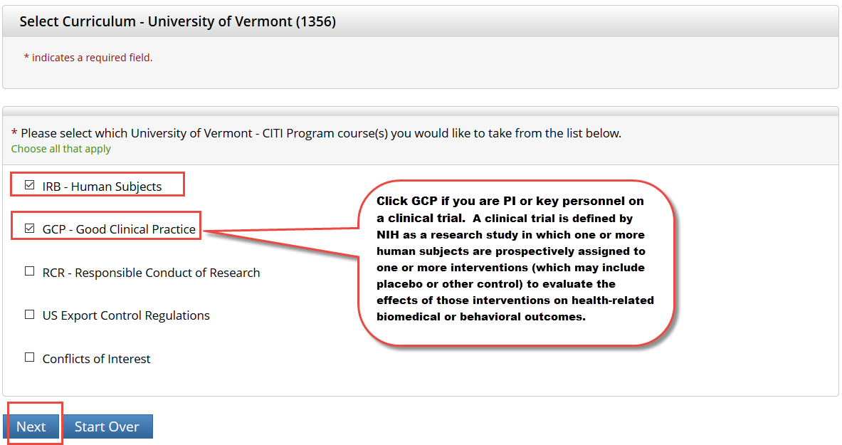

- Then, choose the applicable options and click Next. Please note that the “Biomedical Research” or “Social Behavioral Education Sciences” option will fulfill the UVM Human Subjects training requirement.
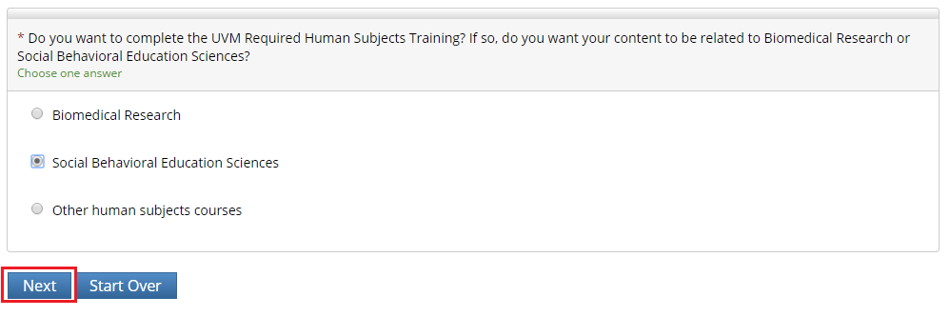
- Answer as applicable and click Next.
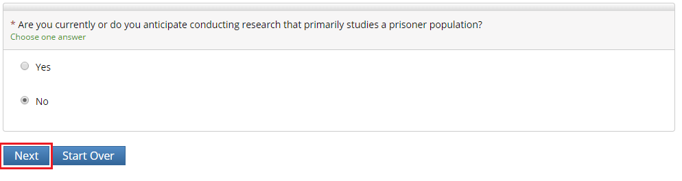
- Then, choose the “Good Clinical Practice” course if you are PI or clinical research personnel on a clinical trial and click Next. Please note that when you select the “Good Clinical Practice Course for Clinical Trials Involving Investigational Drugs (ICH / international focus)” this is same as “GCP for Clinical Trials with Investigational Drugs and Biologics (ICH Focus)” and the course does include the Biologics component.
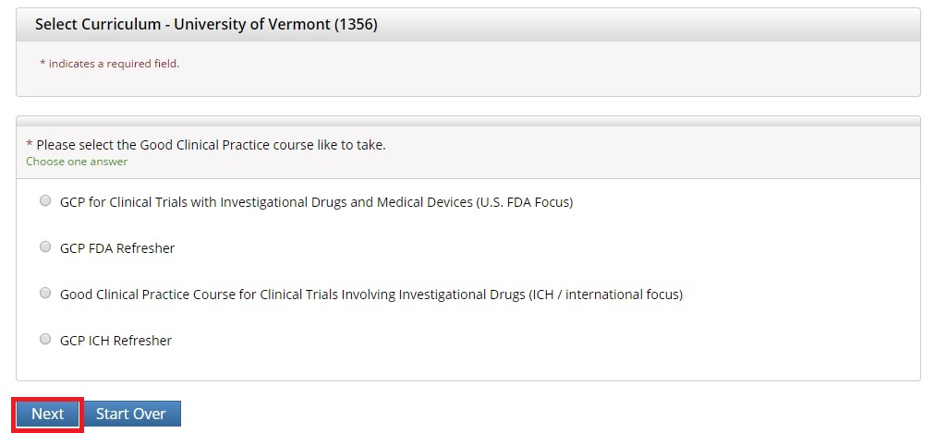
- The course(s) will now be added to your UVM course listing! Click on the newly added course within “University of Vermont Courses” to begin the training.
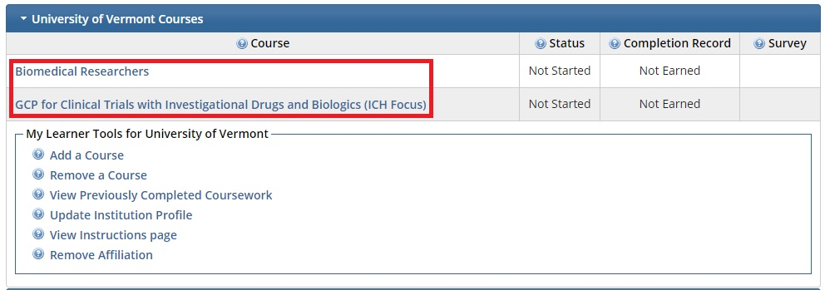
- Complete the Integrity Assurance Statement and then begin working through the course modules. Note that you only need to take the modules listed under “Required Modules” to complete the course.
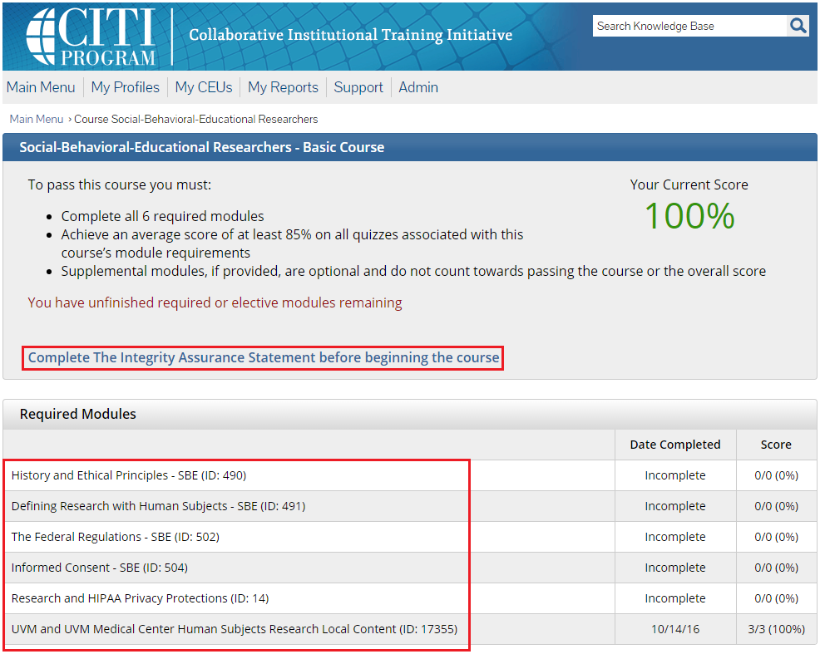

Note: The supplemental modules are available to you as a member of the UVM research community.

