Introduction

Savelsberg and King believe trials produce lasting effects on collective memory. Further, Maurice Halbwachs believed accounts of the past to be “largely, if not entirely, reflecting the interests of present-day actors and institutions” (Savelsberg & King, 19). These actors, and carrier groups, shape what reaches the public. Ronnie Golz has initiated and designed a memorial seeking to educate Berlin residents and tourists about Adolf Eichmann, a Nazi responsible for the deportation and killing of millions during the Holocaust. This paper will look at the Eichmann trial and commemoration of it today, specifically in Berlin, in order to contemplate what makes a memorial successful and what may have elicited its construction in the first place. Memorials set in the vernacular space are proposed as more effective than those set apart from everyday life, however whether or not people actually notice and then absorb the information is questionable. The Eichmann Bus Shelter presents an opportunity for conscious reflection on the past, an important component of historical consciousness (Savelsberg & King, 128). What it lacks may be interested readers who fully absorb the content presented, making it little more than an ordinary, unrecognizable bus shelter.
Law and Memory

“Unless we write the record of this movement with clarity and precision, we cannot blame the future if in days of peace it finds incredible the accusatory generalities uttered during the war. We must establish incredible events by credible evidence.”
–Justice Robert Jackson, on the Tribunal at Nuremberg

Savelsberg and King’s book, American Memories: Atrocities and the Law, studies the ways law affects and is affected by American memories of atrocities. The book focuses on American memories committed by Americans and others in order to gain insight into what shaped these memories. While legal proceedings are viewed as strong shapers of collective memory, it is acknowledged that they may not paint the whole picture. What is remembered from trials is shaped by sources that disseminate the facts to the public, often resulting in simplification and even more selectivity. The book seeks to understand the causes and effects of collective memory as it relates to the law.
Chapter 1 begins the book’s argument that criminal trials against perpetrators of human rights violations create collective memories of atrocities and block forgetting. When legal or quasi-legal proceedings have taken place in Germany, Chile, Iraq, and South Africa (and more), the authors believe they strongly formed collective memory and reduce the likelihood of repetition (Savelsberg & King, 3-4). Collective memory is the cultural mechanism that allows for both direct and indirect counteractions of violence (Savelsberg & King, 8). The book will study the ways legal proceedings disseminate memory, acknowledging that collective memories are socially constructed and thus are constantly mediated and filtered by present-day actors (Savelsberg & King, 9-10).
Collective memory and collective trauma belong to groups of people, not simply the individual (Savelsberg & King, 16). While history is an inclusive chronicling of the past, collective memory is more selective and malleable (Savelsberg & King, 17). Maurice Halbwachs importantly believed that accounts of the past are “largely, if not entirely, reflecting the interests of present-day actors and institutions” (Savelsberg & King, 19). Memories of the past are not universal, even within cohorts. Mnemonic struggles occur when groups are in conflict and argue for their own legitimacy, and can lead to changes in collective memory (Savelsberg & King, 21-22). Collective memory is the product of legal proceedings, but also truth commissions, art, museums, and the media (Savelsberg & King, 26). While truth commissions may provide evidence for future trials, they are distinct in their aim to integrate actors back into society, instead of the law’s focus on “othering” (Savelsberg & King, 28-29).
The My Lai massacre of 1968 was expected to be “seared into the American consciousness”, however the memories of later generations are not consistent with this expectation (Savelsberg & King, 35). Savelsberg and King look at media and textbook depictions of the massacre after trials, which show the selectivity of information before it reaches a broad audience. Textbooks focus on Lt. Caller as culpable and a collective forgetting of the larger circumstances around the event takes place (Savelsberg & King, 46-47). Americans continue to express great military pride, showing that My Lai did not have an enduring affect (Savelsberg & King, 49). The analysis in Chapter 3 confirms the authors’ thesis: when low-level perpetrators are put on trial and found guilty, “effects of law on the formation of collective memory are undermined” (Savelsberg & King, 52).
The pasts highlighted by the government carry particular weight and affect the collective memory of a nation. While both America and Germany have histories of hate and cruelty, trials have played a more important role in addressing German atrocities (Savelsberg & King, 108). America remembers past inhumanity by commemorating the individuals who fought against cruelty, while Germany acknowledges past evil more directly with the Day of Commemoration of the Victims of National Socialism Day (Savelsberg & King, 111). The authors argue that Germany remembers these days because they were addressed in a court of law. American memory focuses on glory, pride, and foreign evil, but evades acknowledgment of our own atrocities. Arguably, the legal response against perpetrators during the Nazi regime solidified both German and American collective memory. The lack of legal response in the United States perpetuates an image of a heroic nation.
Memories may mobilize social change by inspiring “social movements activity, even nourish(ing) revolutions” (Savelsberg & King, 123). Law may be influenced by analogies presented by collective memory. As an example, “drawing parallels between the Holocaust and the treatment of Japanese in the United States helped secure formal apologies along with legal recourse” (Savelsberg & King, 127). Historical consciousness is another socially constructed and changing component of memory. This consciousness involves conscious reflection on the past (Savelsberg & King, 128). Carrier groups are necessary to mobilize support by reminding people of past atrocities (Savelsberg & King, 129). Analogical bridging, historical consciousness, and carrier groups are vital components of collective memory and its influence on law (Savelsberg & King, 133).
In the same way that the My Lai massacre of 1968 was expected to be imprinted into the American consciousness, it was hypothesized that the Eichmann trial of 1961 would leave lasting impressions on the world. While the trial brought victims of the Holocaust to the forefront, Adolf Eichmann may not be as widely remembered today as was predicted. Criminal trials against perpetrators of human rights violations do seem to create collective memories of atrocities and block forgetting, but the memorial to Eichmann’s violations lacks the widespread notice that the trial elicited and therefore may do little to foster collective memory or block forgetting.
Remembering Eichmann

Adolf Eichmann coordinated the deportation of millions of Jews and Roma to killing centers and was a member of several criminal organizations (ushmm.org). After the war, he fled to Argentina and lived under a fake name (ushmm.org). He was captured in 1960 and went on trial in Jerusalem in 1961 (ushmm.org). The televised trial captured worldwide attention. It represented the first time many people had learned details about the Holocaust (NPR Staff 2011). Witness testimonies provided the most striking accounts of the horrors committed. In contrast to the document focus of the Nuremberg trials, Eichmann’s trial expressed and elicited emotions. Deborah Lipstadt, historian and professor of religion and Holocaust studies at Emory University said, “There was a march of survivors, I would say approximately 100 survivors, who came into the witness box and told the story of what happened to them. And people watched them and listened to them and heard them in a way they hadn’t heard them before” (NPR Staff 2011).
The Eichmann trial of 1961 raised awareness for young people and Holocaust survivors previously unrecognized. Before the trial, Israel was in a time of suppression and forgetting, trying to build itself as a state (Hoare 2015). Israel was significantly affected by the trial, as it created a new legal category: “crimes against the Jews” (Yablonka & Tlamin 2003). The Holocaust became a central narrative in Israel. The trial solidified the Holocaust as part of Israeli collective memory. The televised trial seared images into the public, of witnesses and Eichmann himself. Israel chose the death penalty for Eichmann in 1962, the first and only time the state has ever done so. At the end of the trial, one of the judges said, “We are not required (to give the death penalty)…we chose to do so because you are deserving of the death sentence” (NPR Staff 2011).
Roger McLaughlin reviewed a 1966 study that tested the public’s knowledge (in Oakland, CA) of the Holocaust in general and the Eichmann trial specifically. While 84% of respondents were aware of the trial, only 13% could answer four simple questions about Eichmann and his capture (McLaughlin 1970, 575). However, most respondents rejected all items that were used to assess anti-Semitism (McLaughlin 1970, 576). While people endorsed the trial, it seems to have been based largely on social conformity, bringing “a sense of uneasiness to those who recall the same apathetic acceptance of the murder of Jews” before and during WWII (McLaughlin 1970, 576). McLaughlin’s review may present parallels between the predictions of My Lai becoming engrained in American memory. The Eichmann trial was an international spectacle but could have had less impact on people who were not directly affected by the Holocaust or the trial’s outcome.
In Germany, the Eichmann trial is specifically commemorated at the site of Adolf Eichmann’s office in Berlin. The building was destroyed during the trial, but a bus shelter at the location now displays pictures and information (TracesofWar.com). This site is part of a larger Bus Shelter Project initiated by Berlin artist and resident Ronnie Golz. The website for the United States Holocaust Memorial Museum presents information about conferences. In 2011, a conference addressing the Eichmann trial took place in Berlin, another way Germany (as well as the U.S. by mention), continues to remember the trial and its affect on international memory.
While memories of the trial have undoubtedly faded over the years, it continues to spark attention. Just this past month, BBC premiered The Eichmann Show, examining how the trial was televised and garnered international attention (Honan 2015). Reactions to the drama appeared on social media forums, people saying it was “brilliant and sobering…never knew that it was the trial which first brought the Holocaust home to millions” (Wyatt 2015). A German citizen wrote, “I really hope…German channels will pick up (the show) to remind us that we can never let anything like this happen again” (Wyatt 2015). While people may not have known specifics about the Eichmann trial, dramatized accounts today remain relevant ways for people to remember.
The Eichmann Bus Shelter Project

Berlin is littered with monuments and plaques commemorating different aspects of the Holocaust. In a city so inundated by concerns about the past, Ronnie Golz argued, “Knowledgeable and politically involved citizens in general visit memorials and memorial sites. A memorial site positioned in the midst of day-to-day life could perhaps reach less interested citizens” (Golz). Bus stops are places people stand for shorter periods of time and the bus schedule interrupts the “smooth flow of daily life” (Golz). Golz believed that, by catching people’s attention unaware, the posters could successfully tell them something about where they were. The memorial set in the “vernacular space of the city create(s) a relationship between everyday space, memory and lived experience” (Gould & Silverman 2012, 2). After gaining the approval of public transport bus shelter owners, Golz was able to turn a non-existent site into a memorial. The stop features two large posters, in German and English, which provide a brief history of Eichmann and site itself.
Jennifer Jordan’s study of post-1989 Berlin argues, “Both plaques and larger memorial sites constitute a form of collective memory refracted through bureaucratic and political processes, the work of activists and historians, and the actions of passersby” (Jordan 2007, 14). The larger structure of a given society, residents, and unassuming visitors determine the collective memory at a particular site. The Bus Shelter Project represents the work of a local activist, Topography of Terror historians, and relies on public reception and perception. These sites can be reclaimed as memorials but their effect is dependent on consumers that may be unaware and uninterested. Mr. Golz says that, almost two decades after the creation of the Eichmann shelter in 1998, he “continually sees bus passengers reading the two posters while waiting for the bus.” However, media coverage of the shelter has, naturally, stopped since the inauguration in December 1998. “Memorial work may contribute to certain kinds of social integration” but the extent possible seems limited by the types of people likely to be at a given site (Jordan 2007, 5). The Eichmann shelter is located on a popular Berlin bus line with access to numerous tourist destinations. Therefore, many of the passersby are likely tourists single-mindedly on their way to a different monument or historic site with little desire to look out for other, less prominent, memorials.
Ronnie Golz’s idea of creating memorials within bus shelters is, however, a good one in its attempt at demystifying the past. Jonathan Bach wrote, “the key task for memory sites is to unmask, and thereby make legible, the respective magical belief systems and attendant crimes of the National Socialists…” (Bach 2013, 2). If Bach is correct and demystifying the past is the goal of memory sites, then the bus shelter provides ample opportunity to do so. However, the true strength of its demystification may lie in whether or not readers absorb and remember the information. It has been shown that museum visitors are most likely to learn through their visit if they enter with previous knowledge. There is no way to measure what people truly learn via the bus shelter posters but the fact that they exist is a step towards unmasking what happened during the Holocaust.
The “memory landscape” of Berlin has been used to “refer to the overwhelming number of memory sites, from barely noticeable plaques to massive monuments that together have come to forge an urban identity for Berlin as a city of commemoration” (Bach 2013, 1). While both America and Germany have histories of hate and cruelty, trials have played a more important role in addressing German atrocities (Savelsberg & King, 123). According to Savelsberg and King’s argument, collective memory formed via trials after the Holocaust. These trials brought perpetrators to the forefront and, today, have effected the commemoration of the country’s difficult past. In a city of commemoration, it is likely that one bus stop is often lost among the crowd. Ronnie Golz, the designer and initiator of the project, gives tours to Berlin visitors, taking these tourists to see the location of Eichmann’s office and Golz’s memorial. Tours that include visits to smaller sites of memory perhaps provide a more complete visit to Berlin and increase understanding of German history. Particularly, Gould and Silverman (2012) highlight the importance of vernacular memorials. These memorials ground historical memory and are set in the confines and routines of everyday life, potentially making them more important than large, overly done monuments set apart from daily life.
The effects of any given marker “cannot be guaranteed, but such objects do constitute one of the ways people live with memory and with the past” (Jordan 2007, 10). While the effects of The Bust Shelter Project may be relatively unknown, it enables people to live among the past and form memories that surround it and therefore prevent, to a certain extent, collective forgetting. It may be argued that sites like the bus shelter are more helpful in preventing forgetting than large monuments that provide little, if any, context for their existence. The Eichmann shelter is focused on providing information to the public (albeit in a condensed form) and may be viewed as more important than an inaccessible monument. This small memorial contributes to a broader reckoning with a national past and is the result of “civic participation (and arguably social integration) of a range of Berlin’s residents…” (Jordan 2007, 15). Formed through the efforts of one Berlin resident, it represents the memorial needs of the city’s citizens rather than of the government. However, Savelsberg and King argue that pasts highlighted by the government carry particular weight and affect the collective memory of a nation. It seems likely that smaller memorials, set within in a vernacular space, have less of an impact on the formation of collective memory.
Conclusion
The importance of trials in establishing collective memory is not clearly portrayed through the Eichmann bus shelter. One sentence of the posters mentions the 1961 trial of Adolf Eichmann. However, the trial remains necessary for the way it brought up components of the past. Regardless of its mention in conjunction with Eichmann and the memorialization of his deeds, the trial served as a way to shed light on the Holocaust, perpetrators, and specifically, victims. Marianne Hirsch conceptualized the process called “postmemory”, whereby individuals understand historical events through other people’s memories. For those too young in 1945, the Eichmann trial provided an opportunity to establish postmemory. Similarly, memorials today, even small ones, have the power to establish a relationship with a past not directly experienced. Germany is a unique place of remembrance - “rarely does a nation call upon itself to remember the victims of the crimes it perpetrated” (Gould & Silverman 2012, 7). The urban landscape of Berlin, scattered with sites of memory, memorializes wrongs committed by citizens, something rarely seen in the United States. American memory continues to focus on glory, pride, and foreign evil, evading acknowledgement of our own atrocities. The legal response against perpetrators during the Nazi regime, according to Savelsberg and King, solidified both German and American collective memory creating a city (Berlin) scattered with memorials to different aspects of the Holocaust.
Savelsberg and King believe trials are strong shapers of collective memory. An in-depth look at the creation of one memorial related to the trial of Adolf Eichmann may provide insight into what constitutes a successful site of memory and the lingering effects of one trial. While the Eichmann shelter does not thoroughly address the trial, Eichmann himself did not receive widespread attention for his crimes until the trial began and was aired on televisions across the world. The widespread media coverage of the trial and the inclusion of victim testimony created an emotionally laden event. Therefore, the fact that a memorial exists at all can be linked to the dissemination of information during and after Eichmann’s trial. While the media inevitably further shapes and simplifies events, the coverage meant that people could begin to see the widespread effects of the Holocaust and understand that it could not be forgotten. The Eichmann Bus Stop Shelter allows the creation of historical memory within a lived, vernacular setting but the effects on collective memory are likely small. While a vernacular setting appears promising, the extent to which people notice and actually absorb the information is far less promising. Ronnie Golz has been a present-day actor to bring Eichmann and his past to light. He decided that a place and figure should be remembered and made it happen. Legal proceedings disseminate memory, but collective memories are socially constructed and therefore constantly mediated and filtered my present-day actors actively trying to block collective forgetting.

Appendix:
Paris – Holocaust museum: The museum has a specific exhibit on the Eichmann trial that acknowledges its international effect and mentions a comparison to Nuremberg. The exhibit presents document photos as well as videos of the trial.

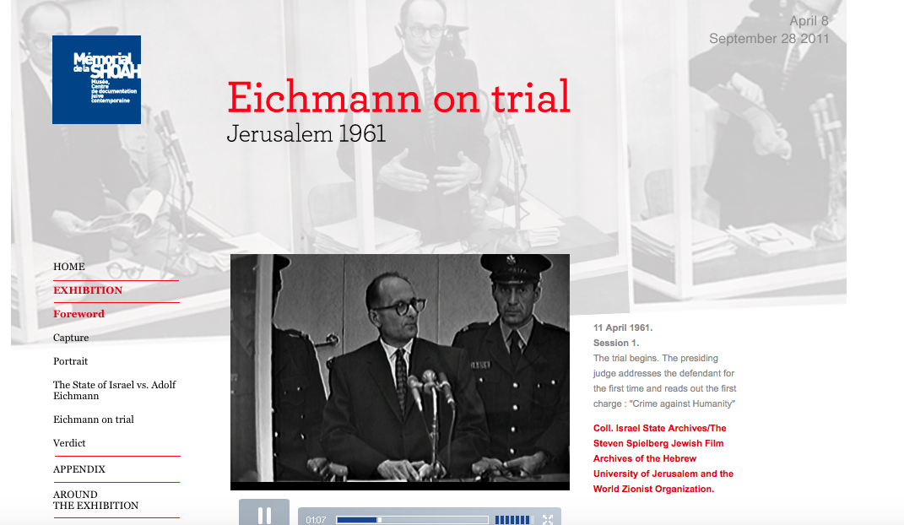

United Kingdom – The Eichmann Show: This drama aired on BBC but there is evidence that people outside of the UK watched it. It was clearly a source of learning as well as a reminder of what happened.
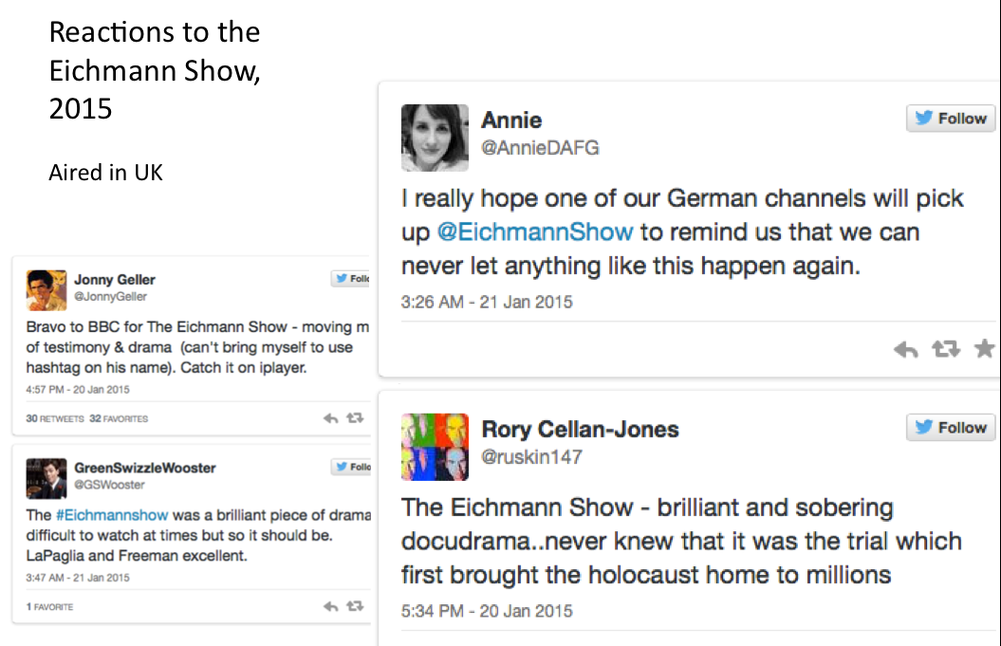

Germany - Bus stop memorial: Located at the site of Eichmann’s office in Berlin. As a bus stop shelter, it is likely that many people stand there but whether or not they read the text is unknown. It could easily be a memorial that produces no affect to the public. However, if someone did read it information is given so they would learn the context and outcome of the Eichmann trial.

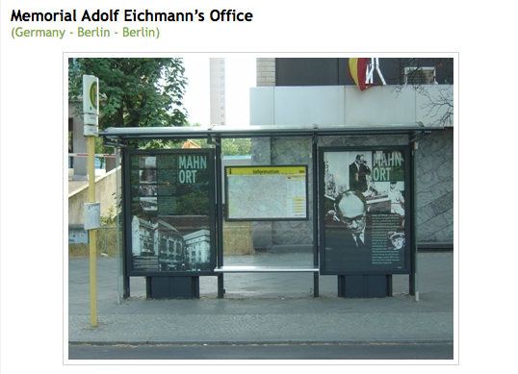

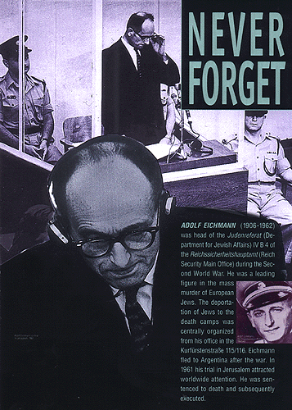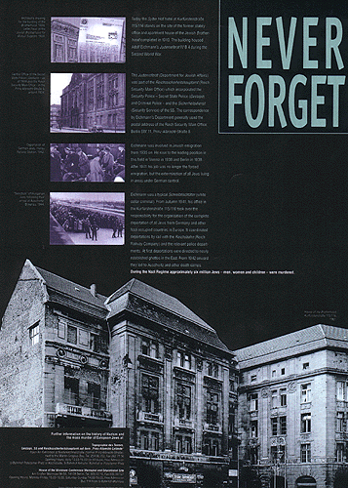

Ronnie Golz, left, at the unveiling of another Bus Stop Shelter in 2007. In total, Golz has initiated five Bus Stop Shelters at sites related to the Holocaust in Berlin.

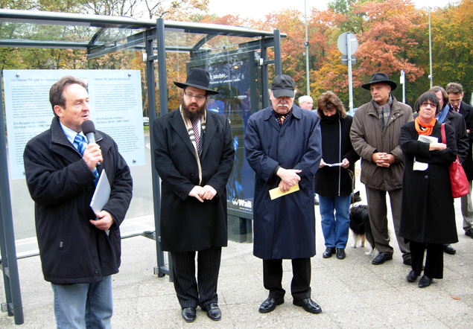

References:

Bach, Jonathan. 2013. “Memory Landscapes and the Labor of the Negative Berlin.” International Journal of Politics, Culture, and Society 26:31-40.

Eichmann on Trial. (2011). Retrieved from http://juger-eichmann.memorialdelashoah.org/index-en.html

Golz, Ronnie. “Never Forget.” Webfelix. http://www.rgolz.de/i-ronnie-memorial.html.

Gould, Mary R. and Rachel E. Silverman. 2012. “Stumbling Upon History: Collective Memory and the Urban Landscape.” GeoJournal 78:791-901.

Hoare, L. (2015, January 21). Was Eichmann Trial 'Most Important TV Event'? Retrieved from http://blogs.forward.com/the-arty-semite/213210/was-eichmann-trial-most-important-tv-event/?

Honan, C. (2015, January 21). Monster Who Wished 10 million Jews Had Been Murdered. Retrieved from http://www.dailymail.co.uk/news/article-2920791/Monster-wished-10-million-Jews-murdered-week-s-TV-drama-Eichmann-s-trial-new-book-reveals-horror-man-claimed-just-small-cog-Nazi-machine.html

Jordan, Jennifer A. 2007. “Memorial Projects as Sites of Social Integration in Post-1989 Berlin?” German Politics & Society 24(4):77-94.

McLaughlin, R. (1970). The Apathetic Majority: A Study Based on Public Responses to the Eichmann Trial. by Charles Y. Glock; Gertrude J. Selznick; Joe L. Spaeth. American Sociological Review, 35(3), 575-576. Retrieved from JSTOR.

Memorial Adolf Eichmann’s Office. (n.d.). Retrieved from http://en.tracesofwar.com/article/3035/Memorial-Adolf-Eichmanns-Office.htm

NPR Staff. (2011, March 27). The Eichmann Trial: Fifty Years Later. Retrieved from http://www.npr.org/2011/03/27/134821325/the-eichmann-trial-fifty-years-later

(2014). Retrieved from http://www.ushmm.org

Wyatt, D. (2015, January 21). The Eichmann Show: Twitter reactions to 'powerful and important' Holocaust trial drama. Retrieved from http://www.independent.co.uk/arts-entertainment/tv/news/the-eichmann-show-twitter-reactions-to-powerful-and-important-holocaust-trial-drama-9991901.html

Yablonka, H., & Tlamin, M. (2003). The Development of Holocaust Consciousness in Israel: The Nuremberg, Kapos, Kastner, and Eichmann Trials. Israel Studies, 8(3), 1-24. Retrieved from JSTOR.

