MIGRATING YOUR PCBACKUP FROM YOUR HOME DIRECTORY ON ZOO,
TO THE NEW /BACKUP FILE SYSTEM

1. Create your own directory on the /backup system. Italicized characters are ones you type into the telnet zoo prompt.

Log into zoo with SSH-terminal, set the terminal type to vt100, and get to your zoo> prompt. Then change directories into the backup directory:

zoo> cd /backup

Next, create your own directory in the /backup space using the mkdir unix command:

zoo> mkdir YourLoginName

YourLoginName is your NetId so the command should look something like:

zoo> mkdir jstudent

Then, change directories into your newly created directory:

zoo> cd YourLoginName

Once again YourLoginName is your NetID, so the command should look:

zoo> cd jstudent

Next, issue the “print working directory” command, or pwd:

zoo> pwd

You should see something on the next line that looks like:

/.../uvm.edu/fs/backup/jstudent

Block or highlight and copy this /.../uvm.edu/fs/backup/jstudent path name so you can paste it into SSH-FTP

(continued on back)
2. Upload your files to your newly created /backup/jstudent directory:

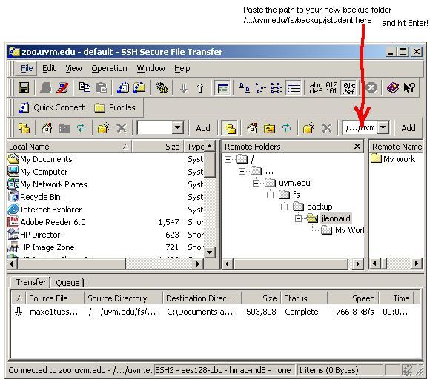

Now you are ready to click drag and drop from your own PC in the left pane, to your newly create backup folder in the far right pane. Backup your academic work. You should have no more than one Gigabyte of backed up folders and files. Do not backup music, videos, DVDs, movies etc., unless it is very temporary (1 day) while you are changing personal computers.

3. Remove your PCBackup folder from your home directory on zoo:

Login to zoo with SSH-terminal. Be sure you are in your home directory:

zoo> cd

From your zoo> prompt, issue the rm command to remove your PCBackup folder:

zoo> rm -rf PCBackup

