Group 5
Alena Warren
Mike Sullivan
Cory McKenna
Mike Haring
Michelle Lemons

Module Outcome: To understand why and how market failures occur, and be able to identify them.

In this module we will examine what constitutes a market failure, and what type of goods or services are typical of market failures. Although markets do work efficiently for some goods it does not efficiently allocate all types. This is a result of the characteristics of the good such as excludability, rivalness, and congestibility, which have already been discussed.
First we will look at the definition of a market failure and what would be considered a failure. Second, will be the focus on those goods that are nonexcludable and rival (open access regimes) and those that are nonexcludable and nonrival (public goods). These are placed in the context of market failures to understand why the market cannot efficiently allocate them. Third, the topic of missing markets is considered. After completion of this module an understanding of market failures and missing markets should be developed, along with what types of goods could be considered a market failure.

Objective #1: Market Failures
Economics is the study of the allocation of limited, or scarce, resources among
alternative, competing ends. It is the job of the Markets to efficiently allocate those resources among the ends; this is done by utilizing individual self interest with the allocation via the pricing mechanism.
Most simply: A market failure is when the resources are not being allocated efficiently
among the ends.
-Markets are a tool of allocation, but not a perfect tool.
-Markets only function efficently with a narrow class of goods.
-Markets only balance supply and demand, possibly with desirablility, under a very
restrictive range of assumptions.
Types of Market Failures:
1. Structural problems--
Monopolies
2. Inherent characteristics of certain types of resources--
3. No institutions clearly defining property rights—

4. Missing Markets--
For a market to actually be in balance would be impossible because for that to
happen: All goods and resources must be both excludable and rival, market actors must be
able to make transactions with zero cost, people must have perfect information concerning
all costs and benefits of every good.. and even with all that the markets would still NOT
account for future generations.
THEREFORE-- Markets are destined to fail, at least partially.....

This table, taken from Ecological Economics by Herman E. Daly and Joshua Farley, shows how excludability and rivalness act differently in markets.

 | Excludable | Nonexcludable
Rival | Market goods; food, clothes, cars, houses, waste absorption capacity when pollution is regulated | Open access regimes (“tragedy of the commons”), e.g. ocean fisheries, logging of unprotected forests, air pollution, waste absorption capacity when pollution is unregulated.
Nonrival | Potential market good, but if so, people consume less than they should (i.e. marginal benefits remain greater than marginal costs); e.g., information, cable TV, technology. | Pure public good, e.g. lighthouses, streetlights, national defense, most ecosystem services,
Nonrival but Congestible | Market goods, but greatest efficiency would occur if price fluctuates according to usage, e.g., toll roads, ski resorts. | Nonmarket goods, but charging prices during high-use periods could increase efficiency; e.g. non-toll roads, public beaches, national beaches

Activity #1:
Read box 10.1 on page 162 of Ecological Economics by Herman E. Daly and Joshua Farley, viewable through this link:
http://books.google.com/books?id=WGKt763MIbsC&pg=PA162&lpg=PA157&dq=ecological+economics+by+herman+e+daly&output=html&sig=plsrulIdTlHLNbOE1nBOqqCUYk8
1) How does the story of the Atlantic Cod Fishery and other Open Access Regimes
demonstrate a market failure?
2) What would a neoclassical economist say is a solution to the problem of species
extinction due to market failure?
3) What are some solutions to fix current market failures such as this?
4) What are some solutions to avoid this type of market failure in the future?
Activity #2: Refer to this site: http://en.wikipedia.org/wiki/Market_failure
Read this article on Market failures which gives a good basic idea and do a short one
paragraph summary and response.
Activity #3:
“In the final years of the 20th century, the world was hit by a plague of epidemic
proportions--AIDS, a life-threatening disease that remained stubbornly immune to any cure
or vaccine. In the developed nations of the West, AIDS was slowly brought under control
through a combination of education, prevention, and cutting-edge medicines. But in the
developing world, where health care expenditures were often paltry, AIDS continued to
rampage. By the year 2000, 25 million people in Africa alone were infected with the
disease. Millions had already died. Nearly all of the medicines that treated AIDS had
been developed--at great expense--by the major western pharmaceutical firms. These
medicines were expensive to produce and often difficult to administer. They demanded
levels of income and structures of distribution that often were sorely lacking in the
developing world. Increasingly, activists groups were demanding that the pharmaceutical
companies respond to the AIDS epidemic with drastic measures, giving their drugs away for
free or abandoning the patent rights that had long protected their intellectual property.
The pharmaceutical firms needed to respond to their critics. The question was, how?”
Reference: http://www.caseplace.org/cases/cases_show.htm?doc_id=172522
Write a two paragraph explanation on how this situation is a market failure, and a
hypothetical way to resolve this daunting issue.
Objective #2: Public Goods
Open access regimes are a good or service that can be classified as nonexcludable but rival. That is a firm cannot sell the good but when being used by one person it cannot be used by another. The use of an open access regime often leads to what Garret Hardin termed a “tragedy of the commons.” This results from the lack of enforceable property rights on a good, which are very hard to establish.
Pure public goods are related to open access regimes but they are both nonrival and nonexcludable. Anyone can use public goods regardless of who pays for them, and as a result the market is not capable of maximizing their production nor can it efficiently allocate them. Thus, public goods should be provided by the government or another social institution. Since the market cannot produce or allocate these resources it often leads to scarcity of public goods compared to private goods (Daly and Farley).


Garret Hardin -1963 (Source: oceanworld.tamu.edu)

Activity 1:
1. After reading the above article by Hardin can you think of an example in your area that would constitute a “tragedy of the commons?” Why do you think so?
2. Using information provided in this module, how do open access goods result in a market failure?

Activity #2
1. Research further characteristics of public goods here: http://william-king.www.drexel.edu/top/prin/txt/Govch/PG7.html.
2. Considering what we know about public goods determine which items depicted in the following pictures are examples of public goods and which are not.

A.
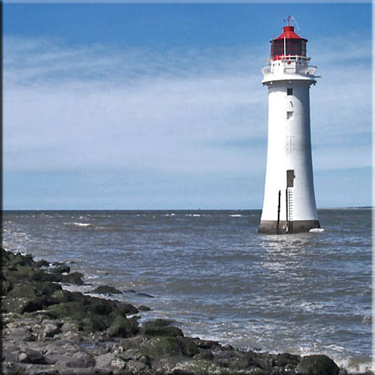
(Source: thelensflare.com)

B.
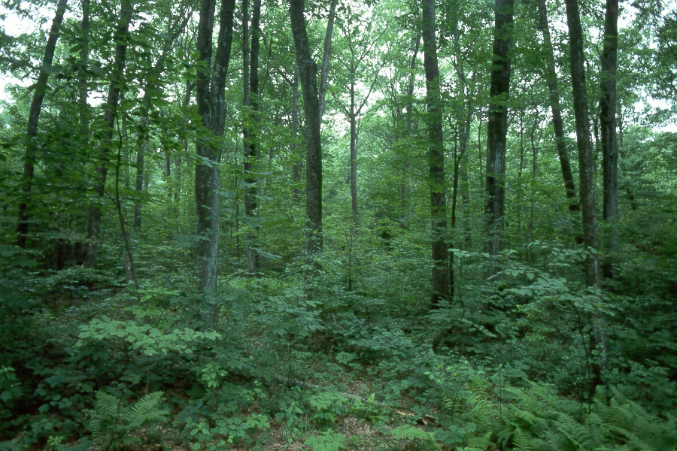
(Source: mass.gov)
C. 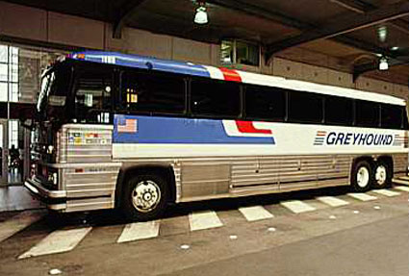
(Source: dkimages.com)

D. 
(Source: img.alibaba.com)

E. 
(Source: edu.Dudley.gov.uk)

Answers: A, B, E

Activity #3:
For a written assignment or discussion: Why do public goods constitute a market failure and what, if anything, can be done to incorporate them into the market? Should they be incorporated into the market?

Activity #4: Please read the article below on the Free-Rider Effect, and do a free write response to the reading. You may wish to come up with your own example of a situation in which the Free-Rider effect would purpose some obstacle, or simply respond to the park example given.
Below reading is box 10.3, took from Ecological Economics by Herman E. Daly and Joshua Farley page. 170
The Free-Rider Effect
What would happen if some institution solicited voluntary donations to build a public park in my neighborhood? I am trying to decide how much to donate. If I meet standard neoclassical economic assumptions, I want to maximize my own utility. I live close to the proposed park site and would value I more than most people. I decide that I am indifferent between a park of the proposed size and $1000, and prefer the park over any cost less than $1000. However, I rationalize that I contribute nothing to the park and others contribute what it’s worth to them, that will only reduce the size of the park by one one-hundred-thousandth. I would vastly prefer a park 99.999% of the size of the proposed park at zero cost to myself than the proposed full-size park for $1000. Alternatively, if I contribute what the park is worth to me and others contribute less, the resulting park will be smaller because of insufficient funds, and therefore no longer worth $1000 to me.
From this narrow perspective of self-interest, my best strategy, regardless of what others choose, is to contribute nothing and instead rely on the contributions of others. Unfortunately, if everyone else also makes a similarly rational calculation in his or her own self-interest, the city ends up with no park whatsoever and everyone is worse off than they would have been if the park had been built. This is known as the free-rider effect, and it is a serious obstacle to the provision of public goods. In this case, rational self-interest has created an invisible foot that kicks the common good in the rear!

Objective #3: Missing Markets
In theory, markets are an efficient way to allocate goods. We have seen in objective #1 that sometimes markets simply cannot allocate certain types of goods efficiently, leading to a market failure. But besides goods, there are certain groups of people that markets do not reach, creating a less efficient system. The most important way that this relates to ecological economics is the idea that future generations are a missing market. As future generations are unable to participate in our markets today, their demand is not met. If future generations were included in an analysis of markets, we would see that our current system is not operating at Pareto efficiency. Allocating more resources to future generations and less to our own would likely be much more efficient in the long-run.

The problem of future generations as a missing market is explained well in this passage from the article “The Intergenerational Case of Missing Markets and Missing Voters,” by Jacobus A. Doeleman and Todd Sandler found in Land Economics:

“In the latter half of the 20th century, novel forms of pollutants (e.g.. chlorofluorocarbons, greenhouse gases, cadmium, plutonium) have placed current and future generations at risk. These pollutants can result in market failures in the form of missing markets, in which costs and benefits associated with an activity are not taken into account by a pricing mechanism. For some of these problems, transnational cooperation may be required to address the market failure. During the last two decades, this need for transnational cooperation has taken on a global nature as in the cases of protecting the stratospheric ozone shield, curbing global warming, limiting the spread of deserts, and stemming deforestation.' Transnational cooperation is not sufficient to correct problems with an intergenerational dimension unless the current decision makers adjust for the long- and medium-term consequences of their actions. That is, markets may be missing not only among countries owing to transboundary externalities, but also among generations due to intergenerational externalities.-In the latter case, an action of the current generation imposes costs or benefits on a subsequent generation and no market exists to account for these costs or benefits. This intergenerational case of missing markets is particularly problematic, because the sequencing of generations provides a firstmover advantage where the current generation can optimize its own well-being and ignore the consequences of those to come.' If generations overlap, then this problem may be rectified, in part, but difficulties may still arise. Even government intervention may be powerless owing to missing voters, who have a vested interest in today's decisions but are yet to be born. The development of advanced technologies, the growth of population, and the growth of economies have created and will continue to create these transnational, intergenerational externalities, thus increasing the prevalence and importance of the missing-voter, missing-market problems. When markets and/or voters are missing, some form of intervention may be justified. In relevant situations, the paper recommends intervention at the constitutional level to protect the rights of future generations against adverse implications.”

The problem of the demand of future generations could be solved by assuming a certain demand, and ensuring that the resources will exist in the future to meet those demands. That means investing in renewable resources, not over-harvesting stocks, and maximizing reuse and recycling of non-renewable resources like minerals. In the case of fossil fuels, there is no way to recycle, but money generated by extracting them could be invested in substitute energy sources.

This solution does not fit with the neo-classical economic way of thinking. Economists of this school would tend to either ignore future generations as ineligible to participate in markets, or at least discount the costs and benefits that occur in the future because it is less important than the present. Another solution, as suggested by Doeleman and Sandler is that of instituting a law to guarantee the rights of future generations.

Source:
Doeleman, Jacabus A & Sandler, Todd (February 1998). “The Intergenerational Case of Missing Markets and Missing Voters.” Land Economics. 74 (1), 1-15.

Activity #1: For discussion or free write. What policies or practices exist today that protect the rights and interests of future generations? Be creative: think about issues like pollution, land and wildlife conservation as well as laws, taxes, etc.…

Activity #2: Watch and respond to the video “Dirty Little Secret.” This video shows what happens when the government does not adequately prepare for future generations. In your response, address potential solutions to this economic policy dilemma.
http://www.youtube.com/watch?v=KGpY2hw7ao8
Activity #3: Write about how we would consume oil and/or other non-renewables differently if future generations were represented in the current market. You may want to do some research and cite examples of how these markets work now and provide ideas for fixing any problem you find.

Module Synthesis:
Choose a real life example of something you think to be a market failure (such as access to information, or unsustainable consumption of resources, etc.) Research the issue and write a brief paper explaining why it is a market failure and what could be done to allocate the good or service more efficiently. Use specific examples and cite at least three sources of information.

