Ecological Economics

This teaching/learning module is designed for use by any student for their own private exploration into some basic and crucial concepts of ecological economics. It is also intended to be used as a framework for any instructor looking for a model that introduces students to the concepts of ecological economic concepts. The activities are designed to show proof of learning and enhance what the student has learned about the field.

“We can't solve problems by using the same kind of thinking we used when we created them.”
—Albert Einstein (theoildrum.com)

We begin with a discussion of the history of economics. Why is classical economics failing us as a planet? How did we get to this state of environmental degradation and how much of a role has neo-classical economics played?

Next we move to crucial difference between economic growth and development. Growth is simply an increase in consumption of the Earth’s finite resources. Development has potential to continue indefinitely because it is focused on technology and not consumption. Economic growth is viewed as the number one goal of many world governments however we discuss why development should replace it.
One of the biggest reasons for replacing it is our discovery that more consumption doesn’t really make people happier. We discuss the difference between some of the indicators we use to gage the progress of society. Most notably we believe that the Human Development Index should take the place of GDP for assessing the well being of a country.
We conclude with a discussion about how to go about bringing change. That is, how do governments switch to promoting a sustainable economic system and why it is important? Overall greed doesn’t make anyone happy and all parts of life are interconnected. We should strive for a closed loop economy focusing on decrease of consumption, increase of efficiency, and an increase of mutuality of economics and ecology. We conclude with a real life example of a success story in Boston.

Objective 1

Hunter-Gatherer to post-Industrial Revolution Societies

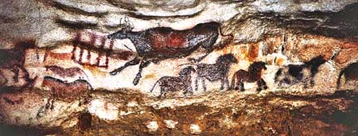
source: www.historian.net/images/2d2.jpg

Objective: To understand and analyze the history of the economic transformation from hunter-gatherer societies to post-Industrial Revolution societies.

Introduction

Our World today, especially in the United States, is a model of economic growth. This wasn’t always the case and if there is going to be a future for our planet, it’s wise to look to our ancestor’s lifestyles and how and why they evolved over time to become what we see today. The pattern of economic developments we’ve seen over the course of human habitation can be generally classified into consecutive stages. This section is designed so that after reading and watching the relevant videos, you will be able to analyze and critique our economy today.

Before continuing forward, watch the following movie The Day The World Took Off. This is an excellent overview of the objectives of the lesson.

- Hunter-Gatherer Societies:
▪ Pre-agricultural societies that usually involved a nomadic life of foraging for food—men hunted for meat and women were the gatherers for edible vegetation.
▪Once food sources started to become scarce, they’d pick up and move.
▪It was essential for them to be highly mobile; therefore material possessions had little value.
▪Accumulation of wealth (possessions) = death.
▪Property rights were of no use and therefore didn’t exist. All resources were held as public goods.
▪ Community incentives existed rather than individual incentives.

Activity 1: Watch the following video on the !Kung Bushmen of South Africa The Hunters- A !Kung Bushmen film and then explain what the advantages and disadvantages of hunter-gatherer societies are. Do you think they have a higher or lower quality of life than we do today?

2. Traditional Society:
▪The development of food storage led to sedentary lifestyles.
▪Agriculture and property rights are born. At this stage, subsistence was still intact. Output was driven by consumption of those who produced it and trade was still yet to be established.
- Transitional Stage:
▪Surplus production allowed for the division of labor that led to specialization and therefore trade. There is then the emergence of an infrastructure to support this trade. Income, savings, and investment grow and the beginning of external trade is seen.

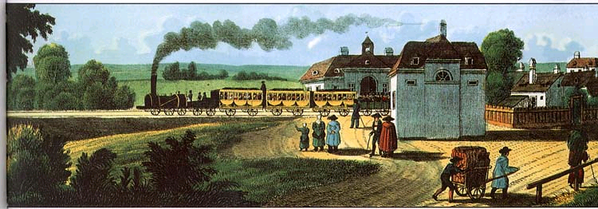
source: www.industrial-revolution.org/img/front.jpg
- Take-off:
▪With this new trade network in place, ideas and knowledge become easily disseminated and with that comes the birth of new technologies.
▪Industrialization increases as workers move from the agricultural sector to the manufacturing sector.
▪Population increased, which placed a higher demand on agriculture. This spurred the invention of new technologies to help agriculture yield the necessary output to sustain the growing population.
▪The most crucial technological leap was the use of nonrenewable resources such as fossil fuels. This freed us from the fixed supply of energy from the sun, allowing us to grow and destroy at unnatural rates.
- High Mass Consumption:
▪New technologies and fossil fuel energy allowed for unprecedented production of consumer goods, which led to the inception of the market economy to allocate those goods and this in turn stimulated production even more.
▪Our economy today is geared toward mass consumption. Consumer durable industries flourish.

Activity 2: Taking the information given to you in both films, in you own opinion do you think that the benefits to society of the Industrial Revolution outweigh the costs to the world today? Explain your answer by using specific examples from The Day The World Took Off.

Conclusion:

The Industrial Revolution did bring about some positive advances and contributions:

▪International trade exploded, bringing countries closer together.
▪Greater ability to meet basic needs.
▪Advances in hygiene and medical science.

All of the aforementioned resulted in an increased population whose needs had to be met through greater energy use and more rapid depletion of resources. Growing populations caused immobility that meant land was under constant use and therefore didn’t have the chance to recuperate between uses. Per capita consumption grew astronomically and the waste it caused is now compromising the health and function of our ecosystems.

Sources: (1) Ecological Economics, Herman E. Daly and Joshua Farley
(2) http://www.bized.co.uk/virtual/dc/copper/theory/th9.htm “Rostow’s Model- Stages of Economic Development

Objective 2

Growth vs. Development

The objective of this module is to define and comprehend the differences between growth and development.

This goal will be accomplished through a series of activities. These activities are:
- Researching your towns’ growth and development policies.
- Briefly researching examples of growth and development.
- Taking the ecological footprint quiz, and completing a free write about your
contribution to growth and development.

Ecological economics is based on the relationship between the economy and the larger ecosystem on which it depends. This relationship is defined by the level of throughput in a particular system. When a system experiences growth, it is experiencing a quantitative increase in throughput. This means that the physical size of the economy is expanding. However, its expansion it constrained by the boundaries the ecosystem on which it depends for resources.

Development, on the other hand, is not hindered by the limits of the ecosystem. Rather, it is only limited by our own technological capacity. Development uses throughput to increase quality of life within an ecosystem instead of using it to physically expand the economy. Improvement in health care, education, and environmental quality are all examples of development.

Activities:
- Research your towns’ growth and development policies. Then write a letter to your town offices supporting or opposing their policies, if you oppose their policies then suggest some improvements.
- Briefly research Ecovillages, the expansion of Las Vegas, Megacities, and the transition to green living.
Examples: Look at the pictures provided and determine whether they represent
examples of growth or development. Write a short statement about each
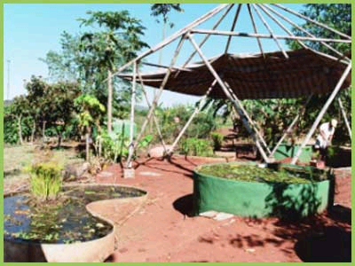

http://www.livingroutes.org/photogallery/brazilgallery.htm
EcoVillages

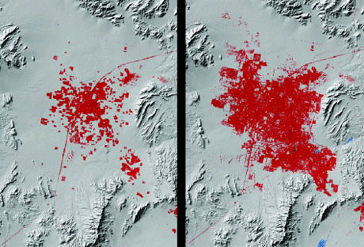

http://images.google.com/imgres?imgurl=http://www.apartmenttherapy.com/images/uploads/6-29-urban-growth-of-las-ve.jpg&imgrefurl=http://www.apartmenttherapy.com/ny/news/urban-population-explosion-more-apartment-therapy-025665&h=312&w=460&sz=54&hl=en&start=2&tbnid=8QfyWcsZh_FOtM:&tbnh=87&tbnw=128&prev=/images%3Fq%3DGrowth%2Bof%2BLas%2BVegas%2B%26gbv%3D2%26hl%3Den%26sa%3DG

Las Vegas: These images show the size of the city of Las Vegas between 1973 and 1992.

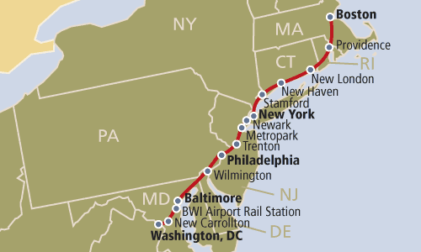
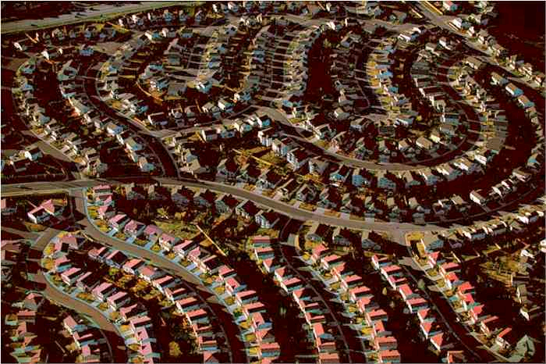

http://www.flatrock.org.nz/topics/environment/assets/denver_suburbs.jpg
http://www-atlas.usgs.gov/articles/transportation/IMAGES/acelaexpress.gif

Suburbs = Megacity from Boston to Washington D.C.

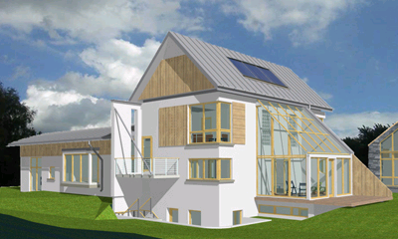


http://www.leehaydenre.com/images/slideshow/suburban_home.jpg http://www.mmaa.ie/irish-architect-images/residential-4-1-sustainable-home.jpg
Green Living
Technological advances in solar panels, wind turbines, and water treatment.

- Ecological Footprint Quiz.
- Take the quiz at http://www.earthday.net/footprint/index.asp, try and be as truthful in your responses as possible.
- When you have completed the quiz click on the “ What You Can Do- individual” link on the right side of the page. Read the suggestions and make a list of which ones contribute to either growth or development.
- Write a brief paragraph about how you can reduce your personal contribution to growth.

Objective 4

Paradigm Shift

Before our economic and political policies can evolve, our own mindsets must evolve to lead the way. While we now live in an industrialized world, the seeds of our civilizations lie in the past and should not be left out of the picture.
When the flow of production was at its slowest, and technology was not yet a word, when the human race still hunted and gathered, and when an ocean was as vast as eternity, lifestyles were simple. Throughput was minimal, mutual relationships were paramount to maintaining a steady supply of resources, and self-sufficient, sustainable production of the bare necessities was the only option.
Today, we are at risk of watching the economy consume entire oceans of resources. What was once limitless is now scarce; what were once the heavens are now gliding paths for enormous flocks of gas powered aeroplanes. While our flow of production continues to keep up with this ever-expanding web of resource consumption, our stocks have approached scarcity. Our waste absorption capacity is limited, and the carbon emissions into our atmosphere are worrisome, but have not sparked enough government interventions to make any great differences. It has become more and more apparent that we cannot rely solely on the government or the market to initiate our paradigm shift—it must stem from the earth, and from the people who live upon it.

Introduce the three central ideas that will help the paradigm shift from economic growth to economic development; provide examples to illustrate.

The three standpoints are decreasing consumption/throughput, efficiency and mutuality. For these ideas to move from the proposal stage to action is truly up to the individual and their communities. It is however imperative for individuals and communities to keep in mind the importance of the interrelation of these three aspects. It will mean finding a balance of all three central ideas specific to each individual and/or community to start a paradigm shift from economic growth to development.
The combination of these three themes is the simple idea of consumers, producers and businesses forming a local partnership. Forming local partnerships would allow a decrease in consumption of non-local goods, increase efficiency by cutting down transport cost and efficiently using local resources, and lastly, help form mutuality among businesses, producers and consumers. Three excellent examples of these practices are The Vermont Fresh Network, a partnership among local farms and restaurants; Growing Vermont, a partnership among business owners and local producers; and lastly, Community Supported Agriculture, which is a partnership of local farms and local consumers.

Activity: Examine these central themes and their application to these
organizations further by following the links provided below. Then, Write a short paragraph describing how these three organizations were able to incorporate the ideas of decreasing consumption/throughput, efficiency and mutuality.

The Vermont Fresh Network - http://www.vermontfresh.net/
Community Supported Agriculture - http://www.nal.usda.gov/afsic/pubs/csa/csa.shtml
Growing Vermont - http://www.noveltytheory.com/vtprod.htm

Objective 4(A)

Examine previous examples of sustainable land use/community development, and how reviving traditional land use practices can be fundamental to a paradigm shift.

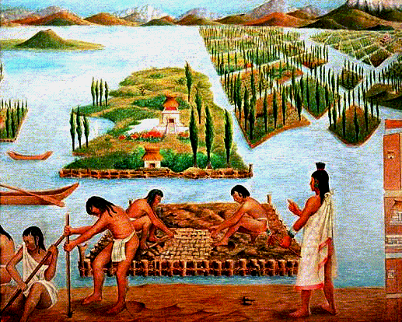

Chinampas of Mexico, agricultural system rooted to Aztec civilizations.

As our stocks become scarce, we should look to the past and unearth our old traditional moments of efficiency, sustainability, and low ecological impact. Recently, historians have begun to check on these former agricultural systems, such as the Chinampas of Mexico. These farmlands were raised beds, organized in a matrix of water canals which irrigated the soils. The beds were polycultural, (meaning that many different species grew in the same bed), not monocultural Having a diverse population within the bed minimized the susceptibility to virus or insect damage, as well as maintained and sustained the nutritional value of the soil.
While the Chinampas were not very useful for large-scale, mass production of agricultural goods, they were efficient, disease free, and very interesting. As the demand for agricultural goods increases, the market will expand monocultural farmlands across appropriate boundaries, and crops will require heavier pesticide use. If private organizations begin to develop their farmlands, with these historical, polycultural moments from the past in mind, they will be much more efficient and will rely much less on transportation costs, growth in the market, or ecologically damaging farming practices.
Today’s reality is that a large majority of the population lives in the city. These cities are the biggest players in throughput, and also the biggest players in the spread of information. The market urges the expansion of these cities, not only in terms of their physical boundaries, but also in terms of the billions of dollars worth of imports that they depend on. However, certain communities have seen some bumpy roads in their history, which have shifted the need for growth to the need for development. The Dudley Street Neighborhood Initiative is a perfect example of a successful shift towards community development.
In the late 1980’s and early 1990’s, the Dudley Street neighborhood community was revitalized. For several decades, it had deteriorated into a vast expanse of derelict buildings and waste dumps. Socioeconomic barriers had isolated the neighborhood into abandonment. But after the establishment of the Dudley Street Neighborhood Initiative, a community-based activism group, the fight for social and economic justice was fixed to the need for environmental rehabilitation, and major steps of progress were made. Voluntary education programs within the neighborhood were established to teach community development and sustainability. An urban agricultural greenhouse was built, which would eventually supply many of the neighborhood businesses, which began to sprout up as community members took control of their surroundings.
The urban agricultural facility, much like the Chinampas, was not a mass-production, monocultural system that exported goods throughout the nation. Instead, it sustained the neighborhood which managed it, nothing more, and nothing less. The small scale agriculture operation serves as an educational resource for self-sustainability, as well as the major source of produce for the neighborhood’s markets and cafes. Visit the website: http://www.dsni.org/.

Activity: Walk through your neighborhood and establish relationships with you’re your neighbors, if you have not already done so. Find out if there are any foods that you both consume on a daily basis. If so, design a structured meal-sharing plan so that you can enjoy at least one meal together per week, or a few cups of coffee per week, or some other consumptive practice. Once you have gone through several trials of mutual food preparation, decide if you have decreased overall consumption on the days when meals are shared. If not, try to rethink your preparation method and schedule, to increase efficiency of production. You may begin to find that not only are you saving on food costs and utility costs, but also time. Connect your discoveries to the mutual efficiency achieved on the Chinampas and in the Dudley Street Neighborhood.

Source: Layzer, Judith. The Environmental Case. CQ Press. Washington, D.C. 2006

Group 10- Trekkers

Cecelia Angelone
Joe Cahill
Michael Haulenbeck
Jackie Leveroni
Tom Mertz
April Owens
Brian Sewell

