Part III – Synthesis

Analysis receives the bulk of attention in university education and in scientific research, but is only an intermediate step in problem solving. Once we have gained a greater understanding of the component pieces of a problem, we must reassemble those pieces in a way that helps us to better understand the whole. This is what we call synthesis.
While much analysis is compatible with a disciplinary approach, synthesis demands transdisciplinarity. Parts of your problem concern people’s values. Other parts are probably measured in dollars and cents, and yet others may be measured in tons of physical output, degrees, acres, parts per million, kilowatt hours, and so on. Synthesis demands that this information is assembled in a way that aids in decision making and communication.
Just as there is no single correct way to analyze the different components of your problem, there is no single best-approach to synthesis. In Chapter 6 we offer a general overview of synthesis – a fairly non-technical way for understanding how the pieces of your puzzle fit together. For many problems, this framework will be enough to reveal reasonably clear solution paths. Other problems however are likely to be more difficult, where different reasonable prioritizations of objectives may lead to very different outcomes. While the paths themselves may be very distinct, it can be very difficult to decide which is most desirable. Chapter 7 outlines some more sophisticated general frameworks, including dynamic systems modeling, multi-criteria evaluation, and integrated social and environmental accounting that can help you choose a desirable alternative. While only one of the frameworks we present has “systems” in the title, they each require systems thinking.
Disciplinary methodologies don’t necessarily conflict with these frameworks, but rather fit within their synthesis umbrella. While individual methodologies can be applied like recipes in a cookbook, these frameworks are really about a way of thinking, or seeing the big picture. For the sake of brevity, we outline the typical steps taken in their application, a discussion of the terms and concepts captured by each, a handful of examples to illustrate their usefulness, and some suggestions on where to find more information.
A word of warning for the student in a one or two semester class: these frameworks are meant to help compile a lot of information. Each piece of the puzzle may in and of itself represent an entire semester long project. Pulling together the pieces into a coherent framework – even a general one – may be beyond the scope of a course, and consequently these chapters may seem daunting. Even so, it’s important to communicate the results of analysis with the eventual goal of synthesis in mind. Alternatively, you may be at the stage of a project where the component pieces have already been assembled, and the bulk of your effort will be to assemble information in a synthesis framework. In this case, these chapters may seem too superficial and we encourage you to work with your professor and sponsor to seek more information on these, or other, synthesis frameworks.

CHAPTER
6

Bringing it all Together

Just as the economic system is a subset of a sustaining and containing ecosystem which cannot be ignored, your ecological economic problem occurs within a broader system. The impacts of your proposed solutions on the entire system, and of the system on your solutions, must be considered. If you ignore this basic fact, you may find that your solutions aggravate the existing problem or else create new ones, as we discussed in Chapter 3.
An analogy may help illustrate our point. A simple system is like a hill, while a complex system is like a mountain range. To get to the top of a hill, all we need to do is take any step that leaves us higher (better off) than the previous step. As we discussed in Chapter 4, hill-climbing is really the underlying assumption behind marginal analysis – we look at the impact of an infinitesimally small change, and move in that direction. In complex systems, as in real mountain ranges, the same strategy will fail, as there will be many hills and valleys that lay between you and your destination. What’s more, your destination is measured by more than just one objective, such as altitude – you may instead desire a peak with a great view, that is accessible to all your companions (not just the most athletic), and whose ascent does not require unaffordable gear. Once you’ve chosen your destination, just pointing your compass towards the highest peak and walking straight won’t work either (many conventional economists are proponents of exactly this approach, dubbed MRAP, for Most Rapid Approach Path) – you would almost certainly confront cliffs too steep to scale, and rivers too deep to ford. To choose your destination and get to where you’re going, you need a map of the terrain. Sometimes you will need to walk downhill, sometimes along ridgelines that lead away from the highest peak, but provide a less treacherous path. Systems thinking is meant to provide you with a map. Quite often, however, you will be heading into poorly charted territory, so even the best maps may not have as much detail as you would like.
The closer you move to the decision and communication stages in addressing your problem, the more critical it becomes to maintain a systems perspective. In Chapter 3 we asked you to examine different alternative solution states, and in Chapters 4 and 5 to list and analyze the objectives that you will use to compare the different states. Each alternative state should describe a whole system; however each different objective focuses only on a single component. Synthesis begins with recalling that systems are complex, and these analyzed components interact to generate non-linear, often unexpected outcomes. During synthesis, you cannot address each objective separately at a single point in time, but must consider what will happen to the whole now and in the future when you alter the components.
As with the other aspects of problem solving, synthesis is easier to learn about through examples instead of in abstract. Case 6 in this chapter draws on a workshop and field-course in the Philippines that focused on the conversion of mangrove ecosystems to shrimp aquaculture. Though the setting is exotic, most of the insights apply to the profit driven destruction of healthy ecosystems everywhere. We will also return to the problems of urban sprawl to illustrate some of our points.

[CASE 6 - Conversion of Mangrove Ecosystems to Shrimp Aquaculture in Puerto Princesa, Palawan, Philippines (incl. Figure 6.1)]

■ HOW DO THE OBJECTIVES INFLUENCE ONE ANOTHER?

The reason that analysis alone is an inadequate approach to problem solving is that the different components in a system influence each other, and cannot be understood in isolation. To solve a problem, you need to understand how components interact. The components of interest are the objectives of which possible goal states are comprised, and any factors that affect them – in particular those factors that might be manipulated in order to achieve specific objectives.
Broadly speaking, most ecological economics problems require an understanding of how sustainable scale, just distribution and economic efficiency influence each other. These influences run in both directions. Figure 6.2 illustrates these interactions.

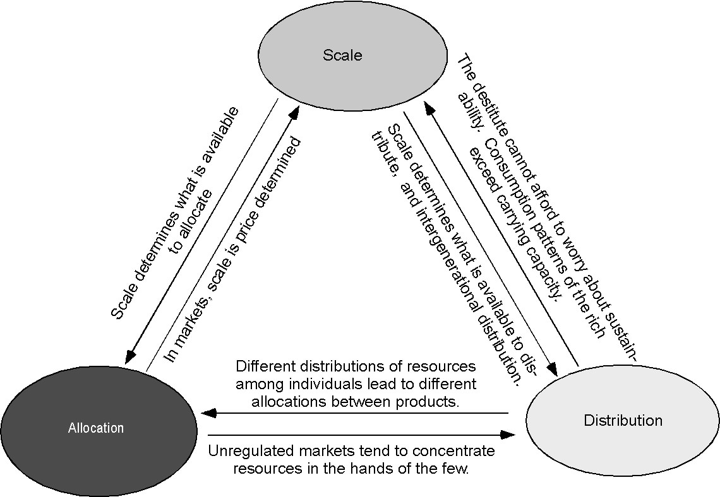

Figure 6.2: How scale, distribution and allocation influence each other.

Problem solving requires an understanding of both how a given factor influences other factors, and how it is influenced by them. Sometimes a specific action designed to achieve an objective may have a strong influence on other factors and objectives, and is in turn strongly influenced by them. This action is an example of a critical factor, to which you will need to pay close attention. These have system wide influence, and are highly sensitive to change. A good example is economic growth. Another factor may strongly influence others, but be only weakly influenced by them – think of a volcanic eruption. This will be an active factor in your solution set, a driver of change. When the situation is reversed, you are dealing with a passive factor, an indicator of change. Human health, for example, is influenced by environmental problems, but does little to influence them directly. Finally, some factors will readily absorb influences without changing and without transmitting those influences to other factors in the system. These are buffer factors. In certain circumstances, waste absorption capacity can be a great buffer, though in other cases, such as mangrove conversion for aquaculture highlighted in Case 6, it is heavily influenced by other activities.

[SIDE BAR: A hierarchy of influence factors: 1. Critical, 2. Active, 3. Passive, 4. Buffer]

Additional examples from Case 6 can help illustrate these concepts. The aquaculture industry was initially an active factor, or driving force of change. Aquaculture generated income for the managers but reduced the productivity of other industries such as fisheries, ecotourism and traditional extraction. It therefore had considerable influence on economic objectives. Aquaculture reduced the capacity of the ecosystem to sustain traditional uses, and redistributed resources from the many to the few, and therefore had considerable influence on social objectives. It clearly had a large and negative influence on ecosystem function, and ecological objectives. Initially, other economic, social and ecological objectives seemed to have little influence on conversion.
Over time, however, the Tagabinet community reacted to the destruction of their traditional livelihoods in fisheries and resource extraction from the mangroves, and began to work with local NGOs and government to oppose the local aquaculture project. In other areas, degradation of ecosystem functions such as storm buffers and waste absorption capacity has wiped out the local aquaculture industry. In the future, the potential for ecotourism growth could divert resources from aquaculture, and lead to policy measures to halt its expansion. In Tagabinet, the workshop and field-course served as a final catalyst that led to the destruction of one set of shrimp ponds. Pursuit of various social, ecological, and economic objectives, such as those described above, have ultimately had a huge impact on aquaculture. Feedback loops emerging in response to aquaculture’s impacts have converted it from an active factor to a critical one in the problem of mangrove conversion.
In contrast, customary use of the mangrove ecosystem by the Tagabinet community for food and building material was a relatively passive factor. The low level of harvesting had a modest impact on economic, social and ecological objectives, but was heavily affected by changes in any of these areas. The waste absorption capacity of the mangroves adjacent to the aquaculture ponds makes them an example of buffers.
Understanding these influences and categorizing your objectives and associated factors accordingly will allow you to rethink or fine tune your proposed solutions to better achieve all your objectives. You will be able to focus your solutions on the drivers of change, and your evaluation of success on the indicators of change, and thus minimize the chances of your proposed solutions being ineffective or becoming part of the problem.
In addition to the strength and direction of influences within your system, you will have to pay attention to influences between the system on which you are focused and the broader system in which it is nested. Again, the same categories of critical, active, passive and buffers can still apply. The global price of shrimp is an active variable, as it can have a huge impact on the decision to convert mangroves, but nothing that happens in Tagabinet could influence prices. A decision to shut down aquaculture in Tagabinet but allow it to move further down the coast would be critical: it might take decades of regrowth to restore the economic, ecological and social functions provided by the mangroves, and downstream communities would also suffer.
As you are trying to figure out influences, you must also pay close attention to time lags. Long term outcomes may be the opposite of short term ones. For example, additional clearing and dike building in Tagabinet might generate new jobs and income in the short run. The jobs, though low-paying and temporary, may be critical to the well-being of those who have them. Once the dikes have been constructed, however, aquaculture employs few people. By degrading the capacity of a mangrove to serve as a nursery, it reduces oceanic fish stocks and the jobs they provide for fishermen. In the long run, complete destruction of the illegal fishponds would probably create the most jobs. The policy implications of the time lag are important. The feasibility of halting expansion would be greatly facilitated by efforts to find alternatives for those who lose their jobs.

[BOX 6-1. Time Lags and Urban Sprawl]

EXERCISE 6.1
Influence Matrix

Constructing an influence matrix can build understanding of the factors associated with a given problem. We suggest a simplified version of this useful exercise. This can be done using your own problem or an example from one of the case studies. For example, we’ve already highlighted some potential solutions and objectives for the problem of urban sprawl.
Begin by categorizing the different objectives as ecological, social, or economic. In many cases there may be considerable overlap, but don’t worry because that’s the point. It can also be quite useful to add to this list two additional categories: policy (which can include plans, rules and legislation), and non-local influences. Make a matrix using these elements to label both rows and columns.
Across the rows, estimate the strength of the influence one objective has on each of the others as best you can by assigning it a number from 0 to 5, where 0 indicates no influence, and 5 indicates a profound influence. Ideally, this process would involve extensive group dialogue with a broad range of stakeholders, a detailed literature review, and input from other knowledgeable experts. In a semester long course, you may need to supplement such activities with your own subjective assessments as rough approximations. Fill in each cell with the appropriate number. Now add up these numbers across the rows. These row totals roughly measure the influence that each objective has on all the others. When you add down the columns, you get a measure of how heavily that objective is influenced by others. The minimum possible score is 0, and the maximum is 5 times the number of objectives in your list. As a general rule of thumb, if the row or column total is more than half the maximum score, influence is strong. If less than half, it is weak. Each of your objectives (plus the categories of policy and outside influences) will now have two scores: influence by other elements and influence on other elements. You can use those scores to fill in the following matrix.

Table 6.1 • Sample Influence Matrix

 |  | Influence ON other elements:
 |  | Strong | Weak
Influenced BY other elements: | Strong | Critical | Passive
Influenced BY other elements: | Weak | Active | Buffer

Which objectives in your list are the best indicators of change, and should be closely monitored, and which are the best leverage points for solving your problem?

■ WHAT ARE THE KEY POSITIVE AND NEGATIVE FEEDBACK LOOPS IN THE SYSTEM?

Perhaps the most important influence linking components in a system are feedback loops. We have mentioned these repeatedly, but it is now time to examine them more closely. They are critical to effective problem solving in at least three ways. First, understanding existing feedback loops will help you identify leverage points where you can have the biggest impact on the problem. Second, recognizing how your proposed solutions could generate feedback loops will help you maximize positive outcomes and minimize negative ones. Third, understanding feedback loops may help you to create them where needed, or adjust them where they do not function properly.

Identify Existing Feedback Loops

In Exercise 6.1, you took a big step towards identifying the simplest type of feedback loop. When one component of your system influences another, and is in turn influenced by that component, you have a feedback loop. The strength of the loop is determined by the strength of the influence. All that remains is for you to identify the type of loop. If both components reinforce each other, you have a positive feedback loop. For example, if fish ponds degrade the nursery function of mangroves, it will reduce wild fish stocks and harvests. As the supply of wild fish decreases, the price of fish will increase, making aquaculture more attractive. If components act on each other in opposite directions, you have a negative feedback loop. As shrimp aquaculture expands on a global scale, it drives down the price of shrimp, reducing incentives to invest in aquaculture.
In many cases however, feedback loops may not be so simple. One component of a system may act on another, which acts on another, and another and another . . . before finally acting again on the first one. Each of the individual links in the loop has either a direct relationship, indicated by a (+) sign, or an inverse relationship, indicated by a (–) sign. For example, when demand increases, harvest effort increases – a direct relationship. When stock level decreases, harvest costs increase – an inverse relationship. The larger feedback loop will be negative if there are an odd number of inverse relationships between components in the loop, and positive if there is an even number, as shown in Figure 6.3.

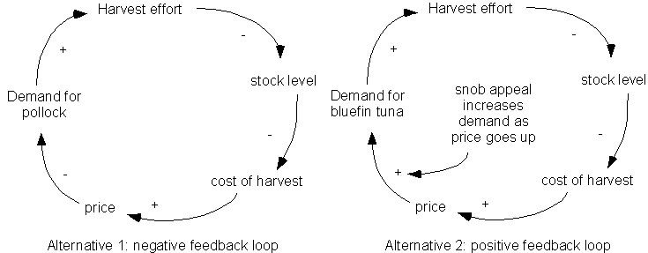

Figure 6.3 • Negative vs. positive feedback loops in a fishing system.

Put another way, the number of inverse relationships (-) in a loop determines the sign of the entire loop. In Figure 6.3, alternative one demonstrates the case where an increase in fish would lead to an increase in harvests, reducing stock levels, increasing costs, increasing price, which then reduces demand, creating a negative feedback loop in aggregate. However, if one sign is changed in the loop, then the entire loop switches. In alternative 2 some fish such as bluefin tuna have snob appeal, so when the price goes up, demand increases. This creates a positive feedback loop in the aggregate. You can get an idea of the strength of the feedback loop by estimating the strength of the influence at each link. The total strength of the loop, roughly speaking, is determined by multiplying the strengths of influence at each link – if one link merits a zero, the entire feedback loop in question is broken.
More often then not, however, you will discover that one component acts on several others which eventually feedback to act on the first one in conflicting fashions. Outside influences also affect different components in a loop. In complex systems, it is nearly impossible to figure out all the feedback loops, and final outcomes can never be predicted. Systems modeling often aided by computers (see Box 6-2 and further elaboration in Chapter 7), can provide a more sophisticated understanding of feedback loops, but we simply don’t know enough to accurately predict what will happen in complex systems. Prediction however is not our goal. Studying feedback loops can help us anticipate many possible outcomes so that we are better prepared to react to them. Even more important for problem solving, understanding feedback loops can help reveal critical leverage points for problem solving.

[BOX 6-2: Computer Science and Complex Systems]

Sometimes, a small nudge to the right leverage point can create a desirable feedback signal, or even flip the direction of a signal, and make a desirable outcome more likely. For example, as shrimp aquaculture expands, it reduces fish stocks and fisheries jobs. If the community understands the cause of the problem and has a sense of empowerment, it might successfully mobilize against the aquaculture industry. Alternatively, fishermen might lose their jobs and leave the community to find work elsewhere. The community suffers, its protests against conversion are weakened, and conversion is facilitated. If there is an NGO such as the Environmental Legal Assistance Center that helps the community, it might make the difference between community collapse and cohesion. But even if the NGO builds the community ties and does the research required to understand the problem, it may still lack the credibility to sway government policy. Collaboration with scientists and academic researchers at this point might boost credibility and draw media attention, which is enough to get the government to act, shutting down an illegal fish farm. If the event is exciting enough to draw national media coverage, potential investors in aquaculture might begin to incorporate the risk of closure into their financial calculations. Together with falling prices, this might be enough to slow down aquaculture expansion. Figure 6.4 illustrates both dynamics.

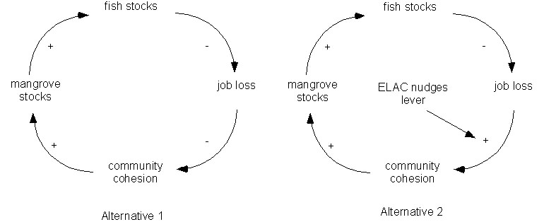

Figure 6.4 • Understanding feedback loops can help identify leverage points. In this case, ELAC helped change the direction of the feedback loop between loss of fishery jobs and community cohesion, which changed the entire feedback loop from positive to negative.

Identifying Feedback Loops that Emerge from your Proposed Solutions

As we identify potential leverage points, however, we must always recognize that we are intervening in a complex system. Our intervention may lead to additional feedback loops which could reinforce or undermine our efforts, or lead to entirely new problems elsewhere. The better we understand feedback loops, the more we guard against the likelihood of such events. As we consider possible solutions to our problems, it is incumbent upon us to consider the feedback loops that might result.
Let’s take some examples this time from the problem of urban sprawl, and begin by focusing on the narrow problem of reducing traffic. Two particular alternatives for reducing traffic include (1) building more roads to speed the flow of traffic, or (2) locating jobs, residences, recreation areas and shopping areas in close proximity to reduce the need for motorized transport. If we build more roads, traffic will flow faster in the short run, reducing commute times. Over the longer term, however, faster commuting could allow people to live further away from their work, which ultimately could lead to increased urban sprawl, and traffic returning to previous levels. This would feedback into more road construction in a positive feedback loop, illustrating several of Senge’s principles from Chapter 3: “The harder you push, the harder a system pushes back”; “Behavior grows better before it grows worse”; and the “Easy way out usually leads back in.”
Alternatively if the focus is on reducing automobile dependence (a root cause of traffic) by rezoning land so that jobs, stores, parks and residences are all in walking or biking distance, this will also reduce traffic but without creating a demand for more sprawl. It may even reduce the need for existing roads. Fewer roads equal more green space. In addition, people who live near their work will also live near their co-workers, which might help to build stronger communities. People who do not depend so much on cars will not need to spend so much on them, reducing the number of hours they will need to work and making that extra time available for family and community. Carrying out more activities in the same neighborhood could help build a sense of place. Strong community and a sense of place combined with more green space might reduce people’s urge to drive places on weekends, further reducing the need for transportation.
In the rezoning alternative, there are again positive feedback loops, but ones that strengthen a number of other objectives, rather than weaken them. Rezoning may well be cheaper than road construction. The trick lies in finding the appropriate leverage point. The practice of examining the various feedback loops between elements of your problem will greatly strengthen your understanding of the entire system, and give you far more insight into developing more desirable alternatives. Figure 6.5 demonstrates how these self-reinforcing cycles may be drawn for these distinct alternatives in the same system.
Notice that time lags occur in fundamentally different parts of the system. Building more roads may be seen as the quick fix, and may indeed reduce commuting times in the short run. But over the longer term could result in even greater traffic than before. Rezoning land may result in reduced traffic, but this may take some time to evolve as people break their automobile dependence. This alternative may not have the immediate payback of shortened commuting times, but could result in a more enduring solution to the traffic problem.

Traffic
Worsening
Build More
Roads
Reduce Commuting
Times
More People
Move to Suburbs
DELAY
Alternative 1
Alternative 2
Automobile
Independence
Rezone
Land
Reduce
Traffic
DELAY
More Time Away from Car
Figure 6.5 • Feedback Loops in the Urban Sprawl System

Creating and Adjusting Feedback Loops

To create a feedback loop, you need both a feedback signal, or indicator, and a mechanism for responding to it. Sometimes you may find the signal does not exist, but can be created. For example, when the United States required firms to report their toxic releases into the environment these emissions reduced dramatically within a few short years – without a law requiring reductions, only a law requiring firms to inform the public! Other times the signal exists, but the response mechanism is absent or perverse – perhaps the signal is ignored, those who are aware of it are unable to respond, or those who respond to it respond inappropriately. This is true of climate change where the scientific findings are clear, but nonetheless disputed, or when the individual response is to turn up air-conditioners that run on coal-generated electricity. Yet another possibility is that multiple, conflicting feedback signals exist, and we are not sure how to respond. In all cases, time lags can be a serious problem – humans unfortunately act on a time scale appropriate to a large mammal, but cause ecological impacts that are geological in scale. Feedback signals may only be recognized when it is far too late to adjust.
The mechanism we use for many allocation decisions is the market system, but the only internal feedback signal to which pure markets respond is price. Any resource we value that does not have a price does not send a feedback signal to the market. Since most non-excludable resources, including most ecosystem services, have no price, there is no adequate feedback signaling the market of their increasing scarcity. Most stock-flow resources do have a price, but that price reflects only scarcity in the market, and not scarcity of the resource in situ. In other words, the basic problem is one of a time lag – current prices do not signal future scarcity. Thus, oil prices have held relatively constant for the last century, in spite of increasing demand and decreasing in-ground supply. If the petroleum geologists do not know how much oil actually remains in the ground, how can the price signal possibly tell us?

[SIDE BAR: In the textbook, see Chapter 10 on general market failures, Chapter 11 on market failures and biotic resources, and Chapter 12 on market failures and abiotic resources.]

The market signal for biological resources may also be inadequate. For example, the cost of harvesting schooling fish may remain relatively constant even as stocks decrease, especially as new technologies help us locate and harvest the remaining fish ever more cheaply. In addition, the extraction and use of stock-flow resources also affects the scarcity of fund-service resources, and these impacts will not be captured by the price signal.
Sometimes feedback signals will be perverse, as is the case in alternative 2 in Figure 6.3 above. As the population of bluefin tuna has declined, the price per pound has soared, increasing the pressure to harvest the remaining fish. The higher prices have shown evidence of stimulating demand as price is equated with status, the so-called “snob effect,” producing a backward bending demand curve (so much for the “law” of demand).
In many cases, feedback signals exist, but are not received or recognized by those who can act on them. Scientists were aware of the problems with ozone depletion for a long time before they could communicate its importance to politicians and get them to act. Svante Arrhenius first recognized the possibility of human induced global warming in the 19th century, yet in spite of near-consensus in the scientific community, many 21st century politicians still refuse to act. Sometimes, signals are ignored. When measurements of the ozone layer in Antarctica first showed an enormous hole, scientists assumed there was some problem with the measurements and ignored it. Some fishermen in the Philippines may be unaware that the loss of mangroves is reducing their harvests. Even when they are aware, they may lack the power to act.
Conflicting signals also make it difficult to act, or to act appropriately. DDT persists in the environment for 90 years or more, causing widespread ecological damage. We see signals of this damage in species loss and ecosystem disruption. But decreasing DDT applications in some cases can lead to an increase in malaria, an often fatal disease. The spread of malaria could be a signal that more DDT is needed. But DDT accumulates in the environment with every application. Mosquitoes will almost certainly develop resistance to DDT within a few decades at most, leaving future generations with an ineffective insecticide and a contaminated environment – but perhaps by then there will a vaccine for malaria. Complex systems can create tough choices.
So how do we adjust feedback loops? First, we need a signal. Both critical and passive factors are good candidates for signals, as they are sensitive to changes in the system. Sometimes local stakeholders will be most in tune with the system and recognize the signals. Other times fairly sensitive measures by scientists may be required.
Once we have a signal, we need to make sure it is acted upon. There are two general approaches we can consider. First, we can try to educate and empower those affected by undesirable impacts so that they can supply the feedback signal directly to whoever is causing the problem, and force them to act on it. Second, we could create mechanisms through which scientists, experts, and local communities can communicate with decision makers who already have the power to act, such as government. Of course once the government has received the feedback signal, it must transmit it back to the direct instigator of the problem, but this is a problem we leave for Part VI of the textbook, and Part IV in the workbook. Both critical and active factors are good candidates for action.
Another alternative is to simply break the feedback loop. Ban the clearing of mangroves. Cap the harvest effort for fish. Typically, such an approach will also require government intervention.
So what role can you play in manipulating feedback loops? First, your research can help you pinpoint which feedback loops are most important to solving your problem. Second, your understanding of the system can help you figure out appropriate signals, and who has the skills and knowledge required to measure them. Finally, you can help communicate the signals back to those who can act, and suggest leverage points for action. We turn to the topic of communication in Part IV of the workbook.

EXERCISE 6.2
Feedback Diagrams

The goal of this exercise is to familiarize you with feedback loops and feedback diagrams, and to understand how they can inform your problem solving efforts.
First, return to Figure 6.3. We show a simple negative feedback loop in which increasing demand for fish ultimately leads to higher prices, affecting demand in a negative or positive fashion. For most fish species, increasing prices are a negative feedback on demand, but it does not seem to be sufficient to stabilize fishing stocks. Do you see anywhere you could intervene in this system to stabilize fishing stocks? For example, how could you break the link the between demand and harvest levels? What impact would this have on intragenerational distribution? On intergenerational distribution?
In real life of course, complex systems consist of numerous interlinking loops. What if bluefin tuna were a major predator of pollock? How would these two loops interact? Both figures 6.3 and 6.4 contain fish stocks as key components. How would these two loops interact? Can you identify other key leverage points?
More factors than price affect the demand for fish. Arguably, the biggest impact on the demand for fish has been population growth. Redraw the feedback loop and include population growth as a second influence on demand. Pollution probably has substantial impacts on fish stocks. Draw pollution in as another influence on stocks. Draw labor prices in as another influence on harvest costs. Are there any key connections between population growth and pollution? Between population growth and labor costs? You should be beginning to get some idea of the complexity involved in real systems.
Now turn to your own problem, and try drawing some simple feedback diagrams. See if you can change the sign of any of the steps in the loop. Try to identify the leverage points. Think of any new feedback loops that might be initiated by your solution. Where are signals lacking? Where can you create them?

■ WHAT ENDS GET PRIORITY, AND TO WHAT EXTENT SHOULD RESOURCES BE REALLOCATED TO ACHIEVE THEM?

The last and most difficult part of synthesis is deciding which ends should get priority, and to what extent resources should be reallocated to achieve them. To do this requires that you bring it all together – integrate what you have done throughout the workbook. You need to think carefully about the desired ends and the available means, which we first considered in Chapter 1. You need to consider the distribution of costs and benefits among stakeholders, as we discussed in Chapter 2. You need to remember that we are not pursuing individual ends, but rather feasible alternatives that meet a suite of objectives to a greater or lesser extent. Deciding what individual objectives get priority helps us decide between alternatives, but usually achieving our desired ends requires that we allocate our resources towards a suite of objectives. These themes were covered in Chapters 3 and 4. Chapter 4 also discussed the importance of marginal analysis. As we allocate more and more resources towards any one end, marginal benefits decline and marginal opportunity costs increase – this is critical in deciding the extent to which we should reallocate resources. To evaluate which ends get priority, we have to draw on stakeholder inputs in the form of knowledge, skills and values, informed by disciplinary scientific expertise, as discussed in Chapter 5. And in this chapter, we have focused on the influences objectives have on one another, and the feedbacks associated with them – yet another reason we cannot focus on objectives in isolation.
There are many different options for integrating this information, some quite sophisticated. We review several frameworks in Chapter 7. Here we only present a simple and general framework that is a simplified form of multi-criteria evaluation.
Drawing on your efforts so far, you should already be able to at least roughly assess the relative extent to which different alternatives will achieve different objectives – that is, you should be able to rank alternatives according to how well they achieve each individual objective. You can put together a simple matrix containing this information, as shown in Table 6.1 for Case 6 in the Philippines.

Table 6.1 • Ranked alternatives for addressing the problem of mangrove conversion to seafood aquaculture in Tagabinet, Palawan, Philippines. In some cases, the rank of alternatives is little more than an educated guess.

 |  | Alternatives for Tagabinet
 | Objectives | 1. Do nothing | 2. Halt expans. | 3. Destroy new dikes | 4. Destroy all dikes | 3. and reforest | 4. and reforest
Economic | Aquaculture profits | 1 | 2 | 3 | 4 | 3 | 4
 | Fishery health | 6 | 5 | 4 | 3 | 2 | 1
 | Ecotourism potential | 6 | 5 | 4 | 3 | 2 | 1
 | raw material, food extraction | 6 | 5 | 4 | 3 | 2 | 1
 | Financial costs | 4 | 1 | 2 | 3 | 5 | 6
Social | Job generation (SR) | 3 | 6 | 5 | 4 | 2 | 1
 | Job generation (LR) | 6 | 5 | 4 | 3 | 2 | 1
 | Income distribution (SR) | 3 | 6 | 5 | 4 | 2 | 1
 | Income distribution (LR) | 6 | 5 | 4 | 3 | 2 | 1
 | Cultural values | 6 | 5 | 4 | 3 | 2 | 1
Ecological | Nursery for fisheries | 6 | 5 | 4 | 3 | 2 | 1
 | Sediment retention (SR) | 6 | 3 | 4 | 5 | 2 | 1
 | Sediment retention (LR) | 6 | 5 | 4 | 3 | 2 | 1
 | Waste filtration | 6 | 5 | 4 | 3 | 2 | 1
 | Coral reef health | 6 | 5 | 4 | 3 | 2 | 1
 | Storm buffer | 6 | 5 | 4 | 3 | 2 | 1

To create such a matrix, you will need to draw heavily on local and scientific knowledge, as well as stakeholder values. Even then, it will not be easy. You will almost certainly notice that the extent to which a given alternative achieves a given objective may change over time. For example, in the case of Tagabinet, in the short run building dikes and destroying dikes both create jobs. Once dikes were built, a few community members would be employed to manage and protect the ponds, but fish populations would slowly decline, leading to a loss of jobs for fishermen. If dikes were destroyed, it might take decades for the mangroves to regain their health naturally and restore the coastal fishery and associated jobs, or years to decades for them to do so following reforestation.
You are also likely to find that you cannot rank all alternatives for each objective. Sometimes the problem will be a lack of information. Will destroying the dikes create more jobs than managing the ponds? In the Tagabinet project, no one worked with the stakeholders to make that calculation, and the rankings assigned above are simply an educated guess. At other times you will confront the uncertainty and ignorance that surrounds all complex systems. We rarely have all the data we need, we can rarely trust all the data we have, and we can never be sure how the system will change over time. Very often, educated guesses are the very best we can do.
Once you have completed a matrix, you can compare each alternative. If one is better than another for all the objectives, you can throw out the inferior alternative right away. In the example shown, no alternative is inferior to all others for every objective. To progress any further, you must prioritize your objectives.
Prioritizing your ends requires stakeholder input – they are the ones affected by the problem, and hence they are the ones who must decide on the relative value of each objective. Probably the best approach, but the most difficult to arrange, is to bring the stakeholders together to look at the big picture of how each possible alternative meets the desired ends and discuss them as a group. In other words, to get input from stakeholders requires communication of your research, and the distinction between synthesis and communication becomes somewhat artificial. Different stakeholder groups will almost certainly have different rankings for the objectives, and may change their rankings as they listen to other stakeholders. Communication between stakeholders is also important. Ultimately, however, deciding what ends get priority is often very close to deciding what stakeholder groups get priority – an extremely difficult decision indeed.
It is important then to point out that it is never possible to communicate with all relevant stakeholders, no matter how hard you try. Future generations are a stakeholder group that outnumber all others. We must be careful to think about the welfare of those with whom we have not been able to communicate. We should also be aware that stakeholders too closely linked to a problem are likely to be biased towards their own interests, and the opinions of people with no vested interest in the outcome can also be important. Informed observers with no vested interests can be very useful in prioritizing objectives.
In addition, we must recognize that we can never be certain our prioritization of ends is the best one, nor can we know if our recommended reallocation of resources will best achieve the ends we prioritize. Whenever possible, we should therefore try to avoid irreversible outcomes, and implement solutions that can be adapted as we acquire more knowledge. We should give more weight to outcomes that allow more flexibility. To deal with uncertainty we should use extensive sensitivity analysis. Play around with priorities to see how this affects the desirability of alternatives. If a small change in assumptions regarding some objectives leads to a big change in the desirability of alternatives, then you must pay special attention to those objectives. Particularly when uncertainty affects key biophysical variables, we should leave a margin of error to prevent irreversible harm.

SIDEBAR: In the textbook, see Chapter 20 pp. 361-362 for more discussion on the importance of adapting solutions to changing conditions and of leaving a margin of error when dealing with the biophysical environment.

Ideally, as you go through the process of ranking alternatives according to the different objectives and assigning weight to the various objectives, some alternatives will begin to emerge as more desirable than others. You may also gain insights into how to make any given alternative even better. If a desirable alternative does clearly emerge through this process, you can turn your attention to communication. If not, you may need to use a more sophisticated integrating framework, such as one of those outlined in Chapter 7. It has been our experience however that for many problems, a general synthesis is all that is required. Just by laying out all the pieces of the puzzle, a clear picture of the solution begins to emerge. Your remaining task is then to communicate your results to those with the power and authority to act, and perhaps also find ways to encourage them to do so.
In the Philippines as it turned out, a general synthesis was all that was required. In the ten day field portion of the course, it was impossible to do detailed studies of the impacts of possible alternatives on the multiple desired objectives. However, by bringing together stakeholders, economists, ecologists, resource managers, aquaculture experts, lawyers, and many others from academia, the non-profit sector and government, we were able to develop some fairly rough estimates of the impacts of different alternatives on the various objectives. The ongoing work of local NGO partners, supported by on-site interviews with community members revealed that the Tagabinet community was very upset with the fish pond expansion, claiming that it threatened access to important resources. Interviews documented strong community support for halting the expansion. An interdisciplinary team of researchers at the workshop integrated this information into rapid assessments of the value and distribution of both economic benefits from shrimp aquaculture and ecological and economic costs, which also drew heavily on published studies from other sites. Lawyers with ELAC documented the illegality of the fish farm. A working group of ecologists, economists and ecological restoration experts estimated the costs of restoring the mangrove ecosystem following the removal of the dikes, and the number of jobs it would create. This basically took care of the analysis.
Synthesis in this case did not require any sophisticated methodologies. Workshop participants simply presented their results to each other, and synthesis occurred in the ensuing discussions. The evidence in favor of halting the expansion of aquaculture was overwhelming, and participants unanimously agreed that it was time to communicate results to decision makers.
The NGO partners (APEX and ISANet in particular) arranged for a press conference to present workshop results to the media, followed by a presentation to government officials. While community members and NGOs had communicated bits and pieces of the information, this was apparently the first time all the pieces had been assembled into the big picture and presented to government. Even without the use of rigorous methodologies for synthesis, it was clear to the government officials and the mayor in particular, that continued destruction of the mangrove was unacceptable. In fact, the mayor decided that the existing dikes should be torn down, including the original illegal fishpond, and that a message needed to be sent to other people contemplating illegal destruction of mangroves. The NGO participants and the local government arranged for another press-conference for the day after the workshop to be held at the site of the shrimp ponds. Owners of the fish ponds, representatives of the DENR, and members of the local community were all invited. One goal was to tear down at least the newly constructed dikes, though there were questions about the legality of this action, as the DENR had earlier rescinded the order for destruction.
At this second press conference, the mayor, NGO representatives, community members and the owners of the fishpond were all given the opportunity to make their case. Confronted by the obvious illegality of the ponds, the DENR signed an order to tear down the dikes. NGO staff and local university students accompanied about 100 community members in the destruction of the new dikes, and promised to return to destroy the original fishpond as well. The mayor committed resources to reforestation of the site, which promised to directly provide more jobs than were lost by destroying the fishpond. He also agreed to fund a database project designed to chronicle and improve mangrove restoration techniques. The press conference and the destruction of the dikes were shown on television, and made it into the national papers, sending a powerful message to others contemplating the clearing of mangroves. The mayor was congratulated by the minister of the environment for his efforts.
Needless to say, one could hardly expect all course projects to have such a dramatic finale, but the level of sophistication achieved by the projects was no more than one might expect from a semester long course.

EXERCISE 6.3
Multi-Criteria Ranking of Decision Alternatives

Similar to Table 6-1 for Case 6 in the Philippines, organize the objectives as rows and decision alternatives as columns for your problem of study. For each objective, rank the alternatives from best (1) to worse (number of alternatives). In the case of a tie, assign the same ranking and skip the next number in sequence (i.e. if two alternatives tie for second, assign them both 2s, and then the next best alternative a 4). How you go about completing this ranking depends on how well you’ve completed your analysis, synthesis, and communication with stakeholders up to this point. You will undoubtedly need to make some educated guesses. Some useful organizational frameworks for many ecological economic problems include:

- Grouping objectives into economic, social, and ecological categories.
- Grouping objectives into built, natural, social, and human capital.
- Grouping decision alternatives into ones that predominately address sustainable scale, just distribution, or efficient allocation.

If you’re searching for a problem to test this framework, try one of many social policy initiatives and accompanying objectives. For example, an interesting example is tax policy. Objectives may include: funding government expenditures, stabilizing the economy, stimulating or slowing down economic growth, deterring speculation, reducing pollution and resource extraction, rewarding political constituencies, creating a more equal distribution of income, capturing for society the values created by nature and society, creating incentives for the accumulation of capital, preserving incentives to work, and so on. Alternatives may include: a flat income tax, a progressive income tax, a regressive income tax, pollution and depletion taxes, land taxes, wealth taxes, capital gains taxes, sales taxes, financial transaction taxes, and combinations of the above. How would you rank each alternative across each objective? Does a single, dominant strategy emerge? Do any of the organizational frameworks above help you collect your thoughts?

Project Step VI

Synthesizing results and preparing an abstract

Synthesizing results
In project step V, you laid out your methodology and put it into action. It is now time to describe, discuss and synthesize your results.
Describing your results is fairly straight forward. What did you discover when you implemented your methodologies? For most complex problems, there will be several components to this section corresponding to the components of the problem. For example, one component might focus on physical measurements you conducted (or obtained from the literature) while another component might focus on stakeholder values, and yet a third on relevant laws and regulations. One thing we often discover when we implement methodologies is that they fail to work as planned. This information should also enter into your results.
The discussion section is where you explain the significance of your results. How did they contribute to the goals and objectives of your sponsor? To answer this question, you will almost certainly need to synthesize the separate elements of your results into an improved understanding of the whole that can contribute to a solution. For a generic problem, describing how to do this is a difficult task. You will need to tie together scientific research and stakeholder values, assess the relevance of uncertainty and ignorance, evaluate tradeoffs between objectives, and discuss the relative importance of the different objectives. You will need to apply systems thinking, considering feedback loops, non-linear outcomes, and the possibility of unpredictable surprises.
As we expect you to be part of an ongoing effort, a significant part of your discussion may include a chronicle of your mistakes and shortcomings and thereby serve as a roadmap for future teams continuing your research. Describe what went well and what did not go very well. Were there methodologies you attempted that did not work as planned? Others with which you were unable to follow through? Are there key stakeholder groups with whom you were unable to establish a dialogue? Your results can mention these problems, while your discussion might offer suggestions on how future teams can overcome them.
Depending on how far along you are in the problem solving process, your synthesis may begin to reveal some alternatives that emerge quite clearly as desirable solution states to your problem. If so, you should begin to consider where intervention in the system would be most likely to bring about the changes required to reach one of these states. We will ask you to tackle this task more thoroughly in Chapter 9. In other circumstances, a more rigorous synthesis will be required before you begin to consider policies. A number of suitable frameworks for this are described in Chapter 7, and Project Step VII will ask you to choose one of these if needed.
As this is a workbook in problem solving, your discussion should lay out policies for solving your problem. Your policy recommendations should improve the allocation of scarce resources towards desirable ends, including the three intermediate ends of sustainable scale, just distribution and efficient allocation. You should describe the policy, explain why it would work, and discuss any potential negative impacts it might have. If your work has not yet reached the point where you can clearly select key policies, then at least offer some suggestions of policies that might work.

Preparing an abstract
Your project should have a brief summary, or abstract, that offers a complete but concise description of your research and entices your audience to read, view or listen to your final communication. Despite the fact that an abstract is quite brief, it must do almost as much work as the multi-page paper that follows it. In most cases an abstract includes the following sections. Each section is typically a single sentence, although there is room for creativity. In particular, the parts may be merged or spread among a set of sentences. Use the following as a checklist for your summary:

- Motivation. Why do we care about the problem and the results? If the problem isn't obviously “interesting” it might be better to put motivation first; but if your work is incremental progress on a problem that is widely recognized as important, then it is probably better to put the problem statement first to indicate which piece of the larger problem you are breaking off to work on. This section can include the importance of your work, the difficulty of the area, and the impact it might have if successful.

- Problem statement. What problem are you trying to solve? What is the scope of your work (a generalized approach, or for a specific situation)? In some cases it is appropriate to put the problem statement before the motivation, but usually this only works if most readers already understand why the problem is important.

- Approach. How did you go about solving or making progress on the problem? What were your methodologies?

- Results. How did your effort contribute to solving the problem?

- Conclusions and further research. What are the implications of your results? Are they going to change the world or at least your community, initiate or continue along a promising solution path, or simply serve as a road sign indicating that this path is a waste of time ? All of these results can be useful. Are your results general, potentially generalizable, or specific to a particular case? What additional work needs to be done to solve the problem?

A good abstract should be no more than 300 to 400 words. Writing a good abstract before you finish your final communication may help you organize your work, and facilitate your next project step.

CASE 6
Conversion of Mangrove Ecosystems to Shrimp Aquaculture in Puerto Princesa, Palawan, Philippines

David Batker

In January 2003, an interdisciplinary group of students and university professors joined together with two NGOs, the Asia Pacific Environmental Exchange (APEX) and the Industrial Shrimp Action Network (ISANet) to organized a workshop and field-course focused on the impact of industrial shrimp aquaculture on mangrove ecosystems, fisheries and local communities in South-East Asia— specifically the island of Palawan in the Philippines (www.uvm.edu/giee/ateliers/philippines/Philippines.html). APEX and ISANet used their extensive contacts in the Philippines to arrange local partnerships with three other NGOs: the Philippines Rural Reconstruction Movement (PRRM, the largest NGO in the Philippines), the Environmental Legal Assistance Center (ELAC), and Tambuyog (another Filipino NGO working on coastal resource management issues). The NGO partners all had strong contacts with local community and local government, and were able to involve them closely in the research.

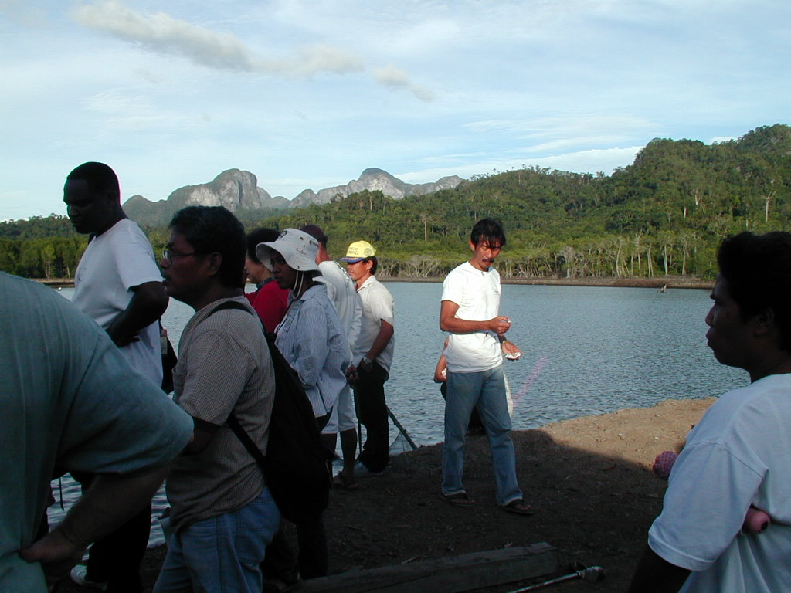

Figure 6.1. Field-course participants and stakeholders at the Tagabinet shrimp ponds, with a view of mountains in the Underground River World Heritage Site in the background.

Several working groups in the field-course tackled the problem of illegal aquaculture ponds (shrimp and fish) in a mangrove ecosystem near the small community of Tagabinet in the municipality of Puerto Princesa on Palawan Island. Tagabinet is a relatively isolated, poor rural community. The mangrove forest in question is pristine, old growth forest near the Underground River National Park and World Heritage Area—one of the best preserved ecosystems on one of the best preserved islands in the Philippines.
Community members depended directly on the mangrove ecosystem for small amounts of building materials, mud crabs, ‘mangrove worms’ – a local delicacy – and other resources. A small indigenous community lived on the borders of the mangrove forest in question, and relied heavily on its resources. Mangroves play a critical role as nurseries for commercial fisheries, as well as in protecting coral reefs and marine habitats by capturing pollutants and sediments in water runoff. As a result, the ecosystem typically produces more seafood when intact than when converted to shrimp ponds—not to mention that shrimp are carnivores, and require up to 5 kilos of fishmeal to produce one kilo of shrimp. Mangroves protect against storms and wave surges, sequester large amounts of carbon, and provide vital habitat for a number of terrestrial and marine species, including many that are threatened. The Tagabinet mangrove also contributed to the spectacular beauty of the area, and hence played a role in a growing ecotourism industry.
A license for an existing fishpond in the mangrove forest expired in 1999, and was not renewed. A religious organization from outside the community purchased the fishpond, and then in 2002 began to expand it, clearing 14 hectares of mangrove and constructing large dikes to create ponds, and in the process disrupting hydrological flows and threatening the remaining mangroves. High intensity aquaculture can generate impressive financial returns for 3-9 years before succumbing to pollution and disease, but employs only a handful of local people (though building the dikes employs more people for a brief period). From a short term economic perspective, aquaculture can seem very desirable. Even though it is technically illegal to clear mangroves, the federal Department of the Environment and Natural Resources (DENR) in the Philippines can and does give permits for aquaculture in mangrove ecosystems, renting the land to private owners at very low rates. Tagabinet lies within the city boundaries of Puerto Princesa under the leadership of Mayor Edward Hagedorn. The Environmental Legal Assistance Center was working with the community of Tagabinet to protect their rights to the benefits from the intact mangrove ecosystem.
Nearby mangrove ecosystems deforested in the 1940s had not yet grown back, so conversion was for all practical purposes irreversible and already underway: Decisions were urgent. No baseline data on the ecosystem existed, and there was no time for extensive research: Facts were uncertain. Not only did the community depend on the mangroves, but the Philippines had already lost 70% of its mangrove cover: Stakes were high. The system met the needs of many different stakeholder groups in different ways: Values mattered.
A number of alternatives were available to address this problem. The first option, as always, was to do nothing, which in this case would be to allow the continued expansion of the fish ponds. A second alternative was to allow the existing fishponds to remain, but get the authorities to enforce existing laws and prevent further expansion. A third alternative was to obtain permission from the authorities to destroy the new dikes. A fourth alternative was to gain permission to destroy all of the dikes. The third and fourth alternatives could occur with reforestation or without.
These actions could be rated according to a number of objectives. First, economic objectives included monetary revenue from the ponds, from commercial fisheries dependent on the mangrove ecosystem, and from ecotourism, as well as the food and other raw materials harvested from the healthy mangroves. Social criteria included employment, distribution of the benefits from the system, cultural values of the ecosystem to the local community and to the indigenous group, and respect for the law. Ecological criteria included preservation of the various ecosystem services. Political feasibility of any alternative was also important.
This was clearly a complex problem that did not lend itself to the slow, conservative and nominally value-free approach of traditional science and economic analysis. The complexity of the problem made analysis a challenge, but one that was fully met by the abilities of the workshop participants. While synthesis generally proves more challenging then analysis, this was not the case here: Once the pieces were all gathered in the same place, such a clear picture emerged that assembly into a synthetic whole proved quite simple, as described below.

BOX 6-1. Time Lags and Urban Sprawl

In a less exotic example of the influence of time lags, consider the seemingly simple solution to urban sprawl of forbidding new construction beyond the current city limits. This has been done in a number of cities, such as Portland, Oregon. However, continued growth in demand and a fixed supply of land causes property values to skyrocket. Those who already own land, generally the wealthier groups in society, make windfall profits. Speculative investment in land becomes more profitable, further increasing speculative demand in a positive feedback loop. Rent skyrockets, harming poor renters. Property taxes can also soar, forcing poor landowners to sell or face yet greater poverty. The poor must move to outlying communities with fewer restrictions on growth, then commute to work where they once lived. Over time, development may simply leapfrog the political jurisdiction of the city that limited growth. Portland has reputedly suffered some of these impacts due to their urban growth boundary. Such outcomes were foreseeable for those who bothered to look.

BOX 6-2: Computer Science and Complex Systems

Ecological-economic problems involve enormous amounts of information concerning systems that interact in a very complex fashion. Can computer science contribute to organizing this information and modeling these interactions in a way that facilitates understanding the problem? Can computer modeling help to understand possible outcomes of different interventions? Many problems of concern are global in nature. We cannot use the traditional scientific method of repeated observations and experimentation when our sample size is one. Can we develop computer simulation models that will allow repeated observation and experimentation in a virtual system? Can we trust the results?
There are numerous examples in the tradition of ecological economics to illustrate the role of computer science. In fact, many ecological economists come from a systems modeling background, a tradition that has its roots in computer science and the work of Jay Forrester of the Massachusetts Institute of Technology (MIT). Probably the most well-known systems model is Forrester’s World Dynamics Model that formed the basis for the Limits to Growth study of Donella Meadows and colleagues, later revised and expanded in Beyond the Limits (1992). This transdisciplinary research highlighted physical, social, and environmental limits to exponential material consumption and population growth. The World Model, and other systems models, is not meant to be predictive to the day or decimal point, but rather be illustrative of possible futures that could be chosen or avoided given decisions made today.
The Global Unified Metamodel of the BiOsphere (GUMBO) is the most recent incarnation of the global systems modeling approach, developed to simulate the integrated earth system and assess the dynamics and values of ecosystem services. As a “metamodel” it represents a synthesis and simplification of several existing dynamic global models in both the natural and social sciences. At an intermediate level of complexity, GUMBO simulates the dynamic feedbacks among human technology, economic production and welfare, and ecosystem goods and services within the earth system. Model components include modules to simulate carbon, water, and nutrient fluxes through the Atmosphere, Lithosphere, Hydrosphere, and Biosphere of the global system, and social and economic dynamics within the Anthroposphere. These five spheres are linked across eleven biomes, which together encompass the entire surface of the planet. The dynamics of eleven major ecosystem goods and services for each of the biomes are simulated and evaluated.
The current version of the model can be downloaded and run on the average personal computer to allow users to explore for themselves the complex dynamics of the system and the full range of policy assumptions and scenarios (see www.uvm.edu/giee/GUMBO/). Hint, hint: another potential exercise!!!

Cole, A., W. Allen, M. Kilvington and A. Fenemor (2001) Sustaining Ecosystems Services in the Motueka Catchment: Participatory Modelling with an Influence Matrix. Unpublished report.
This exercise was adapted from Cole, A., W. Allen, M. Kilvington and A. Fenemor (2001) Sustaining Ecosystems Services in the Motueka Catchment: Participatory Modeling with an Influence Matrix. Unpublished report
Note that this is modified and simplified description of the actual dynamics in the Tagabinet case.
Meadows, Donella. 1997. “Places to Intervene in a System,” Whole Earth, winter issue.
As a project in one applied problem solving course, a group of students helped to organize the course described here.
Meadows, Donnella H., Meadows, Dennis L., Randers, Jorgen and William W. Behrens III, The Limits to Growth, Universe Books, New York, NY, 1972.
Meadows, Donnella H., Meadows, Dennis L., and J. Randers, Beyond the Limits: Confronting Global Collapse, Envisioning a Sustainable Future, Chelsea Green Publishing Co., Post Mills, VT, 1992.
Boumans, R., R. Costanza, J. Farley, M. A. Wilson, R. Portela, J. Rotmans, F. Villa, and M. Grasso. 2002. Modeling the Dynamics of the Integrated Earth System and the Value of Global Ecosystem Services Using the GUMBO Model. Ecological Economics 41: 529-560.

