

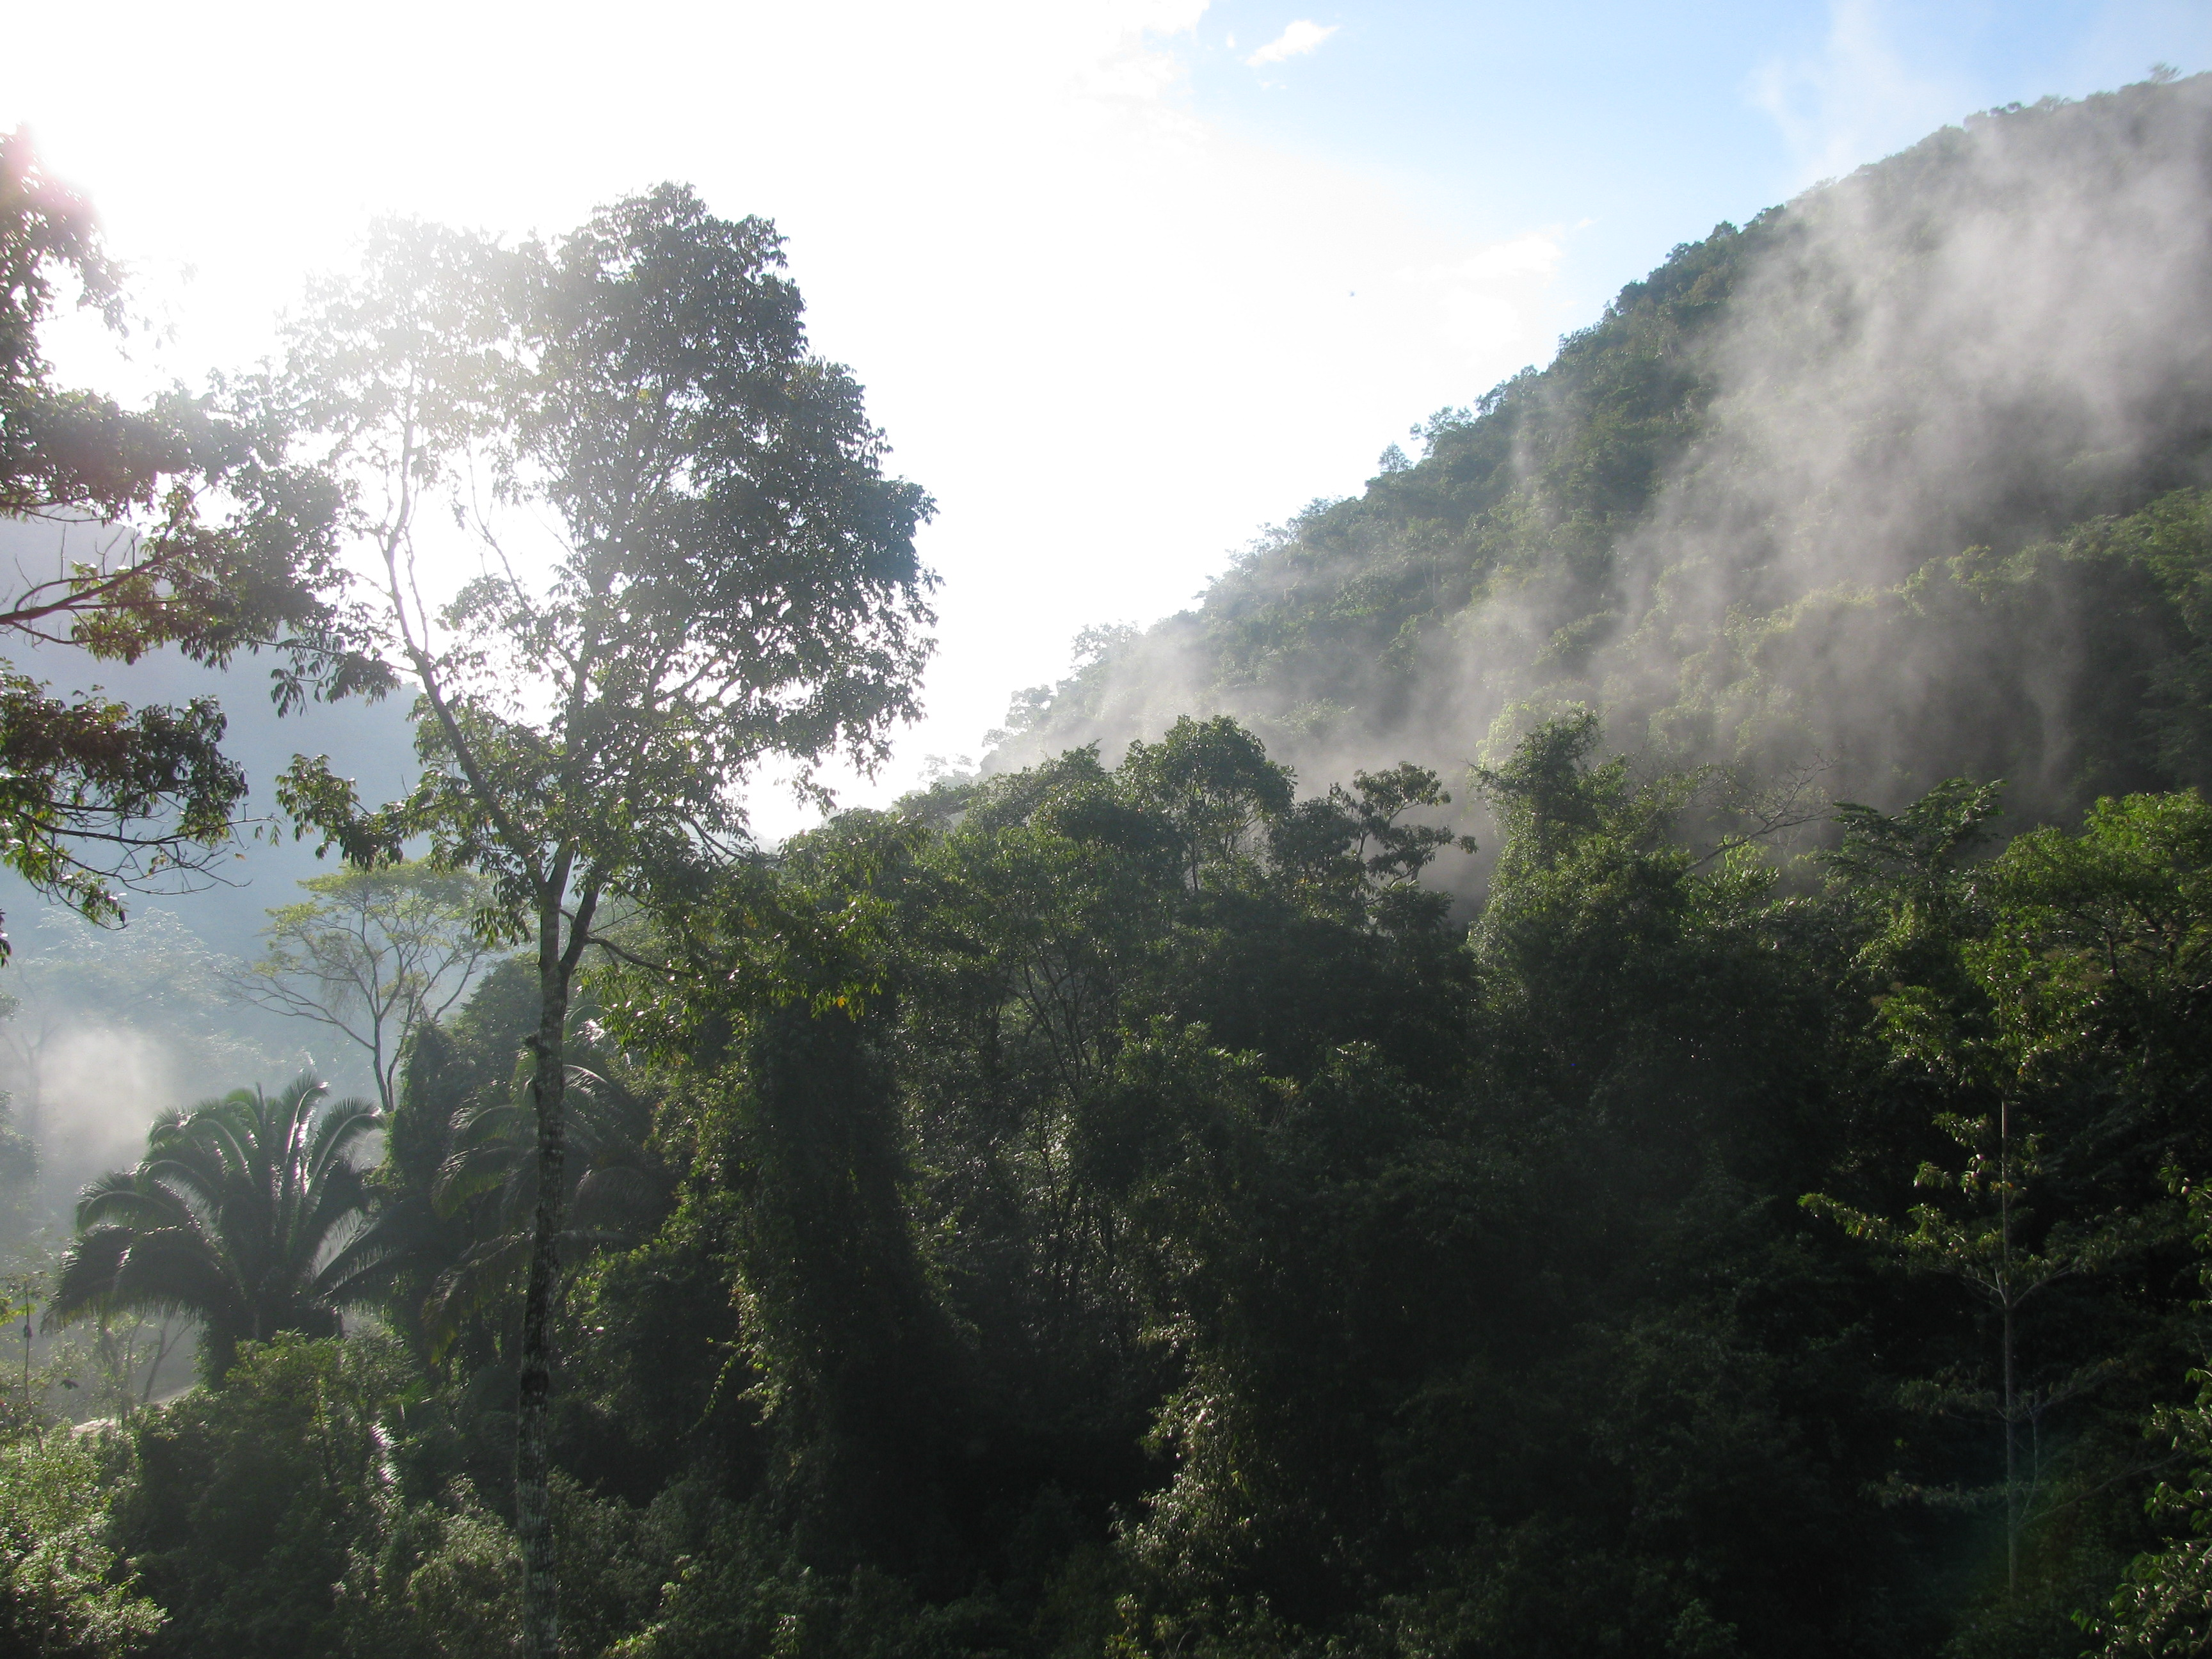
Effective Signage in Chiquibul Forest, Belize

Applications of Sustainable Development
Galen University
Spring 2009

Report by: Kate Lucas, Greg Sluss,
Jim Casey & Elica Chan

Table of Contents

Acknowledgements ............................................................................. 3

Introduction and Mission Statement ................................................ 4

Background Research ........................................................................ 5

Activities and Methods ....................................................................... 7

Results and Findings .......................................................................... 11

Recommendations .............................................................................. 11

Works Cited ........................................................................................ 13

Appendices
Appendix A - Project Proposal Form ......................................... 14
Appendix B – Guidelines for Signage Manual .......................... 17
Written and provided by FCD
Appendix C – Full Literature Review ........................................ 19
Appendix D – Effective Signage Manual .................................. 26

Acknowledgments

First and foremost, the Effective Signage Group (ESG) would like to thank Friends for Conservation and Development (FCD), specifically Park Manager Derric Chan and Executive Director Rafeal Manzanero. Without the involvement, commitment and cooperation of FCD this project would not exist. ESG would also like to thank Mr. Michael Preston of the Belize Hotel Association and the Belize Tourism Board for his time and input related to standardized signage in Belize. Finally, ESG would like to extend a special thanks to Jay Ashman and Kaela Gray; without their dedication this project and this class would never have come into being and the projects would have faltered.
Introduction and Mission Statement

Friends for Conservation and Development (FCD) is a non-profit, non-governmental organization based out of historic San Jose Succotz, a town in Belize’s Cayo district. As an organization, FCD aims to educate the public and protect the environment of Belize. FCD is responsible for the management of the Chiquibul Forest System. This area includes 263,000 acres of broadleaf tropical forest in the Chiquibul National Park, 147,823 acres within the Chiquibul Forest Reserve and 25,549 acres within the Caracol Archaeological Reserve (See Figure 1).

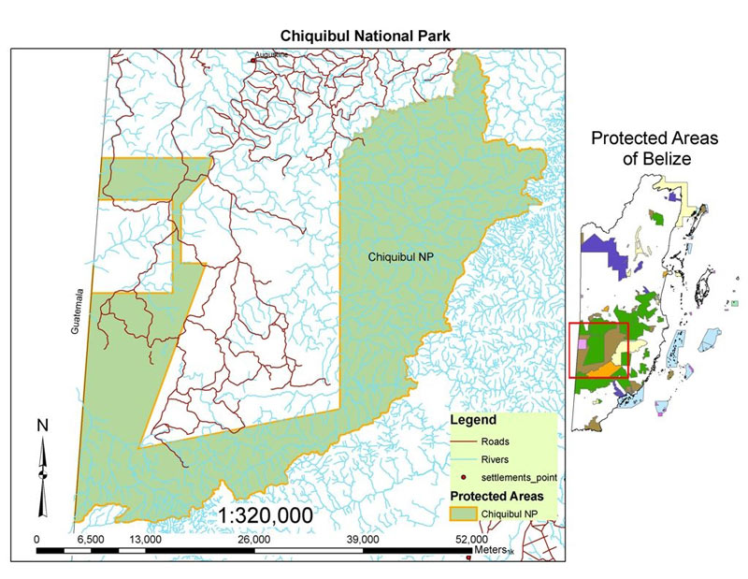
Figure 1: Map of the Chiquibul Forest System

These areas are under significant threat of loss of biodiversity due to an inability to properly manage and monitor the area with the limited staff and resources available to FCD. Specifically, there are major threats from illegal deforestation, agricultural incursions from neighboring Guatemala, illegal hunting, logging and harvesting of xate (a palm leaf commonly used in floral arrangements) and other non-timber resources from within the forest boundaries. FCD has implemented a management plan that seeks to enforce protection within the area.
The goal of the Effective Signage Group (ESG) is to work with FCD to develop a manual to outline a standardized signage system in the Chiquibul Forest System. Due to the limited financial and human resources available to FCD, the management of the Chiquibul often falls short of set objectives. ESG believes that an effective signage system would be a beneficial addition to the Chiquibul in order to help to protect and maintain the area in light of the limited resource base. Additionally, FCD hopes, in the future, to implement tourism operations to generate income. For these operations to function effectively, a proper system of signage is necessary. The manual created will also potentially provide a jumping off point for the standardization of all of Belize’s protected area signage.

Background Research
(Full Literature Review available in Appendix C)

Belize, a young country at only 28 years since independence, is a nation of incredible ecological diversity (Balboni, 2007). This biological diversity, however, is being threatened at an alarming rate. Specifically, deforestation in Belize is occurring at a rate of 2.3% per year – higher than any other Central American nation (Mondabay, 2006). The resulting loss of biodiversity threatens to destroy far more than beautiful forests. Through the power of ecosystem services to “benefit human populations… [both] directly [and] indirectly,” biodiversity helps to regulate social, ecological and economic stability throughout the world (Costanza et al, 1997).
Much of this biodiversity loss is fueled, both directly and indirectly, by a lack of environmental literacy throughout Belize. As is true in other developing nations, social and economic issues generally take precedence over issues of sustainability and protected areas, even when conservation and preservation may benefit the local community (EPA). Through environmental education, local communities are informed about the benefits provided by natural resources and ecosystem services. Environmental education generally leads to a genuine and dynamic concern for the natural environment (Tilbury, 1995). Thus, it is through community education and involvement that long-term sustainability of natural resources and protected areas can be attained (Fiallo et al, 1995).
Additionally, in areas with limited management resources, signage can act as a means to regulate and inform individuals. Signage is a relatively inexpensive and effective method by which a managing organization can direct the behavior of visitors through education. In order to do this, a comprehensive and standardized system of regulatory, informative and interpretive signs must be implemented within and outside the area in question (Lassiter, 2007). Without signage, dangers and confusion may arise and disregard toward the park may pervade (FFP, n.d.). On the other hand, if properly implemented, effective, mass communication can be achieved and the resource base is not only protected but also shared with the public (NPS, 2006).
Activities and Methods
After receiving preliminary information from Friends for Conservation and Development (FCD) at their office in San Jose Succotz, the Effective Signage Group (ESG) made plans with FCD rangers to make a trip into the Chiquibul Forest to learn more about the signage manual project from within the confines of the area in which the signs are to be implemented.
On February 24th, 2009, ESG was picked up in San Ignacio by FCD Executive Director Rafael Manzanero and began the journey to the FCD headquarters in Chiquibul National Park. ESG had met with the FCD before, but the group was still somewhat confused about what specifically needed to be done for the project. ESG drove for about two hours and eventually arrived at the headquarters, which is located a short ways past the bridge over the Macal River towards Caracol. ESG remained at the headquarters for a few hours and spoke with representatives from the FCD before making the way back to San Ignacio as the sun began to set.
Driving to the FCD headquarters, ESG discussed effective signage and observed the few signs, outside of the Chiquibul, that existed along the way. Mr. Manzanero explained the problems with them as well as the need for new signs and a standardized system that would dictate uniformity amongst park signs in Belize. He told ESG how the success of the tourism industry in the park is dependent on effective signage and how important tourism is for the generation of revenue that is used to sustain park management and maintain the park in functioning form. Most of the signs that ESG drove by were broken or weathered to the point that they were unreadable. If it were not for the entrance gate of the Mountain Pine Ridge area, visitors would not know of their location within a protected area. Of the few, relatively new signs that were standing and readable, few were effective. ESG spoke with Mr. Manzanero about a sign outside of Chiquibul that indicated the Elijio Panti National Park (See Figure 2). Mr. Manzanero was disappointed and pointed out that the rules and regulations section, which should have been the main focus of the sign, was minimized on a smaller sign to the bottom-left of the main sign. He also expressed his opinion that the sign is ambiguous, and he pointed out the several logos of organizations on the bottom of the sign. He asked ESG which organization the group would have assumed was responsible for the creation of the sign, and the group all chose the wrong one (due to its relatively large size).

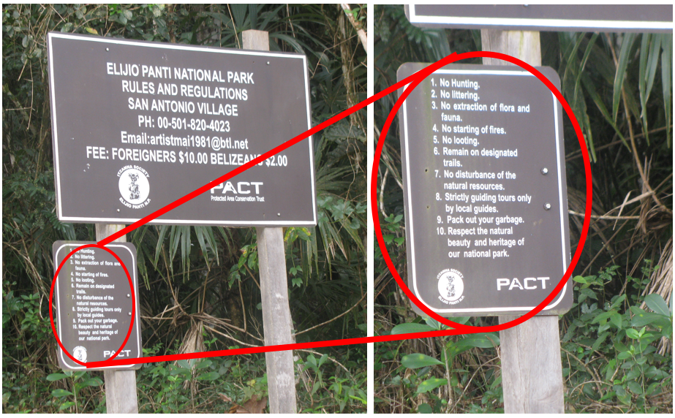
Figure 2: Entrance sign to Elijio Panti National Park

ESG’s preliminary understanding of how the group was to go about the project came from what Mr. Manzanero expressed while in the truck or at FCD headquarters in the Chiquibul. He explained that park signs in Belize tend to be brown with white text, but there is no official template that their design or color scheme follows. It was made clear that ESG’s assistance was needed in order to make a manual that would outline this standardized template for Belize’s park signs. It was on this trip that ESG was made aware of the work necessary to complete the manual.
Upon returning from the Chiquibul trip, the group received a document from FCD containing guidelines for the creation of a signage manual (see Appendix B). Additionally, the group was given a signage manual from Mexico, Manaul De Señalización para Áreas Naturales Protegidas (Signage Manual for Natural Protected Areas), to study and base the Chiquibul signage manual upon. ESG then worked to translate the Mexican manual and apply pertinent information to the outlining of an appropriate manual for the Chiquibul Forest.
As the guidelines provided by Park Manager Derric Chan of FCD requested (See Appendix B), ESG then attempted to make contact with and interview several important community members who have insight into what a standardized signage system in Belize should contain. ESG was successful in interviewing Mr. Michael Preston. Mr. Preston is presently a member of both the Belize Hotel Association (BHA) and the Belize Tourism Board (BTB). He is also the owner and manger of Midas Resort, located in San Ignacio town. Mr. Preston has a wealth of knowledge pertaining to the tourism industry in Belize and often travels to Europe to promote Belize as a tourism destination in the Caribbean. As a result, he was an ideal person to interview to gain an understanding of what the tourism industry would like to see implemented in the way of standardized signage, specifically in the Chiquibul Forest. Mr. Preston was more than willing to host ESG at his resort to conduct an interview. After describing the standardized signage project to Mr. Preston he became interested in the work and enthusiastically answered questions pertaining to the project. He liked the idea of implementing a signage system for the park because a large number of tourists who visit the Cayo District visit Caracol, the Archealogical Reserve located within the Chiquibul. Tour operators routinely promote this site as an attraction for tourists. It would greatly improve the tourist experience if there was an increase in information, direction and commodities within the park. This increased accessibility, he stated, would increase the tourist presence in this part of Belize. Mr. Preston also stated that in order to incorporate a professional standardized signage system, it would be necessary for the Government of Belize to give full support after completing an in depth review of the proposal. This would help to avoid flaws or misunderstandings and ensure that all institutions co-managing the parks are aware of the proposed signage system. He also provided ESG with a list of signs that could be put in place for the tourists who visit the Chiquibul. The suggestions given to ESG were used to give the group an idea of other signs to include and how to improve the content of the manual.
Additionally, in the planning process regarding the creation of the manual, ESG attempted to contact the Forest Department several times. After receiving word that e-mail would be the most effective means for ESG to communicate with the Forest Department, their office was e-mailed a list questions about what their expectations or input would be in the creation a professional system of signage for a parks system or forest reserves. A response is still pending.
Also, signage from the Department of Archaeology and other directional signs around the Cayo District were measured in order to create a basis for comparison of signage dimension. With these dimensions recorded, we were able to create realistic size recommendations for the signage in Chiquibul.
Upon completing the background work for the manual creation, ESG worked to arrange all of the information in a comprehensible, organized and stylistically appealing manual. Due to limited graphical design software, this task was undertaken entirely in Microsoft Word. A first draft was completed on March 30th, 2009 and the product was delivered to Rafeal Manzanero and Derric Chan at FCD on April 3rd, 2009. After the draft was reviewed by FCD, ESG performed the necessary and desired revisions and had a final copy printed and bound for FCD (See Appendix D).
Results and Findings
As a result of the time spent working with FCD, the ESG was able to acquire a greater knowledge and understanding of the necessity for a system of standardized signage not only throughout protected areas but also throughout entire nations. ESG was able to overcome various limitations and challenges in order to make the concept of a standardized signage system for the Chiquibul Forest System nearly a reality. These limitations include communication issues between members of ESG as well as with FCD. Additionally, the limited staff at FCD combined with their vast amount of responsibility made it difficult to find time to meet. This specific limitation slowed that rate at which ESG could properly undergo the task of creating a signage manual while simultaneously assuring that the work was of the desired nature. Other communication flaws and time constraints with various individuals made it difficult and or impossible to acquire interviews suggested in the guidelines provided by FCD.
These issues aside, ESG was able to finish the manual and present it to FCD. Throughout our time spent in Belize, both as a part of and apart from this project, ESG has come to realize the benefits that a standardized system of signage could provide to the nation. ESG hopes that the manual created can go on to aid the country in creating a nationwide system of signage for protected areas.

Recommendations
ESG would like to see the system of standardized signage implemented within the Chiquibul Forest System. Because of the limited financial and human resources available to FCD, ESG believes that this project should be continued in the future. This continuation could include, but should not be limited to, student service-learning groups working with FCD to assess the Chiquibul area to outlining an efficient implementation regimen. Service-learning groups could also work with FCD to find and increase financial support for the production and the implementation of signage.
Additionally, ESG would like FCD to continue to advocate for a national system of standardized signage. The manual should be presented to regulatory bodies such as the Belizean Government and the Forest Department for approval and necessary changes made as requested and required. As such, ESG will provide FCD with a modifiable, electronic copy of the manual so that necessary modifications can be made. This manual has the potential to provide the basis of standardization for the entire country of Belize and ESG would like to see it reach its full potential.

Works Cited
Balboni, B., & Palacio, J. (2007). Taking Stock: Belize at 25 Years of Independence. Belize: Cubola Productions

Costanza, R. Et al. (1997). The value of the world’s ecosystem services and natural capital. Nature, 287, 253-260.

Environmental Education. United States Environmental Protection Agency. Retrieved on Feb. 5, 2009 from http://epa.gov/enviroed/index.html.

Fiallo, E.A., Jacobson, S.K. (1995). Local communities and protected areas: Attitudes of rural residents towards conservation and Machalilla National Park, Ecuador. Environmental Conservation, 22(3), 241-249.

Friends of Forest Park. (n.d.) Signage Project. Retrieved on, Feb. 5, 2009, from
http://www.forestparkconservancy.org/programs/signage-project/signage- project#documentContent

Lassiter, K. (2007). A Marine Educational Strategy for Tourists and Residents: Design and Assessment of Signage in Island and Jefferson Counties, WA.

Mongabay.com. (2006, February 06). Belize: Environmental Profile. Retrieved
February 22, 2009, from http://rainforests.mongabay.com/20belize.htm

National Parks Service. (2006). Management Policies 2006. Washington, DC: U.S. Government Printing Office.

Tilbury, D. (1995). Environmental Education for Sustainability: defining the new focus of environmental education in the 1990s. Environmental Education Research, 1(2), 195-212.
Appendix A – Project Proposal Form

Project Proposal Form

1. Group Information: Who is in your group? What are their roles in the group? What is their contact information and when do you plan on meeting?
Name | E-mail | Phone | Role in Group | Group Meeting times
1. Kate Lucas | kblucas@uvm.edu | 665-8039 | Group Leader | During Class,
2. Jimmy Casey | jmcasey@uvm.edu | 665-8154 |  | Mon/Weds: 4:30-6:30
3. Elica Chan | elicabet05@hotmail.com | 607-9677 | Group Liaison | Thurs: 9-12
4. Greg Sluss | gsluss2018@wsc.ma.edu | 624-7730 |  | Fri: anytime but 12:30-3

2. Project Description: Write a one-paragraph description of the problem. What is the nature of the problem? Why is it a problem?

The Chiquibul National Forest is one of the largest remaining intact blocks of tropical rainforest worldwide. The environmental stability of this area, however, is being threatened due to a lack of knowledge of the area as well as illegal incursions and exploitation of the resources with the forest. This is in part an adverse effect of the national government’s lack of a standardized sign system for protected areas.

3. The Desired Ends
Briefly describe the desired ends. What does your group envision as the solution to your problem (goal)? How will your project contribute to realizing a MDG objectives?
1. Eradicate extreme poverty and hunger 2. Achieve universal primary education
3. Promote gender equality and empower women 4. Reduce child mortality
5. Improve maternal health 6. Combat HIV/AIDS, malaria, and other diseases
7. Ensure environmental sustainability 8. Develop a global partnership for development

By the end of the project period, we hope to have acquired sufficient information and had ample time to produce a complete manual for creating a standardized sign system for the Chiquibul Forest System. This manual will hopefully be adequate for proposal to the Forest Service and the national government of Belize. Improper use and management of protected areas can have adverse effects upon the environmental sustainability of the region, country and the global ecosystem. As such, we feel it is imperative to sustainability as a whole to educate and inform all members of the nation about proper use and management of protected areas as well as the over arching importance of preserving biodiversity.

4. Partner Information
Briefly describe your project partner and what its role will be.

FCD is a NGO located in San Jose Succotz that aims to educate the public and protect the environment of Belize. We anticipate that FCD will provide information about the problem areas within the Chiquibul National Forest and what they expect in terms of a proposed sign system. We also expect to be provided with technical information necessary for the signs with which we are not familiar.

Organization | Contact information  (name of contact person, address, phone, e-mail address, etc.)
Friends of Conservation and Development (FCD) | Derric Chan, San Jose Succotz, 823-2657, dchan@fcdbelize.org

5. Timeline

Estimated date | Activity | How objectives will be met | Person(s)  responsible | Complete?
Feb. 5 | Project Proposal due | -Identify why it’s a problem  -Think of alternatives  -Meet with group | Entire group | 
Feb. 10 | Partnership Agreement due | -Meet with partner  -Identify needs  -Schedule meetings  -Identify group liaison | Entire group | 
Feb. 24 | Literature Review due | - Research web and other sources  -Divide responsibilities among group  -Write report | Elica, Greg and Jimmy will do research on various subjects. Kate will compile and write review. | 
Feb. 24 | Mountain Pine Ridge/Chiquibul Visit |  |  | 
March 3 | Revised Literature Review due |  |  | 
March 7 | Additional Research for manual | - Interview various groups and individuals involved with protected areas.  - Forest Department  - Tour Guides/ BTB |  | 
March 12 | Outline for Manual |  |  | 
March 12 | Presentation #1 |  |  | 
April 2 | Draft Final Report due
April 3 | Meet with FCD to show manual | .
April 7 | Practice presentation
April 9 | Complete final manual | Revise as suggested, print and bind.
April 16 | Final Report due
April 23 | Final Presentation

6. Proposed Budget
Identify anticipated expenses, including transportation, copying, purchases of materials and equipment, and possible contribution to project partner for continuation of project-related work.
Category of expense | Anticipated expense in $BZ | Justification | Running Total
1. Transportation to FCD headquarters and Chiquibul  2. Materials for manual/sample sign  3. Donation for Implementation of Signs | $30  $200  $150 | $1.50 bus fair to/from Succotz and possible transportation to forest areas.  High quality paper/ink and binding processes. Possible sign materials.  Added incentive to implement sign system. | $30  $230  $380

Format drafted from “A Workbook For Problem-Based Learning,” Farley, Erickson and Daly
Appendix B – Guidelines for Signage Manual
Written and provided by FCD

Guidelines for Signage Manual for Chiquibul National Park
and Chiquibul Forest Reserve
Summary
The Chiquibul National Park constitutes of 263,000 acres of primary broadleaf forest and together with the Chiquibul Forest Reserve 147,823 acres and Caracol Archaeological Reserve 25,549 acres it totals 436,372 acres. The history of the Chiquibul forest is etched in the era of Chicle Tapping and logging. The Chiquibul forest comprises of numerous cave systems, underground rivers, gorges, valleys several of the highest peaks in Belize and major Maya sites including Caracol. Uses of the chiquibul forest dates as early as 1920s when logging had started; during the life of this industry numerous roads were built and many of these are still in operation. In 1995 the boundaries of these protected areas were redefined but these were never demarcated or monitored. Isolated management activities were conducted from time to time but until 2008 a management plan was devised for the Chiquibul National Park. Management in the Caracol Archaeological Reserve has been conducted since the 1980s and has relatively improved during the last decade. The National Protected Areas System Plan recommends the holistic approach of management for the Maya Mountain block and as such it is important to consolidate all management perspectives.
The management plans and the consolidation of the Chiquibul Maya Mountains have brought a concerted vision and effort for the Chiquibul Forest. In 2007, Friends for Conservation and Development (FCD) signed a co-management agreement with the Forest Department to manage the Chiquibul National Park and in 2008 a co-management agreement with the Institute of Archaeology was made to manage the Chiquibul Cave System.
Currently there are major threats from agricultural incursions from Guatemalan communities and major illegal hunting, logging and extraction of xate and other non-timber forest products in the Chiquibul Forest. With the management programs in place FCD is committed to implement and enforce protection. Bearing this in mind, at the forefront FCD is now charge with the development of a Signage System for the Chiquibul Forest. The objective of this manual will be help administrators of the park implement a standardized system of signage guided by the formats provided on such a manual. Signage will consist but not limited to entrance signs, intersections, specific features, instructions for visitors, labellings, caution signs, and overall information for users of the park.

Guidelines for Manual
- The direct contact at Friends for Conservation and Development will be the Park Manager Derric Chan, in his absence the next contact should be the Executive Director Mr. Rafael Manzanero
- In the field the direct contact will be Assistant Park Manager, Jaime Requeña
- A work plan should be presented to FCD on the development of the plan.

The Manual
- To elaborate a signage manual for the Chiquibul Forest including Chiquibul National Park and Chiquibul Forest Reserve
- The manual should be a comprehensive manual that will include research on signs for protected areas in Belize (Consider that Belize has not yet developed a national signage guideline for protected areas.)
- The Manual should include but not limited to roads, recreation, rules and regulation, interpretation, entrance signs, information points.
- The Manual should consider colors, fonts, sizes for the signs appropriate for the protected areas.
- The Manual may be used as a standardized system eventually, if done appropriately.
- The persons working on the manual should conduct surveys with tour guide, local community members, stakeholders and government agencies.
- The manual should be presented to Friends for Conservation and Development at the end of the working period.

Appendix C – Full Literature Review

Effective Signage in Chiquibul National Park

Jim Casey
Elica Chan
Greg Sluss
Kate Lucas

Galen University – Spring 2009
Table of Contents

Biodiversity and Protected Areas Conservation in Belize 3 - 4
Research Contributed by E. Chan, Written by K. Lucas

Environmental Education 4 - 5
Research Contributed by J. Casey, Written by K. Lucas

Protected Areas Management and Signage 5 - 6
Research Contributed by G. Sluss, Written by K. Lucas

Biodiversity and Protected Areas Conservation in Belize
The conservation of biodiversity is paramount to social, ecological and economic stability worldwide (Mongabay, 2006). In addition to the inherent value many cultures and individuals place upon the natural world, biodiversity allows for the proper function of a wide array of ecosystem services. By definition, ecosystem services “represent the benefits human populations derive, directly or indirectly, from ecosystem functions” (Costanza et al, 1997). These services include, but are not limited to, the following: generation and maintenance of quality soil, air and water quality maintenance, water supply, gas regulation, pest control, detoxification and decomposition of wastes, pollination necessary for crop production, climate stabilization, prevention and/or mitigation of natural disasters, nutrient cycling, food production, raw materials and recreation (UNDP)(Costanza et al)(Mongabay, 2006). Biodiversity and these services, however, are being threatened by rapid environmental degradation. The major causes of this degradation are habitat destruction, invasive species, pollution and over-harvesting. The underlying factors responsible for these issues are generally market and policy failures, social, political and institutional weaknesses and a lack of knowledge pertaining to the importance of biodiversity (UNDP).
Belize as a nation is home to incredible biological diversity and natural resources. These resources, however, are being threatened by an annual deforestation rate of 2.3% – the highest in Central America. This is largely due to a lack of regulation and management, understaffed parks and illegal harvesting activities, both domestic and via incursions from Guatemala (Mongabay, 2006).
In an effort to combat environmental degradation, several groups within Belize have been working to protect and conserve natural resources through the implementation of protected areas. As defined by the Convention on Biological Diversity, a protected area is “a geographically defined area, which is designated or regulated and managed to achieve specific conservation objectives” (CBD, 2007). In Belize, the Belize Audubon Society (BAS, 2008) maintains nine protected areas, totaling 192,000 acres (BAS 2008). Additionally, Friends for Conservation and Development is responsible for the Chiquibul Forest System (Chiquibul National Park and Forest Reserve), which encompasses 264,003 acres of tropical forest (FCD). This protected area is part of a “tri-national bioregion forming the largest contiguous block of tropical forest north of the Amazon” (FCD).

Belize Audubon Society. (2008). BAS Managed Protected Areas. Retrieved
February 22, 2009, from http://www.belizeaudubon.org/protected_areas/protected-areas.html

Convention of Biological Diversity. (2007, May 25). Protected Area Provisions in CBD.
Retrieved February 22, 2009, from http://www.cbd.int/protected/background.shtml

Costanza, R. Et al. (1997). The value of the world’s ecosystem services and natural capital. Nature, 287, 253-260.

FCD. (n.d.). Friends for Conservation and Development. Retrieved February 22, 2009, from http://www.fcdbelize.org/

I.B. (2004). Importance of Biodiversity. Retrieved February 22, 2009, from
http://www.jamaicachm.org.jm/BHS/importance_of_biodiversity.htm

Mongabay.com. (2006, February 06). Belize: Environmental Profile. Retrieved
February 22, 2009, from http://rainforests.mongabay.com/20belize.htm

PACT. (2006). Welcome to PACT. Retrieved February 22, 2009, from
http://www.pactbelize.org/

UNDP. (n.d). Biodiversity in Crisis. Retrieved February 22, 2009, from
http://www.undp.org/biodiversity/biodiversitycd/bioCrisis.htm

UNDP. (n.d.). The Importance of Biodiversity. Retrieved February 22, 2009, from
http://www.undp.org/biodiversity/biodiversitycd/bioImport.htm

Environmental Education
Environmental education is becoming an increasingly integral part of global conservation efforts. According to the Unites States Environmental Protection Agency (EPA), “environmental education increases awareness and knowledge about environmental issues or problems” (EPA). History has shown a distinct correlation between the definition and promotion of environmental education and the dynamic of concern towards the environment (Tilbury, 1995).
As a result, the desired outcome of all environmental education is an increase in environmental literacy. This can be achieved through various components, as outlined by the EPA. First, an awareness and sensitivity towards both environmental issues and the environment itself must be realized. In addition, a similar knowledge and understanding of these issues must be paired with an attitude of concern. Finally, skills to “identify and resolve environmental challenges” must also be acquired in order for individuals to begin participation in the resolution process (EPA).
Unlike the United States’ relatively recent application of environmental education, the United Kingdom has promoted environmental education in varying contexts for over a century. In the past thirty years, the UK has adopted widespread environmental education in an effort to enhance sustainable development efforts through environmental literacy. Under the term “education for sustainable development,” all schools in the UK are required to “develop [students’] awareness and understanding of, and respect for, the environments in which they live, and secure their commitment to sustainable development at a personal, local, national and global level” (NFER).
In the context of developing Latin American nations, social and economic strife commonly jeopardize the very existence of many protected areas. Poverty-stricken communities tend to exhaust natural resources in order to sustain themselves. The conflict between local communities and protected areas must be resolved and public involvement must be implemented to promote the long-term sustainability of protected areas (Fiallo et al, 1995).
In a 1995 study of Machalilla National Park in Ecuador, the local attitudes, values, ideas and knowledge in relation to protected areas, conservation and natural resource management were analyzed. The results of a 90-household survey revealed an overwhelming negative opinion of the neighboring park. The study also revealed, however, that positive attitudes towards the environment and conservation tend to correspond directly to an increasing knowledge of conservation issues, the perceived benefits of the park and friendly relations with the park staff. Similarly, negative attitudes towards the park stemmed directly from a lack of public participation in the park’s creation and management. In order for protected areas management to work effectively, “a multifaceted approach, incorporating community involvement, environmental education, the development of feasible economic alternatives, and long-term social as well as ecological monitoring, is needed to attain the goal of conserving biological diversity” (Fiallo, et al, 1995).

Environmental Education. National Foundation for Education Research. Retrieved on Feb. 5, 2009 from: http://www.nfer.ac.uk/research-areas/environmental- education.
Environmental Education. United States Environmental Protection Agency. Retrieved on Feb. 5, 2009 from http://epa.gov/enviroed/index.html.
Fiallo, E.A., Jacobson, S.K. (1995). Local communities and protected areas: Attitudes of rural residents towards conservation and Machalilla National Park, Ecuador. Environmental Conservation, 22(3), 241-249.
Tilbury, D. (1995). Environmental Education for Sustainability: defining the new focus of environmental education in the 1990s. Environmental Education Research, 1(2), 195-212.

Protected Areas Management and Signage
Proper management of protected areas is essential to effectively conserve biodiversity and maintain beneficial relations with human populations. Through a wide array of management policies, protected areas management strives to “pass on to future generations natural, cultural, and physical resources that meet desired conditions better than they do today” (NPS, 2006). Through proper management tactics, the United States National Park Service also seeks to exercise authority over the concerned protected area to ensure the “public’s appropriate use and enjoyment of park resource, including education and interpretation of park resources while preventing unacceptable impacts” caused by misuse and exploitation (NPS, 2006). In doing so, the NPS emphasizes consistency in the creation of “one” unified “national park system” that takes into consideration and consults local, state, tribal and federal entities (NPS, 2006). Additionally, all park management and regulation should fall in line with the foundation of park ideals and the obligation to preserve park resources while also providing the public with the maximum enjoyment of said resources presently and for future generations. Once again, this regulation must avoid and/or minimize adverse impacts on the resources at hand (NPS, 2006).
In the management of protected areas, signage provides an inexpensive and effective means to inform the public, visitors and management officials alike. Additionally, signs are permanent structures that the audience can selectively interpret at a pace enjoyable to themselves (Lassiter, 2007). Signs can be regulatory, informative or interpretive (Lassiter, 2007). Regulatory signs are used by natural resource managers to alter the conduct of recreational users through rules, warnings and guidance. Informative signs, most often located on-site at the destination, provide a “how-to” demonstration or identification of an attraction. Interpretive signs are used to encourage responsible use of resources and increase awareness about various aspects of a given area (Lassiter, 2007).
Park signage functions to directly provide information and direction to park visitors, communicates the park rules and regulations and also encourages learning (PPS, n.d.). More specifically, park signs offer clear directional indicators to facilities and points of interest. Educational and interpretive signage works to explain the history and importance of the specific area, thus increasing benefit to both the visitor and location via environmental literacy. Signage also provides an additional level of safety through classification of dangerous areas and the difficulty rating and length of specific trails (FFP, n.d.). Through the combination of various signage types, the visitor experience is enhanced and the area protected to the highest degree possible (Lassiter, 2007). Without signage, confusion often arises and an environment of disregard toward the park pervades (FFP, n.d.).
Overall, signs are used to direct behavior through education (Lassiter, 2007). A good sign is easy on the eyes, well organized and contains graphics that are pleasing and easy to understand. Additionally, signs must be provocative, interesting and in an area of high visibility. Perhaps most importantly, an effective sign will enhance the reader’s knowledge and understanding of the environment while also developing the reader’s environmental ethic (Lassiter, 2007). Unfortunately, any signage is one-way communication that excludes dialogue. That being said, in areas of limited staff and resource, signage is often the best and only means of mass information.

Friends of Forest Park. (n.d.) Signage Project. Retrieved on, Feb. 5, 2009, from
http://www.forestparkconservancy.org/programs/signage-project/signage- project#documentContent

Lassiter, K. (2007). A Marine Educational Strategy for Tourists and Residents: Design and Assessment of Signage in Island and Jefferson Counties, WA.

National Parks Service. (2006). Management Policies 2006. Washington, DC: U.S. Government Printing Office.

Project for Public Spaces (PPS). (n.d.). Creating Park Signage. Retrieved on, Feb. 5, 2009, from http://www.pps.org/topics/design?referrer=breadcrumb

Appendix D – Effective Signage Manual

This report was completed through contributions from Kate Lucas, Greg Sluss, Jim Casey and Elica Chan. Greg, Jim and Elica contributed to the methods section of this report. Kate wrote the other sections, compiled the writing of the rest of the group and edited the report.

Kate Lucas:

Greg Sluss:

Jim Casey:

Elica Chan:

