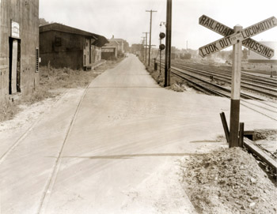
PHOTO 1 (LakeStSnd.jpg)
Intersection of Lake & Depot Streets, looking south, 1936
Louis L. McAllister
Geographic Position: UTM 18T0641404 4925846

Louis McAllister took this photograph of the intersection of Lake Street and Depot Street in 1936. The photograph reveals several character-defining features of the waterfront on Lake Champlain during this time. Numerous railroad tracks parallel Lake Street to the west (right), while one set of railroad tracks crosses the street at a diagonal to the east (left). The intersection of the two streets is marked with a railroad sign that reads, “Railroad Crossing, Look Out for the Locomotive.” A series of utility poles and overhead utilities lines are located between Lake Street and the paralleling tracks to the west. Two people, two vehicles, and four railroad cars are seen in the background of the image. The original caption on the back of the photograph reads, “A view of the project area looking south along its length from the intersection of Depot Street and Lake Street.”
Four industrial buildings line Lake Street to the east. As Burlington became a major port city along Lake Champlain during the mid to late 19th century, raw goods were shipped via boat and rail to the waterfront in Burlington to be stored and processed into manufactured goods. In 1853, the waterfront consisted mostly of railroad tracks with a few buildings throughout the landscape. By 1877, the industry along the waterfront had expanded and several buildings were erected along the lakeshore. Warehouses, lumberyards, sawmills, and other industrial buildings such as those shown here, were popular structures along the Burlington waterfront during this time. Because these structures are industrial in nature, they were not assigned street numbers, which makes tracking their histories somewhat challenging.
The building in the foreground appears to be a two story wood frame building, clad in vertical sheets of metal. At the time the photograph was taken, J.O. Middlebrook & Sons occupied the building, using it to store agricultural implements and twine. The door is located in the southwest corner of the building and is marked overhead with a “Quaker State Motor Oil” sign. The adjacent building to the south is a two story rectangular wood framed, metal clad storage building with a low-pitched gable roof and overhanging eave to the west. The eave provides some shade and protection from the elements when loading and unloading goods into the building from the adjacent railroad track. This building was also occupied by J.O. Middlebrook & Sons to store agricultural implements and fertilizer during the 1930s.
Continuing south along Lake Street, the third building shown in the photograph is a one story, wood frame and iron clad building used for lumber and building materials storage. In 1935 it was owned by the Burlington Lumber Company Incorporated, whose sign is seen on the building in the photograph. The building is constructed of wood posts and beams and is divided into four north-south bays approximately 16-feet wide. The westernmost bay of the building may date to 1853 or before, as it appears on the 1853 map of Burlington.
In the background of the photograph is a fourth building, which is a two story Sears and Roebuck & Company Merchandise Warehouse, owned by the John E. Booth Lumber Corporation. The building is framed with steel posts and beams with brick veneer and is used to house tire storage and agricultural implements.

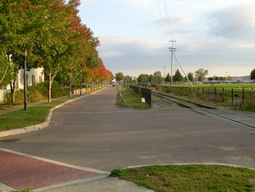
PHOTO 1A (LakeSt216S2006.jpg)
216 Lake Street
Intersection of Lake & Depot Streets, looking south, taken October 9, 2006
Photographer: Carrie A. Mardorf
Geographic Position: UTM 18T0641404 4925846

Since the decline of the lumber industry along the Burlington waterfront, the land along Lake Champlain has been significantly altered. Many dilapidated industrial buildings and abandoned railroad tracks that were once used during the late 19th century and early 20th century remained along the waterfront throughout the mid 20th century. In the 1980s, the city of Burlington made efforts to clean up the former industrial waterfront in attempts to attract residents and visitors to the area for active and passive recreation. To accomplish these goals, new zoning regulations were adopted for the waterfront area, including Lake Street in 1986. Two years later in 1988, the Burlington bike path was completed, which turned the old railroad right-of-way to a scenic bike path along the waterfront extending north to Colchester and south to South Burlington. Strides to improve the Lake Street and waterfront area continued into the 1990s. In 1990, the city adopted the Waterfront Revitalization Plan, followed by the creation of Waterfront Park in the following year.
Today the intersection of Lake Street and Depot Street is much more scenic than industrial in nature. Depot Street has been slightly realigned at the intersection allowing greater visual sightlines to oncoming traffic. The streets have been repaved, and curb and gutters edge both streets. A stamped concrete and painted crosswalk extends across Depot Street. Some of the railroad tracks remain to the west of Lake Street, though they are separated from the street by a decorative metal fence. An allee of maple trees (Acer species) lines the east side of the street, screening an adjacent parking lot and residential building.
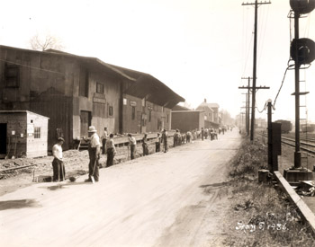

PHOTO 2 (LakeStS1936.jpg)
Lake Street, looking southeast, taken May 8, 1936
Photographer: Louis L. McAllister
Geographic Position: UTM 18T0641477 4926655

Lake Street was the focus of a repaving project in 1936. At that time, the street appears to be a two-lane compacted gravel road with no curb or gutter. To the west (right) of the street, are several railroad tracks, overhead utility poles and a railroad signal light. Tall herbaceous grasses grow between the railroad tracks and the street, giving it a rough, unkempt look. Along the east edge of the street is a group of men hand-digging a narrow trench for new underground utilities. The new utilites were part of a WPA project that also widened the road and repaved the surface in asphalt. More information about the project is given in the caption which reads, “Lake Street WPA Project No. 65-12-336 looking south from intersection of Depot Street. This project consists of widening pavement to twenty-four feet with Telford Stone base construction, surfacing with a leveling course of penetration macadam varying in thickness from one to four inches and constructing Hot Mix stone filled sheet asphalt wearing surface two inches in thickness.”
Industrial buildings, warehouses, and one railroad track line the east side of Lake Street. A large, two story, low-pitched gable roofed structure appears in the foreground. This wood framed, metal clad storage building is divided into two sections, with the southern section slightly higher in height. Several doors and windows punctuate the west façade in a seemingly random order, and two signs are displayed above windows in the taller, southern half of the building, but are not readable. Four wood steps lead up to a narrow elevated platform that spans the length of the building on the west side. The wood platform with overhanging eave provide a semi-sheltered a loading and unloading zone when moving and transporting goods from the building to the adjacent railroad track to the west. Also along the single railroad track to the north of the larger two story building, is a small light-colored shed with a six-pane window and shed roof. At the time of the photograph, the building and shed were owned by J.O. Middlebrook & Sons and used to store agricultural implements and fertilizer. Although the construction date of the building is not known, it likely dates to the late 19th century when development along the Burlington waterfront was expanding rapidly with increased manufacturing and storage facilities.
In the background of the image are two additional buildings. The building adjacent to the Middlebrook owned building is a one story, wood frame and iron clad building owned by the Burlington Lumber Company. To the south, is the Sears and Roebuck & Company Merchandise Warehouse, owned by the John E. Booth Lumber Corporation.
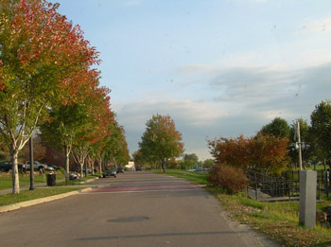
PHOTO 2A (LakeSt121S2006.jpg)
121 Lake Street, looking southeast, taken October 9, 2006
Photographer: Carrie A. Mardorf
Geographic Position: UTM 18T0641477 4926655

Today, Lake Street and the Burlington waterfront are quite scenic, with views overlooking Lake Champlain and the Adirondack Mountains to the west. The decline of industry along the Burlington waterfront, left abandoned and dilapidated buildings that remained throughout the mid 20th century. Beginning in the 1980s, Burlington made efforts to renew the waterfront by removing the former industrial buildings and began to draft plans to develop the area. The area currently boasts many recreational activities such as the Burlington bike path, skate park, and a large amount of green space.
Lake Street is currently a paved, two-lane street with on-street parking along the east side. A concrete curb and gutter create a definite edge to the east of the street, while mixed species herbaceous vegetation softens the west edge of the pavement. Some railroad tracks to the west (right) were retained in the redevelopment plan, but are screened from view by a decorative fence and a few understory trees. The fence also acts as a safety barrier for pedestrians. Other vegetation lining the street includes a row of maple trees (Acer species) along the east edge that creates a uniform street frontage. A gravel parking lot provides overflow parking for large events is also located east of the Lake Street on the far left side of the photograph.
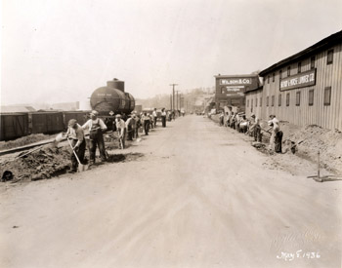

PHOTO 3 (LakeStN1936.jpg)
Lake Street, looking north, taken May 8, 1936
Photographer: Louis L. McAllister
Geographic Position: UTM 18T0641563 4926443

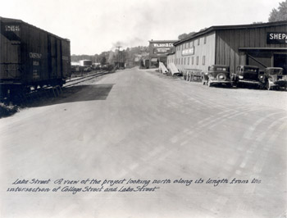
PHOTO 4 (LakeStNc1936.jpg)
Intersection of Lake and College Streets, looking north, taken circa 1936
Photographer: Louis L. McAllister
Geographic Position: UTM 18T0641587 4926393

In 1936, Lake Street was at the center of Burlington’s industrial waterfront. Oriented north-south, the street roughly paralleled the shore of Lake Champlain and provided access to several warehouses, lumberyards, and manufacturing businesses along the waterfront. Two McAllister photographs show an open streetscape with limited buildings and vegetation. Railroad tracks line the west edge of Lake Street, as evidenced by a tanker car and boxcars in the left foreground. In Photo3, two groups of men line the west and east sides of the street, respectively. The west group of men is digging individual holes that are evenly spaced with standard shovels. To the east, the men are digging a narrow trench for new underground utilities. A string line has been set up using wood posts to outline the exact position and width of the trench. A few overhead utility lines are seen in the background of the image, and vegetation is limited. Photo 4 shows a similar view of Lake Street at this time. The image also provides additional information about the street work being done. The front of the image reads, “Lake Street. A view of the project looking north along its length from the intersection of College Street and Lake Street.” The photograph also has a more detailed caption on the back stating, “Lake Street WPA Project No. 65-12-336 looking north from intersection of College Street. This project consists of widening pavement to twenty-four feet with Telford Stone base construction, surfacing with a leveling course of penetration macadam varying in thickness from one to four inches and constructing Hot Mix stone filled sheet asphalt wearing surface two inches in thickness.”
Both photographs depict two buildings located along the east side of Lake Street. In the foreground is a large two-story, seven bay rectangular building with vertical board and batten siding, with a smaller one story, four bay addition to the north. Windows on both the main block and addition are relatively small and evenly spaced. A sign reading “Shepard & Morse Lumber Co.” is centered between the first and second stories on the main block. The building was likely constructed between 1869 and 1877, as a long, rectangular building with similar features appears on the 1877 bird’s eye view of Burlington. Interestingly, the property on which the building is sited has been an operating lumberyard since 1869, then owned by H.B. Stucy. By 1901, Shepard & Morse Lumber Company occupied the site, and continued to run the lumberyard throughout the 1930s. The building is the largest of a complex of buildings on the property.
North of the Shepard & Morse Lumber Company building is a three story, three bay frame building with brick veneer. “Wilson & Co, Certified” is painted in white on the center of the exterior façade. The large rectangular first floor windows appear to contain large multi-paned glass, while the second story has two recessed arches flanking the white letters of the sign. The building contains refrigeration machinery; Wilson & Company was a meat wholesaler. Since the building not numbered with a street address, tracking the building history is difficult. The brick veneer building likely dates to the late 19th century, as it does not appear on the 1869 Beers Map or the 1877 Bird’s Eye of Burlington. By 1901, four refrigerating companies occupied buildings in the vicinity of the Wilson & Company building including the Northern Provision Company, the Baldwin Refrigerator Co., the Monarch Refrigerator Works, and Eclipse Refrigerator Works. By 1931, Wilson & Company occupied the building, and continued to do so throughout the early 1940s.
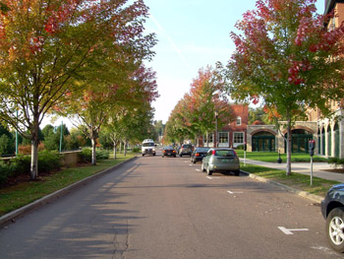

PHOTO 3A (LakeSt86N2006.jpg)
86 Lake Street, looking north, taken October 9, 2006
Photographer: Carrie A. Mardorf
Geographic Position: UTM 18T0641563 4926443

PHOTO 4A (LakeSt60N2006.jpg)
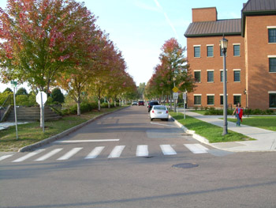
60 Lake Street
Intersection of Lake and College Streets, looking north, taken October 9, 2006
Photographer: Carrie A. Mardorf
Geographic Position: UTM 18T0641587 4926393

The view looking north down Lake Street today hardly recalls Burlington’s early industrial working-class waterfront of earlier decades. As industry and manufacturing declined throughout the mid 20th century, the buildings along Lake Street and the waterfront gradually fell into disrepair. The unsightly buildings and overall rundown state of the area, created an opportunity to revitalize the waterfront. During the 1980s, efforts were made to clean up the former industrial waterfront area through zoning regulations, recreation initiatives, and a revitalization plan. In 1988, the Burlington bike path was constructed, creating a north-south recreational corridor through the waterfront area and linking the city of Burlington to adjacent towns. Efforts to improve the area continued into the 1990s. Today the waterfront area attracts many visitors and residents through the several amenities and recreational opportunities it provides.
As a result of these revitalization efforts, the streetscape of Lake Street has changed significantly. The street allows for two-lane traffic and on-site, metered parking to the east. Concrete curbs and gutters, and allees of young maple trees define the street edges. A low concrete wall with deciduous shrub plantings helps to further define the space to the west, while a six-foot sidewalk parallels the street to the east (right).
The Shepard & Morse Lumber Company building was torn down prior to 1942 and the lot remained vacant through 1972. During the early 2000s, 60 Lake Street was constructed at the intersection of Lake Street and College Street. The building commonly called “Lake and College” houses several tenants including the Waterfront Theatre and organizations and businesses such as Vermont Businesses for Social Responsibility and Merritt & Merritt & Moulton, lawyers.
Through the tree canopy, the partial façade of the Wilson & Company building at 86 Lake Street can be seen. The exterior of the building remains virtually unchanged, still exhibiting three bays with large rectangular, multi-paned windows on the first floor with recessed arches that have been converted into windows on the second floor. The large white letters that once adorned the exterior façade have been removed. Today, the building is occupied by Otter Creek Associates and Gentlemen's Top Option Salon
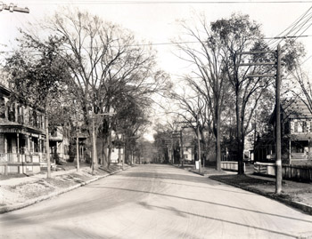

PHOTO 5 (PearlSt36End.jpg)
36 Pearl Street
Intersection of Pearl and North Champlain Streets, looking east, taken circa 1934
Photographer: Louis L. McAllister
Geographic Position: UTM 18T0641784 4926734
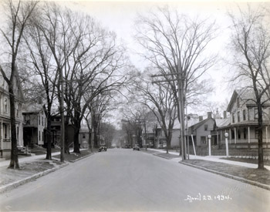
PHOTO 6 (PearlSt36E1934.jpg)
36 Pearl Street
Intersection of Pearl and North Champlain Streets, looking east, taken April 23, 1934Photographer: Louis L. McAllister
Geographic Position: UTM 18T0641784 4926734

Two McAllister photographs taken in circa 1934 show the intersection of Pearl Street and North Champlain Street lined with several large American elm trees (Ulmus americana). Looking to the east, the trees create a shady residential setting with their upright, vase-shaped branching patterns. The majority of the trees appear to have a moderate diameter-at-breast-height (dbh) indicating they are 20 to 30 years old, with the exception of two younger elms at the far left which have a significantly smaller dbh. The trees are pruned to allow room for the overhead utility lines, which also line both sides of the street.
Pearl Street is wide, edged with a stone curb, and appears to be paved in asphalt with a small-sized gravel on the surface, judging from the wheel tracks visible on the street. Narrow sidewalks are located between the street and the residential houses. A wood paling fence edges the walk to the south (right) in front of a two-story frame dwelling. The photograph shows the facades of five houses, partially obscured by vegetation. On the left of the image is 38-40 Pearl Street and 42 Pearl Street farther east. On the right is 37-39 Pearl Street with 41-45 Pearl Street and 47 Pearl Street to the east.
38-40 PEARL STREET
38-40 Pearl is a two-story six-bay wood framed, duplex unit with a gable front roof. The building is sided with narrow wood clapboards and 1-over-1 windows appear to have dark colored shutters. A small, elevated, one-story porch with painted and turned posts and spindles and lattice is attached to the front of 38 Pearl. 40 Pearl also appears to have a similar porch, though set back some distance. This building in its current configuration is first seen on the 1853 map of Burlington, indicating that it was built between 1830 and 1853. A smaller building at the intersection of Pearl Street and North Champlain Street is shown on the 1830 map of Burlington by Ammi B. Young, but it is not known if the building shown on the map is the same as the building shown in the McAllister photograph. In 1869, the property was owned by N. Bacon who ran a store out of the building. In 1901, the building was occupied by F. J. Beaupre (38 Pearl) and Mrs. W.W. Bassett (40 Pearl). By 1931, Louis Izzo operated a local grocery store out of 38 Pearl, while Mr. Albert C Brooks occupied 40 Pearl. In 1935, the store continued at 38-40 Pearl which was then connected to 44-46 Pearl via the one story brick addition. By 1942, George’s Cash Market, meats and provisions, occupied 38 Pearl and Mario R Izzo occupied 40 Pearl.
42 PEARL STREET
The building located at 42 Pearl is a two story, three bay, wood frame dwelling with a gable front roof with two small porches to the west and south. Examining the 1935 footprint of the building, a small rectangular one story brick addition to the west connected the building to the adjacent 38-40 Pearl property. In 1931, Edward J. Derochia occupied the building, but no longer resided in the building in 1942. The 1942 city directory lists Mrs. Jennie Duclos and George E Gonyo living in the building at 42 Pearl and 42-1/2 Pearl, respectively. By 1942, 42 Pearl demolished the brick addition and created a two-story wood frame porch.
37-39 PEARL STREET
37-39 Pearl is a two story, three bay, frame dwelling with a gable front roof and paired eave brackets. Windows are 1-over-1 with dark colored shutters, and the roof appears to be alternately banded with light and dark colored slate. A one story porch with columnar posts and lattice wraps around the house to the north and west. In 1830, the property contained a building at the corner of Pearl Street and Champlain Street, but it is not known if the building is the same structure. The building with a similar footprint noted as E. Rhone’s property shows up on the 1869 Beers map, indicating the building shown in the McAllister photograph was constructed by 1869. In 1901, Edward Flannery was listed as residing in the building, but in 1931, the building had two residents-- Ralph O. St. Peter (37 Pearl) and Mrs. Agnes B. O’brien (39 Pearl). Prior to 1934, the property was encompassed with a paling fence, with stringers facing toward the outside to the adjacent streets.
In 1934, after Pearl Street paving improvements, the paling fence was removed, and a hedge of deciduous shrubs was planted along the property line. Two posts with circular signs were placed on either side of the driveway. The roof was also replaced, as the patterned banding of slate is no longer present in Photo 6. Also at this point in time, the building included three rectangular wood frame additions to the rear. Eleven years later, by 1942, 37-39 Pearl was converted to apartments, though the only residents listed in the building were Joseph L Berger (37 Pearl) and Harold G. Stowell (39 Pearl).
41-45 PEARL STREET
Not much is known about 41-45 Pearl Street. The building at 41-45 Pearl is a two-story framed duplex dwelling, with a gable front hipped roof and a small central porch. The exact construction date is unknown, however, the building was constructed before 1901 when the 1901 city directory lists BO Foster, Frank H. Sweetland, Charles B Sabens, and Mrs Margaret E Patten as residents of the building. In 1931, the building had four residents including Charles A. Therrien (41 Pearl), Mrs. Bridget Demag and Mrs. Anna Morgan (43 Pearl) and Ernest C. Jones (45 Pearl). By 1942, the building remained unaltered and housed four residents. Residents included Frank L Pecor (41 Pearl), Mrs. Georgia Remillard and Eva M Burns (43 Pearl), and Frederick E. DeForge (45 Pearl).
47-49 PEARL STREET
The building located at 47-49 Pearl is a two-story, possibly three bay frame dwelling, with a porch running the full length of the building. The building also has a gable roof with two chimneys at the gable ends. 47 Pearl first shows up on the 1869 Beers map as part of the R. Tibbitts property, indicating it was constructed between 1853 and 1869. The building was vacant in 1901, but by 1935, the building contained a small store in the northwest corner with living space taking up the remainder of the floorspace of the building. Frank Casavant was the sole occupant of the building in 1931; however, by 1942, 47-49 Pearl had been enlarged through several additions. The store located in the building also enlarged, taking up half of the floorspace on the northern/streetside side of the building, while the rear half of the building was converted to apartments. However, Claude S Parks, veterinarian’s office and Claude S Parks were listed as the only residents in the building during this time.
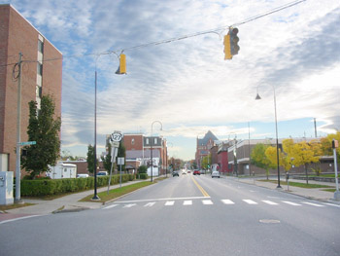
PHOTO 5A &6A (PearlSt10ChamplainE2006.jpg)
10 N. Champlain Street
Intersection of Pearl and North Champlain Streets, looking east, taken October 14, 2006
Photographer: Carrie A. Mardorf
Geographic Position: UTM 18T0641784 4926734

Today the intersection of Pearl Street and North Champlain Street has changed. The shady residential block has evolved into a more open atmosphere with state-owned office buildings and a low-rise apartment building. The framed residential houses seen in McAllister’s photographs lined the street throughout the 1940s and 1950s. In January of 1959, the city of Burlington approved downtown renewal projects, which claimed 23 acres of private property along Pearl, Cherry, Bank, and South Champlain Streets. The residential houses were razed to rid of urban blight and provide room for the new urban renewal projects.
This portion of Pearl Street was effected by the urban renewal project as well. City residents who lost their homes were relocated in available housing throughout the city. To aid in relocating elderly displaced residents, the Champlain Apartment building seen at the left side of the photograph was constructed at 10 North Champlain Street. The six-story brick veneer building was designed by local Burlington architecture, planning, interior design firm, Freeman, French, and Freeman in 1966 and 1967. Today the building is owned and operated by the Burlington Housing Authority and provides apartments for lower-income elderly individuals over age 62 and individuals with disabilities. The building contains 50 one and two-bedroom apartments.
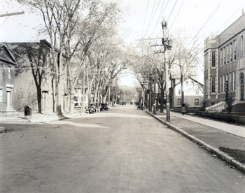
Across the street located at 39 Pearl Street, is the Vermont District Courthouse and State Office Building designed by Linde-Hubbard Associates of Burlington in 1968. The building is set back from the street and is not shown in the view. Though the buildings at the intersection of Pearl Street and North Champlain Street have changed, the street itself appears similar in its appearance with two-lanes of through traffic and two lanes of on-street parking. The American elms (Ulmus americana) once seen along the street with their distinguishing vase-shaped canopies were lost in the 1960s due to Dutch elm disease. Today the street is lined with columnar Norway maples (Acer platanoides) and a hedge in front of Champlain Apartments and smaller understory trees to the south in front of the state courthouse and office building. The lack of trees along the street creates an open environment with expansive sightlines to downtown Burlington, shown in the background of the image.

PHOTO 7 (PearlSt94End.jpg)
94 Pearl Street, looking east, date taken unknown
Photographer: Louis L. McAllister
Geographic Position: UTM 18T0641954 4926784

Like many of the downtown streets of Burlington during the 1930s and 1940s, the intersection of Pearl Street and Grove Street is characterized by tall, vase-shaped American elm (Ulmus americana) trees and overhead utility lines lining a primarily residential street. The street is wide with on-street parking to both sides, and a mailbox is seen at the northeast corner of the intersection of Pearl and Grove Streets. Three buildings are distinguishable in the foreground of the image, including 98 Pearl, 102-108 Pearl, and 97-103 Pearl.
98 PEARL STREET
98 Pearl is a two story frame dwelling with brick veneer sited at the corner of Pearl Street and Grove Street. First seen on the 1853 map of Burlington, the property was constructed during the mid 19th century, and was occupied by C. Eldridge in 1869. At the turn of the century in 1901, two people resided in the house—Mrs. Margaret Shepard and Wm. E. Whitney. By 1931, several additions were constructed to the north and east of the house, enlarging the dwelling; during this same year, Mrs. Eda A. Safford and Mrs. Eda M. Blodgett resided in the house. Mrs. Eda A. Safford continued to reside in the structure in 1942.
102-108 PEARL STREET
To the east of 98 Pearl is a three story wood frame building with brick veneer. Like the adjacent property to the west, 102-108 Pearl has a similar history. In 1869, C.Eldridge owned the property and ran a store out of the easternmost portion of the building. By 1931, the building retained a similar footprint, but had been converted into apartments and offices. Tenants for 1931 included George Pecue, Mrs. Mabel A Rogers, boarding, Mrs. Anna J O’Kane, Charles A. Moss, and the Burlington Free Dispensary. By 1942, many of the building’s occupants had moved out, including the Burlington Free Dispensary. Four people resided in the building in 1942, including a barber shop.
97-103 PEARL STREET
Historically in 1869, 97-103 Pearl was part of the Seymour estate located at the corner of Pearl Street and St. Paul Street. A large house occupied the site, but was demolished by 1901. Sometime between 1901 and 1931, the Catholic High School was constructed on the site. The building is a two story brick building with bearing wall construction, presumably associated with the adjacent Cathedral of Immaculate Conception. In 1935, the floor plan of the high school contained numerous class rooms flanking a gym and auditorium in the center of the building.
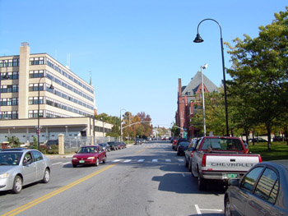
PHOTO 7A (PearlSt94E2006.jpg)
94 Pearl Street, looking east, taken October 9, 2006
Photographer: Carrie A. Mardorf
Geographic Position: UTM 18T0641954 4926784

The existing view of the intersection of Pearl and Grove Streets retains very little of its historic character. Though the street width remains the same, loss of overstory vegetation and small-scale residential buildings have resulted in an open streetscape with tall, mid-rise buildings. By 1971 residential buildings including 98 Pearl, 102-108 Pearl were no longer present along Pearl Street. In the 1950s, several properties on the northern side of Pearl Street from Grove Street to Elmwood Avenue were demolished to provide space for a newly designed Federal Building. The local architecture firm of Freeman, French, and Freeman designed the eight-story building that opened in 1960. The building contains offices for numerous federal departments including the United States Post Office, General Services Administration, the United States Department of Agriculture Forest Service, and District Attorney’s Office, among others.
The brick Catholic High School located across the street at 97-103 Pearl is no longer extant today. Though it continued in its educational endeavors throughout the 1950s, when the adjacent Cathedral of the Immaculate Conception burned in 1972, the congregation decided to rebuild the church using the entire city block. It is presumed that the high school was demolished to clear the block for the new Cathedral. The project landscape architect, Dan Kiley sited the new Cathedral in the center of the city block within a grove of 123 honey locust trees (Gleditsia triacanthos) that align to the exterior angled façade of the Cathedral. Some of the locust trees are seen on the right of the photograph.
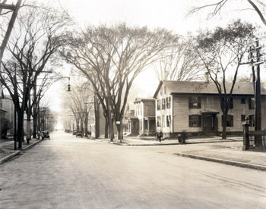
Additionally, the Masonic temple building which was constructed in 1897-98 in the Romaneque Revival Style is seen in the background from this vantage point. The building is located at the corner of Pearl Street and Church Street.

PHOTO 8 (Pearl143Wnd.jpg)
143 Pearl Street
Intersection of Pearl Street and Elmwood Avenue, looking west, date taken unknown
Photographer: Louis L. McAllister
Geographic Position: UTM 18T0642109 4926811

Photographed by McAllister during the 1930s, the intersection of Pearl Street and Elmwood Avenue is characterized by numerous American elm trees (Ulmus Americana) lining both sides of the street. The diameter of the trees is quite large, suggesting that they were planted in the late 19th century or early 20th century. The trees add an additional vertical element in the streetscape with high, upright branches arching out over the street, though their forms enclose the streetscape and direct and contain views down the street. The street appears to be quite wide with two lanes of through traffic and on-street parking on both sides of Pearl Street. The curb of Pearl Street is stone cut into segmented pieces. Also lining the street are overhead utility lines, which are seen just under the picturesque elm branches.
Along the south (left) of the street are streetlights that hang over the center of the street for illumination at night. The lights appear to be a lantern style of light suspended from a chain from an overhanging arm. On the light post closest to the foreground is a narrow vertical sign reading “DYOLA.” The sidewalks appear to be somewhat narrow, probably no more than five or six feet wide. In the northeast corner of the intersection (right side of the photograph) is an elaborate cast iron and wrought iron fence with pointed finials. The fence encompasses the grounds of the 1st Unitarian Church, located at the top of Church Street on Pearl Street. The McAllister photograph shows numerous partial facades of residential and commercial buildings lining both sides of Pearl Street, including the Catholic High School to the south (left). Clearly seen in the photograph are properties 3-5 Elmwood and 118 Pearl.
3-5 ELMWOOD AVENUE
At the intersection of Pearl Street and Elmwood Avenue is a large two story, three bay by six bay wood frame dwelling clad in narrow wood clapboards and capped with a gable roof. The building first appears on the 1853 Presdee and Edwards map, indicating it was constructed during that year or prior to that year. In 1869, J.H. Worcester owned the property and the building, but by 1901, Dr. Clifford A. Pease, MD occupied the building, either as a residence or office for his medical practice. The building remained at the intersection of Pearl and Elmwood until 1930 when it was relocated to the corner of Elmwood and Peru Street to provide space for the construction of a gas station. In 1931, Edward’s service station occupied the site and was constructed fireproof building materials with a small brick square “L” to the south with three gas tanks. By 1942, the gas station remained, but had changed names to George Crocker, Gas and Oil.
118 PEARL STREET
118 Pearl is a two-story, three bay, frame dwelling in the Italianate style. Italianate characteristic features of the building in the Italianate style include the detailing of the window lintels and sills and the paired eave brackets. The building first appears on the 1877 bird’s eye view of Burlington, indicating it was probably constructed between 1869 and 1877. Three decades later in 1901, Henry J. Nelson occupied the building. However thirty years later, the building stood vacant, and was vacant in 1942. Between 1926 and 1942, the small enclosed front porch was constructed, and the porch to the east was enlarged.
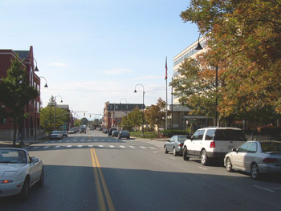
PHOTO 8A (PearlSt5ChurchW2006.jpg)
5 Church Street
Intersection of Pearl Street and Elmwood Avenue, looking west, taken October 14, 2006
Photographer: Carrie A. Mardorf
Geographic Position: UTM 18T0642109 4926811

Much has changed looking at the landscape of the intersection of Pearl Street and Elmwood Avenue today. The majority of the smaller-scale residential buildings shown in the McAllister photograph have been demolished to make space for larger urban renewal projects. The large elm trees succumbed to Dutch elm disease during the 1960s, creating an open streetscape with expansive views, in comparison to the contained views of the 1930s. Vegetation today consists mostly of maple trees (Acer species) and shorter ornamental crabapples (Malus species).
Pearl Street itself remains unchanged with two traffic lanes and on-street parking on both sides of the street. As mentioned previously, the original two story frame dwelling located at 3-5 Elmwood Avenue was relocated, and a gas station was construction in its former location. The gas station remained throughout the 1950s, when it and several adjacent properties, including 118 Pearl, were demolished to construct a new federal building. The new Federal Building was designed by the local architecture firm, Freeman, French, and Freeman and opened in 1960. The eight story building contains offices for numerous federal departments including the United States Post Office, General Services Administration, the United States Department of Agriculture Forest Service, District Attorney’s Office, and district courtrooms, among others.
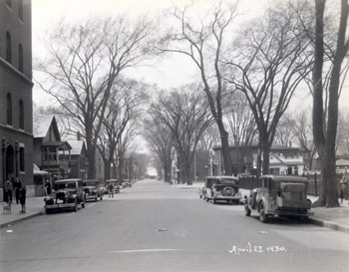
PHOTO 9 (PearlSt152W1934.jpg)
152 Pearl Street
Intersection of Pearl Street and Church Street, looking west, taken April 23, 1934
Photographer: Louis L. McAllister
Geographic Position: UTM 18T0642123 4926796

The streetscape of Pearl Street in 1934 contained several buildings and landscape features that characterize the street. One of the most prominent features of the street are the large, upright, vase-shaped, American elms (Ulmus Americana) that line both sides of the street, creating a corridor. Pearl Street is wide with enough space for two lanes of traffic and on-street parking along both sides of the street. The street appears to be paved in asphalt with a cut stone curb. Several cars are seen parked on the street, and six people can be seen in the view. Along the south side (left) of the street are several small-scale residential buildings with a larger brick commercial building in the foreground. To the north, a decorative cast and wrought iron fence with molded posts and pointed finials marks the edge of the sidewalk and adjacent property line. Also to the north in the background is a gas station with a circular Texaco sign suspended from a pole along Pearl Street. Buildings clearly seen in the photograph include 143 Pearl Street, 135-137 Pearl Street, and 3-5 Elmwood.
143 PEARL STREET
The large brick 5-1/2 story commercial building on the left side of the image is 143 Pearl Street. Also known as the Masonic Temple building, it was designed by the Wilson Brothers of Philadelphia and constructed in 1897-98 in the Romanesque Revival style. Features of the building include a steel post and beam interior, a brick exterior with rounded arch windows and hipped pyramidal roof. Sited at the corner of Pearl Street and Church Street the building is divided into five bays of varying sizes that provide retail store frontage along Church Street to the southeast. The section shown in the McAllister photograph is the northwest corner of the building marked as 143 Pearl on the 1935 Sanborn map. Four stories are visually divided by narrow light-colored string courses, and windows are evenly spaced and with rounded arch forms, typical of the style. A large arched doorway with scroll-like and floral detailing on the surround marks the main entrance to the upper story Masonic Lodge rooms.
In 1931, the building had several tenants including the Vermont Baptist State Convention, Mutual Benefit Life Insurance Company, Oren S. Nims, dentist, Alfred A. Starbied, Mason secretary AASR, and Archie Harriman, Mason grand secretary F&AM.
In 1942, building was occupied by new tenants including the Colonial Optical Company, W.D. & A.R. Hill Office, Donald E. Beach, accountant, Northern Chemical Service, exterminators, Oren S Nims, dentist, Charles L Hudgins, Mason secretary AASR, and Aaron H Grout, Mason grand secretary F&AM.
135-137 PEARL STREET
135-137 Pearl is a two story, frame rectangular building with a gable roof and two story porch, located to the west of the Masonic Temple. A small unreadable sign marks the entrance to the building, which was used as a store during the 1930s. The building also has two smaller rectangular additions to the south, which are not seen in the photograph. In 1931, the building was occupied by the Community Fruit Store (135 Pearl), the Majestic Diner (137 Pearl), and offices of the Unitarian Church (137 Pearl). By 1942, 135 Pearl was vacant, and Angelo Sultanos and Angelo’s Café, a restaurant occupied 137 Pearl.
3-5 ELMWOOD AVENUE
3-5 Elmwood is a small light-colored, cross-gabled building with large overhanging pent-like eaves located at the intersection of Pearl Street and Elmwood Avenue. The building serves as a gas station and is built of fireproof construction with three gas tanks to the south. The building was built in the early 1930s, when a large two story frame dwelling was moved from the corner. In 1931, Edward’s service station occupied the building, and by 1942, the gas station remained, but had changed its name to George Crocker, gas and oil.
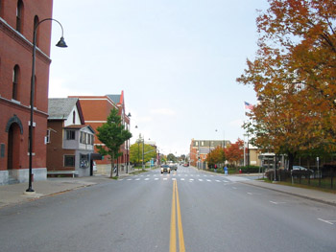
PHOTO 9A (PearlSt152W2006.jpg)
152 Pearl Street
Intersection of Pearl Street and Church Street, looking west, taken October 14, 2006
Photographer: Carrie A. Mardorf
Geographic Position: UTM 18T0642123 4926796

While some of the buildings located along this section of Pearl Street remain today, significant losses in vegetation create a different street character than present historically. The loss of the American elms that once lined the street has left an open urban landscape. Some deciduous trees have been replanted on the Unitarian Church property to the north (right). Pearl Street retains its original width with two lanes of through traffic with on-street parking to both sides. The decorative iron fence bounding the adjacent church property to the north (right) also remains, but has lost some of its pointed finials and decorative posts. A streetlight fixture is located along the sidewalk to the south of the street. The post of the light curves in a semi-circular form to suspend the bell-shaped fixture. The light is shielded and cast downward to limit light spill and light pollution into the night sky.
The Masonic Lodge building is seen to the south of Pearl Street on the left of the image, virtually unchanged from its 1930s appearance. In 1972 no tenants or residents were listed in the building at 143 Pearl, though stores likely occupied the frontage along Church Street. In 1983, the building was sold and underwent a $3 million rehabilitation. Today the building houses retail stores, apartments, and continues to facilitate Masonic Lodge meetings and ceremonies,
West of the Masonic Lodge, 135-137 Pearl also remains virtually unchanged from its 1930s appearance. The only immediate difference is the two-story porch, which was enclosed some time during the mid 20th century. In 1972, the building was occupied by the Black Angus Steakhouse. In 1984, a gay and lesbian nightclub appropriately called, “135 Pearl” occupied the building. In June 2006, the nightclub closed after 22 years of occupying the building; the building now remains vacant.
The gas station at 3-5 Elmwood Avenue remained throughout the 1950s, until it was razed to construct a new Federal Building. In 1960 an eight story Federal Building, designed by local architecture firm, Freeman, French, and Freeman, opened to house numerous federal offices including the United States Post Office, which occupies the building today.

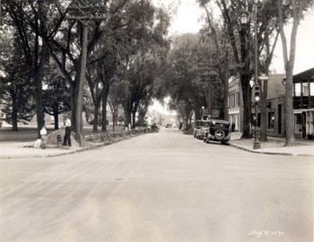
PHOTO 10 (WinooskiAve16S1931-1.jpg)
16 South Winooski Avenue
Intersection of Pearl Street and Winooski Avenue, looking south, taken August 10, 1931
Photographer: Louis L. McAllister
Geographic Position: UTM 18T0642259 4926809

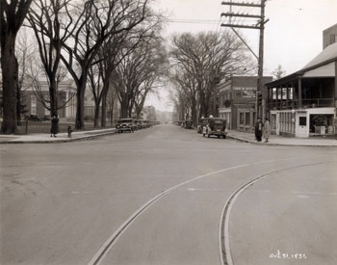
PHOTO 11 (WinooskiAve16S1931-2.jpg)
16 South Winooski Avenue
Intersection of Pearl Street and Winooski Avenue, looking south, taken October 31, 1931
Photographer: Louis L. McAllister
Geographic Position: UTM 18T0642259 4926809

Two McAllister photographs depict the appearance of the intersection of Pearl Street and South Winooski Avenue during 1931. Taken as “before and after” photographs, the images show changes that were made to the streetscape at this time. In Photo 10, buildings and large American elm trees define the edges of South Winooski Avenue and enclose the space. Approximately nine elm trees of varying sizes and one evergreen tree are seen to the east (left) of the street, while seven to eight elms line the west side. Utility poles and overhead utility lines are also seen lining both sides of the street. South Winooski appears to be wide enough for two lanes of traffic with on-street parking to the west only. Several cars are parked alongside the west curb. The southwest (right) corner of the intersection is marked with a metal post containing a traffic light, street signs, and a lantern-style street light suspended from an “S” shaped bracket. On the opposite corner, a man is digging a hole adjacent to the fire hydrant as a small boy looks on. In the background of the image are three additional people with a truck. It appears that the east side of South Winooski Avenue is dug up for underground utility work.
Photo 11, though similar to Photo 10, has some substantial differences. Streetcar tracks have been laid in the pavement and are seen turning from Winooski Avenue west onto Pearl Street in the foreground. South Winooski has been widened significantly to provide extra space for on-street parking to the east. Several cars are shown parked on both sides of the street in Photo 11. To widen the street, some American elms were removed, including four trees along the west side of the street. The metal post, street light, street signs, and traffic light was also removed. This is confirmed in the city report for 1931, stating, “It was necessary to remove about fifteen shade trees along the sides of this project in order to widen the pavement to the proposed width. The electric light poles also had to be reset on the westerly side of the Street.”
Two buildings are clearly shown in both McAllister photographs along the western edge of the street. The building located at the southwest corner (right) of the intersection is 7 South Winooski, while the adjacent building to the south is 11-13 South Winooski. The open green space with many trees at the southeast corner of the intersection is part of the property at 16 South Winooski.
7 SOUTH WINOOSKI AVENUE
7 South Winooski is a 1-1/2 story frame building with a two story frame addition and porch to the east. Though the main block is not seen in the photograph, the side addition is quite large, housing what appears to be a barbershop on the lower level. The upper level of the addition is a large porch with square posts supporting a shed roof. A three-bay stone addition to the rear of the building is punctuated by three large rectangular windows, while an overhead sign reads “Monumental Works.” In 1931, the Carl D. Densmore Company, Inc. monument company occupied the building, though no mention is given to the barbershop on the lower level of the east addition.
11-13 SOUTH WINOOSKI AVENUE
A two story, three bay brick garage occupies the site at 11-13 South Winooski, just south of the Monument company. The east façade of the building showcases an elaborate cornice, large windows on the first and second floors, and Shell sign. On the north side of the building is a painted advertisement reading, “Yandow Tire & Battery Co., Storage 50⊄” The floorplan of the building contains an office, large entryway, auto supply room, and large garage with a capacity for 60 cars. Four gasoline tanks are located in front of the building along the street; the white signs on top two of the tanks can be seen just above the cars parked on the street in front of the building. Yandow Garage occupied of the building in 1931 and continued to do so through the early 1940s.
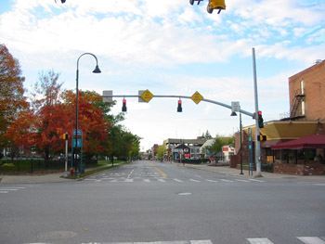
PHOTO 10A & 11A (WinooskiAve16S2006.jpg)
16 South Winooski Avenue
Intersection of Pearl Street and Winooski Avenue, looking south, taken October 14, 2006
Photographer: Carrie A. Mardorf
Geographic Position: UTM 18T0642259 4926809

The streetscape of the intersection of Pearl Street and South Winooski Street today is quite different. The widened street of the 1930s, now utilizes the former on-street parking spaces as an additional lane for through traffic. Loss of vegetation, buildings, overhead utility poles, and other landscape features along the street create an open space along the east side of South Winooski Avenue. More modern traffic lights, signage, and street signs have been added to the landscape at the street corners. Though the property at 16 Winooski remains similar in its historic character with deciduous trees, open green space, and iron fence, the buildings at 7 South Winooski and 11-13 South Winooski have been demolished.
By 1942, the 7 South Winooski had been demolished and replaced with a small, one story cinder block gas station two gas tanks. The Shell Oil Company Station was the tenant of the building during this time, and then later changed to Bob’s Shell Service in 1972. During the late 20th century, the gas station was demolished and a blocky, angular brick building was constructed as seen in the photograph from 2006. Asiana House occupies the building currently.
Similarly, 11-13 South Winooski was demolished prior to 1971. The site of the former building is now part of Asiana House, an adjacent alley, and parking lot for Brooks Pharmacy.

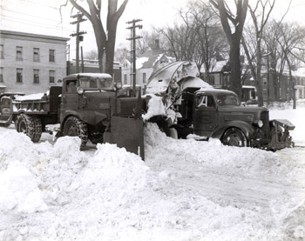
PHOTO 12 (WinooskiAve16NE1944.jpg)
16 South Winooski Avenue
South Winooski Avenue, looking northeast, taken February 20, 1944
Photographer: Louis L. McAllister
Geographic Position: UTM 18T0642247 4926754

Taken on February 20, 1944 by Louis McAllister, this image shows several buildings lining Pearl Street in the background, with South Winooski Avenue and new city snow removal equipment in the foreground. The winter of 1944 had near record snow falls, as George C. Stanley, Street Department Superintendent, stated in the 1944 city report, “the past winter was one of exception demands on the Street Department for Snow Removal Work.” Along with salting streets to melt the snow, equipment such as the trucks shown here were extensively used. The caption for the photograph reads, “This view shows the Snow King Rotary Plow loading snow from S. Winooski Avenue into truck which hauled the snow to the dumping area at the foot of College Street. Each load contained approximately ten cubic yards when piled high above the cab as shown in this picture.”
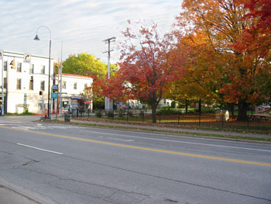
The large American elm trees in this view are located on the property at 16 South Winooski Avenue, which was historically the “Church Green” of the 1st Congregational Church in 1869. In 1871, a 2-1/2 story frame building with brick veneer dwelling was erected as the church parsonage. By 1931, the property and the house remained part of the church, and Rev. Charles S Jones resided there through the 1940s. For more information pertaining to the buildings located on Pearl Street at this intersection please see (link to Rebecca McNamara Photo Pair 1 and Erin Rainwater Page)

PHOTO 12A (WinooskiAve16NE2006.jpg)
16 South Winooski Avenue, looking northeast, taken October 14, 2006
Photographer: Carrie A. Mardorf
Geographic Position: UTM 18T0642247 4926754

The southeast corner of the intersection of Pearl Street and South Winooski Street remains similar in appearance as it did in the 1940s. Though the large American elm trees on the property at 16 South Winooski have been lost to Dutch Elm Disease, several maples (Acers species) have been planted lining the east edge of the street. Today the house is occupied by the Ronald McDonald House. For more information about the current buildings located on Pearl Street at this intersection please see (link to Rebecca McNamara Photo Pair 1 and Erin Rainwater Page).

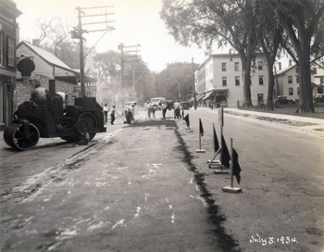
PHOTO 13 (WinooskiAve16N1934.jpg)
16 South Winooski Avenue, looking north taken July 3, 1934
Photographer: Louis L. McAllister
Geographic Position: UTM 18T0642249 4926731

This McAllister photograph, taken on July 3, 1934 shows the repaving of South Winooski Avenue. Several workers are shown in the background laying and spreading the asphalt, with a steam roller to the left and many construction flags on the right. Caption reads, “P.W.A. Project #2232. A view of the South Winooski Avenue surfacing project looking northerly near its intersection with Pearl Street. The binder course is here shown in process of application. Note rough and uneven condition of old surface.” More detail is given about the South Winooski Avenue paving project in the 1931 city report. The report discusses the project as follows:
This job is divided into two sections A), Main Street to College Street where the pavement was widened on the westerly side a width of five feet and paved with seven inches of concrete. A new concrete curb was also constructed on this section. B). From College Street to Pearl Street. On this section the old stone curbs and gutters were removed on both sides of the street, the street widened five feet on either side and new concrete integral curbs and gutters constructed. A new pavement was constructed on the entire area of the street consisting of a stone base obtained from the salvaged cobble stone gutters and stone curbing. On this stone base was constructed approximately two and one half inches of asphalt hot-mix binder. This binder course was finished two inches in thickness to be constructed next year over the entire pavement area. This method of construction allows the full use of the old pavement as a base on which a new wearing surface can be constructed at a very minimal unit cost, thus salvaging all of the value which had previously been put into the construction of the old pavement. It was necessary to remove about fifteen shade trees along the sides of this project in order to widen the pavement to the proposed width. The electric light poles also had to be reset on the westerly side of the Street. The total cost of this job, including all new curbs and gutters, pavement, removal of trees and all labor and materials in connection with the complete job, was $7176.98. The cost of the paving alone was $2,068.10. The total area paved was 1318 square yards, making a unit cost of one dollar and fifty-seven cents ($1.57) per square yard. This was a much needed improvement and has helped considerably to solve the traffic and parking problems in that section of the business streets.

The McAllister photograph also gives insight to the character of the street during the 1930s. Overhead utility lines run along the west (left) side of the street. To the east (right) are three large American elms (Ulmus americana) lining the street and adjacent sidewalk. A decorative cast iron fence lines Pearl Street just north of the elms. The elms and fence are located at 16 South Winooski Avenue, which was occupied by Rev Charles S Jones, of the 1st Congregational Church, who continued to reside there through the 1940s. Historically, the property belonged to the 1st Congregational Church in 1830, and was used as the “Church Green” in 1869.
Two buildings are shown lining the west (left) side of the street. In the foreground is 11-13 South Winooski, with 7 South Winooski farther north. In the background of the image, several buildings line North Winooski Avenue and Pearl Street. For more information pertaining to the buildings shown along North Winooski Avenue and Pearl please click here (link to Rebecca McNamara Photo Pair 1 and Erin Rainwater Page).
11-13 SOUTH WINOOSKI AVENUE
The building located at 11-13 South Winooski is a two story brick garage with steel trusses, plastered walls, and concrete floor. The floorplan of the building contains an office, large entryway, auto supply room, and large garage with a capacity for 60 cars. Four gasoline tanks are located in front of the building along the street, suggesting that the building also serves as a gas station. A Shell sign and AAA sign on the front facade confirm the building is a gas station. In 1931, Yandow Garage was listed as the occupant of the building in the Burlington City Directory. Yandow Garage continued to occupy the building in 1942, though the business name had changed to Yandow Tire & Battery Company. The building layout and use slightly changed during this time too, to include auto sales and service in the rear and tire sales in the front half of the building. The four gas tanks remained along the South Winooski Avenue in 1942.
7 SOUTH WINOOSKI AVENUE
7 South Winooski is a 1-1/2 story frame building with a two story frame porch to the east. The main block of the building is rectangular sided with wood clapboards with a gable roof and brick chimney. The side porch is a saltbox-type addition with square posts. A tall stone wall encompasses the rear of the building, presumably for storage, and large sign on the wall says “Monumental Works.” In 1931, the Carl D. Densmore Company, Inc. monument company occupied the site.
By 1942, the building had been demolished and replaced with a small, one story cinder block gas station with a concrete floor, with two gas tanks to the north. As a result, the address of the property changed from South Winooski to Pearl Street. The Shell Oil Company Station was the tenant of the building during this time.
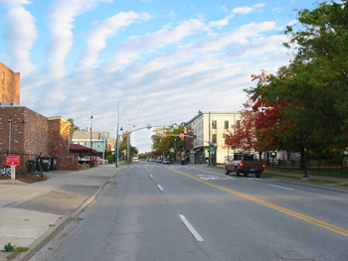
Historically, there was a building present at the corner of South Winooski Avenue and Pearl Street since 1830. The structure remained on the property throughout the 19th century, was owned by Dr. S. Waper in 1869, but was destroyed some time prior to 1901. In 1901 the lot remained vacant.

PHOTO 13A (WinooskiAve16N2006.jpg)
16 South Winooski Avenue, looking north, taken October 14, 2006
Photographer: Carrie A. Mardorf
Geographic Position: UTM 18T0642249 4926731

Today, South Winooski Avenue retains some of its features from earlier decades, though many elements have changed. The street utilizes the on-street parking areas from the 1930s as to create a four-lane street for through traffic. The street may have been additionally widened at some point during the mid to late 20th century. The American elms on the property at 16 South Winooski have been lost and removed, but other deciduous trees have been replanted in their place, maintaining the density of vegetation along the east side of the street. Other losses of significant landscape features including buildings at 7 South Winooski and 11-13 South Winooski along the west side of the street create an open expanse. Modern traffic lights, signage, and street signs have also been added to the streetscape; these small-scale elements additionally change the character of the street.
Throughout the 1940s, the Shell Oil Company Station remained at the corner of Pearl Street and South Winooski Avenue. By 1972, the name of the gas station changed to Bob’s Shell Service. During the late 20th century, the gas station was demolished and a blocky, angular brick building was constructed in its location. Today, Asiana House occupies the site.
Similarly, the Yandow Garage located at 11-13 South Winooski was demolished prior to 1971. The site of the former building is now part of Asiana House, an adjacent alley, and parking lot for Brooks Pharmacy.
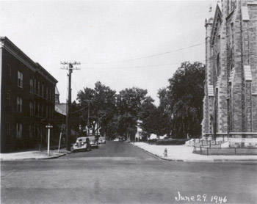

PHOTO 14 (CherrySt84W1946.jpg)
84 Cherry Street
Intersection of Cherry & St. Paul Streets, looking west, taken June 29, 1946
Photographer: Louis L. McAllister
Geographic Position: UTM 18T0642001 4926654

Taken at the intersection of Cherry Street and St. Paul Street looking west down Cherry Street, this McAllister photograph depicts how the west half of downtown Burlington looked in 1946. Bordering the downtown business district and adjacent residential area to the west, this area is a transition zone between commercial and residential uses. The more residential areas are characterized by large overstory deciduous trees seen in the background of the photograph, while the more commercial areas have limited or no trees like in the foreground. Cherry Street is narrower than other adjacent streets, with two through lanes and on-street parking along the south side of the street. Three cars are parked along the cut stone curb to the south side of the street. The street corners are characterized by a utility pole that supports overhead utility lines, a street sign, and a fire hydrant.
To the south (left) is a brick building, 35 St. Paul Street, and along the north (right) side of the street is the Cathedral of Immaculate Conception, 97 Cherry Street. The Cathedral has a low iron railing surrounding the lawn area in the foreground, while a low hedge marks the property to the west in the background. The caption on the photograph reads, “This view of Cherry Street taken from the intersection of St. Paul Street shows the new stone-filled sheet asphalt hot plant mix pavement in front of the Cathedral Church only a few days after its completion. This pavement was constructed approximately two inches in thickness over the old pavement as a base. The gutters were first built up to maintain a uniform depth of six inch curb face.”
35 ST. PAUL STREET
The building at 35 St. Paul Street is a three story, five bay wood frame building with a brick veneer. The building first appears on the 1853 map of Burlington, indicating it was constructed during the mid 19th century. By 1869, J.W. Carpenter owned the property, and after the turn of the century in 1901, the building remained occupied by a single tenant—W.N. Perry. However, by 1931, the building was subdivided into apartments and offices. Tenants included Yvonne N Turk, physician, David Manson, dentist, Harry T. Bason, Leonard Johonnott, and Irene Wadsworth. One apartment was also listed as vacant at the time. In 1942, the building continued to house a number of occupants including Erald F. Foster, physician, David Manson, dentist, Thomas O’Halloran, Mrs. Edyth D. Bushnell, Leonard Johonnott, and Raymond McKenzie.
97 CHERRY STREET
The Cathedral of the Immaculate Conception is a Gothic Revival church constructed of local materials including marble and slate from the Rutland area, limestone from Isle of la Motte, and redstone from the local Burlington area. Sited on the location of the former St. Mary’s Church that was constructed in 1841, the Cathedral was built to replace the St. Mary’s Chruch and accommodate the growing Catholic and immigrant population in Burlington during the late 1860s. The building was designed and constructed by Patrick Keeley from Brooklyn beginning in the early 1860s. The design called for two separate part of the church—the Cathedral to Immaculate Conception and a smaller chapel to St. Patrick. While the cornerstone for the foundation of the chapel was set on June 10, 1862, the cornerstone for the Cathedral wasn’t set until one year later during the summer of 1863. After a lengthy construction process, the Cathedral opened for worship on May 18, 1867, and was consecrated almost six months later on December 8, 1867 as the “first church in the northeast designed, created, and dedicated as a Cathedral Church.” Though the building was opened and utilized by parishioners, the bell tower was not yet completed. Nevertheless, the original bell from the 1841 St. Mary’s Church was placed in the unfinished bell tower while construction on the tower progressed. In 1899 the original bell cracked and was replaced with a new bell weighing 4500 pounds one year later. In 1904, construction of the bell tower was completed, and the tower was opened. Little was done to the church between the early 1900s and 1940s, with the exception of resetting the alter in 1936 after vibrations from adjacent traffic on St. Paul and Cherry Streets caused the alter to sink.

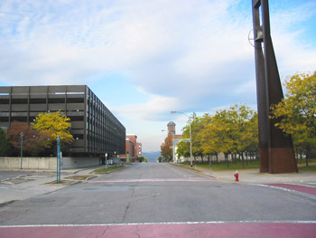
PHOTO 14A (CherrySt20PineW2006.jpg)
20 Pine Street
Intersection of Cherry & St. Paul Streets, looking west, taken October 14, 2006
Photographer: Carrie A. Mardorf
Geographic Position: UTM 18T0642001 4926654

The appearance of the streetscape at the intersection of Cherry Street and St. Paul has changed, but remains similar to its 1946 appearance through abstract forms. The tall church tower is recalled through a more modern steel bell tower, while the former historic brick commercial block is recalled through the rectangular form of the parking garage across the street. The width of the street remains with two lanes of traffic with on-street parking along the south side. Parking is reserved for loading and unloading zones for Chittenden County Transportation Authority (CCTA) buses. A hydrant remains on the northwest corner (left) though the fixture has been replaced with a more modern and efficient version. Stamped concrete and painted crosswalks are seen at the intersection.
One of the most significant changes in the area today is the closing of St. Paul Street to the south. Beginning in 1959, the city of Burlington approved a major urban renewal project to rid of urban blight and unsightly slums west of the downtown business district. As a result, twelve acres of land were razed such as the block south of Cherry Street and three streets were closed, including St. Paul Street to accommodate the urban renewal project. Though approved, resistance to the project by residents in the area slowed the acquisition of property and the demolition of structures, but by 1965 demolition had begun. Four years later, in 1969, the first of many office buildings were completed.
Prior to 1979, Burlington Square Mall, now called Burlington Town Center, was constructed along with a 620-space parking garage, both seen on the far left. The mall provides over an additional 150,000 square feet of retail and commercial space in the downtown business district. The associated parking garage was designed by the architectural firm of Mies Van der Rohe. In 2001 the Burlington Town Center was renovated.
The Cathedral of Immaculate Conception has also changed drastically. In 1949, the redstone Gothic Revival structure underwent a complete interior renovation in preparation for the 100-year anniversary of the diocese in 1954. However, on March 13, 1972, the Cathedral burned. The fire was first report at 11:20 PM and adjacent residences were evacuated. Though firefighters tried to contain and control the fire, the church’s bell tower collapsed shortly after midnight, sending the 4500 pound bell to the ground. By morning, all that remained of the Cathedral was smoldering ruins. Fortunately, only one firefighter was injured during the battle to control the flames; however, the loss of the Cathedral of the Immaculate Conception marked the eighth major fire in Burlington over a period of thirteen months. The nearby St. Paul’s Church, one block south of the Cathedral on St. Paul Street burned only thirteen months earlier.
In 1973, shortly after the devastating fire, the congregation of the Cathedral of Immaculate Conception decided to rebuild their church. Prominent New York architect Edward Larrabee Barnes was selected to design the new cathedral. Barnes is known for his wide range of geometric civic, educational, and ecclesiastical structures that respond heavily to building site and local building materials. His monunmental yet simple structures combine formal order and careful detailing to result in powerful and effective buildings.
Inspired by H. H. Richardson’s Billings Library at the University of Vermont, Barnes’s design draws upon local references to the library building through the exterior banding of glazed green and dark brown brick, while accommodating the challenges of a declining Catholic population in the community. The new, angular, five-sided church was designed on a smaller-scale to seat 450 people in the sanctuary and oriented on an east-west axis to capture sunlight at sunrise and sunset.
Barnes collaborated with prominent Vermont-based landscape architect Dan Kiley to design the site. Kiley is noted as being one of the most important landscape architects of the 20th century, having worked and studied under notable Warren Manning and later Walter Gropius at the Harvard Graduate School of Design. He became of the first modern landscape architects in the country using geometric and ordered forms in landscapes, often collaborating with contemporaries Eero Saarinen and Louis Kahn. His works include numerous public spaces, often designing plazas, but despite the popularity of his work during the 1970s, Kiley’s built landscapes are being lost, altered, and redesigned at an alarming rate.
Kiley sited the building in the center of the city block reorienting the main entrance to be located off Pine Street, instead of Cherry Street. Kiley also used Barnes’s angular design for the new Cathedral to dictate new circulation patterns and vegetation throughout the site. The building sits within a grove of 123 honey locust trees (Gleditsia triacanthos) that align to the exterior angled façade of the Cathedral, while two sidewalks parallel the trees and criss-cross the site. The historic bell was salvaged from the ruins and placed in a free-standing steel belltower at its former location of the corner of Cherry and St. Paul Streets, serving to recall the former Cathedral building that burned. On March 13, 1977, the new Cathedral reopened to parishioners, and was dedicated two months later on May 26, 1977.
Today the Cathedral and surrounding landscape remain unaltered from their 1970s appearance. However, in June 2006 the city of Burlington approved a feasibility study regarding a new public transportation facility located along St. Paul Street, which would effect the Barnes building and Kiley landscape. Since the transportation center is currently in the initial design phase, awareness about the building and landscape are being raised, in hopes of designing a facility that is compatible with the adjacent landscape and minimally obtrusive to the Barnes and Kiley design.
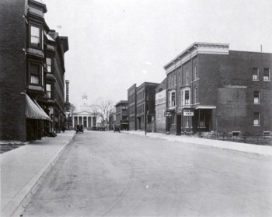
PHOTO 15 (CherrySt108End.jpg)
108 Cherry Street, looking east, date taken unknown
Photographer: Louis L. McAllister
Geographic Position: UTM 18T06420417 4926665

Cherry Street in downtown Burlington is characterized by a wide expanse of pavement, bordered by two narrow concrete sidewalks which are flanked by commercial buildings to the north and south. The business district of downtown Burlington is quite dense with several two and three story buildings edging both sides of the street. Several buildings are seen in this photograph, but 108-114 Cherry, 115-117 Cherry, and the 1st Congregational Church are the most clearly defined. Many buildings shown in the photograph are located at the intersection of Cherry Street and Church Street, including the Sherwood Hotel on the left, marked by its dark vertical sign.
108-114 CHERRY STREET
108-114 Cherry is a three story four-plex frame building with a brick veneer. Though the full front façade is not shown in the photograph, the protruding bay windows are prominent features. A striped awning covers a doorway on the lower level. The exact construction date of this building is not known; however a building of similar size and footprint appears on the 1853 map of Burlington, so it is assumed that this building dates to the mid-19th century. After the turn of the century the building had five tenants including Edward J. Thomas, Joseph Sullivan Miss Eliza Mattimore, Eds. Dwyer, and John H. Drew. By 1931, the building was listed as the Dwyer Block in the Burlington City Directory. It contained two stores including a second hand store operated by George L. Lavalley and a meats/butcher shop operated by Archie R. LaBounty. Other residents in the building at that time included Mrs. Susan Dwyer, Burt H. Isham, and Alfred J. Shanks.
Almost a decade later, Archie R. LaBounty’s meat shop remained in the building. New businesses in the Dwyer Block in 1942 included OBoyle’s New & Used Furniture and Ann’s Beauty Shoppe. New residents included Henry Brunelle, Jr,, Arthur J. Boothman, Mrs. Bertha A. Black, Mrs. Ann G. Blake, and Raymond H McGee.
115-117 CHERRY STREET
The building located at 115-117 is a three story, six bay frame building with brick veneer. Two hanging signs are noted on the front façade of the building reading, “The Salvation Army” and “Silver [unidenfiable word] Inn.” Constructed in two stages, the western part of the building (115 Cherry) was built first around the late 1800s. This portion of the building contains three bays, divided by slightly protruding brick piers. Three windows are evenly spaced on the second and third floors, with the second story, central bay containing a protruding bay window. Four 1-over-1 windows are seen on the west façade, on the right side of the image. The eastern half of the building (117 Cherry) was probably constructed at a later date due to the differences in fenestration on the three bay section. Though 117 Cherry has the same arched and protruding bay windows, the rhythm and proportion of the window placement and lack of projecting brick piers differentiate it from 115 Cherry. The two sections of the building are tied together with a bracketed Italianate cornice that was probably added at the time of completion of 117 Cherry to unify the two facades. In 1901, 115 Cherry is listed in the Burlington City Directory as the LaFayette House occupied by Fred A. Degree. 117 Cherry is not listed at this time, indicating it was constructed post-1901. In 1931, James E Gannon resided in 115 Cherry, while the Salvation Army and Harold Snowden occupied 117 Cherry. The Salvation Army continued to occupy the building into the early 1940s, while 115 Cherry was vacant.
1st CONGREGATIONAL CHURCH
Terminating the east axis of Cherry Street is the 1st Congregational Church with a prominent façade composed of a portico and steeple in the Greek Revival style. Positioned on South Winooski Avenue, the church is located on the former site of the Old White Church, which dated to 1812, but burned in 1839. At that time South Winooski Avenue was called “White Street” named after the Old White Church, which once stood at the east end of Cherry Street.
The 1st Congregational Church was designed by Henry Serle and built in 1842. The original design of the church included five bays, marked by white Ionic columns of the portico to contrast with the red brick bearing walls and stone foundation. Several additions and alterations to the building of the years have changed the church. To celebrate the 100th anniversary of the congregation, the building was enlarged by adding a sixth bay in the Ionic portico. In the 1930s, the parish expanded the church again by adding an addition to the east to connect the adjacent chapel and vestry to the church. During this time, the building also underwent a Colonial style renovation.
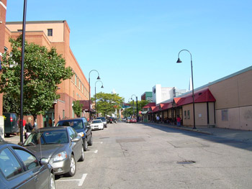
PHOTO 15A (CherrySt108E2006.jpg)
108 Cherry Street, looking east, taken October 9, 2006
Photographer: Carrie A. Mardorf
Geographic Position: UTM 18T06420417 4926665

Though Cherry Street today is characterized by expansive paving, adjacent sidewalks, and flanking buildings, the scene of the streetscape has been significantly altered. Very few buildings pictured in the McAllister photograph remain today. Impacted by the urban renewal project of the late 1950s and 1960s, 108-114 Cherry Street and 115-117 Cherry Street were demolished as part of the project. Older, unsightly buildings were razed to rid of urban blight and to create space for redevelopment projects. Today the John Zampieri State Office Building stands at 108 Cherry Street, while Old Navy of the Burlington Town Center and the Cherry Street CCTA Bus Terminal occupy the site of the former 115-117 building.
As part of the urban renewal project of the 1960s, redevelopments were sought that increased retail and commercial space in the downtown business district. Prior to 1979, Burlington Square Mall, now called Burlington Town Center, was constructed. The development provided an additional 150,000 square feet of retail and commercial space to downtown Burlington. Throughout the 1980s, redevelopment of the business district continued as the Church Street Marketplace was designed and constructed. The colorful banners of the Church Street Marketplace are seen at the intersection of Church and Cherry Streets.
Another aspect of the urban renewal project was the creation of the Chittenden County Transportation Authority (CCTA) to increase public transportation in downtown Burlington and throughout Chittenden County, in hopes of drawing residents and visitors to the newly redeveloped area. Today, the CCTA is still in operation, using the Cherry Street bus station as its main hub. The buses operate on a “pulse system” in which all buses depart from the terminal at the same time and return at relatively the same time.

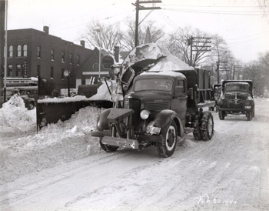
PHOTO 16 (WinooskiAve16NW1944.jpg)
16 South Winooski Avenue, looking northwest, taken February 20, 1944
Photographer: Louis L. McAllister
Geographic Position: UTM 18T0642258 4926763

This McAllister photograph was taken from the center of South Winooski Avenue looking northwest. The prominent subject of the photograph are two trucks removing a large amount of snow from the street. The caption reads, “This view shows the Snow King Rotary Plow loading snow from S. Winooski Avenue into truck which hauled the snow to the dumping area at the foot of College Street. Each load contained approximately ten cubic yards when piled high above the cab as shown in this picture.” Other prominent features shown in the photograph include a three story brick building, utility poles, deciduous tree canopies, and a Shell gas station sign. The large brick building to the left of the photograph is located at 180-184 Pearl Street. The building exhibits several bays with rounded arched 1-over-1 windows with a marquee on the front façade reading “Drugs” and “Ice Cream Bar”.
180-184 Pearl was likely constructed during the late 19th century, and by 1901 occupants of the builing included the Burlington Furniture Company and M.H. and M.G. Rosenburg. Three decades later in 1931, the building was listed as the Clement Block, which was subdivided into many offices and apartments at that point in time. Tenants of the building 1931 include the Wager Linen and Art Shop, Mrs. Elizabeth Blow, Arthur Sherwin, Gadue Beauty Parlor & Training School, Mary L. Briggs, William S. Wager, Mrs. Harriet Conant, Francis J. Arnold, physician, Eva Hammond, May Adrien, Alice Byrnes, Neil L. Gover, Bert Irish, Irene M Livingstone, and two vacancies.
In 1942, the building retained many of its residents. On the street level, Clement Block tenants included the New York Beauty Shoppe and Young’s Pharmacy. Upper floors contained Morrill’s Beauty Shop, Francis J Arnold, physician’s office, eleven other individuals, and three vacancies.
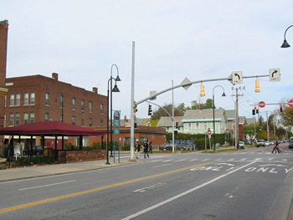

PHOTO 16A (WinooskiAve16NW2006.jpg)
16 South Winooski Avenue, looking northwest, taken October 21, 2006
Photographer: Carrie A. Mardorf
Geographic Position: UTM 18T0642258 4926763

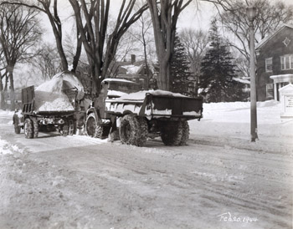
Today the broader streetscape of Pearl Street and South Winooski Avenue is quite open with few buildings and limited vegetation. South Winooski has been widened to four lanes, and a lot of overhead infrastructure such as traffic lights, pedestrian lights, and signs dot the landscape today. The Clement block remains standing along the northern edge of Pearl Street. In 1972, the building contained two businesses including the Signal Finance Corporation and Young’s Pharmacy, nine private residences, and five vacant spaces. Today the Four Season Beauty Salon and numerous apartments occupy the space.

PHOTO 17 (WinooskiAve38NE1944.jpg)
38 South Winooski Avenue, looking northeast, taken February 20, 1944
Photographer: Louis L. McAllister
Geographic Position: UTM 18T0642254 4926656

During the winter of 1944, near record amounts of snow fell on the city of Burlington. McAllister, interested in recording different methods of snow removal, took this photograph showing one method of snow removal used to by the Burlington City Streets Department. The caption reads, “This view shows the Snow King Rotary snow loader mounted on Walter Snow Fighter truck loading snow from the street into a 10 cubic yard truck body. One of these truck loads is loaded in approximately ¾ of a minute. An average fall of 6 inches of snow will require the hauling of approximately 250 loads of snow from business streets.”
This McAllister photograph also shows the chapel of the 1st Congregational Church complex along the east side of South Winooski Avenue. The building is a two story, three bay, brick block with a gable roof. Windows are 18-over-18 and are arranged symmetrically on the front façade of the building. An oculus window in the gable peak and small white portico also characterize the building. The chapel is part of several additions that were added to the church since its erection in the 1840s. In the 1930s, the chapel was connected to the church through another series of additions that linked the two buildings together. A white gable-peaked sign appears in front of the chapel, listing the acting reverend and the times of church services. The adjacent landscape contains several deciduous and evergreen trees. A single light post is also shown in the foreground along the street, topped with a lantern light fixture.
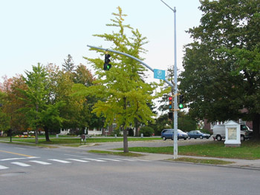

PHOTO 17A (WinooskiAve38NE2006.jpg)
38 South Winooski Avenue, looking northeast, taken October 14, 2006
Photographer: Carrie A. Mardorf
Geographic Position: UTM 18T0642254 4926656

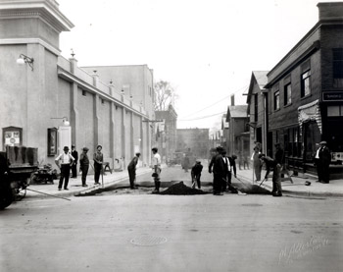
Today the chapel remains part of the 1st Congregational Church complex, but is screened from view by young and dense deciduous trees. Though large American elm trees were lost and removed over the past decades, new trees were planted in their place. A small parking lot has been added to the west side of the chapel, immediately in front of the main façade. The white church sign remains in the landscape over 60 years later. South Winooski Street also appears similar in character. Noticeable changes include the addition of modern street lights, traffic lights, and signage at the intersection.

PHOTO 20 (CenterSt195BankSnd.jpg)
195 Bank Street
Looking south down Center Street, date taken unknown
Photographer: Louis L. McAllister
Geographic Position: UTM 18T0642230 4926549

This view of the intersection of Bank Street and Center Street shows a group of eight men spreading hot asphalt mix to repave a section of Center Street, while eight men look on. A truck to the left of the photo contains work supplies, while the asphalt steamroller is seen in the background. Center Street contains no vegetation and can be characterized by wide concrete sidewalks spanning approximately ten feet in width and several buildings lining the east and west sides of the street. Two buildings, 191-195 Bank Street and 207 Bank Street, located the intersection of Center Street are easily discernable.
191-195 BANK STREET
A two story three bay frame building is located at 191-195 Bank. The east façade contains three doors and large sections of windows on the lower level with three evenly spaced 1-over-1 windows on the upper level. A striped awning is drawn back over one of the doors on the east side. A sign on the main facade is partially shown, reading, “Smoke.” The building was probably constructed during the late 19th century, as it was occupied by the H.W. Steadman, V.S.; Gregory Grain Co. and the O.K. Steam laundry in 1901. Thirty years later in 1931, residents of the building included the Patten, Irwin & White Hardware Store and the W.E. Greene Co. However, by 1935 the building was destroyed, marked on the 1935 Sanborn map as a stone foundation with the label “H.W. Abraham.” In 1942, the Sanborn map continues to show the foundation with a label “Old foundation. Plank Floor Level with Ground.”
207 BANK STREET
The Majestic Theatre at 207 Bank Street is located at the southeast (left) corner of the intersection and is a large brick building with plastered exterior walls. The prominent view of the building is of the west façade of the building, which exhibits seven bays with six protruding piers and pointed finials on top. Two white doors located in the first and sixth bay provide access into the building. The corner of the main façade faces north and is similar in character with an oversized-cornice with detailed dentils and molding. A globe light fixture is seen attached to the front façade with a scrolling metal bracket. A slightly smaller globe light fixture is attached to the west façade with a simpler metal bracket. At eye level are two framed cases that contain featured movie posters.
The movie theatre was constructed in 1911, when J.R. Lockwood and E.R. Hutchinson bought the property at the corner of Bank and Center Streets from John L Southwick. Shortly after, Lockwood and Hutchison gave a building contract to the architectural and building company, the W. Shelton Company to construct Burlington’s first movie theater showing motion pictures. The theater opened on May 16, 1912 with a sold out audience paying 5 cents a ticket. After the opening day, ticket prices rose to 10 cents for adults and 5 cents for children. The first film featured on the screen was a silent movie, with music by a four-piece orchestra.
Popularity of the Majestic Theater grew and by the late 1920s, the theater had installed a large pipe organ to accommodate the silent movies. A few years later in November of 1925, the first talking movie appeared on the screen at the local theater. Also during that same year, the building received a new air system.
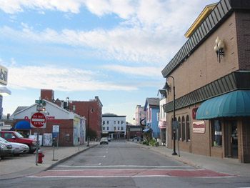
When World War II struck the United States, the popularity of the Majestic continued to increase as movies offered a way to escape the pressures and stress of daily life. New Year’s Day quickly became a popular event at the theater for local city newsboys, as local businessman John Flynn handed out free tickets to the Majestic on the first of the year. An anecdotal account of the New Years Day event, recalled, “If you missed the free tickets, you could always sneak into the Majestic. The side door was infamously easy and William Castle, the long-time doorman, smiled on children who lacked the money to pay their way in.” During the 1940s, the Majestic Theater burned and sustained $30,000 in damages. However, the theater was redesigned with excellent acoustics, and brown substitute leather seats.

PHOTO 20A (CenterSt191BankS2006.jpg)
191 Bank Street
Looking south down Center Street, taken October 14, 2006
Photographer: Carrie A. Mardorf
Geographic Position: UTM 18T0642230 4926549

Today the intersection of Bank Street and Center Street remains similar to its historic appearance of the mid 20th century. The street continues to lack vegetation and buildings are the predominant feature of the landscape. The Majestic Theater no longer stands at the corner, having been replaced by a Mobil gas station. The Majestic continued to show movies throughout the 1940s and early 1950s; unfortunately, declining audiences in addition to increased competition from the Flynn Theater forced the Majestic to close in 1954. Ironically, the two theaters were owned by the same corporation. After entertaining the residents of Burlington for over 42 years, the Majestic Theater was sold the same year. Two years later in February 1956, the “best theater in Vermont” was demolished to construct a gas station on the former site. The gas station remains on the former Majestic site today.
The building located at 191 Bank Street was rebuilt in the mid 20th century years after the demolition of the old structure. The new 191 Bank Street building appears to have been constructed on the old foundation, as it is similar in size and massing as the old building. Today the two story brick building houses Climb High and the Champlain Clothing Company, two outdoor gear apparel stores.
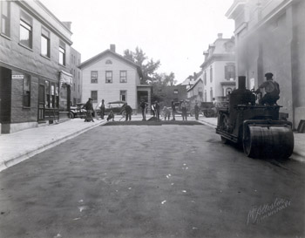
PHOTO 21 (CenterSt9Nnd.jpg)
9 Center Street, looking north, date taken unknown
Photographer: Louis L. McAllister
Geographic Position: UTM 18T0642248 4926511

This McAllister photograph of Center Street, historically known as Catlins Lane, shows eleven men spreading loose asphalt aggregate over a section of the street. One additional man is seated on the steamroller to the right of the image, rolling the asphalt into a smooth continuous pavement. A concrete curb and gutter edge the street adjacent to a wide concrete sidewalk. Three buildings are clearly shown in the photograph-, including 191-195 Bank Street to the left, 207 Bank Street to the right, and 196 Bank mid-left. Overall, Center Street contains no vegetation and can be characterized by the expansive pavement and flanking buildings.

191-195 BANK STREET
191-195 Bank is a two story frame building whose east façade is punctuated by three doors and a block of windows on the first floor and four evenly spaced 1-over-1 windows on the second floor. A striped awning is drawn back over the door closest to Bank Street. Likely constructed during the late 19th century, the building was occupied by the H.W. Steadman, V.S.; Gregory Grain Co. and the O.K. Steam laundry in 1901. Later in 1931, the Patten, Irwin & White Hardware Store and the W.E. Greene Co were tenants of the building. However, by 1935 the building was destroyed, marked on the 1935 Sanborn map as a stone foundation, and labeled “H.W. Abraham.” By 1942, the foundation remained, labeled, “Old foundation. Plank Floor Level with Ground.”
207 BANK STREET
207 Bank Street is the Majestic Theater located at the southeast (right) corner of the intersection of Bank and Center Streets. The theater is a large brick building with plastered exterior walls with protruding piers and elaborate, oversized-cornice. One globe light fixture and a white door are also seen on the west façade of the building.
The movie theatre was constructed in 1911 by the , the W. Shelton Company, and opened on May 16, 1912. As Burlington’s first movie theater to show motion pictures, the opening performance sold out with tickets priced at 5 cents each. After opening day, ticket prices rose to 10 cents for adults and 5 cents for children. The theater grew in its popularity and by the late 1920s, the theater had installed a large pipe organ, a new air system, and played the first talking movie in the city.
The popularity of the Majestic continued to increase throughout World Ward II as movies offered a way to escape the realities of war. New Year’s Day quickly became a popular event at the theater for local city newsboys, as local businessman John Flynn handed out free tickets to the Majestic on the first of the year. An annecdotal account of the New Years Day event, recalled, “If you missed the free tickets, you could always sneak into the Majestic. The side door was infamously easy and William Castle, the long-time doorman, smiled on children who lacked the money to pay their way in.” During the 1940s, the Majestic Theater burned and sustained $30,000 in damage, but was soon remodeled afterwards, featuring better acoustics and faux-brown leather seats.
196 BANK STREET

The building located at 196 Bank Street was constructed between 1830 and 1853 and is a two-story, three bay frame dwelling with gable roof, central chimney and porch to the east. The house is clad in narrow clapboards and the 2-over-2 windows are symmetrically spaced. The far left window on the second story appears to be a 6-over-6 window. In 1869, the property belonged to F. Woodworth. By 1901, the small building was occupied by the Dwyer Hack Company and Mrs. Margaret Dwyer, and in 1931, the building was a single family residence occupied by Albert T. Wright. Approximately a decade later in 1942, the building was divided into apartments and Arthur G Boss and Hector J Remillard occupied the building.

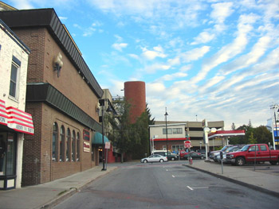
PHOTO 21A (CenterSt9N2006.jpg)
9 Center Street, looking north, taken October 14, 2006
Photographer: Carrie A. Mardorf
Geographic Position: UTM 18T0642248 4926511

Today the appearance of the intersection of Bank Street and Center Street remains somewhat similar to its appearance during the mid 20th century. The street continues to lack vegetation, and buildings are the predominant feature of the landscape. The Majestic Theater no longer stands at the east corner—a Mobil gas station takes its place. Throughout the 1940s and early 1950s, the Majestic continued to show movies. However, competition from the Flynn Theater which was constructed in the 1930s and declining audiences competition from forced the theater to close in 1954. Ironically, the two theaters were owned by the same corporation. After 42 years of playing movies in downtown Burlinton, the Majestic Theater was sold in 1954. Two years later in February 1956, the “best theater in Vermont” was demolished to construct a gas station on the former site. The gas station remains today.
The building located at 191 Bank Street was rebuilt in the mid 20th century years after the demolition of the old structure. The new 191 Bank Street building appears to have been constructed on the old foundation, as it is similar in size and massing as the old building. Today the two story brick building houses Climb High and the Champlain Clothing Company, two outdoor gear apparel stores.
The building at 196 Bank Street remained a residence until 1972, when James Hair Styling and Empire Launderers & Cleaners occupied the building. Some time between 1972 and 2006, the building was demolished. Today a tall brick columnar structure and an adjacent gas station stands on the site of the former building.
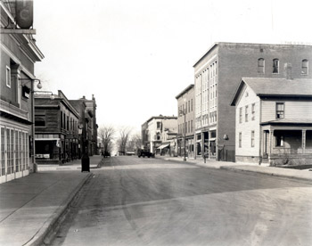
In the background of the image, is a concrete parking ramp that resulted from the 1960s urban renewal project. Located along South Winooski Avenue and next to the Church Street Marketplace, the ramp provides an additional 400 parking spaces for the downtown business district. The ramp was constructed circa 1976 and was funded with $1.6 million from the Economic Development Administration.

PHOTO 22 (BankSt207Wnd.jpg)
207 Bank Street, looking west, date taken unknown
Photographer: Louis L. McAllister
Geographic Position: UTM 18T0642256 4926543

A view looking west along Bank Street shows the spatial organization of the street, buildings, sidewalks, and other small-scale landscape features. Bank Street in downtown Burlington is characterized by a wide expanse of pavement, bordered by two narrow concrete sidewalks which are flanked by commercial buildings to the north and south. The business district of downtown Burlington is quite dense with several two to three story buildings edging both sides of the street. Several buildings are seen in this photograph, including 190-194 Bank Street, 196 Bank Street, 191-195 Bank Street, and 207 Bank Street.
190-194 BANK STREET

190-194 Bank Street is a four story, three bay brick building with numerous windows on the main façade. The lower level of the building has a central entrance flanked by two large display windows with drawn back striped awnings. The windows on the second, third, and fourth stories appear to be arranged symmetrically in groups of three. Three windows with arched lintels appear on the east façade on the fourth floor. A simple cornice caps the building. In 1901, the Burlington city directory lacks information about the building, suggesting it was not built yet. By 1931, occupants of the building included the G. S. Blodgett Co, wholesale plumbing, George Hunt, dentist, H. Glenn Hunt, Chiropractor, and the Underwood Typewriter Company. A decade later in 1942, the G. S. Blodgett Co, wholesale plumbing, William H. Morrison, dentist, and H. Glenn Hunt, Chiropractor were the only remaining occupants of the building.

196 BANK STREET

The building located at 196 Bank Street was constructed between 1830 and 1853 and is a two-story, three bay frame dwelling with gable roof, central chimney and porch to the east. The house is clad in narrow clapboards and the 2-over-2 windows are symmetrically spaced. The far left window on the second story appears to be a 6-over-6 window. In 1869, the house ad property belonged to F. Woodworth. By 1901, the small building was occupied by the Dwyer Hack Company and Mrs. Margaret Dwyer. In 1931, the building was a single family residence occupied by Albert T. Wright. Approximately a decade later in 1942, the building was divided into apartments and Arthur G Boss and Hector J Remillard occupied the building.
191-195 BANK STREET
191-195 Bank is a two story frame building whose east façade is punctuated by three doors and a block of windows on the first floor and four evenly spaced 1-over-1 windows on the second floor. A striped awning is drawn back over the door closest to Bankd Street. Likely constructed during the late 19th century, the building was occupied by the H.W. Steadman, V.S.; Gregory Grain Co. and the O.K. Steam laundry in 1901. Later in 1931, the Patten, Irwin & White Hardware Store and the W.E. Greene Co were tenants of the building. However, by 1935 the building was destroyed, marked on the 1935 Sanborn map as a stone foundation labelled “H.W. Abraham.” By 1942, the foundation remained, labeled, “Old foundation. Plank Floor Level with Ground.”
207 BANK STREET
207 Bank Street is the Majestic Theater located at the southeast (right) corner of the intersection of Bank and Center Streets. The theater is a large brick building with plastered exterior walls with protruding piers and elaborate, oversized-cornice. One globe light fixture and a white door are also seen on the west façade of the building.
The movie theatre was constructed in 1911 by the , the W. Shelton Company, and opened on May 16, 1912. As Burlington’s first movie theater to show motion pictures, the opening performance sold out with tickets priced at 5 cents each. After opening day, ticket prices rose to 10 cents for adults and 5 cents for children. The popularity of the Majestic Theater grew and by the 1925, the theater had installed a large pipe organ, a new air system, and had played the first talking movie in the city of Burlington.
The popularity of the Majestic continued throughout World War II as movies offered a way to escape the pressures and stress war. New Year’s Day quickly became a popular event at the theater for local city newsboys, as local businessman John Flynn handed out free tickets to the Majestic on the first of the year. An annecdotal account of the New Years Day event, recalled, “If you missed the free tickets, you could always sneak into the Majestic. The side door was infamously easy and William Castle, the long-time doorman, smiled on children who lacked the money to pay their way in.” During the 1940s, the Majestic Theater burned and sustained $30,000 in damage, but the theater was remodeled afterwards, featuring better acoustics and faux-brown leather seats.
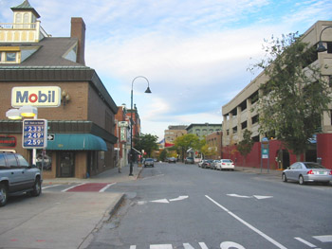
PHOTO 22A (BankSt93WinooskiW2006.jpg)
93 S. Winooski Avenue, looking west down Bank Street, taken October 14, 2006
Photographer: Carrie A. Mardorf
Geographic Position: UTM 18T0642256 4926543

Today Bank Street has a different appearance than previously seen during the mid 20th century. The street continues to lack vegetation, and buildings are the predominant feature of the landscape. The Majestic Theater no longer stands along Bank Street, instead it is replaced by a Mobil gas station. Throughout the 1940s and early 1950s, the Majestic continued to show movies. However, competition from the Flynn Theater which was constructed in the 1930s and declining audiences forced the theater to close in 1954. Ironically, the two theaters were owned by the same corporation. After 42 years of playing movies in downtown Burlinton, the Majestic Theater was sold in 1954. Two years later in February 1956, the “best theater in Vermont” was demolished to construct a gas station on the former site. The gas station remains today.
The building located at 191 Bank Street was rebuilt in the mid 20th century years after the demolition of the old structure. The new 191 Bank Street building appears to have been constructed on the old foundation, as it is similar in size and massing as the old building. Today the two story brick building houses Climb High and the Champlain Clothing Company.
The building at 196 Bank Street remained a residence until 1972, when James Hair Styling and Empire Launderers & Cleaners occupied the building. Some time between 1972 and 2006, the building was demolished. Today a tall brick columnar structure and an adjacent gas station (not shown) stand on the site of the former building.
190-194 Bank Street was occupied throughout the mid 20th century. In 1972, the building was listed as the Lash Building in the Burlington City Directory. The building contained one vacancy, James hair styling, and Empire Launderers & Cleaners. Between 1972 and 2006, the building was demolished, and a modern concrete parking ramp was constructed.
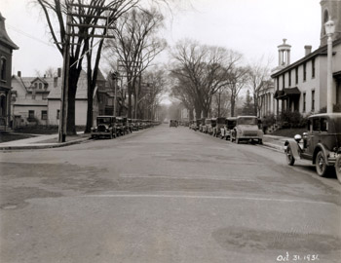
PHOTO 23 (WinooskiAve70N1931-2.jpg)
70 South Winooski Avenue, looking north, taken October 31, 1936
Photographer: Louis L. McAllister
Geographic Position: UTM 18T0642273 4926541

A view of the intersection of South Winooski Avenue and Bank Street looking north shows the character-defining features of the landscape during 1936. South Winooski Avenue is a wide expanse of pavement, appearing to accommodate two lanes of through traffic with on-street parking along the west and east sides of the street. The pavement looks rough, seemingly patched together multiple times with asphalt, creating a patchwork arrangement on the ground plane. Tall and arched branches of American elm trees frame views down the street corridor and provide a shady residential atmosphere. Overhead utility poles, lamp posts and concrete sidewalks line the edges of the street.
The most prominent building in the photograph is 70-72 South Winooski, located along the east (right) side of the street. This building was likely built during the mid 1850s. This two story, six bay, gable-roofed frame with brick veneer building is predominantly constructed in the Federal style with two small covered porticos centered on the main façade. The two central doors hint to the fact that the building is a duplex, which is confirmed by the 1935 Sanborn Map. In 1869, David Kern is listed as the property owner of 70-72 South Winooski. At the turn of the century, the building partially remained in the Kern family, as Mrs. Sophia C. Kern resided in 72 South Winooski, while Charles R. Kempter occupied 70 South Winooski. By 1931, Mrs. Sophia C. Kern continued to live in #72, and Edward R Hutchinson resided in #70. By 1942, however, the building housed two new residents— Alba C. Booth and Mary E. Pease.
Other structures seen in the photograph include the 1st Congregational Church, the 1st Methodist Church and the partial facades of two residential houses along the west side of the street.
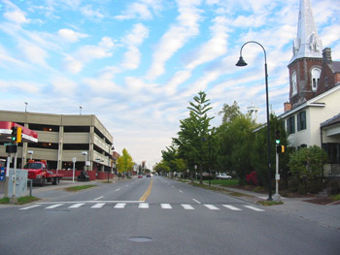
PHOTO 23A (WinooskiAve70N2006.jpg)
70 South Winooski Avenue, looking north, taken October 14, 2006
Photographer: Carrie A. Mardorf
Geographic Position: UTM 18T0642273 4926541

Today the character of the intersection of South Winooski Avenue and Bank Street has changed. Residential buildings along the west edge of the street have been removed and replaced with a gas station and modern concrete parking ramp. The parking ramp was funded with $1.6 million in January 1979 by the Economic Development Administration to create additional parking spaces for the urban renewal redevelopment projects at that time. The ramp provides an additional 400 parking spaces for the downtown business district and the Church Street Marketplace. The addition of new buildings and features and the loss of historic landscape features, including tree canopy, utility lines, and historic street lights also change the character of the street.
The buildings along the eastern side of the street are extant today, including 70-72 South Winooski, the 1st Congregational Church, and the 1st Methodist Church. 70-72 South Winooski remained occupied throughout the mid-20th century. In 1972, occupants included Richard Conklin, dentist, Robert Perrin, dentist, Theod Zolotas, Brian Marshall, Josh Brady, and one vacancy. Currently , the property is occupied by the UPS Store and is listed on the National Register of Historic Places. Mature plantings to the west of the building partially screen the building from view.
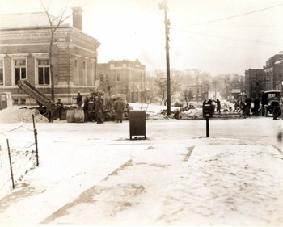
PHOTO 24 (WinooskiAve106Snd.jpg)
106 South Winooski Avenue, looking south, date taken unknown
Photographer: Louis L. McAllister
Geographic Position: UTM 18T0642277 4926451

This McAllister photograph shows the intersection of South Winooski Avenue and College Street looking south toward the Burlington Free Library (left). The section of South Winooski Avenue between Main Street and College was widened in 1934, which is likely when this photograph was taken. Ten men are working preparing forms for the concrete curb and gutter and gravel base material. The street is quite open with limited vegetation. One small deciduous tree is seen north of the library and three shorter, understory deciduous trees are located between the library and the adjacent fire station, which are sited on the former city market grounds. The sidewalk east of South Winooski Avenue is quite wide, exceeding ten feet in width. A mailbox and other unidentified object are located along the College Street curb in the foreground. To the left is a post and wire fence that is part of the adjacent gas station property, north of the library. For more information pertaining to the history of the Burlington Free Library on College Street please click here (link to Jesse Zanavich Page).
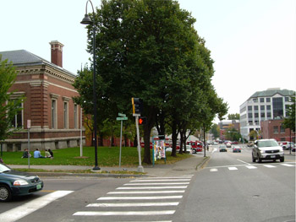
PHOTO 24A (WinooskiAve222CollegeS2006.jpg)
222 College Street, looking south down South Winooski Avenue, taken October 9, 2006
Photographer: Carrie A. Mardorf
Geographic Position: UTM 18T0642277 4926451

Today the view of the intersection of South Winooski Avenue and College Street remains quite similar to its 1930s appearance. The Burlington Free Library remains on the southeast corner (left) and the fire station is still in operation to the south. The landscape is more enclosed with tall deciduous trees obstructing views further south. Larger mid-rise buildings are seen in the background at the intersection of South Winooski and Main Street. Other elements of change include the narrowing of the side walk, and the removal of the mailbox, For more information about the evolution of the Burlington Free Library on College Street please click here (link to Jesse Zanavich Page).
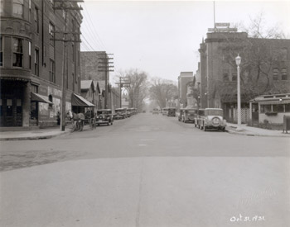

PHOTO 25 (WinooskiAv106N1931-1.jpg)
106 South Winooski Avenue, looking north, taken October 31, 1931
Photographer: Louis L. McAllister
Geographic Position: UTM 18T0642294 4926424

The intersection of South Winooski Avenue and College Street is characterized by limited vegetation and buildings of a variety of scales flanking east and west sides of South Winooski Avenue. Overhead utility lines are to the west, while a lantern-style street light marks the eastern corner. The street appears to be two lanes wide with on-street parking on both sides. A cut stone curb lines the street and the adjacent sidewalks. Prominent buildings in this view include 212-214 College, 102 South Winooski, and 106 South Winooski.
212-214 COLLEGE STREET
Sited at 212-214 College Street, the Hall Block is a four-story brick building originally constructed in December 1894 by S.P. Saxe & Son. A significant feature of the building is its twin towers with pressed metal floral detailing and tall conical roofs at the corners of College and Center Streets and College and South Winooski Avenue. Another significant feature is the large advertisement and mural for “Hall Furniture” on the east façade. The site was originally the location of the Wheeler Block, which burned in 1885. After the construction of the Hall Block, George A. Hall occupied the building in 1901. Thirty years later in 1931, the Hall Furniture Company, Metropolitan Life Insurance Company, Headquarters of the 388th Infantry USA, and Patrick Mahoney, dentist utilized the commercial building. In 1942, the Hall Furniture Company, Metropolitan Life Insurance Company continued to occupy the building, while the Richmond Office Equipment Inc. was a new tenant that year.
102 SOUTH WINOOSKI AVENUE
A three story brick rectangular block located at 102 South Winooski houses general offices for the Green Mountain Power Company. The site was occupied by single family residential houses in 1901, when Luther F. Clow resided in a smaller frame dwelling. Between 1901 and 1931, the large brick building was constructed. The Green Mountain Power Company occupied the building from 1931 to 1942. The building appears to be a vernacular form of Art Deco and has an electric sign on top of the building that reads, “Light, Heat, Power.”

106 SOUTH WINOOSKI AVENUE
A small one story gas station occupies the property at 106 South Winooski. The building is constructed with a concrete floor and glass block. The gas station is positioned at an angle to the intersection and is surrounded by a lattice fence. One large deciduous tree is between the gas station and the adjacent Green Mountain Power Company building. Originally a block of single-family residential houses in the early 1900s, the gas station was not built until the 1920s or 1930s. In 1931, the property was listed as vacant in the city directory. However, by 1942, the Manning Co, gas and oil occupied the site.

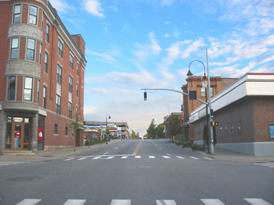
PHOTO 25A (WinooskiAv222CollegeN2006.jpg)
222 College Street, looking north up South Winooski Avenue, taken October 14, 2006
Photographer: Carrie A. Mardorf
Geographic Position: UTM 18T0642294 4926424

Today the intersection of College Street and South Winooski Avenue retains a feeling of its historic character with some change evident. The Hall Block at 212-214 College Street towers high about the street level. In 1972, occupants of the building included the Intimiate Apparel Shop, Tina’s Fabrics, and Data Processing, Inc. In 2002, the building underwent a major restoration. Today, North Face, lawyers’ offices, and residential apartments occupy the building.
Across the street to the east, is the current Merrill Roxy Cinema. The gas station that was present in the 1940s continued operations into 1971, then called Leonard’s Shell Service Station. A decade later, in 1981, the Pizzagalli Construction Company constructed Hoyt’s Nickelodeon on the site of the former gas station. The Nickelodeon was the first movie to be constructed in Burlington since the construction of the Flynn on Main Street in the 1930s. Since its construction, the movie theater has changed names to Merrill’s Roxy Cinema. The theater is popular for showcasing independent films.
Burlington City Annual Report. 1930, p 214.

Presdee and Edwards Map. Burlington, Vermont 1853.
Bird’s Eye View. Burlington, Vermont 1877.
Sanborn-Perris Map. Burlington, Vermont 1942.
Sanborn-Perris Map. Burlington, Vermont 1942.
Sanborn-Perris Map. Burlington, Vermont 1926 with 1935 updates.
Sanborn-Perris Map. Burlington, Vermont 1942.
Presdee and Edwards Map. Burlington, Vermont 1853.
Sanborn-Perris Map. Burlington, Vermont 1942.
Community Economic Development Office; Waterfront. www.cedoburlington.org/ 9 November 2006.
Community Economic Development Office; Waterfront. www.cedoburlington.org/ 9 November 2006.
Community Economic Development Office; Waterfront. www.cedoburlington.org/ 9 November 2006.
www.cedoburlington.org/
Sanborn-Perris Map. Burlington, Vermont 1942.
Sanborn-Perris Map. Burlington, Vermont 1926 with 1935 updates.
Sanborn-Perris Map. Burlington, Vermont 1942.
www.cedoburlington.org/
Bird’s Eye View. Burlington, Vermont 1877.
Beers Map of Burlington Vermont. 1869.
Burlington City Directory, 1931, 1942 (Burlington: H. A. Manning Co., 1916-1986).
Sanborn-Perris Map. Burlington, Vermont 1942; Burlington City Directory, 1931, (Burlington: H. A. Manning Co., 1916-1986).
Beers Map of Burlington Vermont. 1869; Bird’s Eye View. Burlington, Vermont 1877.
Burlington City Directory, 1901, 1942 (Burlington: H. A. Manning Co., 1916-1986).
Burlington City Directory, 1931, 1942 (Burlington: H. A. Manning Co., 1916-1986).
Community Economic Development Office; Waterfront. www.cedoburlington.org/ 9 November 2006.
Community Economic Development Office; Waterfront. www.cedoburlington.org/ 9 November 2006.
Burlington City Directory, 1942, 1972 (Burlington: H. A. Manning Co., 1916-1986).
Presdee and Edwards Map. Burlington, Vermont 1853.
A.B.Young Map. Burlington, Vermont 1830.
Beers Map of Burlington Vermont. 1869.
Burlington City Directory, 1901 (Burlington: H. A. Manning Co., 1916-1986).
Burlington City Directory, 1931 (Burlington: H. A. Manning Co., 1916-1986).
Sanborn-Perris Map. Burlington, Vermont 1926 with 1935 updates
Burlington City Directory, 1942 (Burlington: H. A. Manning Co., 1916-1986).
Sanborn-Perris Map. Burlington, Vermont 1926 with 1935 updates
Burlington City Directory, 1931, 1942 (Burlington: H. A. Manning Co., 1916-1986).
Burlington City Directory, 1942 (Burlington: H. A. Manning Co., 1916-1986).
Sanborn-Perris Map. Burlington, Vermont 1942.
A.B.Young Map. Burlington, Vermont 1830.
Beers Map of Burlington Vermont. 1869.
Burlington City Directory, 1901, 1931 (Burlington: H. A. Manning Co., 1916-1986).
Sanborn-Perris Map. Burlington, Vermont 1926 with 1935 updates
Sanborn-Perris Map. Burlington, Vermont 1942; Burlington City Directory, 1942 (Burlington: H. A. Manning Co., 1916-1986).
Burlington City Directory, 1901 (Burlington: H. A. Manning Co., 1916-1986).
Burlington City Directory, 1931 (Burlington: H. A. Manning Co., 1916-1986).
Burlington City Directory, 1942 (Burlington: H. A. Manning Co., 1916-1986).
Presdee and Edwards Map. Burlington, Vermont 1853; Beers Map of Burlington Vermont. 1869.
Sanborn-Perris Map. Burlington, Vermont 1926 with 1935 updates; Burlington City Directory, 1901 (Burlington: H. A. Manning Co., 1916-1986).
Burlington City Directory, 1931 (Burlington: H. A. Manning Co., 1916-1986).
Sanborn-Perris Map. Burlington, Vermont 1942.
Burlington City Directory, 1942 (Burlington: H. A. Manning Co., 1916-1986).
Urban Renewal source?!?
Historic Guide to Burlington Neighborhoods, Vol. 1; 38.
“Champlain Apartments.” Burlington Housing Authority. http://www.burlingtonhousing.org/article/articleview/1608/1/105/ 7 Novmember 2006.
Historic Guide to Burlington Neighborhoods, Vol. 1; 38
Sanborn-Perris Map. Burlington, Vermont 1942.
Presdee and Edwards Map. Burlington, Vermont 1853; Beers Map of Burlington Vermont. 1869.
Burlington City Directory, 1901 (Burlington: H. A. Manning Co., 1916-1986).
Burlington City Directory, 1931 (Burlington: H. A. Manning Co., 1916-1986); Sanborn-Perris Map. Burlington, Vermont 1926 with 1935 updates.
Burlington City Directory, 1942 (Burlington: H. A. Manning Co., 1916-1986).
Beers Map of Burlington Vermont. 1869.
Burlington City Directory, 1931 (Burlington: H. A. Manning Co., 1916-1986).
Burlington City Directory, 1942 (Burlington: H. A. Manning Co., 1916-1986).
Beers Map of Burlington Vermont. 1869.
1901 directory
Burlington City Directory, 1901, 1931 (Burlington: H. A. Manning Co., 1916-1986).
Sanborn-Perris Map. Burlington, Vermont 1926 with 1935 updates.
Historic Guide to Burlington Neighborhoods, Vol. 1; 42
Historic Guide to Burlington Neighborhoods, Vol. 1; 42
fire article
Historic Guide to Burlington Neighborhoods, Vol. 1.
Presdee and Edwards map. Burlington, Vermont 1853.
Beers Map of Burlington Vermont. 1869; Burlington City Directory, 1942 (Burlington: H. A. Manning Co., 1916-1986).
Historic Guide to Burlington Neighborhoods, Vol. 1.
Burlington City Directory, 1931 (Burlington: H. A. Manning Co., 1916-1986). , Sanborn-Perris Map. Burlington, Vermont 1926 with 1935 updates.
Burlington City Directory, 1942 (Burlington: H. A. Manning Co., 1916-1986).
1869, 1877 maps
Burlington City Directory, 1901 (Burlington: H. A. Manning Co., 1916-1986).
Sanborn-Perris Map. Burlington, Vermont 1926 with 1935 updates; Sanborn-Perris Map. Burlington, Vermont 1942.
Historic Guide to Burlington Neighborhoods, Vol. 1.
Historic Guide to Burlington Neighborhoods, Vol. 1; 42
“Preservation Burlington Walking Tours: Downtown and Waterfront.” Preservation Burlington. http://www.homestead.com/preservationburlington/walkingtourwaterdown.html. 11 November 2006.
Sanborn-Perris Map. Burlington, Vermont 1942.
Sanborn-Perris Map. Burlington, Vermont 1942
Burlington City Directory, 1931 (Burlington: H. A. Manning Co., 1916-1986).
Burlington City Directory, 1942 (Burlington: H. A. Manning Co., 1916-1986).
Sanborn-Perris Map. Burlington, Vermont 1926 with 1935 updates.
Burlington City Directory, 1931 (Burlington: H. A. Manning Co., 1916-1986).
Burlington City Directory, 1942 (Burlington: H. A. Manning Co., 1916-1986).
Historic Guide to Burlington Neighborhoods, Vol. 1; 185-6.
Burlington City Directory, 1931, 1942 (Burlington: H. A. Manning Co., 1916-1986).
Burlington City Directory, 1972 (Burlington: H. A. Manning Co., 1916-1986).
Historic Guide to Burlington Neighborhoods, Vol. 1; 43
Burlington City Directory, 1972 (Burlington: H. A. Manning Co., 1916-1986).
http://www.135pearl.com/Upcoming%20Events.htm
Historic Guide to Burlington Neighborhoods, Vol. 1; 42
Report of City of Burlington, Vermont, 1931.
Burlington City Directory, 1931 (Burlington: H. A. Manning Co., 1916-1986).
Sanborn-Perris Map. Burlington, Vermont 1926 with 1935 updates.
Burlington City Directory, 1931, 1942 (Burlington: H. A. Manning Co., 1916-1986).
Burlington City Directory, 1942 (Burlington: H. A. Manning Co., 1916-1986).
Burlington City Directory, 1972 (Burlington: H. A. Manning Co., 1916-1986).
Burlington City Directory, 1971 (Burlington: H. A. Manning Co., 1916-1986).
79th Report of City of Burlington, Vermont, 1944; 163,
A.B.Young Map. Burlington, Vermont 1830; Beers Map of Burlington, Vermont 1869.
Vermont Historic Sites and Structures Survey; David Blow, Historic Guide to Burlington Neighborhoods, (Burlington: Queen City Printers, Inc.), 1991, 47.
Burlington City Directory, 1931, 1942 (Burlington: H. A. Manning Co., 1916-1986).
Report of City of Burlington, Vermont, 1931; 216.
Burlington City Directory, 1931, 1942 (Burlington: H. A. Manning Co., 1916-1986).
A.B.Young Map. Burlington, Vermont 1830; Beers Map of Burlington, Vermont 1869.
Sanborn-Perris Map. Burlington, Vermont 1926 with 1935 updates.
Sanborn-Perris Map. Burlington, Vermont 1926 with 1935 updates.
Sanborn-Perris Map. Burlington, Vermont 1926 with 1935 updates.
Burlington City Directory, 1931 (Burlington: H. A. Manning Co., 1916-1986).
Burlington City Directory, 1942 (Burlington: H. A. Manning Co., 1916-1986).
Sanborn-Perris Map. Burlington, Vermont 1942.
Burlington City Directory, 1931 (Burlington: H. A. Manning Co., 1916-1986).
Sanborn-Perris Map. Burlington, Vermont 1942.
Sanborn-Perris Map. Burlington, Vermont 1942.
A.B.Young Map. Burlington, Vermont 1830; Beers Map of Burlington, Vermont 1869; Burlington City Directory, 1931 (Burlington: H. A. Manning Co., 1916-1986).
Burlington City Directory, 1972 (Burlington: H. A. Manning Co., 1916-1986).
Burlington City Directory, 1972 (Burlington: H. A. Manning Co., 1916-1986).
Presdee and Edwards map. Burlington, Vermont 1853.
Beers Map of Burlington, Vermont 1869; Burlington City Directory, 1931 (Burlington: H. A. Manning Co., 1916-1986).
Burlington City Directory, 1931 (Burlington: H. A. Manning Co., 1916-1986).
Burlington City Directory, 1942 (Burlington: H. A. Manning Co., 1916-1986).
“The Cathedral is 100 Years Old Today” Joe Heaney, Burlington Free Press, Dec 8, 1967.
“A Commemorative of the Solemn Liturgy of Dedication of the Cathedral Church of the Immaculate Conception of the Diocese of Burlington, Vermont” May 26, 1977.
“A Commemorative of the Solemn Liturgy of Dedication” May 26, 1977.
“A Commemorative of the Solemn Liturgy of Dedication” May 26, 1977.
“A Commemorative of the Solemn Liturgy of Dedication” May 26, 1977.
“A Commemorative of the Solemn Liturgy of Dedication” May 26, 1977.
“The Cathedral is 100 Years Old Today” Joe Heaney, Burlington Free Press, Dec 8, 1967
“A Commemorative of the Solemn Liturgy of Dedication” May 26, 1977
“The Cathedral is 100 Years Old Today” Joe Heaney, Burlington Free Press, Dec 8, 1967
A History of the Church Street Marketplace. www.churchstmarketplace.com/history.html 3 November 2006.
A History of the Church Street Marketplace. www.churchstmarketplace.com/history.html 3 November 2006.
A History of the Church Street Marketplace. www.churchstmarketplace.com/history.html 3 November 2006.
A History of the Church Street Marketplace. www.churchstmarketplace.com/history.html 3 November 2006.
December 1977, pge 102-103
CEDO
A Commemorative of the Solemn Liturgy of Dedication” May 26, 1977
“Fire Destroys Catholic Cathedral” Chirstopher Hapner, Burlington Free Press, March 14, 1972
“Fire Destroys Catholic Cathedral” Chirstopher Hapner, Burlington Free Press, March 14, 1972
“Fire Destroys Catholic Cathedral” Chirstopher Hapner, Burlington Free Press, March 14, 1972,
“Fire Destroys Catholic Cathedral” Chirstopher Hapner, Burlington Free Press, March 14, 1972,
“A Commemorative of the Solemn Liturgy of Dedication” May 26, 1977.
“Architect Edward Larabeee Barnes” http://www.greatbuildings.com/architects/Edward_Larabee_Barnes.html. 10 November 2006.
A Commemorative of the Solemn Liturgy of Dedication” May 26, 1977.
“A New-Richardon Romaneque Cathedral” Edward L Barnes, Architectural Record (January 1979:129-136)
“Daniel Urban Kiley” Cultural Landscape Foundation. http://www.tclf.org/pioneers/kiley.htm. 7 November 2006.
"Daniel Urban Kiley” Cultural Landscape Foundation. http://www.tclf.org/pioneers/kiley.htm. 7 November 2006.
“Daniel Urban Kiley” Cultural Landscape Foundation. http://www.tclf.org/pioneers/kiley.htm. 7 November 2006.
“A Commemorative of the Solemn Liturgy of Dedication” May 26, 1977.
“Landslide: Landscapes at Risk” Cultural Landscape Foundation. http://www.tclf.org/landslide/kiley_burlington.html
Sanborn-Perris Map. Burlington, Vermont 1926 with 1935 updates.
Presdee and Edwards map. Burlington, Vermont 1853.
Burlington City Directory, 1901 (Burlington: H. A. Manning Co., 1916-1986).
Burlington City Directory, 1931 (Burlington: H. A. Manning Co., 1916-1986).
Burlington City Directory, 1942 (Burlington: H. A. Manning Co., 1916-1986).
Burlington City Directory, 1931 (Burlington: H. A. Manning Co., 1916-1986).
Burlington City Directory, 1931 (Burlington: H. A. Manning Co., 1916-1986).
Burlington City Directory, 1942 (Burlington: H. A. Manning Co., 1916-1986).
Beers Map of Burlington Vermont, 1869.
First Congregational Church Building, 1842-1992, (Burlington, VT: First Congregational Church, 1992), p. 3, and Vermont Division for Historic Preservation, Vermont Historic Sites and Structures Survey, South Winooski Avenue, (Montpelier, VT, Division for Historic Preservation, n.d.).
First Congregational Church Building, 1842-1992, (Burlington, VT: First Congregational Church, 1992).
First Congregational Church Building, 1842-1992, (Burlington, VT: First Congregational Church, 1992).
Historic Guide to Burlington Neighborhoods, Vol. 1.
A History of the Church Street Marketplace. www.churchstmarketplace.com/history.html 3 November 2006.
A History of the Church Street Marketplace. www.churchstmarketplace.com/history.html 3 November 2006.
A History of the Church Street Marketplace. www.churchstmarketplace.com/history.html 3 November 2006.
Burlington City Directory, 1901 (Burlington: H. A. Manning Co., 1916-1986).
Burlington City Directory, 1931 (Burlington: H. A. Manning Co., 1916-1986).
Burlington City Directory, 1942 (Burlington: H. A. Manning Co., 1916-1986).
Burlington City Directory, 1972 (Burlington: H. A. Manning Co., 1916-1986).
Historic Guide to Burlington Neighborhoods, Vol. 1.
Burlington City Directory, 1901 (Burlington: H. A. Manning Co., 1916-1986).
Burlington City Directory, 1931 (Burlington: H. A. Manning Co., 1916-1986).
Sanborn-Perris Map. Burlington, Vermont 1926 with 1935 updates.
Sanborn-Perris Map. Burlington, Vermont 1942.
“Majestic Played the Silents” Burlington Citizen July 1980
“Majestic Played the Silents” Burlington Citizen July 1980
“Majestic Played the Silents” Burlington Citizen July 1980
“Majestic Played the Silents” Burlington Citizen July 1980
It’s 15 Years Since We Welcomed the New Year at the Majestic” Chris Hapner Burlington Free Press, 1969.
It’s 15 Years Since We Welcomed the New Year at the Majestic” Chris Hapner Burlington Free Press, 1969.
‘It’s 15 Years Since We Welcomed the New Year at the Majestic” Chris Hapner Burlington Free Press, 1969.
‘It’s 15 Years Since We Welcomed the New Year at the Majestic” Chris Hapner Burlington Free Press, 1969.
It’s 15 Years Since We Welcomed the New Year at the Majestic” Chris Hapner Burlington Free Press, 1969.
“Majestic Played the Silents” Burlington Citizen July 1980
Majestic Played the Silents” Burlington Citizen July 1980
Majestic Played the Silents” Burlington Citizen July 1980
Beers Map of Burlington Vermont, 1869.
Burlington City Directory, 1901 (Burlington: H. A. Manning Co., 1916-1986).
Burlington City Directory, 1931 (Burlington: H. A. Manning Co., 1916-1986).
Sanborn-Perris Map. Burlington, Vermont 1926 with 1935 updates.
Sanborn-Perris Map. Burlington, Vermont 1942.
“Majestic Played the Silents” Burlington Citizen July 1980
“Majestic Played the Silents” Burlington Citizen July 1980
“It’s 15 Years Since We Welcomed the New Year at the Majestic” Chris Hapner Burlington Free Press, 1969.
“It’s 15 Years Since We Welcomed the New Year at the Majestic” Chris Hapner Burlington Free Press, 1969.
“It’s 15 Years Since We Welcomed the New Year at the Majestic” Chris Hapner Burlington Free Press, 1969.
“It’s 15 Years Since We Welcomed the New Year at the Majestic” Chris Hapner Burlington Free Press, 1969.
“It’s 15 Years Since We Welcomed the New Year at the Majestic” Chris Hapner Burlington Free Press, 1969.
A.B. Young Map of Burlington Vermont, 1930
Beers Map of Burlington, Vermont 1869,
Burlington City Directory, 1901, 1931 (Burlington: H. A. Manning Co., 1916-1986).
Burlington City Directory, 1942 (Burlington: H. A. Manning Co., 1916-1986).
“Majestic Played the Silents” Burlington Citizen July 1980
“Majestic Played the Silents” Burlington Citizen July 1980
Burlington City Directory, 1972 (Burlington: H. A. Manning Co., 1916-1986).
A History of the Church Street Marketplace. www.churchstmarketplace.com/history.html 3 November 2006.
A History of the Church Street Marketplace. www.churchstmarketplace.com/history.html 3 November 2006.
“Majestic Played the Silents” Burlington Citizen July 1980
“Majestic Played the Silents” Burlington Citizen July 1980
“It’s 15 Years Since We Welcomed the New Year at the Majestic” Chris Hapner Burlington Free Press, 1969
‘It’s 15 Years Since We Welcomed the New Year at the Majestic” Chris Hapner Burlington Free Press, 1969
‘It’s 15 Years Since We Welcomed the New Year at the Majestic” Chris Hapner Burlington Free Press, 1969
“It’s 15 Years Since We Welcomed the New Year at the Majestic” Chris Hapner Burlington Free Press, 1969
“Majestic Played the Silents” Burlington Citizen July 1980
“Majestic Played the Silents” Burlington Citizen July 1980
Burlington City Directory, 1972 (Burlington: H. A. Manning Co., 1916-1986).
Burlington City Directory, 1972 (Burlington: H. A. Manning Co., 1916-1986).
Vermont Division for Historic Preservation. Vermont Historic Sites and Structures Survey. Pearl Street. Montpelier, Vt. Division for Historic Preservation, n.d.
Sanborn-Perris Map. Burlington, Vermont 1926 with 1935 updates.
Beers Map of Burlington, Vermont 1869
Burlington City Directory, 1901 (Burlington: H. A. Manning Co., 1916-1986).
Burlington City Directory, 1931 (Burlington: H. A. Manning Co., 1916-1986).
Burlington City Directory, 1942 (Burlington: H. A. Manning Co., 1916-1986).
A History of the Church Street Marketplace. www.churchstmarketplace.com/history.html 3 November 2006.
A History of the Church Street Marketplace. www.churchstmarketplace.com/history.html 3 November 2006.
Burlington City Directory, 1972 (Burlington: H. A. Manning Co., 1916-1986).
Report of City of Burlington, Vermont, 1934.
Beers Map of Burlington, Vermont 1869
Historic Guide to Burlington Neighborhoods, Vol. 1; 27.
Historic Guide to Burlington Neighborhoods, Vol. 1; 27.
Burlington City Directory, 1901 (Burlington: H. A. Manning Co., 1916-1986).
Burlington City Directory, 1931 (Burlington: H. A. Manning Co., 1916-1986).
Burlington City Directory, 1942 (Burlington: H. A. Manning Co., 1916-1986).
Burlington City Directory, 1901 (Burlington: H. A. Manning Co., 1916-1986).
Burlington City Directory, 1931, 1942 (Burlington: H. A. Manning Co., 1916-1986).
Sanborn-Perris Map. Burlington, Vermont 1942.
Burlington City Directory, 1901 (Burlington: H. A. Manning Co., 1916-1986).
Burlington City Directory, 1942 (Burlington: H. A. Manning Co., 1916-1986).
Burlington City Directory, 1972 (Burlington: H. A. Manning Co., 1916-1986).
Historic Guide to Burlington Neighborhoods, Vol. 1; 27
Burlington City Directory, 1972 (Burlington: H. A. Manning Co., 1916-1986).
Historic Guide to Burlington Neighborhoods, Vol. 1; 27
Historic Guide to Burlington Neighborhoods, Vol. 1; 27.

