Back closures, early 19th century, western Europe

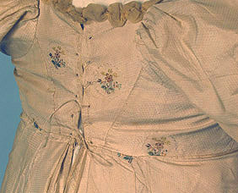
1808-11? Eyelets with lacing.

More images of this gown at: http://www.uvm.edu/~hag/regency/00-all-costume-fashion-images/1810-whitaker-composit.jpg

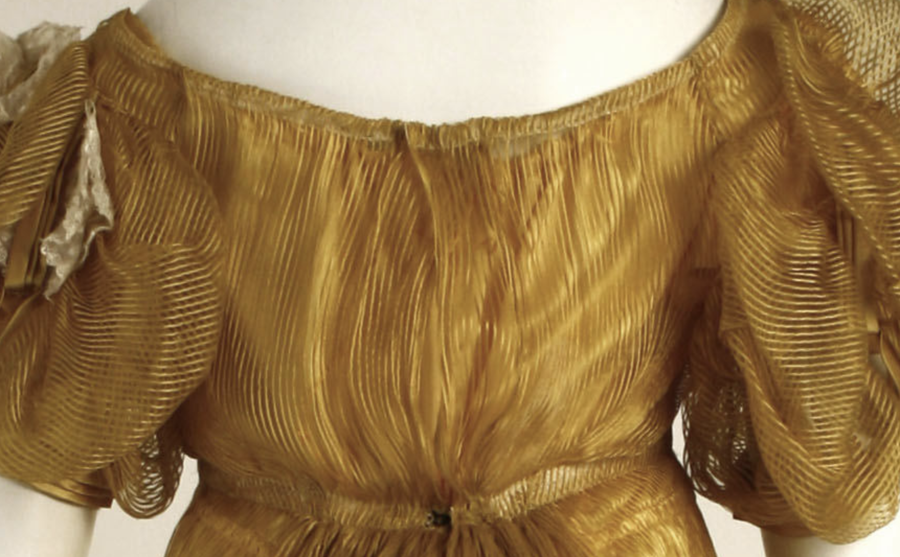
Metropolitan Museum of Art, (for more images search on 1970.281.3), possibly a hook at neckline and waist but more probably ties. The extra bit of fabric in the back is drawn in (though here it looks like they mounted it by crossing the back pieces over and pinning). This drawn-in back is pretty common esp. in these evening gowns.
https://www.metmuseum.org/art/collection/search/107942

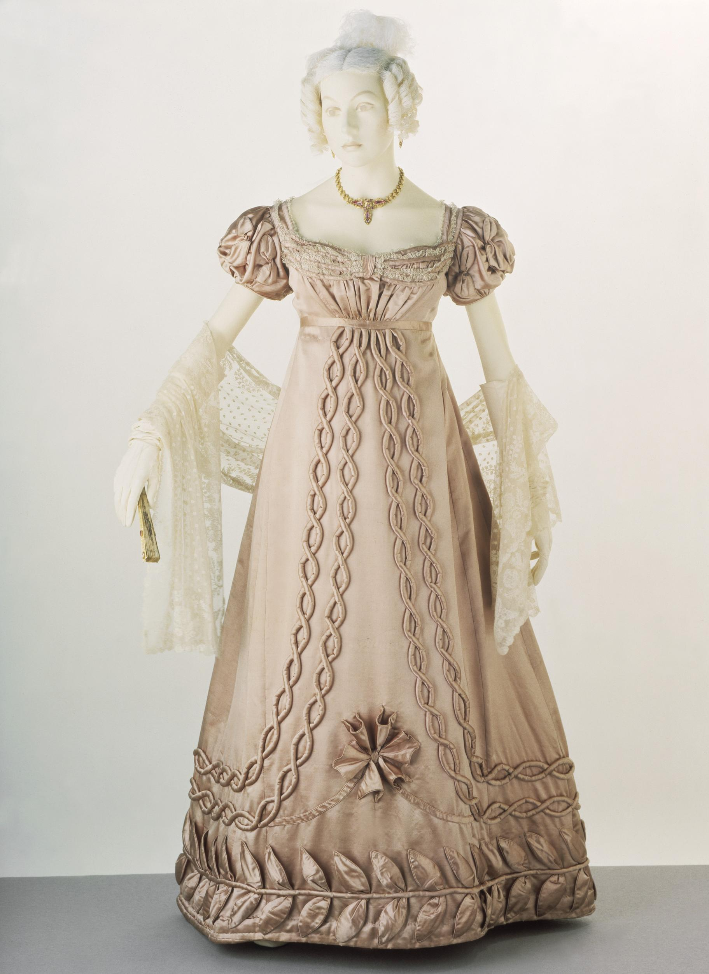
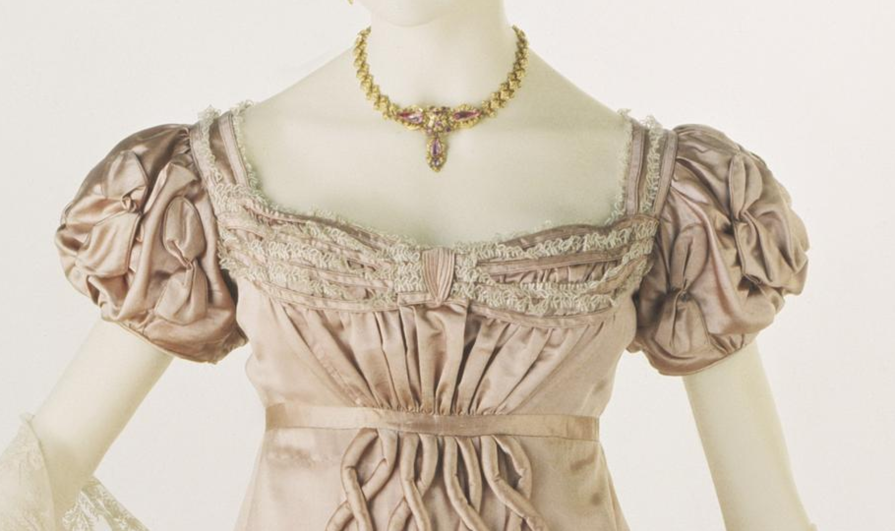
T.156-1962 Victoria and Albert Museum. One of my absolute favorites! Note the more ornate bodice and sleeves but the decoration at the hem is more ornate than the blue gown and the skirt is wider, thus the later date. According to the description it fastens with hooks and eyes. (No back view).
https://collections.vam.ac.uk/item/O74454/evening-dress-unknown/

Descriptions are unsatisfying. Even my “go to” Ackermann’s disappoints. You start to see mentions of back closures after 1815 but they describe them as “fastens behind”—well, yes, but tell me how! Finally, in January 1819 we find a dinner gown made of merino that “fastens behind with small grey silk buttons.”

So, given that I think (think!) the blue gown is slightly before 1819, I’m inclined to believe it did not button up the back.

Hope Greenberg, 7-22-2019

