Niche separation among sulfur-oxidizing bacterial populations in cave streams

Jennifer L. Macalady¹*
Sharmishtha Dattagupta¹
Irene Schaperdoth¹
Daniel S. Jones¹
Greg K. Druschel²
Danielle Eastman²

¹Department of Geosciences, Pennsylvania State University, University Park, PA 16802 USA
²Department of Geology, University of Vermont, Burlington, VT 05405

*Corresponding author. Mailing address: Geosciences Department, Pennsylvania State University, University Park, PA 16802. Phone: (814) 865-6330. Fax: (814) 863-7823. E-mail: jmacalad@geosc.psu.edu.

Keywords
Frasassi cave, Epsilonproteobacteria, Thiovirga, Beggiatoa, Thiothrix, sulfur oxidation, microelectrode voltammetry

Summary
The large, sulfidic Frasassi cave system affords a unique opportunity to investigate niche relationships among sulfur-oxidizing bacteria, including epsilonproteobacterial clades with no cultivated representatives. Oxygen and sulfide concentrations within the cave waters range over more than two orders of magnitude as a result of seasonally and spatially variable dilution of the sulfidic groundwater aquifer. Full cycle rRNA methods were used to quantify dominant populations in biofilms collected in both diluted and undiluted zones. Sulfide concentration profiles within biofilms were obtained in situ using microelectrode voltammetry. Populations present in rock-attached streamers showed a strong dependence on the sulfide/oxygen supply ratio of the bulk water (R = 0.97, p < 0.0001). Filamentous Epsilonproteobacteria dominated at high sulfide to oxygen ratios (>150), whereas Thiothrix dominated at low ratios (<75). In contrast, biofilms at the sediment-water interface were dominated by Beggiatoa regardless of sulfide and oxygen concentrations or supply ratio. Microelectrode sulfide measurements revealed sub-mm scale variations as large as those among sampling sites, but the variability in chemistry at small spatial scales did not result in mixing of the main biofilm populations. Our results highlight the versatility and ecological success of Beggiatoa in diffusion-controlled niches, and demonstrate that high sulfide/oxygen ratios in turbulent water are important for the growth of filamentous Epsilonproteobacteria.
The Frasassi cave system hosts a rich, sulfur-based lithoautotrophic microbial ecosystem (Sarbu et al., 2000; Macalady et al., 2006; Jones et al., 2007; Macalady et al., 2007). Previous studies of the geochemistry of the cave waters has revealed that they are mixtures of slightly salty, sulfidic groundwater diluted 10-60% by oxygen-rich, downward-percolating meteoric water (Galdenzi and Cocchioni, 2007). Initial observations of the abundant biofilms in cave streams and pools suggested that they respond dynamically to seasonal and episodic hydrologic changes. In particular we noted that changes in specific conductivity (tracking freshwater dilution) and water flow characteristics correspond with morphological differences in the biofilms. These initial observations motivated a systematic, multi-year study of the geochemistry and population structure of biofilms collected from cave waters with a wide range of hydrological and geochemical characteristics. The goal of the study was to identify environmental factors controlling competition among the biofilm-forming microorganisms. Unraveling the effects of changing hydrologic conditions is not trivial because both dilution and changes in water flow rates have multiple effects relevant to microbial metabolism. The input of meteoric water increases water depth and flow rates, dilutes dissolved species in the sulfidic aquifer, and adds dissolved oxygen. Water flow conditions that increase turbulence also increase sulfide degassing from the water and oxygen transport into the water from the oxygenated cave air. We found that sulfide/oxygen ratios and physical water flow characteristics are both important for determining the distributions of sulfur-oxidizing groups.

Results and Discussion
Field observations and geochemistry
Two common biofilm morphologies were observed in collections from within the cave system over a 3-year period (Fig. 1). Microbial streamers 1 to 5 mm thick were attached to rocks in quickly flowing or turbulent water (Supplementary Fig. 1 upper panel). Sediment surface biofilms < 1 mm thick were present in eddies or stream reaches with slower flow, at the interface between the water column and fine gray sediment (Supplementary Fig. 1 lower panel). At many sample sites, we observed that the two biofilm types coexisted in a patchwork corresponding to spatial variations in water flow characteristics. All of the biofilms contained abundant extracellular elemental sulfur particles, as evidenced by observations under phase contrast microscopy and by rapid dissolution of the particles in ethanol. Dissolved ion concentrations in the cave waters were strongly correlated with specific conductivity (0.89 < R < 0.98, p < 0.0001), consistent with previous work showing that the cave water geochemistry is controlled by mixing between slightly salty groundwater and downward percolating meteoric water (Galdenzi and Cocchioni, 2007). In contrast, dissolved oxygen concentrations were not correlated with specific conductivity (R = -0.39, p = 0.04). Total dissolved sulfide and oxygen concentrations for each biofilm sample collected in the study are plotted in Fig. 2.
In situ Au-amalgam microelectrode voltammetry was used to investigate the spatial variability of sulfide and other redox-active species within biofilms and the surrounding bulk water. Voltammetric signals are produced when dissolved or colloidal species interact with the working electrode surface. The electron flow resulting from redox half-reactions at the 100 μm diameter tip is registered as a current that is proportional to concentration (Taillefert and Rozan, 2002; Skoog et al., 2007). The gradients associated with microbial metabolism in biofilms are thus readily measured using this technique. Aqueous and colloidal species that are electroactive at Au-amalgam electrode surfaces include: H₂S, HS⁻, S₈, polysulfides, S₂O₃²⁻, S₄O₆²⁻, HSO₃⁻, Fe²⁺, Fe³⁺, FeS_{(aq)}, Mn²⁺, O₂, and H₂O₂ (Brendel and Luther, 1995; Dollhopf et al., 1999; Druschel et al., 2004; Druschel et al., 2003; Glazer et al., 2006; Glazer et al., 2004; Luther et al., 1991; Luther et al., 2001; Taillefert et al., 2000; Xu et al., 1998). Iron species were not detected (Fe²⁺ and Fe³⁺ < 5 μM, FeS < approximately 0.5 μM as an FeS monomer after Theberge and Luther, 1997; Luther et al., 2003; Roesler et al., 2007), consistent with total dissolved Fe concentrations < 0.1 uM measured using ICP-MS (see Experimental procedures). Oxygen concentrations were at or below 15 μM (detection limit) for all waters analyzed, as expected based on values obtained from spectrophotometric tests.

16S rDNA clone libraries
Clone libraries were constructed to investigate evolutionary relationships among the most abundant biofilm populations and to facilitate the evaluation of 16S rRNA probes. We recently described the phylogeny of clones from two Frasassi stream biofilms dominated by Beggiatoa species (Macalady et al., 2006). Four additional biofilms were selected for 16S rDNA cloning in order to capture a wide range of geochemical conditions and biofilm morphologies (Figure 2, cloned samples indicated by large circles). Libraries were constructed using bacteria-specific primers because FISH analyses indicated that the biofilms contained few archaea (described below). Sample FS06-12 was also cloned using universal primers, but only bacterial sequences were retrieved. The taxonomy of clones from each library is summarized in Fig. 4 and Supplementary Table 1.
Between 25 and 97% of the clones in each library were associated with known or putative sulfur oxidizing clades within gamma-, beta- and epsilonproteobacteria (Fig. 4). Gammaproteobacteria clones (Fig. 5) include representatives of three major sulfur-oxidizing groups, Beggiatoa (86-92% identity), Thiothrix (92-99% identity), and an unnamed clade containing "Thiobacillus baregensis" (94-99% identity) and the recently described sulfur-oxidizing lithoautotroph Thiovirga sulfuroxydans (86-93% identity) (Ito et al., 2005). Most betaproteobacterial clones were related to species of the sulfur-oxidizing genera Thiobacillus (> 97% identity) or Thiomonas (90-99% identity). Frasassi Beggiatoa clones were retrieved from four geochemically diverse sample locations (Fig. 4) and form a coherent clade most closely related to non-vacuolate, freshwater Beggiatoa strains (Ahmad et al., 2006).
Epsilonproteobacterial clones (Fig. 6) were phylogenetically related to Arcobacter species, and to members of the Sulfurovumales, Sulfuricurvales, and 1068 groups, which have few or no cultivated representatives. The majority were associated with the Sulfurovumales clade (Fig. 4) and were distantly related to cultivated strains including the named species Sulfurovum lithotrophicum (88-94 % identity). Sulfuricurvales group clones were rare and shared 96-97% identity with Sulfuricurvum kujiense. Frasassi clones in both Sulfurovumales and Sulfuricurvales were most closely related to clones from other sulfidic caves and springs (98-99% identity), including filaments from Lower Kane Cave Groups I and II (Engel et al., 2003). Arcobacter clones were diverse and only distantly related to the closest cultivated strains (91-94% identity). The 1068 group has no cultivated representatives and contains clones from deep subsurface igneous rocks, sulfidic caves and springs, groundwater and wetland plant rhizospheres. Frasassi clones associated with the 1068 group included phylotypes that shared less than 92% identity with each other, and there add significantly to the known diversity within this clade. There was support in both neighbor joining and maximum likelihood phylogenies for the placement of the 1068 group at the base of the epsilonproteobacteria (Fig. 6).

Biofilm morphology and population structure
Twenty-eight biofilms, including those selected for 16S rDNA cloning, were homogenized and examined using epifluorescence microscopy after fluorescence in situ hybridization (FISH) using the probes and hybridization conditions listed in Table 1. Probe BEG811 has been used previously to identify Beggiatoa populations in environmental samples from Frasassi (Macalady et al., 2006), and is identical to new Beggiatoa clones retrieved in this study (Fig. 5). Similarly, probe EP404 targeting epsilonproteobacteria matches Frasassi clones from this and all previous studies with no mismatches (n > 120), with the exception of 7 clones within the Arcobacter and 1068 groups (Fig. 6). The EP404 probe does not match any publicly available sequences outside the epsilonproteobacteria.
FISH experiments revealed three major biofilm types, as shown in Fig. 2. The dominant group in each biofilm sample accounted for more than 50% of the total DAPI cell area (Fig. 2, colored symbols) with one exception. Sediment surface biofilms (n = 15) were dominated by 5-8 um diameter Beggiatoa filaments with abundant large sulfur inclusions and gliding motility. Streamers (n = 13) were dominated either by 1.5 um diameter gammaproteobacterial filaments with holdfasts and sulfur inclusions (Thiothrix), or by filamentous epsilonproteobacteria with holdfasts and no sulfur inclusions (1-2.5 um diameter). Non-filamentous cells targeted by EP404 made up less than 5% of the EP404-positive cell area in each sample. As reported previously (Macalady et al., 2006), the 23S rDNA probe GAM42a produces no signal from Frasassi Beggiatoa filaments at 35 % formamide concentration. GAM42a-positive filaments with holdfasts and sulfur inclusions did not bind with probe EP404 or Delta495a, and were assumed to be members of the Thiothrix clade. Archaeal cells in the biofilms were rare or not detected using the probe ARC915. Consistent with this result, bacterial cell area measured using the EUBMIX probe was consistently within 15% of the area measured using the nucleic acid stain DAPI. Representative FISH photomicrographs of the three major biofilm types are shown in Supplementary Fig. 2.

Niches of sulfur-oxidizing populations
It is clear from Figure 2 that sulfide and oxygen concentrations exert an important control on competition among sulfur-oxidizing populations. Filamentous epsilonproteobacteria colonize waters with high sulfide and low oxygen, and Thiothrix colonize waters with low sulfide and high oxygen. A similar pattern was suggested by 16S rDNA clone frequencies in a study of Lower Kane Cave (Engel et al., 2004), but has not been demonstrated to our knowledge. Figure 2 also suggests that either sulfide or oxygen concentrations alone are poor predictors of biofilm compositions. All of the dominant sulfur-oxidizing populations tolerate very low oxygen concentrations (<5 uM). Furthermore, Beggiatoa-dominated biofilms colonize the entire range of sulfide and oxygen concentrations measured in the cave waters.
The role of sulfide and oxygen concentrations in determining the composition of the biofilms is most clearly demonstrated in Fig. 7, showing biofilm community composition plotted against sulfide/oxygen ratios. Probe EP404 was hybridized with all samples in order to provide a quantitative metric for biofilm composition. We observed a strong linear correlation between filamentous epsilonproteobacterial biomass and the sulfide/oxygen ratio of water hosting streamers (Fig. 7, R = 0.97, p < 0.0001). Correlations between epsilonproteobacterial biomass and either sulfide or oxygen concentrations alone were weaker, with R values of 0.82 (p = 0.002) and -0.80 (p = 0.003) respectively. Beggiatoa biofilms not included in the correlation had <20% filamentous Epsilonproteobacteria. Including Beggiatoa biofilms in the correlation resulted in a slightly lower R value (0.95).
In sharp contrast to streamer populations, Beggiatoa filaments colonized the entire range of sulfide, oxygen, and sulfide/oxygen ratios observed in the cave waters (Figs. 2 and 7). Consistent with this result, Beggiatoa biofilms were observed immediately adjacent to both Thiothrix and filamentous epsilonproteobacterial streamers in situ, always in less turbulent or more slowly flowing water. In the cave streams, turbulence increases sulfide degassing from the water and increases oxygen transport from the oxygenated cave air, so more turbulent water should have slightly lower sulfide and higher oxygen concentrations, and a lower sulfide/oxygen ratio. While changes in turbulence and water depth have the potential to alter gas exchange and therefore water chemistry, our data suggest that physical effects are more significant for microbial growth. Because Beggiatoa filaments lack holdfasts, they can be washed out by flows which are too strong to allow the accumulation of fine sediment. Likewise, non-motile Thiothrix or epsilonproteobacteria filaments may become buried below the zone where oxidants are available in stream reaches that are accumulating sediment.
Our results support the idea that morphological and behavioral adaptations to physical constraints are responsible for the separate niches colonized by large, filamentous bacteria (Schulz and Jorgensen, 2001; Preisler et al., 2007). As reported in other environments, Beggiatoa mats at Frasassi inhabit diffusion-controlled sediment niches, and can respond to changing geochemical conditions by gliding vertically in the sediment column. Sulfide concentration profiles through Beggiatoa mats reflect diffusion-controlled transport, although Frasassi sediments differ from typical marine or lacustrine sediments in that sulfide diffuses both from water above and sediment below the biofilms (Fig. 3). Non-motile filaments with holdfasts (Thiothrix, filamentous epsilonproteobacteria) colonized niches with strong currents and a relatively narrow supply ratio of turbulently mixed sulfide and oxygen. Interestingly, vacuolated marine Beggiatoa with holdfasts have recently been identified at cold seeps (Kalanetra et al., 2004). Frasassi clones are only distantly related (~88% identity) to the attached marine Beggiatoa species. Although the evolutionary origins of holdfasts in the attached marine Beggiatoa are still obscure, our results suggest that there could be strong selective pressure for Beggiatoa to develop holdfasts in the cave environment. They thrive across the full range of sulfide and oxygen concentrations we observed, and could theoretically harvest more of the available chemical energy if they could colonize turbulent water.

Among streamer populations, we observed a strong niche separation between Thiothrix and epsilonproteobacteria based on sulfide/oxygen ratios. Microbial activity within biofilms is expected to modify sulfide/oxygen ratios on a sub-mm scale due to oxygen consumption at the biofilm surface and sulfide production from sulfate reduction or sulfur disproportionation deeper in the biofilm. High sulfate concentrations (1-3 mM), the presence of deltaproteobacterial cells detected using probes Delta495a and SRB385 (data not shown), and abundant clones from sulfate reducing and sulfur disproportionating clades (Fig. 4, Supplementary Table 1) strongly suggest that sulfide is produced within Frasassi stream biofilms. Sulfide concentrations within streamers based on microelectrode voltammetry were spatially variable, consistent with the fact that they are floating free in turbulent water currents. Nonetheless sulfide concentrations varied several-fold within individual biofilms, typically reaching the highest values in the center (Fig. 3). Despite the likelihood of radically increasing sulfide/oxygen ratios with depth into the biofilms, we found no evidence for Thiothrix streamers containing significant biomass of filamentous epsilonproteobacteria. Thiothrix-dominated biofilms contained at most 3.6 area % epsilonproteobacterial filaments.
Although much work remains to be done on the physiology of Frasassi biofilm populations, we can speculate about the mechanisms responsible for niche separation between Thiothrix and filamentous epsilonproteobacteria based on our current data. Whereas both groups tolerate low oxygen (< 3 uM) and sulfide (< 50 uM) concentrations, Thiothrix-dominated biofilms do not occur at sulfide concentrations above 210 uM, suggesting that sulfide toxicity may play a role in excluding them from high-sulfide environments. The absence of epsilonproteobacterial filaments in waters with oxygen concentrations above 3 uM is also striking, suggesting that oxygen toxicity may be limiting the epsilonproteobacteria. Functional genomic studies provide some evidence that epsilonproteobacteria may be uniquely sensitive to oxygen compared to other proteobacteria inhabiting sulfidic and microoxic environments due to electron transport proteins with the potential to produce mM levels of superoxide anions during oxidative stress (St. Maurice et al., 2007). Further work will be required to determine whether this explanation is generalizable to filamentous epsilonproteobacteria common in the cave environment. Filamentous epsilonproteobacteria are also apparently unable to store elemental sulfur intracellularly, an attribute that may limit their ability to consume toxic levels of oxygen in the absence of high sulfide concentrations.
The extremely robust positive correlation between sulfide/oxygen ratios and the biomass of filamentous epsilonproteobacteria strongly suggests that there is selection in the cave environment based on this niche dimension. We cannot rule out the possibility that other factors are also partially responsible for the niche separation between Thiothrix and filamentous epsilonproteobacteria. Since waters with the highest sulfide/oxygen ratios in the study are also generally the least diluted with meteoric water, other aspects of the water chemistry may be important. For example, the least diluted waters (e.g. Pozzo di Cristalli, Fissure Spring) typically contain 10-20% higher dissolved inorganic carbon than the most diluted waters (e.g. Ramo Sulfureo, Cave Spring) (Galdenzi and Cocchioni, 2007). Adaptations to changing water chemistry such as facultative anaerobic or heterotrophic metabolism, or differing strategies for nutrient uptake, could also potentially play a role.
Filamentous epsilonproteobacteria have previously been described from Lower Kane Cave (LKC), Wyoming (Engel et al., 2003). The LKC Epsilonproteobacterial filaments are associated with 2 major clades, each incorporating bacterial sequences with approximately 85% nucleotide identity. The taxonomy of the epsilonproteobacteria is currently in revision due to a large number of unaffiliated environmental clones. For the purposes of this study, the two clades containing LKC filament groups are designated according the Hugenholtz taxonomy employed in the greengenes online workbench (DeSantis et al., 2006). Both clades fall within the provisional Thiovulgaceae family proposed by Campbell et al. (2006). Sulfuricurvales (includes LKC group I) and Sulfurovumales (includes LKC group II) are both present in Frasassi clone libraries (Fig. 4). Frasassi sequences differ significantly from LKC clones, and do not hybridize with previously published probes LKC59 and LKC1006 targeting environmental groups (Engel et al., 2003). LKC waters have an order of magnitude lower sulfide concentrations than those hosting filamentous epsilonproteobacteria at Frasassi (Fig. 2). Nonetheless, Fig. 7 shows that the LKC biofilms colonize waters within the filamentous epsilonproteobacterial niche defined by high sulfide/oxygen supply ratios. As in Lower Kane Cave, no sulfur inclusions were observed in epsilonproteobacterial filaments, suggesting that this is a consistent physiological attribute. The niches of Sulfuricurvales- and Sulfurovumales-group epsilonproteobacterial filaments with respect to sulfide, oxygen, and other factors that may influence their growth remain to be investigated in future work.

Experimental procedures
Field site, sample collection and geochemistry
The Grotta Grande del Vento-Grotta del Fiume (Frasassi) cave system is forming in Jurassic limestone in the Appennine Mountains of the Marches Region, Central Italy. The waters of the cave system are near-neutral (pH 6.9-7.4) and have specific conductivities ranging from 1200 - 3500 uS/cm, or roughly 4-5% of average marine salinity. The major ions are Na⁺, Ca²⁺, Cl⁻, HCO₃⁻ and SO₄²⁻ (Galdenzi and Cocchioni, 2007). Electron donors and acceptors other than oxygen and sulfur species are present in low concentrations with the exception of ammonium (30-175 uM). Dissolved iron and manganese concentrations are below 0.1 uM and .04 uM respectively. Nitrate and nitrite have not been detected at any sample site (< 0.7 and < 2.0 uM respectively). Organic carbon concentrations range between 0.16 and 4.5 mg/L. Dissolved methane is present in trace amounts (Macalady et al., unpublished data).
Biofilms from cave springs and streams were collected at water depths ranging from 5 to 40 cm at sample locations shown in Figure 1 in May (wet season) and August (dry season) in 2005, 2006 and 2007 . Samples were analyzed using full-cycle rRNA methods as described in Macalady et al. 2006. Briefly, biofilms were harvested using sterile plastic transfer pipettes into sterile tubes, stored on ice, and processed within 4-6 hours of collection. Subsamples for FISH were fixed in 4% paraformaldehyde and stored at -20 °C. Samples for clone library construction were preserved in 4:1 (volume) RNAlater (Ambion).Water samples were collected in acid-washed polypropylene bottles and stored at 4 °C until analyzed. Conductivity, pH, and temperature of the waters were measured in the field using probes (WTW, Weilheim, Germany). Dissolved sulfide (methylene blue method) and oxygen (indigo carmine method) concentrations were measured in the field using a portable spectrophotometer according to the manufacturer’s instructions (Hach Co., Loveland, CO). Duplicate sulfide analyses were within 1%. Replicate oxygen analyses were within 20%. Nitrate, nitrite, ammonium and sulfate were measured at the Osservatorio Geologico di Coldigioco Geomicrobiology Lab using a portable spectrophotometer within 12 hours of collection according to the manufacturer’s instructions (Hach Co., Loveland CO).

Microelectrode voltammetry
Voltammetric analyses in the field were accomplished using a DLK-60 potentiostat powered with a 12V battery and controlled with a GETAC ruggedized computer. To protect the electrochemical system from drip waters and high humidity, the potentiostat was contained inside a storm case© containing dryrite humidity sponges and which was modified with rubber stripping to allow the communication ribbon cable and electrode cables to go outside the case while keeping the inside sealed. Electrodes were constructed after the methods of Brendel and Luther (1995). Briefly, 100 μm diameter 99.99% pure gold wire was soldered to a copper lead wire and sealed inside a 5 mm glass tube drawn to a 500 mm diameter tip. The electrodes were polished with successive diamond pastes (15, 6, 1, and ¼ μm), plated with a Hg thin film from a 0.01 M Hg(NO₃)₂ 0.1 M HNO₃ solution by applying a potential of 0.1 V (vs. Ag/AgCl) and finally polarized at -9.0 V in a 1.0 M NaOH solution for 60 seconds to fully amalgamate the Hg and Au. Ag/AgCl reference electrodes and Pt counter electrodes were also constructed in the lab by soldering Ag or Pt wire to the copper lead and encasing the connection in epoxy with the respective wires extending approximately 1 cm from the terminus. Ag/AgCl reference electrodes are plated with AgCl by applying a potential of +9.0 V to the electrode in saturated KCl for 90 seconds and inserting the wire inside a Teflon heat shrink tube with a vycor frit on one end.
Voltammetric analyses in the cave system involved placing working (Au-amalgam) electrodes into a narishege 3-axis micromanipulator held above each biofilm sampling site with a 2-arm magnetic base on a steel plate. The reference and counter electrodes were placed in the flowing water near the biofilm. The working electrode was lowered to the air-water interface, then to the biofilm-water interface and subsequently lowered in increments to profile the biofilm. Voltammetric scans utilized both cyclic voltammetry between -0.1 and -1.8 V (vs. Ag/AgCl) at scan rates from 200 to 2000 mV/second with a 2 second conditioning step, and square wave voltammetry between -0.1 and -1.8 V (vs. Ag/AgCl) at scan rates from 200-1000 mV/sec, with a pulse height of 25 mV. Analyses were done at least in sets of ten sequential scans at each sampling point in space, with the first 3 scans discarded as sulfide at these levels can plate to the Au-amalgam surface without any applied potential, as it requires 2-3 scans to clean this excess sulfide off before reproducible results can be obtained.

Clone library construction
Environmental DNA was obtained using phenol-chloroform extraction as described in (Bond et al., 2000) using 1x Buffer A instead of PBS for the first washing step. Small subunit ribosomal RNA genes were amplified by PCR from the bulk environmental DNA. Libraries were constructed from each sample using the bacteria-specific primer set 27f and 1492r. Each 50 μL reaction mixture contained: environmental DNA template, 1.25 U ExTaq DNA polymerase (TaKaRa Bio Inc., Shiga, Japan), 0.2 mM each dNTPs, 1X PCR buffer, 0.2 μM 1492r universal reverse primer (5’-GGT TAC CTT GTT ACG ACT T-3’) and 0.2 μM 27f primer (5’-AGA GTT TGA TCC TGG CTC AG-3’). A universal library was constructed from sample FS06-12 using universal forward primer 533f (5'- GTG CCA GCC GCC GCG GTA A -3') and 1492r. Thermal cycling was as follows: initial denaturation 5 min at 94 °C, 25 cycles of 94 °C for 1 min, 50 °C for 25 sec and 72 °C for 2 min followed by a final elongation at 72 °C for 20 min. PCR products were cloned into the pCR4-TOPO plasmid and used to transform chemically competent OneShot MACH1 T1® E. coli cells as specified by the manufacturer (TOPO TA cloning kit, Invitrogen, Carlsbad, CA). Colonies containing inserts were isolated by streak-plating onto LB agar containing 50 μg/mL kanamycin. Plasmid inserts were screened using colony PCR with M13 primers (5'-CAGGAAACAGCTATGAC-3' and 5'-GTAAAACGACGGCCAG-3'). Colony PCR products of the correct size were purified using the QIAquick PCR purification kit (Qiagen Inc., USA) following the manufacturer's instructions. Full length sequences for between 70 and 80 clones from each bacterial library were obtained, in addition to 60 sequences from the universal library constructed from sample FS06-12.

Sequencing and phylogenetic analysis
Clones were sequenced at the Penn State University Biotechnology Center using T3 and T7 plasmid-specific primers. Sequences were assembled with Phred base calling using CodonCode Aligner v.1.2.4 (CodonCode Corp.) and manually checked for ambiguities. The nearly full-length gene sequences were compared against sequences in public databases using BLAST (Altschul et al., 1990) and submitted to the online analyses CHIMERA_CHECK v.2.7 (Cole et al., 2003) and Bellerophon 3 (Huber et al., 2004). Putative chimeras were excluded from subsequent analyses. Non-chimeric sequences were aligned using the NAST aligner (DeSantis et al., 2006) , added to an existing alignment containing >150,000 nearly full length bacterial sequences in ARB (Ludwig et al., 2004), and manually refined. Alignments were minimized using the Lane mask (1286 nucleotide positions). Phylogenetic trees were computed using neighbor joining (general time reversible model) with 1000 bootstrap replicates. Neighbor joining trees were compared with maximum likelihood trees (general time reversible model, site specific rates and estimated base frequencies). Both analyses were computed using PAUP* 4.0b10(Swofford, 2000).

Light Microscopy
Light microscopy was performed on live samples within 4 hours of collection at the Osservatorio Geologico di Coldigioco Geomicrobiology Lab.

Probe design and fluorescence in situ hybridization (FISH)
Probes were checked against all publicly available sequences using megaBLAST searches of the nonredundant databases at NCBI. Samples and isolates grown in the lab for use as control cells were fixed in 3 volumes of freshly prepared 4% (w/v) paraformaldehyde in 1X PBS for 3-4 hours and stored in 1:1 PBS/ethanol solution at –20°C. FISH experiments were carried out as described in Hugenholtz et al. 2001 using the probes listed in Table 1. Briefly, fixed samples (homogenized by vortexing and pipetting) and control cells were applied to multiwell, Teflon-coated glass slides, air-dried, and dehydrated by successive immersion in 50%, 80% and 90% ethanol washes (3 min. each). Hybridizations were carried out in 8 uL/well of buffer containing 0.9 M NaCl, 20 mM Tris/HCl pH 7.4, 0.01% sodium dodecyl sulfate (SDS), 25-50 ng of each oligonucleotide probe, and formamide concentrations given in Table 1. Oligonucleotide probes were synthesized and labeled at the 5’ ends with fluorescent dyes (Cy3, Cy5, FLC) at Sigma-Genosys (USA). Slides were incubated for 2 hours at 46 °C in chambers equilibrated with the hybridization buffer, then immersed in wash buffer (20 mM Tris/HCl pH 7.4, 0.01% SDS, 5 mM EDTA and NaCl concentrations determined by the formula of Lathe (Lathe, 1985)) for 15 min. at 48 °C. Slides were then rinsed with distilled water, air-dried, counterstained with 4’,6’-diamidino-2-phenylindole (DAPI), mounted with Vectashield (Vectashield Laboratories, USA) and viewed on a Nikon E800 epifluorescence microscope. Images were collected and analyzed using NIS Elements AR 2.30, Hotfix (Build 312) image analysis software. The object count tool was used to measure areas covered by cells hybridizing with specific probes. Ten images were collected for each sample, taking care to represent the sample variability, and a total DAPI-stained area of approximately 3*10⁴ μm² (equivalent to 5*10⁴ E. coli cells) was analyzed for quantitation.

Statistical analyses
The program MINITAB (Minitab Inc., State College, PA, USA) was used for all statistical analyses. A two-sided Student’s t-test was used to compare sulfide/oxygen ratios associated with Thiothrix and epsilonproteobacteria, and correlations between parameters were analyzed using the Pearson method.

Nucleotide sequence accession numbers
The 16S rRNA gene sequences determined in this study have been assigned to GenBank accession numbers EF467442-EF467519 and EU101023-EU101289.

Acknowledgements
We thank A. Montanari for logistical support and the use of facilities and laboratory space at the Osservatorio Geologico di Coldigioco (Italy), S. Mariani, S. Galdenzi, S. Cerioni, P. D’Eugenio, M. Mainiero, S. Recanatini, R. Hegemann, H. Albrecht, K. Freeman and R. Grymes for field assistance. We also thank B. Thomas and J. Moore for water analyses, and L. Albertson and T. Stoffer for laboratory assistance. D. E. contributed to this research as an undergraduate student and was supported in 2006 by a Barrett Foundation scholarship. This work was supported by grants to J.L.M. from the Biogeosciences Program of the National Science Foundation (EAR 0311854 and EAR 0527046) and NASA NAI (Penn State Astrobiology Research Center). G.K.D. gratefully acknowledges support from the American Chemical Society Petroleum Research Fund (43356-GB2) and NSF-EPSCoR-VT (EPS 0236976).
Table 1. Oligonucleotide probes used in this study.

Probe | Target group | Sequence (5’ → 3’) | % form-amide | Target site | Reference
§EUB338 | most Bacteria | GCT GCC TCC CGT AGG AGT | 0-50% | 16S (338-355) | (Amann et al., 1990)
§EUB338-II | Planctomycetales | GCA GCC ACC CGT AGG TGT | 0-50% | 16S (338-355) | (Daims et al., 1999)
§EUB338-III | Verrucomicrobiales | GCT GCC ACC CGT AGG TGT | 0-50% | 16S (338-355) | (Daims et al., 1999)
ARCH915 | Archaea | GTG CTC CCC CGC CAA TTC CT | 20% | 16S (915-934) | (Stahl and Amann, 1991)
GAM42a | γ-Proteobacteria, including Frasassi Thiothrix clones | GCC TTC CCA CAT CGT TT | 35% | 23S (1027-1043) | (Manz et al., 1992)
cGAM42a | competitor | GCC TTC CCA CTT CGT TT | 35% | 23S (1027-1043) | (Manz et al., 1992)
DELTA495a | most δ-proteobacteria, some Gemmatimonas group | AGT TAG CCG GTG CTT CCT | 45% | 16S (495-512) | (Macalady et al., 2006)
cDELTA495a | competitor | AGT TAG CCG GTG CTT CTT | 45% | 16S (495-512) | (Macalady et al., 2006)
SRB385 | some δ-proteobacteria, some Actinobacteria and Gemmatimonas group | CGG CGT CGC TGC GTC AGG | 35% | 16S (385-402) | (Amann et al., 1990)
EP404 | ε-proteobacteria | AAA KGY GTC ATC CTC CA | 30% | 16S (404-420) | (Macalady et al., 2006)
EP404mis | negative control for EP404 | AAA KGY GTC TTC CTC CA | 30% | 16S (404-420) | (Macalady et al., 2006)
BEG811 | Frasassi Beggiatoa clade | CCT AAA CGA TGG GAA CTA | 35% | 16S (811-828) | (Macalady et al., 2006)

§ combined in equimolar amounts to make EUBMIX

FIGURE CAPTIONS

Fig. 1.
Map of the Frasassi cave system showing sample locations (open circles). Major named caves are shown in different shades of gray. Topographic lines and elevations in meters refer to the surface topography. Base map courtesy of S. Mariani.

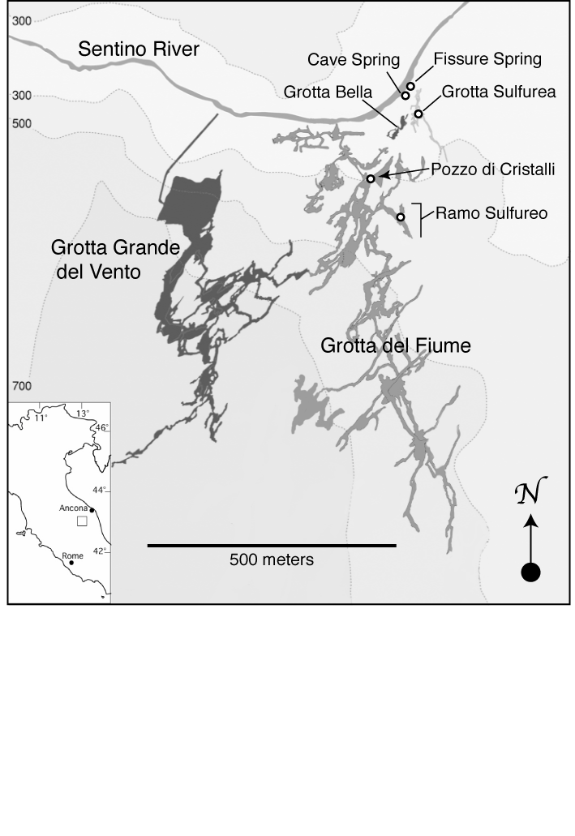
Fig. 2
Dissolved oxygen and total sulfide concentrations for waters hosting Frasassi biofilm samples. Concentration field for Lower Kane Cave (Engel et al. 2003) is shown in gray for comparison. Symbols are colored if more than 50% of the biofilm cell area is composed of a single population or group based on FISH. Colored boxes with error bars show the mean ± 1 standard deviation for each major biofilm type. Samples analyzed by 16S rDNA cloning are circled. The open diamond symbol represents a filamentous Epsilonproteobacterial biofilm from Lower Kane Cave reported in Engel et al. 2004.

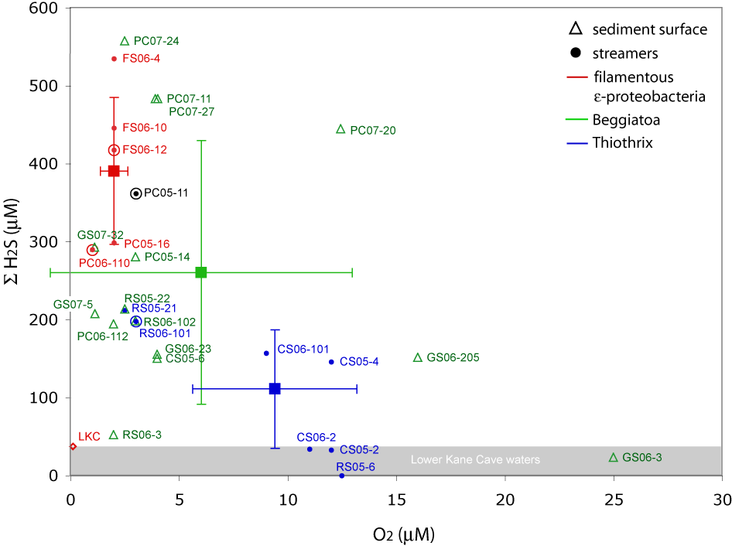

Fig. 3.
Vertical sulfide concentration profiles measured using in situ Au-amalgam microelectrode voltammetry. Zero depth corresponds to the upper surface of the biofilms. Dissolved oxygen concentrations were <15 uM (detection limit) for all points. Marine sediment curve is from a Beggiatoa mat described in (Jorgensen and Revsbech, 1983).

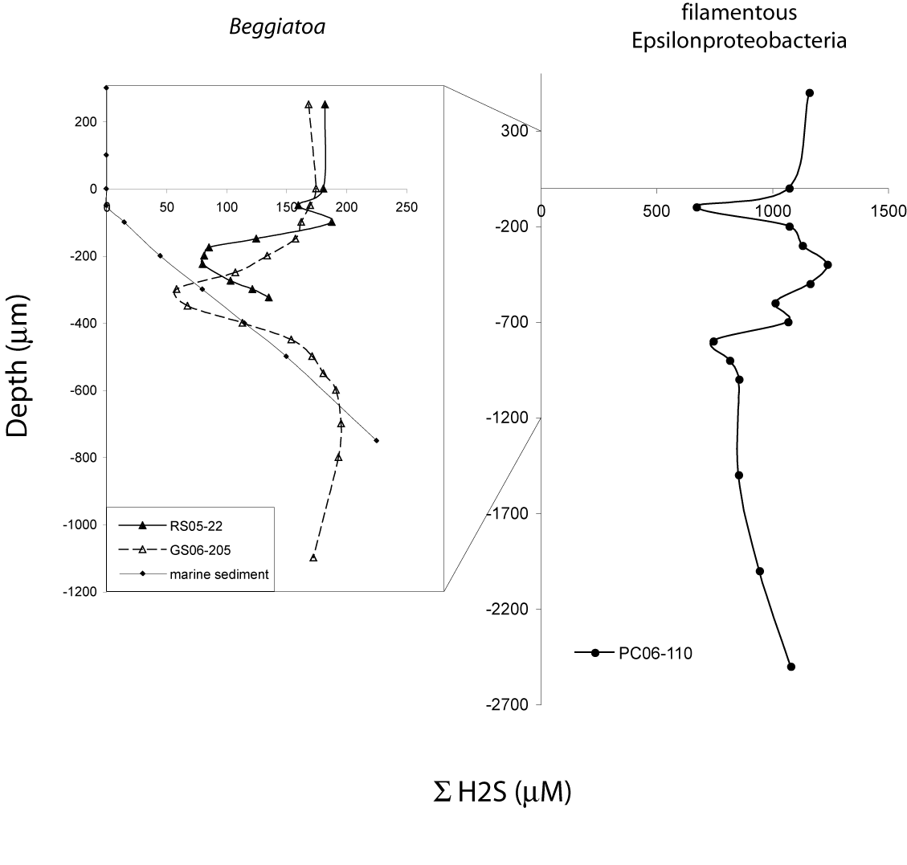

Fig. 4.
Taxonomy of 16S rDNA clones in Frasassi stream biofilms. Colored wedges represent known or putative sulfur oxidizing clades, with Gamma(beta)proteobacteria in blue/green tones and Epsilonproteobacteria in red/brown tones. Deltaproteobacteria associated with sulfate-reducing clades are shown in black. White wedges include all other clones (see Supplementary Table 1). GS02-zEL and GS02-WM clone libraries are described in Macalady et al. 2006.

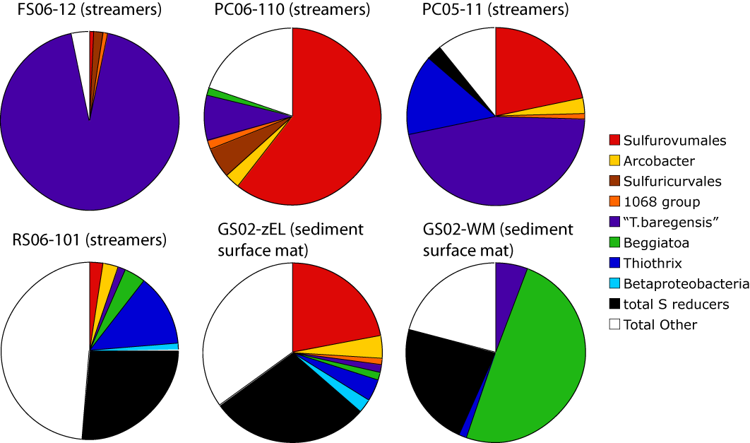

Fig. 5.
Neighbor-joining phylogenetic tree showing Gamma(beta)proteobacteria. Frasassi clones are shown in bold followed by the number of clones represented in each phylotype. Neighbor joining bootstrap values > 50% are shown. Filled circles indicate that the node is also present in the maximum likelihood phylogeny. Sequences identical to the probe BEG811 are indicated by the dashed line.

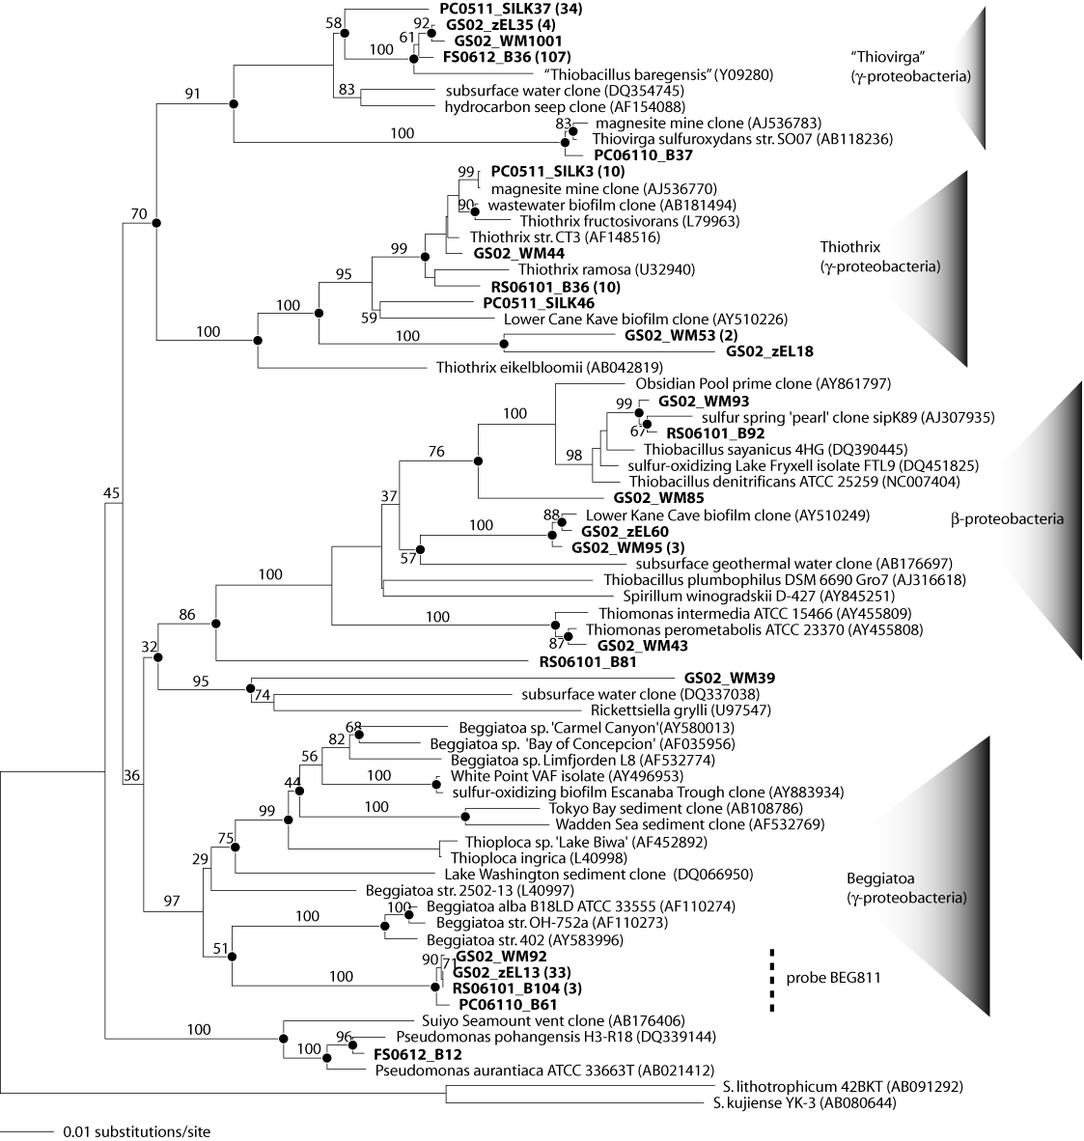

Fig. 6.
Neighbor-joining phylogenetic tree showing Epsilonproteobacteria. Frasassi clones are shown in bold followed by the number of clones represented in each phylotype. Neighbor joining bootstrap values > 50% are shown. Filled circles indicate that the node is also present in the maximum likelihood phylogeny. Sequences which hybridize with probe EP404 are indicated by the dashed line.

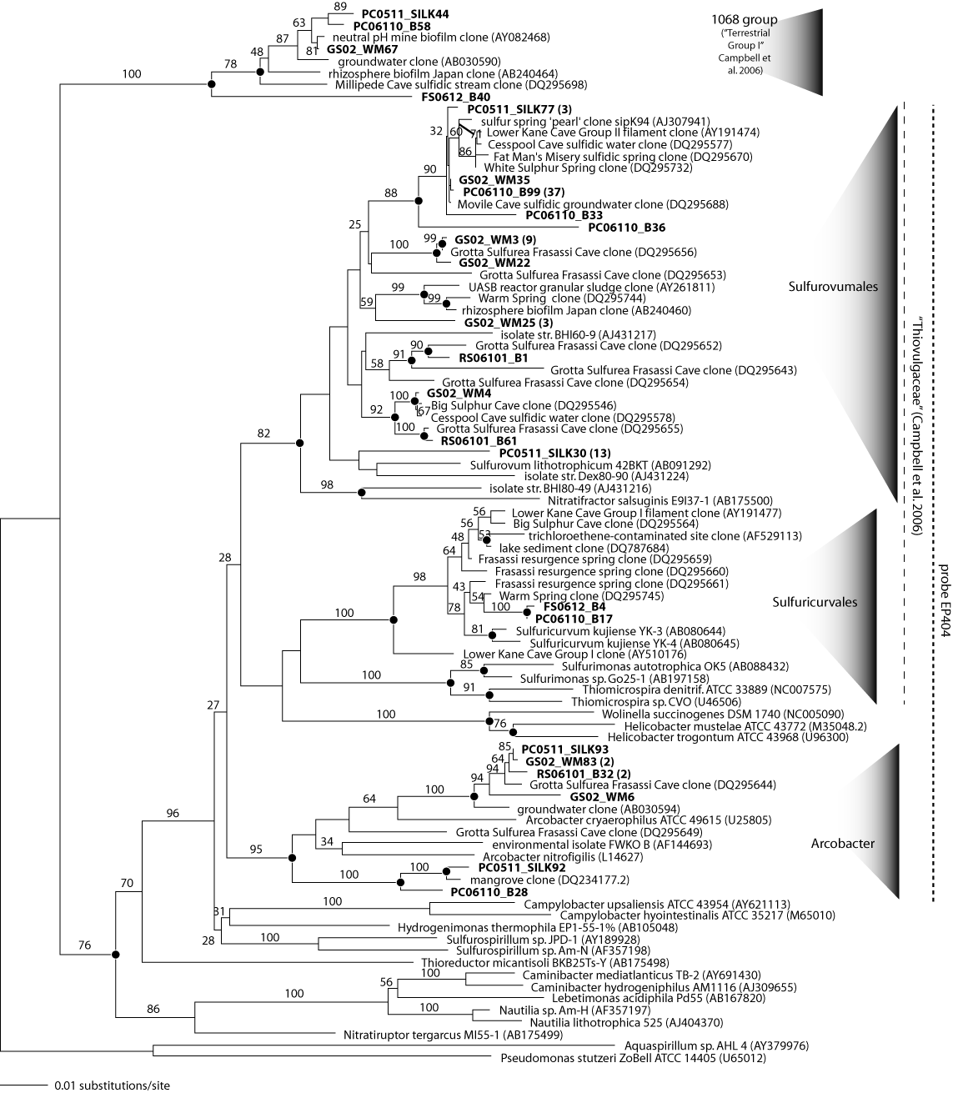

Fig. 7.
Sulfide/oxygen ratios for Frasassi biofilms analyzed using FISH. The upper panel shows a linear correlation (p < 0.0001) between sulfide/oxygen ratio and the microbial composition of streamers. The open diamond (not included in correlation) represents a biofilm from Lower Kane Cave (Engel et al. 2004) and assumes 0.2 uM O₂ (detection limit). The dashed arrow shows how the sulfide/oxygen ratio for the sample would change assuming an O₂ concentration of 0.1 uM. The lower panel shows the distribution of biofilm types compared based on sulfide/oxygen ratios. Colored boxes and associated bars show the average ± 1 standard deviation for each major biofilm type. Mean sulfide/oxygen ratios associated with Thiothrix and filamentous Epsilonproteobacteria habitats are significantly different (p = 0.0004).

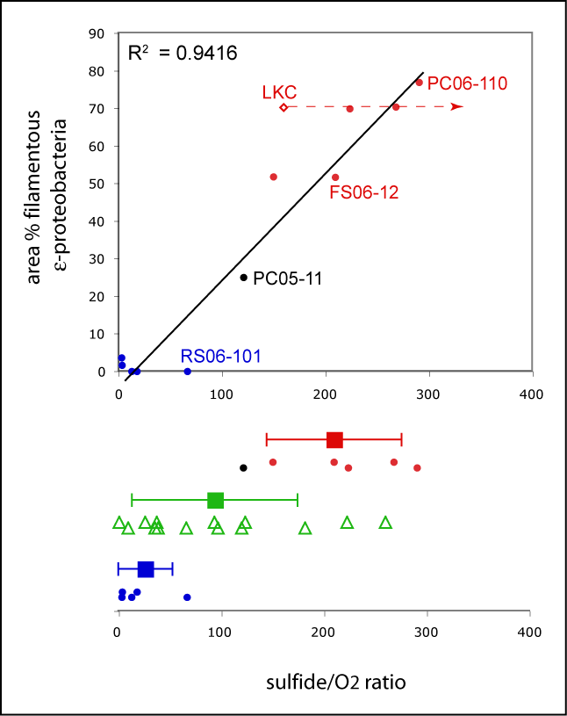

Supplementary Fig. 1.
Field photos showing streamer (upper) and sediment surface (lower) biofilms. Upper panel shows voltammetry working microelectrode in streamer sample PC06-110. Lower panel shows sediment surface biofilm GS06-205 after microelectrode voltammetry and sample collection. Fine gray sediment is exposed where sediment surface mat has been removed.

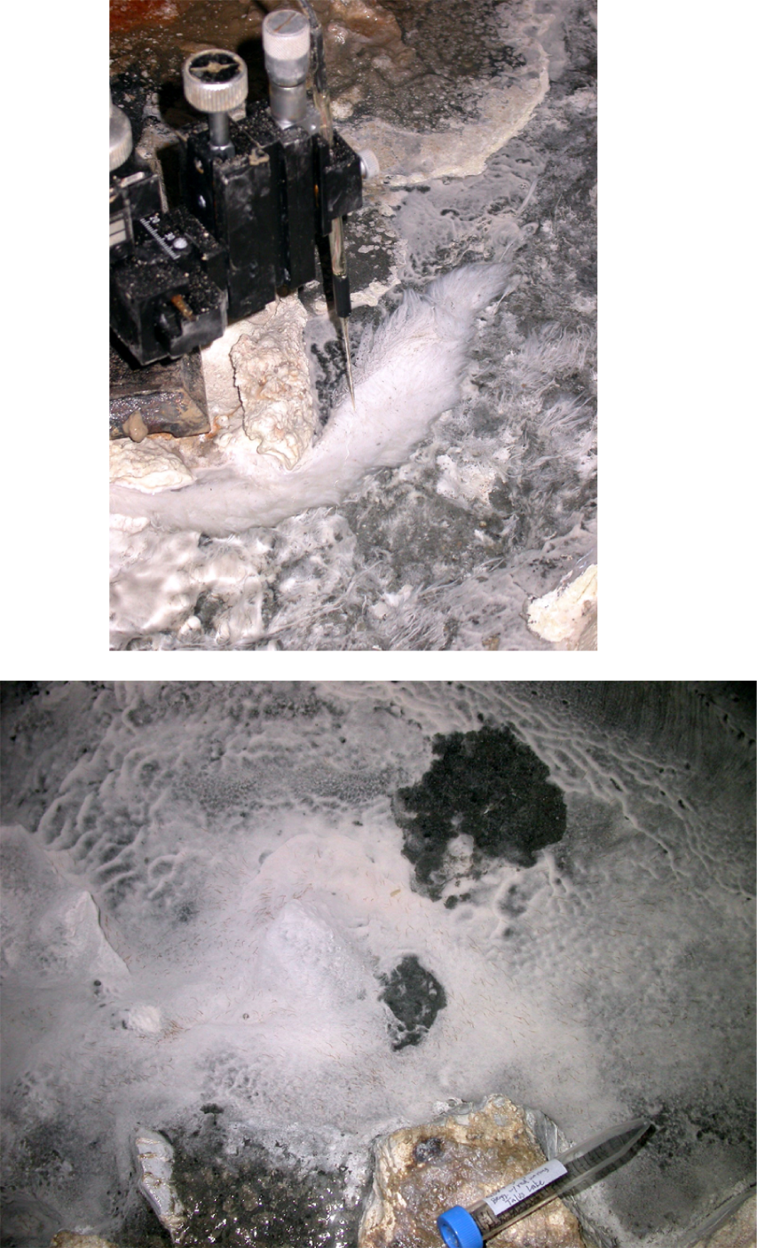
Supplementary Fig. 2.
Representative FISH photomicrographs for three major biofilm types. Blue indicates fluorescence from the nucleic acid stain DAPI. Green indicates fluorescence from the domain-specific bacterial probe EUBMIX. Red indicates fluorescence from group-specific bacterial probes as follows: EP404 (upper), Beg811 (middle), GAM42a (lower). Scale bars are 10 um.

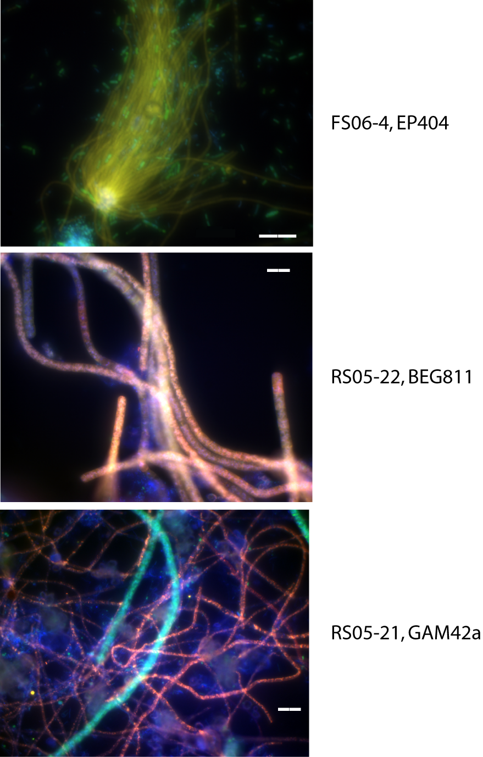
REFERENCES

Ahmad, A., Kalanetra, K.M., and Nelson, D.C. (2006) Cultivated Beggiatoa spp. define the phylogenetic root of morphologically diverse, noncultured, vacuolate sulfur bacteria. Canadian Journal of Microbiology 52: 591-598.
Amann, R., Binder, B.J., Olson, R.J., Chisholm, S.W., Devereux, R., and Stahl, D.A. (1990) Combination of 16S rRNA-targeted oligonucleotide probes with flow cytometry for analyzing mixed microbial populations. Applied and Environmental Microbiology 56: 1919-1925.
Bond, P.L., Smriga, S.P., and Banfield, J.F. (2000) Phylogeny of microorganisms populating a thick, subaerial, predominantly lithotrophic biofilm at an extreme acid mine drainage site. Applied And Environmental Microbiology 66: 3842-3849.
Cole, J.R., Chai, B., Marsh, T.L., Farris, R.J., Wang, Q., Kulam, S.A. et al. (2003) The Ribosomal Database Project (RDP-II): previewing a new autoaligner that allows regular updates and the new prokaryotic taxonomy. Nucleic Acids Research 31: 442-443.
Daims, H., Brühl, A., Amann, R., Schleifer, K.-H., and Wagner, M. (1999) The domain-specific probe EUB338 is insufficient for the detection of all Bacteria: Development and evaluation of a more comprehensive probe set. Systematic and Applied Microbiology 22: 434-444.
DeSantis, T.Z., Hugenholtz, P., Larsen, N., Rojas, M., Brodie, E.L., Keller, K. et al. (2006) Greengenes, a chimera-checked 16S rRNA gene database and workbench compatible with ARB. Appl. Environ. Microbiol. 72: 5069-5072.
Engel, A.S., Porter, M.L., Stern, L.A., Quinlan, S., and Bennett, P.C. (2004) Bacterial diversity and ecosystem function of filamentous microbial mats from aphotic (cave) sulfidic springs dominated by chemolithoautotrophic "Epsilonproteobacteria". FEMS Microbiology Ecology 51: 31.
Engel, A.S., Lee, N., Porter, M.L., Stern, L.A., Bennett, P.C., and Wagner, M. (2003) Filamentous "Epsilonproteobacteria" dominate microbial mats from sulfidic cave springs. Applied and Environmental Microbiology 69: 5503-5511.
Galdenzi, S., and Cocchioni, M. (2007) get from Galdenzi. Journal of Cave and Karst Studies.
Huber, T., Faulkner, G., and Hugenholtz, P. (2004) Bellerophon; a program to detect chimeric sequences in multiple sequence alignments. Bioinformatics 20: 2317-2319.
Ito, T., Sugita, K., Yumoto, I., Nodasaka, Y., and Okabe, S. (2005) Thiovirga sulfuroxydans gen. nov., sp. nov., a chemolithoautotrophic sulfur-oxidizing bacterium isolated from a microaerobic waste-water biofilm. Int J Syst Evol Microbiol 55: 1059-1064.
Jones, D.S., Lyon, E.H., and Macalady, J.L. (2007) Geomicrobiology of sulfidic cave biovermiculations. Journal of Cave and Karst Studies.
Jorgensen, B.B., and Revsbech, N.P. (1983) Colorless sulfur bacteria, Beggiatoa spp. and Thiovulum spp., in O2 and H2S microgradients. Appl. Environ. Microbiol. 45: 1261-1270.
Kalanetra, K.M., Huston, S.L., and Nelson, D.C. (2004) Novel, attached, sulfur-oxidizing bacteria at shallow hydrothermal vents possess vacuoles not involved in respiratory nitrate accumulation. Applied and Environmental Microbiology 70: 7487-7496.
Lathe, R. (1985) Synthetic oligonucleotide probes deduced from amino acid sequence data: theoretical and practical considerations. Journal of Molecular Biology 183: 1-12.
Ludwig, W., Strunk, O., Westram, R., Richter, L., Meier, H., Yadhukumar et al. (2004) ARB: a software environment for sequence data. Nucleic Acids Research 32: 1363-1371.
Macalady, J.L., Jones, D.S., and Lyon, E.H. (2007) Extremely acidic, pendulous microbial biofilms from the Frasassi cave system, Italy. Environmental Microbiology 9: 1402-1414.
Macalady, J.L., Lyon, E.H., Koffman, B., Albertson, L.K., Meyer, K., Galdenzi, S., and Mariani, S. (2006) Dominant microbial populations in limestone-corroding stream biofilms, Frasassi cave system, Italy. Applied and Environmental Microbiology 72: 5596-5609.
Manz, W., Amann, R., Ludwig, W., Wagner, M., and Schleifer, K.-H. (1992) Phylogenetic oligodeoxynucleotide probes for the major subclasses of Proteobacteria: problems and solutions. Systematic and Applied Microbiology 15: 593-600.
Preisler, A., de Beer, D., Lichtschlag, A., Lavik, G., Boetius, A., and Jorgensen, B.B. (2007) Biological and chemical sulfide oxidation in a Beggiatoa inhabited marine sediment. ISME J 1: 341.
Sarbu, S., Galdenzi, S., Menichetti, M., and Gentile, G. (2000) Geology and biology of the Frasassi caves in central Italy: An ecological multi-disciplinary study of a hypogenic underground karst system. In Ecosystems of the world. Wilkens, H. (ed). New York, NY: Elsevier, pp. 359-378.
Schulz, H.N., and Jorgensen, B.B. (2001) Big bacteria. Annual Review of Microbiology 55: 105-137.
St. Maurice, M., Cremades, N., Croxen, M.A., Sisson, G., Sancho, J., and Hoffman, P.S. (2007) Flavodoxin:Quinone Reductase (FqrB): a Redox Partner of Pyruvate:Ferredoxin Oxidoreductase That Reversibly Couples Pyruvate Oxidation to NADPH Production in Helicobacter pylori and Campylobacter jejuni. J. Bacteriol. %R 10.1128/JB.00287-07 189: 4764-4773.
Stahl, D.A., and Amann, R. (1991) Development and application of nucleic acid probes. In Nucleic acid techniques in bacterial systematics. Stackebrandt, E., and Goodfellow, M. (eds). Chichester, England: John Wiley & Sons Ltd., pp. 205-248.
Swofford, D.L. (2000) PAUP*: Phylogenetic analysis using parsimony and other methods (software). In. Sunderland, MA: Sinauer Associates.

Brendel, P.J., and Luther, G.W. (1995) Development of a Gold Amalgam Voltammetric Microelectrode for the Determination of Dissolved Fe, Mn, O-2, and S(-II) in Porewaters of Marine and Fresh-Water Sediments. Envirol Sci Technol. 29 (3), 751-761.
Dollhopf M. E., Nealson K. H., and Luther G. W. (1999) In situ solid state Au/Hg voltammetric microelectrodes to analyze microbial metal reduction. Abstr Pap Am Chem S 217, U853-U853.
Druschel, G.K., Hamers, R.J., Luther, G.W., and Banfield, J.F. (2003) Kinetics and mechanism of trithionate and tetrathionate oxidation at low pH by hydroxyl radicals. Aquat Geochem, 9(2), 145-164.
Druschel G. K., Sutka R., Emerson D., Luther G. W., Kraiya C., and Glazer. B. (2004) Voltammetric investigation of Fe-Mn-S species in a microbially active wetland. In Eleventh Internat. Symp. Water-Rock Interaction WRI-11, Vol. 2 (ed. R. B. Wanty and R. R. Seal), pp. 1191-1194.
Glazer, B.T., Marsh, A.G., Stierhoff, K., and Luther, G.W. (2004) The dynamic response of optical oxygen sensors and voltammetric electrodes to temporal changes in dissolved oxygen concentrations. Anal Chim Acta, 518(1-2), 93-100.
Glazer, B.T., Luther, G.W., Konovalov, S.K., Friederich, G.E., Nuzzio, D.B., Trouwborst, R.E., Tebo, B.M., Clement, B., Murray, K., Romanov, A.S. (2006) Documenting the suboxic zone of the Black Sea via high-resolution real-time redox profiling. Deep-Sea Res Pt II 53 (17-19), 1740-1755.
Luther, G.W., Ferdelman, T.G., Kostka, J.E., Tsamakis, E.J., Church, T.M. (1991) Temporal and Spatial variability of reduced sulfur species (FeS2, S2O32-) and porewater parameters in salt-march sediments. Biogeochemistry 14(1), 57-88.
Luther G.W., Glazer B.T., Hohmann L., Popp J.I., Taillefert M., Rozan T.F., Brendel , P.J., Theberge S.M., and Nuzzio D.B. (2001) Sulfur speciation monitored in situ with solid state gold amalgam voltammetric microelectrodes: polysulfide as a special case in sediments, microbial mats and hydrothermal vent waters. J Environ Monitor 3, 61-66.
Skoog DA, Holler FJ, and Neiman TA (1998): Principles of instrumental analysis. Fifth
edition, Brooks/Cole-Thomas learning. Pacific Grove, CA, p. 658.
Taillefert M., Bono A.B., and Luther G.W. (2000) Reactivity of freshly Fe(III) in synthetic solutions and marine (pore)waters: voltammetric evidence of an aging process. Environ Sci Technol 34, 2169-2177.
Taillefert, M. and Rozan, T.F. (2002): Electrochemical methods for the environmental analysis of trace elements biogeochemistry. Taillefert and Rozan, (eds.) Environmental Electrochemistry: Analyses of Trace Element Biogeochemistry. ACS Symposium Series 811. American Chemical Society, Washington D.C., p. 3-14.
Xu K., Dexter S. C., and Luther G. W. (1998) Voltammetric microelectrodes for biocorrosion studies. Corrosion 54(10), 814-823.

