GEOL 235 Final Paper Fall 2011

This paper should be 8-12 pages in length, 1.5 spacing, 12 point Times New Roman. You will address the potential differences in organic P vs. inorganic P mobility in Missisquoi Bay using the datasets and figures below. Start with a description of the system and problem, possible controlling reactions governing P mobility, how these reactions may change in time to affect harmful algal blooms, and how all of this may be different for organic vs. inorganic forms of P (Introduction/review). Next discuss how the data supports what you think is going on in the system in terms of how P is mobile, what controls this, how that may affect harmful algal blooms, and if organic P is somehow different from inorganic phosphorus (results/discussion). Finally draw all of this together into a concise concluding section summarizing the story and making suggestions for what additional analyses, monitoring, experiments may help additionally sort out any differences between organic and inorganic P. The tables and figures are for use in your writeup and should be incorporated into your paper (with reference to specific tables and figures to support your ideas) but should not count towards the 8-12 pages. You may feel free to supply additional figures, illustrations, etc., of your own construction or taken from sources (with appropriate referencing). You should also find pertinent literature sources to help describe fundamental reactions and how they control these things, and reference them in your writing.

This is to be an original paper, written in your own words. I encourage discussion among your classmates, but papers that show duplicate wording, or plagiarism (wording lifted from sources without reference) will be flagged for disciplinary action. From the UVM academic integrity policy: Plagiarism is defined as: All ideas, arguments, and phrases, submitted without attribution to other sources, must be the creative product of the student. Thus, all text passages taken from the works of other authors (published or unpublished) must be properly cited. The same applies to paraphrased text, opinions, data, examples, illustrations, and all other creative work.( http://www.uvm.edu/policies/student/acadintegrity.pdf; accessed 11-14-2011).

Table 1. Average total and reactive Al, Ca, Fe, Mn, and P concentrations by depth segment for 2008 for all cores collected (for detailed dataset see Smith 2009).
 | Reactive (mg g⁻¹ dry sediment)
Depth (cm) | Al | Ca | Fe | Mn | P
0-1 | 0.76±0.09 | 1.58±0.27 | 8.69±1.63 | 0.81±0.32 | 0.57±0.10
1-2 | 0.75±0.09 | 1.29±0.18 | 8.34±1.80 | 0.56±0.22 | 0.56±0.11
2-3 | 0.69±0.07 | 1.13±0.18 | 6.43±1.79 | 0.39±0.14 | 0.44±0.11
3-4 | 0.69±0.07 | 1.09±0.18 | 5.64±1.19 | 0.34±0.11 | 0.40±0.06
4-6 | 0.65±0.08 | 1.06±0.23 | 5.23±1.08 | 0.28±0.09 | 0.38±0.07
6-10 | 0.64±0.07 | 1.06±0.24 | 5.23±1.25 | 0.27±0.11 | 0.35±0.09
Total (mg g⁻¹dry sediment)
Depth (cm) | Al | Ca | Fe | Mn | P
0-1 | 22.96±6.30 | 3.88±1.03 | 43.44±8.25 | 1.46±0.49 | 1.43±0.52
1-2 | 24.10±6.80 | 3.55±1.04 | 43.91±9.22 | 1.19±0.37 | 1.50±0.53
2-3 | 24.29±7.28 | 3.38±0.91 | 41.83±7.71 | 1.05±0.32 | 1.34±0.49
3-4 | 24.40±7.23 | 3.13±0.72 | 42.02±10.41 | 1.00±0.33 | 1.31±0.54
4-6 | 25.07±7.45 | 3.22±0.77 | 41.82±9.64 | 0.88±0.24 | 1.24±0.46
6-10 | 26.10±8.70 | 3.42±1.19 | 42.07±10.30 | 0.87±0.21 | 1.32±0.48

Table 2: 2008 and 2007 percent RFe and RP of TFe and TP, respectively. Total Fe and TP show no trend with depth but RFe and RP tend to decrease with depth.
Sediment extraction correlation statistics
 | Ascorbic acid (reactive) |  |  | Aqua regia (total)
2007 | R² | p | n | R² | p | n
P vs. Fe | 0.86 | < 0.001 | 51 | 0.91 | < 0.001 | 53
P vs. Mn | 0.57 | < 0.001 | 51 | 0.65 | < 0.001 | 53
P vs. Ca | 0.59 | < 0.001 | 36 | 0.57 | < 0.001 | 30
P vs. Al | 0.24 | < 0.01 | 36 | 0.32 | < 0.001 | 30
2008
P vs. Fe | 0.90 | < 0.001 | 202 | 0.62 | < 0.001 | 202
P vs. Mn | 0.66 | < 0.001 | 202 | 0.63 | < 0.001 | 202
P vs. Ca | 0.69 | < 0.001 | 184 | 0.17 | < 0.001 | 185
P vs. Al | 0.47 | < 0.001 | 184 | 0.69 | < 0.001 | 185

Table 3: Sediment extraction data presented as the average percentage of reactive iron comprising the total amount of iron in each sample interval (%RFe of TFe) and as the average percentage of reactive phosphorus comprising the total amount of phosphorus in each sample interval (%RP of TP)

2007 vs. 2008 % reactive Fe or P of total
 | %RFe of TFe |  | %RP of TP
Depth (cm) | 2007 | 2008 | 2007 | 2008
0-1 | 14% | 22% | 34% | 42%
1-2 | 6% | 20% | 25% | 41%
2-3 | 7% | 17% | 24% | 37%
3-4 | 6% | 14% | 24% | 35%
4-6 | 7% | 13% | 25% | 34%
6-10 | 6% | 13% | 26% | 32%

.
\

Table 10: Organic P forms and concentrations in µg/mg dry sediment for 2007 cores. “Mono gen” includes integrations from peaks that were too broad to identify specific monoesters.
 |  | M:D | 6.1 | 9.2 | 4.6 | 9.5 | 8.8 | 7.8 | 8.7 | 8.4 | 6.7 | 6.7
 |  | Total P | 405.9 | 414.6 | 442.2 | 300.0 | 481.9 | 457.5 | 440.7 | 425.5 | 258.7 | 471.1
Totals |  | Po | 86.9 | 109.9 | 111.9 | 69.3 | 107.0 | 92.9 | 93.9 | 91.5 | 62.1 | 107.9
 |  | Pi | 319.1 | 304.7 | 330.3 | 230.7 | 374.9 | 364.6 | 346.8 | 334.0 | 196.6 | 363.2
Organic P | Diesters | Total  Diesters | 12.2 | 10.8 | 19.9 | 6.6 | 10.6 | 10.5 | 9.7 | 9.4 | 7.8 | 14.1
 |  | OthDi | 6.1 | 3.7 | 6.6 | 2.1 | 3.4 | 3.7 | 3.1 | 3.0 | 1.8 | 7.1
 |  | DNA | 6.1 | 7.0 | 13.3 | 4.5 | 7.2 | 6.9 | 6.6 | 6.4 | 6.0 | 7.1
 | Monoesters | Total  Mono | 74.7 | 99.1 | 92.0 | 62.7 | 93.0 | 82.3 | 84.2 | 79.1 | 52.5 | 93.8
 |  | Other  Mono | 49.9 | 70.9 | 58.8 | 41.7 | 56.9 | 49.4 | 56.0 | 53.6 | 33.6 | 66.0
 |  | scyllo  P | 6.1 | 7.0 | 11.1 | 5.1 | 5.3 | 8.2 | 7.1 | 6.4 | 6.2 | 7.1
 |  | IHP | 18.7 | 21.1 | 22.1 | 15.9 | 30.8 | 24.7 | 21.2 | 19.1 | 12.7 | 20.7
 |  | Mono  gen | 0.0 | 0.0 | 0.0 | 0.0 | 0.0 | 0.0 | 0.0 | 0.0 | 0.0 | 0.0
2007 Inorganic P | (μg/mg dry sediment) | Phosph  -onates | 0.0 | 0.0 | 0.0 | 0.0 | 3.4 | 0.0 | 0.0 | 3.0 | 1.8 | 0.0
 |  | Poly  P | 2.8 | 0.0 | 3.1 | 0.0 | 0.0 | 0.0 | 0.0 | 0.0 | 0.0 | 3.3
 |  | Pyro  P | 2.8 | 3.7 | 3.1 | 2.1 | 0.0 | 6.9 | 3.1 | 3.0 | 1.8 | 3.3
 |  | OrthoP | 313.4 | 301.0 | 324.1 | 228.6 | 374.9 | 357.8 | 343.7 | 331.0 | 194.8 | 356.6
 | Depth  (cm) |  | 0-1 | 1-2 | 2-3 | 3-4 | 4-8 | 0-1 | 1-2 | 2-3 | 3-4 | 4-6
 | Date |  | June |  |  |  |  | Oct
Table 11: Organic P forms and concentrations (μg/g dry sed.) from 2008 cores.
Totals |  | M:D | 9.0 | 8.9 | 8.5 | 11.3 | 7.1 | 10.0 | 8.2 | 9.5 | 13.1 | 6.1 | 5.8 | 6.7 | 5.2 | 5.4 | 5.9 | 7.2 | 7.0 | 7.2 | 4.8 | 6.6
 |  | Total P | 301.7 | 307.2 | 330.6 | 436.5 | 357.1 | 328.7 | 173.3 | 159.8 | 159.9 | 309.8 | 361.0 | 331.0 | 444.8 | 237.5 | 308.5 | 250.8 | 234.7 | 244.3 | 229.9 | 246.8
 |  | Po | 64.9 | 70.4 | 75.7 | 86.4 | 72.5 | 58.2 | 38.3 | 39.9 | 33.9 | 68.5 | 76.5 | 78.8 | 85.4 | 44.2 | 70.3 | 47.4 | 45.5 | 59.6 | 52.6 | 41.2
 |  | Pi | 236.8 | 236.9 | 254.9 | 350.1 | 284.6 | 270.5 | 135.0 | 119.8 | 126.0 | 241.3 | 281.6 | 252.2 | 359.4 | 191.6 | 238.2 | 203.4 | 189.1 | 184.7 | 177.2 | 205.6
Organic P | Diesters | Total  Diesters | 6.3 | 7.1 | 7.9 | 7.0 | 8.9 | 5.3 | 4.0 | 3.7 | 2.4 | 9.6 | 11.2 | 10.3 | 13.8 | 6.9 | 10.2 | 5.8 | 5.2 | 7.3 | 8.7 | 5.2
 |  | OthDi | 2.1 | 0.0 | 0.0 | 3.5 | 2.9 | 2.6 | 1.4 | 1.3 | 0.0 | 2.5 | 2.9 | 2.6 | 3.6 | 1.7 | 2.5 | 2.0 | 1.6 | 3.7 | 3.4 | 1.7
 |  | DNA | 4.2 | 7.1 | 7.9 | 3.5 | 6.1 | 2.6 | 2.6 | 2.4 | 2.4 | 7.1 | 8.3 | 7.6 | 10.2 | 5.2 | 7.7 | 3.8 | 3.5 | 3.7 | 5.3 | 3.5
 | Monoesters | Total  Mono | 56.4 | 63.3 | 67.8 | 79.4 | 63.6 | 52.9 | 32.9 | 35.0 | 31.5 | 58.9 | 65.3 | 68.5 | 71.6 | 37.3 | 60.2 | 41.6 | 40.4 | 52.3 | 42.1 | 34.3
 |  | Other  Mono | 32.6 | 41.2 | 0.0 | 51.1 | 0.0 | 0.0 | 19.1 | 24.9 | 20.6 | 36.6 | 42.6 | 0.0 | 0.0 | 0.0 | 40.1 | 26.6 | 27.2 | 28.3 | 24.8 | 22.2
 |  | Scyllo  P | 4.2 | 5.5 | 2.6 | 3.5 | 2.9 | 2.6 | 2.4 | 2.6 | 3.7 | 7.4 | 5.8 | 7.6 | 10.2 | 3.3 | 4.9 | 2.0 | 1.6 | 4.4 | 3.2 | 1.7
 |  | IHP | 19.6 | 16.6 | 0.0 | 24.9 | 0.0 | 0.0 | 11.4 | 7.5 | 7.2 | 14.9 | 17.0 | 0.0 | 0.0 | 0.0 | 15.1 | 13.0 | 11.5 | 19.5 | 14.0 | 10.4
 |  | mono  gen | 0.0 | 0.0 | 65.1 | 0.0 | 60.7 | 50.3 | 0.0 | 0.0 | 0.0 | 0.0 | 0.0 | 60.9 | 61.4 | 34.0 | 0.0 | 0.0 | 0.0 | 0.0 | 0.0 | 0.0
Inorganic P |  | Phosph-  onates | 2.1 | 0.0 | 0.0 | 0.0 | 0.0 | 0.0 | 1.4 | 1.3 | 0.0 | 0.0 | 2.9 | 0.0 | 0.0 | 1.7 | 0.0 | 0.0 | 0.0 | 0.0 | 1.8 | 1.7
 |  | Poly  P | 0.0 | 0.0 | 0.0 | 0.0 | 0.0 | 0.0 | 0.0 | 0.0 | 0.0 | 0.0 | 0.0 | 0.0 | 0.0 | 0.0 | 0.0 | 0.0 | 0.0 | 0.0 | 0.0 | 0.0
 |  | Pyro  P | 6.3 | 4.6 | 2.6 | 3.5 | 2.9 | 2.6 | 1.4 | 1.3 | 1.3 | 2.5 | 2.9 | 2.6 | 3.6 | 1.7 | 2.5 | 2.0 | 1.6 | 0.0 | 0.0 | 0.0
 |  | Ortho  P | 230.5 | 232.3 | 252.3 | 346.6 | 281.8 | 267.9 | 133.6 | 118.5 | 124.7 | 238.8 | 278.7 | 249.6 | 355.9 | 190.0 | 235.7 | 201.4 | 187.5 | 184.7 | 177.2 | 205.6
 | Depth |  | 0-1 | 1-2 | 2-3 | 3-4 | 4-6 | 6-10 | 0-1 | 1-2 | 0-1 | 1-2 | 2-3 | 3-4 | 4-6 | 6-10 | 0-1 | 1-2 | 2-3 | 3-4 | 4-6 | 6-10
 | Date |  | May |  |  |  |  |  | July |  | Aug |  |  |  |  |  | Oct

Figure 1: Seasonal reactive P (RP) concentrations with respect to sediment depth segment across (a) 2007 and (b) 2008. Reactive P increases in the surface sediments in 2007 but decreases in 2008. Concentrations represent averages when multiple samples were extracted. Error bars for 2007 and 2008 represent the average standard deviation for replicate extractions from multiple cores (2008 had 6 cores collected, sectioned, extracted, and aslnalyzed for June, July, and August).

Figure 2 (a,b): Core profile data obtained from lowering 2 electrodes spaced ~ 2 cm apart in one core collected in June 2008. Redox species were detected at approximately the same depth indicated core redox profiles are relatively homogenous.
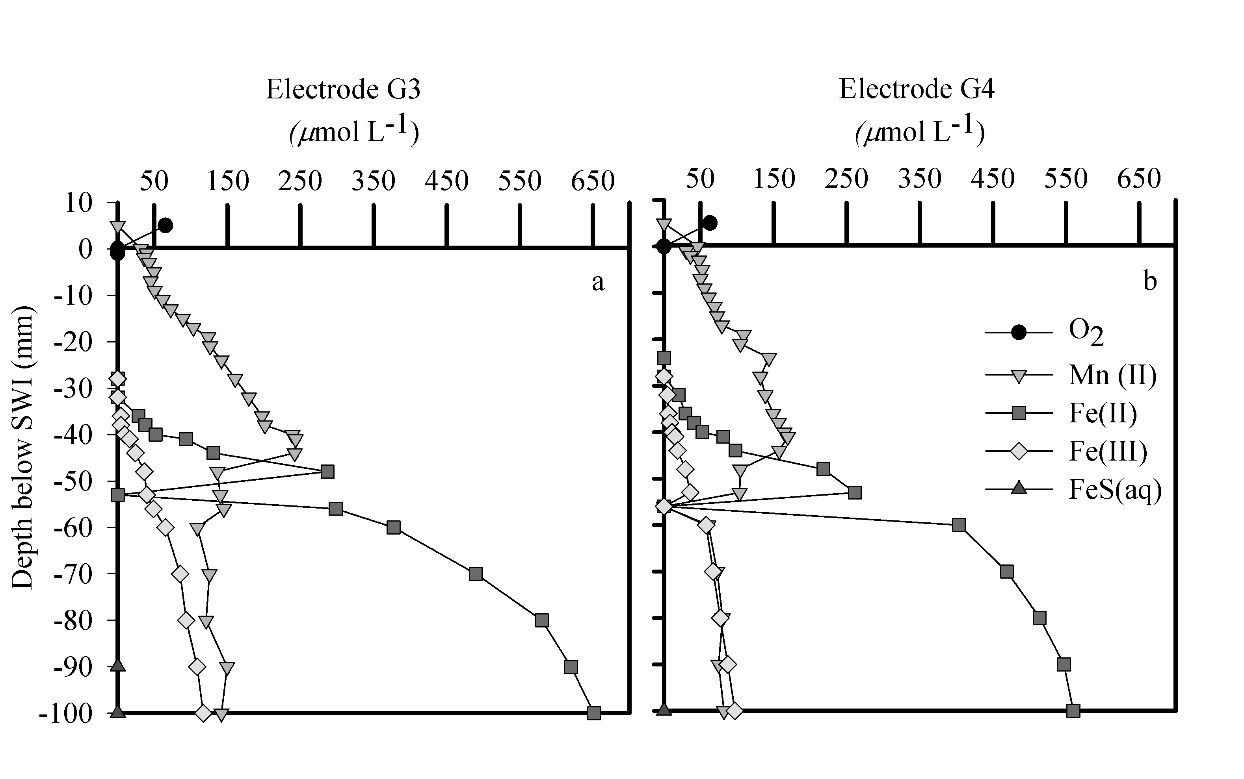

Figure 3 (a-d): Core profile data obtained from four cores (H1-4) collected within a 1 meter grid (June 2009, 13:00 h). The data indicate that Mn(II) is detected at approximately the same depths (within 2 mm) in all cores but Fe(II) and Fe(III) are more variable.
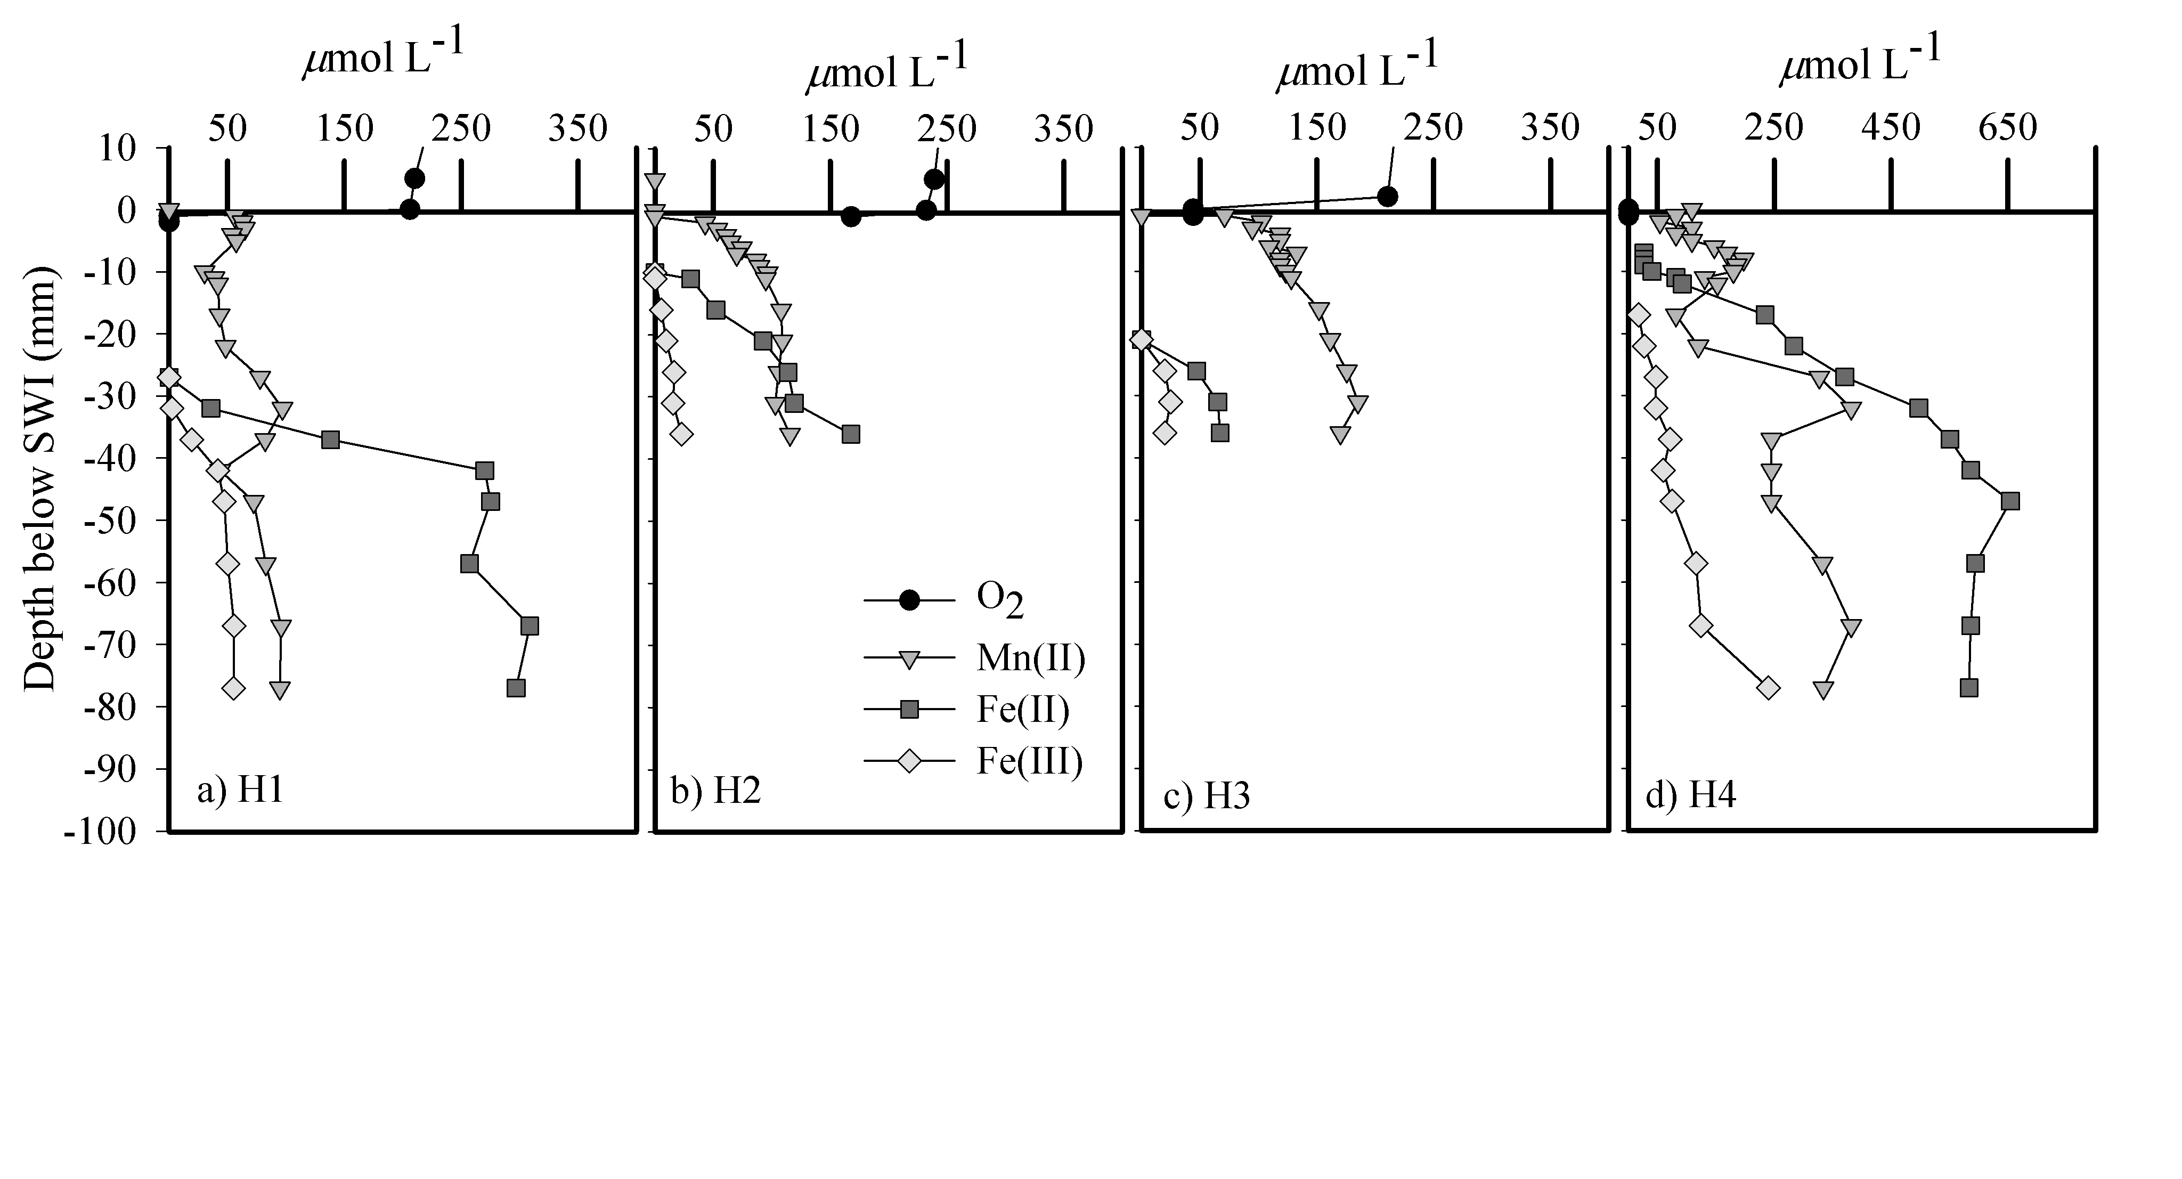

Figure 4 – Redox front positions (defined as depth where O₂ became immeasurable, or where Mn(II) or Fe(II) species became measurable using voltammetric electrodes in core profiles) different times through the 2007 and 2008 season. Samples collected and analyzed at midday were used for these comparisons (between 12:00 h and 20:00 h for all samples). Large diamonds are whole water cyanobacteria cell counts, averaged across 5 samples through the water column; the scale for these measurements is located at the right axis in cells mL⁻¹.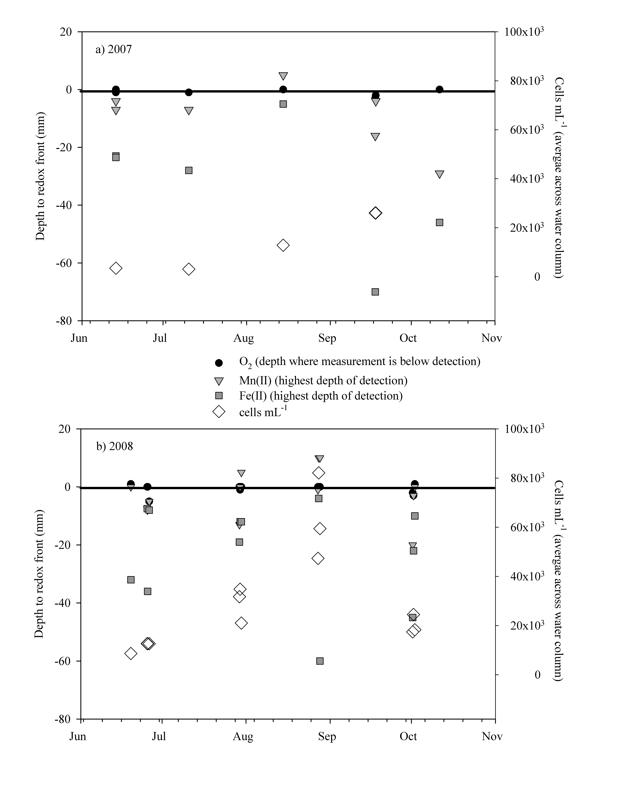

Figure 5 (a-e): Diel redox measurements at the sediment-water interface (SWI) from (a)September of 2007, (b) June, (c) July, (d) August, and (e) October of 2008. Measured in situ, using voltammetric Au-amalgam electrode positioned at the SWI by SCUBA divers.
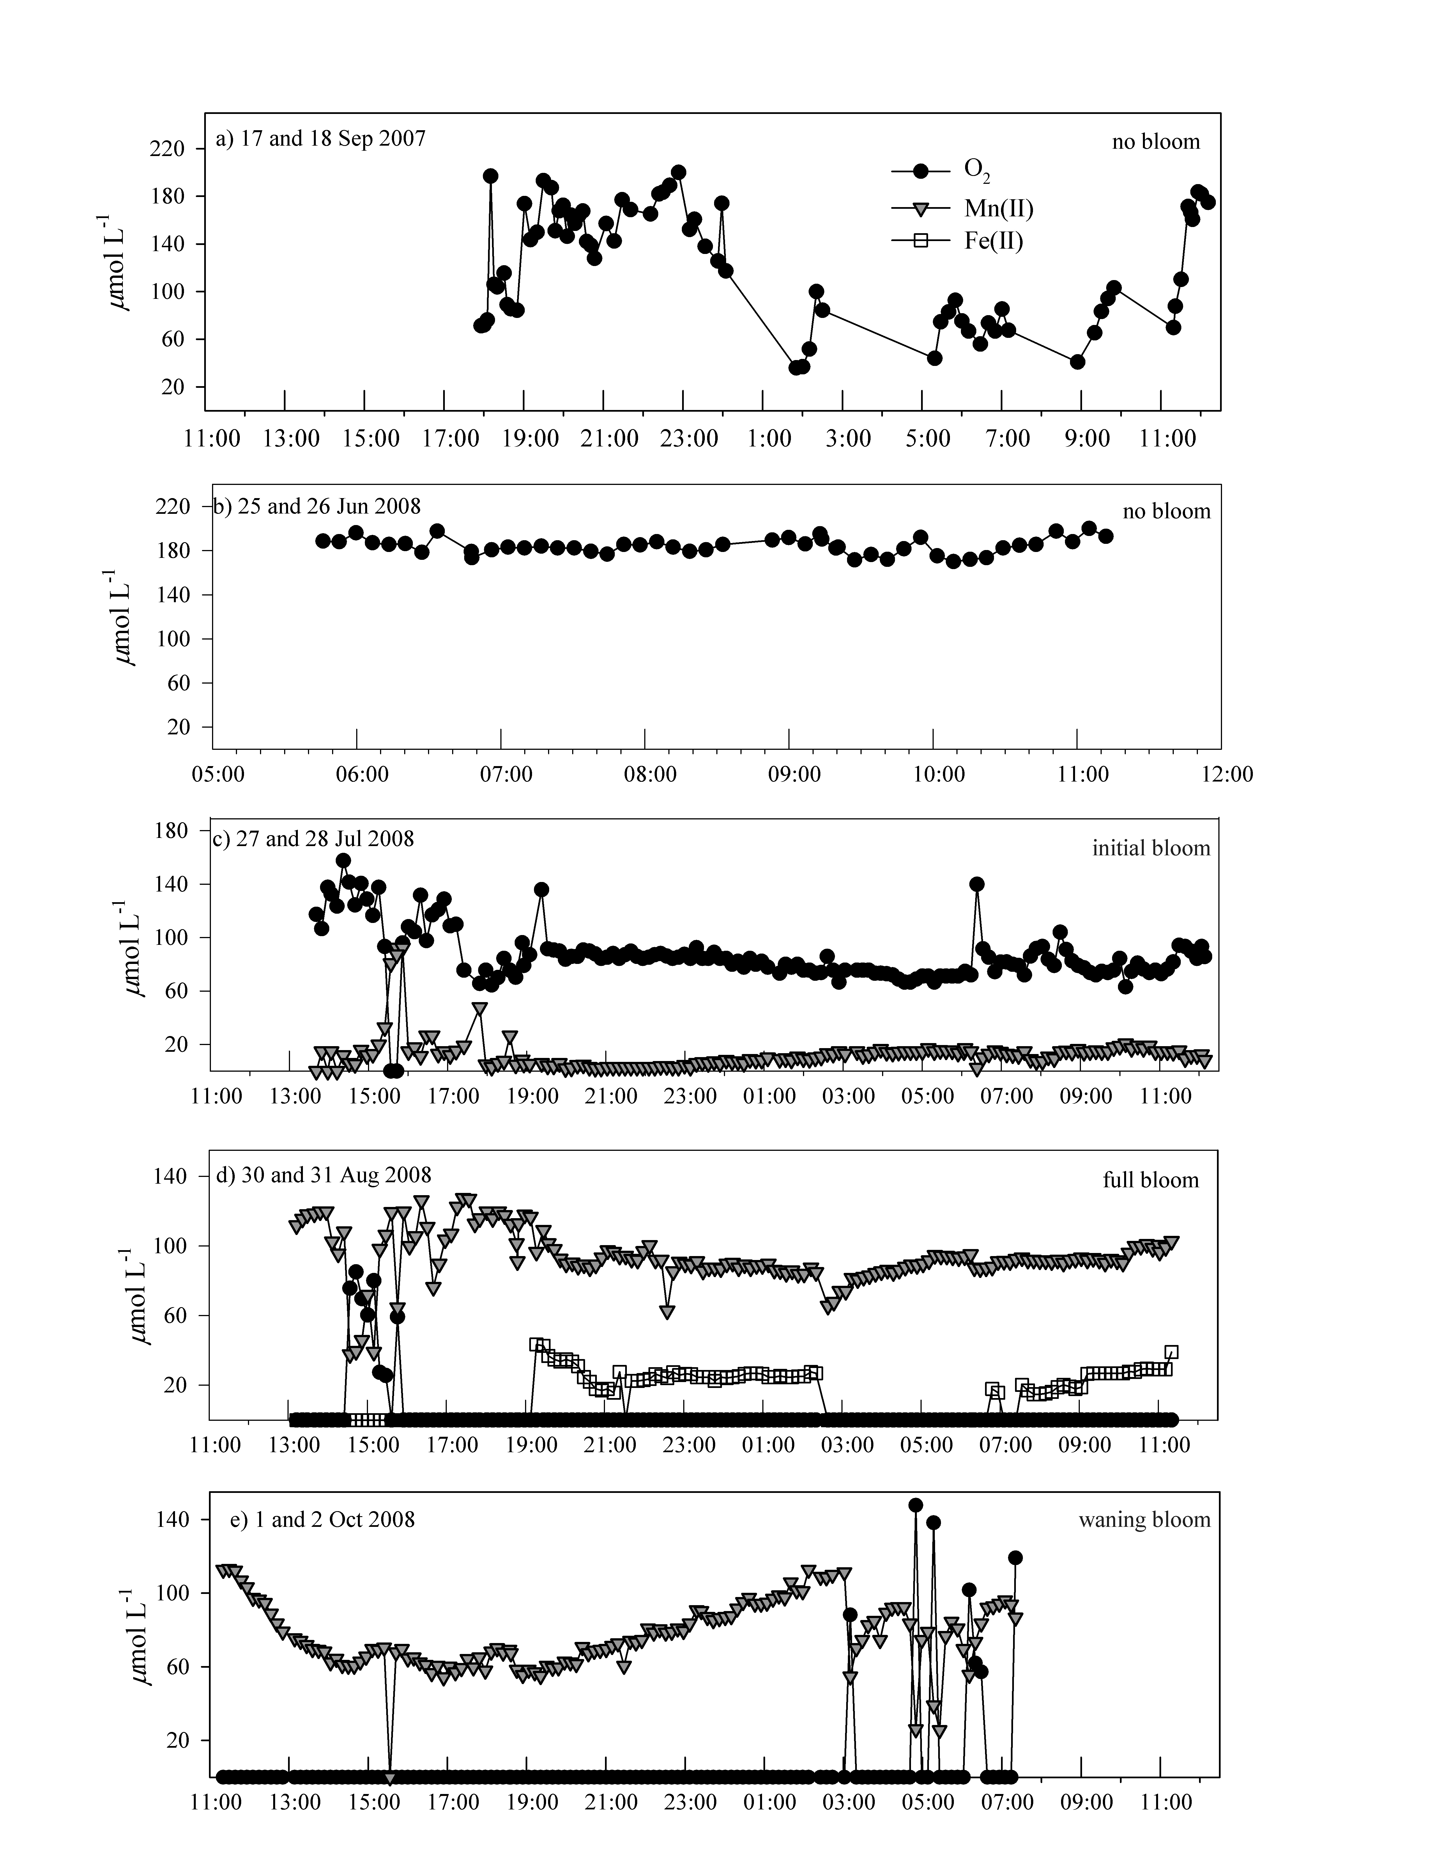
Figure 6: Water column water samples from 5 depths collected at each sampling date. Gray markers and lines plot 2007 data, black markers and lines plot 2008 data. (a) Soluble reactive phosphorus (SRP) concentrations from filtered samples collected at each depth; (b) Total phosphorus (TP) concentrations from unfiltered samples collected at each depth.

Figure 7: Water and sediment column pH profiles from cores collected midday in June and August 2009. Although water column pH values were elevated (8.6 and 8.5, respectively, just below water surface) the sediment pH remained near neutral.

