11

Crop Rotations

. . . with methods of farming in which grasses form an
important part of the rotation, especially those that
leave a large residue of roots and culms, the decline of
the productive power is much slower than when crops
like wheat, cotton, or potatoes, which leave little
residue on the soil, are grown continuously.
—Henry Snyder, 1896

There are very good reasons to rotate crops. Rotating crops usually means fewer problems with insects, parasitic nematodes, weeds, and diseases caused by plant pathogens. Rotations that include nonhost plants are effective for controlling insects like corn rootworm, nematodes like soybean cyst nematode, and diseases like root rot of field peas. When specific soil diseases are present [the word break—which with this insert has now gone away—shd be “pres-ent”], the length of time between growing the same or similar crop may vary from relatively short (1 to 2 years for leaf blight of onions) to fairly long (7 years for clubroot of radish or turnip). Also, the other crops in the rotation should contain some that are nonhosts or actually suppress the disease. Root growth may be adversely affected when continuously cropping to a single crop [when what is continuously cropped?] (see figure 11.1). This means that the crops may be less efficient in using soil nutrients and added fertilizers. In addition, rotations that include legumes may supply significant amounts of nitrogen to succeeding crops. A legume harvested for seed, such as soybeans, provides little N for the following crop. On the other hand, a multiyear legume sod such as alfalfa may well supply all the nitrogen needed by the following crop. Growing sod-type forage grasses, legumes, and grass-legume mixes as part of the rotation also increases soil organic matter. When you alternate two crops, such as corn and soybeans, you have a very simple rotation. More complex rotations require three or more crops and a 5- to 10-year (or more) cycle to complete.
Crop and Varietal Mixtures
Not only do rotations help in many ways, but growing mixtures of different crops and even different varieties (cultivars) of a given crop sometimes offers real advantages. For example, faba (fava) bean helps corn to get phosphorus on low P soils by acidifying the area around its roots. Also, when some varieties of a species are prized for a certain quality, such as taste, but are susceptible to a particular pest, growing a number of rows of the susceptible variety alternating with rows of resistant varieties tends to lessen the severity of the pest damage.
[fig. 11.1 about here]
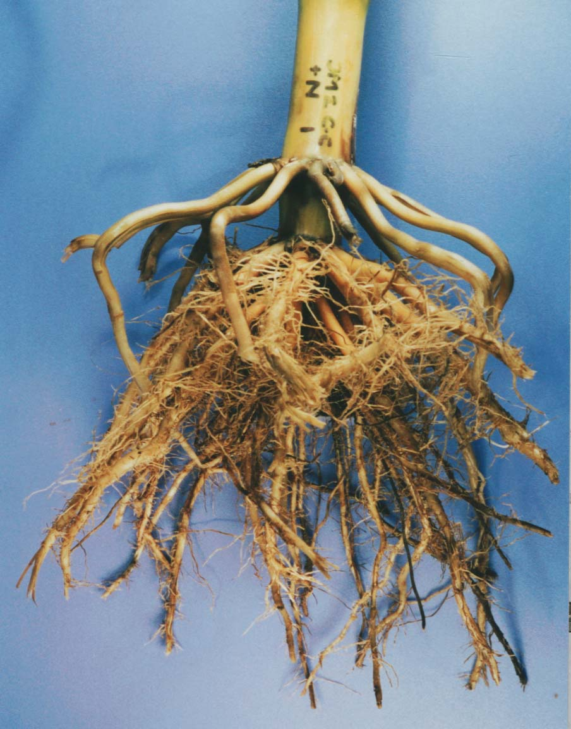
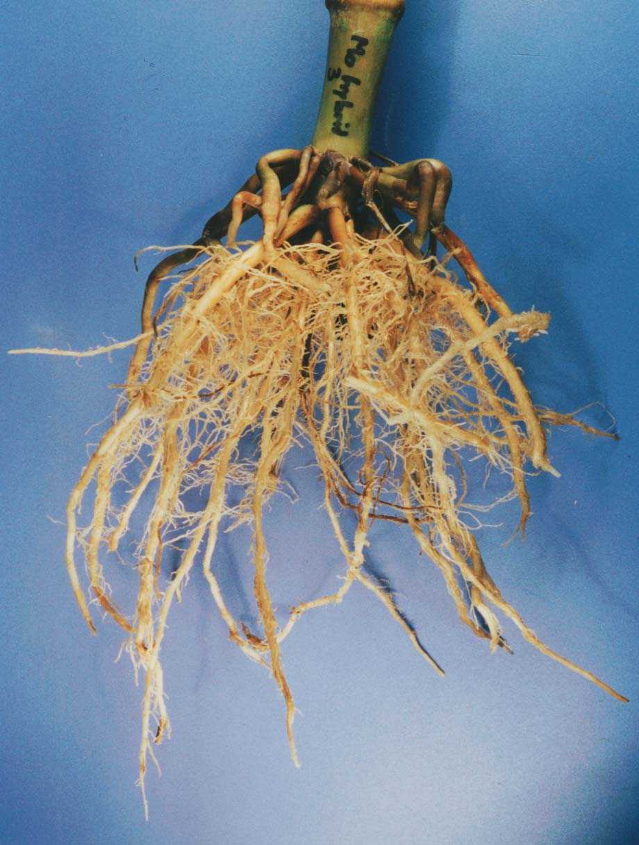
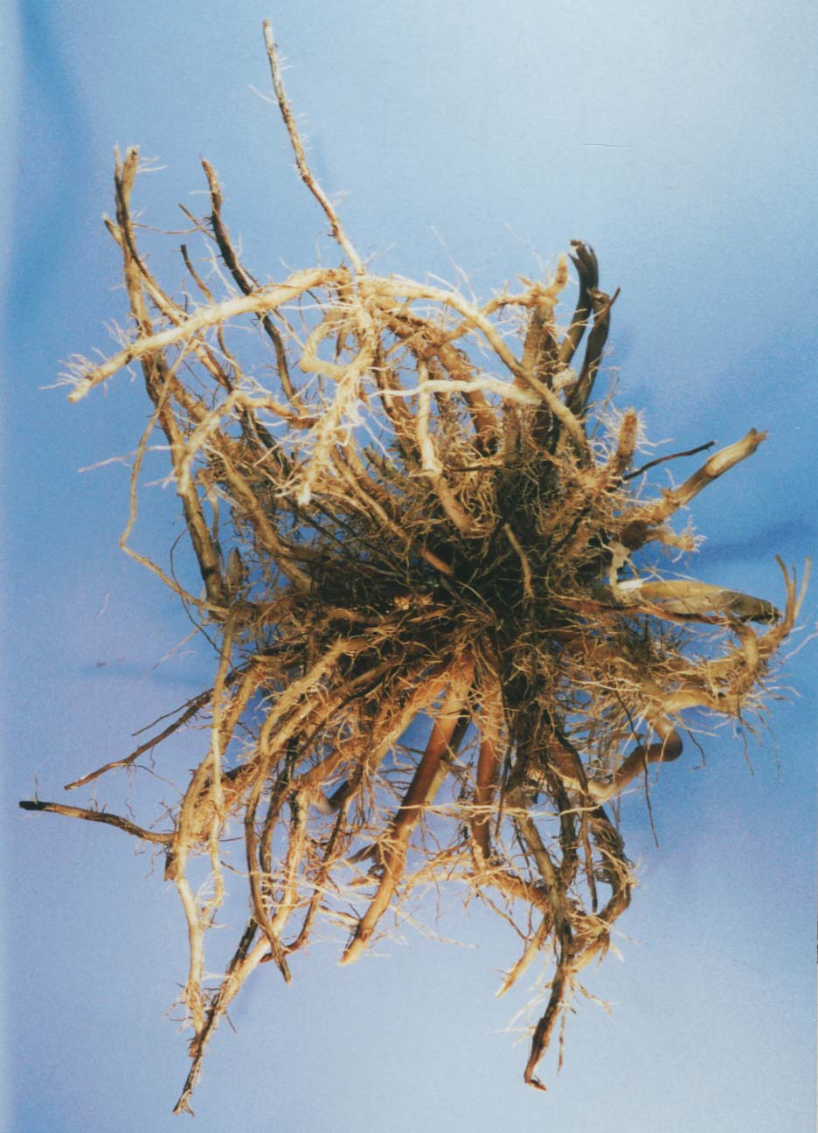
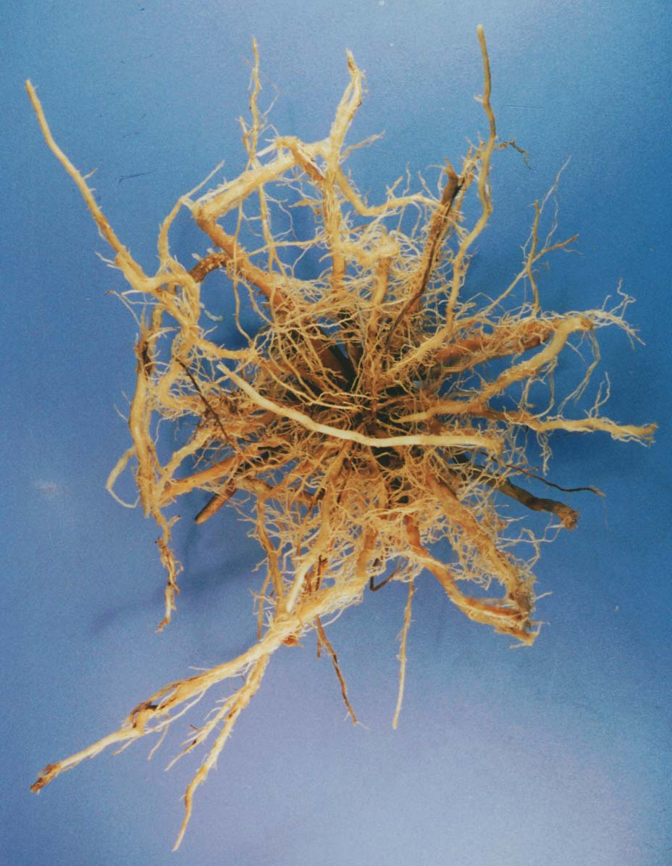
a
b
Figure 11.1. Corn roots: (a) continuous corn with mineral fertilizer; , (b) corn following alfalfa with dairy manure compost. (pPhotos by Walter Goldstein).

Rotations are an important part of any sustainable agricultural system. Yields of crops grown in rotations are typically 10% higher than those of crops grown in monoculture in normal growing seasons, and as much as 25% higher in droughty growing seasons. When you grow a grain or vegetable crop following a forage legume, the extra supply of nitrogen certainly helps. However, yields of crops grown in rotation are often higher than those of crops grown in monoculture, even when both are supplied with plentiful amounts of nitrogen. Research in Iowa found that even using 240 pounds of N per acre when growing corn after corn, yields were not as good as corn with little or no N applied grown following alfalfa. [fix end of sentence] In addition, following a nonlegume crop with another nonlegume also produces higher yields than a monoculture using recommended fertilizer rates. For example, when you grow corn following grass hay, or cotton following corn, you get higher yields than when corn or cotton is grown year after year. This yield benefit from rotations is sometimes called a rotation effect. Another important benefit of rotations is that growing a variety of crops in a given year spreads out labor needs and reduces risk caused by unexpected climate or market conditions. Other benefits may occur when perennial forages (hay-type crops) are included in the rotation, including decreased soil erosion and nutrient loss.
[source of fig. 11.2?]
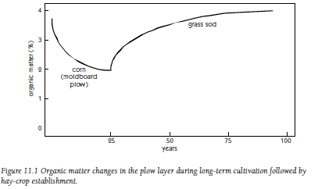
[H1]Rotations AND Soil
Organic Matter Levels
2..
You might think you’re doing pretty well if soil organic matter remains the same under a particular cropping system. However, if you are working soils with depleted organic matter, you need to build up levels to counter the effects of previous practices. Maintaining an inadequate level of organic matter won’t do.
The types of crops you grow, their yields, the amount of roots produced, the portion of the crop harvested, and how you manage crop residues will all affect soil organic matter. Soil fertility itself influences the amount of organic residues returned, because more fertile soils grow higher-yielding crops, with more residues.
The decrease in organic matter levels when row crops are planted on a virgin forest or prairie soil is very rapid for the first 5 to 10 years, but, eventually, a plateau or equilibrium is reached. After that, soil organic matter levels remain stable, as long as production practices aren’t changed. An example of what can occur during 25 years of continuously grown corn is given in figure 11.2. Soil organic matter levels increase when the cropping system is changed from a cultivated crop to a grass or mixed grass–legume sod. However, the increase is usually much slower than the decrease that occurred under continuous tillage.
[fig. 11.2 about here]
A long-term cropping experiment in Missouri compared continuous corn to continuous sod and various rotations. More than 9 inches of topsoil was lost during 60 years of continuous corn. The amount of soil lost each year from the continuous corn plots was equivalent to 21 tons per acre. After 60 years, soil under continuous corn had only 44% as much topsoil as that under continuous timothy sod. A 6-year rotation consisting of corn, oats, wheat, clover, and 2 years of timothy resulted in about 70% as much topsoil as found in the timothy soil, a much better result than with continuous corn. Differences in erosion and organic matter decomposition resulted in soil organic matter levels of 2.2% for the unfertilized timothy and 1.2% for the continuous corn plots.
In an experiment in eastern Canada, continuous corn led to annual increases in organic matter of about 100 pounds per acre, while 2 years of corn followed by 2 years of alfalfa increased organic matter by about 500 pounds per acre per year and four years of alfalfa increased organic matter by 800 pounds per acre per year. (Keep in mind that these amounts are small compared to the amounts of organic matter in most soils—3% organic matter represents about 60,000 pounds per acre to a depth of 6 inches.)
Two things happen when perennial forages are part of the rotation and remain in place for some years during a rotation. First, the rate of decomposition of soil organic matter decreases, because the soil is not continually being disturbed. (This also happens when using no-till planting, even for nonsod-type crops, such as corn.) Second, grass and legume sods develop extensive root systems, part of which will naturally die each year, adding new organic matter to the soil. Crops with extensive root systems stimulate high levels of soil biological activity and soil aggregation. The roots of a healthy grass or legume-grass sod return more organic matter to the soil than roots of most other crops. Older roots of grasses die, even during the growing season, and provide sources of fresh, active organic matter. Rotations that included three years of perennial forage crops have been found to produce a very high-quality soil in the corn and soybean belt of the Midwest.
We are not only interested in total soil organic matter—we want a wide variety of different types of organisms living in the soil. We also want to have a good amount of active organic matter and high levels of well-decomposed soil organic matter, or humus, in the soil. Although most experiments have compared soil organic matter changes under different cropping systems, few experiments have looked at the effects of rotations on soil ecology. The more residues your crops leave in the field, the greater the populations of soil microorganisms. Experiments in a semiarid region in Oregon found that the total amount of microorganisms in a two-year wheat-fallow system was only about 25% of the amount found under pasture. Conventional moldboard plow tillage systems are known to decrease the populations of earthworms, as well as other soil organisms. More complex rotations increase soil biological diversity. Including perennial forages in the rotation enhances this effect.

[H1]Residue Availability
As pointed out in chapters 5 and 9 [references ok?], more residues are left in the field after some crops than others. High residue-producing crops—especially those with extensive root systems—should be incorporated into rotations whenever possible. There is considerable interest in the possible future use of crop residue for a variety of purposes, such as for biofuel production. However, farmers should keep in mind that frequent removal of significant quantities of residue from their fields—and there may be more pressure to remove them if production of biofuels from crop residue becomes economically viable—can have a very negative effect on the soil’s health.
[H1]Species Richness and
Active Rooting Periods
In addition to the quantity of residues remaining following harvest, a variety of types of residues is also important. The goal should be a minimum of three different species in a rotation, more if possible. The percent of the time that living roots are present during a rotation is also important. The period that active roots are present varies considerably, ranging from 32% of the time for a corn-soybeans rotation to 57% for a beans-wheat rotation to 76% for a three-year beans-wheat-corn rotation (table 11.1). As mentioned above, when soils are covered with living vegetation for a longer period of time, there tends to be decreased erosion as well as a decreased loss of nitrate and less groundwater contamination.

Table 11.1
Comparison of Rotations:
Percent of Time Active Roots Are Present
and Number of Species
Rotation | Years | Active Rooting Period (%) | Number of  Species
Corn-soybeans | 2 | 32 | 2
Dry beans–winter wheat | 2 | 57 | 2
Dry beans–winter wheat/cover | 2 | 92 | 3
Dry beans–winter wheat–corn | 3 | 72 | 3
Corn–dry beans–winter wheat/cover | 3 | 76 | 4
Sugar beets–beans–wheat/cover–corn | 4 | 65 | 5
—Michigan Field Crop Ecology (1998). [Source needs to be clarified, so that readers can find it: What is it, who is the author, and who published it?]

[H1]Rotations and water quality
When annual crops are grown and planted in the spring, there is a considerable amount of time when the soil is not occupied by living plants. As indicated in table 11.1, there are active roots only 32% of the year when corn and soybeans are grown. This means that for a large portion of the year there are no living plants to take up nutrients, especially nitrate, that can leach out of the soil. This is especially a problem in the Midwest, where many soils have tile drainage, which accentuates the discharge of high-nitrate water into streams and rivers. In addition to not taking up nutrients, the lack of growing plants means that the soils are wetter and more apt to produce runoff and erosion as well as leaching. Thus, rotations that include perennial forages and winter grains help maintain or enhance the quality of both ground and surface waters. And, while intensive use of cover crops helps water quality in a similar way, they [“they” refers to cover crops?] should not be viewed as a substitute for a good rotation of economic crops.
[H1]Farm Labor and Economics
Before discussing appropriate rotations, let’s consider some of the possible effects on farm labor and finances. If you grow only one or two row crops, you must work incredibly long hours during planting and harvesting seasons, and not as much at other times. Including forage hay crops and early harvested crops along with those that are traditionally harvested in the fall would allow you to spread your labor over the growing season, making the farm more easy to manage by family labor alone. In addition, when you grow a more diversified group of crops, you are less affected by price fluctuations of one or two crops. This may provide more year-round income and year-to-year financial stability.
Although there are many possible benefits of rotations, there are also some costs or complicating factors. It is critically important to carefully consider the farm’s labor and management capacity when exploring diversification opportunities. You may need more equipment to grow a number of different crops. There may be conflicts between labor needs for different crops; cultivation and side-dressing nitrogen fertilizer for corn might occur at the same time as harvesting hay in some locations. In addition, some tasks, such as harvesting dry hay (mowing, tedding when needed, baling, and storing) can require quite a bit of labor that may not always be available. Finally, the more diversified the farm, the less chance for time to relax.

[H1]General Principles
Try to consider the following principles when you’re thinking about a new rotation:

1. Follow a legume forage crop, such as clover or alfalfa, with a high-nitrogen-demanding crop, such as corn, to take advantage of the nitrogen supply.
Crop Rotations and Plant Diseases
Carefully selected rotations, especially when alternating between grains and broadleaf plants, can greatly assist control [fix phrasing] plant diseases and nematodes. Sometimes a one-year break is sufficient for disease control, while for other diseases a number of years of growing a nonhost crop are needed to sufficiently reduce inoculum levels. Inclusion of pulse crops in a rotation seems to stimulate beneficial organisms and reduce the severity of cereal root diseases. Severity of common root rot of wheat and barley is reduced by a multiyear break of growing broadleaf plants. Rotations can be relatively easy to develop for control of diseases and nematodes that have a fairly narrow host range. However, some diseases or nematodes have a wider host range, and more care is needed in developing or changing rotations if these are present. In addition, some diseases enter the field on contaminated seed, while others, like wheat leaf rust, can travel with the wind for long distances. Other tactics, aside from rotations, are needed to deal with such diseases.
—Krupinsky et al. (2002).
2. Grow fewer nitrogen-demanding crops, such as oats, barley, and wheat, in the second or third year after a legume sod.
3. Grow the same annual crop for only one year, if possible, to decrease the likelihood of insects, diseases, and nematodes becoming a problem. (Note: For many years, the western corn rootworm was effectively controlled by alternating between corn and soybeans. Recently, populations of the rootworm with a longer resting period have developed in isolated regions in the Midwest, and they are able to survive the very simple two-year rotation.)
4. Don’t follow a crop with a closely related species, since insect, disease, and nematode problems are frequently shared by members of closely related crops.
5. If specific nematodes are known problems consider planting nonhost plants (such as grain crops for root-knot nematode) for a few years to decrease populations before planting a very susceptible crop such as carrots or lettuce. High populations of plant parasitic nematodes will also affect the choice of cover crops (see chapter 10 for a discussion of cover crops).
6. Use crop sequences that promote healthier crops. Some crops seem to do well following a particular crop (for example, cabbage family crops following onions, or potatoes following corn). Other crop sequences may have adverse effects, as when potatoes have more scab following peas or oats.
7. Use crop sequences that aid in controlling weeds. Small grains compete strongly against weeds and may inhibit germination of weed seeds, row crops permit midseason cultivation, and sod crops that are mowed regularly or intensively grazed help control annual weeds.
8. Use longer periods of perennial crops, such as a forage legume, on sloping land and on highly erosive soils. Using sound conservation practices, such as no-till planting, extensive cover cropping, or strip-cropping (a practice that combines the benefits of rotations and erosion control), may lessen the need to follow this guideline.
9. Try to grow a deep-rooted crop, such as alfalfa, safflower, or sunflower, as part of the rotation. These crops scavenge the subsoil for nutrients and water, and channels left from decayed roots can promote water infiltration.
10. Grow some crops that will leave a significant amount of residue, like sorghum or corn harvested for grain, to help maintain organic matter levels.
11. When growing a wide mix of crops—as is done on many direct-marketing vegetable farms—try grouping into blocks according to plant family, timing of crops (all early-season crops together, for example), type of crop (root vs. fruit vs. leaf), or cultural practices (irrigated, plastic mulch used).
12. In regions with limited rainfall, the amount of water used by a crop may be a critically important issue—usually one of the most important issues. Without plentiful irrigation, growing high water-use crops such as hay, as well as sunflower and safflower, may not leave sufficient moisture in the soil for the next crop in the rotation.
13. Be flexible enough to adapt to annual climate and crop price variations, as well as development of soil pathogens and plant parasitic nematodes. For example, dryland rotations have been introduced in the Great Plains to replace the wheat-fallow system, resulting in better use of water and less soil erosion. (It is estimated that less than 25% of the rainfall that falls during the 14-month fallow period in the Central High Plains is made available to a following crop of winter wheat.) In years with low soil water at the start of the season or following high-water-using crops such as sunflower and corn, consider planting low-water-using crops such as dry peas or lentils instead of other high-water-using crops. (See box “Flexible Cropping Systems” and table 11.2 for discussion and information on flexible, or dynamic, cropping systems.) As discussed above (see point 5) [number correct?], reconsider your crop sequence and cover crop use if nematodes become a problem.
[table 11.2 about here]
[H1]Rotation Examples
It’s impossible to recommend specific rotations for a wide variety of situations. Every farm has its own unique combination of soil and climate and of human, animal, and machine resources. The economic conditions and needs are also different on each farm. You may get useful ideas by considering a number of rotations with historical or current importance.
A five- to seven-year rotation was common in the mixed livestock-crop farms of the northern Midwest and the Northeast during the first half of the 20th century. An example of this rotation is the following:

Year 1. Corn
Year 2. Oats (mixed legume-grass hay seeded)
Years 3, 4, and 5. Mixed grass-legume hay
Years 6 and 7. Pasture

The most nitrogen-demanding crop, corn, followed the pasture, and grain was harvested only two of every five to seven years. A less nitrogen-demanding crop, oats, was planted in the second year as a “nurse crop” when the grass-legume hay was seeded. The grain was harvested as animal feed, and oat straw was harvested to be used as cattle bedding; both eventually were returned to the soil as animal manure. This rotation maintained soil organic matter in many situations, or at least didn’t cause it to decrease too much. On prairie soils, with their very high original contents of organic matter, levels still probably decreased with this rotation.
In the corn belt region of the Midwest, a change in rotations occurred as pesticides and fertilizers became readily available and animals were fed in large feedlots instead of on crop-producing farms. Once the mixed livestock farms became grain-crop farms or crop-hog farms, there was little reason to grow sod crops. In addition, government commodity price support programs unintentionally encouraged farmers to narrow production to just two feed grains. The two-year corn-soybean rotation is better than monoculture, but it has a number of problems, including erosion, groundwater pollution with nitrates and herbicides, depletion of soil organic matter, and in some situations increased insect problems. Research indicates that with high yields of corn grain there may be sufficient residues to maintain organic matter. With soybeans, residues are minimal.
The Thompson mixed crop-livestock (hogs and beef) farm in Iowa practices an alternative five-year corn belt rotation similar to the first rotation we described—corn/soybeans/corn/oats (mixed/grass hay seeded)/hay. For fields that are convenient for pasturing beef cows, the Thompson eight-year rotation [preceding sentence refers to five-year rotation] is as follows:
Crop Rotation on Organic Farms
Crop rotation is always a good idea, but on organic farms a sound crop rotation is essential. Options for rescuing crops from disease are limited on organic farms, making disease prevention through good crop rotation more important. Similarly, weed management requires a multiyear approach. Since nutrients for organic crop production come largely through release from organic matter in soil, manure, compost, and cover crops, a crop rotation that maintains regular organic matter inputs and large amounts of active soil organic matter is critical.
To obtain the benefits of a diverse crop rotation and take advantage of specialty markets, organic farmers usually grow a high diversity of crops. Thus, organic field crop producers commonly grow five to ten crop species, and fresh market vegetable growers may grow thirty or more. However, because of the large variation in acreage among crops and frequent changes in the crop mix due to weather and shifting market demands, planning crop rotations on highly diversified farms is difficult. Therefore, many organic farmers do not follow any regular rotation plan, but instead place crops on individual fields (or parts of fields) based on the cropping history of the location and its physical and biological characteristics (e.g., drainage, recent organic matter inputs, weed pressure, etc.). Skilled organic growers usually have next year's cash crops and any intervening cover crops in mind as they make their placement decisions but find that planning further ahead is usually pointless because longer-term plans are so frequently derailed.
Although precise long-term rotation plans can rarely be followed on farms growing a diverse mix of crops, some experienced organic farmers follow a general repeating scheme in which particular crops are placed by the ad hoc approach described above. For example, some vegetable operations plant cash crops every other year and grow a succession of cover crops in alternate years. Many field crop producers alternate some sequence of corn, soybeans, and small grains with several years of hay on a regular basis, and some vegetable growers similarly alternate a few years in vegetables with two to three years in hay. These rest periods in hay or cover crops build soil structure, allow time for soilborne diseases and weed seeds to die off, and provide nitrogen for subsequent heavy-feeding crops. Some vegetable growers alternate groups of plant families in a relatively regular sequence, but this generally requires growing cover crops on part of the field in years when groups that require less acreage appear in the sequence. Within all of these generalized rotation schemes, the particular crop occupying a specific location is chosen by the ad hoc process described above. Organizing the choices with a general rotation scheme greatly simplifies the decision-making process.
Dividing the farm into many small, permanently located management units also greatly facilitates effective ad hoc placement of crops onto fields each year. By this means, a precise cropping history of every part of each field is easy to maintain. Moreover, problem spots and particularly productive locations can be easily located for planting with ap [I can’t see the end of this box]propriate crops.
—C. Mohler

Year 1. Corn
Year 2. Oats (mixed/grass hay seeded)
Years 3 to 8. Pasture

Organic matter is maintained through a combination of practices that include the use of manures and municipal sewage sludge, green manure crops (oats and rye following soybeans and hairy vetch between corn and soybeans), crop residues, and sod crops. These practices have resulted in a porous soil that has significantly lower erosion, higher organic matter content, and more earthworms than neighbors’ fields
A four-year rotation under investigation in Virginia uses mainly no-till practices as follows:

Year 1. Corn, winter wheat no-till planted into corn stubble
Year 2. Winter wheat grazed by cattle, foxtail millet no-till planted into wheat stubble and hayed or grazed, alfalfa no-till planted in fall
Year 3. Alfalfa harvested and/or grazed
Year 4. Alfalfa harvested and/or grazed as usual until fall, then heavily stocked with animals to weaken it so that corn can be planted the next year

This rotation follows many of the principles discussed earlier in this chapter. It was designed by researchers, extension specialists, and farmers and is similar to the older rotation described earlier. A few differences exist: This rotation is shorter; alfalfa is used instead of clover or clover-grass mixtures; and there is a special effort to minimize pesticide use under no-till practices. Weed-control problems occurred when going from alfalfa (fourth year) back to corn. This caused the investigators to use fall tillage followed by a cover crop mixture of winter rye and hairy vetch. Some success was achieved suppressing the cover crop in the spring by just rolling over it with a disk harrow and planting corn through the surface residues with a modified no-till planter. The heavy cover crop residues on the surface provided excellent weed control for the corn.
Traditional wheat-cropping patterns for the semiarid regions of the Great Plains and the Northwest commonly include a fallow year to allow storage of water and more mineralization of nitrogen from organic matter for use by the next wheat crop. However, the wheat-fallow system has several problems. Because no crop residues are returned during the fallow year, soil organic matter decreases unless manure or other organic materials are provided from off the field. Water infiltrating below the root zone during the fallow year moves salts through the soil to the low parts of fields. Shallow groundwater can come to the surface in these low spots and create “saline seeps,” where yields will be decreased. Increased soil erosion, caused by either wind or water, commonly occurs during fallow years, and organic matter decreases (at about 2% per year, in one experiment). In this wheat monoculture system, the buildup of grassy weed populations, such as jointed goat grass and downy brome, also indicates that crop diversification is essential.
Farmers in these regions who are trying to develop more sustainable cropping systems should consider using a number of species, including deeper-rooted crops, in a more diversified rotation. This would increase the amount of residues returned to the soil, reduce tillage, and lessen or eliminate the fallow period. (See box “Flexible Cropping Systems.”)
A four-year wheat-corn-millet-fallow rotation under evaluation in Colorado was found to be better than the traditional wheat-fallow system. Wheat yields have been higher in this rotation than wheat grown in monoculture. The extra residues from the corn and millet also are helping to increase soil organic matter. Many producers are including sunflower, a deep-rooting crop, in a wheat-corn-sunflower-fallow rotation. Sunflower is also being evaluated in Oregon as part of a wheat cropping sequence.
Vegetable farmers who grow a large selection of crops find it best to rotate in large blocks, each containing crops from the same families or having similar production schedules or cultural practices. Many farmers are now using cover crops to help “grow their own nitrogen,” utilize extra nitrogen that might be there at the end of the season, and add organic matter to the soil. A four- to five-year vegetable rotation might be as follows:

Year 1. Sweet corn followed by a hairy vetch/winter rye cover crop
Year 2. Pumpkins, winter squash, summer squash followed by a rye or oats cover crop
Year 3. Tomatoes, potatoes, peppers followed by a vetch/rye cover crop
Year 4. Crucifers, greens, legumes, carrots, onions, and miscellaneous vegetables followed by a rye cover crop
Year 5. (If land is available) oats and red clover or buckwheat followed by a vetch/rye cover crop

Another rotation for vegetable growers uses a two- to three-year alfalfa sod as part of a six- to eight-year cycle. In this case, the crops following the alfalfa are high-nitrogen-demanding crops, such as corn or squash, followed by cabbage or tomatoes, and, in the last two years, crops needing a fine seedbed, such as lettuce, onions, or carrots. Annual weeds in this rotation are controlled by the harvesting of alfalfa a number of times each year. Perennial weed populations can be decreased by cultivation during the row-crop phase of the rotation.
Most vegetable farmers do not have enough land—or the markets—to have a multiyear hay crop on a significant portion of their land. Aggressive use of cover crops will help to maintain organic matter in this situation. Manures, composts, or other sources of organic materials, such as leaves, should also be applied every year or two to help maintain soil organic matter.
Cotton alternating with peanut is a common simple rotation in the Southeast coastal region. The soils in this area tend to be sandy, low in fertility and water-holding capacity, and have a subsoil compact layer. As with the corn-soybean alternation of the Midwest, a more complex system is very desirable from many viewpoints. A rotation including a perennial forage, for at least a few years, may provide many advantages to the cotton-peanut system. Research with two years of Bahia grass in a cotton-peanut system indicates greater cotton root growth, more soil organic matter and earthworms, and better water infiltration and storage.

Flexible Cropping Systems
As discussed in point 13 under “General Principles,” it may be best for many farmers to adapt more “dynamic” crop sequences rather than strictly adhere to a particular sequence. Many things change from year to year, including prices paid for crops, pest pressures, and climate. And many farmers do deviate from plans and change what they plant in a particular field—for example, in a wetter than normal field a dry spring opens the opportunity for a vegetable farmer to plant an early-season crop, thus potentially enhancing the diversity of crops grown in that field. However, this issue is especially important for dryland farmers in water-limiting regions such as the Great Plains. In dryland agriculture low water availability is usually the greatest limitation to crop growth. In such regions, where much of the water needed for a crop is stored in the soil at planting time, growing of two heavy water users in a row may work out well if rainfall was plentiful the first year. However, if rainfall has been low, following a heavy-water-using crop (such as sunflowers or corn) with one that needs less water (such as dry pea or lentil) means that water stored in the soil may be enough, along with rainfall during the growing season, to result in a reasonable yield.

Table 11.2
Comparison of Monoculture, Fixed-Sequence Rotations,
and Dynamic Cropping Systems

 | Monoculture | Fixed-Sequence Rotations | Dynamic Cropping Systems
Numbers and types of crops | Single crop | Multiple crops; number depends on regionally adapted species, economics, farmer knowledge, infrastructure. | Multiple crops; number depends on regionally adapted species, economics, farmer knowledge, and infrastructure.
Crop  diversity | N/A | Diversity depends on length of fixed sequence. | Diversity high due to annual variation in growing conditions and marketing opportunities, as well as changes in producer goals.
Crop -  sequencing flexibility | N/A | None, although fixed-sequence cropping systems that incorporate opportunity crops increase flexibility. | High. All crops, in essence, are opportunity crops.
Biological and ecological knowledge | Basic knowledge of agronomy | Some knowledge of crop interactions is necessary. | Extended knowledge of complex, multiyear crop and crop-environment interactions.
Management complexity | Generally low, though variable  depending on crop type | Complexity variable depending on length of fixed sequence and diversity of crops grown. | Complexity inherently high due to annual variation in growing conditions, markets, and producer goals.
—
Modified from Hanson et al. (2007).

[H1]Summary
There are literally dozens of rotations that might work well on a particular farm. The specific selection depends on the climate and soils, the expertise of the farmer, whether there are livestock on the farm or nearby, equipment and labor availability, family quality-of-life considerations, and financial reality (potential price minus the cost of production). (However, vegetable farmers will sometimes include low-return crops in their rotations because customers expect to find them in the mix at a farm stand or farmers’ market.) From an ecological view, longer and more complex rotations are preferred over shorter ones. It also makes a lot of sense, once equipment is in place, to stay flexible instead of having a rotation set in stone. If you’re ready to adjust to rapid market changes, changes in labor availability, crop pest outbreaks, or unusual weather patterns, you’ll be in a stronger position economically, while still maintaining a complex rotation.

Sources
Anderson, S.H., C.J. Gantzer, and J.R. Brown. 1990. Soil physical properties after 100 years of continuous cultivation. Journal of Soil and Water Conservation 45: 117–121.
Baldock, J.O., and R.B. Musgrave. 1980. Manure and mineral fertilizer effects in continuous and rotational crop sequences in central New York. Agronomy Journal 72: 511–518.
Barber, S.A. 1979. Corn residue management and soil organic matter. Agronomy Journal 71: 625–627.
Cavigelli, M.A., S.R. Deming, L.K. Probyn, and R.R. Harwood, eds. 1998. Michigan Field Crop Ecology: Managing Biological Processes for Productivity and Environmental Quality. Extension Bulletin E-2646. East Lansing: Michigan State University.
Coleman, E. 1989. The New Organic Grower. Chelsea, VT: Chelsea Green. See this reference for the vegetable rotation.
Francis, C.A., and M.D. Clegg. 1990. Crop rotations in sustainable production systems. In Sustainable Agricultural Systems, ed. C.A. Edwards, R. Lal, P. Madden, R.H. Miller, and G. House. Ankeny, IA: Soil and Water Conservation Society.
Hanson, J.D., M.A. Liebig, S.D. Merrill, D.L. Tanaka, J.M. Krupinsky, and D.E. Stott. 2007. Dynamic cropping systems: Increasing adaptability amid an uncertain future. Agronomy Journal 99: 939–943.
Gantzer, C.J., S.H. Anderson, A.L. Thompson, and J.R. Brown. 1991. Evaluation of soil loss after 100 years of soil and crop management. Agronomy Journal 83: 74–77. This source describes the long-term cropping experiment in Missouri.
Grubinger, V.P. 1999. Sustainable Vegetable Production: From Start-Up to Market. Ithaca, NY: Natural Resource and Agricultural Engineering Service.
Havlin, J.L., D.E. Kissel, L.D. Maddux, M.M. Claassen, and J.H. Long. 1990. Crop rotation and tillage effects on soil organic carbon and nitrogen. Soil Science Society of America Journal 54: 448–452.
Karlen, D.L., E.G. Hurley, S.S. Andrews, C.A. Cambardella, D.W. Meek, M.D. Duffy, and A.P. Mallarino. 2006. Crop rotation effects on soil quality at three northern corn/soybean belt locations. Agronomy Journal 98: 484–495.
Katsvairo, T.W., D.L. Wright, J.J. Marois, D.L. Hartzog, K.B. Balkcom, P.P. Wiatrak, and J.R. Rich. 2007. Cotton roots, earthworms, and infiltration characteristics in sod–peanut–cotton cropping systems. Agronomy Journal 99: 390–398.
Krupinsky, M.J., K.L. Bailey, M.P. McMullen, B.D. Gossen, and T.K. Turkington. 2002. Managing plant disease risk in diversified cropping systems. Agrononmy Journal 94: 198–209.
Luna, J.M., V.G. Allen, W.L. Daniels, J.F. Fontenot, P.G. Sullivan, C.A. Lamb, N.D. Stone, D.V. Vaughan, E.S. Hagood, and D.B. Taylor. 1991. Low-input crop and livestock systems in the southeastern United States. In Sustainable Agriculture Research and Education in the Field, pp. 183–205. Proceedings of a conference, April 3–4, 1990, Board on Agriculture, National Research Council. Washington, DC: National Academy Press. This is the reference for the rotation experiment in Virginia.
Mallarino, A.P., and E. Ortiz-Torres. 2006. A long-term look at crop rotation effects on corn yield and response to nitrogen fertilization. In 2006 Integrated Crop Management Conference, Iowa State University, pp. 209–217.
Merrill, S.D., D.L. Tanaka, J.M. Krupinsky, M.A. Liebig, and J.D. Hanson. 2007. Soil water depletion and recharge under ten crop species and applications to the principles of dynamic cropping systems. Agronomy Journal 99: 931–938.
Meyer-Aurich, A., A. Weersink, K. Janovicek, and B. Deen. 2006. Cost efficient rotation and tillage options to sequester carbon and mitigate GHG emissions from agriculture in eastern Canada. Agriculture, Ecosystems and Environment 117: 119–127.
Mohler, C.L., and S.E. Johnson. 2009 Crop Rotation on Organic Farms: A Planning Manual. No. 177. Ithaca, NY: Natural Resource, Agriculture, and Engineering Service.
National Research Council. 1989. Alternative Agriculture. Washington, DC: National Academy Press. This is the reference for the rotation used on the Thompson farm.
Peterson, G.A., and D.G. Westfall. 1990. Sustainable dryland agroecosystems. In Conservation Tillage: Proceedings of the Great Plains Conservation Tillage System Symposium, August 21–23, 1990, Bismark, ND. Great Plains Agricultural Council Bulletin No. 131. See this reference for the wheat-corn-millet-fallow rotation under evaluation in Colorado.
Rasmussen, P.E., H.P. Collins, and R.W. Smiley. 1989. Long-Term Management Effects on Soil Productivity and Crop Yield in Semi-Arid Regions of Eastern Oregon. Pendleton, OR: USDA Agricultural Research Service and Oregon State University Agricultural Experiment Station, Columbia Basin Agricultural Research Center. This describes the Oregon study of sunflowers as part of a wheat cropping sequence.
Werner, M.R., and D.L. Dindal. 1990. Effects of conversion to organic agricultural practices on soil biota. American Journal of Alternative Agriculture 5(1): 24–32.

