3

Amount of Organic
Matter in Soils

The depletion of the soil humus supply is apt to be
a fundamental cause of lowered crop yields.
—J.H. Hills, C.H. Jones, and C. Cutler, 1908

The amount of organic matter in any particular soil is the result of a wide variety of environmental, soil, and agronomic influences. Some of these, such as climate and soil texture, are naturally occurring. Agricultural practices also influence soil organic matter levels. Tillage, crop rotation, and manuring practices all can have profound effects on the amount of soil organic matter. Hans Jenny carried out pioneering work more than 60 years ago on the effect of natural influences on soil organic matter levels in the U.S.
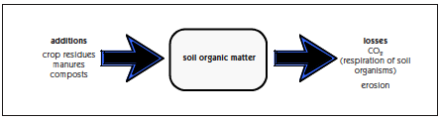 Figure 3.1 Additions and losses of organic matter from soils.

The amount of organic matter in a soil is the result of all the additions and losses of organic matter that have occurred over the years (figure 3.1). In this chapter, we will look at why different soils have different organic matter levels. While we will be looking mainly at the total amount of organic matter, keep in mind that all three “types” of organic matter—the living, dead, and very dead—serve critical roles and the amount of each of these may be affected differently by natural factors and agricultural practices.

Anything that adds large amounts of organic residues to a soil may increase organic matter. On the other hand, anything that causes soil organic matter to decompose more rapidly or be lost through erosion may deplete organic matter.
If additions are greater than losses, organic matter increases. When additions are less than losses, there is a depletion of soil organic matter. When the system is in balance, and additions equal losses, the quantity of soil organic matter doesn’t change over the years.
Natural Factors
Temperature
In the United States, it is easy to see how temperature affects soil organic matter levels. Traveling from north to south, higher average temperatures lead to less soil organic matter. As the climate gets warmer, two things tend to happen (as long as rainfall is sufficient): more vegetation is produced because the growing season is longer, and the rate of decomposition of organic materials in soils also increases, because soil organisms work more rapidly at higher temperatures and are active for longer periods of the year. Faster decomposition with warmer temperatures becomes the dominant influence determining soil organic matter levels.

Rainfall
Soils in arid climates usually have low amounts of organic matter. In a very dry climate, such as a desert, there is little growth of vegetation. Decomposition is also low because of low amounts of organic inputs and low microorganism activity when the soil is dry. When it finally rains, a very rapid burst of decomposition of soil organic matter occurs. Soil organic matter levels generally increase as average annual precipitation increases. With more rainfall, more water is available to plants and more plant growth results. As rainfall increases, more residues return to the soil from grasses or trees. At the same time, soils in high rainfall areas may have less soil organic matter decomposition than well-aerated soils — decomposition is slowed by restricted aeration.
Storage of Organic Matter in Soil

Organic matter is protected in soils by:
- Formation of strong chemical organic matter-clay (and fine silt) bonds;
- Being inside small aggregates (physically protected);
- Conversion into stable substances such as humic materials that are resistant to biological decomposition; and
- Restricted drainage, sometimes related to texture, that reduces the activity of the organisms that need oxygen to function.
e) Char produced by incomplete burning

Organic matter in large aggregates — but outside of the small aggregates that make up the larger ones — and freely occurring particulate organic matter (the “dead”) is available for soil organisms to use. However, poor aeration resulting from restricted drainage because of a dense subsurface layer, compaction, or being in the bottom of a slope may cause a low rate of use of the organic matter. So the organic matter needs to be in a favorable chemical form and physical location for organisms to use it plus there need to be the environmental conditions in the soil—sufficient moisture and aeration—for most soil organisms to use the residues and thrive.

Soil Texture
Fine textured soils, containing high percentages of clay and silt, tend to have naturally higher amounts of soil organic matter than coarse textured sands or sandy loams. The organic matter content of sands may be less than 1 percent; loams may have 2 to 3 percent; and clays from 4 to more than 5 percent. The strong chemical bonds that develop between organic matter and clay and fine silt protect organic molecules from attack and decomposition by microorganisms and their enzymes. Also, clay and fine silt combine with organic matter to form very small aggregates that in turn protect organic matter inside from organisms and their enzymes. In addition, fine textured soils tend to have smaller pores and less oxygen than coarser soils. This also limits decomposition rates, one of the reasons that organic matter levels in fine textured soils are higher than in sands and loams.
Soil Drainage and Position in the Topography
Decomposition of organic matter occurs more slowly in poorly aerated soils. In addition, some major plant compounds such as lignin will not decompose at all in anaerobic environments. For this reason, organic matter tends to accumulate in wet soil environments. When conditions are extremely wet or swampy for a very long period of time, organic (peat or muck) soils, with organic matter contents over 20 percent, develop. When these soils are artificially drained for agricultural or other uses, the soil organic matter will decompose very rapidly. When this happens, the elevation of the soil surface actually decreases. Some homeowners in Florida were fortunate to sink corner posts below the organic level. Originally level with the ground, those homes now perch on posts atop a soil surface that has decreased so dramatically the owners park their cars under their homes.
Soils in depressions at the bottom of hills receive runoff, sediments (including organic matter), and seepage from up slope and tend to accumulate more organic matter than drier soils farther up slope. In contrast, soils on a steep slope or knoll will tend to have low amounts of organic matter because the topsoil is continually eroded.

Type of Vegetation
The type of plants that grew on the soil as it formed can be an important source of natural variation in soil organic matter levels. Soils that formed under grassland vegetation generally contain more organic matter and a deeper distribution of organic matter than soils that formed under forest vegetation. This is probably a result of the deep and extensive root systems of grassland species (figure 3.2). Their roots have high “turnover” rates, for root death and decomposition constantly occurs as new roots are formed. Dry natural grasslands also frequently experience slow burning fires from lightning strikes, which contribute biochar that is very resistant to degradation. The high levels of organic matter in soils that were once in grassland partly explains why these are now some of the most productive agricultural soils in the world. By contrast, in forests, litter accumulates on top of the soil, and surface organic layers commonly contain over 50 percent organic matter. However, subsurface mineral layers in forest soils typically contain from less than 1 to about 2 percent organic matter.
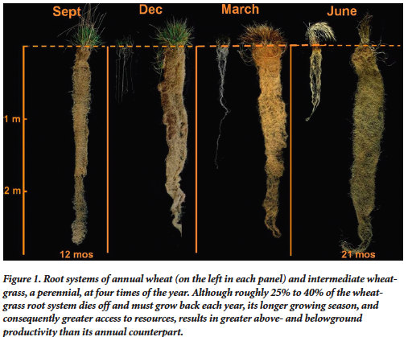
Figure 3.2 Root systems of annual wheat (on left in each panel) and wheatgrass, a perennial at four times of the year. Approximately 25 to 40% of the wheatgrass root system dies back each year, adding considerable amounts of organic matter, and then grows back. Compared to annual wheat, it has a longer growing season and has much more growth both above ground and below ground. Photo by the Land Institute.

Root vs. above ground residue contribution to soil organic matter

Roots, already being well distributed and in intimate contact with the soil, tend to contribute a higher percentage of their weight to the more persistent organic matter (dead and very dead) than above ground residues. In addition, compared to above ground plant parts, many crop roots have higher amounts of materials such as lignin that decompose relatively slowly. One experiment with oats found that only one-third of the surface residue remained after one year while 42% of the root organic matter remained in the soil and was the main contributor to particulate organic matter. In another experiment, 5 months after spring incorporation of hairy vetch, 13 percent of the above ground carbon remained in the soil while close to 50% of the root derived C was still present. Both experiments found that the root residue contributed much more to particulate organic matter (active, dead) than did aboveground residue.

Acidic Soil Conditions
In general, soil organic matter decomposition is slower under acidic soil conditions than at a more neutral pH. In addition, acidic conditions, by inhibiting earthworm activity, encourage organic matter to accumulate at the soil surface, rather than distributed throughout the soil layers.

Human Influences
Loss of organic matter rich topsoil by erosion has dramatically reduced the total amount of organic matter stored in many soils after they were developed for agriculture. Crop production obviously suffers when part or all of the most fertile layer of the soil is removed. Erosion is a natural process and occurs on almost all soils. Some soils naturally erode more easily than others and the problem is also greater in some regions than others. However, agricultural practices accelerate erosion. It is estimated that erosion in the United States is responsible for annual losses of about a billion dollars in available nutrients and many times more in total soil nutrients.
Unless erosion is very severe, a farmer may not even realize that a problem exists. But that doesn’t mean that crop yields are unaffected. In fact, yields may decrease by 5 to 10 percent when only moderate erosion occurs. Yields may suffer a decrease of 10 to 20 percent or more with severe erosion. The results of a study of three Midwestern soils, shown in table 3.1, indicate that erosion greatly influences both organic matter levels and water-holding ability. Greater amounts of erosion decreased the organic matter contents of these loamy and clayey soils. In addition, eroded soils stored less available water than minimally eroded soils.
Table 3.1
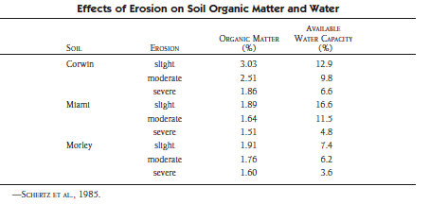
Organic matter also is lost from soils when organisms decompose more organic materials during the year than are added. This occurs as a result of practices that accelerate decomposition such as intensive tillage and crop production systems that return low amounts of residues. Much of the rapid loss of organic matter following the conversion of grasslands to agriculture has been attributed to large reductions in residue inputs, accelerated mineralization of organic matter because of plowing, and erosion.

Tillage Practices
Tillage practices influence both the amount of topsoil erosion and the rate of decomposition of soil organic matter. Conventional plowing and disking of a soil to prepare a smooth seedbed breaks down natural soil aggregates and destroys large, water-conducting channels. The soil is left in a physical condition that is highly susceptible wind and water erosion.
The more a soil is disturbed by tillage practices, the greater the potential breakdown of organic matter by soil organisms. During the early years of agriculture in the United States, when colonists cleared the forests and planted crops in the East and farmers later moved to the Midwest to plow the grasslands, soil organic matter decreased rapidly. In fact, the soils were literally mined of this valuable resource. In the Northeast and Southeast, it was quickly recognized that fertilizers and soil amendments were needed to maintain soil productivity. In the Midwest, the deep, rich soils of the tall-grass prairies were able to maintain their productivity for a long time despite accelerated soil organic matter loss and significant amounts of erosion. The reason for this was their unusually high reserves of soil organic matter and nutrients at the time of conversion to cropland.
Rapid soil organic matter decomposition by soil organisms usually occurs when a soil is intensively tilled. Incorporating residues with a moldboard plow, breaking aggregates open, and fluffing up the soil allows microorganisms to work more rapidly. It’s something like opening up the air intake on a wood stove, which lets in more oxygen and causes the fire to burn hotter. In Vermont, we found a 20-percent decrease in organic matter after five years of growing corn on a clay soil that had previously been in sod for decades. In the Midwest, many soils lost 50 percent of the organic matter within 40 years of beginning cropping. Rapid loss of soil organic matter occurs in the early years, because of the high initial amount of active (“dead”) organic matter available to microorganisms. After much of the active portion is lost, the rate of organic matter loss slows and what remains is mainly the already well decomposed “passive” or “very dead” materials. With the current interest in reduced (conservation) tillage, growing row crops in the future should not have such a detrimental effect on soil organic matter. Conservation tillage practices leave more residues on the surface and cause less soil disturbance than conventional moldboard plow and disk tillage. In fact, soil organic matter levels usually increase when no-till planters place seeds in a narrow band of disturbed soil, while leaving the soil between planting rows undisturbed. Residues accumulate on the surface because the soil is not inverted by plowing. Earthworm populations increase, taking some of the organic matter deeper into the soil and creating channels that also help water infiltrate into the soil.. The beneficial effects of minimizing tillage on soil organic matter levels are often observed quickly at the soil surface but deeper changes are much slower to develop and depletion at depth is sometimes observed. In the upper Midwest there is conflicting evidence whether long term no-till results in greater accumulation of SOM than conventional tillage system when the full profile is considered. In contrast, significant increases in profile SOM have been routinely observed under no-till in warmer locations.
Figure 3.3 5.3
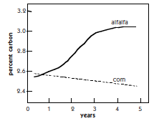
Crop Rotations and Cover Crops
Soil organic matter levels may fluctuate during the different stages of a crop rotation. Soil organic matter may decrease, then increase, then decrease, and so forth. While annual row crops under conventional moldboard plow cultivation usually result in decreased soil organic matter, perennial legumes, grasses, or legume-grass forage crops tend to increase soil organic matter. The high amount of root production by hay and pasture crops, plus the lack of soil disturbance, cause organic matter to accumulate in the soil. This effect is seen in the comparison of organic matter increases when growing alfalfa compared to corn silage (figure 3.3). In addition, different types of crops result in different quantities of residues returned to the soil. When corn grain is harvested, more residues are left in the field than after soybeans, wheat, potatoes, or lettuce harvests. Harvesting the same crop in different ways leaves different amounts of residues. When corn grain is harvested, more residues remain in the field than when the entire plant is harvested for silage or stover is used for purposes like bioenergy (figure 3.4).
Figure 3.3 Organic carbon changes when growing corn silage or alfalfa. Redrawn from Angers, 1992.
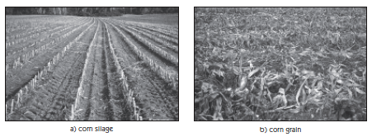
Figure 3.4 Soil surface after harvest of corn silage or corn grain. Photos by Win Way.
Soil erosion is greatly reduced and topsoil rich in organic matter is conserved when rotation crops, such as grass or legume hay, are grown year-round. The permanent soil cover and extensive root systems of sod crops account for much of the reduction in erosion. Having sod crops as part of a rotation reduces loss of topsoil, decreases decomposition of residues, and builds up organic matter by the extensive residue addition of plant roots.
Use of Synthetic Nitrogen Fertilizer
Fertilizing very nutrient deficient soils usually results in greater crop yields. A “fringe benefit” of this is a greater amount of crop residue — roots, stems, and leaves — resulting from larger and healthier plants. However, nitrogen fertilizer has commonly been applied at much higher rates than actually needed by plants, frequently by as much as 50%. Evidence is accumulating that having extra mineral nitrogen in soils actually helps organisms better decompose crop residues — resulting in decreased levels of soil organic matter. (See chapter 17 for a detailed discussion of nitrogen management.)
Use of Organic Amendments
An old practice that helps maintain or increase soil organic matter is to apply manures or other organic residues generated off the field. A study in Vermont during the 1960s and 1970s found that between 20 and 30 tons (wet weight, including straw or sawdust bedding) of dairy manure per acre were needed to maintain soil organic matter levels when silage corn was grown each year. This is equivalent to 1 to 11/2 times the amount produced by a large Holstein cow over the whole year. Varying types of manure — like bedded, liquid stored, digested. — can have very different effects on soil organic matter and nutrient availability. They differ in their initial composition and also are affected by how they are stored and handled in the field, for example surface applied or incorporated.
Organic Matter
Distribution in Soil
With depth in the soil
In general, more organic matter is present near the surface than deeper in the soil (see figure 3.5). This is one of the main reasons that topsoils are more productive than subsoils exposed by erosion or mechanical removal of surface soil layers. Some of the plant residues that eventually become part of the soil organic matter are from the above-ground portion of plants. In most cases, plant roots are believed to contribute more to a soil’s organic matter than the crop’s shoots and leaves. But when the plant dies or sheds leaves or branches, depositing residues on the surface, earthworms and insects help incorporate the residues on the surface deeper into the soil. The highest concentrations of organic matter, however, remain within 1 foot of the surface.
2008.
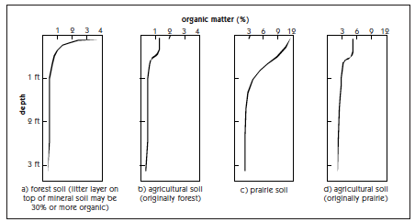
Figure 3.5 Examples of soil organic matter content with depth. Modified from Brady and Weil, 2008.
Litter layers that commonly develop on the surface of forest soils may have very high organic matter contents (figure 3.5a). Plowing forest soils after removal of the trees incorporates the litter layers into the mineral soil. The incorporated litter decomposes rapidly, and an agricultural soil derived from a sandy texture forest soil in the north or a silt loam in the South would likely have a distribution of organic matter similar to that indicated in figure 3.5b. Soils of the tall-grass prairies have a deeper distribution of organic matter (see figure 3.5c). After cultivation of these soils for 50 years, far less organic matter remains (figure 3.5d).

Organic matter and aggregates
Organic matter occurs both outside of aggregates as living roots or larger organisms or pieces of residue from a past harvest. Some organic matter is even more intimately associated with soil. Humic materials may be adsorbed onto clay and small silt particles, and small to medium size aggregates usually contain particles of organic matter. The organic matter inside very small aggregates is physically protected from decomposition because microorganisms and their enzymes can’t reach inside. This organic matter also attaches to mineral particles and thereby makes the small particles stick together better. The larger soil aggregates, composed of many smaller ones, are held together primarily by the hyphae of fungi with their sticky secretions, sticky substances produced by other microorganisms, and by roots and their secretions as well as. Microorganisms are also found in very small pores within larger aggregates. This can sometimes protect them from their larger predators, paramecium, amoeba, and nematodes.
There is an interrelationship between the amount of fine particles in a soil and the amount of organic matter needed to produce stable aggregates. The higher the clay and silt content the more organic matter is needed to produce stable aggregates because more is needed to occupy the surface sites on the minerals during the process of organic matter accumulation. In order to have more than half of the soil composed of water-stable aggregates, a soil with 50 percent clay may need twice as much organic matter as a soil with 10 percent clay.

Active
Organic Matter
Most of the discussion in this chapter so far has been about the factors that control the quantity and location of total organic matter in soils. However, we should keep in mind that we are also interested in balancing the different types of organic matter in soils — the living, the dead (active), and the very dead (humus). We don’t just want a lot of humus in soil, we also want a lot of active organic matter to provide nutrients and aggregating glues when it is decomposed. It also supplies food to keep a diverse population of organisms present. As mentioned earlier, when forest or grassland soils were first cultivated, organic matter decreased rapidly. Almost the entire decline in organic matter was due to a loss of the active (“dead”) part of the organic matter. Although it decreases the fastest when intensive tillage is used, the active portion increases relatively quickly when practices such as reduced tillage, rotations, cover crops, and applying manures and composts are used to increase soil organic matter.

amounts of Living
Organic Matter
In chapter 4, we discuss the various types of organisms that live in soils. The weight of fungi present in forest soils is much greater than the weight of bacteria. In grasslands, however, there are about equal weights of both. In agricultural soils that are routinely tilled, the weight of fungi is less than the weight of bacteria. The loss of surface residues with tillage lowers the number of surface feeding organisms. And as soils become more compact, larger pores are eliminated first. To give some perspective, a soil pore that is one twentieth of an inch is size is considered very large. These are the pores in which soil animals, such as earthworms and beetles, live and function, so the number of such organisms in compacted soils decreases. Plant root tips are generally about 0.1 mm (1/250th of an inch) in diameter and very compacted soils that lost pores greater than that size have serious rooting problems. The elimination of smaller pores and the loss of some of the network of small pores with even more compaction is a problem from small soil organisms.
The total amounts (weights) of living organisms vary in different cropping systems. In general, soil organisms are more abundant and diverse in systems with complex rotations that return more diverse crop residues and that use other organic materials such as, cover crops, animal manures, and composts. Leaves and grass clippings may be an important source of organic residues for gardeners. When crops are rotated regularly, fewer parasite, disease, weed, and insect problems occur than when the same crop is grown year after year.
On the other hand, frequent cultivation reduces the populations of many soil organisms as their food supplies are depleted by decomposition of organic matter. Compaction from heavy equipment also causes harmful biological effects in soils. It decreases the number of medium to large pores, which reduces the volume of soil available for air, water, and populations of organisms — such as mites and springtails — that need the large spaces in which to live.

How much organic matter is enough?
As mentioned earlier, soils with higher levels of fine silt and clay usually have higher levels of organic matter than those with a sandier texture. However, unlike plant nutrients or pH levels, there are few accepted guidelines for adequate organic matter content in particular agricultural soils. We do know some general guidelines. For example, 2 percent organic matter in a sandy soil is very good and difficult to reach, but in a clay soil, 2 percent indicates a greatly depleted situation. The complexity of soil organic matter composition, including biological diversity of organisms as well as the actual organic chemicals present, means that there is no simple interpretation for total soil organic matter tests. We also know that soils higher in silt and clay need more organic matter to produce sufficient water-stable aggregates to protect soil from erosion and compaction. For example, to have a similar aggregation as a soil with 16% clay and with 2% organic matter, a soil with close to 50% clay may need around 6% organic matter.
The question will be raised, How much organic matter should be assigned to the soil? No general formula can be given. Soils vary widely in character and quality. Some can endure a measure of organic deprivation…others cannot. On slopes, strongly erodible soils, or soils that have been eroded already, require more input than soils on level lands.
—Hans Jenny, 1980
Organic matter accumulation takes place slowly and is difficult to detect in the short term by measurements of total soil organic matter. However, even if you do not greatly increase soil organic matter (and it might take years to know how much an effect is occurring) improved organic matter management practices such as adding organic materials, better rotations, reduced tillage, etc. will help maintain the levels currently in the soil. And perhaps more importantly, continuously adding a variety of residues results in plentiful supplies of “dead” organic matter — the relatively fresh particulate organic matter — that helps maintain soil health by providing food for soil organisms and promoting the formation of soil aggregates. A recently developed soil test that oxidizes part of the soil organic matter with supposedly provides a measure of active carbon. It is more sensitive to soil management than total organic matter, and thereby an earlier indicator for soil health improvement. Interpretation of the test is currently an active research area.

The Dynamics of Raising and Maintaining
Soil Organic Matter Levels

It is not easy to dramatically increase the organic matter content of soils or even to maintain elevated levels once they are reached. It requires a sustained effort that includes a number of approaches that add organic materials to soils and minimize losses. It is especially difficult to raise the organic matter content of soils that are very well aerated, such as coarse sands, because the potential for aggregation (that protects particles of organic matter) is limited as are the fine minerals that form protective bonds with organic matter. Soil organic matter levels can be maintained with lower additions of organic residues in high clay-content soils with restricted aeration than in coarse-textured soils because of the slower decomposition. Organic matter can be increased much more readily in soils that have become very organic matter depleted than in soils that already have a good amount of organic matter with respect their texture and drainage condition.
When changing practices on a soil depleted in organic matter, perhaps one that has been intensive row cropped for years and lost a lot of its original aggregation, organic matter will increase slowly as diagrammed in figure 3.6. At first any free mineral surfaces that are available for forming bonds with organic matter will form organic-mineral bonds. Small aggregates will also form around particles of organic matter. Then larger aggregates will form, made up of the smaller aggregates and held by a variety of means—frequently by mycorrhizael fungi and small roots. Once all possible mineral sites are occupied by organic molecules and all of the small aggregates have been formed around organic matter particles, organic matter accumulates mainly as free particles—within the larger aggregates or completely unaffiliated with minerals. This is referred to as free particulate organic matter. After following similar soil building practices for some years (for example, cover cropping or applying manures), the soil will come into equilibrium with your management and the total amount of soil organic matter will not change from year to year. In a sense, the soil is “saturated” with organic matter as long as your practices don’t change—all the sites that protect organic matter are occupied (chemical bonds with minerals and physically protected by being inside small aggregates), and only free particles of organic matter (free POM) can accumulate. But because there is little protection for the free particles of organic matter, they tend to decompose relatively rapidly.
When management practices are used that deplete organic matter, the reverse of what is depicted in figure 3.6 occurs. First free particulate organic matter is depleted, and then as aggregates are broken down physically protected organic matter becomes available to decomposers.. What usually remains after many years of soil depleting practices is the organic matter that is tightly held by clay mineral particles.

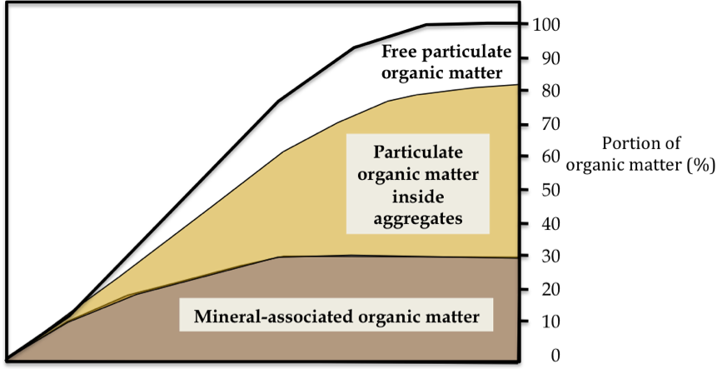
Figure 3.6 Organic matter changes in soil as practices favoring buildup are implemented. Redrawn and modified from Angers (1992).

Assuming that the same management pattern has occurred for many years, a fairly simple model can be used to estimate the percent organic matter in a soil. It allows us to see interesting trends that reflect the real world. To use this model you need to assume reasonable values for rates of addition of organic materials and SOM decomposition rates in the soil. Without going through the details (see Appendix 1 for example calculations), the estimated percent organic matter in soils for various combinations of addition and decomposition rates indicates some dramatic differences (table 3.2). It takes about 5,000 lbs of organic residues added annually to a sandy loam soil (with a an estimated decomposition rate of 3% per year) to result eventually in a soil with 1.7% organic matter. On the other hand, 7,500 lbs of residues added annually to a well-drained coarse texture soil (with a soil organic matter mineralization (decomposition) rate of 5 percent per year) is estimated to result after many years in only 1.5% soil organic matter.
Table 3.2
Estimated levels of soil organic matter after many years with various rates of decomposition (mineralization) and residue additions*
Annual rate of SOM decomposition
percent per year
fine textured, poorly drained

coarse textured, well drainedAnnual organic material additionsAdded to soil if 20% remains after one year
1
2
3
4
5-----lbs per acre per yr------------final % organic matter in soil -----2,5005002.51.30.80.60.55,0001,0005.02.51.71.31.07,5001,5007.53.82.51.91.510,0002,000 10.05.03.32.52.0*Assumes upper 6 inches of soil weighs 2 million lbs.

Normally when organic matter is accumulating in soil it will increase at the rate of tens to hundreds of lbs per acre per year—but keep in mind that the weight of organic material in 6 inches of soil that contains 1 percent organic matter is 20,0000 lbs! Thus the small annual changes, along with the great variation you can find in a single field, means that it usually takes years to detect changes in the total amount of organic matter in a soil.
In addition to the final amount of organic matter in a soil, the same simple equation used to calculate the information in table 3.2 can also be used to estimate organic matter changes as they occur over a period of years or decades. Let’s take a more detailed look at the case where 5,000 lbs of residue is added per year with only 1,000 lbs remaining after one year. Let’s assume that the residue remaining from the previous year behaves the same as the rest of soil’s organic matter — in this case, decomposing at a rate of 3% per year. As we mentioned above, with these assumptions, after many years a soil will end up having 1.7% organic matter. If it starts at 1% organic matter it will have an annual net gain of around 350 lbs of organic matter per acre in the first decade, decreasing to very small net gains after decades of following the same practices (Figure 3.7a). Thus, even though 5,000 lbs per acre are added each year, the NET yearly gain decreases as the soil organic matter reaches a steady-state. If it was a very depleted soil and the additions started when it was at only 0.5% organic matter, a lot of it might be bound to clay mineral surfaces and so helps to form very small aggregates—preserving more organic matter each year. In this case, it is estimated that the net annual gain in the first decade might be over 600 lbs per acre (Figure 3.7a).
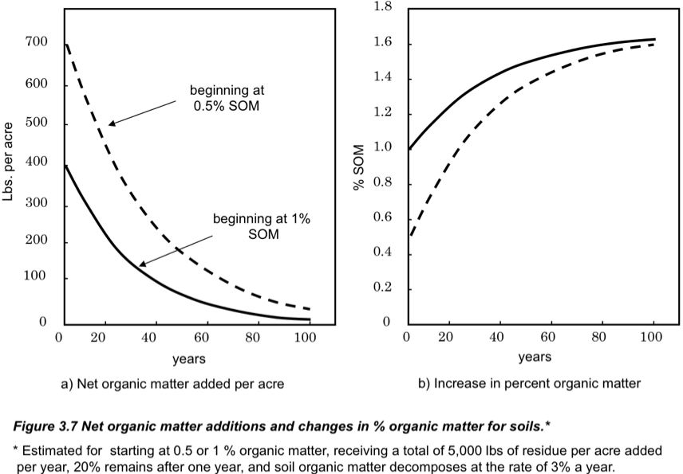

The soil organic matter content rises more quickly for the very depleted soil (starting at 0.5% organic matter) than for the 1% organic matter soil (figure 3.7b), because so much more organic matter can be stored in organo-mineral complexes and inside very small and medium size aggregates. Once all the possible sites that can physically or chemically protect organic matter have already done so, organic matter accumulates more slowly, mainly as free particulate (active) material.
Summary of Soil Organic Changes over Time

Even if you did not completely follow the discussion in this section — or even look at the calculations — there are a still number of important points to remember about organic matter dynamics.

- The change of total soil organic matter takes years to show up in soil tests — with annual changes that are small compared to the amount that’s already there and the great amount of variation in of SOM even within one field, which makes it difficult to determine small changes.
- Increases (or decreases) in particulate organic matter —the active, “dead”— can be detected more rapidly than changes in total soil organic matter.
- When annual additions are greater than losses, SOM accumulates.
- Most of the residue added to the soil in a given year is generally mineralized by the end of a year—often 80 or 90% of fresh residue may be lost.
- Organic matter can increase more rapidly in a very depleted soil because much of what is added can be chemically and physically protected.
- Once all the potential sites that protect organic matter are filled, organic matter accumulation slows and mainly occurs as free particulate organic matter. Thus, when following a group of soil building practices, the amount of organic matter in a soil will eventually approach a new steady state or equilibrium level.
- Soils have very different abilities to store new organic matter—depending on their texture, structure, drainage class, and the relative amount of organic matter currently in the soil compared to the amount it can potentially contain if the a certain group of soil building practices are used for a long period.

Sources
Angers, D.A. 1992. Changes in soil aggregation and organic carbon under corn and alfalfa. Soil Science Society of America Journal 56: 1244–1249.
Brady, N.C., and R.R. Weil. 2008. The Nature and Properties of Soils. 14th ed. Prentice Hall, Upper Saddle River, NJ.
Carter, M. 2002. Soil Quality for Sustainable Land Management: Organic Matter and Aggregation: Interactions that Maintain Soil Functions. Agronomy Journal 94:38–47.
Carter, V.G., and T. Dale. 1974. Topsoil and Civilization. University of Oklahoma Press. Nor-man, OK.
Gale, W.J., and C.A. Cambardella. 2000. Carbon dynamics of surface residue- and root-derived organic matter under simulated no-till. Soil Science Society of America Journal 64:190–195.
Hass, H.J., G.E.A. Evans, and E.F. Miles. 1957. Nitrogen and Carbon Changes in Great Plains Soils as Influenced by Cropping and Soil Treatments. U.S. Department of Agriculture Technical Bulletin 1164. U.S. Government Printing Office. Washington, D.C. This is a reference for the large decrease in organic matter content of Midwest soils.
Jenny, H. 1980. The Soil Resource. Springer-Verlag. New York, NY.
Jenny, H. 1941. Factors of Soil Formation. McGraw-Hill. New York, NY. Jenny’s early work on the natural factors influencing soil organic matter levels.
Khan, S.A., R.L. Mulvaney, T.R. Ellsworth, and C.W. Boast. 2007. The Myth of Nitrogen Fertilization for Soil Carbon Sequestration. Journal of Environmental Quality 36:1821–1832.
Magdoff, F. 2000. Building Soils for Better Crops. 1st Edition. University of Nebraska Press.
Magdoff, F.R., and J.F. Amadon. 1980. Yield trends and soil chemical changes resulting from N and manure application to continuous corn. Agronomy Journal 72:161–164. See this reference for further information on the studies in Vermont cited in this chapter.
National Research Council. 1989. Alternative Agriculture. National Academy Press. Washington, D.C.
Puget, P., and L.E. Drinkwater. 2001. Short-term dynamics of root-and shoot-derived carbon from a leguminous green manure. Soil Science Society of America Journal 65:771–779.
Schertz, D.L., W.C. Moldenhauer, D.F. Franz-meier, and H.R. Sinclair, Jr. 1985. Field evaluation of the effect of soil erosion on crop productivity. pp. 9–17. In Erosion and Soil Productivity. Proceedings of the national symposium on erosion and soil productivity. Dec. 10–11, 1984. New Orleans, LA. American Society of Agricultural Engineers Publication 8-85. St. Joseph, MI.
Tate, R.L., III. 1987. Soil Organic Matter: Biological and Ecological Effects. John Wiley & Sons. New York, NY.
Wilhelm, W.W. J.M.F. Johnson, J.L. Hatfield, W.B. Voorhees, and D.R. Linden. 2004. Crop and Soil Productivity Response to Corn Residue Removal: A Literature Review. Agronomy. Journal 96:1–17 (2004).

