GETTING TO THE PRINGLE HERBARIUM, TORREY HALL
Torrey Hall is near the chapel and Votey Hall at the north end of campus. See more below.
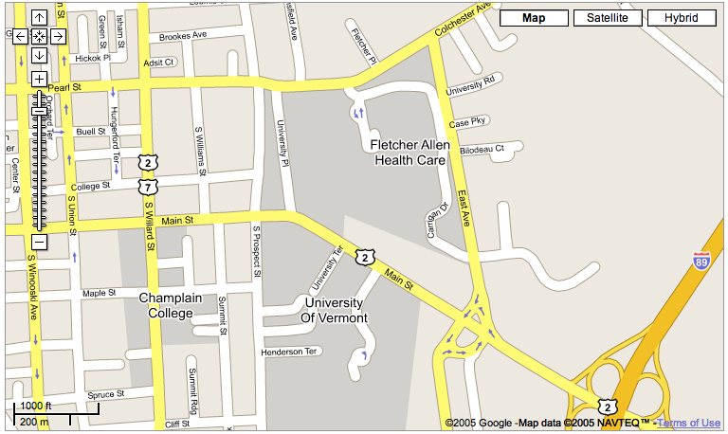

X

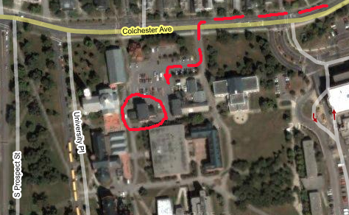
Enter through doors on south side.(North is up in these maps). Go left inside the doors, around the corner, and up the stairs by the display case with the clams. The herbarium is one floor up, at the top of the first flight of stairs. Phone there is 802-656-3221.

